

Interim Project Report-I
on
UPI Fraud Detection Using Machine Learning
Submitted in partial fulfillment for the award of
BACHELOR OF TECHNOLOGY
Degree in
COMPUTER SCIENCE & ENGINEERING
2026–27
Under the Guidance of: [GUIDE NAME]
Submitted By: Mohit Singh | Admission Number: [NOT PROVIDED]
SCHOOL OF COMPUTER SCIENCE & ENGINEERING
GALGOTIAS UNIVERSITY
OCTOBER 2026

PROJECT PROGRESS REPORT MTE / MID TERM EXAM
B.Tech. Project Details — Semester: 7th
TABLE 1.1
Project Details
Field | Details
Project ID | [NOT PROVIDED]
Project Title | UPI Fraud Detection Using Machine Learning
Project Progress | Dataset reviewed; preprocessing and random-forest pipeline trained and evaluated; Jupyter notebook and Flask demonstration website prepared.
Research Paper Title | UPI Fraud Detection Using Machine Learning
Research Report Progress | Interim project report prepared from the implemented project and measured test results.
Suggestions by Guide | [TO BE COMPLETED BY GUIDE]
Suggestions by Examiner | [TO BE COMPLETED BY EXAMINER]

Student Progress Details (Filled by Guide Only)
S. No. | Student Name | Admission Number | Performance | Approval
1 | Mohit Singh | [NOT PROVIDED] | ☐ Excellent ☐ Good ☐ Satisfactory | ☐ Approved ☐ Not Approved
2 | [TEAM MEMBER, IF ANY] | [ADMISSION NO.]

Supervisor Signature: __________________________ Examiner Signature: __________________________

SYNOPSIS
Project Title: UPI Fraud Detection Using Machine Learning
Unified Payments Interface (UPI) supports rapid person-to-person and merchant payments. This project studies a supervised machine-learning pipeline that classifies transaction records as fraud or legitimate and provides a Flask demonstration interface for displaying evaluation metrics and scoring an example transaction.
Problem statement. The project asks whether transaction attributes in the supplied CSV can support binary fraud classification on a held-out sample. The available file contains 250,000 rows and the project does not document its collection method, label rules, or risk-score generation process; results therefore describe this dataset rather than live UPI traffic.
Objectives. Inspect the transaction data; exclude direct identifiers; preprocess numeric and categorical fields; train a random-forest classifier; report accuracy, precision, recall, F1, ROC AUC and the confusion matrix; and connect the saved model to a local Flask website.
Methodology. The pipeline uses a reproducible stratified 80:20 train-test split, median and most-frequent imputation, one-hot encoding, and a 100-tree random forest with class weighting. Transaction ID, timestamp and UPI addresses are omitted as predictors. A notebook documents the evaluation, while Flask provides a dashboard and JSON prediction endpoints.
Results and limitations. On the 50,000-row test set, accuracy was 92.98%, precision 93.09%, recall 92.85%, F1 92.97%, and ROC AUC 0.930. The test confusion matrix was [[23,275, 1,722], [1,787, 23,216]]. The file has a 50.006% fraud rate. The unknown provenance and the strong contribution of `risk_score` require follow-up checks for target leakage and external validity.
Keywords: UPI, transaction fraud, random forest, confusion matrix, ROC AUC, Flask.

TABLE OF CONTENTS
CONTENTS | PAGE
Synopsis
List of Figures
List of Tables
List of Symbols and Abbreviations
Chapter 1: Introduction
Chapter 2: Literature Review
Chapter 3: Proposed Methodology
Chapter 4: Software Implementation
Chapter 5: Results, Discussion and Future Work
Chapter 6: Conclusion
References

Page numbers can be updated in Word after final pagination.

LIST OF FIGURES
FIGURE | DESCRIPTION | PAGE
Figure 3.1 | UPI fraud detection project workflow
Figure 5.1 | Confusion matrix on the held-out test set
Figure 5.2 | ROC curve for held-out predictions
Figure 5.3 | Random-forest feature importance

LIST OF TABLES
TABLE | DESCRIPTION | PAGE
Table 1.1 | Project details and progress
Table 1.2 | Project objectives and deliverables
Table 2.1 | Related approaches and relevance
Table 2.2 | Research gaps and project response
Table 3.1 | Model configuration
Table 4.1 | Software tools and roles
Table 5.1 | Test-set evaluation metrics
Table 5.2 | Confusion-matrix counts

LIST OF SYMBOLS AND ABBREVIATIONS
TERM | MEANING
UPI | Unified Payments Interface
P2P | Person-to-person transaction
P2M | Person-to-merchant transaction
RF | Random forest
ROC | Receiver operating characteristic
AUC | Area under the ROC curve
TP / TN | True positive / true negative
FP / FN | False positive / false negative
API | Application programming interface

CHAPTER 1: INTRODUCTION
This chapter sets out the project context, research question, objectives and scope. It also states the limits of the current evidence so the reported model scores are not mistaken for operational fraud-detection performance.

1.1 Background of the Problem
UPI is an instant payment system that enables bank-account transfers through interoperable applications [5]. High transaction speed makes automated risk screening useful as one part of a broader review process. A classifier can learn associations in past labelled transactions, but its value depends on the quality and timing of the input features and the reliability of the labels.
The supplied dataset contains transaction amount, transaction type, status, sender and receiver age groups, state, banks, device and network, time-of-day fields, a risk score, and a binary fraud label. The project trains a random forest to predict that label and exposes the saved model through a small website.

1.2 Motivation and Significance
The project brings together the main stages of a practical machine-learning exercise: inspecting a CSV, preparing mixed data types, separating training from testing, evaluating predictions, saving a model, and connecting the model to an application. Showing the confusion matrix alongside accuracy helps distinguish false alerts from missed fraud cases.

1.3 Problem Statement
Given the features in the provided transaction file, can a supervised classifier distinguish rows labelled fraud from rows labelled legitimate on a held-out test split, and can the trained pipeline return an understandable score through a web interface?

1.4 Objectives of the Project
- Review the supplied dataset and identify the target and available transaction features.
- Remove direct identifiers from the predictor set and preprocess numeric and categorical fields.
- Train a reproducible random-forest classifier using a stratified train-test split.
- Evaluate the model with precision, recall, F1, ROC AUC, accuracy and a confusion matrix.
- Present test results and a transaction-scoring form through a local Flask website.
TABLE 1.2
Project Objectives and Deliverables
NO. | OBJECTIVE | DELIVERABLE | STATUS
1 | Inspect transaction CSV | Dataset summary and target profile | Completed
2 | Train and evaluate classifier | Saved pipeline and held-out metrics | Completed
3 | Document results | Notebook with metric and matrix outputs | Prepared
4 | Serve model output | Flask dashboard and prediction endpoint | Prepared
5 | Validate real-world use | Provenance, temporal and leakage checks | Future work

1.5 Scope of the Project
This report covers the supplied CSV, the existing scikit-learn pipeline, its single 80:20 stratified evaluation, the confusion matrix and feature importances, and a local Flask demonstration. It does not verify the dataset source, establish label adjudication, compare multiple algorithms, or test a live UPI feed.

1.6 Limitations of the Study
The dataset has an almost 50:50 target distribution, but no provenance or label-generation documentation is present in the project. A row-wise random split may place related transactions in both partitions. The risk-score field is strongly associated with the target and may contain information unavailable at decision time. These issues limit conclusions about generalization.

1.7 Organization of the Report
Chapter 2 reviews relevant approaches and research gaps. Chapter 3 documents the dataset, feature treatment, classifier and evaluation design. Chapter 4 describes the Python and Flask implementation. Chapter 5 presents the measured results, figures and limitations. Chapter 6 concludes the report and identifies follow-up work.

CHAPTER 2: LITERATURE REVIEW
Research on UPI fraud detection motivates using transaction records to identify suspicious patterns. The supplied chapter surveys machine-learning approaches and discusses feature engineering and monitoring [1]. It is useful as background, but it does not establish the origin or validity of the dataset used in this project. The two PDFs supplied with the request are identical copies of that same chapter and are cited once.

2.1 Review of Existing Systems and Techniques

Rule-based screening
Rules flag transactions that meet predefined conditions, such as limits or known risk indicators. Rules are easy to inspect, but require ongoing maintenance and may not capture interactions among multiple transaction fields.

Supervised classification
Supervised models learn a mapping from historical feature rows to supplied labels. Random forests combine tree predictors and can represent nonlinear relationships in mixed feature sets [2]. Their scores remain tied to the data and labels used during training.

Anomaly detection and monitoring
Anomaly methods look for observations that differ from a learned baseline, while monitoring tracks changes after deployment. The supplied UPI chapter discusses these directions [1], but the present project implements a static supervised classifier and does not evaluate online adaptation or drift detection.

2.2 Review of Related Research Work
Jagadeesan et al. review machine-learning concepts for UPI fraud detection and describe the need to consider feature construction and changing fraud patterns [1]. Breiman’s random-forest formulation provides the basis for the ensemble classifier used here [2]. Fawcett explains ROC curves as a way to examine classifier behaviour across thresholds and cautions against relying on a single accuracy value [3]. Pedregosa et al. describe the scikit-learn toolkit used to assemble and evaluate this pipeline [4].

2.3 Comparative Analysis of Existing Approaches
TABLE 2.1
Related Approaches and Their Relevance
APPROACH | STRENGTH | LIMITATION | RELEVANCE
Rule-based screening | Transparent conditions | Needs manual updates; limited interactions | Useful operational baseline, not implemented here
Random forest | Ensemble of trees; handles nonlinear patterns | Importance and scores depend on data quality | Classifier evaluated in this project
Anomaly detection | Can identify patterns outside a baseline | Needs a defined baseline and review process | Discussed in related work; not evaluated here
Flask demonstration | Shows saved metrics and one-row scoring | No authentication, monitoring or payment integration | Prototype interface for this project

2.4 Identification of Research Gaps
TABLE 2.2
Research Gaps and Project Response
NO. | GAP OR UNKNOWN | PROJECT RESPONSE / NEXT REQUIREMENT
1 | Dataset source and label rules are undocumented | Obtain provenance and label-adjudication details
2 | Fraud prevalence is 50.006% in the file | Evaluate at a representative operational prevalence
3 | Risk-score timing and derivation are unknown | Run an ablation without risk_score and verify availability at prediction time
4 | Random row split may share entities across partitions | Use time-based and entity-grouped evaluation
5 | No cost-based threshold study is reported | Set threshold using review capacity and error costs
6 | One model and one split were assessed | Add baselines, repeated validation and external testing

2.5 Summary of Literature Findings
Prior work supports testing supervised classifiers on transaction features, but the usefulness of a model must be judged on a clearly described dataset and evaluation design. This report emphasizes multiple metrics, false-positive and false-negative counts, and the limits imposed by missing data provenance. No claim of superiority over other classifiers is made because the project did not run a comparative experiment.

CHAPTER 3: PROPOSED METHODOLOGY
The implemented workflow reads the supplied CSV, separates the binary target, drops direct identifiers, fits preprocessing and a random forest on the training partition, and evaluates predictions on the held-out partition. The saved pipeline is then loaded by the Flask application.

3.1 System Overview
Figure 3.1. UPI fraud detection project workflow.
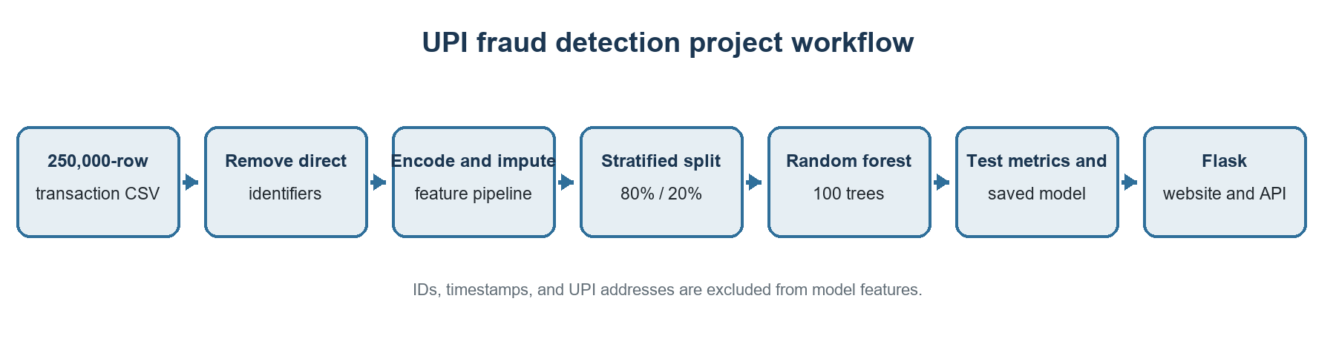

3.2 Dataset Preparation
The dataset has 250,000 records and 20 columns, including the target `is_fraud`. It contains 125,016 fraud labels and 124,984 legitimate labels, a fraud rate of 50.0064%. Each record includes transaction information such as amount, type and status; sender/receiver categories; device and network information; time features; risk_score; and the target. The project files do not identify the dataset publisher, collection process, or label-review protocol.

3.3 Feature Selection and Preprocessing
The pipeline removes `transaction id`, `timestamp`, `sender_upi_id`, `receiver_upi_id`, and `is_fraud` from the predictor matrix. The remaining 15 features are split into numeric and categorical groups. Numeric missing values are filled with the training median and scaled. Categorical missing values are filled with the training mode and one-hot encoded with unseen categories ignored. These operations are part of the fitted scikit-learn pipeline so the test set does not determine preprocessing values.

3.4 Random-Forest Classifier
The project uses a random forest with 100 trees, maximum depth 20, minimum leaf size 2, `balanced_subsample` class weights, random seed 42, and four worker threads. A random forest combines tree predictions to form a classification result [2]. The weighting option operates during tree fitting; it does not make the test data representative of real-world fraud prevalence.
TABLE 3.1
Model Configuration
SETTING | VALUE | PURPOSE
Estimator | RandomForestClassifier | Binary classification
Trees | 100 | Number of tree predictors
Maximum depth | 20 | Limits tree depth
Minimum leaf size | 2 | Minimum records per leaf
Class weighting | balanced_subsample | Weights bootstrap samples by class frequency
Split | 80% train / 20% test | 50,000 records held out
Random seed | 42 | Reproducible partition and estimator
Target | is_fraud | 1 = fraud; 0 = legitimate

3.5 Training and Test Protocol
The data are divided with `train_test_split`, test_size 0.20, random_state 42, and stratification on the target. Training uses 200,000 rows and testing uses 50,000. Preprocessing and model fitting occur on the training rows only. The split preserves class proportions but is not time-based or grouped by participant, bank, or merchant.

3.6 Evaluation Metrics
Accuracy measures the share of correct predictions. Precision is the share of predicted fraud rows that are labelled fraud; recall is the share of labelled fraud rows detected. F1 summarizes precision and recall with their harmonic mean. ROC AUC measures ranking across thresholds [3]. The confusion matrix gives counts for true negatives, false positives, false negatives, and true positives. The project’s web interface labels a transaction as potential fraud when its predicted probability is at least 0.5.

CHAPTER 4: SOFTWARE IMPLEMENTATION
The project is implemented in Python. The Jupyter notebook documents dataset review, training, evaluation and visualization. A command-line training script writes the serialized model bundle, and the Flask server loads that bundle to serve a dashboard and prediction endpoint.

4.1 Technologies and Tools
TABLE 4.1
Software Tools and Their Roles
TOOL | ROLE IN THE PROJECT
Python | Data processing, model training and web server
pandas | CSV loading and feature preparation
scikit-learn | Preprocessing pipeline, random forest, split and metrics
joblib | Persistence of the trained pipeline and test metrics
Jupyter Notebook | Interactive review of training and evaluation
Flask | Dashboard and JSON endpoints
HTML, CSS and JavaScript | Browser dashboard and transaction scoring form

4.2 Training and Model Persistence
The `train.py` entry point calls the project training function. It reads the CSV, builds the preprocessing and classifier pipeline, fits on the training partition, calculates held-out metrics, and saves the estimator, input feature list and metrics together in `app/fraud_model.joblib`. Saving the feature list allows the server to construct a row with the expected model inputs.

4.3 Flask Dashboard and Prediction Workflow
The home page displays accuracy, precision, recall, ROC AUC and the confusion matrix from the saved evaluation. `GET /api/metrics` returns the same metrics as JSON. `POST /api/predict` accepts a JSON transaction record, arranges its fields in the model’s input schema, obtains the fraud probability, and returns that probability with the 0/1 label at a 0.5 threshold.
The browser form collects transaction amount, type, merchant category, status, age groups, state, banks, device/network, risk score and time features. Unknown categories are handled by the one-hot encoder. The current application is a local demonstration: it has no login, audit trail, transaction-system integration, alert review queue, or production monitoring.

4.4 Privacy and Responsible Use
Direct transaction and UPI identifiers are not model inputs. The interface should remain local or be placed behind appropriate access controls before any wider use. A model score should not independently authorize or reject a payment; the dataset and evaluation do not support that operational decision.

CHAPTER 5: RESULTS, DISCUSSION AND FUTURE WORK
The classifier was evaluated once on 50,000 stratified test records. At the project threshold of 0.5, it correctly classified 46,491 records. The estimates below reflect only this held-out subset and its near-balanced label distribution.

5.1 Test-Set Performance
TABLE 5.1
Held-Out Test Metrics
METRIC | VALUE | INTERPRETATION
Accuracy | 92.98% | 46,491 of 50,000 labels correct
Precision | 93.09% | Among fraud predictions, share labelled fraud
Recall | 92.85% | Among fraud labels, share detected
F1 score | 92.97% | Harmonic mean of precision and recall
ROC AUC | 0.9300 | Threshold-independent ranking summary
Test rows | 50,000 | 24,997 legitimate; 25,003 fraud

TABLE 5.2
Confusion-Matrix Counts at Threshold 0.5
ACTUAL CLASS | PREDICTED LEGITIMATE | PREDICTED FRAUD
Legitimate | 23,275 (TN) | 1,722 (FP)
Fraud | 1,787 (FN) | 23,216 (TP)

Figure 5.1. Confusion matrix on the held-out test set.
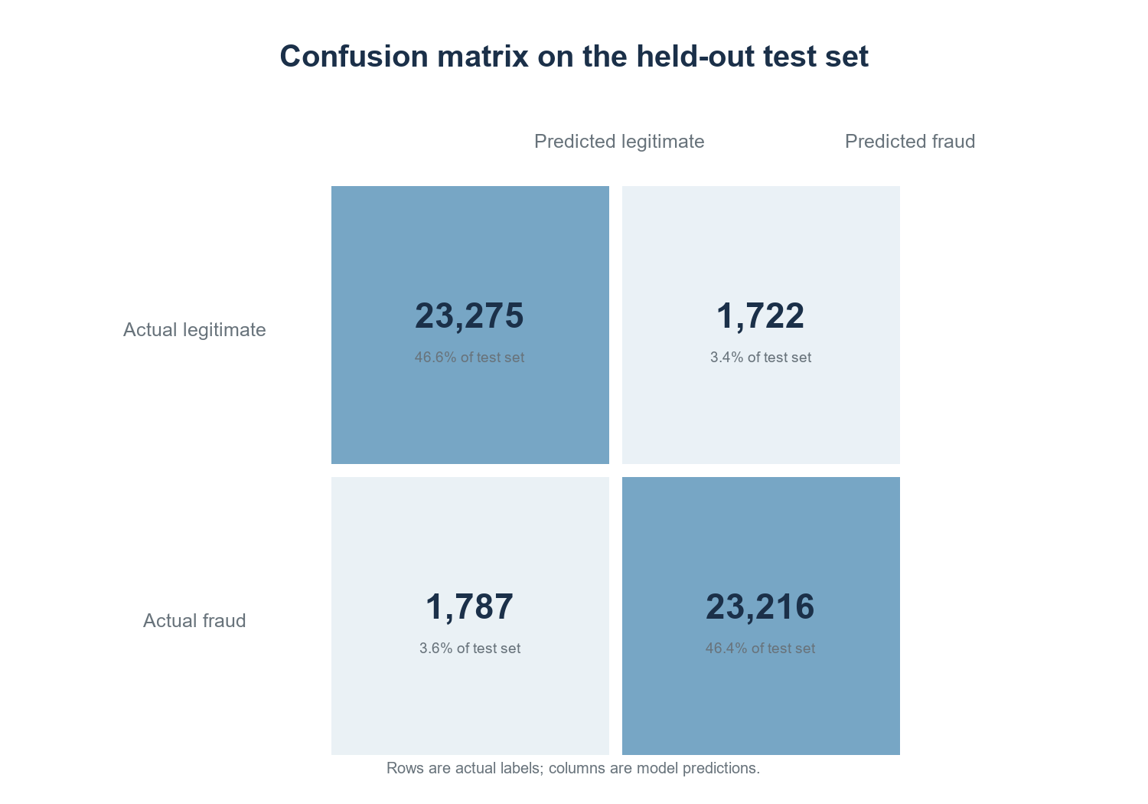

5.2 Discussion
Precision and recall are similar on this test set, and the ROC curve indicates a ROC AUC of 0.930. The 1,722 false positives and 1,787 false negatives show that the model makes both types of error. In a live payment population, a lower fraud prevalence would generally reduce the fraction of alerts that are truly fraudulent even if sensitivity and specificity stayed similar. Therefore, accuracy and this test precision cannot be transferred directly to operational UPI traffic.
Figure 5.2. ROC curve for held-out predictions; plotted points are interpolated at evenly spaced false-positive rates.
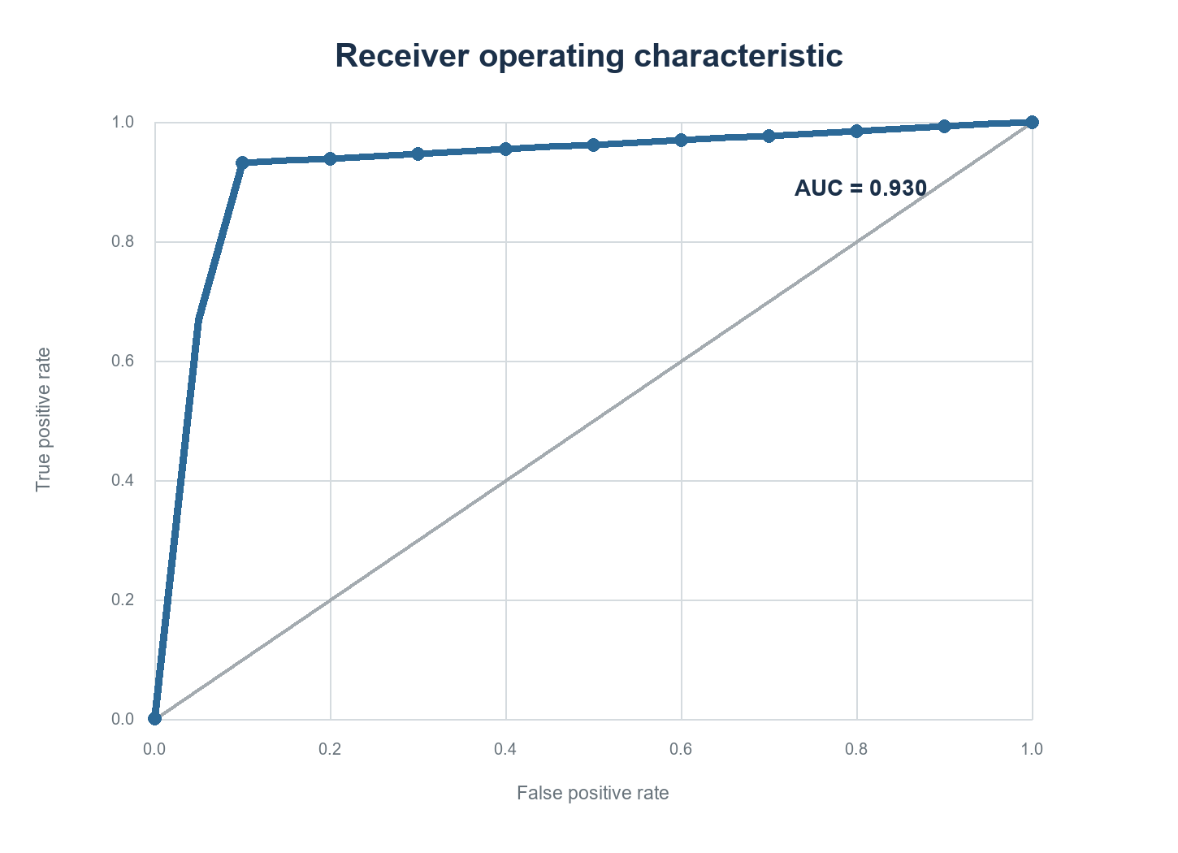

5.3 Feature-Importance Review
The model’s impurity-based feature importance assigns 48.5% to risk_score and 39.5% to transaction amount; merchant category contributes about 5.9%. Together, risk_score and amount account for about 88.0% of the total. The risk score has a mean of 1,163.06 for fraud-labelled rows and 295.39 for legitimate rows. This association is descriptive, not causal. Since the source and time of creation of risk_score are undocumented, it may be a valid early feature or may encode label-related information. An ablation that retrains without it is needed before interpreting model performance.
Figure 5.3. Largest aggregated random-forest feature importances.
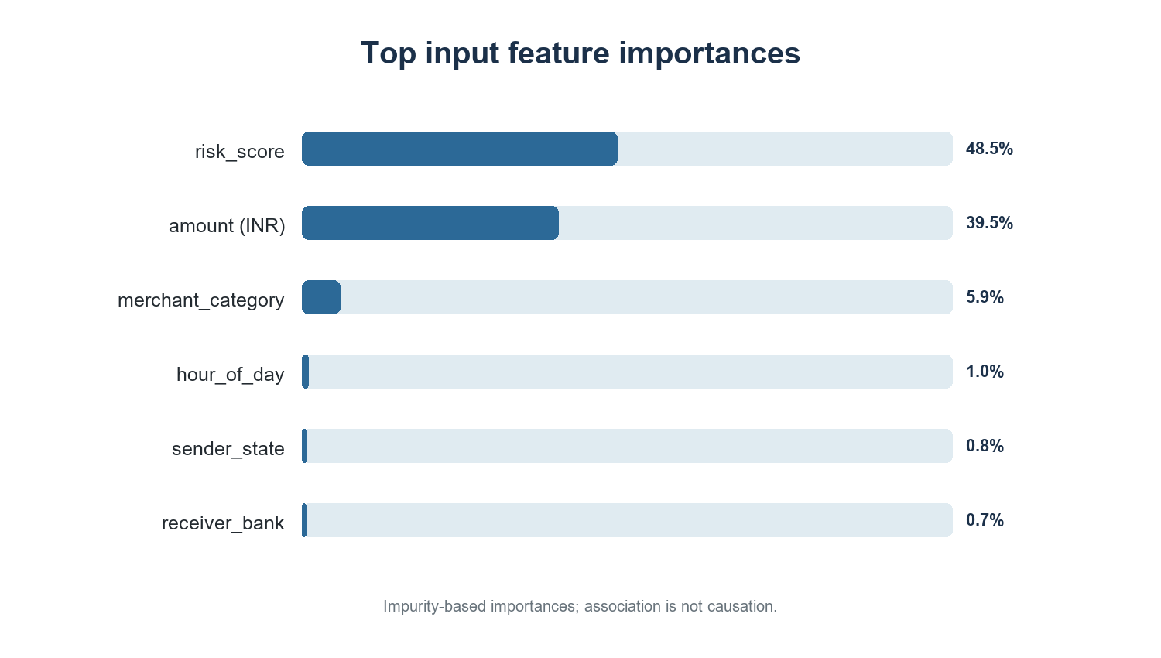

5.4 Limitations and Future Work
The target is almost exactly balanced in the supplied file, and its label provenance is unknown. The random row split does not test performance on later transactions or unseen participants. Only one model, one split and one threshold were assessed. Impurity importance can favour some feature types and should not be read as an explanation of individual model decisions. The output probabilities have not been calibrated for another population.
Next steps are to document data collection and label rules; verify that risk_score is available before the prediction point; compare the current model with an ablation that removes risk_score and with simple baselines; run time-based and entity-grouped tests; and choose a threshold using realistic fraud prevalence, review capacity and error costs. A broader evaluation should also check calibration, subgroup error rates, and performance drift. These experiments are outside the current project results.

CHAPTER 6: CONCLUSION
This interim report documents a complete UPI fraud classification prototype built from the supplied transaction CSV. The project uses a stratified 80:20 split and a class-weighted random forest, reaching 92.98% accuracy and 0.930 ROC AUC on 50,000 held-out rows. It also presents precision, recall, F1, the confusion matrix, a ROC curve and feature importance, and serves the saved model through a local Flask dashboard.
The measured result is encouraging within this file, but dataset provenance and the meaning of the risk-score feature remain unverified. A 50.006% fraud prevalence and random row split also limit how the scores can be interpreted beyond the test sample. The next evaluation should verify labels and feature timing, remove risk_score as a sensitivity check, and test on later and entity-separated records before proposing any operational use.

REFERENCES
[1] S. Jagadeesan, K. S. Arjun, G. Dhanika, G. Karthikeyan, and K. Deepika, “UPI fraud detection using machine learning,” in Challenges in Information, Communication and Computing Technology, 2025, pp. 755–760, doi: 10.1201/9781003559085-130.
[2] L. Breiman, “Random forests,” Machine Learning, vol. 45, pp. 5–32, 2001, doi: 10.1023/A:1010933404324.
[3] T. Fawcett, “An introduction to ROC analysis,” Pattern Recognition Letters, vol. 27, no. 8, pp. 861–874, 2006, doi: 10.1016/j.patrec.2005.10.010.
[4] F. Pedregosa et al., “Scikit-learn: Machine learning in Python,” Journal of Machine Learning Research, vol. 12, no. 85, pp. 2825–2830, 2011.
[5] National Payments Corporation of India, “UPI frequently asked questions,” accessed Oct. 14, 2026. [Online]. Available: https://www.npci.org.in/what-we-do/upi/faqs.
[6] UPI Fraud Detection project dataset, `archive/dataset.csv`, user-supplied file, 250,000 transaction records; source, collection period and label-generation protocol not stated in the project files.

