Case Study – Running Word Press on localhost – module-9

-RUN WORDPRESS ON LOCAL HOST.

- Become root
- sudo -i
- enter the password as edureka

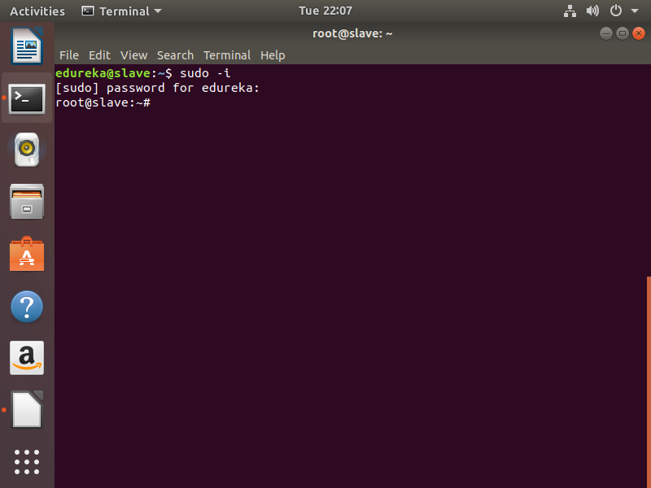

- Enter the commands to install docker-compose
- apt install python-pip

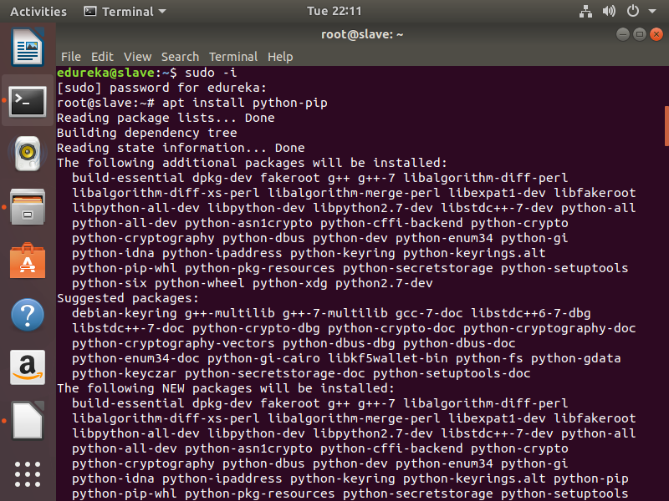
- pip install docker-compose

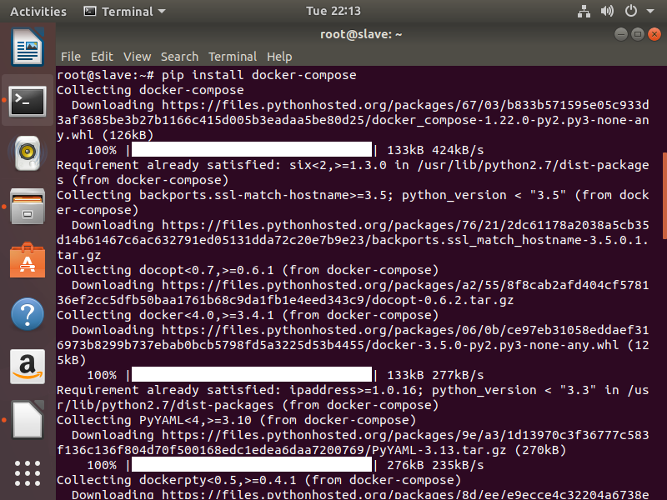

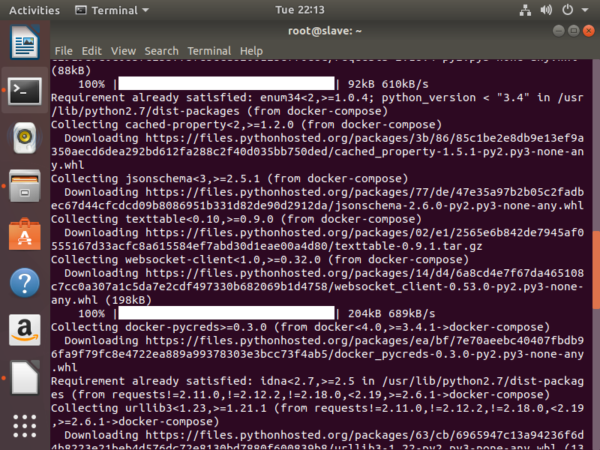
3. check docker-compose version after installing by following command.
- docker-compose –version

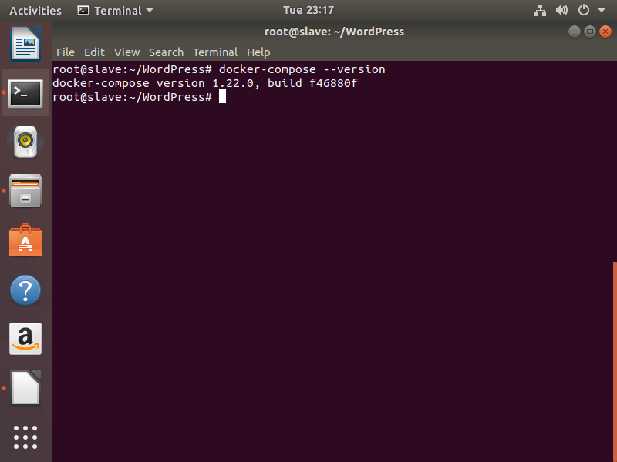

- mkdir WordPress
- cd WordPress
- sudo vi docker-compose.yml

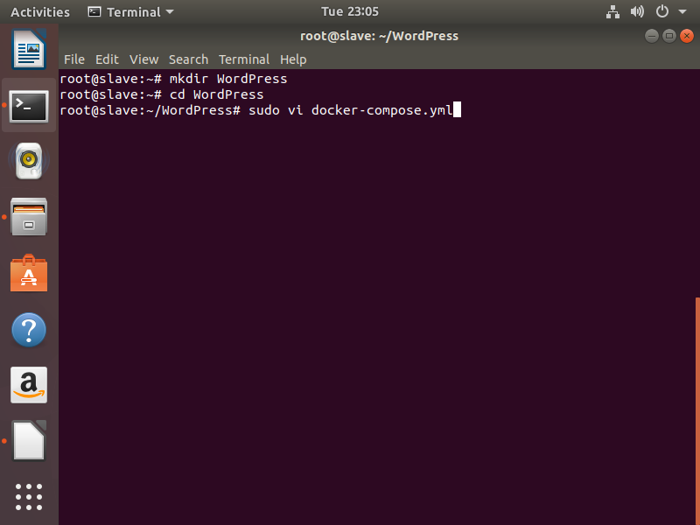
- paste the below code into docker-compose.yml

wordpress:
image: wordpress
links:
- wordpress_db:mysql
ports:
- "8080:80"

wordpress_db:
image: mariadb
environment:
MYSQL_ROOT_PASSWORD: edureka

phpmyadmin:
image: corbinu/docker-phpmyadmin
links:
- wordpress_db:mysql
ports:
- 8181:80
environment:
MYSQL_USERNAME: root
MYSQL_ROOT_PASSWORD: edureka

- save it ( command esc -> :wq )

4. run docker-compose command
- docker-compose up -d

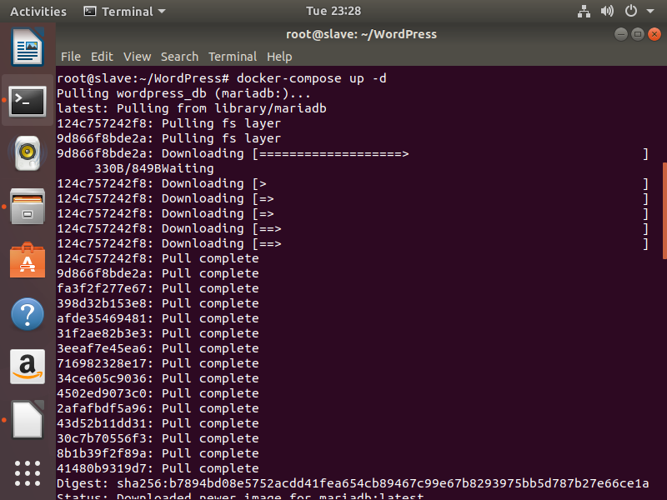

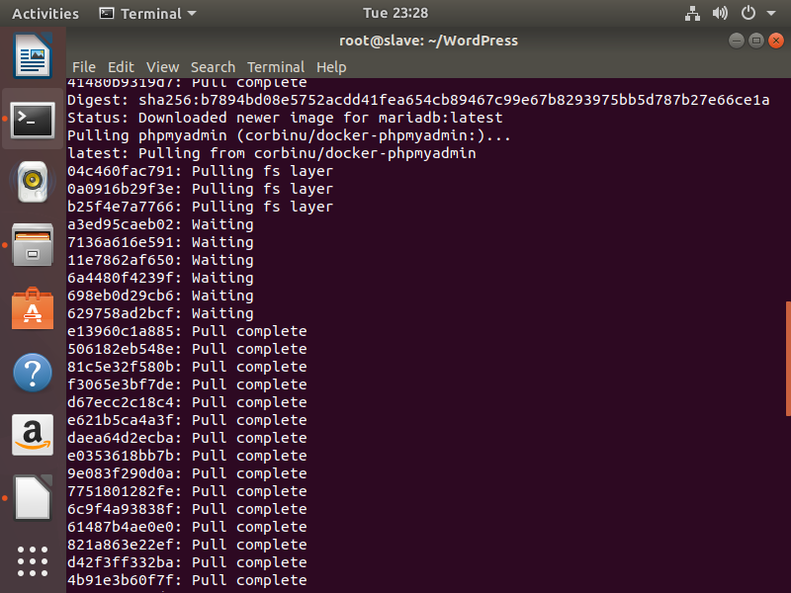
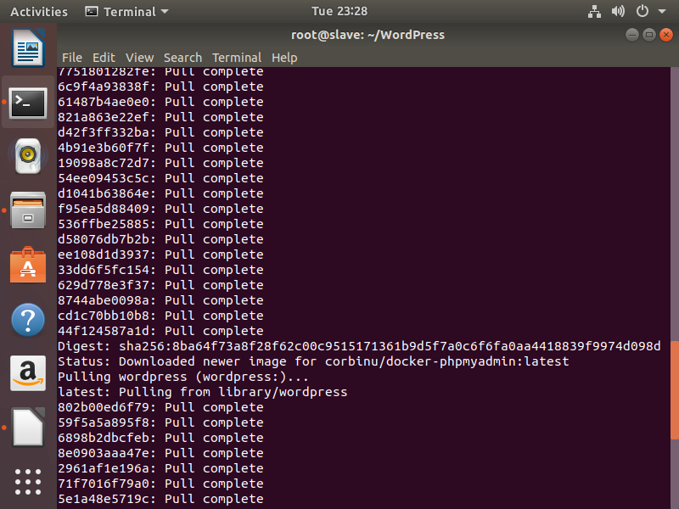
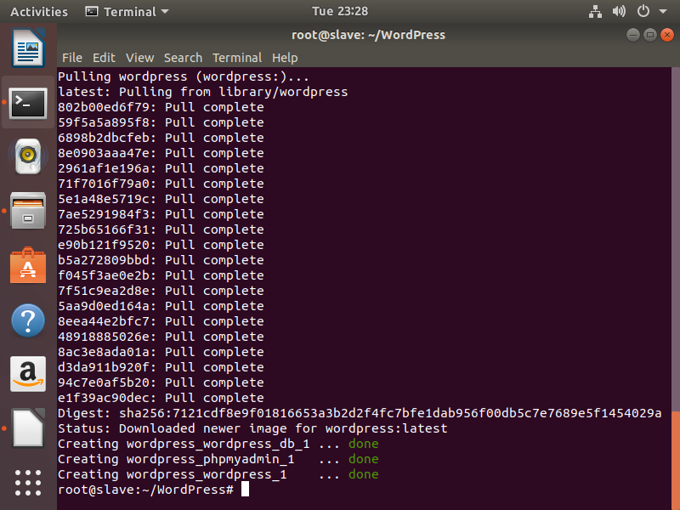
5.

