***In laboratories working with human blood samples, the commonly used liquid sample***

***management tools include a so called 96-well plate. The plate is a plastic frame with pressed***

***wells, that hold a small amount of liquid. The plates are organized in 8 rows (named from A***

***to H) and 12 columns (numbered 1-12). The total number of such wells is thus 96.***

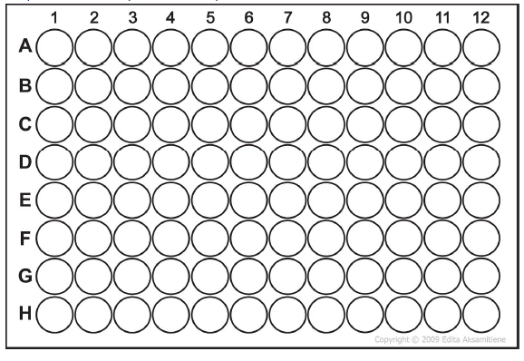

The plate is often manually filled using tools to pipet the liquid from larger containers to the

plate. The samples on the plate are referred to by their ‘place codes’, like A1, B6, H12, and

so on. A good analogy of such coordinate system is the popular board game ‘Battleships’.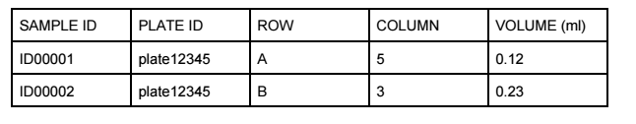

The task

Design a web application where a person working in a laboratory can see the content of a 96-well plate, and can quickly see volume information about each sample, based on the sample’s location on the plate.

1. ASSUME: User has already selected a plate, and the plate contains 10+ samples, and has some empty locations.

2. User wants to see the plate as a 2D structure, and if there are empty spaces on the plate.

3. User wants to see the volume information and SAMPLE ID in each sample well.

4. User is able to move samples to empty wells, and the change of place code is updated to the sample data.