AI TRAVEL PLANNER
Professional Project Report
Project Owner: Mohit Taluja
Submission Date: 23 May 2026

Table of Contents
1. Project Overview
2. Objectives
3. Technologies Used
4. System Architecture
5. Features & Functionalities
6. How I Built This Project
7. Implementation Workflow
8. UI & Screenshots
9. GitHub Repository & Deployment
10. Conclusion & Future Enhancements

1. Project Overview
AI Travel Planner is an intelligent travel planning web application developed using Python and Streamlit. The system helps users generate customized travel itineraries based on destination city, budget, and number of travel days. The platform provides hotel recommendations, weather forecasts, budget estimation, tourist attractions, and downloadable PDF reports.

2. Objectives
• Build a smart AI-based travel planning assistant.
• Provide luxury and budget-friendly trip recommendations.
• Display weather forecasts and travel tips.
• Generate attractive travel itineraries.
• Deploy the project online using Streamlit Cloud.

3. Technologies Used
Frontend: Streamlit
Backend: Python
Libraries: FPDF, JSON, Requests
Version Control: Git & GitHub
Deployment: Streamlit Cloud
IDE Used: Visual Studio Code

4. System Architecture
The application follows a modular architecture where frontend UI components communicate with backend logic modules. The backend processes user inputs and fetches relevant hotel, weather, and tourist attraction data from local JSON datasets and APIs.
Architecture Flow:
- User Input → Streamlit UI
- UI Sends Data → Main Python Logic
- Travel Tools Process Data
- Hotels / Weather / Places Retrieved
- Travel Itinerary Generated
- PDF Export Created

5. Features & Functionalities
• Luxury UI Design
• Destination Selection Dropdowns
• Smart Budget Calculation
• Weather Forecast Display
• Hotel Recommendations
• Tourist Attractions Suggestions
• PDF Travel Report Download
• Responsive Streamlit Dashboard

6. How I Built This Project
Step 1: Designed the project structure and folders.
Step 2: Created tools for hotels, places, weather, and budget calculation.
Step 3: Built the backend logic in main.py.
Step 4: Designed a premium Streamlit UI.
Step 5: Added PDF export functionality.
Step 6: Tested and debugged the application.
Step 7: Prepared GitHub repository and deployment setup.

7. Implementation Workflow
1. User selects city, budget, and trip duration.
2. Backend processes travel requirements.
3. Hotels and tourist attractions are recommended.
4. Weather forecast is displayed.
5. Budget breakdown is calculated.
6. Final travel itinerary is generated.
7. User downloads the PDF report.

8. UI & Screenshots
Main Dashboard UI
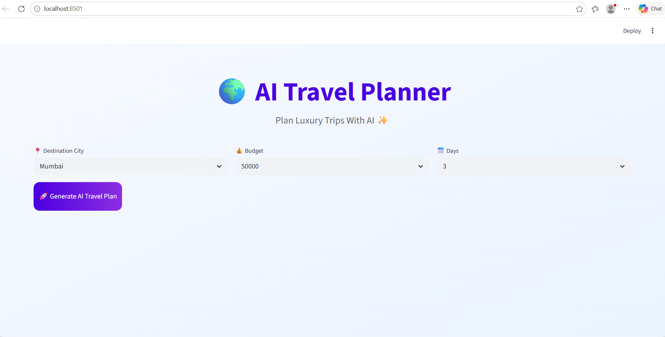

Travel Itinerary & Recommendations
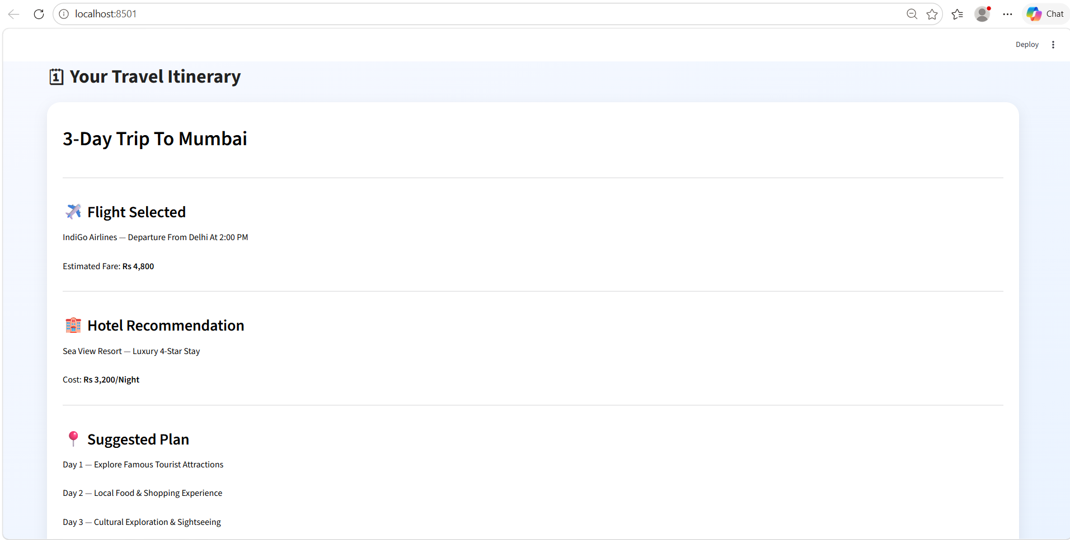

Weather Forecast & Budget Breakdown
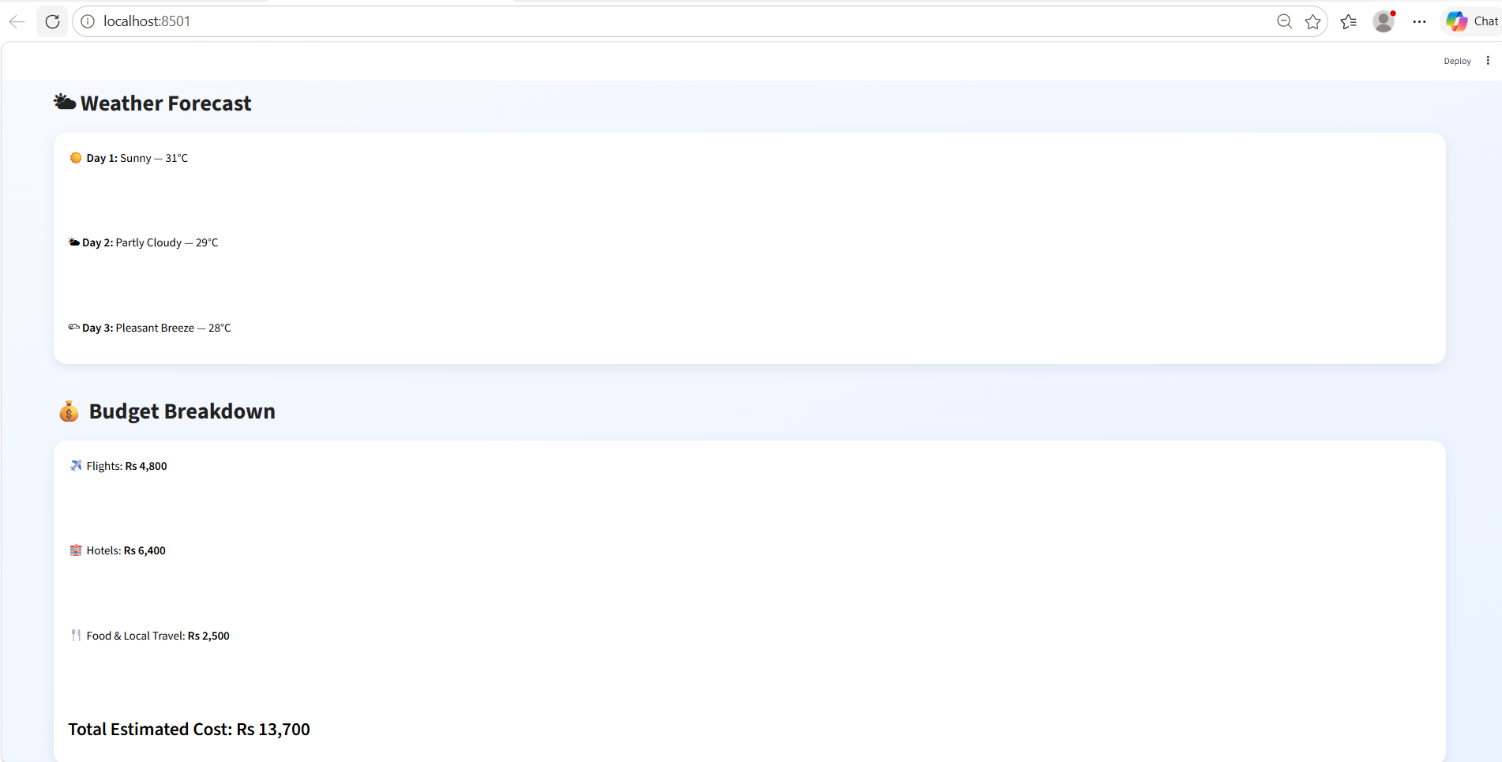

9. GitHub Repository & Deployment
GitHub Repository Link:
https://github.com/your-github-username/ai-travel-planner
Deployment Platform:
Streamlit Cloud
Deployment Steps:
• Push project code to GitHub.
• Connect repository to Streamlit Cloud.
• Add required dependencies in requirements.txt.
• Deploy the application online.

10. Conclusion & Future Enhancements
The AI Travel Planner successfully demonstrates how AI-powered systems can simplify travel planning. The project provides an attractive and interactive user experience while generating personalized travel itineraries.
Future Enhancements:
• Real-time flight APIs
• AI chatbot integration
• Voice-based travel planning
• Multi-language support
• Hotel image previews and maps integration

THANK YOU

