1) One of the fields on a form contains a text box which accepts numeric values in the range of 18 to 25. Identify the invalid Equivalence class.

a) 17

b) 19

c) 24

d) 21

Ans - a) 17

2) Input Box should accept the Number 1 to 10. Identify Equivalence partitioning and Boundary values for testing.

Ans -

|  |  |  |
| --- | --- | --- |
| Invalid | Valid | Invalid |
| 0 | 1 5 10 | 11 |

3) Why is Equivalence & Boundary Analysis Testing used?

Ans -

Equivalence & Boundary Analysis Testing is used to reduce a very large number of test cases to manageable chunks.

Very clear guidelines on determining test cases without compromising on the effectiveness of testing.

Appropriate for calculation-intensive applications with a large number of variables/inputs.

4) Write Test Cases For This Scenario:

If A Job Fails It Should Get Restarted Again. This Should Happen For Three Times. If It Fails again, then It should quit

Ans -

|  |  |  |  |  |  |
| --- | --- | --- | --- | --- | --- |
| **Id** | **Importance** | **Precondition** | **Test Summary** | **Steps to execute** | **Expected result** |
| 1 | High | Job has failed one time | Restart the job if failed for first time | Restart the job if it fails | Job should get Restarted |
| 2 | High | Job has failed second time | Restart the job if fails for Second time | Restart the job if it fails | Job should get Restarted |
| 3 | High | Job has failed third time | Quit the job if fails for Third time | Quit the job if it fails | Quit the job |

5) Write The Test Case/scenario For A Login Page?

Ans - <https://docs.google.com/spreadsheets/d/1Gh_wdtaXDm5AKXkFACjks3UD9U5XSVMbRhYPLDFMKXE/edit?usp=sharing>

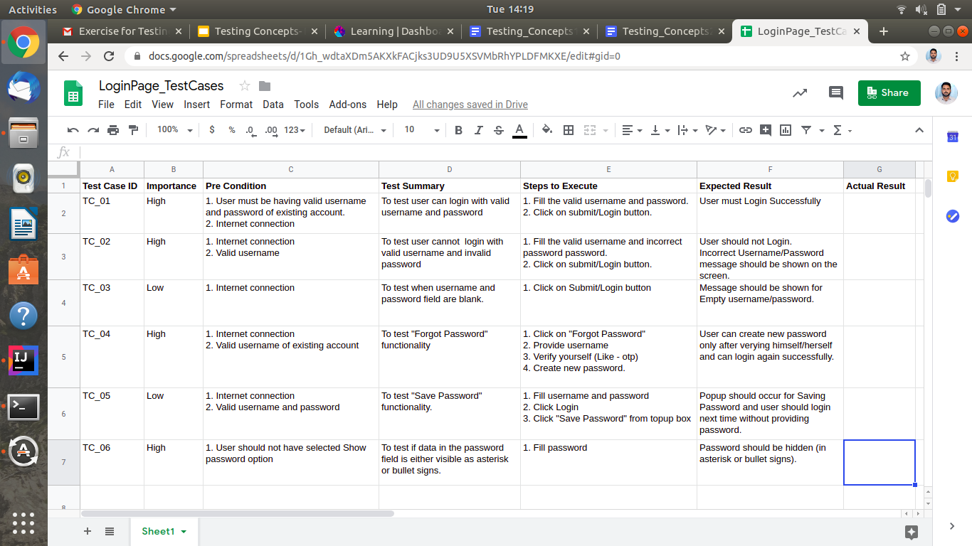

6) What Are The Test Cases/scenario For Mouse? (To verify the functionalities of a mouse)

Ans -

<https://docs.google.com/spreadsheets/d/1fOFe552L1cy-uzCYRFJrpzVddusu60kuK4t_tSPK5TY/edit?usp=sharing>

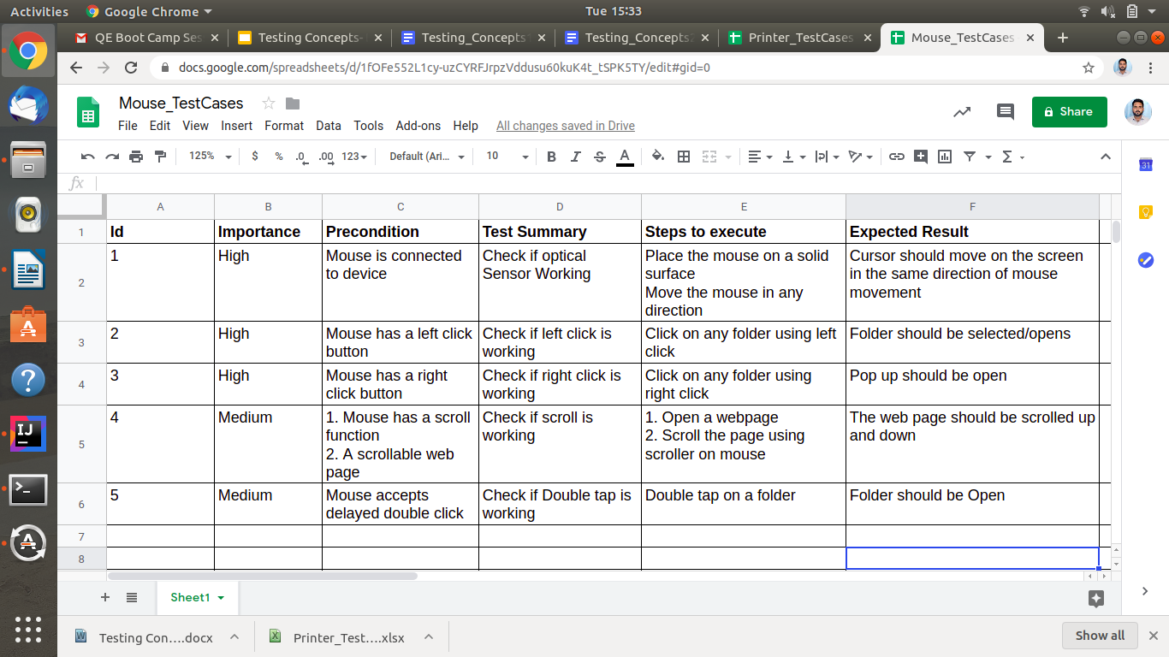

7) Write test cases/scenarios to verify the functionality of a printer?

Ans -

<https://docs.google.com/spreadsheets/d/1OVsbyCScdwIFMva1WxtFYR_z4vK2Da4uiAIFKvTIjM8/edit?usp=sharing>

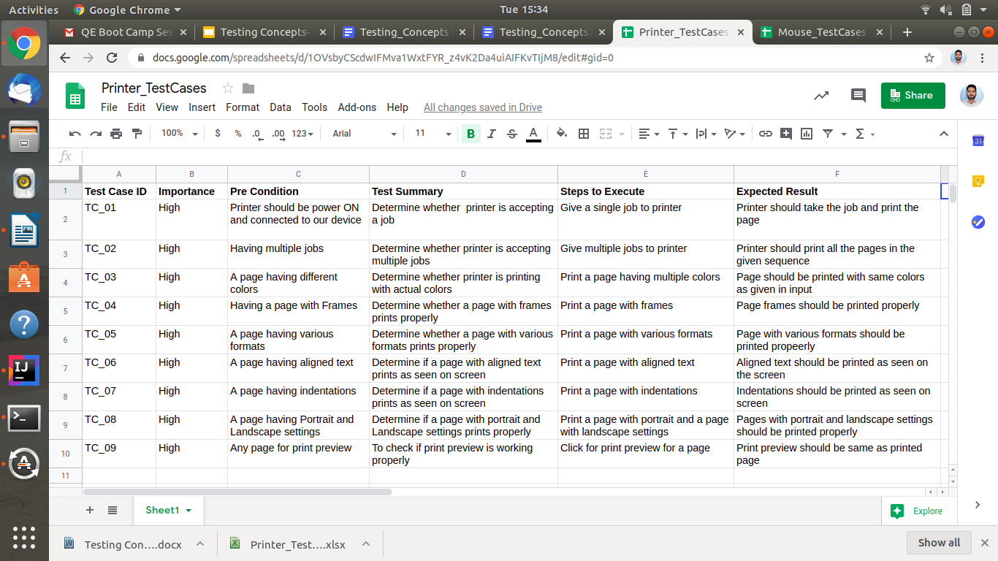

8) Write down test case/scenarios to list down possible steps to test a smartphone.

Ans -

<https://docs.google.com/spreadsheets/d/140Subq1rEeL0wDU3whK8r8OWk4S5SUqsHS7-3x5xOGM/edit?usp=sharing>

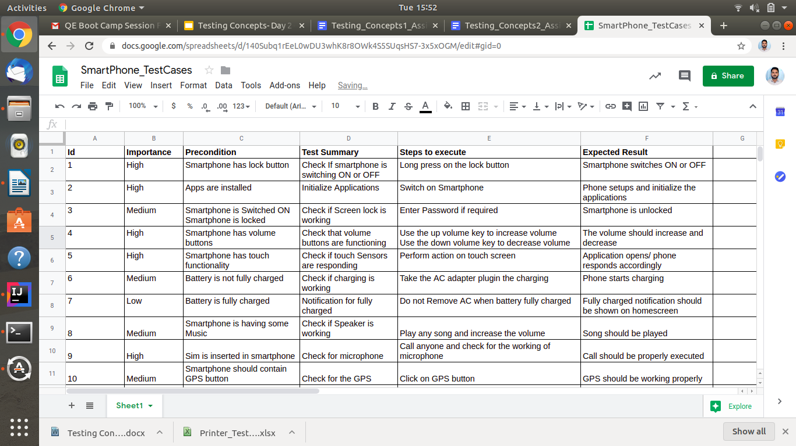

9) There is a text box which accepts numbers from 1-10. List down the test data which needs to be tested for Boundary value analysis.

Ans -

Let the valid input range is from X to Y, then for boundary values we consider :-

X-1, X, X+1, and

Y-1, Y, Y+1

According to the question, boundary values for **1** will be **0**, **1** and for **10** will be **10**, **11**.

**0** and **1** will give **Invalid Class** and **1** and **10** will give **Valid Class.**

10) Suppose you have a bank account that offers variable interest rates:

5% for the first $1000 credit;

10% for the next $1000;

And 15% for the rest.

If you wanted to check that the bank was handling your account correctly what valid input partitions might you use?

Ans -

Based on Scenario 5% should be offered till $1000, 10% for 1001-2000 and 15% for 2000+

|  |  |  |
| --- | --- | --- |
| **5% Interest** | **10% Interest** | **15% Interest** |
| $1000 | $1001 $2000 | $2001 |

11) A mail order company charges $2.95 postage for deliveries if the package weighs less than 2 kg, $3.95 if the package weighs 2 kg or more but less than 5 kg, and $5 for packages weighing 5 kg or more.

Generate a set of valid test cases using equivalence partitioning.

Ans -

|  |  |  |
| --- | --- | --- |
| **Charges $2.95** | **Charges $3.95** | **Charges $5** |
| 1.99 kg | 2 kg 4.99 kg | 5 kg |

|  |  |  |  |  |  |
| --- | --- | --- | --- | --- | --- |
| **Id** | **Importance** | **Precondition** | **Test Summary** | **Steps to execute** | **Expected Result** |
| 1 | High | Weight of package is less than 2 kg | Check how much to charge for weight < 2 kg | Weight the package | Charge $2.95 |
| 2 | High | Weight of package is between 2 to 5 kg | Check how much to charge for 2 kg > weight < 5 kg | Weight the package | Charge $3.95 |
| 3 | High | Weight of package is more than 5 kg | Check how much to charge for weight > 2 kg | Weight the package | Charge $5 |

12) Boiling point of water is at 100 degrees Celsius. Determine the boundary values

Ans -

The boundary is at 100 degrees Celsius, so for the 3 Value Boundary approach the boundary values will be 99 degrees, 100 degrees, 101 degrees. Unless you have a very accurate digital thermometer, in which case they could be 99.9 degrees, 100.0 degrees, 100.1 degrees. For the 2 value approach the corresponding values would be 100 and 101.

13) Exam pass – for 40 marks; merit at 60 and above; and distinction at 80 and above.

Determine the boundary values

Ans -

If an exam has a pass boundary at 40 per cent, merit at 60 per cent and distinction at 80 per cent the 3 value boundaries would be 39, 40, 41 for pass, 59, 60, 61 for merit, 79, 80, 81 for distinction. It is unlikely that marks would be recorded at any greater precision than whole numbers. The 2 value equivalents would be 39 and 40, 59 and 60, and 79 and 80 respectively.

14) Order numbers on a stock control system can range between 10000 and 99999 inclusive. Which of the following inputs might be a result of designing tests for only valid equivalence classes and valid boundaries:

a) 1000, 5000, 99999

b) 9999, 50000, 100000

c) 10000, 50000, 99999

d) 10000, 99999

e) 9999, 10000, 50000, 99999, 100000

Ans - c) 10000, 50000, 99999

15) A program validates a numeric field as follows:

Values less than 10 are rejected, values between 10 and 21 are accepted, values greater than or equal to 22 are rejected. Which of the following input values cover all of the equivalence partitions?

a. 10,11,21

b. 3,20,21

c. 3,10,22

d. 10,21,22

Ans - c. 3,10,22

16) Which test cases are written first: white boxes or black boxes?

Ans -

Black Box testing is done first since we write the test cases based on the expected output and not the code that has been given to us.

17) Can you explain requirement traceability and its importance?

Ans -

Requirement Traceability Matrix (RTM) is a document that maps and traces user requirements with test cases. It captures all requirements proposed by the client and requirement traceability in a single document, delivered at the conclusion of the Software development life cycle. The main purpose of Requirement Traceability Matrix is to validate that all requirements are checked via test cases such that no functionality is unchecked during Software testing.