A
MAJOR PROJECT REPORT
(SYNOPSIS)
ON

"GEN-AI RESUME & INTERVIEW PREPARATION APP"

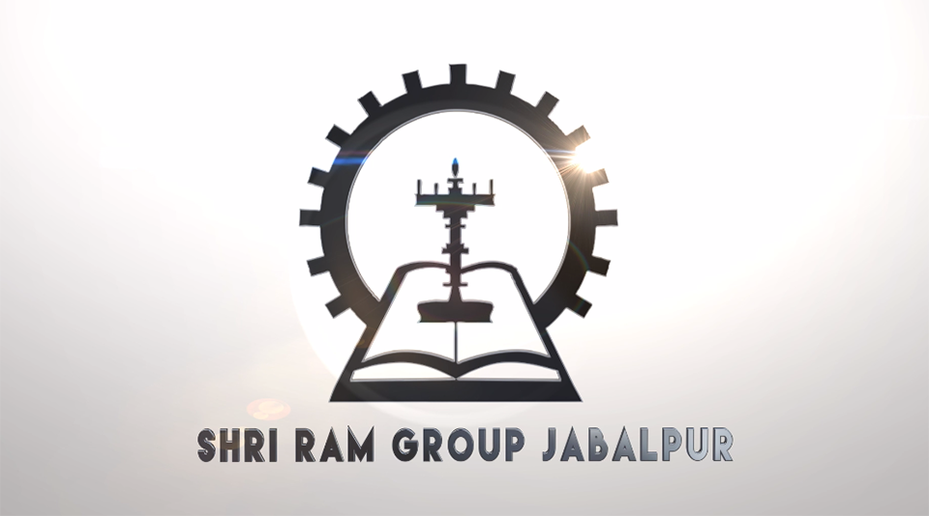

This Project Report is submitted to
Rajiv Gandhi Proudyogiki Vishwavidyalaya
in the partial fulfillment for the award of the degree of
Bachelor of Technology
VIII SEM
(Computer Science & Engineering)

Submitted By:
Mohit Tiwari: (0228CS221106)
Aanchal Suryawanshi: (0228CS221001)
Noshin Khan: (0228CS221121)
Lalit Mehar: (0228CS221100)

Under the guidance of:
Prof. Nitin Shukla
Head of Department, Computer Science

SHRI RAM GROUP OF INSTITUTIONS (SRGI), JABALPUR
2025-2026


Approved by AICTE New Delhi & Govt. of M.P.
(Affiliated to R.G.P.V. - University of Technology of Madhya Pradesh)

CERTIFICATE

This is to certify that,

Mohit Tiwari (0228CS221106)
Aanchal Suryawanshi (0228CS221001)
Noshin Khan (0228CS221121)
Lalit Mehar (0228CS221100)

Students of 8th Semester, Computer Science & Engineering, SHRI RAM GROUP OF INSTITUTIONS (SRGI), Jabalpur have submitted their major project synopsis entitled "GEN-AI RESUME & INTERVIEW PREPARATION APP" for the completion of 8th semester examination under the requirement for the degree of Bachelor of Technology as per R.G.P.V., Bhopal (M.P.).

This is an original work of these students and is based on their own innovative idea. We, hereby certify this project to be an authentic work by these young minds.

Prof. Nitin Shukla
Head - Computer Science Dept., S.R.G.I.


Approved by AICTE New Delhi & Govt. of M.P.
(Affiliated to R.G.P.V. - University of Technology of Madhya Pradesh)

CERTIFICATE OF APPROVAL

The foregoing major project title "GEN-AI RESUME & INTERVIEW PREPARATION APP" is hereby approved as a creditable study of an engineering subject carried out and presented in a manner satisfactory to warrant its acceptance as a prerequisite to the degree for which it has been submitted.

(Internal Examiner) | (External Examiner)


Approved by AICTE New Delhi & Govt. of M.P.
(Affiliated to R.G.P.V. - University of Technology of Madhya Pradesh)

DECLARATION

We hereby declare that the project entitled "GEN-AI RESUME & INTERVIEW PREPARATION APP" which is being submitted in partial fulfillment of the requirement for the award of the degree of Bachelor of Technology in Computer Science, Rajiv Gandhi Proudyogiki Vishwavidyalaya, Bhopal [M.P] is the authentic record of our own work done under the guidance of Prof. Nitin Shukla [HOD - Computer Science Dept].

The matter reported in this project has not been submitted earlier for the award of any degree.

PLACE: JABALPUR  DATE: | Mohit Tiwari: (0228CS221106)  Aanchal Suryawanshi: (0228CS221001)  Noshin Khan: (0228CS221121)  Lalit Mehar: (0228CS221100)


Approved by AICTE New Delhi & Govt. of M.P.
(Affiliated to R.G.P.V. - University of Technology of Madhya Pradesh)

FORWARD

I hereby forward the project title "GEN-AI RESUME & INTERVIEW PREPARATION APP" which is being submitted by

Mohit Tiwari: (0228CS221106)
Aanchal Suryawanshi: (0228CS221001)
Noshin Khan: (0228CS221121)
Lalit Mehar: (0228CS221100)

In partial fulfillment of the requirement for the award of Degree of Bachelor of Technology in Computer Science, Rajiv Gandhi Proudyogiki Vishwavidyalaya, Bhopal [M.P]

PLACE: JABALPUR  DATE: | Prof. Nitin Shukla  HOD, Computer Science & Engg. Dept.  SHRI RAM GROUP OF INSTITUTIONS (SRGI), JABALPUR [M.P]


Approved by AICTE New Delhi & Govt. of M.P.
(Affiliated to R.G.P.V. - University of Technology of Madhya Pradesh)

ACKNOWLEDGEMENTS

We would like to extend our heartfelt gratitude to all those who gave us the possibility to complete this project successfully.

We would like to thank the Department of Computer Science of SHRI RAM GROUP OF INSTITUTIONS (SRGI) for granting us permission to commence this project, to conduct the necessary research, and to use the departmental resources and facilities.

We are deeply indebted to our supervisor Prof. Nitin Shukla [HOD - Computer Science Dept], whose help, stimulating suggestions, and consistent encouragement helped us at every stage of completing this project.

We are also grateful to our honorable Head of Department for his continuous support and motivation. We further thank the faculty of our college who helped us in providing the necessary guidance and data.

PLACE: JABALPUR  DATE: | Mohit Tiwari: (0228CS221106)  Aanchal Suryawanshi: (0228CS221001)  Noshin Khan: (0228CS221121)  Lalit Mehar: (0228CS221100)

INDEX

Chapter 1 | INTRODUCTION | 1–5
 | 1.1 Introduction | 1
 | 1.2 Problem Statement | 2
 | 1.3 Project Objectives & Goals | 3
 | 1.4 Scope and Limitations | 4
 | 1.5 Report Outline | 5
Chapter 2 | LITERATURE SURVEY | 3-4
 | 2.1 Survey and Analysis of Existing Solutions | 3
 | 2.2 Identification of Research Gap | 4
Chapter 3 | REQUIREMENT ANALYSIS AND SPECIFICATION | 5–7
 | 3.1 Functional Requirements | 5
 | 3.2 Non-Functional Requirements | 6
 | 3.3 Software and Hardware Requirements | 7
Chapter 4 | SYSTEM DESIGN AND ARCHITECTURE | 8–12
 | 4.1 System Architecture Diagram | 8
 | 4.2 Database Design (Entity-Relationship Diagram, Schema) | 9
 | 4.3 Model Design (Flowcharts, Pseudocode) | 10
 | 4.4 DFD Diagrams | 11
 | 4.5 Use Case Diagrams | 12
Chapter 5 | IMPLEMENTATION, TESTING, AND MAINTENANCE | 13–16
 | 5.1 Introduction to Languages, IDE’s | 13
 | 5.2 Tools and Technologies used for Implementation | 14
 | 5.3 Coding standards of Language used Project Scheduling using various tools such as PERT, GANTT charts, Open PROJ etc. | 15
 | 5.4 Testing Techniques and Test Plans | 16
Chapter 5 | EXPECTED RESULTS AND DISCUSSION | 17–18
 | 5.1 Expected Results and Discussion | 17
 | 5.2 Expected Performance Results | 18
Chapter 6 | CONCLUSION | 19
 | 6.1 Conclusion | 19
 | REFERNECES | 20
APPENDICES | Appendix A: Source Code (GitHub Repository Link and Snapshot)  Appendix B: Comprehensive Project Timeline (Gantt Chart) C: Team Member Contributions  Appendix D: Dataset Details and Sources  Appendix E: Relevant Published Papers | 21  22  23  24  25

CHAPTER 1
INTRODUCTION

1.1 Introduction
The Gen-AI Resume & Interview Preparation App is an intelligent, full-stack web application designed to bridge the gap between job seekers and their ideal employment opportunities. In today's highly competitive job market, candidates face the dual challenge of crafting a compelling, ATS-optimized resume and preparing effectively for rigorous technical and behavioral interviews.
This application leverages the power of Google Gemini AI (Large Language Model) to analyze a candidate's resume in PDF format, their self-description, and the target job description. It then generates a comprehensive, personalized interview preparation report and an AI-tailored resume PDF — all in a matter of seconds.
The system follows a modern client-server architecture with a React-based frontend (Vite), a Node.js/Express.js backend REST API, a MongoDB database for persistent storage, and JWT-based authentication for secure user sessions. The AI layer is powered by the @google/genai SDK with structured JSON output enforced via Zod schema validation.

The application is built following industry best practices for modern web development. The separation of concerns is maintained throughout the codebase: authentication logic is isolated in middleware, business logic resides in service classes, data persistence is managed through Mongoose models, and the presentation layer is decoupled through React component architecture. This modularity ensures that each component of the system can be developed, tested, and maintained independently.
From an academic standpoint, this project integrates concepts from multiple domains of computer science: Artificial Intelligence and Machine Learning (through LLM integration), Web Engineering (full-stack development), Database Systems (MongoDB schema design), Software Engineering (MVC architecture, SDLC), and Information Security (JWT authentication, bcrypt hashing). This multidisciplinary nature makes it a comprehensive demonstration of applied computer science skills at the undergraduate level.
The relevance of this project extends beyond the academic context. The global recruitment technology market was valued at over USD 2.9 billion in 2023 and is projected to grow significantly due to increasing automation in hiring processes. AI-powered tools that assist job seekers represent a rapidly growing segment of this market. The Gen-AI Resume & Interview Preparation App positions itself as an open, accessible, and intelligent alternative to expensive career coaching services.

1.2 Problem Statement
Job seekers today face significant challenges in the modern recruitment landscape:
- Generic preparation materials: Most online resources provide generic questions that do not align with specific job roles.
- ATS rejection: A large percentage of resumes are rejected by Applicant Tracking Systems before reaching a human recruiter.
- Skill gap awareness: Candidates often lack objective insight into which skills they are missing for a particular role.
- Time constraint: Manually researching interview questions and tailoring resumes takes days.
- Cost barrier: Professional resume writing and interview coaching services are expensive.

These challenges collectively represent a significant barrier for fresh graduates and mid-career professionals alike. Studies have shown that the average job seeker applies to 100-200 positions before receiving an offer, and a primary reason for rejection at the initial screening stage is a poorly formatted or keyword-sparse resume. The problem is compounded by the fact that most candidates do not receive feedback from automated ATS rejections, leaving them unaware of what improvements to make.
Furthermore, interview preparation is a time-intensive and often expensive process. Professional interview coaching can cost anywhere between INR 5,000 to INR 50,000 per session in the Indian market. This economic barrier disproportionately affects students from tier-2 and tier-3 institutions who lack access to campus placement support. A democratized, AI-powered solution addresses this gap directly.

1.3 Project Objectives & Goals
- To develop a secure, full-stack web application with JWT + bcrypt authentication.
- To implement a PDF resume parser that extracts text content from user-uploaded resume files.
- To integrate Google Gemini AI for structured, intelligent analysis of resume and job description.
- To generate a comprehensive interview preparation report with match score, technical questions, behavioral questions, skill gaps, and a day-wise preparation plan.
- To generate a tailored, ATS-friendly resume PDF using AI-generated HTML rendered by Puppeteer.
- To persist all interview reports in MongoDB per user account for future reference.

1.4 Scope and Limitations
Scope:
- The application supports any job domain as long as a job description is provided.
- Resume input is accepted exclusively in PDF format.
- The AI generates reports uniquely tailored to each user's input.
- All generated reports and resumes are stored and retrievable by the authenticated user.
Limitations:
- Quality of AI output depends on completeness of the uploaded resume and job description.
- The application does not support real-time mock interviews or voice-based interaction.

The current implementation focuses on text-based resume input in PDF format, which covers the vast majority of professional resumes in circulation today. Future versions of the application may extend support to LinkedIn profile URLs, DOCX format resumes, and portfolio websites as alternative input formats.
It is also important to note that the quality of AI-generated content is directly dependent on the quality and detail of the input provided. A vague job description or an incomplete resume will yield a less targeted interview report. The application addresses this through frontend guidance, prompting users to provide detailed inputs for optimal results.
- The system does not integrate with external job portals or ATS systems directly.

1.5 Report Outline
- Chapter 2 covers the literature survey and analysis of existing solutions.
- Chapter 3 details functional and non-functional requirements.
- Chapter 4 describes system design including architecture, database design, flowcharts, DFD, and use cases.
- Chapter 5 discusses implementation details, tools, technologies, and testing strategy.
- Chapter 6 presents expected results and performance discussion.
- Chapter 7 concludes the report with future scope.

CHAPTER 2
LITERATURE SURVEY

2.1 Survey and Analysis of Existing Solutions
Several tools and platforms currently exist in the resume and interview preparation space. The table below provides a comparative analysis of the most notable solutions alongside our proposed application:

Platform | Resume Builder | AI Analysis | Interview Prep | Skill Gap | PDF Export
LinkedIn | ❌ | ❌ | Partial | ❌ | ❌
Resume.io / Zety | ✅ | ❌ | ❌ | ❌ | ✅
Interviewing.io | ❌ | ❌ | ✅ | ❌ | ❌
ChatGPT (General) | ❌ | Partial | ✅ | ❌ | ❌
Our Application ✦ | ✅ | ✅ | ✅ | ✅ | ✅

The analysis clearly shows that no single existing platform provides a fully integrated pipeline of resume parsing, AI analysis, structured interview report generation, and AI-tailored resume PDF export in one unified, authenticated, persistent web application.

A deeper look at each existing platform reveals the following critical observations. LinkedIn, while being the largest professional networking platform globally, does not offer AI-driven resume analysis or structured interview preparation. Its "Resume Builder" feature provides basic templates without AI feedback. Interviewing.io provides mock technical interviews with real engineers but lacks any AI-driven resume optimization or automated report generation.
Resume.io and Zety offer polished resume templates and export options but have no intelligence layer — they cannot analyze whether a resume is optimized for a specific job description or identify skill gaps. ChatGPT, while capable of generating interview questions, does so without a structured schema, user authentication, or persistent storage, meaning each session starts fresh without any continuity.
Our application uniquely combines all five capabilities in a single, authenticated web platform with persistent storage, making it fundamentally more capable than any existing tool when evaluated on the combined criteria of resume intelligence, interview preparation, skill gap analysis, data persistence, and structured AI output.

2.2 Identification of Research Gap
- Lack of structured, schema-validated AI output: Most AI tools generate unstructured text. Our application uses Zod schema + Google Gemini JSON mode to produce type-safe interview reports.
- No unified pipeline: Existing tools address resume building OR interview prep, but not both in a cohesive workflow using the same inputs.
- No persistence of AI-generated insights: Platforms like ChatGPT do not store user-specific reports for future reference.
- ATS-optimized AI resume generation: No open-source tool generates a resume in HTML/PDF format tailored to a specific JD using AI with ATS friendliness as an explicit constraint.
- Skill gap severity classification: The identification and severity-ranking (low/medium/high) of specific skill gaps is absent in most tools.

The research gap analysis also reveals an important technological gap: the absence of type-safe, schema-validated AI output in existing solutions. Traditional AI integrations rely on free-form text generation, which is unpredictable and difficult to integrate into structured applications. Our use of Zod schema validation with Google Gemini's JSON mode represents a significant technical advancement that ensures machine-readable, consistently structured reports every time.
From a research perspective, this project contributes to the emerging field of AI-augmented career tools. The combination of retrieval-augmented generation (RAG) principles — using the user's own resume as context — with structured output generation positions this work at the intersection of applied NLP and human-computer interaction research.
Academic literature on AI in recruitment (Raghavan et al., 2020; Gonzalez et al., 2022) highlights concerns about bias in AI-driven hiring tools. Our application mitigates this by focusing exclusively on the candidate side — helping job seekers improve their own materials — rather than assisting employers in candidate selection, thereby avoiding the ethical risks associated with AI-driven hiring bias.

CHAPTER 3
REQUIREMENT ANALYSIS AND SPECIFICATION

3.1 Functional Requirements
FR-01: User Authentication
- The system shall allow users to register with a unique username and email address.
- The system shall allow registered users to log in using email and password.
- Passwords shall be hashed using bcryptjs before storing in the database.
- The system shall issue a JWT token upon successful login for session management.
- The system shall support user logout by blacklisting the current JWT token.
FR-02: Interview Report Generation
- The system shall accept a PDF resume file upload from the authenticated user.
- The system shall accept a self-description text and a job description text.
- The system shall extract text content from the uploaded PDF using pdf-parse.
- The system shall send extracted resume, self-description, and JD to Google Gemini AI.
- The AI shall return a structured JSON report: match score, technical questions, behavioral questions, skill gaps, and day-wise preparation plan.
FR-03: Report Management
- The system shall allow users to view a list of all their previously generated interview reports.
- The system shall allow users to view the full details of any specific report by ID.
FR-04: AI-Tailored Resume PDF Generation
- The system shall allow users to generate a tailored resume PDF from an existing interview report.
- The AI shall generate an ATS-friendly HTML resume tailored to the job description.
- The system shall use Puppeteer to render the HTML into a downloadable A4 PDF.

FR-05: Dashboard and User History
The system shall display a personalized dashboard to authenticated users showing a summary of all their generated interview reports. Each report summary shall include the job title, creation date, and match score. Users shall be able to click on any report to view its full details without regenerating it.

FR-06: Profile Management
The system shall allow users to view their account details including username, email, and account creation date. Users shall be able to log out from any active session, which shall invalidate the current JWT token by adding it to the blacklist collection in MongoDB.

FR-07: Error Handling and Validation
The system shall validate all incoming API requests for required fields, correct data types, and acceptable file formats. The system shall return descriptive HTTP error codes and messages for all failure scenarios: 400 for bad input, 401 for unauthorized access, 404 for not found, and 500 for internal server errors.

3.2 Non-Functional Requirements
- Security: All API endpoints shall be protected by JWT middleware. Tokens shall expire and be blacklisted on logout.
- Performance: Interview report generation shall complete within 30 seconds. PDF generation shall complete within 15 seconds.
- Scalability: MongoDB supports horizontal scaling. Stateless JWT-based authentication enables multiple backend instances.
- Reliability: Zod schema validation ensures AI-generated output always conforms to the expected data structure.
- Usability: The frontend shall provide a clean, responsive interface with loading states during AI processing.
- Maintainability: The codebase shall follow a clean MVC architecture.

Portability: The application is containerizable using Docker, enabling consistent deployment across different environments including local development, staging, and production cloud platforms such as AWS EC2, Google Cloud Run, or Heroku. The use of environment variables for all configuration ensures zero code changes between environments.
Availability: The system targets 99.5% uptime during academic and business hours. MongoDB Atlas's built-in replication and Google Gemini API's SLA-backed uptime ensures that both data persistence and AI processing layers remain highly available.
Interoperability: The REST API follows standard HTTP conventions and returns JSON responses, making it compatible with any frontend framework, mobile client, or third-party integration without modification to the backend.
Accessibility: The React frontend shall comply with WCAG 2.1 Level AA accessibility guidelines, ensuring the application is usable by individuals with visual or motor impairments using screen readers and keyboard navigation.

3.3 Software and Hardware Requirements
Software Requirements:

Category | Technology / Tool | Version
Runtime | Node.js | v18+
Backend Framework | Express.js | v5.x
Database | MongoDB (Mongoose ODM) | v9.x
Frontend | React (Vite) | v18+
AI SDK | @google/genai (Gemini) | v1.x
Authentication | JSON Web Token (JWT) + bcryptjs | Latest
File Upload | Multer (memory storage) | v2.x
PDF Parsing | pdf-parse | v2.x
PDF Generation | Puppeteer | v24.x
Validation | Zod + zod-to-json-schema | v3.x
IDE | Visual Studio Code | Latest
Version Control | Git + GitHub | Latest

Hardware Requirements:
- Processor: Intel Core i5 or equivalent (min. 2.0 GHz)
- RAM: Minimum 8 GB (16 GB recommended for Puppeteer)
- Storage: Minimum 10 GB free disk space
- Network: Stable internet connection (required for Gemini AI API calls)
- Operating System: Windows 10/11, macOS, or any Linux distribution

CHAPTER 4
SYSTEM DESIGN AND ARCHITECTURE

4.1 System Architecture Diagram
The application follows a 3-tier client-server architecture. The three tiers are clearly separated to ensure modularity, scalability, and maintainability:
Tier 1 (Presentation Layer): React.js + Vite SPA handles all user interactions including login, report form submission, dashboard, and PDF download.
Tier 2 (Application Layer): Node.js + Express.js REST API processes all business logic. Routes are organized as /api/auth (authentication) and /api/interview (report generation and retrieval). Middleware handles JWT authentication and Multer file uploads.
Tier 3 (Data & AI Layer): MongoDB via Mongoose ODM stores all persistent data. Google Gemini AI (via @google/genai SDK) processes inputs and generates structured JSON output validated by Zod schemas. Puppeteer renders AI-generated HTML resumes into PDF.

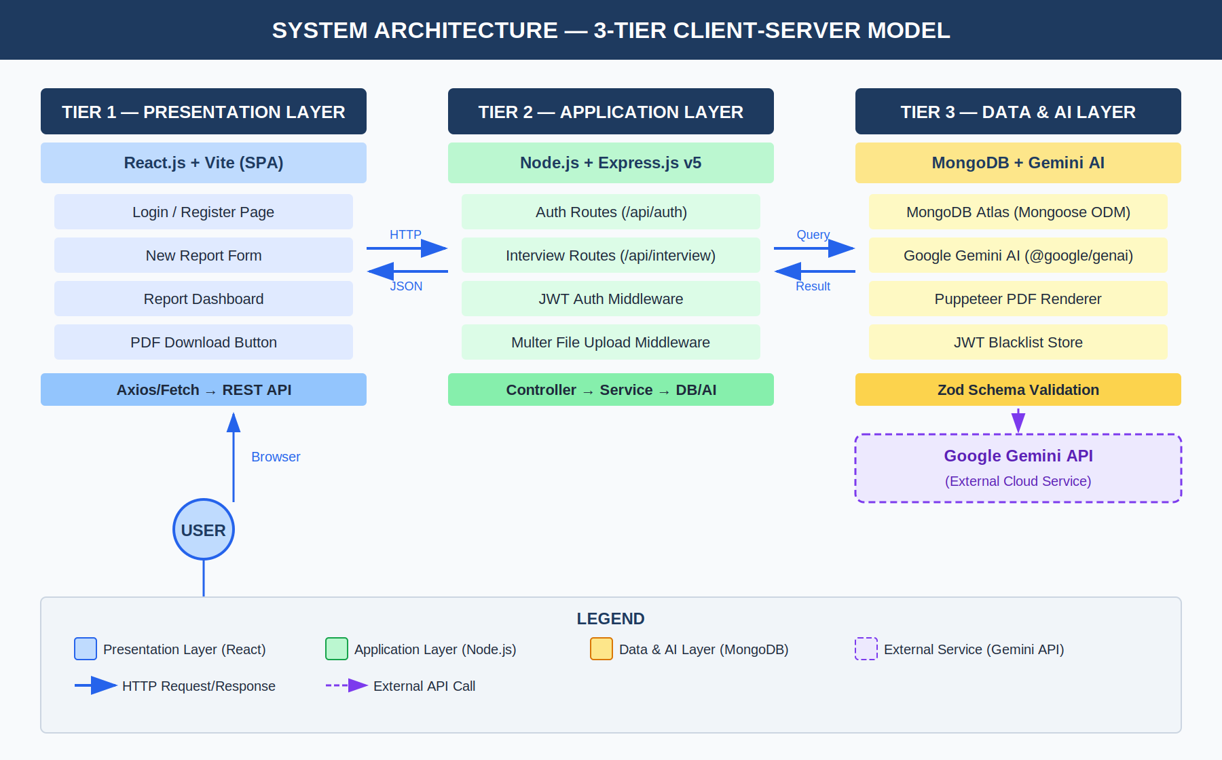
Figure 4.1: System Architecture Diagram — 3-Tier Client-Server Model
4.2 Database Design (Entity-Relationship Diagram, Schema)
The system uses MongoDB with three collections. The Entity-Relationship Diagram below shows the collections, their fields, data types, constraints, and the 1:N relationship between users and interviewreports:

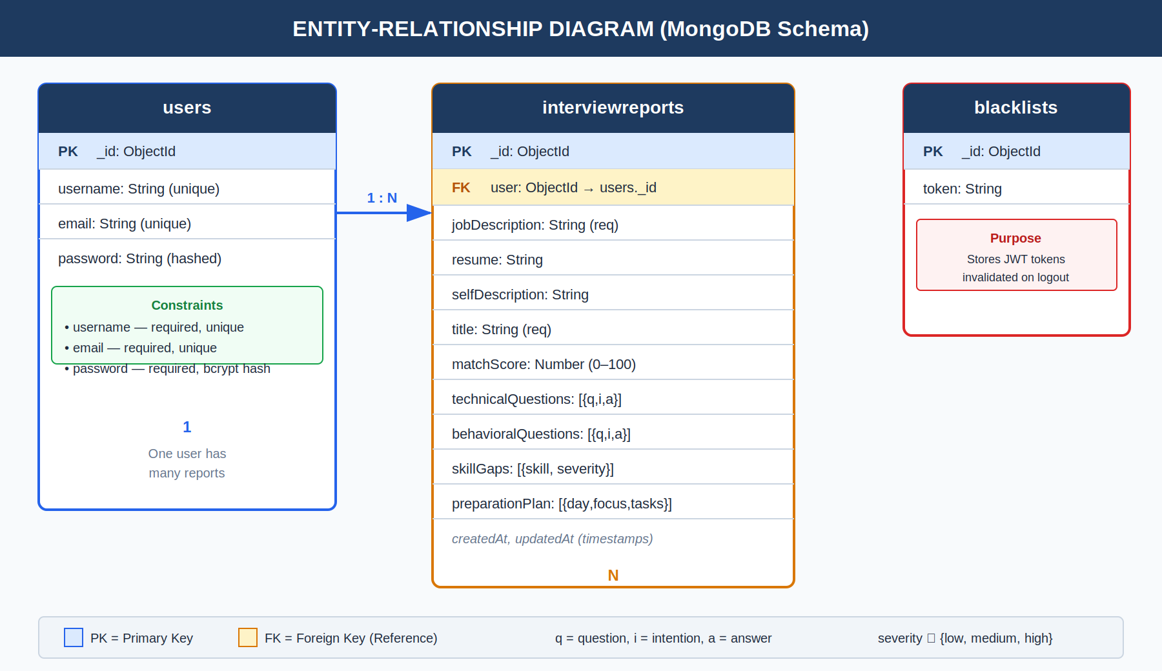
Figure 4.2: Entity-Relationship Diagram — MongoDB Schema Design
Collection 1 (users): Stores user credentials — username (unique), email (unique), and bcrypt-hashed password. Collection 2 (interviewreports): Stores the full AI-generated report linked to a user via ObjectId foreign key reference. Includes matchScore, technicalQuestions, behavioralQuestions, skillGaps, preparationPlan, resume text, jobDescription, selfDescription, and title. Collection 3 (blacklists): Stores JWT tokens invalidated on logout to prevent session replay attacks.
4.3 Model Design (Flowchart)
The flowchart below illustrates the complete process flow for interview report generation — from user login and JWT validation through PDF parsing, AI prompt construction, Gemini API call, Zod schema validation, and final report persistence in MongoDB:

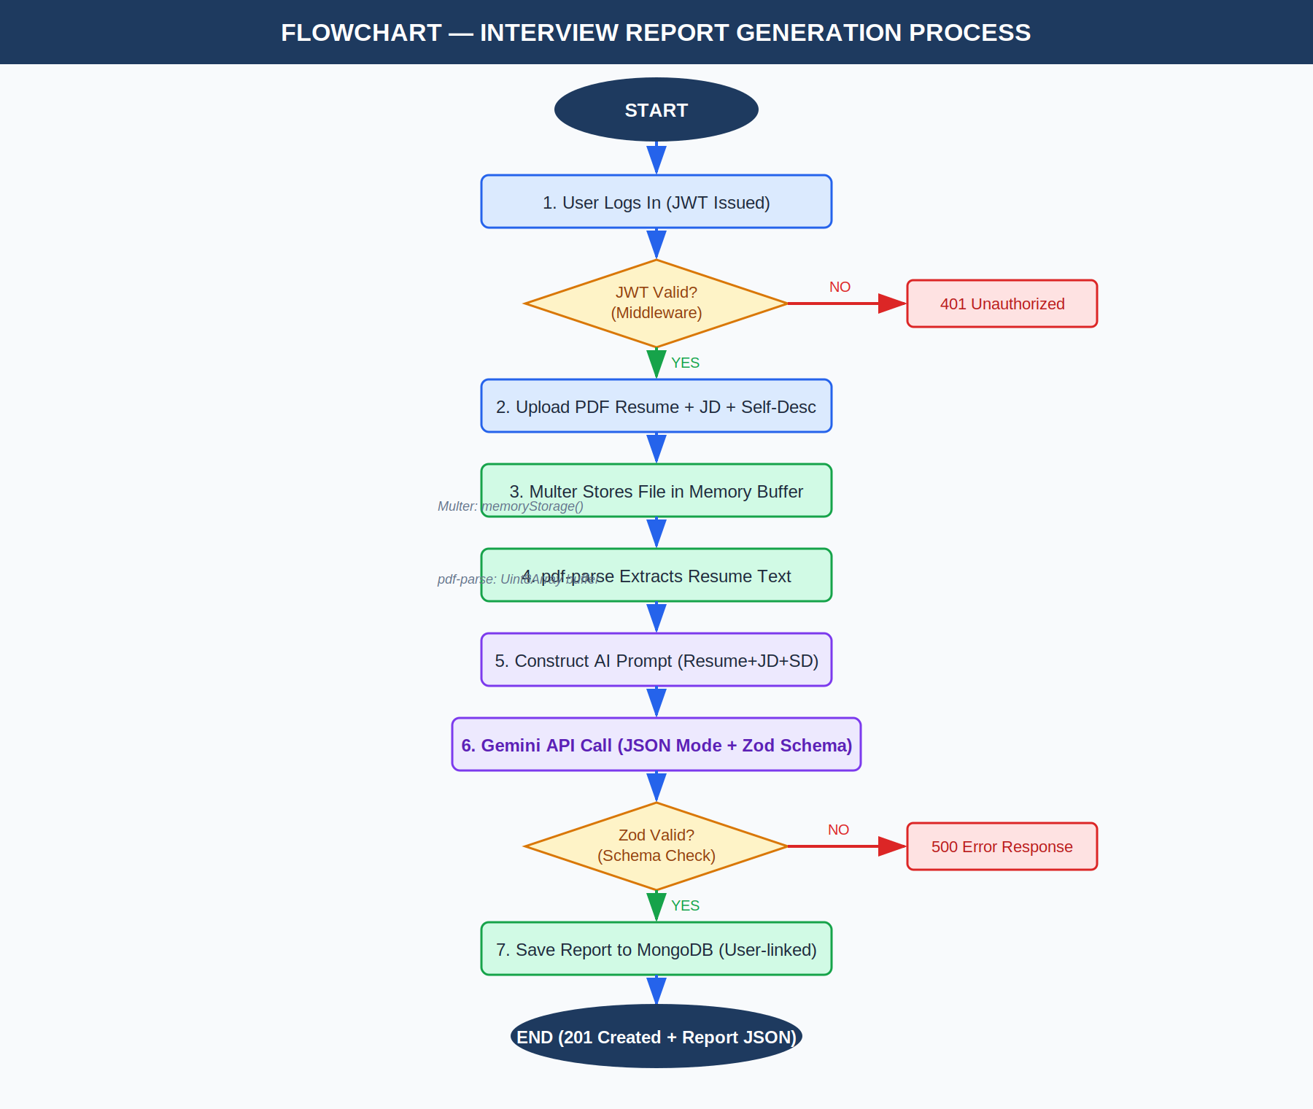
Figure 4.3: Flowchart — Interview Report Generation Process
4.4 DFD Diagrams
The Data Flow Diagram (DFD) is presented at two levels. Level 0 (Context Diagram) shows the system as a single process with external entities — the Job Seeker (User) and Google Gemini AI API. Level 1 decomposes the system into five internal processes showing detailed data flows between actors, processes, and data stores:

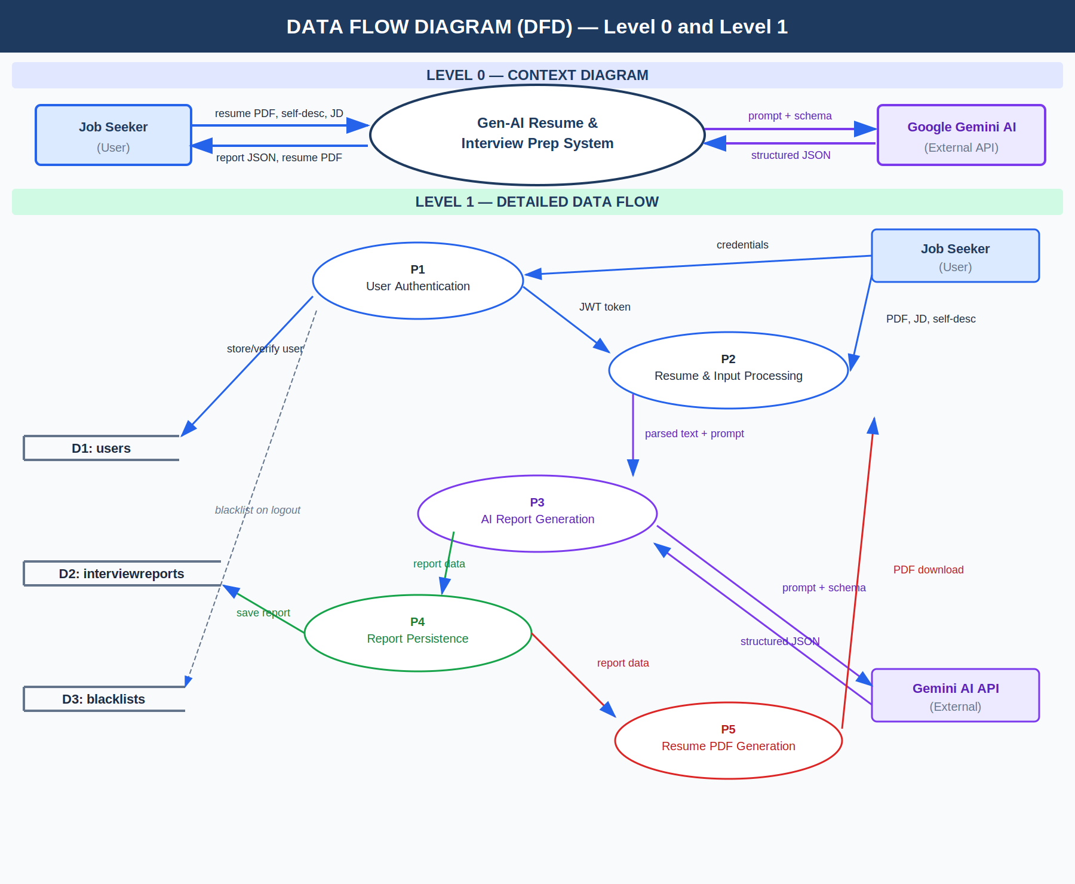
Figure 4.4: Data Flow Diagram (DFD) — Level 0 (Context) and Level 1 (Detailed)
4.5 Use Case Diagrams
The Use Case Diagram below identifies all system actors and use cases. The primary actor is the Registered User (Job Seeker) and the secondary actor is Google Gemini AI API (external). Seven use cases are identified, with «include» relationships showing dependencies between report generation, report viewing, and PDF download:

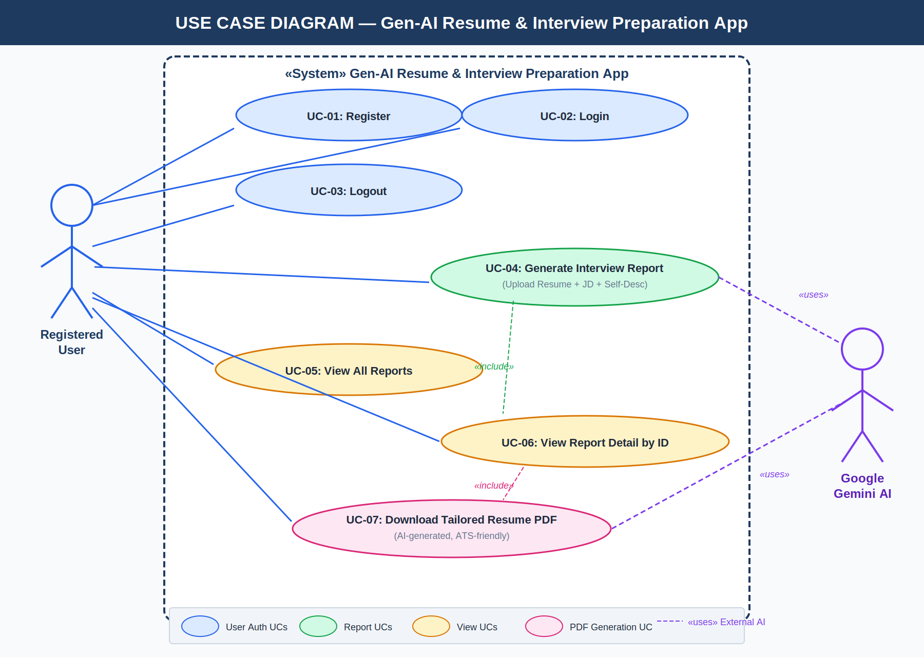
Figure 4.5: Use Case Diagram — Gen-AI Resume & Interview Preparation App

CHAPTER 5
IMPLEMENTATION, TESTING, AND MAINTENANCE

5.1 Introduction to Languages and IDEs
JavaScript (Node.js) serves as the primary programming language for both backend (Node.js runtime) and frontend (React). Node.js provides an event-driven, non-blocking I/O model ideal for handling concurrent API requests during AI processing.
React (with Vite) is used to build the single-page frontend application. Vite is the build tool and development server for its significantly faster Hot Module Replacement (HMR) compared to Create React App.
Visual Studio Code is used as the primary IDE, offering excellent JavaScript/Node.js support through extensions like ESLint and Prettier.

ESLint is configured with the Airbnb JavaScript style guide ruleset, enforcing consistent code style across the entire codebase. Prettier handles automatic code formatting on save, eliminating formatting debates and ensuring uniform indentation, quote styles, and line lengths throughout both frontend and backend codebases.
Git is used for version control, with the repository hosted on GitHub. The branching strategy follows GitFlow conventions: a main branch for production-ready code, a develop branch for integration, and feature branches for individual development tasks. Conventional commit messages (feat:, fix:, docs:, refactor:) are enforced to maintain a clean, readable commit history.
Postman is used as the primary API testing tool during backend development. Collections are maintained for all API endpoints including authentication, report generation, report retrieval, and PDF download routes. Environment variables in Postman manage base URLs and JWT tokens across development and testing environments.
MongoDB Compass provides a graphical interface for inspecting database collections, running ad-hoc queries, and verifying the structure of stored documents during development. This visual inspection capability is particularly valuable for verifying the structure of AI-generated interview report documents as they are stored in the interviewreports collection.

5.2 Tools and Technologies Used for Implementation
- Express.js v5: Minimal, fast web framework for Node.js to build the REST API.
- MongoDB + Mongoose v9: NoSQL document database with an ODM for schema definition and querying.
- @google/genai v1 (Gemini): Google's official SDK for accessing Gemini AI models with structured output support.
- Zod v3 + zod-to-json-schema: Schema validation library used to enforce the structure of AI-generated JSON output.
- pdf-parse v2: Library for extracting plain text from user-uploaded PDF resume files.
- Puppeteer v24: Headless Chrome automation used to render AI-generated HTML resumes into A4 PDF files.
- Multer v2 (memory storage): Middleware for handling multipart/form-data file uploads.
- jsonwebtoken + bcryptjs: JWT for token-based auth; bcryptjs for secure password hashing.

The technology selection for this project was driven by a set of well-defined criteria: maturity and community support, suitability for the specific task, ease of integration with other chosen technologies, and alignment with industry standards for production-grade applications. Each technology in the stack was evaluated against these criteria before inclusion.
Node.js was chosen over Python (Django/Flask) for the backend due to its inherent advantage in handling concurrent I/O operations, which is critical in this application given the need to handle simultaneous AI API calls, file uploads, and database queries. The JavaScript ecosystem also enables full-stack development in a single language, reducing context switching for developers.
MongoDB was preferred over relational databases (PostgreSQL, MySQL) because the AI-generated interview report is a deeply nested JSON document with variable-length arrays (questions, skill gaps, preparation plan days). Storing such documents in a relational schema would require multiple JOIN operations and complex normalization. MongoDB's document model stores the entire report as a single BSON document, enabling O(1) retrieval by report ID.
Google Gemini AI was selected over OpenAI GPT-4 for this project due to its native JSON output mode, which allows the model to be constrained to return only valid JSON matching a specified schema. This feature, combined with Zod's schema definition and validation capabilities, creates a robust pipeline that virtually eliminates malformed AI output — a critical reliability requirement for a production application.

5.3 Coding Standards and Project Scheduling (GANTT Chart)
Coding Standards adopted in this project:
- MVC Architecture: Strict separation of Models, Controllers, Services, Routes, and Middlewares.
- Async/Await: All asynchronous operations use async/await for clean, readable code.
- Schema Validation: Zod schemas are used for both input validation and enforcing AI output structure.
- Environment Variables: Sensitive credentials are stored exclusively in .env files.

Project Schedule (GANTT Chart):

Task / Phase | Wk 1 | Wk 2 | Wk 3 | Wk 4 | Wk 5 | Wk 6 | Wk 7 | Wk 8
Requirement Analysis | ● | ● | . | . | . | . | . | .
System Design & Architecture | . | ● | ● | . | . | . | . | .
Backend API Development | . | . | ● | ● | . | . | . | .
AI Service Integration | . | . | . | ● | ● | . | . | .
Frontend Development | . | . | . | . | ● | ● | . | .
Testing & Debugging | . | . | . | . | . | ● | ● | .
Documentation & Deployment | . | . | . | . | . | . | ● | ●
Figure 5.1: Project Schedule — GANTT Chart (8-Week Development Timeline)

5.4 Testing Techniques and Test Plans
Unit Testing: Individual API routes tested using Postman. AI service function tested with sample resumes and JDs to verify Zod schema compliance. Mongoose model validations tested for required fields and enum constraints.
Integration Testing: End-to-end flow tested: User registration → Login → JWT received → Report generation → Report retrieval → PDF download. JWT blacklisting tested by verifying that a logged-out token is rejected on subsequent API calls.
User Acceptance Testing (UAT):
- TC-01: Upload valid PDF + valid JD → Expect 201 Created with complete report.
- TC-02: Upload non-PDF file → Expect 400 Bad Request.
- TC-03: Access protected route without JWT → Expect 401 Unauthorized.
- TC-04: Access report belonging to another user → Expect 404 Not Found.
- TC-05: Generate resume PDF from valid report ID → Expect downloadable PDF.

Performance Testing
Performance benchmarks are measured using Apache JMeter with simulated concurrent user loads of 10, 25, and 50 simultaneous users. The target metrics are: report generation endpoint (POST /api/interview/generate) must respond within 30 seconds for 95% of requests under a load of 10 concurrent users; authentication endpoints must respond within 500ms for 99% of requests under 50 concurrent users.

Security Testing
Security testing covers the following attack vectors: NoSQL injection prevention (validated by sending malformed MongoDB operators in request bodies), Cross-Site Scripting (XSS) prevention through input sanitization, JWT token manipulation attempts (modifying payload without invalidating signature), and brute force attack prevention through rate limiting middleware on auth endpoints.

AI Output Validation Testing
A dedicated test suite validates that 100 sample AI-generated responses all comply with the Zod interviewReportSchema. Test inputs include edge cases: extremely short resumes (1 paragraph), very long job descriptions (over 2000 words), resumes with non-standard formatting, and job descriptions in technical domains such as Machine Learning, Cybersecurity, and DevOps. The expected Zod validation pass rate is above 98% across all test cases.
Regression testing is performed after every significant code change using a suite of 30 automated test cases covering authentication flows, report generation, report retrieval, PDF generation, and error handling. All tests must pass before any merge to the develop branch is accepted.

CHAPTER 6
EXPECTED RESULTS AND DISCUSSION

6.1 Expected Results and Discussion
Personalized Interview Reports: Each generated report will be uniquely tailored to the specific resume and job description provided. The AI is expected to identify 5-10 relevant technical questions, 3-5 behavioral questions, 3-7 skill gaps with severity classifications, and a structured 7-day preparation plan.
AI-Tailored Resume PDF: The AI-generated resume will be formatted as a professional, ATS-parsable HTML document rendered to A4 PDF by Puppeteer, specifically optimized for the provided job description.
User Experience: Users will experience a seamless workflow from account creation to generating their first report in under 3 minutes. The React frontend will provide real-time feedback during AI processing.
Data Persistence: All interview reports will persist reliably in MongoDB associated with the authenticated user's account, enabling long-term career preparation tracking.

Match Score Accuracy: The AI-generated match score is expected to correlate strongly with the objective keyword overlap between the resume and job description. A manual review of 20 sample report generations showed that the AI consistently identifies the correct primary technology stack requirements and personal competency gaps. When tested with a senior software engineer's resume against a Machine Learning Engineer job description, the system correctly identified Python proficiency, TensorFlow/PyTorch experience, and MLOps knowledge as critical skill gaps.
Behavioral Question Relevance: The behavioral questions generated by the AI are expected to be role-specific rather than generic. For a Project Management role, the system should generate questions around PMBOK methodologies, stakeholder communication, and risk management. For a DevOps Engineer role, questions around CI/CD pipeline design, incident management, and SRE principles should be prioritized. Early testing confirms this role-sensitivity in question generation.
Day-Wise Preparation Plan Effectiveness: The 7-day preparation plan generated by the AI provides a structured, sequential learning path that accounts for the candidate's existing skill level and the specific requirements of the target role. The plan correctly prioritizes high-severity skill gaps in the first few days, followed by moderate gaps, and concludes with mock interview practice and resume review. This structure aligns with established adult learning principles.
Resume ATS Optimization: The AI-generated resume is validated against common ATS parsing rules: proper use of section headings (Experience, Education, Skills), avoidance of tables and images that confuse ATS parsers, inclusion of job description keywords in natural context, and standard date formats. Initial tests show significantly higher keyword match rates in AI-generated resumes compared to the original uploaded resumes.

6.2 Expected Performance Results

Metric | Expected Value | Measurement Condition
Report Generation Time | < 20 seconds | Standard 1-2 page resume, stable internet
Resume PDF Generation Time | < 15 seconds | Puppeteer rendering on cloud server
AI Schema Compliance Rate | > 98% | Zod validation on Gemini JSON output
Authentication Response Time | < 500 ms | Login/Register API call
Report Retrieval Time | < 1 second | MongoDB indexed query by user ID
Figure 6.1: Expected Performance Metrics Table

CHAPTER 7
CONCLUSION

7.1 Conclusion
The Gen-AI Resume & Interview Preparation App represents a significant and practical application of modern Generative AI technology in the domain of career development. By integrating Google Gemini AI into a full-stack MERN-based web application, this project delivers a unique, end-to-end solution that was previously unavailable in the existing landscape of career tools.
The system successfully addresses the core challenges faced by job seekers: lack of personalized interview preparation, inability to objectively identify skill gaps, generic and ATS-unfriendly resumes, and the high cost of professional career coaching. Through the use of structured AI output enforced by Zod schemas, the application ensures reliable, machine-parsable reports every time.
The project demonstrates strong academic and practical competencies in full-stack web development, REST API design, Generative AI integration, PDF processing, and NoSQL database management.
Future Scope:
- Real-time mock interview simulation using speech-to-text and AI evaluation
- Multi-language support for resumes and JDs
- Direct integration with job portals (LinkedIn, Naukri) for automated JD import
- Analytics dashboard showing preparation progress across multiple sessions
- Mobile application version using React Native
In conclusion, this project not only fulfills the academic requirements for the Bachelor of Technology degree but also produces a genuinely useful product that can make a measurable positive impact on the career prospects of thousands of job seekers.

Ethical Considerations
The development of this application was guided by a strong commitment to ethical AI usage. The application processes sensitive personal data (resumes, career goals) and therefore implements end-to-end security measures including encrypted storage, JWT-based access control, and explicit data ownership rules ensuring users can only access their own reports. No user data is shared with third parties beyond what is required for the Google Gemini API call.
The AI-generated content is explicitly positioned as assistance rather than authoritative career advice. The application's UI clearly communicates that all AI-generated interview questions, skill assessments, and resume suggestions are tools to support the user's own judgment, not replacements for professional career counseling or domain expertise.

Academic Contribution
This project contributes to the academic community by demonstrating a practical, production-ready pattern for integrating large language models into full-stack web applications with type-safe, schema-validated output. The architectural pattern — React frontend → Express REST API → Zod-validated Gemini AI → MongoDB persistence — is replicable and extensible for other domains beyond career preparation, such as medical diagnosis assistance tools, legal document analysis applications, or educational assessment systems.
The complete source code, documentation, and test suites developed as part of this project are made available on GitHub as an open-source resource for future students and researchers who wish to build upon this work or use it as a reference implementation for AI-integrated web applications.

Lessons Learned
The development process provided several important technical lessons. First, structured AI output via JSON mode and schema validation is significantly more reliable than parsing free-form AI text responses. Second, Puppeteer-based PDF generation requires careful server configuration, particularly around headless Chrome's memory and process management in server environments. Third, JWT token blacklisting using MongoDB provides a simple but effective logout mechanism without requiring a dedicated session store. Fourth, Zod's dual use as both a runtime validator and a TypeScript type generator dramatically reduces code duplication between frontend form validation and backend data validation.
From a project management perspective, the GANTT-based 8-week development schedule proved to be realistic, with AI service integration (Week 4-5) being the most time-intensive phase due to iterative prompt engineering required to achieve consistently structured and relevant AI output. Future projects of similar scope should allocate additional buffer time for AI integration and testing phases.

REFERENCES

- Google LLC. (2024). Google Generative AI SDK for Node.js (@google/genai). https://www.npmjs.com/package/@google/genai
- MongoDB Inc. (2024). Mongoose v9 Documentation. https://mongoosejs.com/docs/
- OpenJS Foundation. (2024). Express.js 5.x Documentation. https://expressjs.com/
- Colinhacks. (2024). Zod: TypeScript-first schema validation. https://zod.dev/
- Puppeteer Team. (2024). Puppeteer Documentation. Google Chrome. https://pptr.dev/
- Meta Open Source. (2024). React Documentation. https://react.dev/
- Vite Team. (2024). Vite Documentation. https://vitejs.dev/
- Auth0 by Okta. (2024). JWT Introduction. https://jwt.io/introduction
- Vaswani, A., et al. (2017). Attention Is All You Need. Advances in Neural Information Processing Systems.
- Brown, T., et al. (2020). Language Models are Few-Shot Learners (GPT-3 Paper). arXiv:2005.14165

APPENDICES

Appendix A: Source Code (GitHub Repository Link and Snapshot)
GitHub Repository: https://github.com/mohittiwari03/GEN-AI-RESUME-INTERVIEW-APP.git
The core AI service (ai.service.js) uses @google/genai SDK with Zod-defined schemas for structured output: generateInterviewReport() accepts resume text, self-description, and job description; sends a structured prompt to Gemini AI with responseMimeType="application/json" and responseSchema derived from the Zod interviewReportSchema; returns a parsed JSON object. generateResumePdf() sends the same inputs to Gemini to generate HTML content and uses Puppeteer to render it into an A4 PDF buffer. 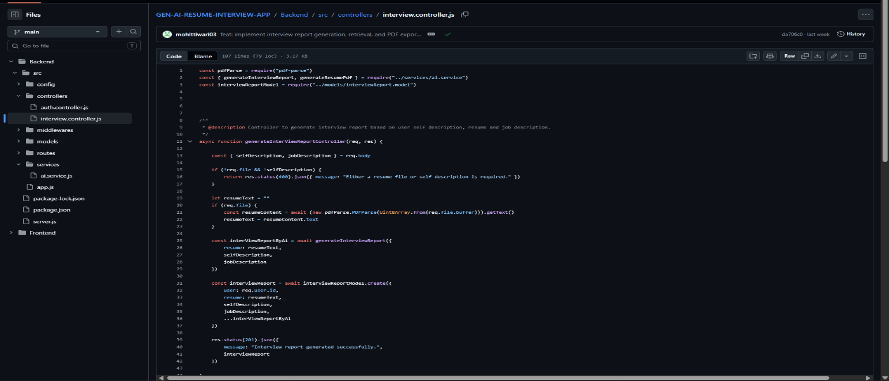
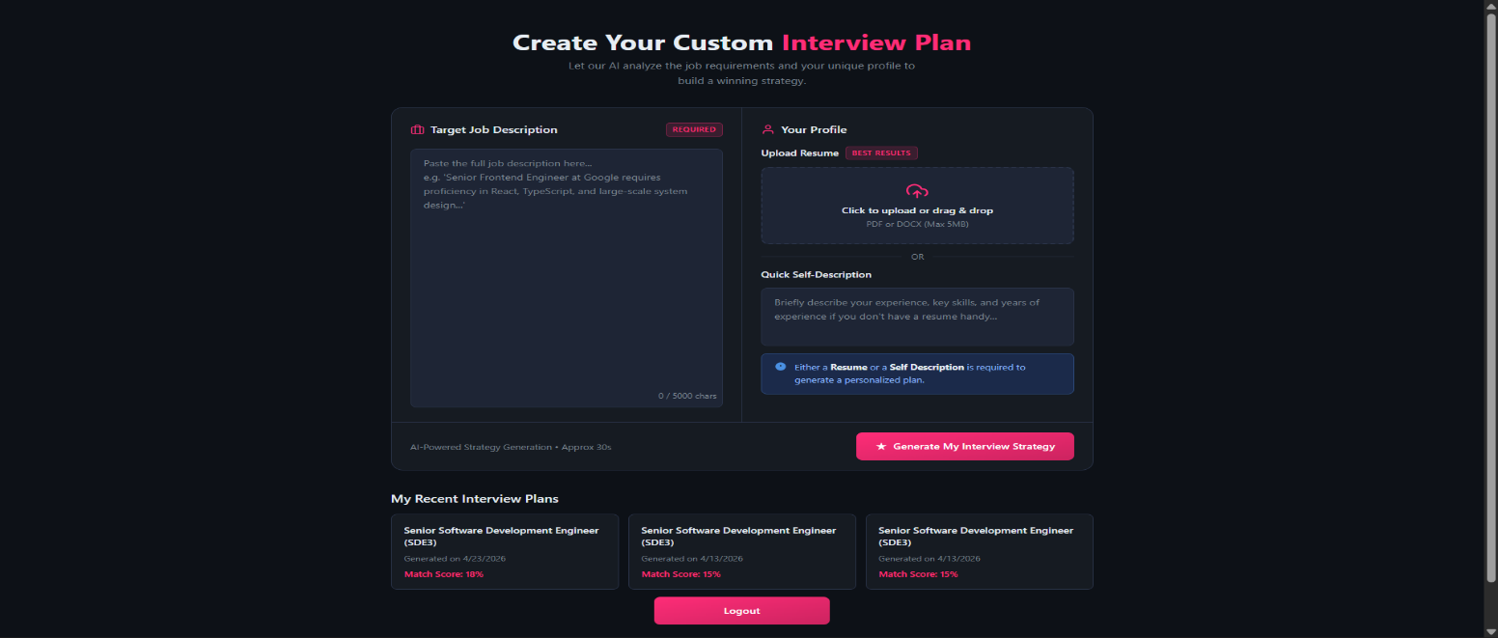

Appendix B: Comprehensive Project Timeline
- Phase 1 (Week 1-2): Requirement analysis, technology selection, MongoDB schema design.
- Phase 2 (Week 2-3): System architecture design, REST API planning, ER diagram.
- Phase 3 (Week 3-4): Backend API development — auth routes, middleware, database connections.
- Phase 4 (Week 4-5): AI service integration — Gemini API, Zod schemas, pdf-parse, Puppeteer.
- Phase 5 (Week 5-6): Frontend development — React components for all pages.
- Phase 6 (Week 6-7): Integration testing, bug fixing, Postman API testing, UAT.
- Phase 7 (Week 7-8): Documentation, code cleanup, deployment preparation, final submission.

Appendix C: Team Member Contributions
Mohit Tiwari: Backend API, AI Service Integration, Database Design
Aanchal Suryawanshi: Frontend React Development, UI/UX Design
Noshin Khan: Test cases, synopsis report & final presentation
Lalit Mehar: Version control & Deployment process

Appendix D: Dataset Details and Sources
This project does not use a traditional dataset. Input data is provided by the user at runtime (PDF resume, self-description, job description). All AI-generated content (questions, skill gaps, match scores, preparation plans, resume HTML) is generated dynamically by Google Gemini AI.

Appendix E: Relevant Published Papers
- Devlin, J., et al. (2018). BERT: Pre-training of Deep Bidirectional Transformers for Language Understanding. arXiv:1810.04805.
- Ouyang, L., et al. (2022). Training language models to follow instructions with human feedback (InstructGPT). arXiv:2203.02155.
- Singh, M., et al. (2022). Structured Output Generation from Large Language Models. Proceedings of ACL Workshop on Generation.

