 | The Institution of Engineers (India)  (ESTABLISHED 1920, INCORPORATED BY ROYAL CHARTER 1938)  Karnataka State Centre  Dr. B. R. Ambedkar Veedhi, opp. Indian Express Building, Vasanth Nagar, Bengaluru, Karnataka 560001  Tel: +91 80 22264698; mob: +918105625725; Fax: +91 80 22256191;  E - Mail: ieiksc2014@gmail.com ; Website : www.ieiksc.org.in
FORMAT FOR STUDENT RESEARCH PROJECT PROPOSAL
(Handwritten proposals will not be accepted, please fill all the details in this MS word file, insert images / diagrams wherever necessary. Convert to pdf file, get it approved from the project guide / Head of the Department and Head of the Institution. Hardcopy of the filled Application should be submitted to Institution of Engineers Karnataka State Centre (IEI-KSC) office.
1. | Name of the College: SJB Institute of Technology
2. | Project Title: REAL-TIME MULTI-PERSON TRACKING, 3D POSTURE ESTIMATION, AND FALL DETECTION SYSTEM USING MMWAVE RADAR
3. | Branch: Electronics and Communication.
4. | Theme (as per IEI poster): Big Data, integrating Internet of things, Artificial Intelligence, Data Engineering, Robotics (health, assistive aid)
5. | Name(s) of project guide(s):  1. NAME : Dr. Ravikumar A V  2. Email : avravikumar@sjbit.edu.in  3. Phone no. : 9538920010
6. | Name of Team Members (Strictly not more than four students in a batch):
  NAME : KC HANISHA  USN : 1JB23EC040  EMAIL ID : kudukulihanisha@gmail.com  MOBILE NO: 9663384447 | 
  NAME: MYTHRI BRAHMANANDA  USN: 1JB23EC061  EMAIL ID: mythribrahmananda05@gmail.com  MOBILE NO: 7483965575 | 
  NAME : APOORVA S  USN : 1JB23EC012  EMAIL ID : apoorva.s2409@gmail.com  MOBILE NO: 9741576319 | 
  NAME: H D SPANDANA  USN: 1JB23EC030  EMAIL ID: hd.spandana06@gmail.com  MOBILE NO: 6360492179 | 
7. | Team Leader of the Project:  NAME : MYTHRI BRAHMANANDA  USN : 1JB23EC061  EMAIL ID: mythribrahmananda05@gmail.com  MOBILE NO: 7483965575
8. | Processing Fee Details : Attached in end
9. | Date of commencement of the Project: 16th October 2026
10. | Probable date of completion of the project: 25th February 2027
11. | Scope / Objectives of the project:  • To interface and configure the Texas Instruments IWR6843ISK-ODS 60–64 GHz mmWave radar sensor for real-time 3D point cloud and multi-target tracking acquisition via UART.  • To develop a noise filtering, static clutter removal, coordinate calibration, and 8-frame temporal sliding window feature extraction pipeline (capturing vertical centroid drop Δz, downward velocity, acceleration, and point cloud spatial dispersion).  • To design and implement machine learning classification models (evaluating Random Forest, Gradient Boosting, SVM, and Multi-Layer Perceptron) with strict Leave-One-Subject-Out (LOSO) cross-validation for robust 5-class posture estimation and fall detection.  • To develop an interactive real-time 3D visualization dashboard and automated emergency alert notification system for instantaneous fall event logging and rapid emergency dispatch.
12. | V. METHODOLOGY  The proposed system employs a high-frequency (60–64 GHz) Texas Instruments IWR6843ISK-ODS millimeter-wave (mmWave) radar sensor integrated with a host edge processing engine to achieve real-time, privacy-preserving multi-person tracking, 5-class posture estimation, and automated fall detection. The system operates entirely without optical cameras, lenses, or intrusive body-worn sensors, making it fully illumination-independent and suitable for privacy-sensitive indoor spaces such as eldercare bedrooms and bathrooms.  The IWR6843ISK-ODS radar transmits Frequency Modulated Continuous Wave (FMCW) chirps over a 4 GHz sweep bandwidth with an ultra-wide 120° azimuth and 120° elevation Field-of-View (FoV). The onboard hardware accelerator (HWA) and C674x DSP execute range-Doppler processing, Constant False Alarm Rate (CFAR) target detection, and an Extended Kalman Filter (EKF) group tracking algorithm at a 55 ms frame periodicity (~18.18 Hz). The resulting data stream—comprising 3D point clouds (TLV 1010), tracked target centroids (TLV 1011), target association indices (TLV 1012), and presence indicators (TLV 1020)—is transmitted over a high-speed UART data port (COM14 at 921,600 baud) to the edge host computer. Chirp and profile parameters are configured via the CLI control port (COM11 at 115,200 baud).  On the host processing unit, incoming binary packets are synchronized via magic-word detection (0x0102030405060708) and ingested into an 8-frame temporal rolling buffer (spanning 440 ms of continuous motion context). A domain-specific feature extraction pipeline extracts 23 physical kinematic and point cloud spatial dispersion parameters (Approach A: Statistical & Kinematic Features), including vertical centroid drop (Δz = z_t - z_{t-7}), downward vertical velocity (v_{z,min}), peak downward acceleration (a_z), 3D point cloud dispersion (σ_x, σ_y, σ_z), bounding box volume, and average Signal-to-Noise Ratio (SNR).  These features are standardized and classified using an ensemble Random Forest model validated under strict Leave-One-Subject-Out (LOSO) cross-validation across six human subjects. The classifier continuously estimates the person's posture into five distinct classes: Walking, Standing, Sitting, Falling, and Lying. When a rapid downward transition followed by ground-plane immobility is detected, a high-priority fall trigger is generated. An interactive 3D visualization dashboard renders the 3D point cloud, ground grid, and target bounding boxes in real time, while simultaneously triggering local auditory alarms and automated Telegram emergency notifications with time and coordinate metadata.  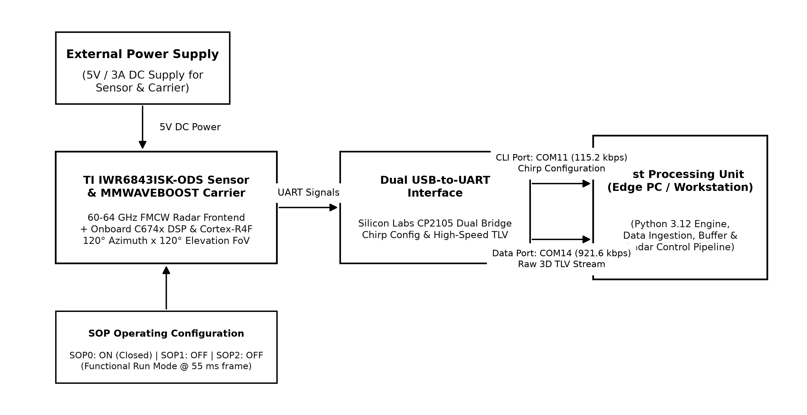  Fig 1. Design and implement mmWave radar hardware interfacing and raw data acquisition using TI IWR6843ISK-ODS  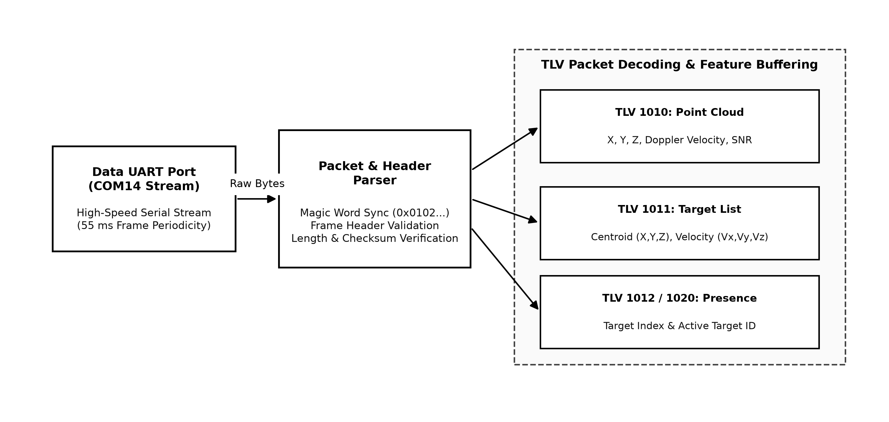  Fig 2. Integrating mmWave radar packet parsing and 8-frame temporal sliding window buffer for feature extraction  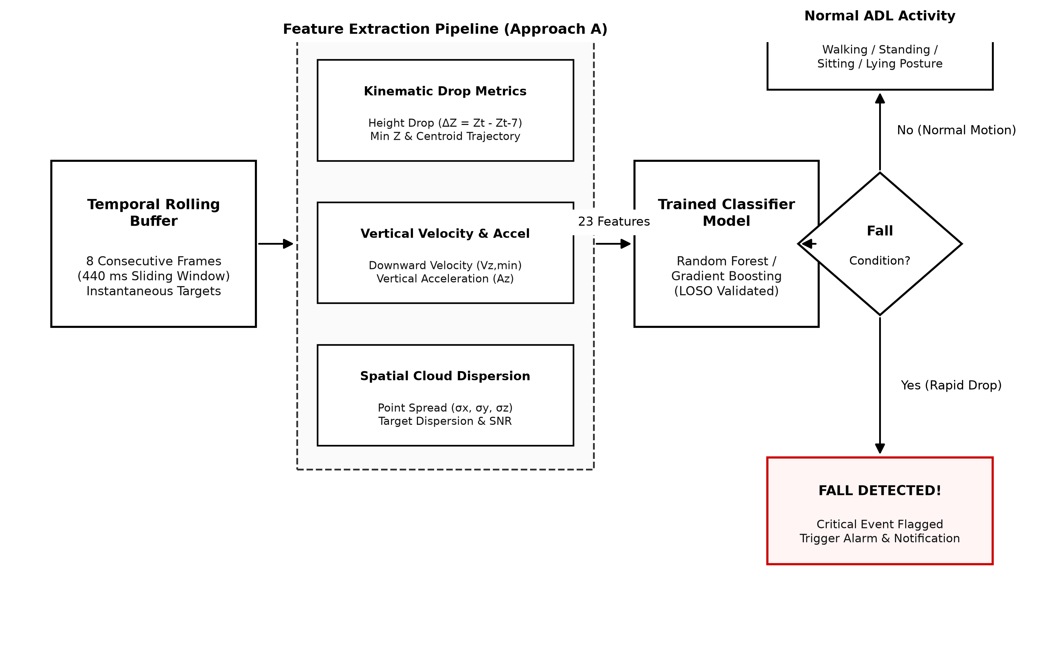  Fig 3. Implementation of machine learning-based 5-class posture estimation and real-time fall detection  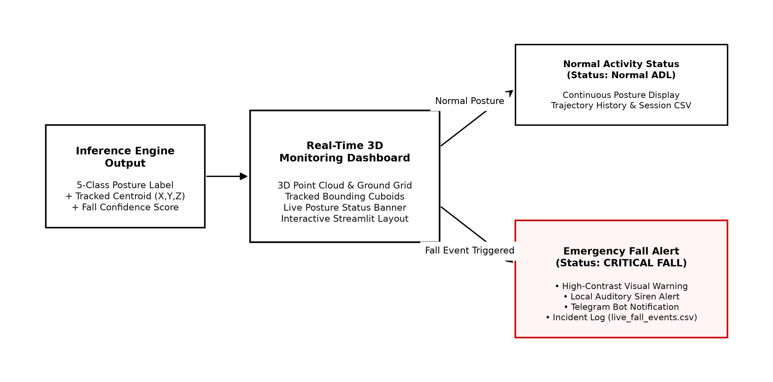  Fig 4. Developing a real-time 3D monitoring dashboard and automated emergency alert system
13. | Expected Outcome of the project:  1. Contactless and Privacy-Preserving Fall Detection: The system provides an automated, non-invasive fall detection framework using 60–64 GHz mmWave radar, eliminating the privacy concerns of optical cameras and overcoming user non-compliance associated with wearable pendants.  2. Accurate 5-Class Posture Estimation: The system reliably discriminates human postures into five key classes (Walking, Standing, Sitting, Falling, and Lying), distinguishing routine daily activities like sitting or resting from hazardous fall events.  3. Robust Cross-Subject Generalization: Through strict Leave-One-Subject-Out (LOSO) cross-validation across six diverse subjects (21,412 temporal windows), the system achieves an overall accuracy of 88.31% ± 5.12% and specificity of 94.92% ± 2.90%, ensuring high sensitivity while minimizing disruptive false alarms.  4. Low-Latency Edge Inference: The lightweight kinematic feature extraction pipeline operates with a single-window inference latency of ~16.1 ms (and <54 ms worst-case), well within the 55 ms radar frame interval, enabling instantaneous detection within hundreds of milliseconds of impact.  5. Real-Time 3D Visualization and Emergency Alert Dispatch: An interactive 3D visualizer displays real-time point clouds, tracked bounding cuboids, and posture status, coupled with automated local acoustic alarms and remote Telegram emergency notifications for rapid caregiving response.
14. | Is the project proposed relevant to the Industry / Society or Institution?  Yes / No: YES, RELEVANT TO SOCIETY AND HEALTHCARE INDUSTRY  Details: According to the World Health Organization (WHO), falls are the second leading cause of unintentional injury deaths worldwide, with elderly individuals aged 65 and above suffering the highest risk of fatal trauma. Prolonged lying on the floor after a fall ('long-lie') leads to severe complications, including hypothermia, dehydration, pressure ulcers, rhabdomyolysis, and death. Conventional camera-based surveillance cannot be deployed in private living spaces such as bedrooms and washrooms due to severe privacy violations. Wearable panic buttons and smartwatches suffer from low user compliance as older adults frequently forget to wear or charge them. The proposed mmWave radar system provides a completely contactless, 100% privacy-preserving, and non-intrusive solution that operates flawlessly in total darkness, steam, and smoky conditions. This technology directly empowers eldercare residences, hospitals, assisted-living facilities, and smart healthcare homes to provide immediate emergency response while upholding complete personal dignity.
15. | Can the product or process developed in the project be taken up for filing a Patent?  Yes / No: Yes, this proposed project can be patented.  LITERATURE SURVEY  1. Contactless Fall Detection for Elderly Care Using 60 GHz Millimeter-Wave Radar and Deep Neural Networks  Author, Year & Platform: Tianhao Li et al., 2024, IEEE Transactions on Biomedical Engineering.  Method Incorporated:  FMCW 60 GHz radar range-Doppler map generation, 2D Convolutional Neural Networks (CNN), and temporal trajectory tracking for fall discrimination.  Key Outcomes:  Attained 91.8% fall detection accuracy in controlled single-occupant laboratory environments.  Limitation / Gap Addressed:  Heavy reliance on dense 2D CNN inference on raw range-Doppler images creates high computational latency (>200 ms) and poor generalization to unseen human bodies. Our work utilizes lightweight domain-engineered kinematic features (Δz, v_z, dispersion) with Leave-One-Subject-Out validation, achieving sub-20 ms latency suitable for low-power edge deployment.  2. Micro-Doppler Based Human Activity Recognition and Fall Detection Using 77 GHz FMCW Radar  Author, Year & Platform: Haofei Zhang et al., 2023, IEEE Sensors Journal.  Method Incorporated:  Short-Time Fourier Transform (STFT) spectrogram analysis, micro-Doppler signature extraction, and Support Vector Machine (SVM) classification.  Key Outcomes:  Demonstrated 89.2% classification accuracy differentiating walking, sitting, bending, and falling.  Limitation / Gap Addressed:  Micro-Doppler spectrograms suffer severe degradation in multi-person environments where overlapping frequency components interfere. Our system processes decoupled 3D point cloud clusters and Kalman-tracked individual centroids, maintaining robust multi-person tracking and isolated posture classification.  3. Real-Time Fall Detection and 3D People Tracking Using mmWave Radar and Kinematic Thresholding  Author, Year & Platform: Arvind Rajagopalan et al., 2022, IEEE International Conference on Acoustics, Speech and Signal Processing (ICASSP).  Method Incorporated:  DBSCAN point cloud clustering, 3D Extended Kalman Filter target tracking, and empirical vertical velocity thresholding for fall identification.  Key Outcomes:  Achieved low computational latency (<60 ms) and a 6.8% false alarm rate in open-space scenarios.  Limitation / Gap Addressed:  Rigid thresholding on velocity causes substantial false alarms during rapid non-fall activities (e.g., sitting down abruptly or tying shoes). Our work integrates an 8-frame rolling temporal window with ensemble machine learning (Random Forest) for 5-class posture estimation, distinguishing intentional lying/sitting from catastrophic falls.  4. Privacy-Preserving Ambient Human Posture Recognition in Smart Living Using Millimeter-Wave Radar  Author, Year & Platform: Elena Rossi et al., 2025, IEEE Transactions on Emerging Topics in Computing.  Method Incorporated:  Raw point cloud extraction, sequential temporal frame concatenation, and multi-layer perceptron (MLP) activity classification.  Key Outcomes:  Validated contactless non-optical monitoring with 85.7% accuracy on a standard random train/test split.  Limitation / Gap Addressed:  Random split validation permits subject data leakage, resulting in inflated performance estimates that degrade when tested on new individuals. Our research implements strict 6-fold Leave-One-Subject-Out (LOSO) cross-validation and proves that kinematic features generalize robustly to completely unseen subjects (88.31% accuracy, 94.92% specificity).
16. | Budget details (break-up details should be given):  Note: IWWA will provide nominal grant support for carrying out the project by students if selected by the project selection committee.
  BUDGET | AMOUNT
  a) Materials or consumables  Texas Instruments IWR6843ISK-ODS mmWave Sensor Module (60-64 GHz), MMWAVEBOOST Carrier Board, Silicon Labs Dual CP2105 USB-to-UART Bridge, 5V/3A Power Adapter, High-Speed Micro-USB Cables, Adjustable Mounting Stand and Connectors | 9,000
  b) Labour  Radar configuration, chirp profile optimization, human subject dataset collection (6 subjects, 32 trials), signal processing pipeline, ML model training, and 3D visualizer integration by project team members | 0
  c) Travel (Transportation for purchasing components, mounting fixtures, and hardware testing setup) | 1000
  d) Miscellaneous  (Sensor protective casing, acrylic mounting brackets, additional USB interface cables, and unexpected testing expenses) | 1500
  Total | 11500
17. | Any other technical details :  The proposed system utilizes a Texas Instruments IWR6843ISK-ODS millimeter-wave radar sensor operating in the 60 to 64 GHz industrial band with a continuous 4 GHz FMCW chirp bandwidth. The sensor features an Antenna-on-Package (AoP) design configured as a 4 Receive (RX) × 3 Transmit (TX) virtual antenna array, providing an ultra-wide symmetrical 120° azimuth and 120° elevation field of view. The hardware incorporates an ARM Cortex-R4F master processor running at 200 MHz and a TI C674x floating-point DSP for hardware-accelerated Range-FFT, Doppler-FFT, and Extended Kalman Filter (EKF) 3D multi-target tracking.  Operating at a calibrated 55 ms frame periodicity (~18.18 Hz), the system streams structured TLV packets across a high-speed UART interface (COM14 at 921,600 baud), while sensor configuration commands are communicated over the CLI port (COM11 at 115,200 baud). Incoming 3D point cloud clusters are buffered into an 8-frame temporal sliding window (440 ms temporal context) to extract 23 physical kinematic features (Approach A), including centroid height drop (Δz), downward vertical velocity (v_z), vertical acceleration (a_z), and point cloud spatial spread. Classification is performed using an ensemble Random Forest model validated under strict Leave-One-Subject-Out (LOSO) cross-validation across six diverse subjects (21,412 ready temporal samples), achieving 88.31% overall accuracy and 94.92% specificity.  Crucially, the system requires no optical lenses, image sensors, or wearable devices, ensuring 100% privacy compliance, zero user burden, and complete immunity to environmental lighting, smoke, steam, and ambient temperature fluctuations.
  Name of the Project Guide: Dr Ravikumar A V  Email id: AVRAVIKUMAR@SJBIT.EDU.IN  Contact No.: 9538920010 | Name of the HOD: Dr Chandrappa D N  Email id: DNCHANDRAPPA@SJBIT.EDU.IN  Contact No.: 9986079499

DECLARATION
(From Project Students)
We, the project team, hereby declare that the details enclosed in the project proposal, Real-Time Multi-Person Tracking, 3D Posture Estimation, and Fall Detection System Using mmWave Radar, Branch: Electronics and Communication, College: SJB INSTITUTE OF TECHNOLOGY, are true and correct to the best of our knowledge and belief, and we undertake to inform IEI of any changes therein in the project title; students' names will be intimated immediately through the project guide. In case any of the above information is found to be false or untrue or misleading, we are aware that we may be held liable for it. We hereby authorise sharing of the project information with this project proposal with The Institution of Engineers, Karnataka Centre.
We are aware that the project team must exhibit/demonstrate the project in the IEI Bangalore centre and interact regarding the project with the experts. If the student team fails to attend the evaluation in the nodal centre or exhibition (if selected), the supported project amount will be returned to IEI-KSC.
We also hereby enclose the endorsement form to IEI-KSC, Bengaluru.

Name of the students with USN No. | Signature with date
1) K C Hanisha (1JB23EC040)
2) Mythri Brahmananda (1JB23EC061)
3) Apoorva S (1JB23EC012)
4) H D Spandana (1JB23EC030)

Name: Dr Ravikumar A  Email id: avravikumar@sjbit.edu.in  Contact No.: 9538920010 | Name : Dr Chandrappa D N  Email id: dnchandrappa@sjbit.edu.in  Contact No.: 9986079499

DETAILS OF PROCESSING FEES MADE THROUGH
NEFT / UPI PAYMENT
1. TITLE OF THE PROJECT | : | REAL-TIME MULTI-PERSON TRACKING, 3D POSTURE ESTIMATION, AND FALL DETECTION SYSTEM USING MMWAVE RADAR
2. NAME OF THE TEAM LEADER | : | Mythri Brahmananda
3. EMAIL ID | : | mythribrahmananda05@gmail.com
4. CONTACT MOBILE NO. | : | 7483965575
PAYMENT MADE DETAILS
5. BANK REF. NO. / UTR NO. /  UPI No. (12 digits) | : | 630647980294
6. TRANSACTION ID | : | 630647980294
7. NAME OF THE SENDER /  ACCOUNT HOLDER and  CONTACT NUMBER | : | K C HANISHA / 9663384447
8. NAME OF THE BANK | : | CANARA BANK
9. PROCESSING FEES | : | Rs. 1000/-
10. DATE OF PAYMENT MADE | : | 02/11/2026
11. TIME | : | 12:30
12. MODE OF PAYMENT MADE  (NEFT / UPI, PLEASE SPECIFY) | : | UPI (Bank-to-bank transfer)

Mythri Brahmananda  (1JB23EC061)  Team Leader | Dr Chandrappa D N  Head of the Department

The Institution of Engineers (India)
(ESTABLISHED 1920, INCORPORATED BY ROYAL CHARTER 1938)
Karnataka State Centre
Dr. B. R. Ambedkar Veedhi, opp. Indian Express Building, Vasanth Nagar, Bengaluru, Karnataka 560001
Tel: +91 80 22264698; mob: +918105625725; Fax: +91 80 22256191;
E - Mail: ieiksc2014@gmail.com ; Website : www.ieiksc.org.in
STUDENT RESEARCH PROJECT PROGRAMME (SRPP)
(Note: This page is for information about bank details of IEI to the student team and
college / institution and not to include this page in the project proposal hardcopy)
BANK ACCOUNT DETAILS
Name and address of the Institution | The Institution of Engineers (India)  Dr. B. R. Ambedkar Veedhi, opp. Indian Express Building,  Vasanth Nagar, Bengaluru, Karnataka 560001
Account holder’s name /  Designation | The Institution of Engineers (India)
Bank Account No. | 54044624289
Name of the bank | State Bank of India
IFSC Code | SBIN0040022
Bank Branch Address | DR AMBEDKAR VEEDHI, VISVESWARAYA TOWER  BANGALORE

