ACKNOWLEDGEMENT

Every work that one complete successful stands on the constant encouragement, goodwill and support of the people around. I hereby, avail this opportunity to express my heartfelt gratitude to a number of people who extended their valuable time, and cooperation in developing this project.

We would like to thank this opportunity to express our deep gratitude and sincere thanks to my respected internal guide **J.V. SHAPARIA Sir** and external guide provide us with the all valuable guidance, encouragement, support and constructive criticism without which this project would not have been materialized.

I am also thankful to Wikipedia encyclopedia the internet online library to guide me to develop the project report and [www.w3c.com](http://www.w3c.com) which also provide lots of information to complete the project.

**ABSTRACT**

* It is PHP project based on an Online shopping of MENS’ clothes, known as MYSTYLE.
* First Admin will create the account in this website, after the Admin is login using the User name, password.
* Admin can upload products in this website. And then he can modify them as per requirements.
* In this website Admin will manage products, user and orders.

|  |  |  |
| --- | --- | --- |
| INDEX | | |
| **Sr. no** | **Topic** | Page no |
| **1** | **Chapter: 1.0 Introduction**  1.1 Purpose  1.2 Scope  1.3 process model | 3 |
| **2** | **Chapter: 2.0 Software Requirement Specification**  2.1 User Characteristics  2.2 Function requirement & Non-functional requirement  2.3 Hardware and Software Requirements | 6 |
| **3** | **Chapter: 3.0 System Analysis and user Based**   * 1. Feasibility study of the new system   2. User-Based Modeling      1. Use Case Diagrams | 11 |
| **4** | **Chapter: 4.0 System Analysis and Design -DataBase**  **4.1 Data modeling**  4.1.1 Data dictionary  4.1.2 Er-Daigram  **4.2 Behavioral modeling**  **4.2.1 Data flow Diagram**  4.2.1.1 Context level Diagram(level 0)  4.2.1.2 DFD – Level 1  4.2.1.3 DFD – Level 2 | 13 |
| **5** | **Chapter: 5.0 Coding and Testing**  5.1Sample Code   * 1. Test Cases with Sample Inputs and Outputs | 18 |
| **6** | **Chapter :6.0System Screenshots**  Screenshots of the User Interface for all Users | 22 |
| **7** | **Chapter :7.0 Future Enhancement** | 28 |
| **8** | **Chapter : 8.0 References** | 29 |

**1.0 INTRODUCTION**

* 1. **Overview:**

**Advantages:**

* **Convenience**. The convenience is the biggest perk. Where else can you comfortably shop at midnight while in your pajamas? There are no lines to wait in or shop assistants to wait on to help you with your purchases, and you can do your shopping in minutes. Online shops give us the opportunity to shop 24/7, and also reward us with a ‘no pollution’ shopping experience. There is no better place to buy informational products like e-books, which are available to you instantly, as soon as the payment goes through. Downloadable items purchased online eliminate the need for any kind of material goods at all, as well, which helps the environment.
* **Better prices.** Cheap deals and better prices are available online, because products come to you direct from the manufacturer or seller without middleman being involved. Many online shops offer discount coupons and rebates as well. Apart from this, online shops are only required to collect a sales tax if they have a physical location in our state, even if we buy from a store across the world.
* **No crowds**. If you are like me, you hate crowds when you're shopping. Especially during festivals or special events, they can be such a huge headache. Also, it tends to be more chaotic when there are more crowds out and this sometimes makes us feel rush or hurried. Grumpy, annoying, and smelly people also annoy me when I'm out shopping. Plus, parking becomes a huge issue. All of these problems can be avoided when you shop online.

**1.2 Scope:**

Purchasing and selling products and services over the internet without the need of going physically to the market is what online shopping all about. Online shopping is just like a retail store shopping that we do by going to the market, but it is done through the internet. Online shopping has made shopping painless and added more fun. Online stores offer product description, pictures, comparisons, price and much more. Few examples of these are Amazon.com, ebay.com, [framt.com](http://www.framt.com/) and the benefits of online shopping is that by having direct access to consumer ,the online stores can offer products that cater to the needs of consumer ,cookies can be used for tracking the customer selection over the internet or what is of their interest when they visit the site again . Online shopping makes use of digital technology for managing the flow of information, products, and payment between consumer, site owners and suppliers. Online shopping can be either B2B (business to business) or B2C (businesstoconsumer).  
  
  
Shopping cart is one of the important facility provided in online shopping, this lets customer to browse different goods and services and once they select an item to purchase they can place the item in shopping cart, and continue browsing till the final selection. Customers can even remove the items from shopping cart that were selected earlier before they place the final order.

**1.3 Process Model:-**

* Iterative Waterfall Model:

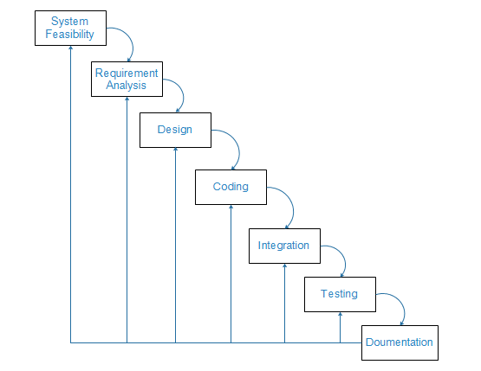

* **Why we use this model?**
* We use iterative modal because every step is repeated so we can easily implement all new changes.
* By working iteratively, the project team goes through a cycle where they evaluate with each iteration, and determine what changes are needed to produce a satisfactory end product.
* In iterative model we can only create a high-level design of the application before we actually begin to build the product and define the design solution for the entire product. Later on we can design and built a skeleton version of that, and then evolved the design based on what had been built.

**2.0** **SOFTWEARE REQUIREMENT SPECFICATION**:

**2.1: USER CHARACTERISTICS:**

* Every user should be comfortable of working with computer and net browsing. He must have basic knowledge of online system.
* We have identified five potential classifications of users of our system:
* **The Admin:**
* The admin can add new products and also modify them.
* Admin can manage the categories of products and sub categories of products.
* Admin can also manage the user connected to our website.
* **The Client**:
* The client is the user with the registration.
* Client can buy products in our website when it is registered.
* He can also cancel his order whenever he want.

* **The General User**:
* The general user is the user without registration.
* The user without registration can see the products in website but cannot order it.
* To order anything in website the user must be registered in website.

**2.2 Function requirement & Non-functional Requirement:**

Users:

* There are three types of users:
* Admin
* Authenticate user
* Unauthenticated user
* **Admin:**

1. Login:

Description: admin can login into admin panel throw their username password

State: admin login into admin panel

Input: admin enter username & password

Output: admin login successfully or login denied

Process: Username & password match with database's data.

1. Add New Products:

Description: admin can add new products.

State: admin adding new products.

Input: admin add new products’ details and other values.

Output: new product added successfully.

Process: product related data stored into database

1. Delete product:

Description: admin can delete category.

State: admin deleting product.

Input: admin enter product select and delete product.

Output: product deleted successfully.

Process: product deleted from database.

* Authenticate user:

1. Login:

Description: Authenticate user can login into their profile through their username password

State: user login into their profile

Input: user enters username & password

Output: user login successfully or login denied

Process: Username & password match with database's data.

1. Sign Up:

Description: user create new account using username, password and other details.

State: user creating new account.

Input: user enters valid data.

Output: Signup success or signup denied.

Process: data store in database.

1. Buy Products:

Description: user buys products.

State: user buying machines.

Input: add to cart the products.

Output: products bought by user.

Process: data stored into database.

1. Cancel their order:

Description: users cancels the order.

State: user canceling the order.

Input: cancel the order.

Output: order will be canceled by user.

Process: - data will be updated in database.

1. Contact to admin:

Description: user send message to admin via mail.

State: Message is being send to admin.

Input: user enters the message or some complain.

Output: admin will receive a message from user.

Process: message information added to database.

* Unauthenticated user:

1. Visit:

Description: enters into website.

State: viewing the products and their details.

Input: search the products.

Output: getting information of product.

Process: will be no change in database.

1. Sign Up:

Description: user create new account using username, password and other details.

State: user creating new account.

Input: user enters valid data.

Output: Signup success or signup denied.

Process: data store in database.

* **NON- FUNCTIONAL REQUIREMENT:**
* **Usability:**

The system shall provide user friendly interface such that it is usable with minimum amount of effort.

* The system should be able to run on a computer system if the configuration is properly.
* All steps of the development should be well documented to ensure maintenance of the system through online system.
* Efficiency:
* There are no performance constraints on the system but it is desirable that the system occupies minimum space on the hard disk.
* Reliability:
* Only the users who have created by the administrator have access the functionality assigned.
* SYSTEM REQUIREMENT:

**2.3 HARDWARE AND SOFTWARE REQUIREMENT**

**Hardware Interfaces**

* **Hardware Interface: Server side:**
* Hardware: Recommended System Requirements
* Operating System: Microsoft Windows, My SQL Server
* RAM: 2 GB
* Processor: Intel Pentium Corei3 Processor
* Table (Hardware Interface: Server side)
* **Hardware Interface: Client side**
* Hardware: Recommended System Requirements
* Operating System: Windows/Linux
* RAM: 125 MB
* Processor: Intel Celeron Processor or Higher
* Table (Hardware Interface: Client side)

**3.0 SYSTEM ANALYSIS MODELING-USER BASED**

**3.1) Feasibility Study of new system:**

**FEASIBILITY STUDY**

Feasibility Analysis is whether a project is operational in practice. The task of Feasibility analysis is to analyses the problem to be addressed in the technical, Economic, legal, use of viability. And the purpose of the project is the use of least Cost in the shortest possible time to determine the problem definition stage of the Envisaged system described by the basic objectives and whether the scale can be Solved, or the possibility of solving the value of the size and address size. Its essence is to maximize the compression system analysis, system design, and a high level in a more abstract way in a system analysis, system design.

Generally speaking, feasibility analysis is studied from the following three aspects:

1. **Technical feasibility**. Technical feasibility from the technical point of view is based on the system functionality, performance and a variety of constraints required by user to achieve the feasibility of the system. It Is often the most difficult during developing the system.

To deploy the application, the only technical aspects needed are mentioned below: Operating Environment Win 2000/XP Platform .Net Framework & IIS Database SQL Server 2005

**For Users:**

Internet Browser

Internet Connection.

**2)** **Economic feasibility.** The project is economically feasible as the only cost involved is having a computer with the minimum requirements mentioned earlier.

* **Time feasibility:**

Scheduling the project task is an important project planning activity. It involves deciding which tasks would be taken up when based on the planned duration of required tests and collection of resources to complete those tasks projected completion date is calculated.

**3.3User-Based Modeling:**

**3.3.1 Use Case Diagram:**

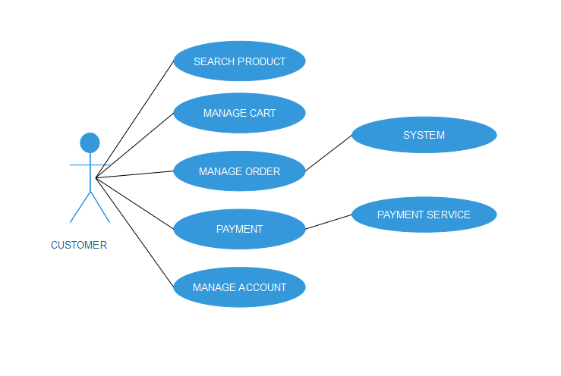

Figure use case diagram

**4.0 SYSTEM ANALYSIS AND DATA DICTIONARY**

**4.1 Data modeling**

**4.1.1 Data dictionary**

1. **Admin:**

|  |  |  |  |
| --- | --- | --- | --- |
| **Column Name** | **Data Type** | **Default Value** | **Description** |
| Id | Int | Null | It is index. |
| Name | Varchar2 | Null | It is a username. |
| Email | Varchar2 | Null | It is a email. |
| Password | Varchar2 | Null | It is a password. |
| image | Varchar2 | Null | It is a image. |

1. **Cart:**

|  |  |  |  |
| --- | --- | --- | --- |
| **Column Name** | **Data Type** | **Default Value** | **Description** |
| Id | Int | Null | It is a index. |
| Pro_id | Int | Null | It is a product id. |
| Quantity | Int | Null | It is a quantity. |
| User_id | Int | Null | It is a user id. |

1. **Category:**

|  |  |  |  |
| --- | --- | --- | --- |
| **Column Name** | **Data Type** | **Default Value** | **Description** |
| id | Int | Null | It is a index. |
| name | Varchar2 | Null | It is a category name. |
| image | Varchar2 | Null | It is a image. |

1. **Contact:**

|  |  |  |  |
| --- | --- | --- | --- |
| **Column Name** | **Data Type** | **Default Value** | **Description** |
| Id | Int | Null | It is a index. |
| Name | Varchar2 | Null | It is a name. |
| number | Int | Null | It is a number. |
| Email | Varchar2 | Null | It is a email. |
| Message | Varchar2 | null | It is a message. |

1. **Order:**

|  |  |  |  |
| --- | --- | --- | --- |
| **Column Name** | **Data Type** | **Default Value** | **Description** |
| Id | Int | Null | It is a index, |
| User_Id | Int | Null | It is a user id. |
| Pro_id | Varchar2 | Null | It is a product id. |
| total | Begint | Null | It is a total. |
| Order_date | Varchar2 | Null | It is a order date. |
| D_date | Varchar2 | Null | It is a delivery date. |

1. **Products:**

|  |  |  |  |
| --- | --- | --- | --- |
| **Column Name** | **Data Type** | **Default Value** | **Description** |
| Id | Int | Null | It is a index. |
| Cat_id | int | Null | It is a category id. |
| Sub_cat_id | Int | Null | It is a subcategory id. |
| Name | Varchar2 | Null | It is a product name. |
| Price | Int | Null | It is a price of product. |
| Size | Varchar2 | Null | It is a size. |
| Des | Varchar2 | Null | It is a description. |
| Img1 | Varchar2 | Null | It is a image one. |
| Img2 | Varchar | Null | It is a image two. |

1. **Slider:**

|  |  |  |  |
| --- | --- | --- | --- |
| **Column Name** | **Data Type** | **Default Value** | **Description** |
| id | Int | Null | It is index. |
| Image | Varchar2 | Null | It is a image. |

1. **Sub_cat:**

|  |  |  |  |
| --- | --- | --- | --- |
| **Column Name** | **Data Type** | **Default Value** | **Description** |
| id | Int | Null | It is a index. |
| cat_id | Varchar2 | Null | It is a category id. |
| Name | Varchar2 | Null | It is a name. |

1. **User:**

|  |  |  |  |
| --- | --- | --- | --- |
| Column name | Data type | Default value | Description |
| ID | INT | NULL | It is a index. |
| Name | Varchar2 | Null | It is a name . |
| Number | Int | Null | It is a number. |
| Address | Varchar2 | Null | It is a address. |
| Image | Varchar2 | Null | It is a image. |
| Email | Varchar2 | Null | It is a email. |
| Password | Varchar2 | Null | It is a password. |

**4.1.1 ER-Diagram:**

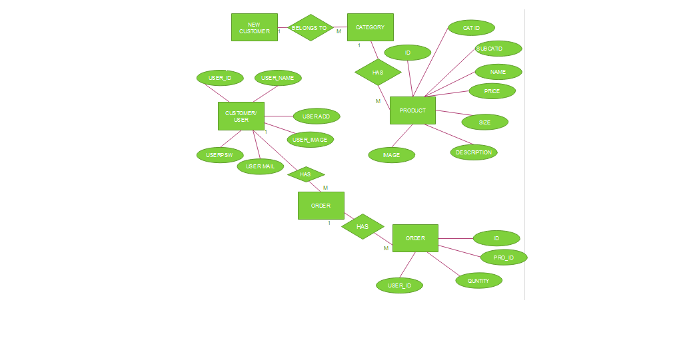

Figure ER-diagram

**4.2 BEHAVIORAL MODELING**

**4.2.1 Data flow Diagram**

4.2.1.1 Context level Diagram (level 0):

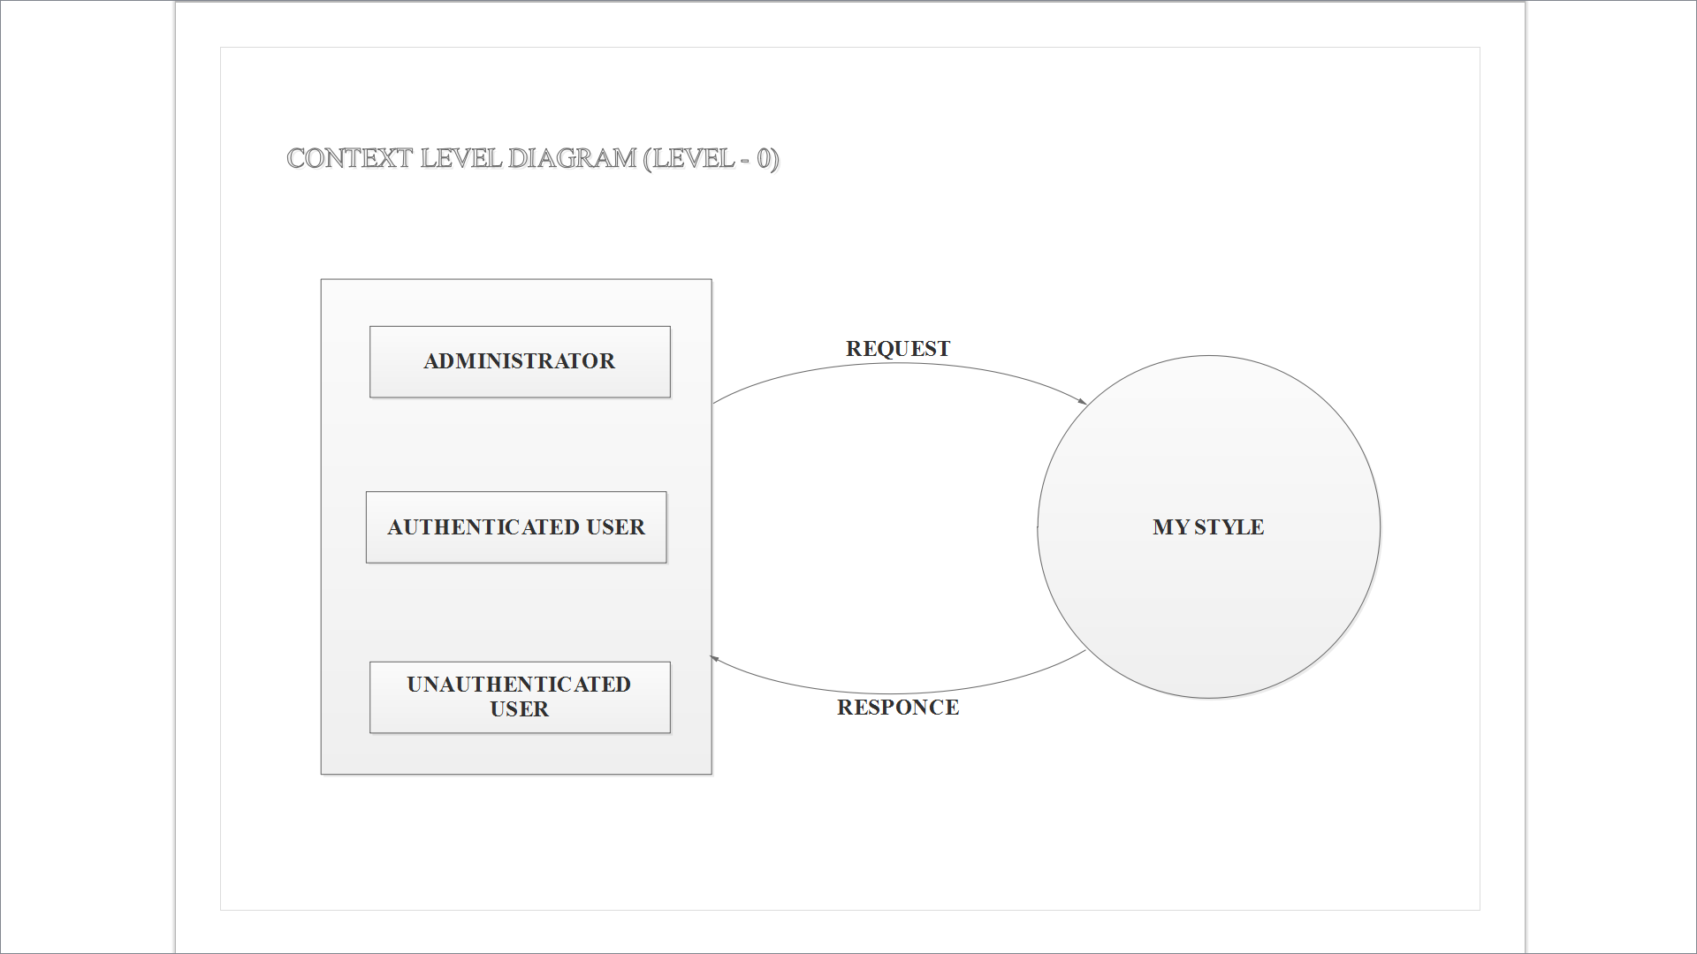

Figure context level diagram

4.2.1.2 DFD – Level 1: Admin

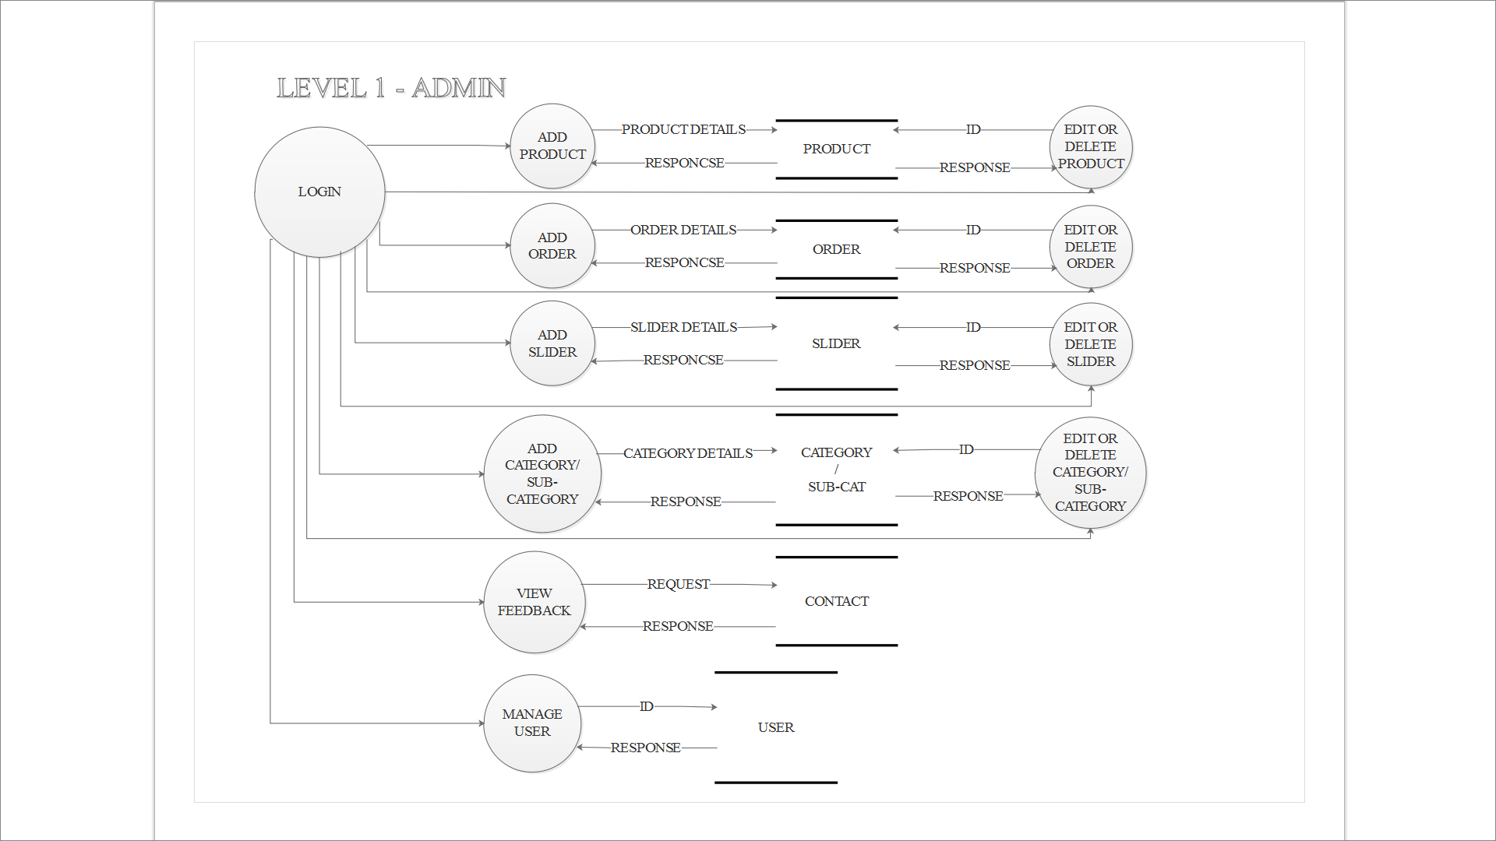

Figure level 1 –admin

4.2.1.3 DFD – Level: User

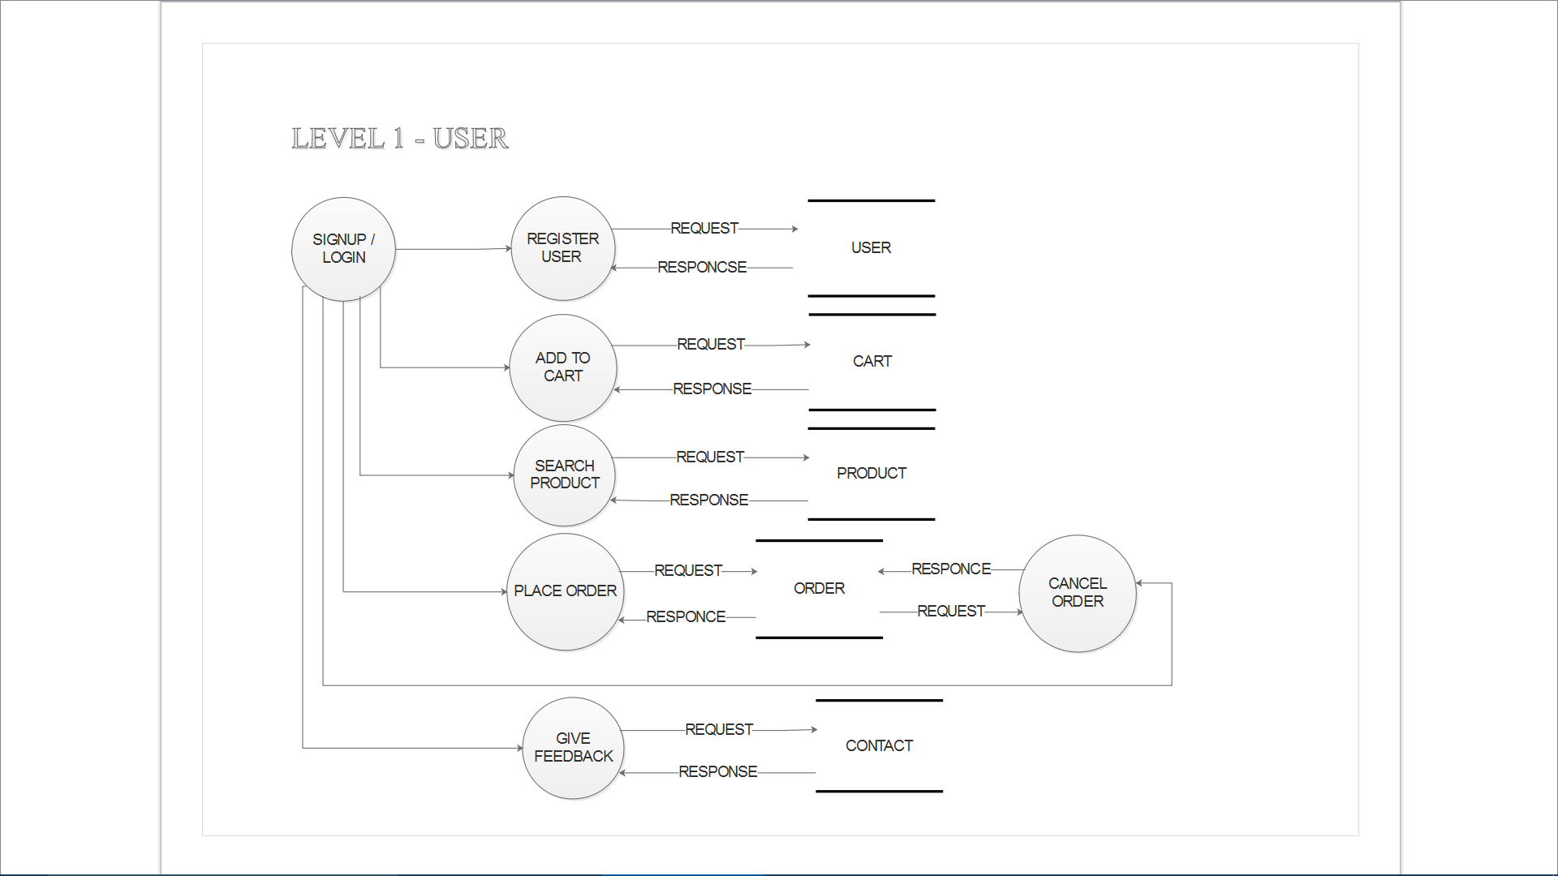

Figure level - 1 user

**Chapter: 5.0 Sample coding/coding Standards:**

**Add_product . php file**

<?php

include("../../conn.php");

$name=$_POST['name'];

$cat=$_POST['cat'];

$sub=$_POST['sub'];

$price=$_POST['price'];

$size= $_POST['size'];

$des=$_POST['des'];

$image1= $_FILES["image1"]["name"];

$image2= $_FILES["image2"]["name"];

move_uploaded_file($_FILES['image1']['tmp_name'],"../../images/i/".$image1);

move_uploaded_file($_FILES['image2']['tmp_name'],"../../images/i/".$image2);

$result=mysql_query("insert into products values(null,$cat,$sub,'$name',$price,'$size','$des','$image1','$image2')",$link);

header("location:products.php");

?>

**5.Testing**

5.1 Testing Plan

|  |  |
| --- | --- |
| Test Case:1(Admin) | |
| Test to be performed | Login of admin |
| Expected Result | Succesufully loged-in |
| Actual Result | Succesufull l oged in |
| Result | PASS |
| Type of Test | Module Test |

|  |  |
| --- | --- |
| Test Case:2(Admin) | |
| Test to be performed | To verify that when admin will click on add products button to add new product for discussion should be reflected on database as well as on the screen |
| Expected Result | product should be added, it should be added on the screen. |
| Actual Result | New product is added into the database as well as on the screen. |
| Result | PASS |
| Type of Test | Module Test |

|  |  |
| --- | --- |
| Test Case:3(Admin) | |
| Test to be performed | To verify that when admin will click on add category button to add new category for discussion should be reflected on database as well as on the screen |
| Expected Result | Category should be added, it should be added on the screen. |
| Actual Result | New category is added into the database as well as on the screen. |
| Result | PASS |
| Type of Test | Module Test |

|  |  |
| --- | --- |
| Test Case:4(Admin) | |
| Test to be performed | To verify that when admin will click on delete, user should be deleted, effect should be reflected in database as well as on the screen |
| Expected Result | User should be deleted in to database and should not be able to login in to the website. |
| Actual Result | User is deleted from database and also not be able to login to the system. |
| Result | PASS |
| Type of Test | Module Test |

|  |  |
| --- | --- |
| Test Case:5(Admin) | |
| Test to be performed | To verify that when admin will click on edit button and fill all details and click done button, user should be updated, effect should be reflected in database as well as on the screen |
| Expected Result | User should be edited in to database. |
| Actual Result | User is edited from database. |
| Result | PASS |
| Type of Test | Module Test |

|  |  |
| --- | --- |
| Test Case:6(authenticate user) | |
| Test to be performed | The login system must work properly and user ID and password must be checked from database. |
| Expected Result | While checking specific error message should be displayed to user if the result does not match. |
| Actual Result | user will be provided with specific error message. |
| Result | PASS |
| Type of Test | Module Test |

|  |  |
| --- | --- |
| Test Case:7(authenticate user) | |
| Test to be performed | Login of authenticate user. |
| Expected Result | Succesufully loged-in |
| Actual Result | Succesufully Loged in |
| Result | PASS |
| Type of Test | Module Test |

|  |  |
| --- | --- |
| Test Case:8(authenticate user) | |
| Test to be performed | To verify that when user will click on Add to cart button to buy product should be reflected on database as well as on the screen |
| Expected Result | The items should add to users’ cart. |
| Actual Result | The cart table is updated in database as well. |
| Result | PASS |
| Type of Test | Module Test |

|  |  |
| --- | --- |
| Test Case:9(unauthenticated user) | |
| Test to be performed | New user can search a products and create a new account . |
| Expected Result | New account can be created by new user. |
| Actual Result | The information of new account will be added on database. |
| Result | PASS |
| Type of Test | Module Test |

**6.0) System Screenshots:**

* 1. : Screenshots of the User Interface for all Users:

HOME PAGE

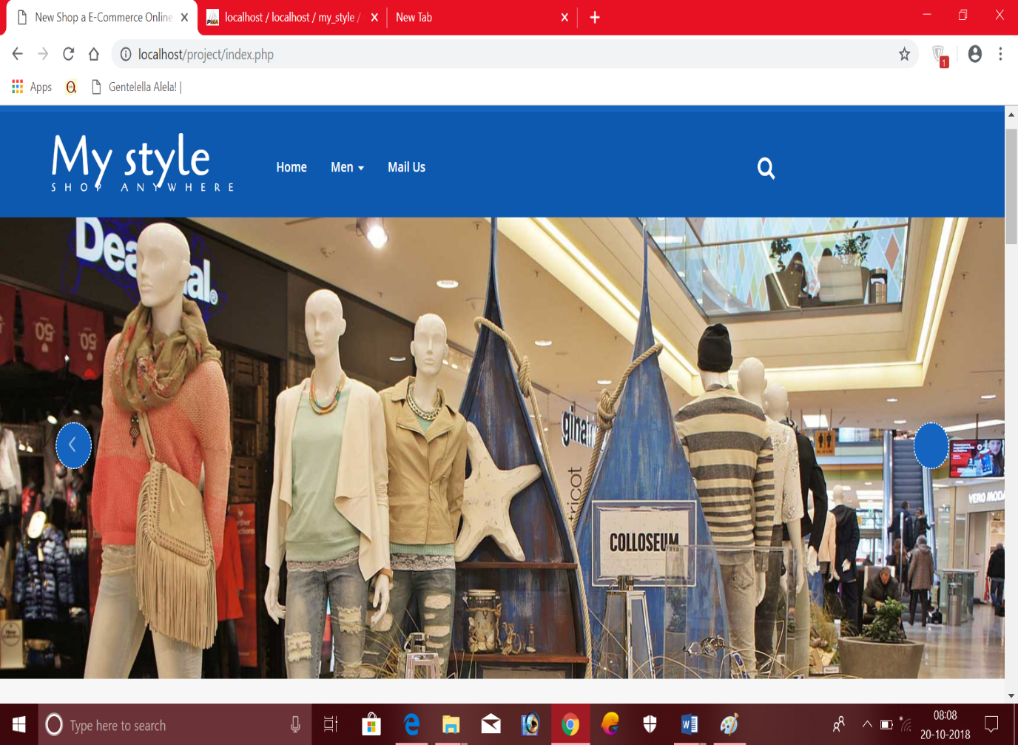

LOG IN:

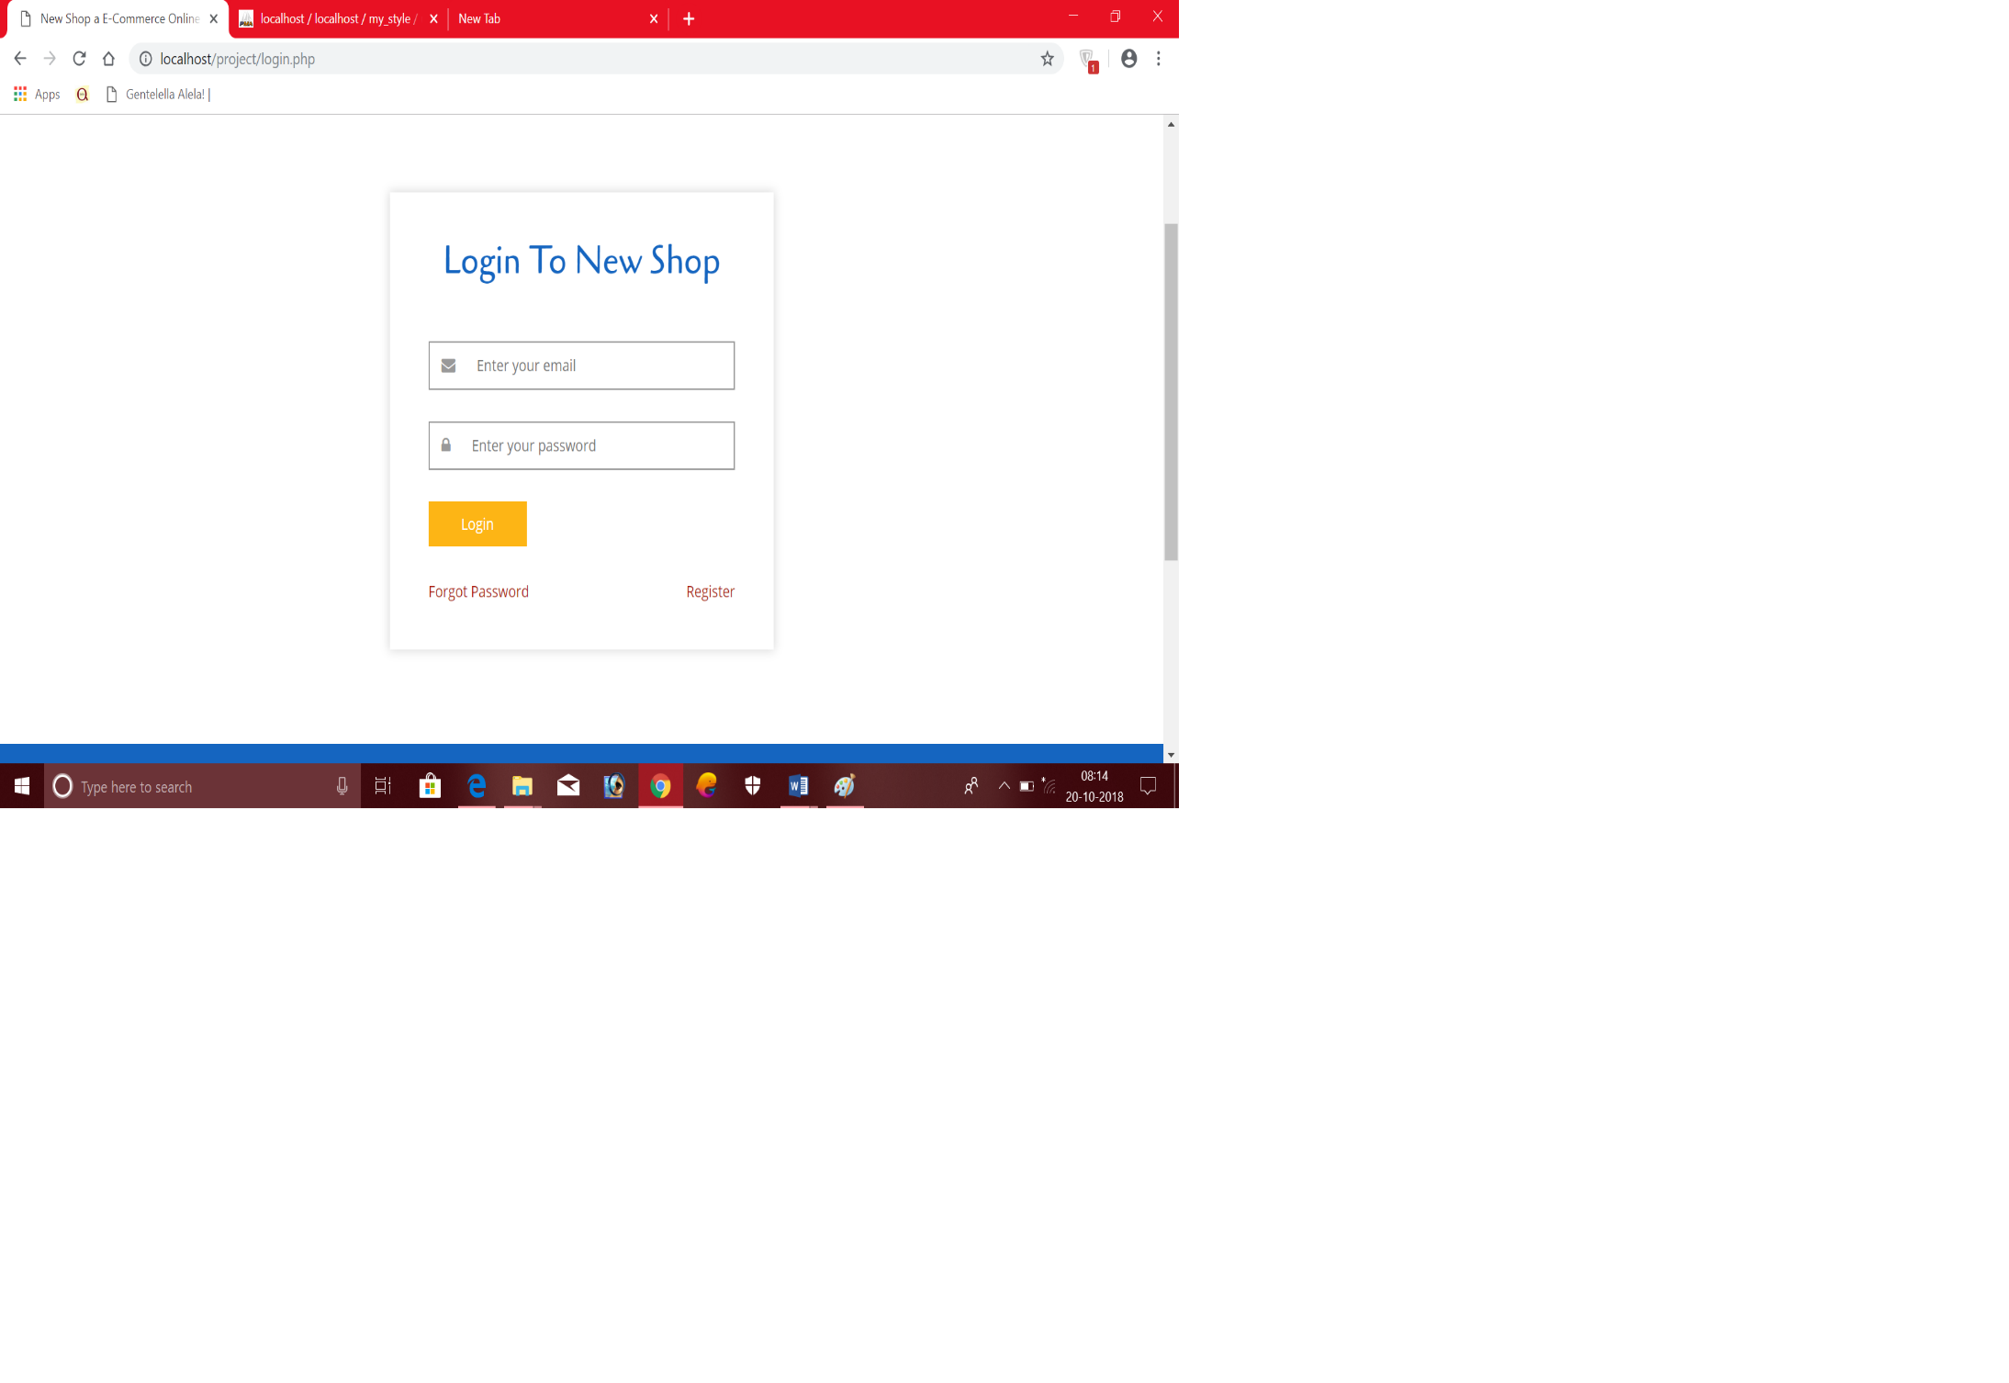

REGISTRATION:

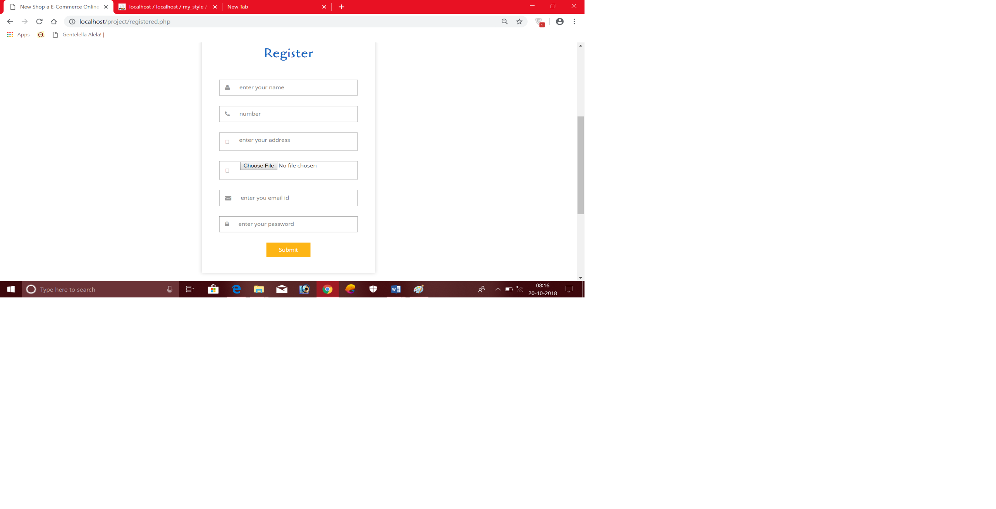

ALL PRODUCTS:

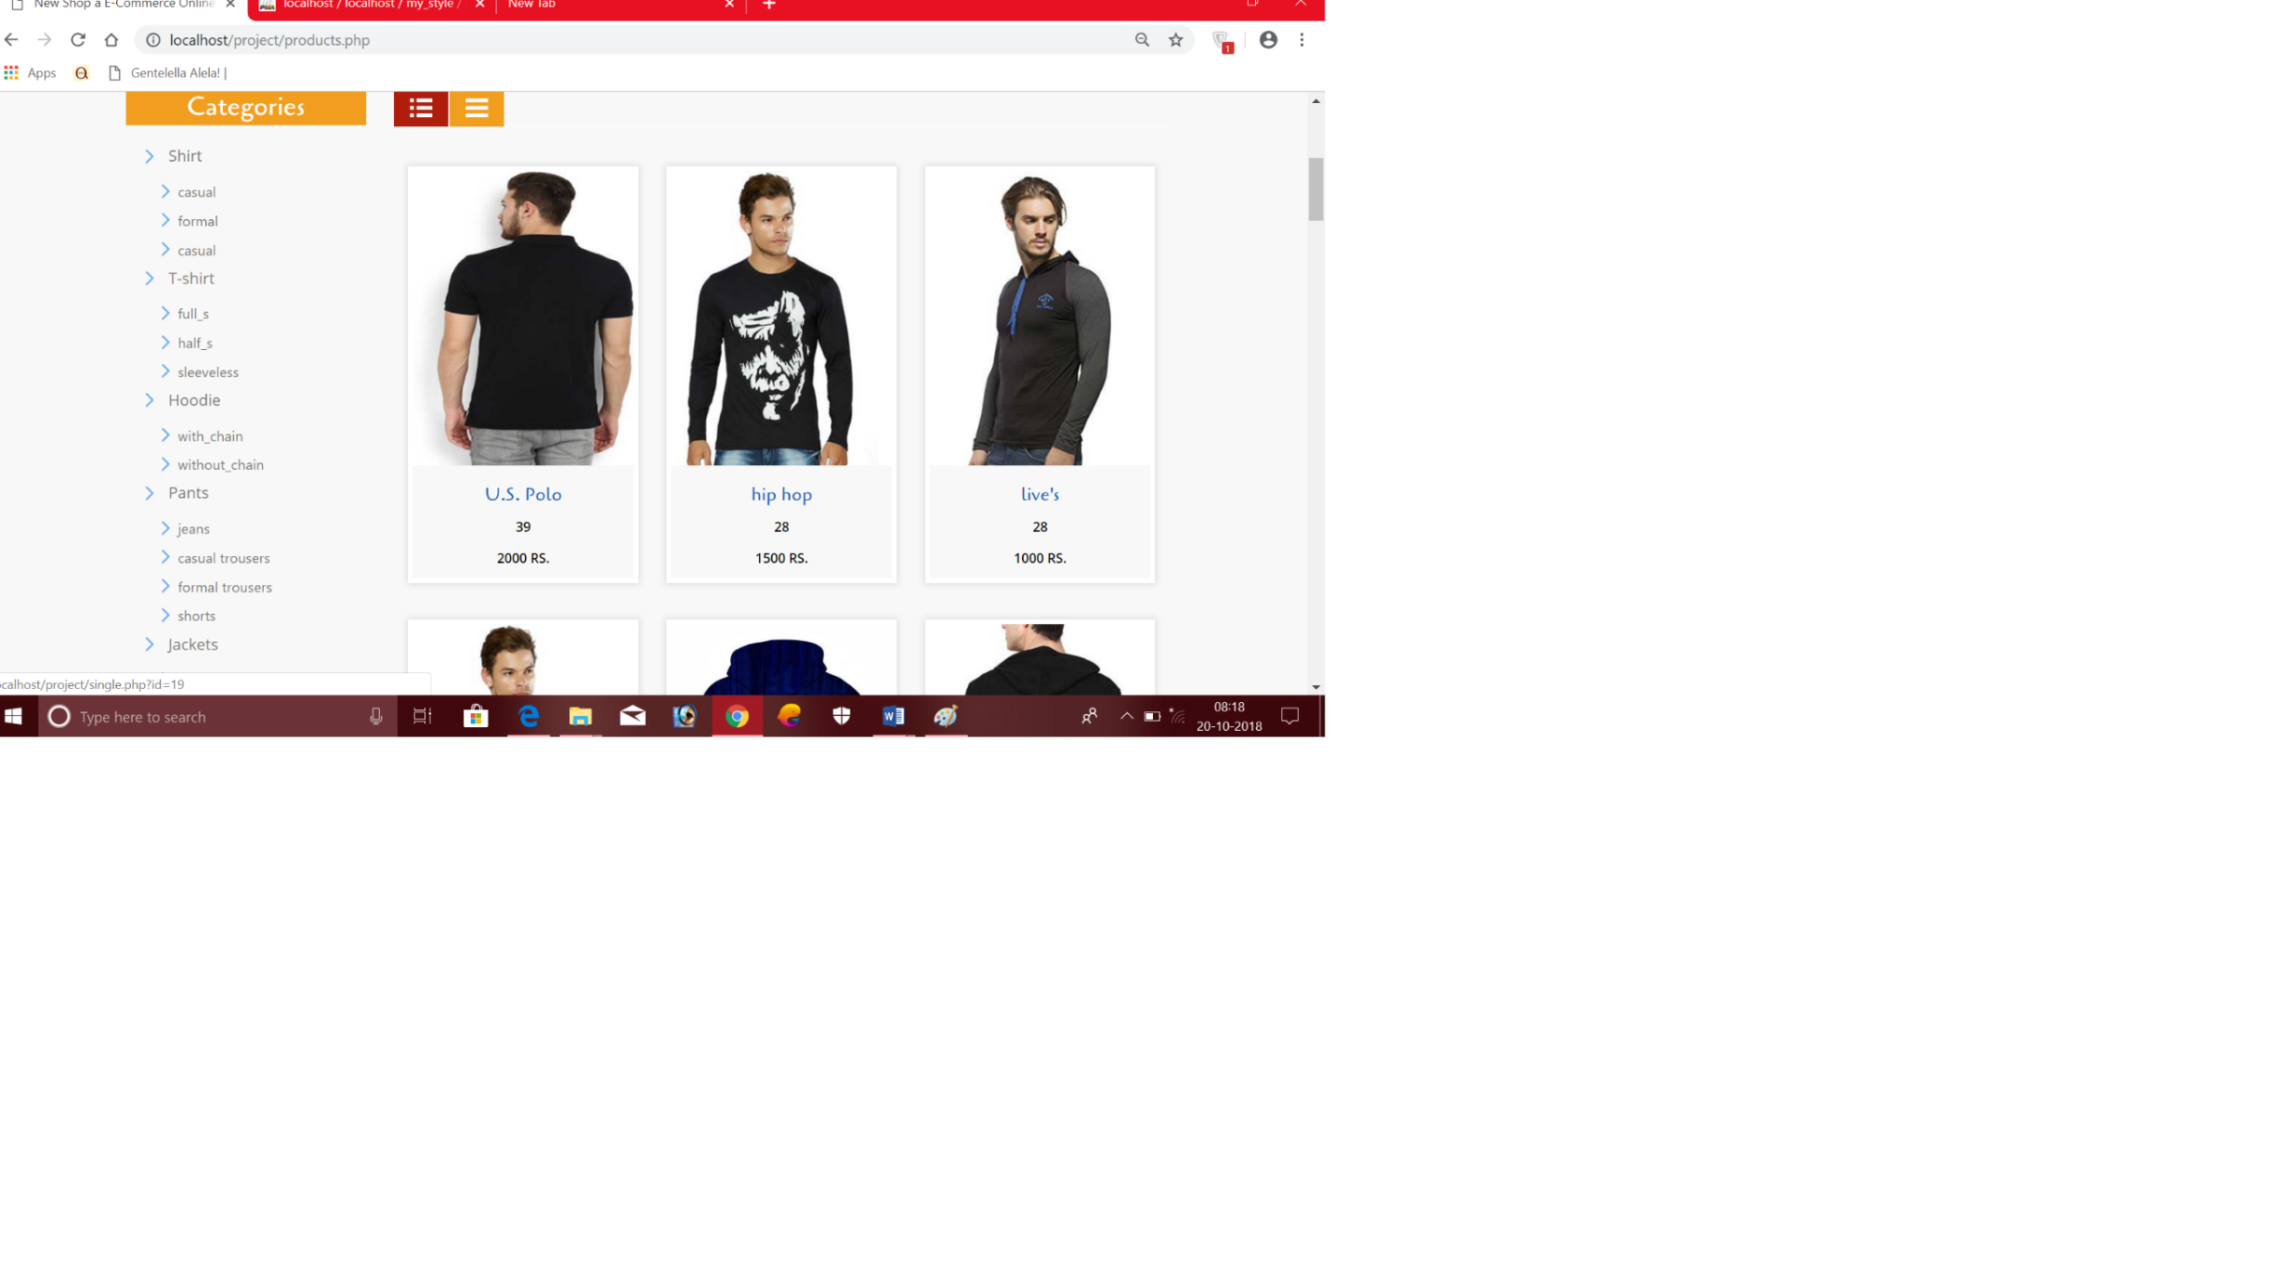

SINGLE PRODUCT:

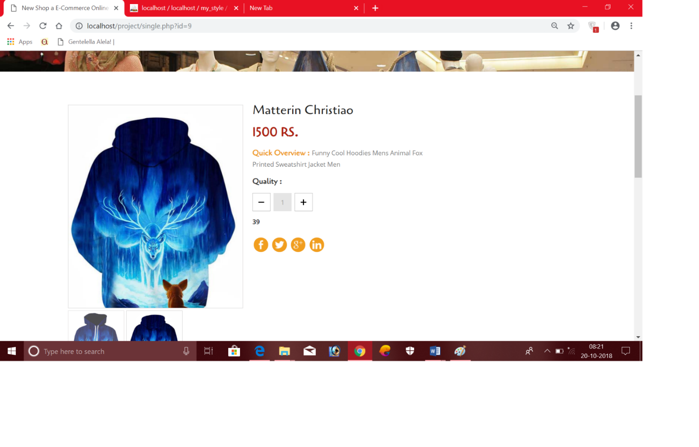

ADD TO CART:

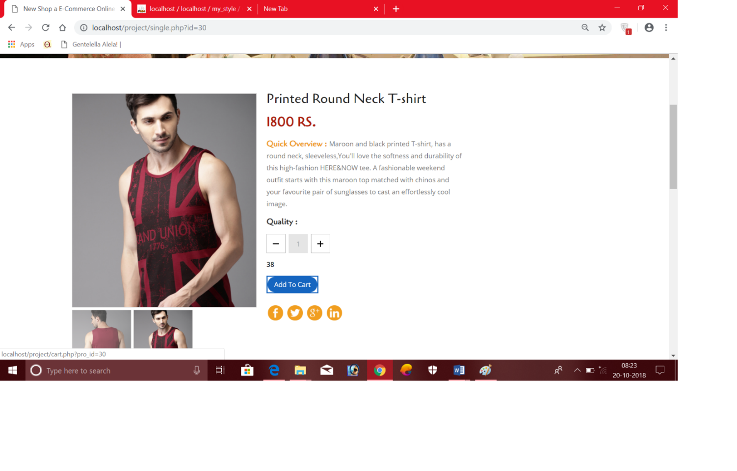

ORDER CONFIRMATION:

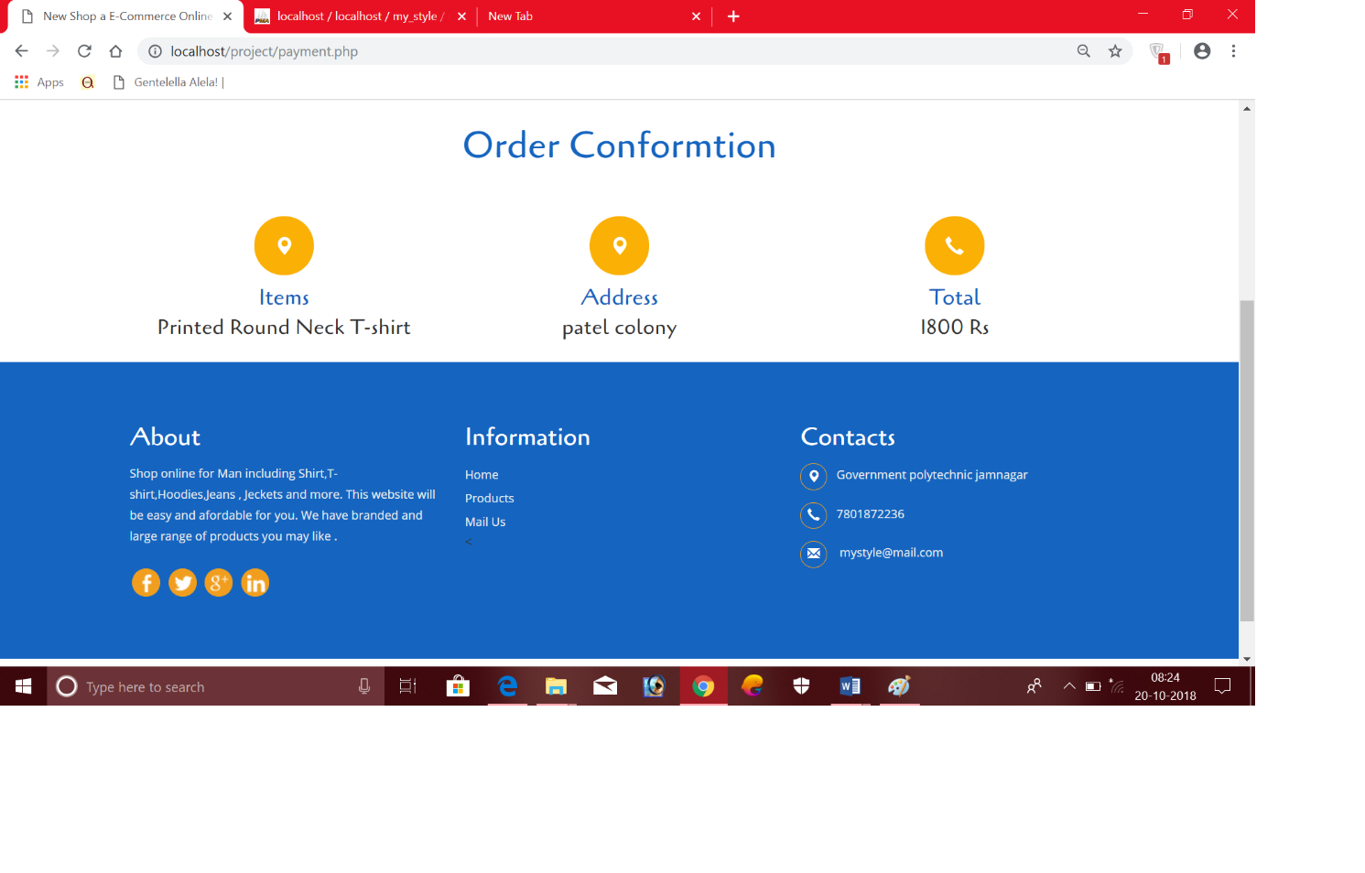

ADMIN LOGIN :

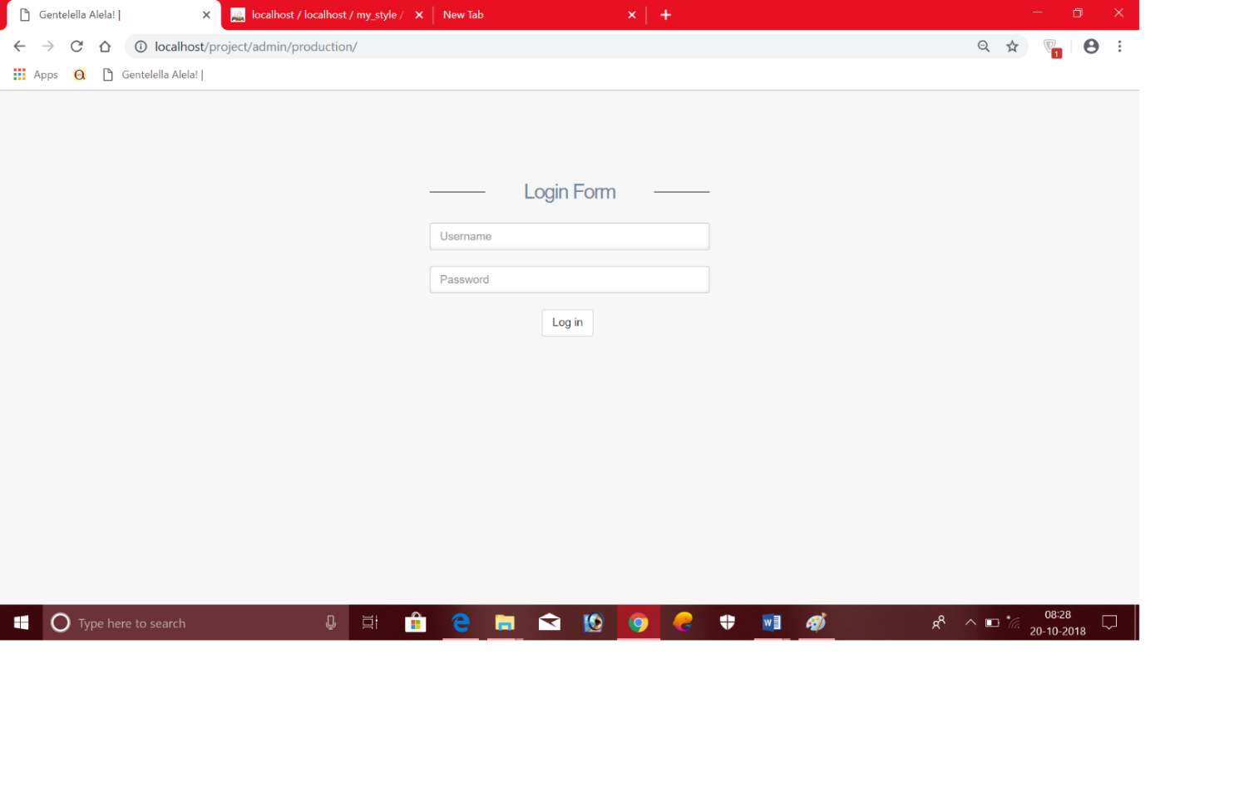

admin main page:

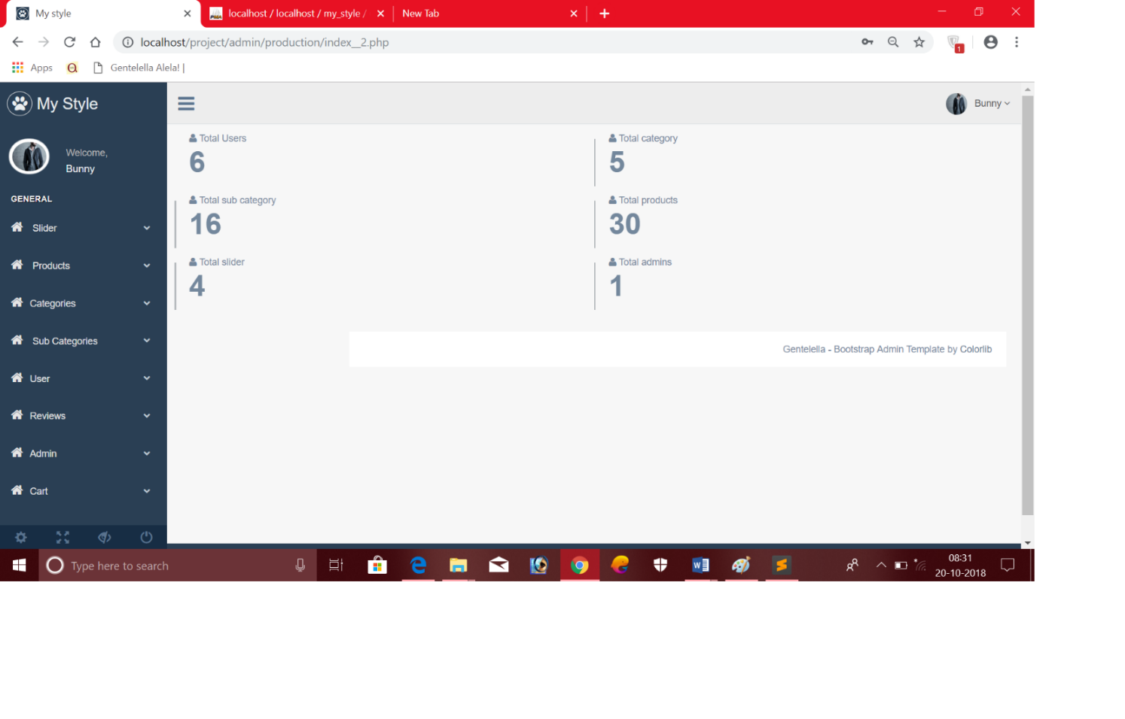

ADD NEW PRODUCT :

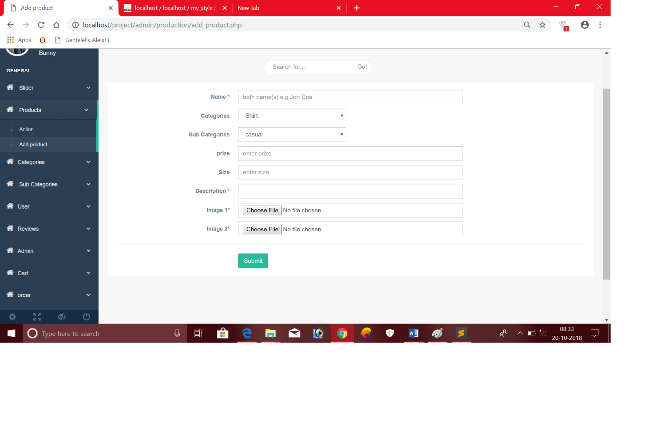

MANAGING ORDERS:

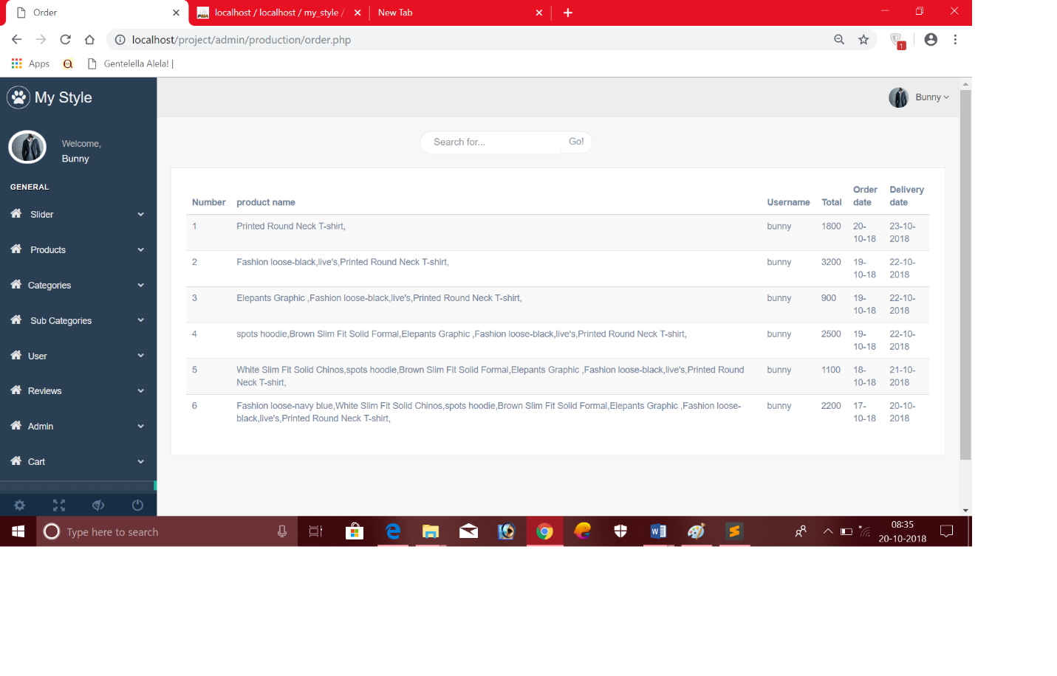

**7.0) FUTURE ENHANCEMENT**

* More products can be added further.
* Different way of payment can be added.
* Tracking order feature can be added.
* Discount offers will be shown in festivals.
* User interface should be more improved

**8.0) REFERENCES**

➔ www.tutorialspoint.com

➔ www.javatpoint.com

➔ www.codechef.com

➔ www.w3schools.com

➔ www.udemy.com