GOVERNMENT POLYTECHNIC JAMNAGAR

**COMPUTER ENGINEERING**

**PROJECT REPORT**

**FOR**



**Diploma 5TH SEMESTER**

**Mohit Vaghela (166250307056)**

**Bhavik Chudasama (166250307007)**

**Government Polytechnic, Jamnagar**

**Computer Engineering**

**2018**

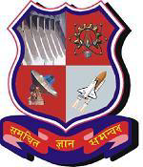

**CERTIFICATE**

**Date :20/10/2018**

This is to certify that the dissertation entitled **“My style”** has been carried out by **Mohit Vaghela, Bhavik Chudasama** under my guidance in fulfillment of the degree of Diploma Engineering in Computer (5th Semester) of Government Polytechnic, Jamnagar during the academic year 2018-19.

**Internal Guide Head of the Department**

J.V. SHAPARIA K.M. SHAH