Prog1:

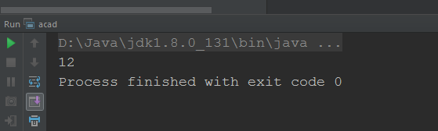

Prog2:

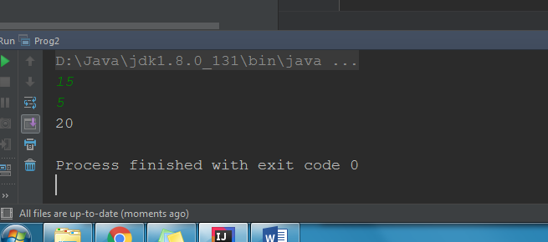

Prog3:

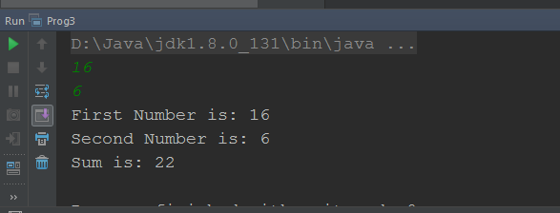

Prog4:

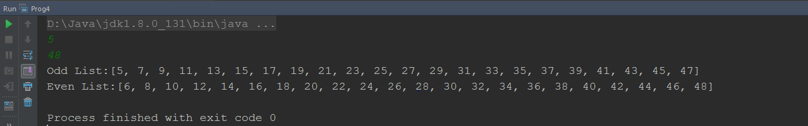

Prog5:

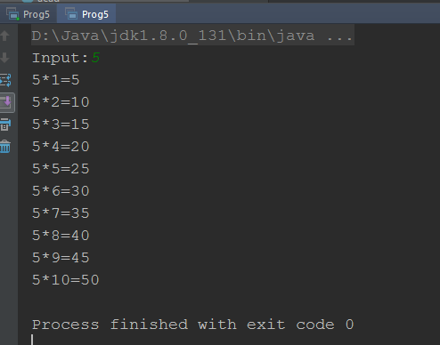

Prog6:

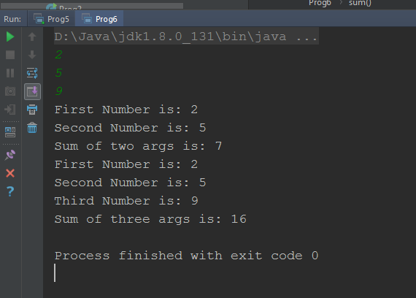

Prog7:

Yes we can overload the method with same return type, but the no of parameters passed to the method should be different , refer to **prog 6** where sum method is overloaded with the **same** return type **void**, but **the parameters passed are 2 and 3** respectively.

Prog8

