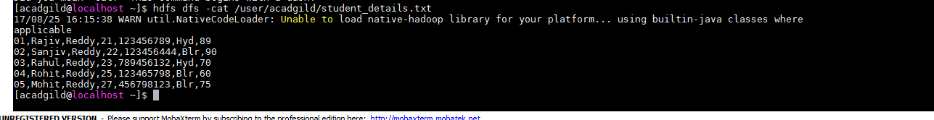

student_details = LOAD 'hdfs://localhost:9000/user/acadgild/student_details.txt' USING PigStorage(',') as (id:int, firstname:chararray, lastname:chararray, age:int, phone:chararray, city:chararray, gpa:int);

Dump student_details

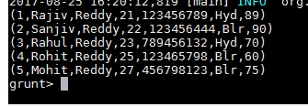

student_name_concat = foreach student_details Generate CONCAT (firstname, lastname);

