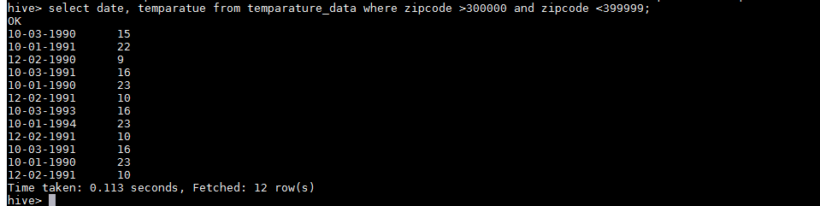

2) select year, MAX(temperature) from custom.temparature_data group by date;

3)select MAX(temperature) from custom.temparature_data group by date having count(*)>1;

4) create view temperature_data_vw as ‘select MAX(temperature) from custom.temparature_data group by date having count(*)>1’;

5)

