Assignment 7.1:

create table Employee

( Name String,

Technology String,

Experience int,

Place String

) ROW FORMAT DELIMITED

FIELDS TERMINATED BY ',';

LOAD DATA LOCAL INPATH '/home/acadgild/emp_details.txt'

OVERWRITE INTO TABLE `Employee`;

Select Technology, Count(*) as Number from Employee Group by Technology;

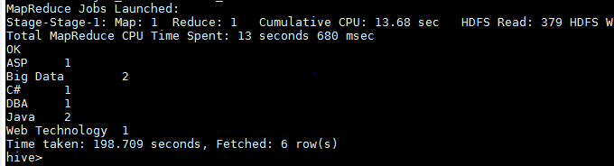

Assignment 7.2:

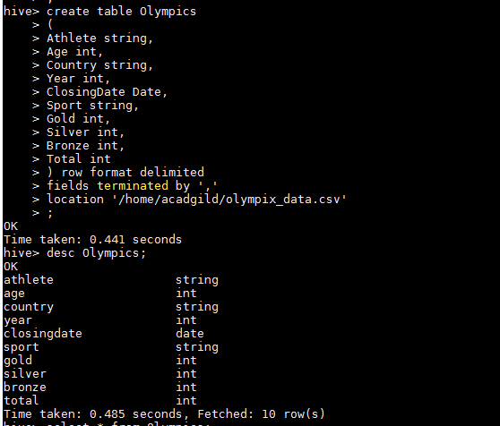

a)

select country, Sum(total) from Olympics group by Country having sport ='Swimming';