Linux examples with explaination and screenshot:

1. pwd : Print working directory, prints the present working directory location

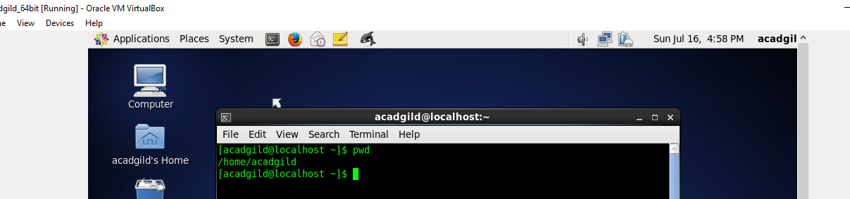

1. vi – file editor

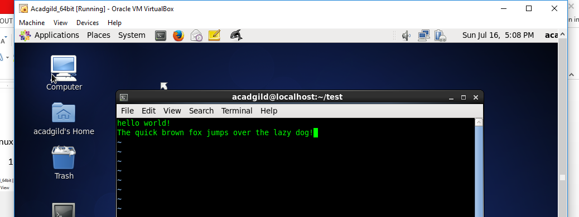

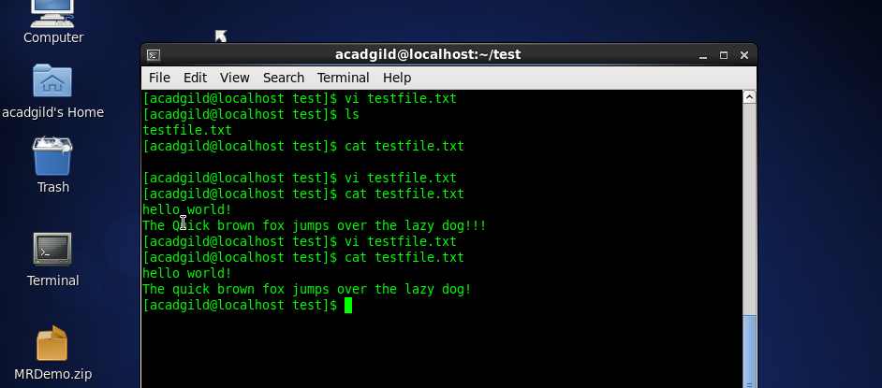

1. touch:

The touch [command](http://www.linfo.org/command.html) is the easiest way to create new, empty [files](http://www.linfo.org/file.html). It is also used to change the timestamps

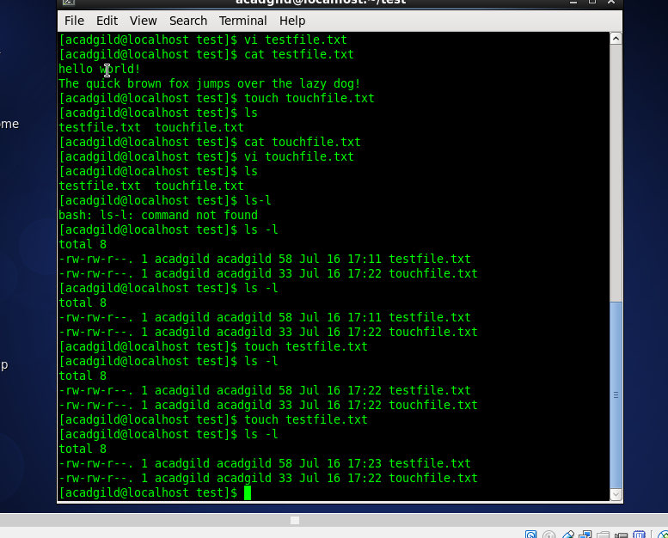

1. mkdir: used to create new directory

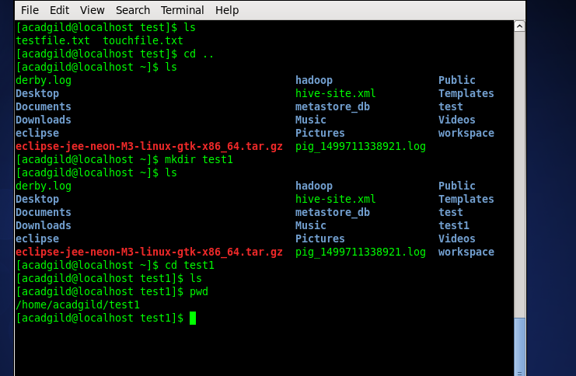

1. rm: remove files

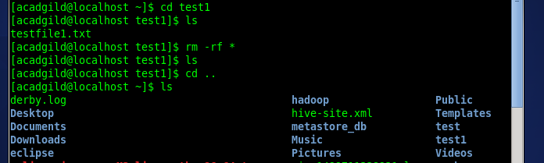

1. ls: list of files In the directory

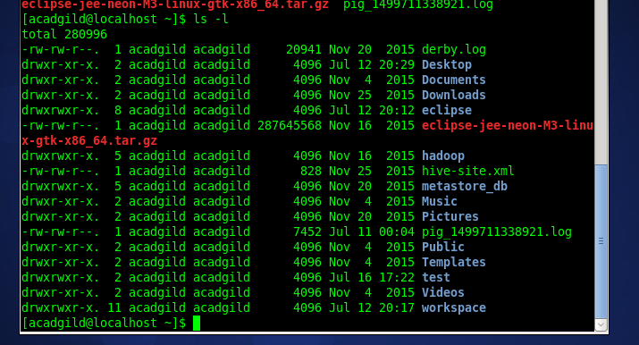

1. echo: displays a line of text

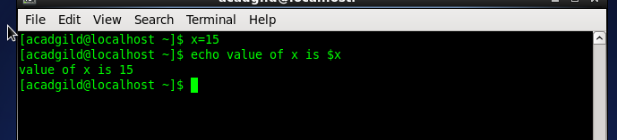

1. cat : cat command allows us to create single or multiple files, view contain of file, concatenate files and redirect output in terminal or files

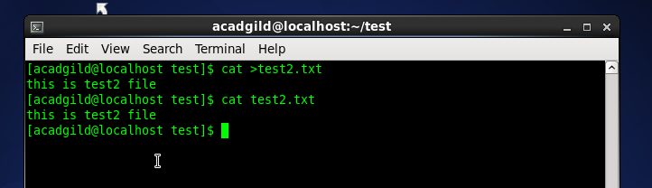

9. who: to display users who have currently logged into ur system

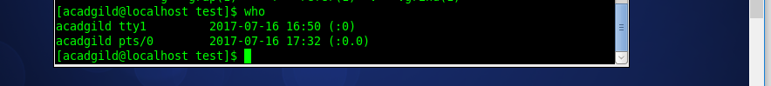

10.cd: change directory

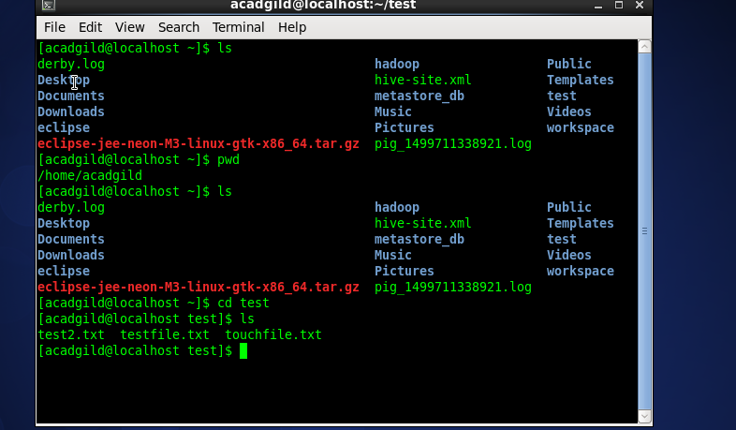

11.date: display current date



12.cal: displays calender

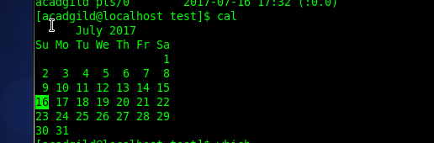

13.mv : used to move or rename file

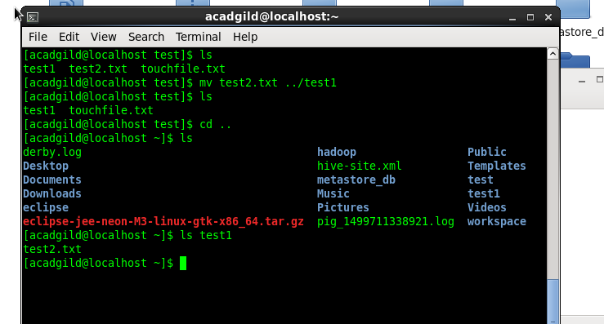

14.cp : Copy file

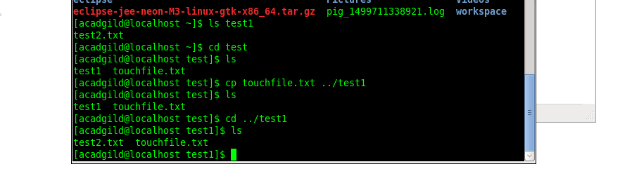

15.which : location of the executables

