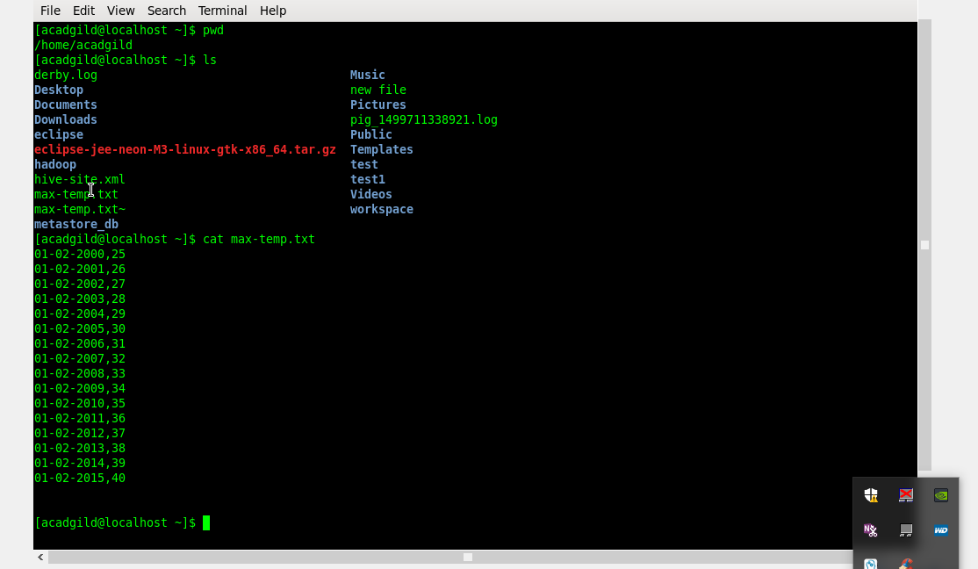

Before moving the file(max-temp.txt) to hdfs

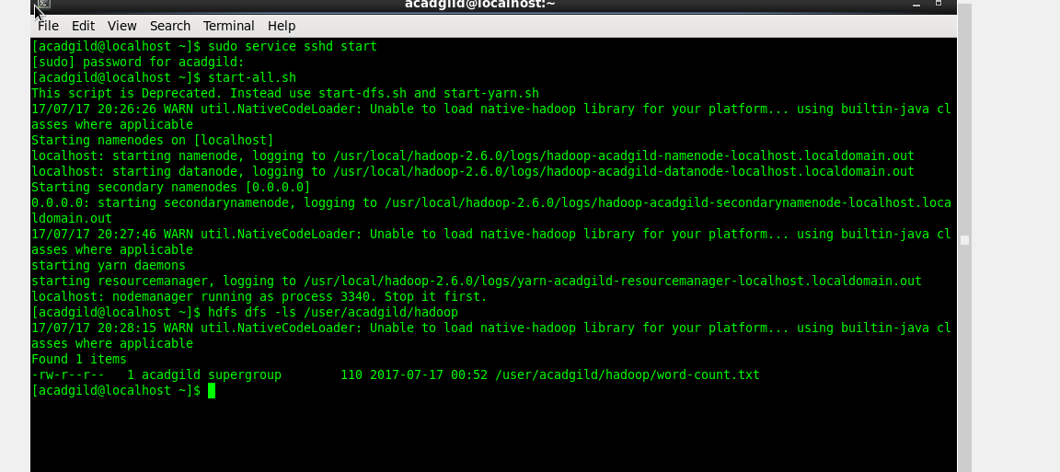

After moving the file:

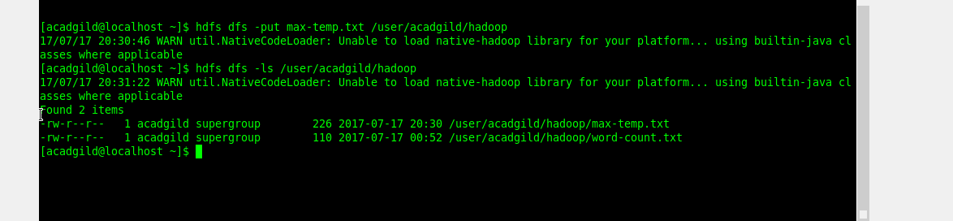

After changing the file permisions for owner and group and removing the access for others;

