**BRAIN DRAIN**

**PROJECT**

SUBMITTED FOR THE COURSE: PHY1999

BY

**17BIT0284 MOHIT VERMA**

**17BEC0269 D. GIRISH CHANDRA**

**17BCE0942 S. SUSHANTH NAIDU**

**17BCE2126 N. CHAITANYA NATH REDDY**

**17BEC0188 K. GOWTHAM SAI**

**18BEE0070 GOURANG SATAPATHY**

**18MIS0093 P. YOSHITHA REDDY**

Slot: TA2

**NAME OF FACULTY:** **PROF. ARUNAI NAMBIRAJ N**

**CERTIFICATE**

This is to certify that the project work entitled “BRAIN DRAIN” that is being submitted for the subject INTRODUCTION TO INNOVATIVE PROJECTS (PHY1999)is a record of bonfire work done under my supervision. The contents of this Project work, in full or in parts, have neither been taken from any other source nor have been submitted for any other

**Place**: Vellore

**Date**: 25th March,2019

**ACKNOWLEDGEMENTS**

We would like to acknowledge the University Management for giving us an opportunity to carry out our studies at VIT University. We would also like to thank our teacher Prof. ARUNAI NAMBIRAJ N for his guidance throughout the course of our project.

**TABLE OF CONTENTS**

* Introduction
* Present Scenario
* Data Collection
* Response Collection
* Inference
* Conclusion
* References

**INTRODUCTION**

Brain drain is the burning issue of every household and even a developing country. Brain drain refers to the emigration of highly skilled or well-educated individuals for better pay or conditions from one country to other. It implies that, in some cases, individuals are prepared in one country but invested in other. Brain drain may also refer to draining of individuals from one profession to the other. Brain drain can be described as the process in which a country loses its most educated and talented workers to other countries through migration.

We have chosen this topic for our project so that we can throw light upon it and bring up solutions to curb such a problem. Our team was working on it, coming up with hypothesis, taking views of the students as well as the faculties. This project mainly focuses on the Indian scenario i.e. emigration of skilled man power from India. In order to understand the causes of brain drain, we conducted surveys and sought out to seek suggestions from experienced faculties and students and arrived at a proper conclusion as to why brain drain in India is so prominent.

This trend is considered a problem, because the highly skilled and competent individuals leave their country and expertise to the economy and benefit of other countries. Their native country thus suffers economic hardships because the ones that remain in the country don’t know how to make a difference.

Brain drain has become a major concern of the developing countries especially, India. The term, which was emerged in 1960s when the skilled workforce started emigrating from the poor countries to the rich countries in search of better job opportunities and living conditions, became a hot topic of discussion over the years.

The problem of Brain-drain, in our age, has become very elusive. The developing countries like India are desperately in need of talents, especially in the field of science and technology but for one reason or the other the talents and fleeing their countries, leaving their native lands impoverished in the process. Brain Drain is an extremely serious problem for developing countries. The destiny of such countries lies in the solution to this great problem. The main motive of this project is to focus on understanding the true nature of brain drain, its causes and potential repercussions on our society and its resources.

As a group, we seek to analyze how brain drain truly spreads in society and how it has adverse effects on the different levels of society it has spread into. Issues such as brain drain cannot be analyzed simply by observing the effects, but they need to be understood from the grassroot level.

**PRESENT SCENARIO**

In the recent years, the cut-offs for admissions became close to 100% in the best Indian universities. While the institutes are in the race of getting the best students in the country, the ambitious youth who fail to meet the “irrational” demands had to compromise on their dream of occupying a seat in any of the prestigious Indian universities. This leads them to explore the scope of higher education abroad. Most of the students who try their luck in higher studies abroad get into good universities as they have an edge over the students from other countries in terms of skills and knowledge. While this is the case of young students, the academically well qualified people prefer going abroad for higher research because they don’t get the best chances, resources and facilities for research in India. A recent study conducted by Indian Institute of Management- Bangalore (IIM-B) shows that the students going for higher studies abroad has increased by 256% in the last 10 years. When 53,000 Indian students went abroad for higher studies in 2000, the figure shot up to 1.9 lakh in 2010. The US is the most sought-after destination for the students, followed by the United Kingdom. There are many Indian students exploring study opportunities in countries in Australia, Germany and France.

The project mainly focuses on the Indian Scenario i.e. brain drain from India to other countries. A report by Associated Chamber of Commerce and Industry of India (ASSOCHAM) pointed out that when a large number of students flocking to foreign universities, it costs India a whooping Rs. 95,000 crores per year. The report further noted that there is a huge difference in the fees paid by the students studying in the premier institutes in India as compared to the students who study aboard. While an Indian Institute of Technology (IIT) student has to pay an average fee of $150 per month, the fee paid by an Indian student studying abroad per month is anywhere

between $1,500 and $4,000.

**WEBSITE CREATION**

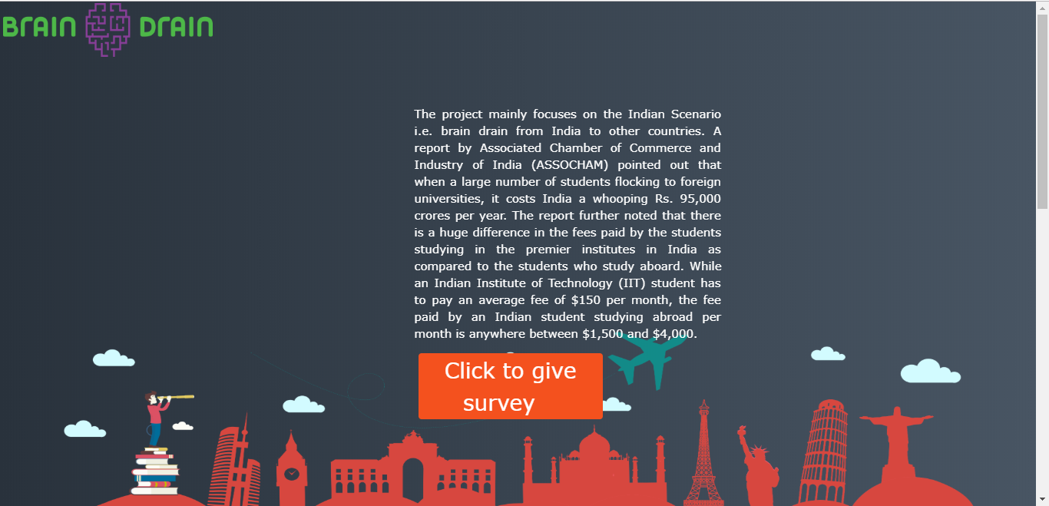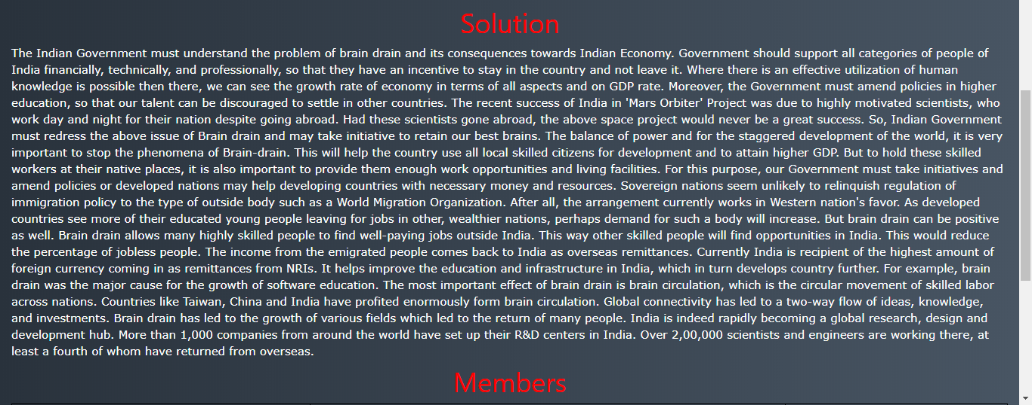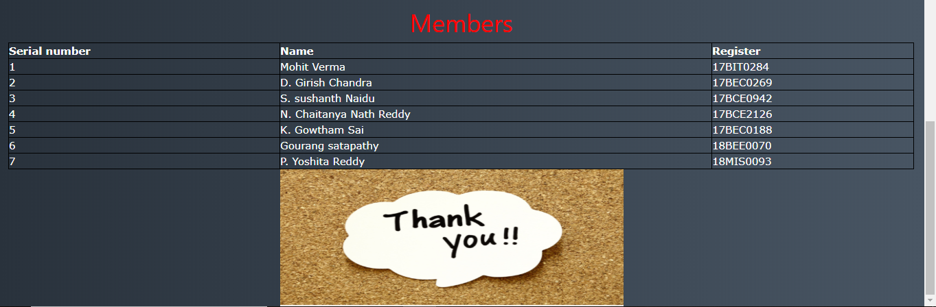

**DATA COLLECTION**

**METHODOLOGY**:

Data was collected from participants through Online Survey (Google forms).

**PARTICIPANTS**:

The participants who took our survey were mainly students having an average age between the range 17-19 years. Also included people of various professions belonging in their mid 30s and mid 40s.

The form of questions and the responses obtained are given in the following pages.

**QUESTIONS ASKED**

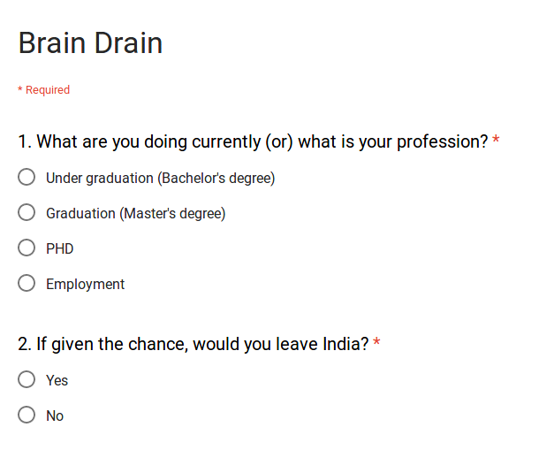

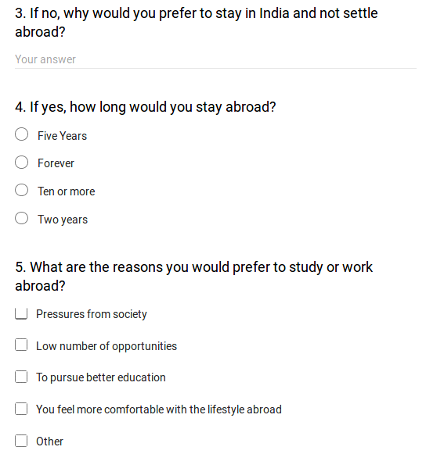

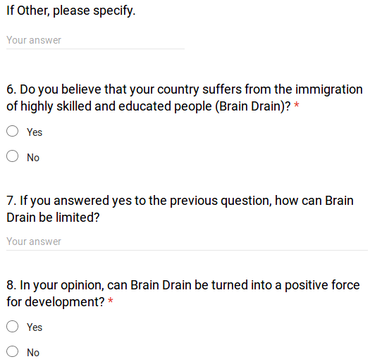



**RESPONSE COLLECTION**

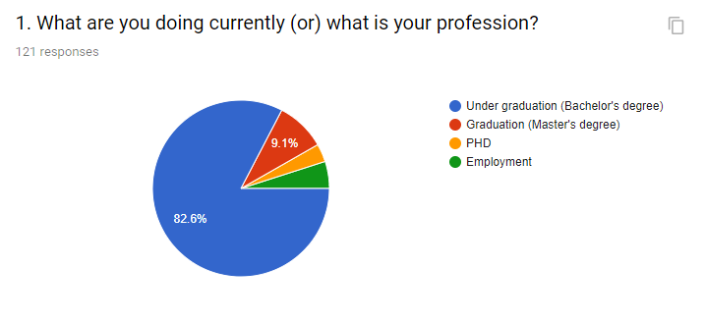

|  |  |  |  |
| --- | --- | --- | --- |
| Under graduation | Graduatio | PHD | Employment |
| 100 | 11 | 4 | 6 |

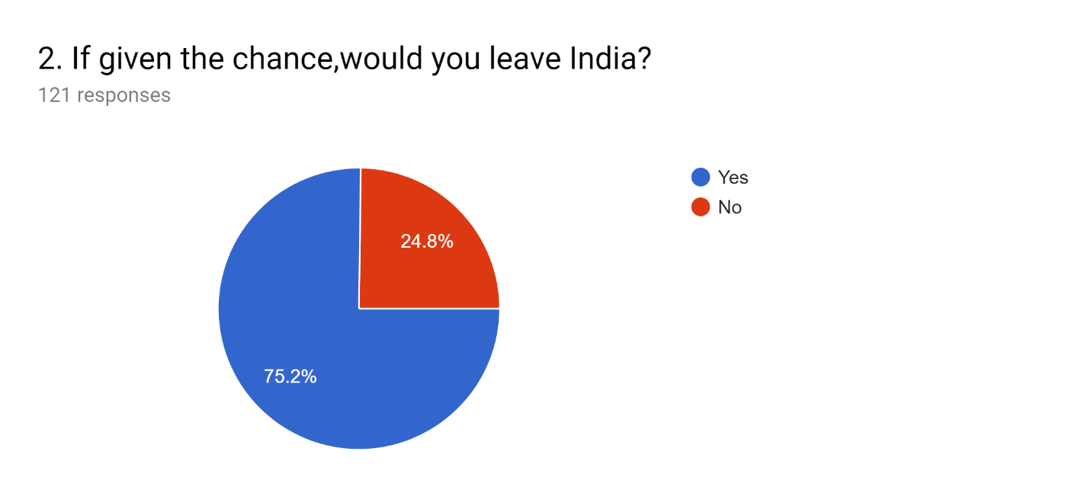

|  |  |
| --- | --- |
| Yes | No |
| 91 | 30 |

**3. If no, why would you prefer to stay in India and not settle abroad?**

* I answered yes
* I love my country
* I love to be in my country. I love to do business and settle here.
* I will stay in India because my family members all here
* Home sweet home
* No
* My country is my love...
* I don't want to leave my country
* .
* Money
* Idk
* Mera bharat mahan
* Last option to stay in India
* It's my nation and I have been here for so many years , so I do love it and would like to serve my country and also live near my family in the same country
* Bcoz ..born as Indian ..And would like to die as Indian💗
* My national is my bright
* I would study abroad but stay in India
* My family's here
* To contribute in the development
* Yes
* Family and food
* M
* I am in favour of being in India and serving my own country.
* Because it is we who can improve condition in India by being the part of the system. It is easy to complain, but when it comes to improving by themselves, no one puts the foot forward.
* This is my country
* Wt do we do by leaving our country
* Because I love India
* I love India
* I'm not interested to go

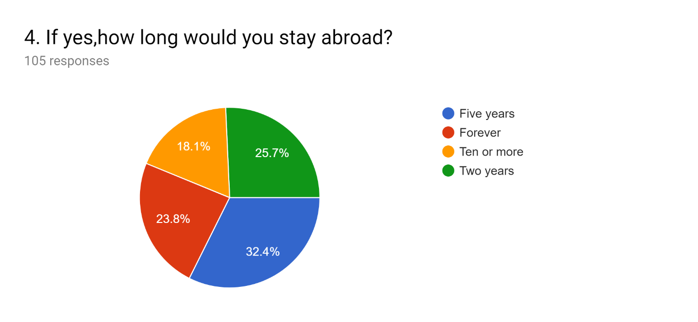

|  |  |  |  |
| --- | --- | --- | --- |
| Forever | Ten or more | Five years | Two years |
| 25 | 19 | 27 | 34 |

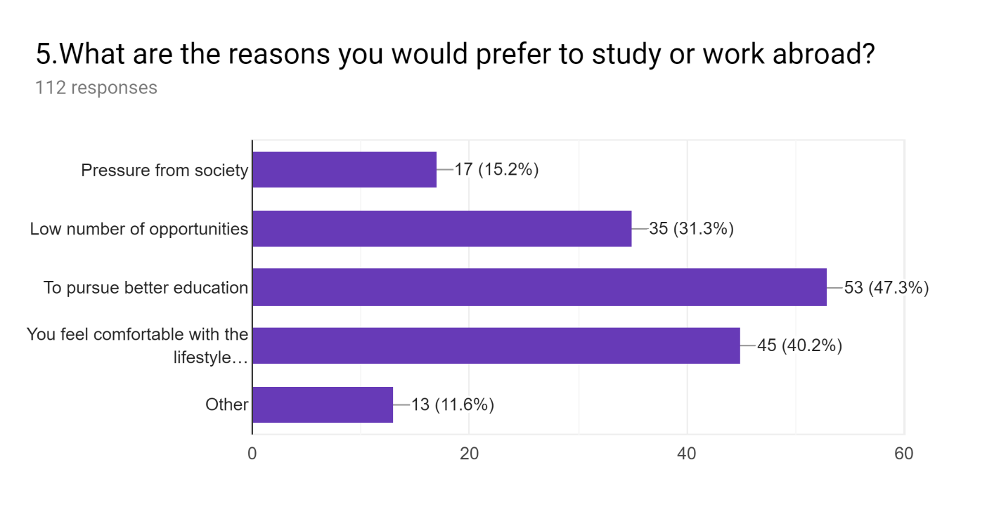

|  |  |  |  |  |
| --- | --- | --- | --- | --- |
| Better education | Pressure from society | Low number of opportunities | More comfortable with western culture | others |
| 53 | 17 | 35 | 45 | 13 |

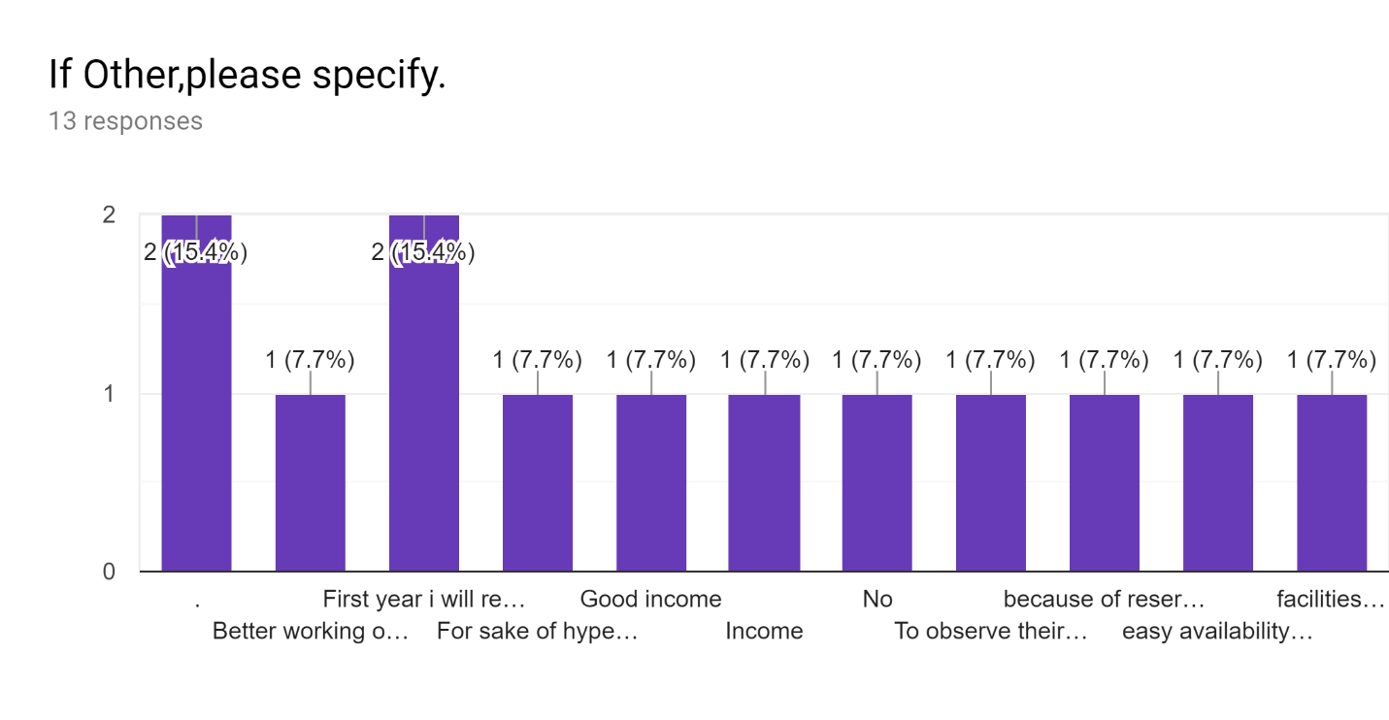

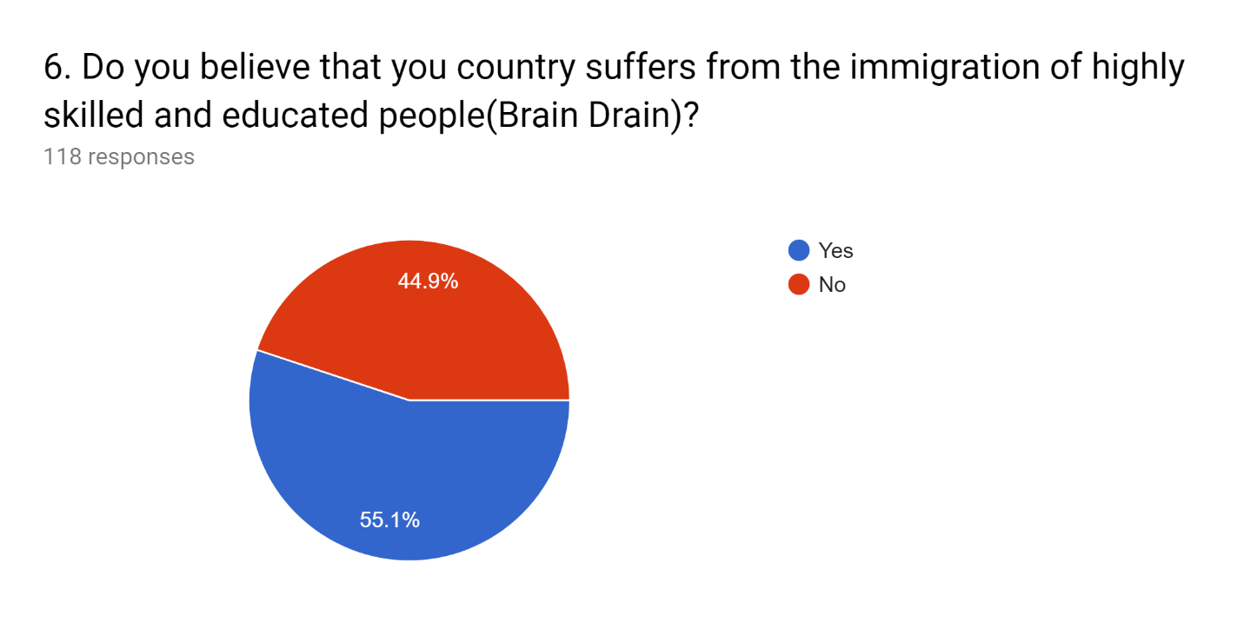

|  |  |
| --- | --- |
| Yes | No |
| 65 | 53 |

**7. If you answered yes to the previous question, how can Brain Drain be limited?**

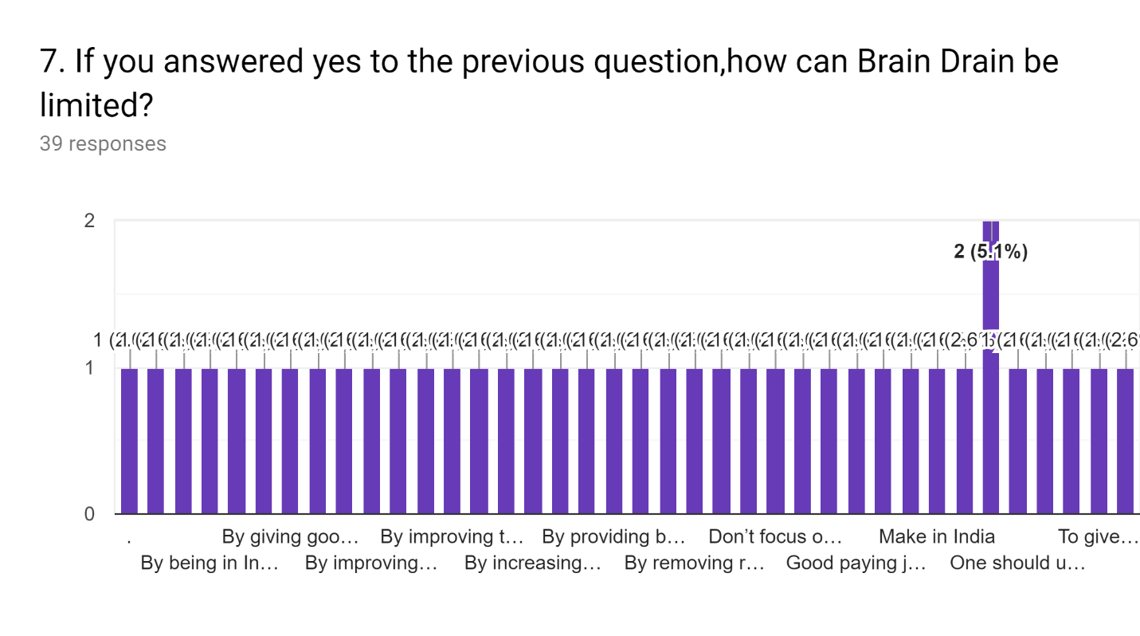

* By providing more opportunities here.
* By giving people the deserved salaries and high living conditions.
* Better prospects for financial development
* I think Brain Drain can be limited by improving facilities and infrastructure in our country. People should also be made aware of the existing opportunities in our country.
* By telling people about the opportunities our country provides and giving them job ideas.
* By introducing more number of fields in education
* Brain drain can be limited by increasing opportunities, improving infrastructure.
* Removing reservation.
* By limiting the time in visa to 2 to 5 years.
* By abolishing the reservation system based in caste which leads to unequal opportunities.
* By dissolving India as a country.
* By changing the infrastructure of our whole corporate world and education system
* Increase opportunities
* Giving enticement for those who go abroad to study to return for work
* Offering better opportunities to all classes of people and not get into any political drama
* Improving education standards in the country
* provide enough employment opportunities, recognize talent

Retaining Indian talent

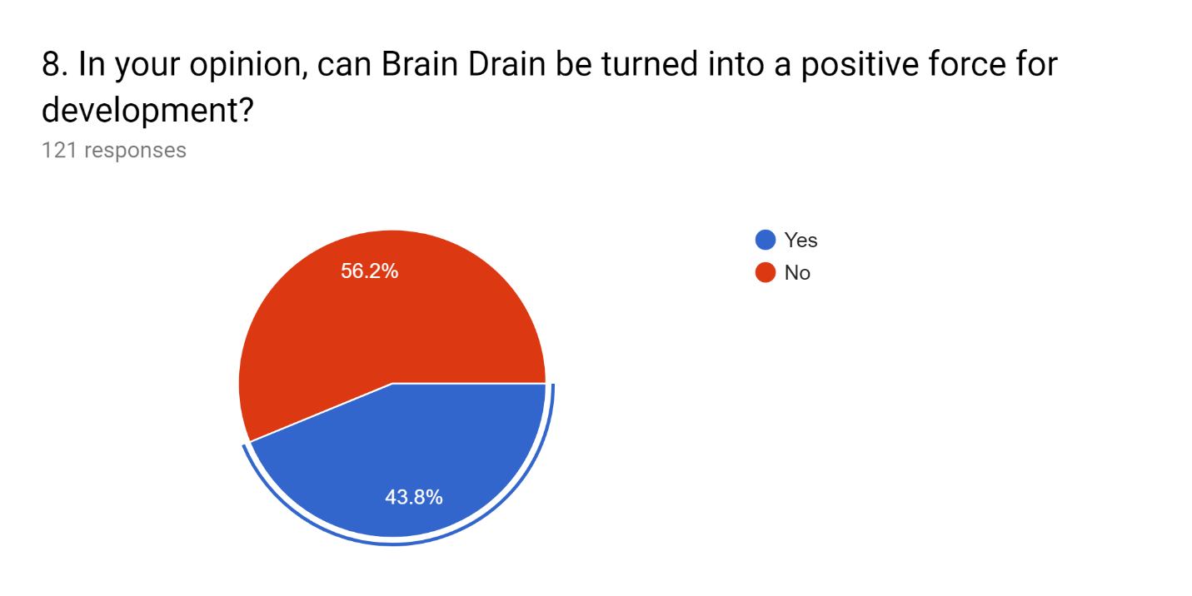

|  |  |
| --- | --- |
| Yes | No |
| 53 | 68 |

**9. If yes, then how would that be done?**

* By using brain drain for positive work same as used for negative work
* By encouraging people to serve in their countries and developing new technologies here for proper development
* It can be a directing force
* Smart work
* By testing there calibre and then hiring
* Good Question
* By making people more aware about outer world
* They can do well in their country by innovating new stuffs, and create employments.
* It can be used to motivate the mass towards productive works , thus increasing the intellectuality and professionalism in the society
* By producing leaders not workers, utilising our potential of human resource, by becoming the producers not the consumers, will boost our economy and certainly the opportunities, don't just make in India but made by india and sold in abroad, and how will you do that, definitely it will not be done by wasting time on answering stupid surveys like this.
* Education is they key. Stage for showing talents has to be open
* Sending funds from foreign to India
* By e
* We go to foreign country and get money which we use in our country which may help to increase economic strength of india
* There are so many people who are talented but not getting opportunities. By Brain Drain other people can get opportunities. It reduces unemployment problems also.
* Control population
* Let them go, just let them go
* Using them for collecting information of other countries.

**INFERENCE**

Considering all the data collected from different sources, the causes for the brain drain in India are mentioned below:

Higher Education:

Higher education in India evolved considerably after independence in terms of the number of universities as well as in terms of access to higher education. Before independence education was limited and elitist; but in the present scenario the impressive increase in higher education has privileged the medium and lower section also. However, the standard of higher education raised some questions over the adequacy of studies, resources, institutional quality and employability of university pass outs. Therefore, students striving for better education standards and job prospective are moving abroad.

Better Employment: -

India has skilled and semi-skilled, employed and unemployed human resource. Low salaries and inefficient working conditions can be the first motive that triggers the movement to the countries with better living standards and facilities. There is huge difference in terms of salary in all three groups of countries namely developed, developing and underdeveloped. Therefore, those workers prefer to move another country in order to have better living conditions with high salaries. Employment is one of the strong reasons for brain drain in India.

Lack of Opportunities:

In developed countries, researchers are provided with funds and necessary equipment to carry out study, which can be another motive that attracts those deprived of these opportunities. Most scientists in underdeveloped countries do not possess laboratory facilities and researchers cannot get sufficient funds. Therefore, when developed countries offer these facilities, researchers and scientists naturally prefer to migrate to these countries.

Favorable migration policies: -

The top appointments are quite few in India. Thus, the talented experts like to seek new pastures abroad. India, with its large reserves of highly-skilled workers, has emerged as one of the most prominent country to fill the supply gaps in the labor-deficient economies of the developed world. Taking into account of these factors, some developed countries have relaxed their migration policies to attract more talent in their country.

Political Problem

When the best of professional manpower leaves their home country and settle in a more developed one, it is a political phenomenon, but it only rarely occurs that the motives are exclusively political. It involves peculiar contradiction; it simultaneously indicates the lack of production and over production of professional manpower on the drained country. In this sense, brain drain is a symptomatic phenomenon, but at the same time it is expressive of a fundamental difficulty. The net effect of this is that the development of science and technology has been accelerated in the developed countries and has been slowed down in the drained countries.

Economic Problem

The economic aspect of brain drain derives from disproportionate economic, technological and scientific development of the developed and the developing countries. It is characteristic of brain drain that the more underdeveloped a country is economically, the more it loses by brain drain while only developed countries profit from the process. The outflow of our nation's talent, especially those highly skilled, educated from our premier institutes like IIT's and IIM's, AIIMS and other R & D institutes at the cost of the "Tax payers" money (in billions) raised a big question mark on the future prospects of Indian infrastructure development and various undergoing research works. Due to high salary and facilities, Indian youth is moving abroad. It is clear from the above fact that why the developed countries prosper at fast pace because of the high intellectual migrants from the poor developing countries. This knowledge gap is increasing, and the poor countries are becoming poorer and rich countries are emerging as knowledge countries and they are ruling the world.

Social problem

Firstly, the main social problem associated with migration may have impacts on national identity. The trend over time, such as one can be discriminated is inherent in ethno-cultural fixtures. Secondly, migration may have impacts on integration, defined as group outcomes set against the societal average. Put differently, this about understands the trajectories of first (and second) generation immigrant performance in a range of economic and social spheres (employment, housing, health, social interaction, marriage and so on). Finally, migration may have impacts on cohesion. This refers to how migration affects neighborhoods and is defined by people’s perceptions of how people get along with each other in their local area or neighborhood.

**CONCLUSION**

The Indian Government must understand the problem of brain drain and its consequences towards Indian Economy. Government should support all categories of people of India financially, technically, and professionally, so that they have an incentive to stay in the country and not leave it. Where there is an effective utilization of human knowledge is possible then there, we can see the growth rate of economy in terms of all aspects and on GDP rate. Moreover, the Government must amend policies in higher education, so that our talent can be discouraged to settle in other countries. The recent success of India in 'Mars Orbiter' Project was due to highly motivated scientists, who work day and night for their nation despite going abroad. Had these scientists gone abroad, the above space project would never be a great success. So, Indian Government must redress the above issue of Brain drain and may take initiative to retain our best brains.

The balance of power and for the staggered development of the world, it is very important to stop the phenomena of Brain-drain. This will help the country use all local skilled citizens for development and to attain higher GDP. But to hold these skilled workers at their native places, it is also important to provide them enough work opportunities and living facilities. For this purpose, our Government must take initiatives and amend policies or developed nations may help developing countries with necessary money and resources. Sovereign nations seem unlikely to relinquish regulation of immigration policy to the type of outside body such as a World Migration Organization. After all, the arrangement currently works in Western nation's favor. As developed countries see more of their educated young people leaving for jobs in other, wealthier nations, perhaps demand for such a body will increase.

But brain drain can be positive as well.

Brain drain allows many highly skilled people to find well-paying jobs outside India. This way other skilled people will find opportunities in India. This would reduce the percentage of jobless people.

The income from the emigrated people comes back to India as overseas remittances. Currently India is recipient of the highest amount of foreign currency coming in as remittances from NRIs. It helps improve the education and infrastructure in India, which in turn develops country further. For example, brain drain was the major cause for the growth of software education.

The most important effect of brain drain is brain circulation, which is the circular movement of skilled labor across nations. Countries like Taiwan, China and India have profited enormously form brain circulation. Global connectivity has led to a two-way flow of ideas, knowledge, and investments.

Brain drain has led to the growth of various fields which led to the return of many people.

India is indeed rapidly becoming a global research, design and development hub. More than 1,000 companies from around the world have set up their R&D centers in India. Over 2,00,000 scientists and engineers are working there, at least a fourth of whom have returned from overseas. 

**REFERENCES**

* <http://www.studyabroad.careers360.com/brain-drain-boon-developed-countries-bane>-

India

* UNESCO Statistics - [http://stats.uis.unesco.org](http://stats.uis.unesco.org/)
* International Organization for Migration (2010), World Migration Report 2010. The
* future of migration: Building Capacities for Change