# Introduction

# Review

## Artificial Life

## Evolutionary Programming

## Genetic Algorithm

## Co-evolution

Selection pressure and co-evolutionary arms race. (Turner 95.)

# Adaptive coloration in Natural Organisms

# Mimicry

Henry W. Bates first published in 1862 his findings about the similarities and dissimilarities between Heliconiinae and Ithomiinae butterflies, after 10 years of research in the Brazilian rain forest. For the next hundred years, it simulated heated discussion among all groups of people, scientists, philosophers, theologians, teachers and amateur naturalists. Bates collected ninety-four pieces of butterfly. He grouped them according to their similar appearance. He found butterflies having similar appearance, exhibiting morphological features which point to completely different species even families. Out of the ninety four species sixty seven are now classified as Ithomiinae, while twenty seven of them are Heliconiinae.

Bates was not only amazed with these finding, he was also determined to find an explanation for it. He found that Heloconiids were extremely abundant and very conspicuously coloured. They also had slow mobility so easier to catch. He noted,

‘*Although they fly slowly and are fragile in construction and apparently have no means of defence, they occur in areas where insectivorous birds hunt in flocks.*’

But these butterflies are not killed by birds, so an assumption is made that these butterflies are unpalatable and any palatable butterfly species which has the capability of having similar appearance will succeed in surviving insectivorous birds. This also provoked the idea that some Pierids pretend to be Heliconiids and thus enjoy protection which is really deserved only by the unappetising Heliconiids.

## Batesian Mimicry

Repulsive animals, such as heliconiids are very conspicuously coloured. Having this noticeable property, they are easily recalled by predators. Their wing pattern works as a warning to them. Once a predator has the knowledge of their inedible and unpalatable property, they would probably never attempt to try it again. As this is true, if any organism within close family and species, but being edible and having a deceptive resemblance to those conspicuously coloured species will be avoided by the predators. expresses,

"Such unpalatable appearing and yet edible animals thus possess a false warning pattern, they 'act a part'. An actor is a mime, and so the representation of a false warning pattern was called mimicry. Since Bates was the first to point out this phenomenon, it has received the name *Batesian Mimicry* in his honour."

In general, the animal which is avoided by predator for unpalatable behaviour is called the **model** and the imitating animal is called the **mimic**.

An important concept in contained in the self-evident term ‘pattern’, or more exactly, warning pattern, camouflage pattern and protective pattern. Man orients himself mainly with his eyes and he therefore pays particular attention to visual stimuli. But many animals orient predominantly by smell also our previous discussion of colouration and morphological characters applies equally well to odurs (olfactory stimuli).

## Mullerian Mimicry

Bates was not able to explain some phenomenon of mimicry. Occasionally two inedible unrelated butterfly species are amazingly similar in appearance. An explanation for this was provided by Fritz Muller in 1878. When there are multiple inedible species it is hard for predators to recognize each of them to know which one to consume and which one to avoid. Because of predator's limited memory, all these species still lose their number even after being inedible. So to save this loss, and to prevent more sacrifice of their own kind, inedible species from different family also tend to evolve to have similar appearance. This phenomenon is referred to as Mullerian Mimicry in the name of Fritz Muller.

## Formation of Mimicry Rings

The set of morphologically different species having similar appearance is considered within a single mimicry ring. This ring constantly evolves. One reason being predators have limited memory, and also newly born predators take certain time for learning.

In discussing the formation of mimicry rings, makes an analogy to the way planets form.

"Like planets forming from a cloud of gas, clusters of mimetic species will arise, and form what we call mimicry 'rings'. Species occupying spaces in between the rings will be pulled into them, but sooner or later these focal patterns, having absorbed all the available species, will stabilize. If they differ too much from each other they will not be able to converge, for predators like birds will never mistake one for the other."

Regarding the dynamics of mimicry, discusses three different theories. Firstly, according to , and , evolution of rings happens in a slow gradual continual process. Secondly, and suggests that mimics are created in a single, final mutational step. Thirdly, a synthetic theory also called *two stage model* has been proposed, which originated by and . According to this theory, in the first step mimics get a very close resemblance to the model, which gets more accurate over time, having a more refined resemblance.

# Modeling the evolution of mimicry

## Past work

## FormAL Framework

### Environment

### Spatial representation

### 3D Visualization

### Agents

### Mobility

## Mimic and Model

### Pattern representation by Cellular Automata

### Species diversity

Hamming distance between different CA patterns have been used to distinguish between species.

Franks and Noble have used different models to diversify species. In (Franks & Noble, Conditions for the evolution of mimicry, 2002) they have used linear difference in number "constrained to a 'ring' of values from 1-20 (where 20 and 1 are neighbours)" to distinguish species diversity. Here the distance of one phenotype from another represents their level of similarity.

### Genetic representation of palatability

### Interaction between Mimics and Models

### Interaction with predators

## Predator

### Learning

#### Hebbian Learning

#### Hopfield Network

### Design of Memory with Hopfield Network

### Interaction and Reproduction

### Interaction with Models and Mimics

# Results and Analysis

Experiment 1: Initial configuration of two prey species:

|  |  |  |  |  |  |
| --- | --- | --- | --- | --- | --- |
|  | **Prey configuration** | | **Predator configuration** | | |
| Population  (Cellular Automata) | Rule 110 (Palatable) | 108 | Population | | 10 |
| Rule 30  (Unpalatable) | 108 |
| Reproduction | Age Limit | 100 | Reproduction | Age Limit | 500 |
| Interval | 1000 | Interval | 800 |
| Mutation Rate | Pattern | 0.05 | Mutation Rate | 0.3 | |
| Genome | 0.5 |
| Demise Age | 2000 | | Demise Age | 2000 | |
|  |  |  | Memory Configuration | Minimum | 2 |
|  |  |  | Maximum | 10 |

Simulation time: **8000 and above**

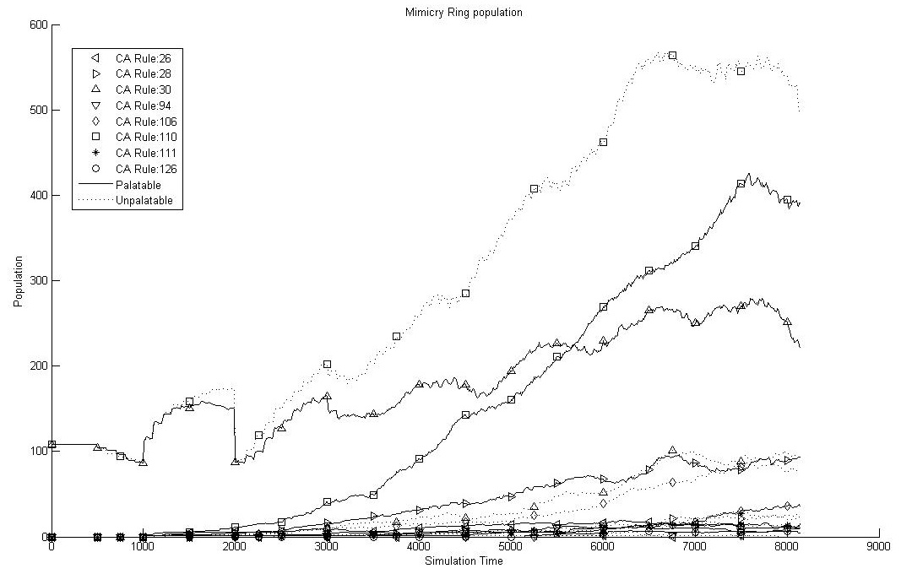

Simulation time: **7600 and onwards**

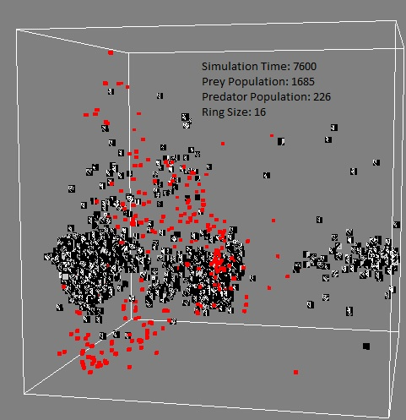

Experiment 2: Initial configuration of four prey species:

|  |  |  |  |  |  |  |
| --- | --- | --- | --- | --- | --- | --- |
|  | **Prey configuration** | | | **Predator configuration** | | |
| Population  (Cellular Automata) | Rule 110 (Palatable) | | 50 | Population | | 10 |
| Rule 30 (Unpalatable) | | 50 |
| Rule 55 (Palatable) | | 50 |
| Rule 190 (Unpalatable) | | 50 |
| Reproduction | Age Limit | | 100 | Reproduction | Age Limit | 500 |
| Interval | | 1000 | Interval | 1500 |
| Mutation Rate | Pattern | | 0.05 | Mutation Rate | 0.3 | |
| Genome | | 0.5 |
| Demise Age | 2000 | | | Demise Age | 2000 | |
|  |  |  | | Memory Configuration | Minimum | 4 |
|  |  |  | | Maximum | 10 |

Simulation time: **9000 and onwards**

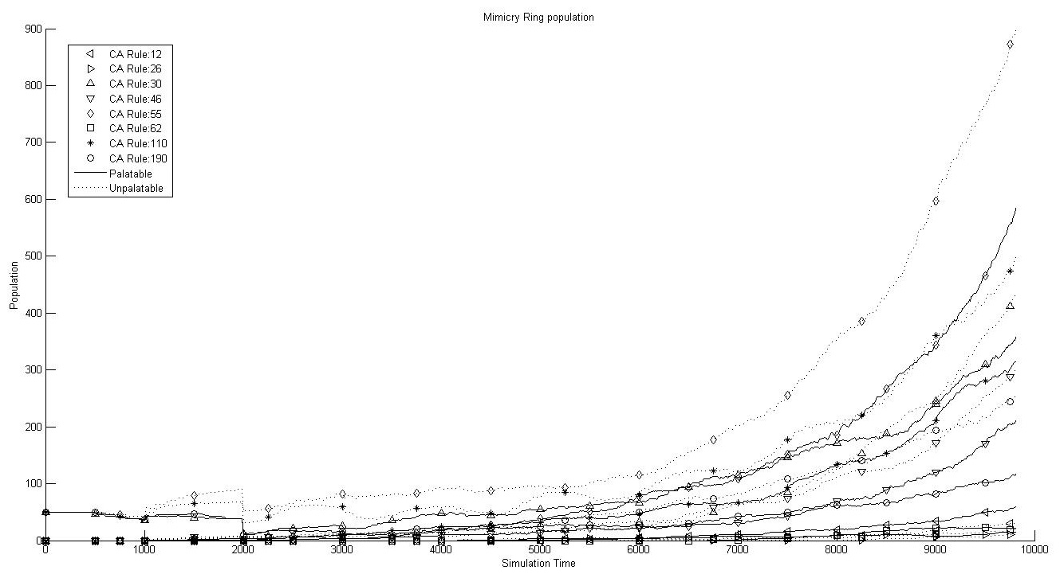

Simulation time: 9000 and onwards

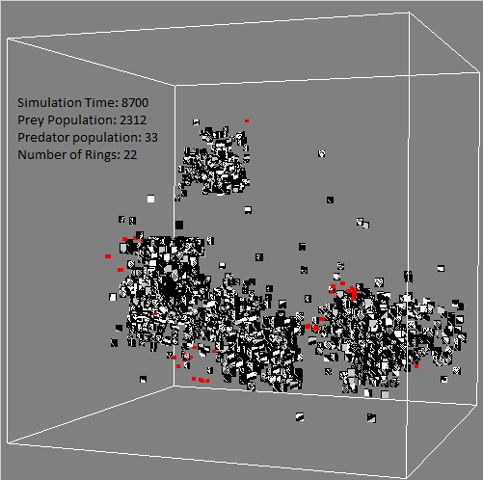

Simulation time: **10000 and onwards**

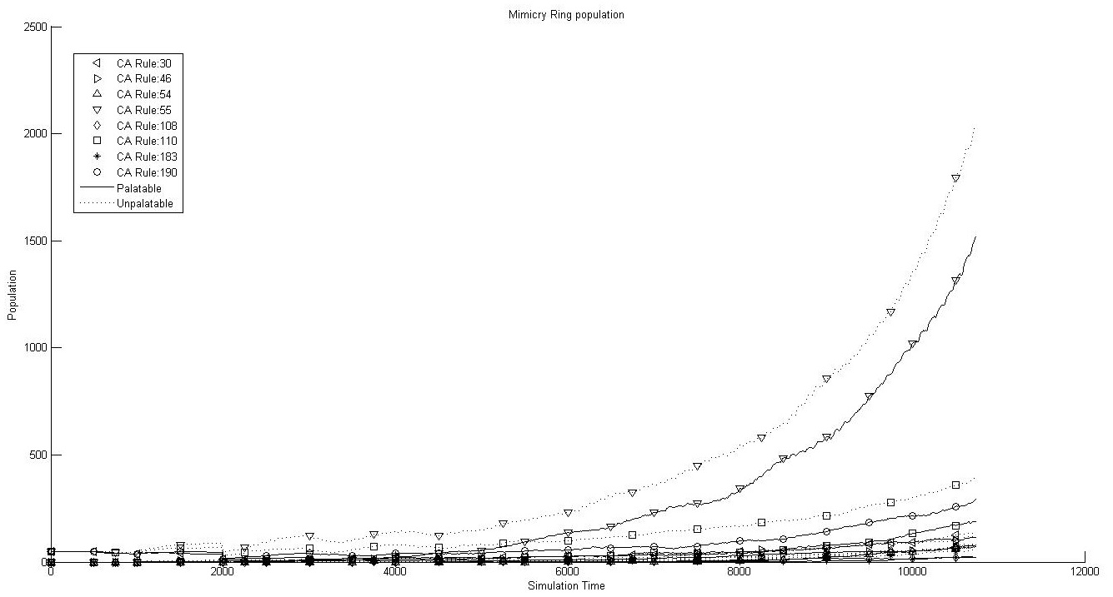

Increased initial population with four species:

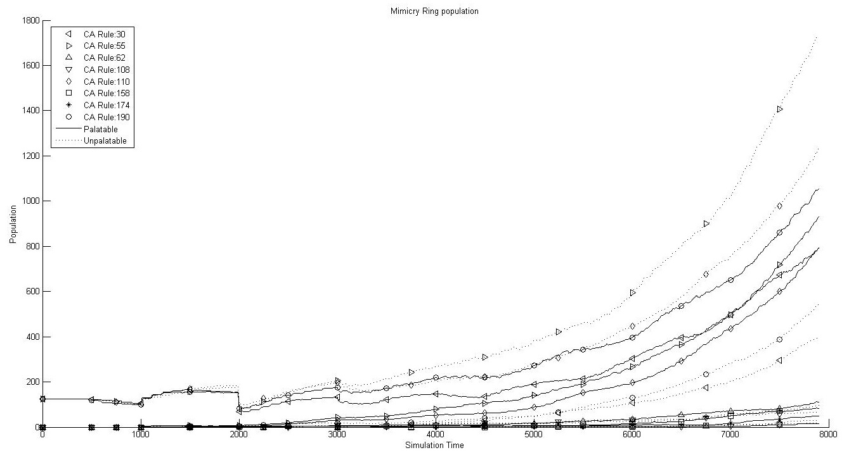

Initial configuration with more unpalatable than palatable species.

Initial configuration with more palatable than unpalatable species.

Initial configuration with only palatable species.

Initial configuration with only unpalatable species.

Initial configuration with different set of CA rules.

Initial configuration with only one CA rule.

Initial configuration with predator motion slower than prey.

Initial configuration with prey population slower than predator.

Initial configuration with larger resolution of the prey CA pattern.

Increasing CA pattern diversity by changing pattern mutation rate.

initialize with a set of prey species with random patterns and then evolve with predator to observe the result.

# Conclusion

# References

Brower, L. P., Alcock, J., & Brower, J. V. (1971). Avian feeding behaviour and the selective advantage of incipient mimicry. *Ecological genetics and evolution* , 261--274.

Edelman, G. M. (1988). *Topobiology: An Introduction to Molecular Embryology.* New York: Basic Books.

Fisher, R. A. (1927). On some objections to mimicry theory - statistical and genetic. *Transactions of the Royal Entomological Society of London* , 269--278.

Fisher, R. A. (1930). *The genetical theory of natural selection.* London: Methuen.

Franks, D. W., & Noble, J. (2002). Conditions for the evolution of mimicry. *ICSAB: Proceedings of the seventh international conference on simulation of adaptive behavior on From animals to animats* (pp. 353--354). Cambridge, MA, USA: MIT Press.

Franks, D. W., & Noble, J. (2003). The origins of mimicry rings. *ICAL 2003: Proceedings of the eighth international conference on Artificial life* (pp. 186-191). Cambridge, MA, USA: MIT Press.

Goldschmidt, R. B. (1945). Mimetic Polymorphism, a Controversial Chapter of Darwinism (Concluded). *The Quarterly Review of Biology* , 205-230.

Grogono, P., Chen, G., Song, J., Yang, T., & Zhao, L. (2003). Laws and life. *ASC 2003: Proceedings of the 7th IASTED Conference on Artificial Intelligence and Soft Computing* (pp. 158--163). International Association of Science and Technology for Development.

Holland, J. H. (1996). *Hidden order: how adaptation builds complexity.* Basic Books.

Nicholson, A. J. (1927). *A new theory of mimicry in insects.* Royal Zoological Society of New South Wales.

Poulton, E. B. (1912). *Darwin and Bergson on the interpretation of evolution.* Bedrock.

Punnett, R. C. (1915). *Mimicry in butterflies.* Cambridge: Cambridge University Press.

Turner, J. R. (1984). Mimicry: the palatability spectrum and its consequences. *The Boilogy of Butterflies (Royal Entomological Society of London Symposium)* , 141--161.

Turner, J. R. (1988). The Evolution of Mimicry: A Solution to the Problem of Punctuated Equilibrium. *The American Naturalist* , S42--S66.

Turner, J. R., Kearney, E. P., & Exton, L. S. (1984). Mimicry and the Monte Carlo predator: the palatability spectrum and the origins of mimicry. *Biological journal of the Linnean Society* , 247--268.

Wickler, W. (1968). *Mimicry in plants and animals.* Newyork Toronto: McGraw-Hill Book Company.