User Management System

# Technologies used:

Express.js for creating Api’s with nodejs, MongoDb for database, Mongoose to communicate with the database as a ODM(Object Data Model), Postman/Thunderclient for Api testing.

# Project Setup In Local Environment:

1. Clone the repository –

git clone <https://github.com/mohiyaddeen7/userManagementSystemTask.git>

1. Install all the npm packages by opening the project in vs code and running the command in vs code terminal –

npm install-server

(for this to run you should have node, and npm installed in your os, to install npm and node - [npm and node install guide](https://docs.npmjs.com/downloading-and-installing-node-js-and-npm))

1. Now you need to setup your mongodb as I have used mongoDb as a database, you need to have mongoDB compass installed, after installing mongoDb compass create a new connection and as

You can see you will have your mongoURI like this : mongodb://localhost:27017 copy this before clicking on save and connect

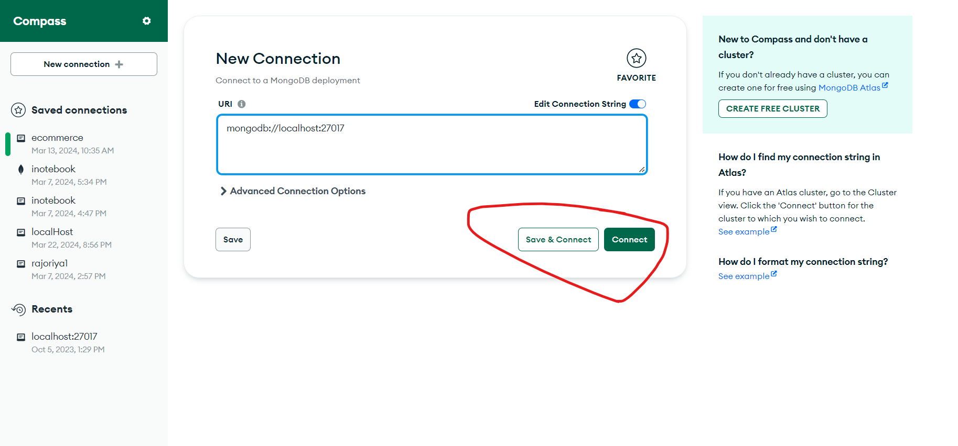

1. Now in the project directory create a .env file with this fields  
   mongodbURI = mongodb://localhost:27017/userManagementDb

port=5000

1. Now we have all things setup now you can run the server by running the command

npm start-server

1. And now our server is successfully started if you see

App listening on : http://localhost:5000

Connected to database successfully

1. Now you can test the api’s with the predefined collections that you can find in the docs folder inside api collection with a file name – userManagementSystemApi
2. You can import this collection in postman or thunderclient to test the api’s

# Api Endpoints:

POST -> /api/users/addUser – adds user to the database with fields in the body of the request

that are –

name(String, Name cannot be more than 50 characters long, Required) ,   
email(String,valid email address, Unique, Required),   
age(Integer, Age must be at least 18 years and Age cannot be more than 100 years, Required), gender(String, Enum- Gender must be either Male, Female, or Other, Required),   
address(String, Address cannot be more than 100 characters long., Optional),   
mobileNo(String, Please fill a valid 10-digit mobile number,Unique, Required)

GET -> /api/users/getUsers – gets all the users who are not marked as deleted

GET -> /api/users/getUsersByFilter – gets all the users with proper validation for query parameters and proper pagination in the response.

Accepted query parameters are :

page(Integer,it indicates page number),  
 limit(Integer, it indicates number of records per page),  
age(Integer,must be a number),  
name(String),userId(ObjectId),  
email(String, must be a valid email address),   
gender(String, Gender must be either Male, Female, or Other),  
mobileNo(Integer, Please fill a valid 10-digit mobile number),  
deleted(Boolean(true,false),it indicates that whether the records that are marked deleted should be retrieved(true) or marked as not deleted(false) and by default its false)

example request endpoint - http://localhost:5000/api/users/getUsersByFilter?page=1&limit=5&gender=Male&deleted=true

PUT -> /api/users/updateUser/userId=:userId – updates user record by userId and the fields that need to be updated are in the body of the request

PUT -> /api/users/updateUser/emailId=: emailed - updates user record by emailId and the fields that need to be updated are in the body of the request

DELETE -> /api/users /softDelete/userId=:userId – (Soft Deletion) – marks the user as deleted whose userId matches the given userId

DELETE -> /api/users /softDelete/ emailId =: emaild - (Soft Deletion) – marks the user as deleted whose emailId matches the given emailId

DELETE -> /api/users /hardDelete/userId=:userId - (Hard Deletion) – removes the user from the databse whose userId matches the given userId

DELETE -> /api/users /hardDelete/ emailId =: emailed - (Hard Deletion) – removes the user from the databse whose emailId matches the given emailId

# Testing the project without setting up:

Note : I have deployed this project as a web service in render.com, so you can test the api’s without setting it up locally but recommended one is to set it up in local environment as the project is under free tier in render.com and it takes time to get a response from the render.com server as its in free tier.

To test the api that are deployed in render.com :

Import the predefined api collections that are in the docs folder in the api collection folder named userManagementSystemApi . when you import this collection to postman you will se a folder name Hosted Api’s under userManagementSystemApi collection