

**Ain Shams University**

**Faculty of Engineering**

**Computer and Systems Engineering Department**

**CSE 321: Software Engineering – 3rd Year CSE – 1st Semester 2016/2017**

**Submitted by:**

|  |  |  |
| --- | --- | --- |
| Name | Section | Student ID |
| Ahmed Mohammed Hesham El-Moselhy | 1 | 1300208 |
| Ahmed Sameh Mohammed Soliman | 1 | 1300114 |
| Ahmed Mohsen Abd El-Ba’eth | 1 | 1300177 |
| Ahmed Nasser Fathy Mosalam | 1 | 1300230 |
| Hassan Saeed Hassan Ahmed | 1 | 1300466 |
| Mohammed Mansour Abo-Bakr | 3 | 14x0008 |

Form1 Code:

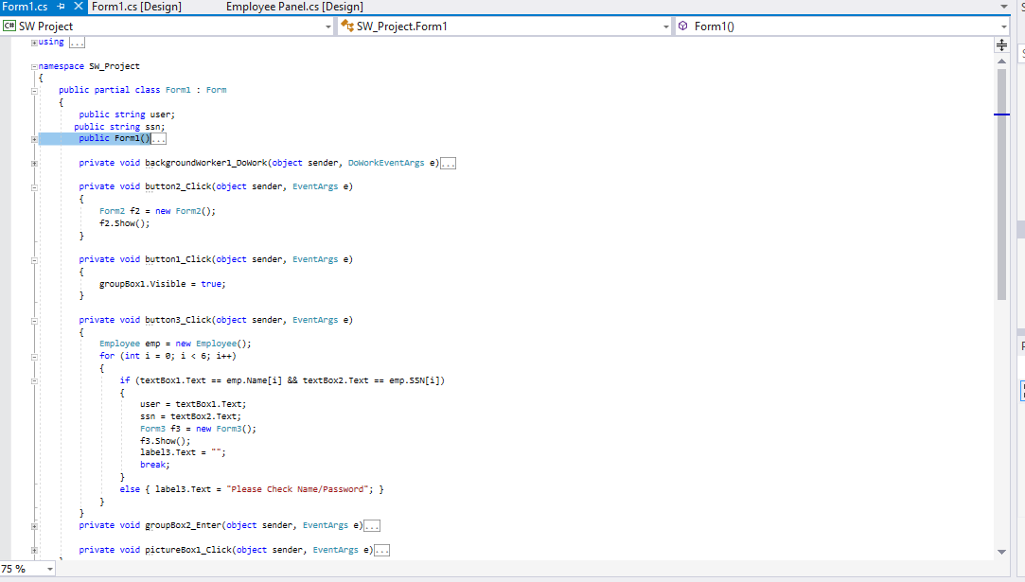

Form1 design:

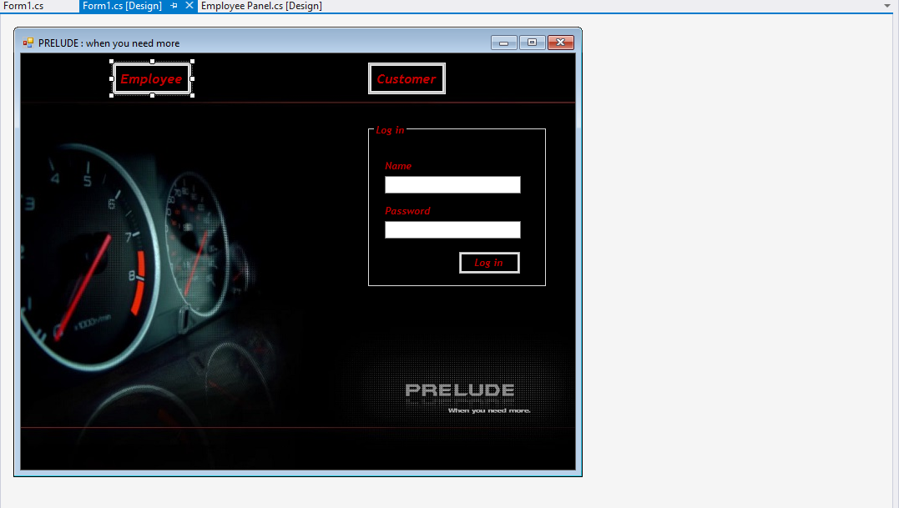

Form2 Code:

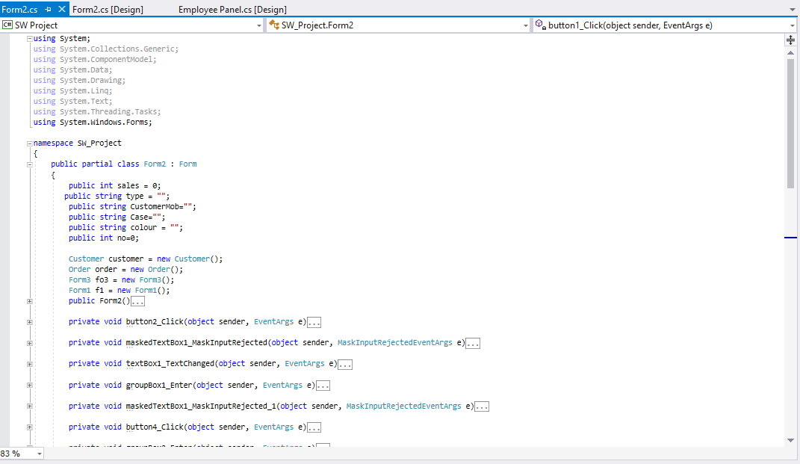

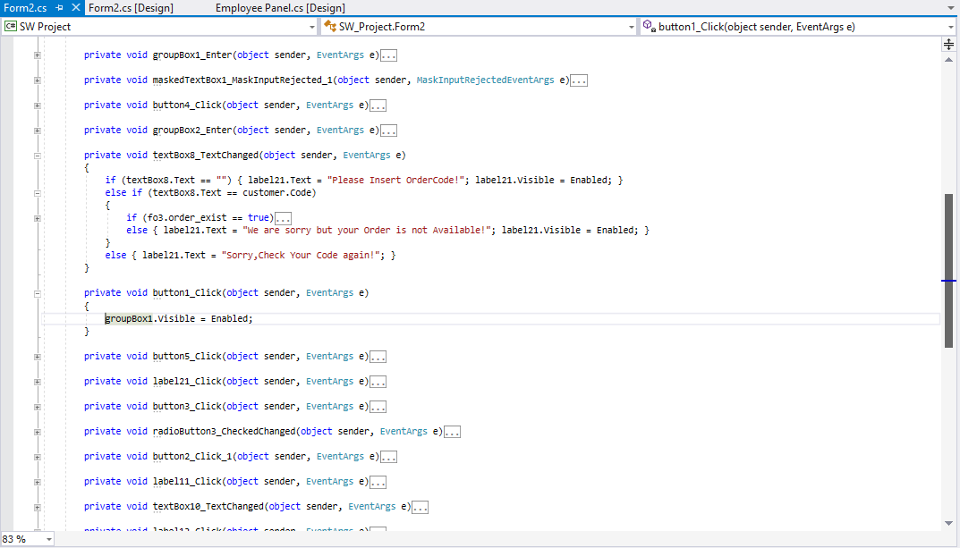

Form2 Design:

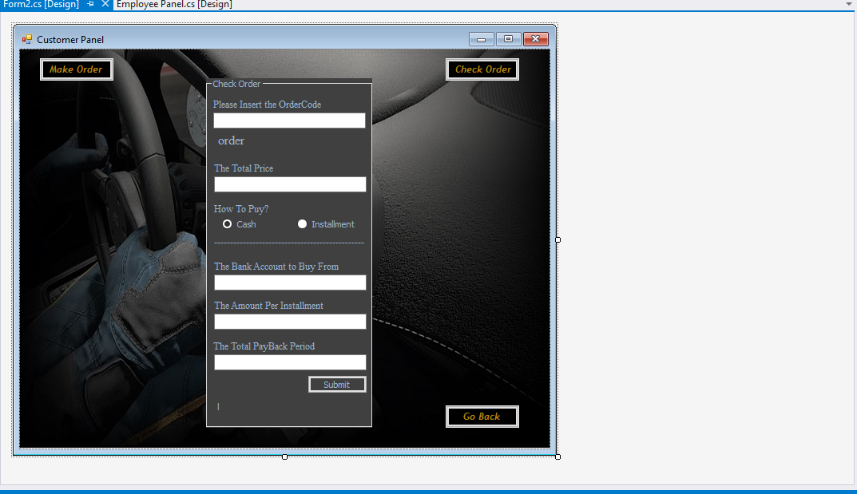

Form3 Code:

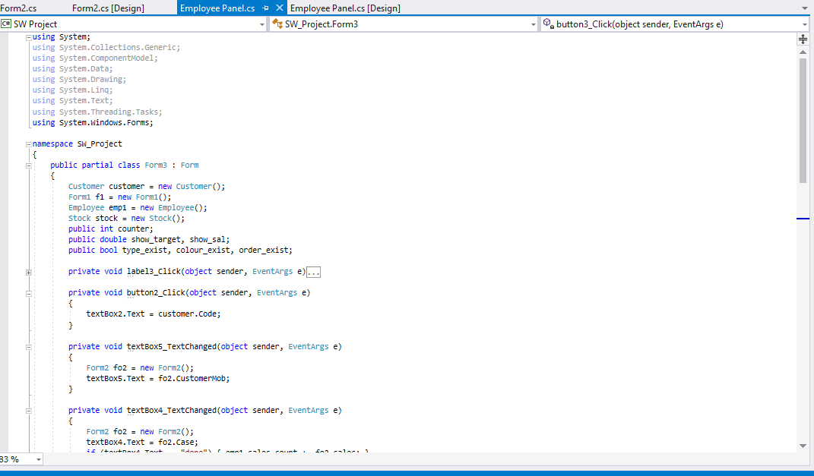

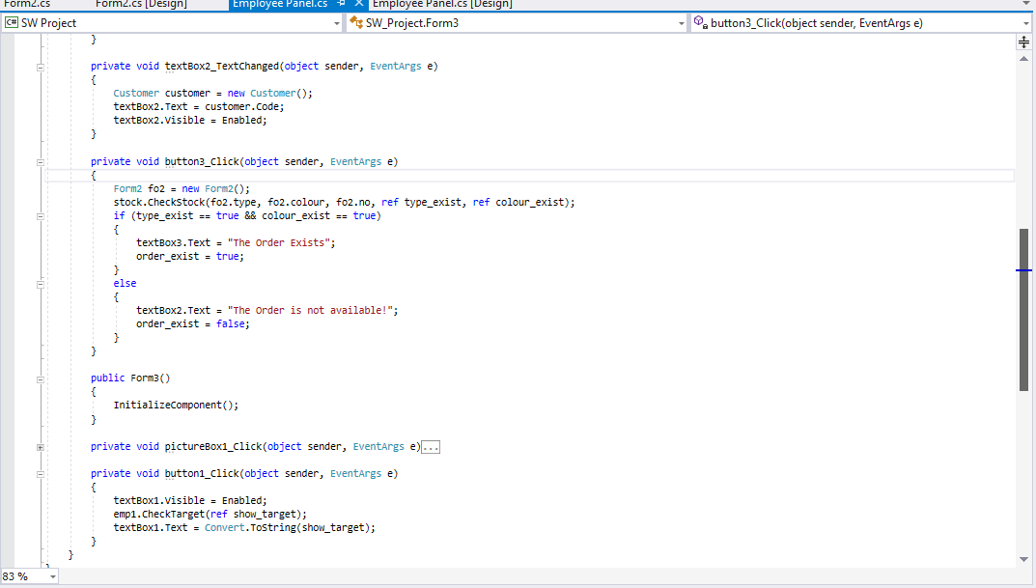

Form3 Design:

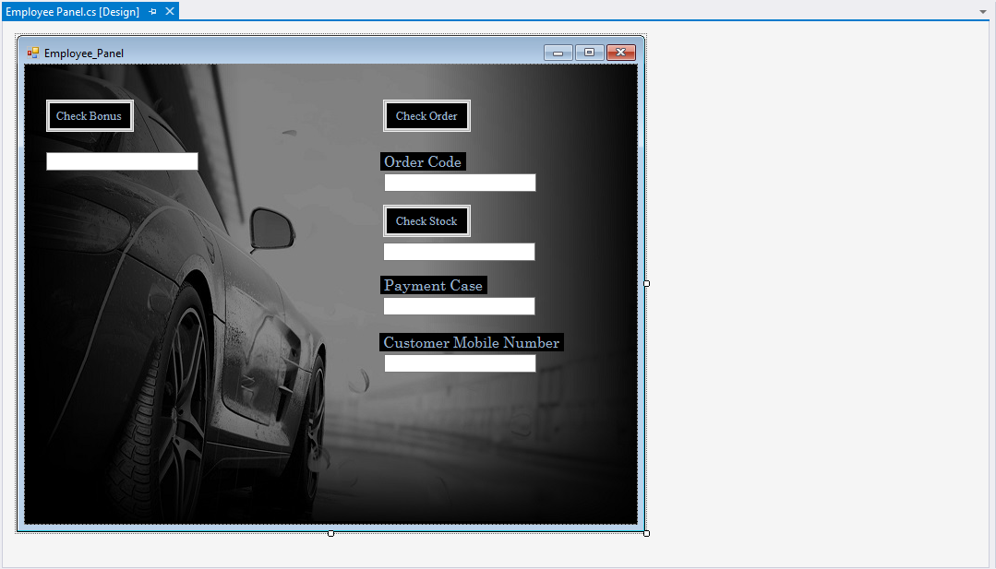

Classes:  
