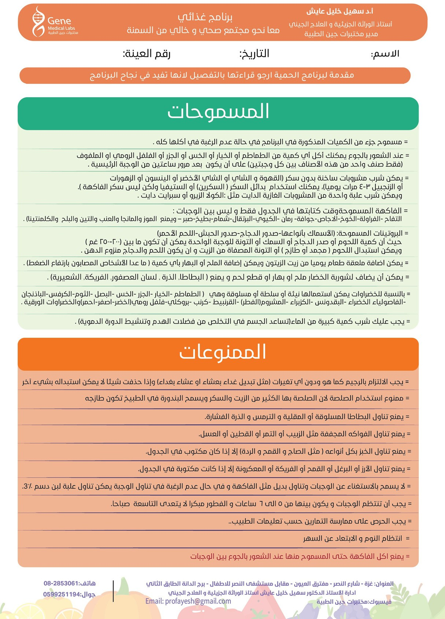

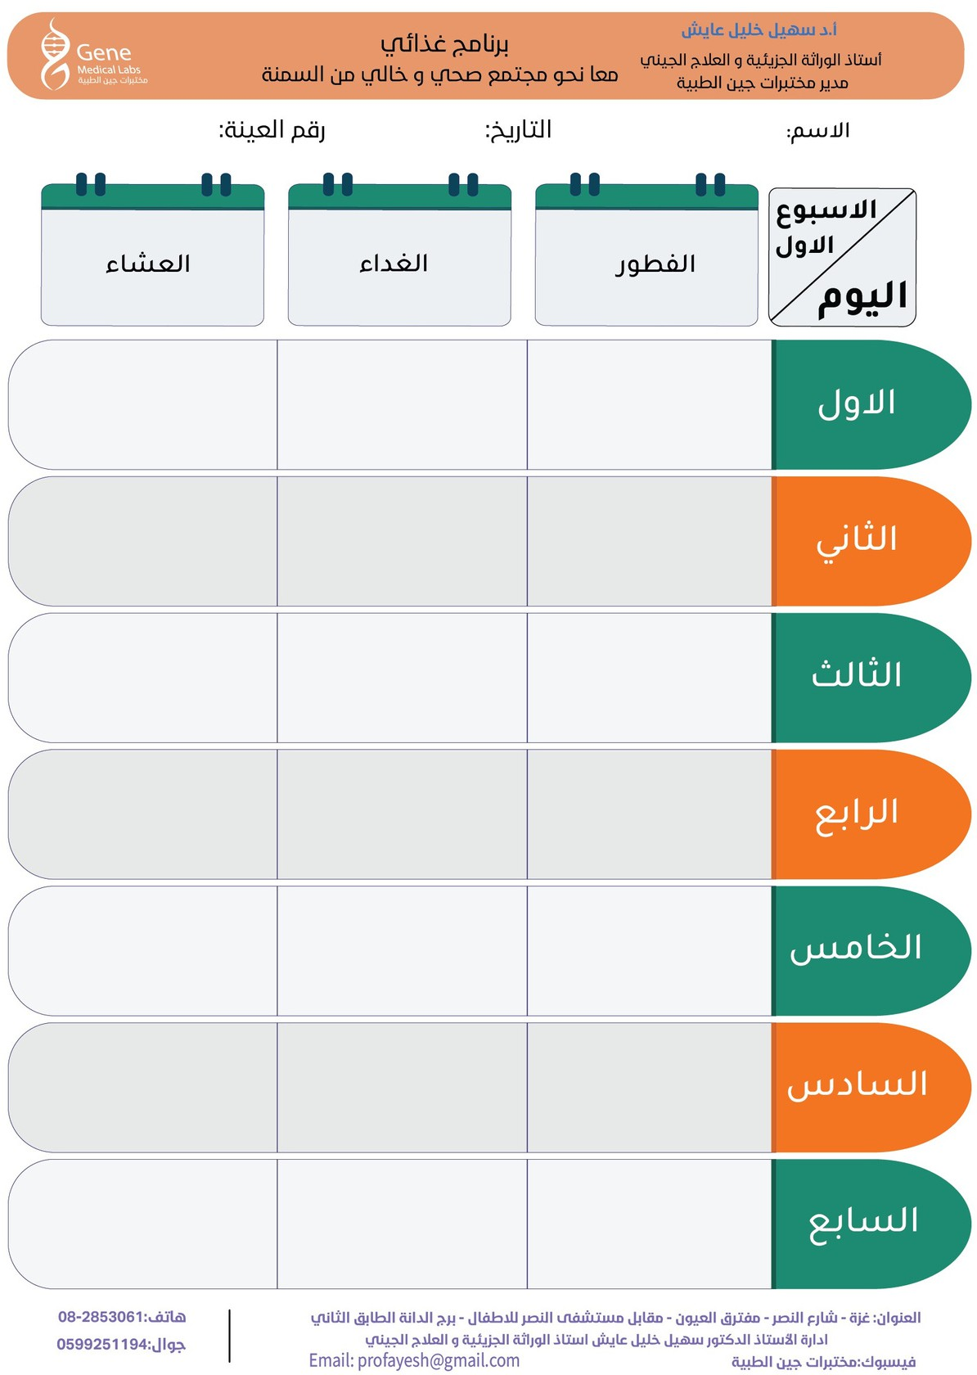

Dinner5

Dinner4

Dinner7

Dinner6

Lunch6

Bf6

Bf5

Lunch5

Lunch7

Bf7

Lunch4

Bf4

Dinner3

Dinner2

Dinner1

Lunch3

Bf3

Bf2

Lunch2

Lunch1

Bf1



Dinner13

Dinner12

Dinner10

Dinner9

Dinner8

Lunch9

Lunch8

Lunch10

Dinner11

Lunch11

Bf8

Bf9

Bf10

Bf11

Bf12

Lunch12

Bf13

Lunch13

Dinner14

Bf14

Lunch14