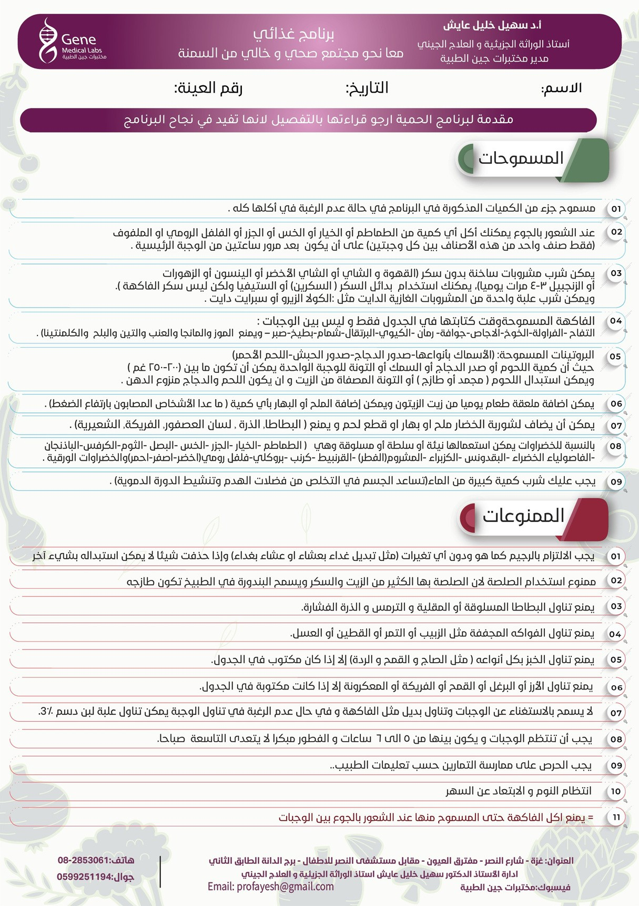

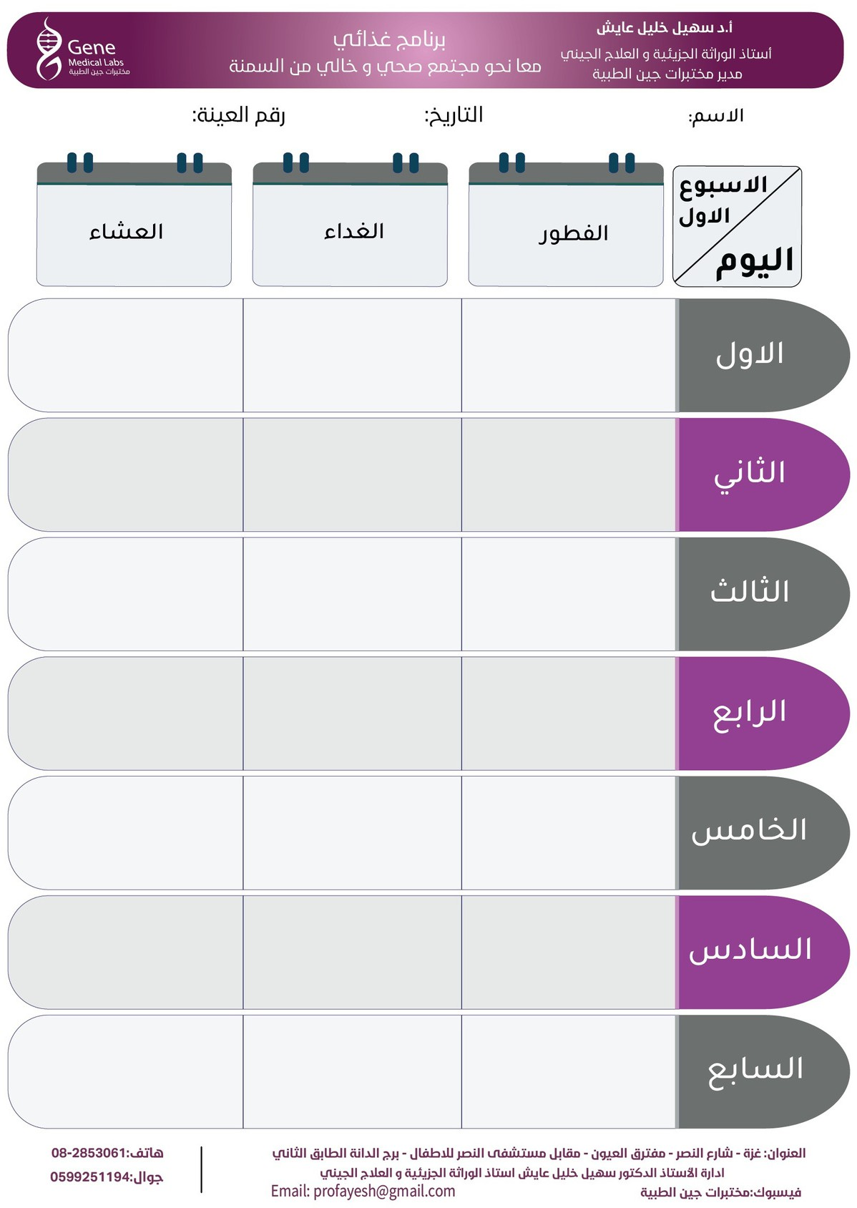

Dinner6

Dinner5

Dinner4

Dinner3

Dinner1

Lunch1

Lunch7

Bf7

Dinner7

Lunch6

Bf6

Lunch5

Bf4

Bf5

Lunch4

Dinner2

Bf3

Lunch3

Lunch2

Bf2

Bf1



Dinner14

Dinner10

Dinner12

Dinner9

Bf14

Lunch13

Dinner13

Lunch14

Bf13

Lunch12

Bf12

Dinner11

Lunch11

Bf11

Bf10

Lunch10

Lunch9

Bf9

Dinner8

Lunch8

Bf8