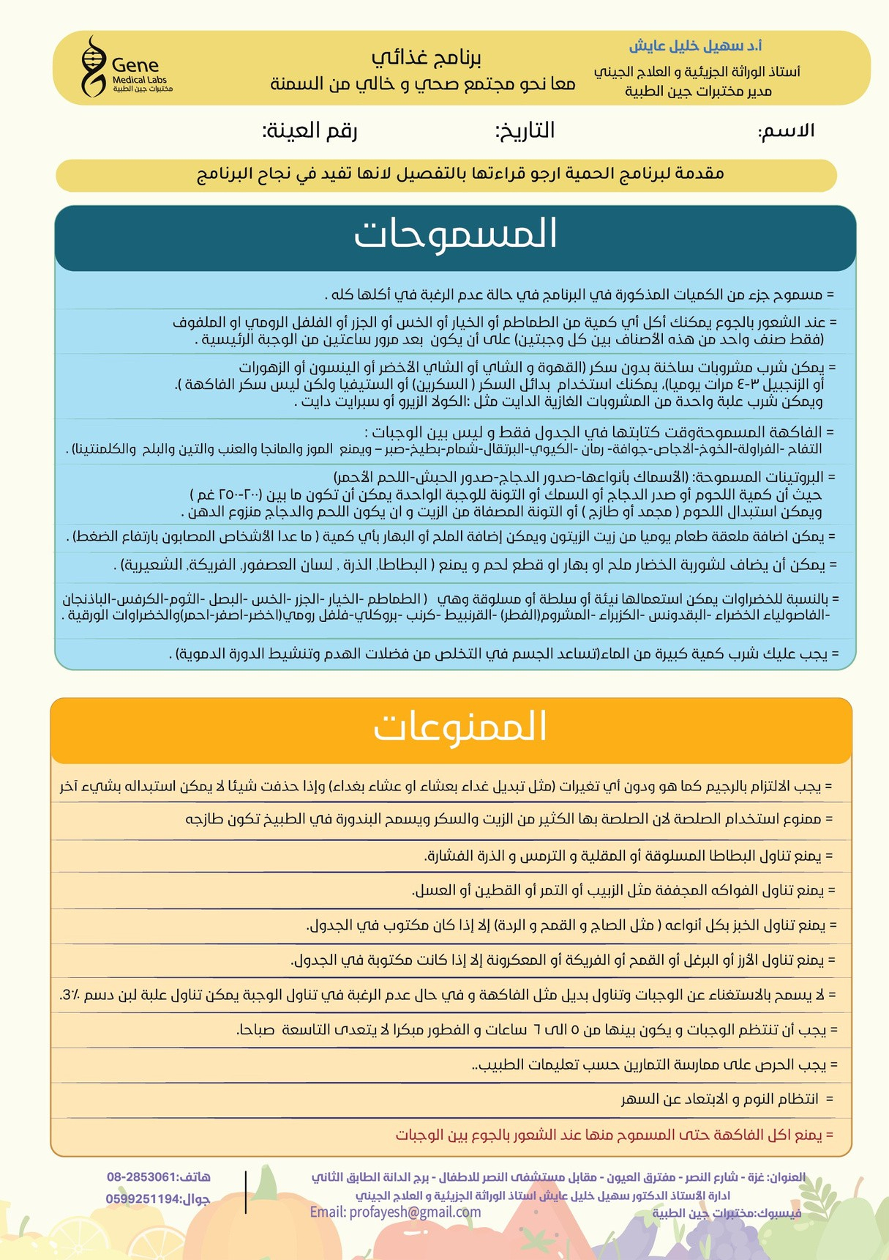

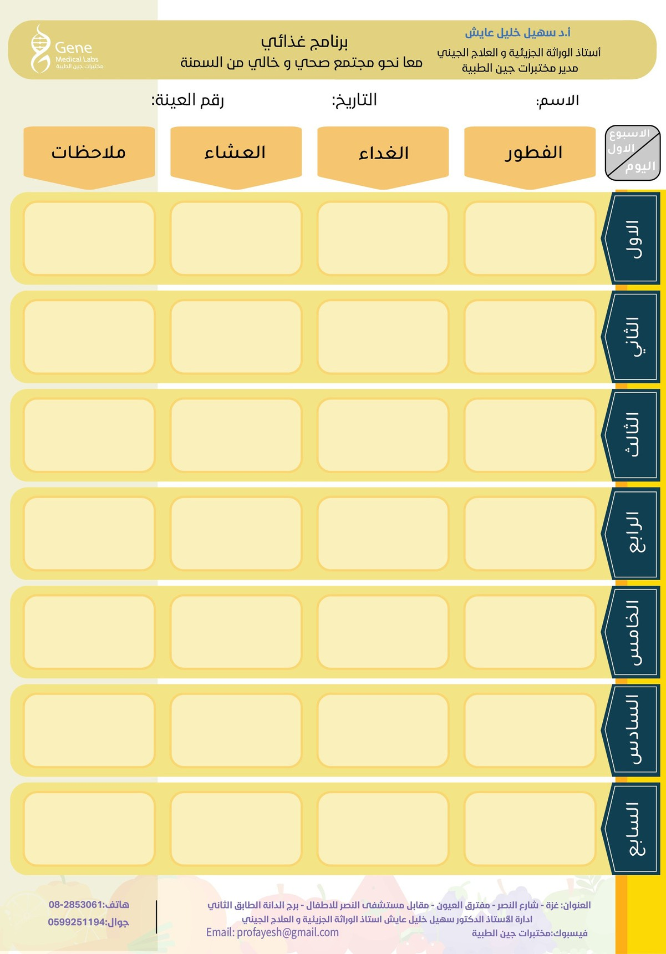

Bf7

Lunch7

Dinner7

Bf6

Dinner5

Lunch6

Dinner6

Lunch5

Bf5

Dinner4

Bf4

Lunch4

Bf3

Lunch3

Dinner3

Dinner2

Lunch2

Bf2

Dinner1

Lunch1

Bf1

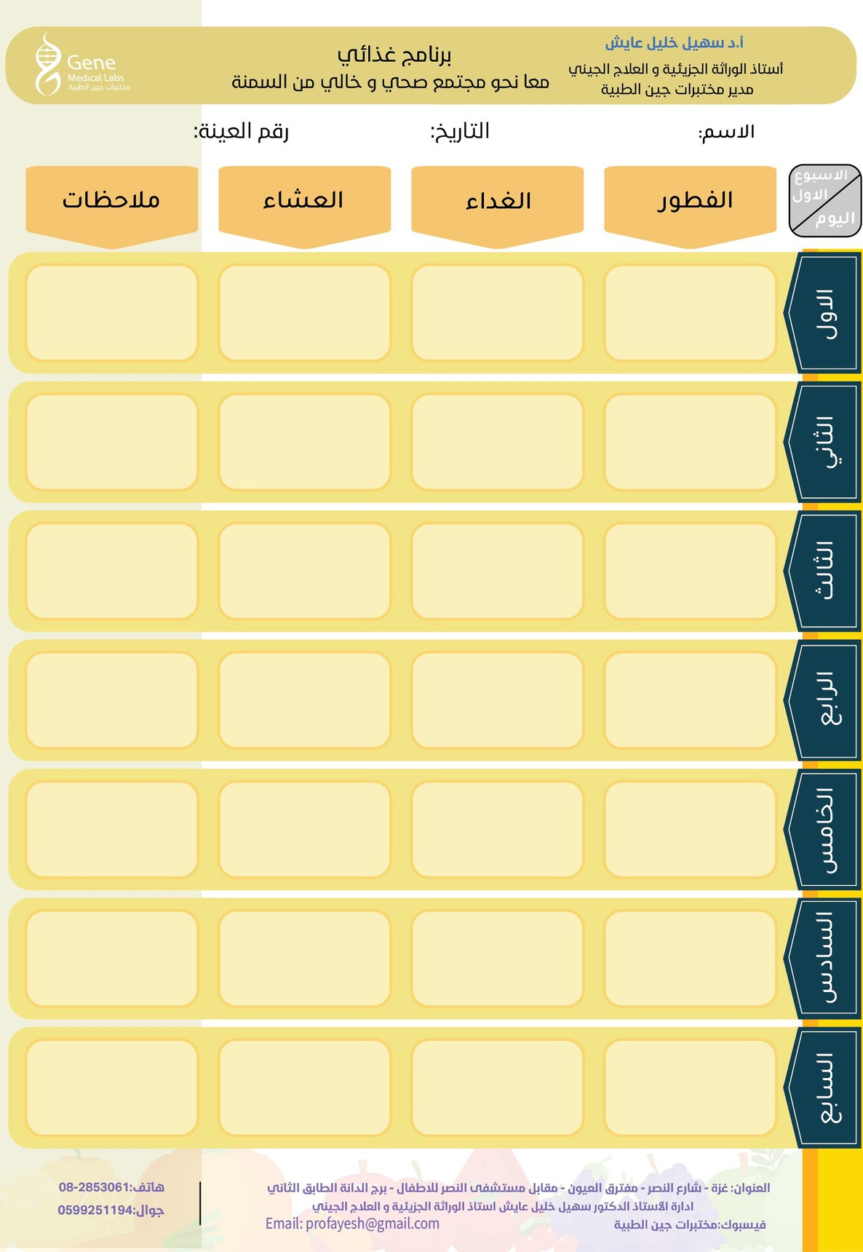

Dinner11

Dinner14

Lunch14

Bf14

Dinner13

Lunch13

Bf13

Dinner12

Bf12

Lunch12

Lunch11

Bf11

Dinner10

Lunch10

Bf10

Dinner9

Lunch9

Bf9

Bf8

Dinner8

Lunch8