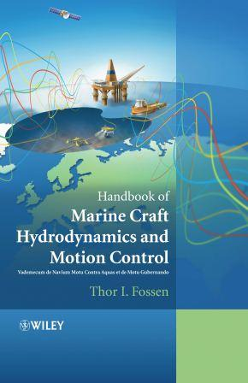 | Handbook of Marine Craft Hydrodynamics and Motion Control  T.I. Fossen  ISBN 9781119991496 (1st ed.) John Wiley & Sons Ltd, UK, 2011  Electronic orders: www.amazon.co.uk, www.wiley.com  Amazon author age: http://www.amazon.com/author/fossen  The 2nd edition will be published in 2019/2020.
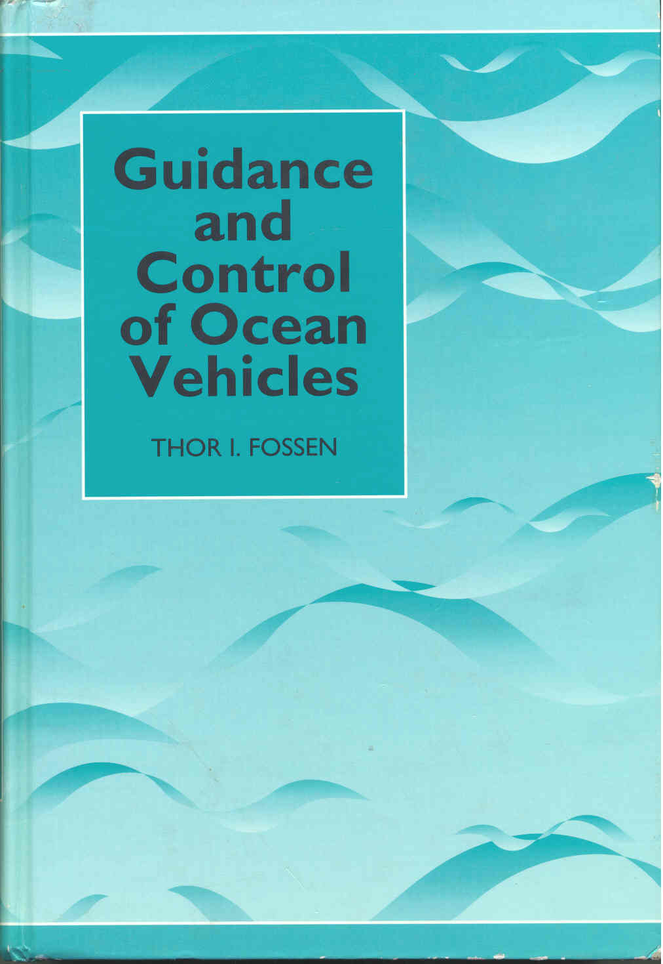 | Guidance and Control of Ocean Vehicles  T. I. Fossen  ISBN 0-471-94113-1. John Wiley & Sons Ltd, UK, 1994  Electronic orders: www.amazon.co.uk, www.wiley.com  Amazon author page: http://www.amazon.com/author/fossen
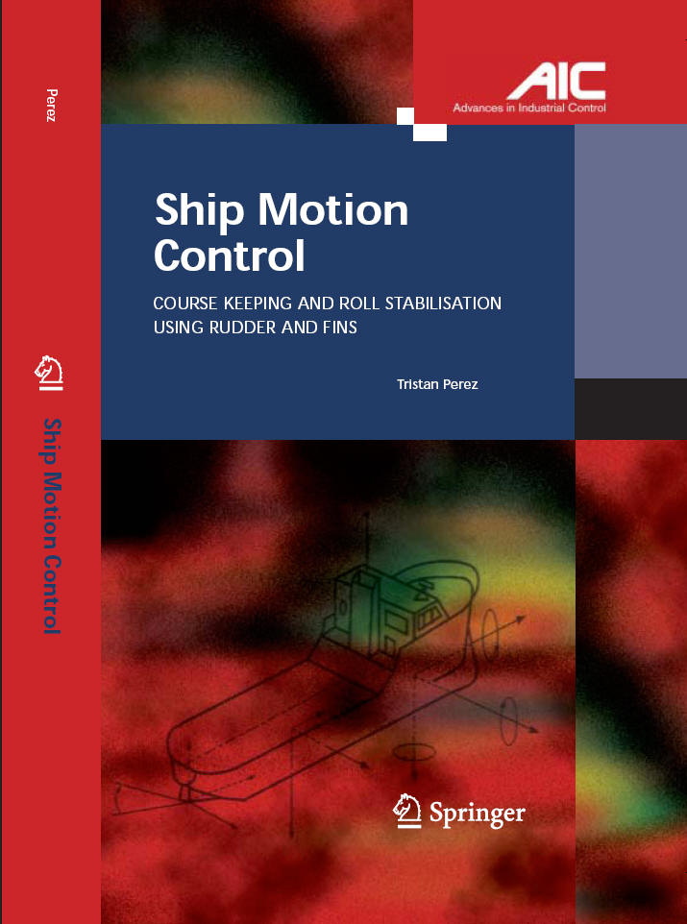 | Ship Motion Control  Course Keeping and Roll Stabilisation using Rudders and Fins  T. Perez  ISBN 1-85233-959-4. Springer Verlag, 1st ed. 2005  Electronic orders: www.amazon.com

