EFFECTIVENESS OF WEARABLE AND MULTI-SENSORY DEVICES IN REDUCING ANXIETY

A Research Study on DeskHelp: A Multisensory Wellness System

Research Conducted at IIITDMJ Design Lab

Mentor: Dr. Sangeeta Pandit (HOD, Design, IIITDMJ)

Abstract
Stress and anxiety among late adolescents (16–19 years) have become a growing public-health concern, driven by academic pressure, social comparison, and the irregular routines common at this age. Most existing wellness tools measure stress and leave the response entirely to the user, which tends to fail precisely when it's needed most, under high cognitive load. This paper presents DeskHelp, a responsive multisensory wellness system designed to close that gap by delivering passive, real-time stress regulation within an everyday desk environment.
The system is designed around a wearable photoplethysmographic (PPG) sensor that provides heart rate (HR) and heart rate variability (HRV) data, from which the Root Mean Square of Successive Differences (RMSSD) is computed as the primary short-term stress indicator and mapped onto a five-level stress index. Each level is intended to drive a coordinated combination of four intervention modalities: visual chromatherapy through a WS2812B NeoPixel RGBW LED ring, acoustic therapy via a MAX98357A-driven speaker, haptic grounding through a DRV2605L-actuated linear resonant actuator, and aromatherapeutic intervention via an ultrasonic piezoelectric atomizer, all coordinated by an ESP32 microcontroller with integrated Wi-Fi and BLE connectivity.
A preliminary survey of the target demographic (n = 35) found a notable prevalence of sleep disturbance, anxiety, and mood variability, lending support to the underlying design direction, though it was too small a sample to generalise from. At this stage, DeskHelp exists as a digital prototype: a fully specified hardware architecture, circuit-level planning, a mobile application with simulated HRV input and stress control, and a CAD-based product model built in Autodesk Fusion. Neither the stress-classification thresholds nor the interventions themselves have yet been validated against real physiological data or tested with human participants, and demonstrating actual efficacy remains a task for future hardware-based work. What this stage of the project does show is that physiological signal analysis, embedded systems design, wireless communication, actuator control, and human-centred product design can be brought together coherently in a single wellness-engineering system aimed at a real and underserved problem.
Keywords: Heart Rate Variability, RMSSD, stress detection, multisensory intervention, adolescent wellness, ambient computing

1. Introduction
Stress has been identified as , a condition of mental strain or pressure due to upsetting conditions. Chronic or prolonged exposure to stressful environments is a major contributor to morbidity and a leading cause of mortality, and its physiological consequences span inflammatory, metabolic, neurodegenerative, and psychiatric domains . The adolescent population — specifically individuals aged 16 to 19 years — represents a particularly vulnerable demographic. This developmental stage is characterised by heightened academic pressure, identity formation, hormonal shifts, peer comparison, and frequently disrupted sleep and routines, all of which may collectively predispose young people to elevated and sustained stress responses.
Physiological stress activates the Hypothalamic-Pituitary-Adrenal (HPA) axis and suppresses parasympathetic nervous system (PNS) activity, producing measurable changes in cardiovascular parameters including Heart Rate (HR) and Heart Rate Variability (HRV) [5]. HRV — the variation in time intervals between successive heartbeats — is among the most accessible and clinically validated non-invasive indicators of autonomic nervous system (ANS) state, with reduced HRV consistently associated with sympathetic dominance and psychological stress [6].
Despite the clinical relevance of physiological stress monitoring, existing wellness technologies exhibit significant limitations. Clinical-grade systems (ECG-based HRV, cortisol assay, EEG) are effective but impractical for continuous naturalistic deployment. Consumer wearables provide monitoring but rarely close the feedback loop to deliver a contextually appropriate intervention without requiring deliberate user effort [7]. Furthermore, as identified through a preliminary survey conducted with the target age group for this study, existing physiological monitoring wearables are often expensive, creating accessibility barriers for wider adolescent adoption.
DeskHelp addresses this intersection by proposing a closed-loop biometric feedback system embedded within a desk lamp — an everyday object present in the study and work environment of the target user. The system passively monitors physiological stress through PPG-based HRV analysis, classifies the user's stress state in real time, and delivers a calibrated multisensory wellness intervention through the lamp itself, without requiring any conscious user interaction. The research was conducted at the IIITDMJ Design Lab under the supervision of Dr. Sangeeta Pandit, Head of Department, Design.

2. Problem Statement and User Research

2.1 Survey Findings
A preliminary survey was administered to 25 participants from the target age group (16–19 years) to understand stress patterns, emotional health, sleep quality, and instinctive coping behaviours. The sample size represents a limitation of the present study and restricts generalisation of findings; however, the data provided directional evidence to inform the design requirements of DeskHelp.

Key findings included: meditate/yoga was the most commonly reported instinctive stress response; a majority of respondents reported moderate to high anxiety and frequent mood swings; sleep disturbances (difficulty falling asleep and disturbed sleep) were prevalent; and peer comparison at score 3 (moderate) was reported by the highest proportion of respondents (48%). These findings confirmed that the target population experiences measurable stress-related symptoms and that existing coping strategies are predominantly self-directed rather than passively supported by ambient technology.

2.2 Research Insights and Gaps
Secondary research and survey findings were synthesised into five key research insights. First, existing stress-monitoring solutions have accessibility limitations, with physiological wearables being expensive and thus creating barriers to wider adoption. Second, stress can be reflected through physiological signals, with HRV — particularly RMSSD — providing an indication of autonomic changes associated with physiological stress. Third, stress intervention should ideally be passive and require minimal conscious effort from the user. Fourth, personalisation is important, as stress responses vary between individuals and interventions should adapt to the detected stress level rather than providing uniform responses. Fifth, HRV-based stress detection requires contextual activity information, as physiological changes during exercise may be misclassified as psychological stress.
The primary research gap identified was that many systems provide a stress score but fail to address the engineering challenge of what the device should do after detecting stress. A closed-loop system following the pipeline Detect → Classify → Decide → Intervene → Measure Response is absent from most consumer wellness products. DeskHelp was designed to fill this gap.

3. Literature Review

3.1 Physiological Basis of Stress Detection
Psychological distress is a major contributor to human physiology and pathophysiology, linked to conditions including autoimmune diseases, metabolic syndrome, sleep disorders, and psychiatric conditions [2]. The response to stressful stimuli is mediated through a complex brain network and the HPA axis, producing autonomic changes measurable through peripheral cardiovascular signals [5].
HRV is well established as a non-invasive marker of ANS activity. Among HRV metrics, RMSSD — the Root Mean Square of Successive Differences between consecutive R-R intervals — is the preferred short-term metric for parasympathetic assessment due to its sensitivity to vagal modulation and robustness to respiratory confounding [8]. The Task Force of the European Society of Cardiology has established normative HRV standards that form the basis of RMSSD interpretation in research and clinical contexts [8].

3.2 Machine Learning and AI Approaches to Stress Detection
Artificial intelligence (AI) and Machine Learning (ML) have promoted a paradigm shift in stress detection, with multiple studies demonstrating accuracy levels of approximately 90% or above using physiological signal inputs . Mentis et al. critically reviewed AI/ML methods for stress detection and identified key approaches including Support Vector Machines (SVMs), Random Forest (RF), Naive Bayes, Artificial Neural Networks (ANNs), Convolutional Neural Networks (CNNs), and Swarm Intelligence (SI) as promising tools for classifying stress from HRV and other physiological features .
HRV features commonly used in ML-based stress classification include RR Mean (inter-beat interval mean), RR STD (inter-beat interval standard deviation), RMSSD, TINN (triangular interpolation of the RR interval histogram), and frequency-domain metrics including LF power (0.04–0.15 Hz), HF power, and VLF power . SVM with RBF kernels has demonstrated accuracy of approximately 92–96% for wearable-based stress detection, while CNN applied to raw PPG/ECG time series has achieved accuracies exceeding 97% in controlled stress paradigms . The current DeskHelp prototype employs a deterministic threshold-based classifier as a computationally efficient baseline; ML-based personalised classification is identified as a key direction for future development.

3.3 Multisensory Ambient Wellness Interventions
Research on affective computing and physiologically driven ambient environments has demonstrated that adaptive lighting, soundscapes, and haptic feedback can function as effective passive stress regulators. Studies in chromotherapy establish that warm-white light promotes parasympathetic activity while cool-white light increases alertness, providing biological grounding for adaptive LED colour temperature control as a wellness modality. Multi-sensory approaches have shown additive calming effects over single-modality interventions by engaging complementary sensory processing pathways . The DeskHelp design integrates four modalities simultaneously to leverage this convergence.

4. Methodology

The journey of developing DeskHelp was guided by a well-structured, phase-based approach that brought together physiological signal analysis, a proposed embedded hardware architecture, software simulation, and CAD-based product design. This work specifically zeroes in on creating and validating a digital system prototype and the proposed hardware architecture. It's important to note that we didn't create a physical DeskHelp unit or conduct any human-subject testing in this study. As such, our methodology clearly separates the components that were implemented in simulation from those that are intended for future hardware development.

Phase 1: Problem Definition and Target User Profiling

In the first phase, we focused on defining the design problem and pinpointing our target user group. DeskHelp is envisioned as an ambient stress-support system aimed at late adolescents aged 16 to 19, a group that often faces significant academic pressure and irregular daily routines. To shape our design requirements, we conducted secondary research on adolescent stress physiology, heart rate variability (HRV), existing stress-management strategies, and ambient computing methods.

From this research, we crafted a system that is non-intrusive, designed to fit seamlessly into a desk environment, responsive to physiological signals, and capable of delivering multisensory interventions without needing the user to be constantly aware of it. These criteria played a crucial role in guiding our decisions regarding the physiological, electronic, software, and product design aspects.

Phase 2: Physiological Signal Framework

We chose Heart Rate (HR) and Heart Rate Variability (HRV) as the key physiological indicators for our stress-estimation framework, as HRV provides insights into the variations in autonomic nervous system regulation. For short-term HRV metrics, we opted for RMSSD (Root Mean Square of Successive Differences) because it can be derived from successive R-R intervals and is widely recognized for its effectiveness in characterizing Stress levels.

Table 1. Five-level stress classification framework based on RMSSD thresholds.

Level | Label | RMSSD Range | Stress Index | Primary Response
L1 | Calm | ≥ 55 ms | Very Low | Breathing light only
L2 | Mild Stress | 35–54 ms | Low | Soft audio + light
L3 | Moderate Stress | 20–34 ms | Moderate | Audio + diffuser on
L4 | High Stress | 10–19 ms | High | All modalities + haptic alert
L5 | Severe Stress | < 10 ms | Severe | All modalities + emergency contact

Phase 3: Proposed System Architecture
The DeskHelp architecture we've envisioned is a closed-loop physiological-feedback system designed to enhance user experience:
Proposed Wearable → BLE → Mobile Application → HRV Analysis → Stress Classification → Wi-Fi → DeskHelp Unit → Multisensory Intervention
This architecture is structured into four key conceptual layers.
First up is the sensing layer, which is set to capture photoplethysmographic (PPG) signals from a wearable device, allowing us to derive R-R intervals for HRV analysis. Next, the processing layer takes charge of calculating RMSSD, figuring out the stress level, and keeping a continuous track of the user's physiological trends. The communication layer is designed to utilize Bluetooth Low Energy (BLE) for the connection between the wearable and the mobile app, while Wi-Fi will facilitate communication between the app and the DeskHelp unit. Finally, the actuation layer is all about translating the assessed stress level into a blend of visual, auditory, haptic, and olfactory interventions.
At this point, it's important to note that this architecture outlines our proposed system design rather than a fully integrated physical implementation.

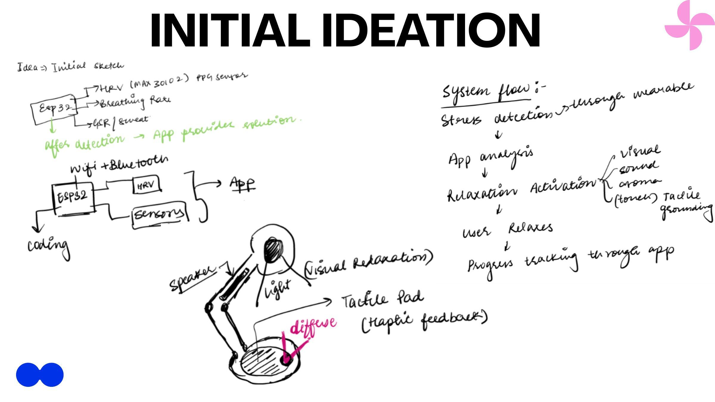
Figure 3. Initial ideation sketch showing the early system flow concept, hardware block diagram (ESP32 with HRV and sensory subsystems), and product concept sketch with annotated modalities.
The proposed closed-loop architecture was formalised as: Wearable Device (PPG Sensor) → Signal Processing → Stress Index Calculation → Stress Level Classification → Detected Stress Level → Multisensory Response. The architecture was decomposed into four functional layers: sensing, processing, communication, and actuation.

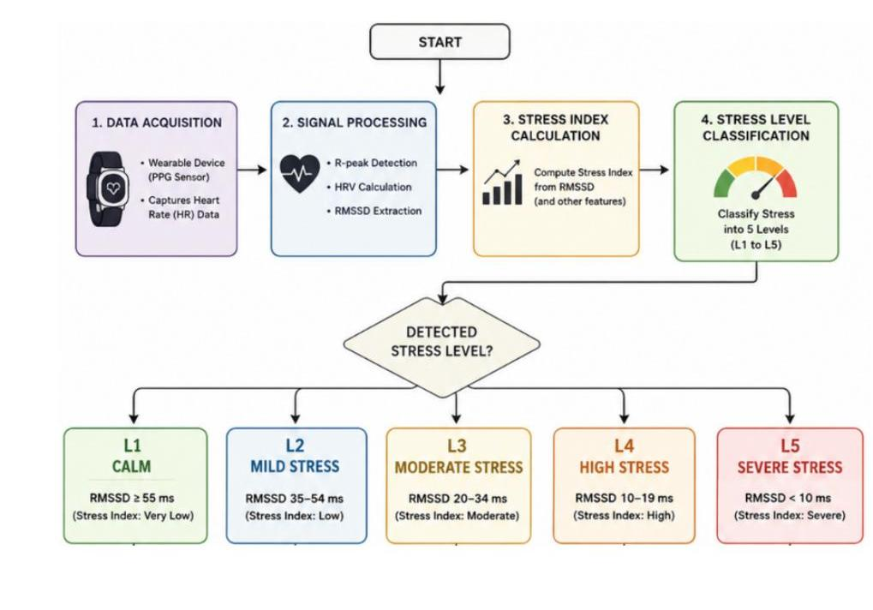
Figure 4. System architecture flowchart showing data flow from acquisition through R-peak detection, HRV calculation, and RMSSD extraction to five-level stress classification (L1–L5) and corresponding multisensory response.
Phase 4: Proposed Electronics Architecture and Component Selection

We've crafted a proposed embedded hardware architecture centered around the ESP32-S3 microcontroller. The ESP32-S3 was chosen for its built-in Wi-Fi and BLE capabilities, a variety of peripheral interfaces, ample GPIO availability, and its ability to manage multiple output modalities effectively.

For the visual intervention subsystem, we're looking at using an SK6812 RGBW LED ring to create adaptive lighting and breathing-light patterns. The audio subsystem will feature a PCM5102A I²S DAC, a MAX98357A Class-D amplifier, and a speaker to deliver soothing audio and guided breathing prompts. When it comes to haptic feedback, we propose using a DRV2605L haptic driver paired with a Linear Resonant Actuator (LRA) to produce controlled tactile patterns. Lastly, the olfactory subsystem is set to incorporate an ultrasonic piezoelectric atomizer, which will be managed through a MOSFET switching circuit.

Table 2. Proposed hardware components for DeskHelp physical implementation.
Subsystem | Component | Interface | Function
Microcontroller | ESP32 | GPIO/I²C/I²S/Wi-Fi/BLE | Central processing, communication
PPG Sensor | MAX30102 | I²C | Heart rate and HRV acquisition
Accelerometer | MPU6050 | I²C | Motion context for stress disambiguation
Visual | WS2812B NeoPixel Ring | Single data pin (RMT) | Chromatherapy, breathing patterns
Audio | MAX98357A + Speaker | I²S | Calming soundscapes, guided breathing
Haptic | DRV2605L + LRA | I²C | Programmable tactile grounding patterns
Aroma | Ultrasonic Piezo Atomizer | MOSFET GPIO | Aromatherapy diffusion
Display | ILI9341 TFT / SSD1306 OLED | SPI / I²C | Status display
Power | LM2596 + TP4056 + MT3608 | Rail | 12V→5V→3.3V distribution

4.5 Phase 5: Mobile Application and HRV Simulation
A digital Progressive Web Application (PWA) was developed to serve as the processing and control hub and to demonstrate the proposed system workflow as a digital proof of concept. Since a physical wearable was not implemented, an HRV simulation was developed that generates synthetic physiological data corresponding to user-selected stress levels. The application processes this data through the RMSSD classification framework and communicates the resulting stress level to the DeskHelp lamp simulation via the same actuation logic proposed for the physical system.

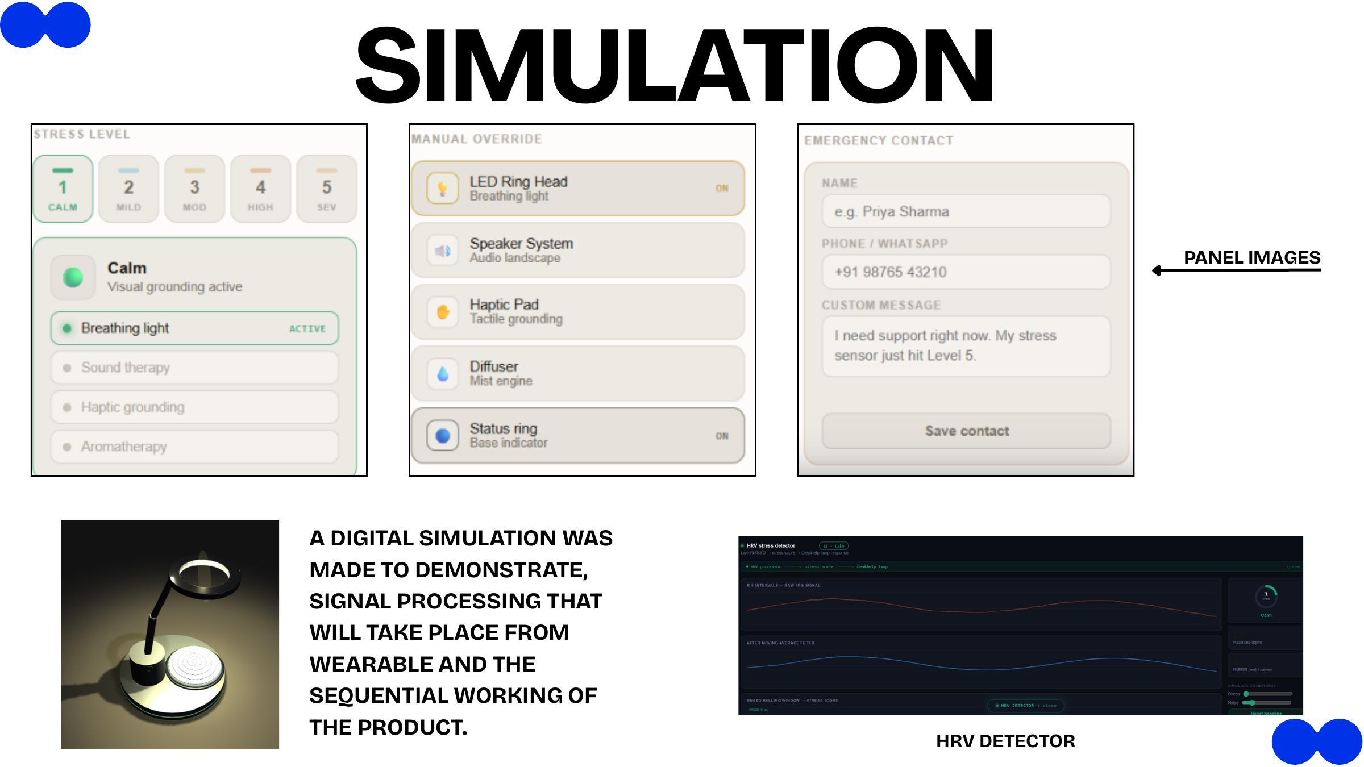
Figure 6. DeskHelp digital simulation showing (left) the five-level stress panel with active intervention modalities at L1 Calm, (centre) manual override panel for individual subsystem control, (right) emergency contact panel, and (bottom) HRV stress detector with live R-R interval and RMSSD charts.
The application interface included a stress-level panel displaying the five classification states and their active intervention modalities; a manual override panel allowing individual control of the LED ring, speaker, haptic pad, diffuser, and status ring; and an emergency contact panel for Level 5 notification. The simulation served as a digital proof of concept for the software workflow and system logic.

4.6 Phase 6: CAD-Based Product Design
The physical form of DeskHelp was developed using Autodesk Fusion 360 for 3D modelling, mechanical integration, and structural refinement. Key design specifications were: base diameter Ø160 mm for a stable circular form factor; ring head diameter Ø120 mm housing the LED chromatherapy ring; overall height 278 mm; and an adjustable dual-joint mechanical arm. The base accommodates the electronics volume, power supply, diffuser reservoir, and haptic module, with the tactile grounding surface positioned centrally for ergonomic interaction.

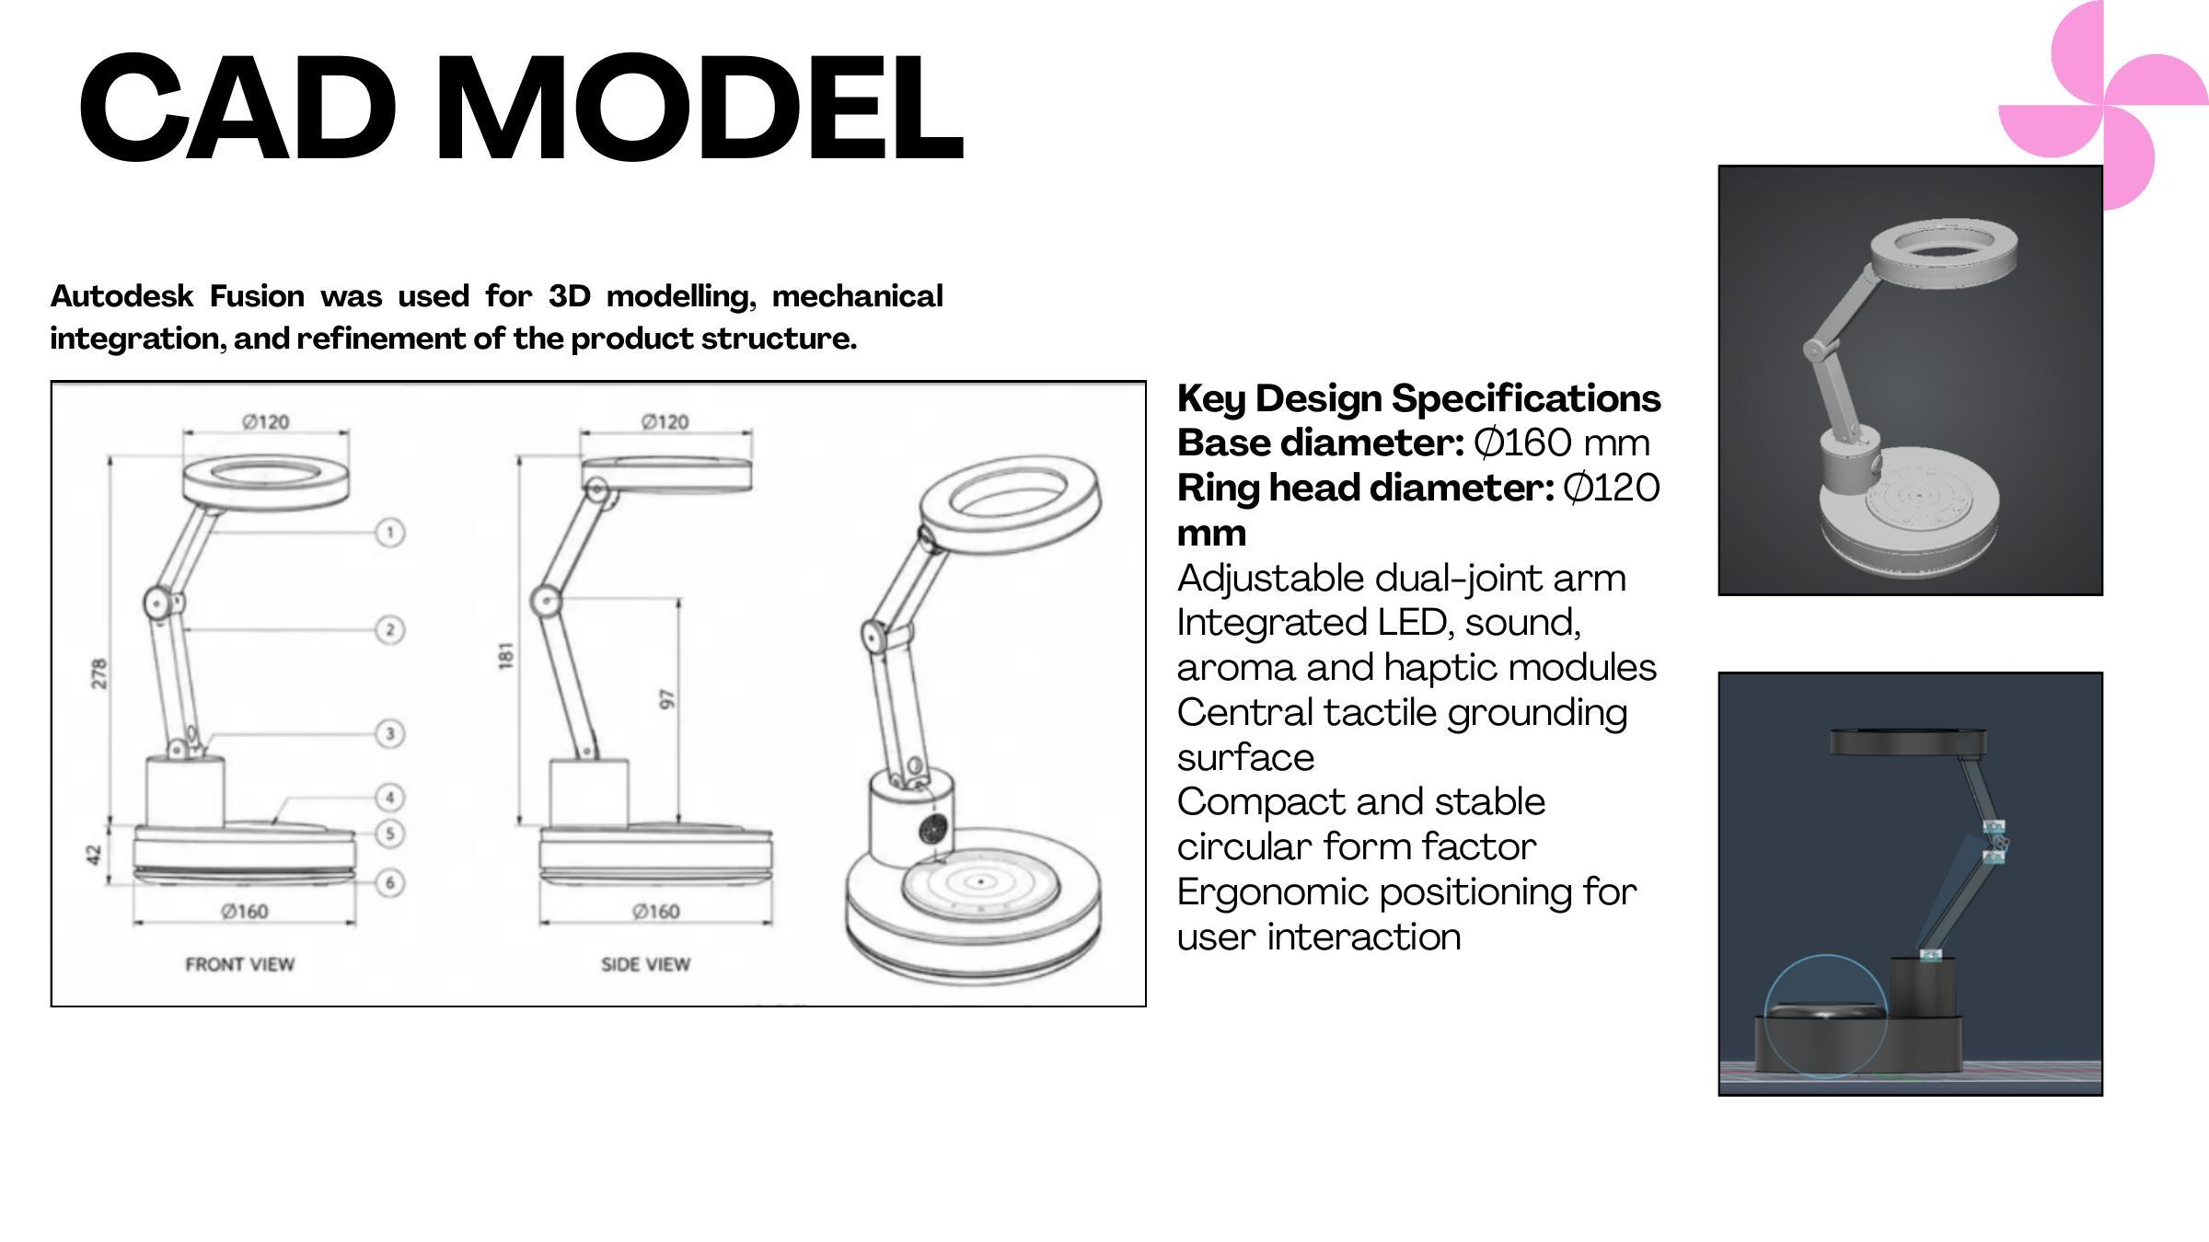
Figure 8. CAD engineering drawings (front view and side view with dimensions) of DeskHelp showing base Ø160 mm, ring head Ø120 mm, arm height 278 mm, and component numbering for assembly reference.
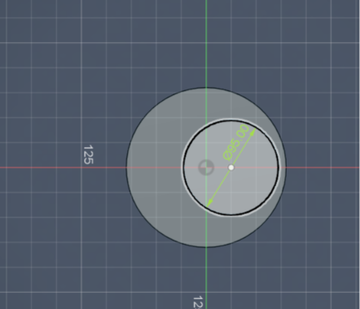
Figure 9. Autodesk Fusion 360 top-view CAD sketch of DeskHelp base showing concentric circular geometry and Ø125 mm inner ring dimension for LED ring integration.
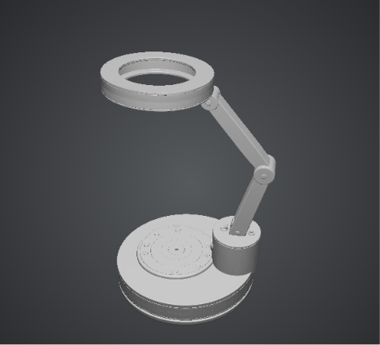
Figure 10. Autodesk Fusion 360 3D render of DeskHelp showing the complete product form: circular base with tactile grounding surface, dual-joint articulating arm, and ring-shaped LED head.
Since the physical product was not fabricated during the present study, the CAD model represents the proposed physical design and serves as the reference geometry for future PCB layout, enclosure fabrication, and hardware assembly.

4.7 Phase 7: Proposed Validation Framework
Since the present study produced a digital prototype, no physical hardware testing or human participant validation was conducted. The proposed future validation framework comprises three stages. Technical bench-level validation would compare RMSSD values against a reference ECG-derived HRV system, measure end-to-end communication latency, and characterise actuator response times. User-based evaluation with the target adolescent population would assess usability, comfort, and perceived effectiveness of each intervention modality. Longitudinal assessment would examine whether repeated system use produces measurable changes in self-reported stress (Perceived Stress Scale) and physiological HRV indicators.

5. Results

5.1 Survey Results Summary
The survey conducted with 25 respondents from the target age group yielded the following directional findings. Regarding instinctive stress coping behaviour, meditation/yoga was the most commonly selected option (frequently rated 4 – Often), followed by sleep and listening to music. Social media scrolling was rated as an occasional response. Regarding emotional health, anxiety levels were predominantly rated at 4 (High) on a 1–5 scale, with mood swings reported as high by the majority. Sadness levels showed greater variability, with most respondents at medium to high ratings. Regarding sleep quality, disturbed sleep was the most widely reported issue, followed by difficulty falling asleep. Hours of sleep receiving adequate ratings (6 hours or more) showed only moderate frequency. Regarding peer comparison, 48% of respondents rated themselves at score 3 (moderate comparison), with 24% at score 4 (high comparison). These results collectively confirmed the presence of measurable stress-related symptom patterns in the target population and supported the design rationale for a passive, non-intrusive intervention system.

5.2 Digital Prototype Outcomes
The outcomes of the present study comprise the following deliverables. A complete system architecture was defined, encompassing the four-layer closed-loop pipeline from PPG sensor acquisition through RMSSD computation and five-level stress classification to coordinated multisensory actuation. A proposed hardware architecture was developed, specifying all electronic components, communication interfaces, GPIO allocations, and power distribution for the DeskHelp lamp unit and wearable sensor module. A mobile PWA was implemented incorporating an HRV simulation module, five-level stress panel, manual override controls, emergency contact management, stress history visualisation, and the HRV detector interface with live R-R interval and RMSSD rolling trend charts. A CAD product model was developed in Autodesk Fusion 360 with dimensioned engineering views (Ø160 mm base, Ø120 mm ring head, 278 mm height) establishing the geometry for future fabrication. A circuit diagram was produced illustrating the proposed wiring between the ESP32 microcontroller and all peripheral components.

6. Discussion

6.1 Significance of the Closed-Loop Design

Most of the wellness technology reviewed in Chapter 2 stops at the point of measurement. A device tells the user their stress score, sometimes with admirable precision, and then leaves the next step — what to actually do about it — entirely up to them. This is precisely the gap the research-gap analysis in Section 2.6 identified, and it is also the gap that the survey data in Chapter 5 puts a number on: 84% of respondents believed a coping technique like meditation would help them, yet 68% admitted they never used one when actually stressed. That gap between knowing and doing is not a motivation problem in the abstract; it is a design problem, and it is the one DeskHelp is built to solve.

The system's contribution, then, is not the sensing itself — HRV-based stress estimation is by now a well-trodden path in the literature — but the decision to close the loop around it. DeskHelp follows a Detect → Classify → Decide → Intervene → Measure Response cycle, and critically, every step after "Detect" happens without requiring the user to do anything at all. The lamp does not ask; it responds. This matters most in exactly the situations where notification-based tools tend to fail: under high cognitive load, an alert asking someone to "take a breathing break" competes for the same limited attention that is already the scarce resource. By folding the intervention into the ambient environment the user is already sitting in, DeskHelp sidesteps the action-requirement altogether, rather than trying to make that requirement easier to meet.

6.2 Multi-Modal Intervention as Design and Therapeutic Choice

Running four sensory channels at once was not an obvious default — a simpler, single-channel device (light alone, or sound alone) would have been considerably easier to build and debug. The choice to combine light, sound, haptics, and aroma was made deliberately, on two separate grounds. The first is evidentiary: as the literature summarised in Section 2.4 shows, single-modality interventions tend to produce comparatively modest effect sizes on their own, whereas approaches that engage multiple, complementary sensory-processing pathways simultaneously tend to show additive calming effects [12]. The second ground is more practical — the ESP32-S3 platform selected for this project has enough peripheral bandwidth and timing headroom to actually drive four concurrent outputs without one starving another, which is not true of every microcontroller in this class.

That said, "enough headroom" does not mean the coordination problem disappears; it just becomes tractable. Each output subsystem speaks a different protocol and runs on a different clock: the LED ring over single-wire GPIO, the audio path over I2S, the haptic driver over I2C, and the aroma engine on a fast PWM line tied to the piezo's resonant frequency. Keeping all four synchronised to the shared breathPhase timing variable described in Chapter 3 — so that the light's exhale, the haptic dome's texture shift, and the sound's volume swell all land together rather than drifting apart — is what motivated the proposed FreeRTOS multi-core task architecture. Distributing the four output loops across separate cores/tasks, rather than servicing them sequentially from a single loop, is the concrete embedded-systems contribution this project makes toward solving that timing problem, and it is arguably where the ECE component of the work is most visible.

6.3 RMSSD Thresholds and Classification Validity

The five-level classification used throughout this report (≥55 ms calm, down through <10 ms severe) should be read as exactly what it is: a working design decision made to give the digital prototype something concrete to demonstrate, not a clinically validated boundary. Published normative RMSSD values for healthy adolescents at rest are generally reported in the 40–80 ms range [8], with values under roughly 20 ms consistently associated with marked sympathetic dominance. Set against that backdrop, the DeskHelp calm-level threshold of 55 ms sits toward the higher end of the adult reference range, which is a deliberate — if provisional — adjustment, since RMSSD baselines in the 16–19 age bracket that this device targets tend to run higher than in adult populations generally.

The honest caveat here is that a single fixed set of thresholds, however reasonably chosen, cannot account for how much HRV varies from one person to the next. Two students with identical stress levels can produce noticeably different RMSSD values simply as a function of age, fitness, or baseline autonomic tone. Recalibrating these boundaries against an individually derived baseline, rather than a population-wide cutoff, is consequently flagged here as one of the non-negotiable requirements for the hardware-validation phase that follows this internship — not a nice-to-have refinement, but a precondition for the classification actually meaning anything at an individual level.

6.4 Future Directions: Machine Learning Integration

The threshold-based classifier used in the current prototype has one clear virtue: it is transparent, computationally trivial, and can run comfortably within the ESP32's resource budget. What it cannot do is adapt — either to the fact that different people have different baselines, or to the fact that the same person's baseline drifts over time with fitness, sleep, or age. Replacing it with a personalised model is the obvious next step, and Mentis et al.'s review of the field points to SVM, Random Forest, and CNN architectures as particularly well suited to classifying stress from HRV-derived features specifically.

There is a second, less commonly discussed option worth naming here, given how the DeskHelp pipeline is already structured: a Bayesian structural time-series model applied to an individual's rolling RMSSD trajectory. Rather than classifying a single reading against a fixed population threshold, this approach would model where a person's own baseline is expected to sit at a given moment and flag stress as a deviation from that expected trajectory — which is a meaningfully different, arguably more personalised notion of "elevated stress." It is also a natural fit here rather than a bolt-on, since the signal-processing pipeline described in Chapter 3 already produces exactly the rolling-window HRV time series such a model would need as input. The one real constraint, as flagged in Section 2.6, is data: training either approach on demographically appropriate normative values would require an Indian-adolescent HRV dataset that, at present, does not really exist in the literature reviewed for this project.

6.5 Limitations
A few limitations of this work deserve honest acknowledgment, since they mark exactly where the project stops being a finished product and starts being a foundation for one.
The most obvious is that what exists today is a digital prototype, not a physical device. No hardware was built, no experiment was run, and no person actually sat at a DeskHelp lamp and had their stress measured before and after. That means the central claim of the project — that this kind of multisensory intervention actually helps — is still a hypothesis grounded in literature and design reasoning, not something demonstrated firsthand. Closing that gap is really the next phase of the work, not an afterthought to it.
Second, the survey of 25 students was never meant to carry statistical weight on its own. It's a small, informal sample, and treating its numbers as representative of students broadly would be a stretch. Its real value was directional — it helped shape decisions about which sensory channels to prioritise and how to frame the problem, not to produce generalisable conclusions.
Third, the thresholds used to translate RMSSD values into the five stress levels are, at this stage, design choices rather than clinically validated cut-offs. They were chosen to make the system behave sensibly in the prototype, but they haven't been checked against real physiological data from a clinical or research setting, so they'd need proper calibration before the system could be trusted to classify stress accurately in practice.
Fourth, the PPG-based method used to estimate inter-beat intervals has only been considered in a controlled, prototype sense — it hasn't been tested on someone actually going about their day, moving around, typing, fidgeting, all the things that introduce motion artefacts and noise into real PPG signals. Whether the same approach holds up outside a clean, still-seated scenario is still an open question.
Finally, and this ties back to a gap the literature review itself surfaced, there simply isn't much HRV data collected specifically from Indian adolescents. That absence matters more than it might first appear, because any future move toward a personalised, machine-learning-based classifier would need training data that reflects the actual population the device is meant to serve. Without it, even a well-designed model risks being calibrated on a demographic that doesn't quite match the people using DeskHelp.

7. Conclusion
This work set out to build DeskHelp, a wellness device that quietly watches over a person's stress levels and responds to them — not with alerts or notifications that demand attention, but through light, sound, touch, and scent working together on a desk lamp. The target group was late-adolescent students, aged 16 to 19, a population that, as the project's own preliminary survey of 25 respondents confirmed, experiences stress frequently but rarely does anything deliberate about it in the moment. That survey turned out to be one of the more important pieces of evidence in this project: it didn't just show that students are stressed, it showed why a passive intervention makes more sense than an app that asks them to stop and meditate.
At its core, DeskHelp reads a person's heart rate variability through photoplethysmography, the same optical sensing principle used in most consumer smartwatches, and derives a stress estimate from RMSSD, a well-established time-domain HRV metric. That estimate is mapped onto a five-level scale, and each level triggers a progressively richer combination of sensory responses. The whole system is stitched together with Bluetooth Low Energy for the wearable-to-phone link and BLE or Wi-Fi for the phone-to-lamp link, with an ESP32 microcontroller sitting at the centre of it all, coordinating everything from the LED ring to the diffuser.
What this internship actually produced goes well beyond a concept sketch. The hardware side is fully specified down to part numbers — a WS2812B NeoPixel LED ring for the light, a MAX98357A amplifier driving the audio, a DRV2605L haptic driver controlling the tactile feedback, and an ultrasonic piezoelectric atomizer for the aroma diffusion — along with a circuit diagram showing how these pieces connect. Alongside that sits a mobile Progressive Web App that simulates the HRV pipeline and lets a user step through all five stress levels to see and hear the lamp respond, plus a complete CAD model built in Autodesk Fusion 360, with proper dimensioned engineering drawings of the enclosure and its parts.
If there's a single takeaway from this project, it's that the different corners of Electronics and Communication Engineering — signal processing, embedded systems, wireless protocols, power electronics, and the less glamorous work of making hardware and software actually talk to each other — don't have to live in separate boxes. They can come together in one object designed around a real, everyday problem. What remains is the next, harder phase: turning this specification into an actual PCB, assembling and testing physical hardware, and eventually teaching the system to learn a person's own stress patterns rather than relying on fixed thresholds.
.

References

[1] K. Rathakrishnan, M. K. Kim, and S. J. Park, "The Effects of Vagus Nerve Stimulation on Insomnia Persons for Stress Reduction and Sleep Induction."
[2] T. R. Gatla, "A Next-Generation Device Utilizing Artificial Intelligence for Detecting Heart Rate Variability and Stress Management."
[3] A.-F. A. Mentis et al., "Applications of Artificial Intelligence–Machine Learning for Detection of Stress: A Critical Overview."
[4] B. A. Hickey et al., "Smart Devices and Wearable Technologies to Detect and Monitor Mental Health Conditions and Stress: A Systematic Review."
[5] R. Jerath et al., "The Future of Stress Management: Integration of Smartwatches and HRV Technology."
[6] G. Xu et al., "An Adaptive System for Wearable Devices to Detect Stress Using Physiological Signals."
[7] P. Schmidt et al., "WESAD: A Multimodal Dataset for Wearable Stress and Affect Detection."
[8] A. Sano and R. Picard, "Stress Detection Using Wearable Physiological Sensors."
[9] R. Wang et al., "Mobile Heart Health: Monitoring Stress through Smartphones."
[10] F. Shaffer and J. P. Ginsberg, "Heart Rate Variability as an Index of Stress and Health."
[11] M. Zubair et al., "Stress Detection from Electrodermal Activity and HRV."
[12] J. Hernandez et al., "Automatic Stress Detection in Working Environments."
[13] L. Kennedy and K. Parker, "Biofeedback Wearables for Stress Reduction."
[14] E. Sykianaki et al., "Mental Health Monitoring through Smartwatch Sensors."
[15] K. Al-Shargie et al., "Wearable EEG Systems for Real-Time Stress Assessment."
[16] K. Hovsepian et al., "AI-Based Stress Detection Using Physiological Signals."
[17] J. Kim et al., "Detection of Stress and Mental Fatigue Using HRV."
[18] Dr. S. Pandit, Supervision Discussions and Feedback, IIITDMJ Design Department, June–July 2025.

