Question 1 :

#include <stdio.h>

#include <string.h>

int main() {

char str[100];

printf("Enter string : ");

scanf("%[^\n]s", &str);

printf("String in reverse order : ");

for (int i = strlen(str) - 1; i >=0; i--) {

printf("%c", str[i]);

}

printf("\n");

return 0;

}

Output :

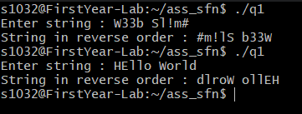

Question 2 :

#include <stdio.h>

#include <string.h>

#include <ctype.h>

int main() {

char str[100];

printf("Enter string : ");

scanf("%[^\n]s", &str);

int alpha = 0;

int digits = 0;

int sp = 0;

for (int i = 0; i < strlen(str); i++) {

if (isalpha(str[i])) alpha++;

else if (isdigit(str[i])) digits++;

else if (str[i] != " ") sp++;

}

printf("Alphabets = %d\n", alpha);

printf("Digits = %d\n", digits);

printf("Special chars = %d\n", sp);

return 0;

}

Output :

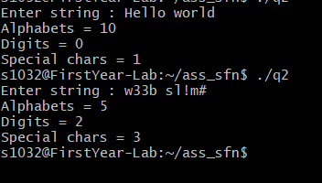

Question 3 :

#include <stdio.h>

#include <string.h>

#include <ctype.h>

int main() {

char str[100];

printf("Enter your string : ");

scanf("%[^\n]s", &str);

int l = -1;

int h = -1;

int count = 0;

while (l <= (int) strlen(str)) {

if (isspace(str[h + 1])) {

if (l != h) {

l = h + 1;

count++;

} else l++;

}

h++;

}

printf("No. of words = %d\n", count);

return 0;

}

Output :

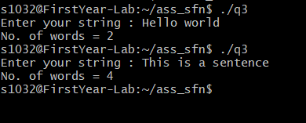

Question 4 :

#include <stdio.h>

#include <string.h>

#include <math.h>

int search(char c, char str[]) {

for (int i = 0; str[i] != '\0'; i++) {

if ((char) str[i] == c) return i;

}

return -1;

}

int maxIdx(int nums[], int n) {

int max[2] = {nums[0], 0};

for (int i = 1; i < n; i++) {

if (nums[i] > max[0]) {

max[0] = nums[i];

max[1] = i;

}

}

return max[1];

}

void concat(char str[], char c) {

int i = 0;

while (str[i] != '\0') i++;

str[i] = c;

str[i + 1] = '\0';

}

int main() {

char str[100];

char uniqueStr[100] = "";

printf("Enter your string : ");

scanf("%[^\n]s", &str);

for (int i = 0; i < strlen(str); i++) {

if (search(str[i], uniqueStr) == -1) concat(uniqueStr, str[i]);

}

int uLen = strlen(uniqueStr);

int count[uLen];

for (int i = 0; i < uLen; i++) count[i] = 0;

for (int i = 0; i < strlen(str); i++) {

int idx = search(str[i], uniqueStr);

count[idx]++;

}

printf("Maximum occuring character here = %c ", uniqueStr[maxIdx(count, uLen)]);

printf("with no. of occurances = %d", count[maxIdx(count, uLen)]);

return 0;

}

Output :

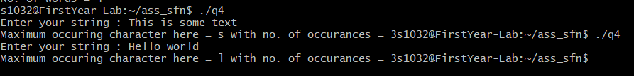

Question 5 :

int main() {

char str[100];

printf("Enter your string : ");

scanf("%[^\n]s", &str);

int len = strlen(str);

for (int i = 0; i < len; i++) {

for (int j = 0; j < len - i - 1; j++) {

if ((int) str[j] > (int) str[j + 1]) {

char temp = str[j];

str[j] = str[j + 1];

str[j + 1] = temp;

}

}

}

printf("Your string in ascending order : \n");

printf("%s\n", str);

return 0;

}

Output :

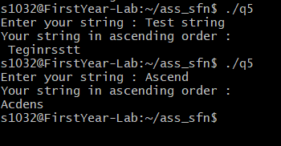

Question 6 :

#include <stdio.h>

#include <string.h>

int main() {

char str1[100];

printf("Enter first string : ");

scanf("%[^\n]s", &str1);

while (getchar() != '\n') {}

char str2[100];

printf("Enter second string : ");

scanf("%[^\n]s", &str2);

int j = strlen(str1);

for (int i = 0; i < strlen(str2); i++, j++) {

\*(str1 + j) = str2[i];

}

\*(str1 + j) = '\0';

printf("%s\n", str1);

return 0;

}

Output :

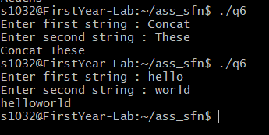

Question 7 :

#include <stdio.h>

#include <string.h>

int search(char s1[], char s2[]) {

int l1 = strlen(s1);

int l2 = strlen(s2);

int idx = -1;

for (int i = 0; i < l1; i++) {

if (s1[i] == s2[0]) {

int j = 1;

for (; j < l2; j++) {

if (s1[i + j] != s2[j]) break;

}

if (j == l2) {

idx = i;

break;

}

}

}

return idx;

}

int main() {

char str1[100];

char str2[100];

printf("Enter first string : ");

scanf("%[^\n]s", &str1);

while(getchar() != '\n') {}

printf("Enter the string that is to be searched in str1 : ");

scanf("%[^\n]s", &str2);

const int idx = search(str1, str2);

if (idx > -1) printf("Found at index %d\n", idx);

else printf("String not found\n");

return 0;

}

Output :

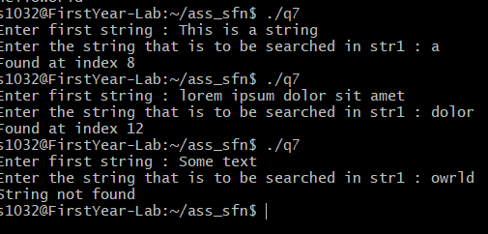

Question 8 :

#include <stdio.h>

#include <string.h>

int main() {

char str1[100];

char str2[100];

int i = 0;

printf("Enter first string : ");

scanf("%[^\n]s", &str1);

while(getchar() != '\n') {}

printf("Enter second string : ");

scanf("%[^\n]s", &str2);

for (; i < strlen(str2); i++) {

\*(str1 + i) = str2[i];

}

\*(str1 + i) = '\0';

printf("Now str1 becomes: \n");

printf("%s", str1);

return 0;

}

Output :

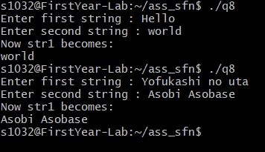

Question 9 :

#include <stdio.h>

#include <string.h>

void ascii(char c) {

printf("Ascii value of %c is %d\n", c, c);

}

int main() {

char str[100];

printf("Enter string : ");

scanf("%[^\n]s", &str);

for (int i = 0; i < strlen(str); i++) {

ascii(str[i]);

}

return 0;

}

Output :

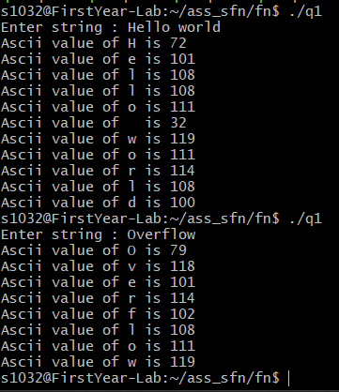

Question 10 :

#include <stdio.h>

void printPrimes(int l, int h) {

if (l < 2) l = 2;

for (; l <= h; l++) {

int flag = 0;

for (int i = 2; i <= l / 2; i++) {

if (!(l%i)) flag = 1;

}

if (!flag) printf("%d ", l);

}

}

int main() {

int l, h;

printf("Enter te interval : ");

scanf("%d %d", &l, &h);

printPrimes(l, h);

return 0;

}

Output :

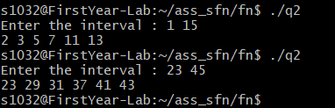

Question 11 :

#include <stdio.h>

int factorial(int n) {

if (n == 1) return 1;

return factorial(n - 1) \* n;

}

int sumSeries(int n) {

if (n <= 1) return 1;

return factorial(n - 1) + sumSeries(n - 2);

}

int main() {

int n;

printf("Enter the number : ");

scanf("%d", &n);

int sum = sumSeries(n);

printf("Sum of the series ");

for (int i = 1; i <= n - 1; i++) {

printf("%d!/%d + ", i, i);

}

printf("%d!/%d = %d\n", n, n, sum);

return 0;

}

Output :

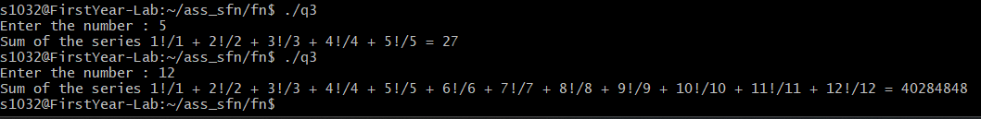

Question 12 :

#include <stdio.h>

#include <math.h>

int decToBin(int d) {

int bin = 0;

int p = 0;

while (d) {

bin += (d % 2) \* pow(10, p);

d >>= 1;

p++;

}

return bin;

}

int main() {

int n;

printf("Enter number : ");

scanf("%d", &n);

printf("Binary = %d\n", decToBin(n));

}

Output :

