SIMATS ENGINEERING

CSA4307
INTERNET PROGRAMMING

CO2 - ASSESSMENT TOOL 3

R Mohnish (192411112)

Code of Conduct
I R Mohnish (192411112) that this submission is my original work and that I have adhered to the guidelines specified for this assessment. I understand that any violation of academic integrity rules will result in disciplinary action.
Signature of the student: R Mohnish

QUESTION 1: RESPONSIVE WEB DESIGN AND ADAPTIVE LAYOUTS
Scenario: A company wants its website to work seamlessly on mobile phones, tablets, and desktop computers. The layout must adjust to screen size without requiring separate websites.

Responsive Web Design
Responsive Web Design (RWD) is an approach in which a website automatically adjusts its layout, images, text, and navigation according to the size and orientation of the device. The same HTML content is presented differently through CSS. For example, three product cards may appear in one row on a desktop, two columns on a tablet, and a single column on a phone.
Responsive design is important because people visit websites using different devices. It improves readability, makes buttons easier to use, reduces horizontal scrolling, and provides a consistent experience. It also reduces maintenance because developers do not need to create separate desktop and mobile websites. A responsive website can be more accessible and easier to navigate when content is organized clearly.

CSS Techniques for Responsiveness
Important techniques include fluid widths, flexible layout systems, responsive images, media queries, and suitable CSS units. Percentages and fractional units such as fr allow elements to share available space. Flexbox and Grid arrange content without relying on fixed coordinates. Images can use max-width: 100% and height: auto to avoid overflowing their containers. Media queries apply new rules at selected viewport widths. Units such as rem, %, and vw can be used where they make sense.
The viewport meta tag is also essential for mobile layouts because it tells the browser to use the device's actual width when laying out the page. Without it, mobile browsers may scale a desktop-sized layout down, making text and controls difficult to use.

Flexbox and Grid Layouts
Flexbox is mainly one-dimensional and works well for navigation bars, toolbars, and aligning items in a row or column. Properties such as display: flex, gap, justify-content, align-items, and flex-wrap help arrange items and allow them to wrap when space is limited. CSS Grid is two-dimensional and works well for dashboards, galleries, and card collections. The repeat() and minmax() functions can create columns that adapt to the container width. For example, repeat(auto-fit, minmax(220px, 1fr)) asks the browser to fit as many columns as possible while keeping each column at a practical minimum width.

Example and User Experience
The following example uses CSS Grid to create an adaptive group of service cards. The cards automatically move to fewer columns when the viewport becomes narrow.
<!DOCTYPE html>
<html lang="en">
<head>
<meta charset="UTF-8">
<meta name="viewport" content="width=device-width, initial-scale=1.0">
<title>Responsive Layout</title>
<style>
body { font-family: Arial, sans-serif; margin: 0; padding: 20px; }
.cards {
display: grid;
grid-template-columns: repeat(auto-fit, minmax(220px, 1fr));
gap: 16px;
}
.card { padding: 20px; border: 1px solid #ccc;
border-radius: 8px; background: #f5f7fb; }
img { max-width: 100%; height: auto; }
</style>
</head>
<body>
<h1>Our Services</h1>
<section class="cards">
<article class="card"><h2>Design</h2><p>Clear interfaces.</p></article>
<article class="card"><h2>Development</h2><p>Reliable websites.</p></article>
<article class="card"><h2>Support</h2><p>Helpful assistance.</p></article>
</section>
</body>
</html>
Working: The viewport tag sets the page width to the device width. Grid creates the card layout, minmax() sets a useful minimum column width, and 1fr allows columns to share available space. The gap property creates consistent spacing. As the screen narrows, fewer columns fit, so the cards flow into additional rows.
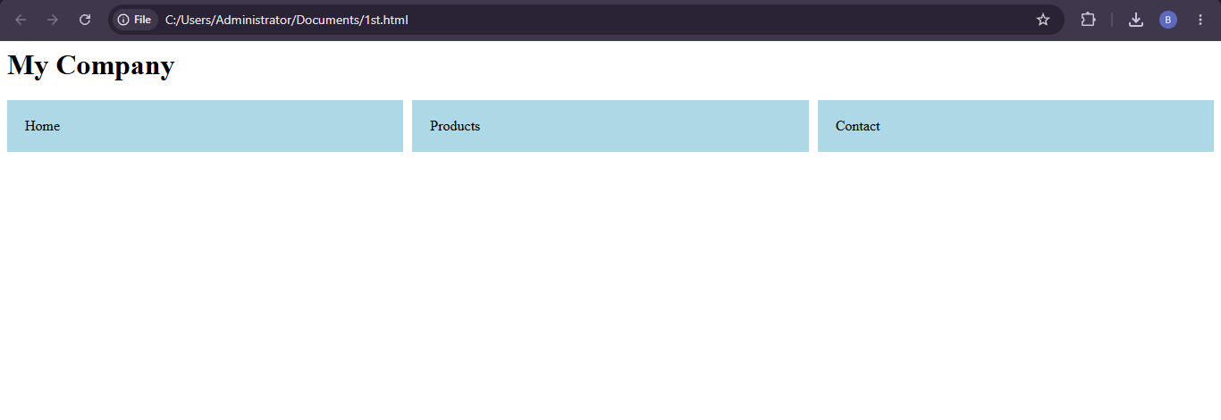Conclusion: Responsive design combines fluid sizing, media queries, and flexible layouts to create a website that works across devices.

QUESTION 2: CLIENT-SIDE FORM VALIDATION
Scenario: A webpage contains a form where user input must be checked before submission.

Client-Side Validation
Client-side validation checks data in the browser before it is sent to the server. It can identify missing or incorrectly formatted information immediately. For example, a registration form can check that the name is not empty, the email resembles a valid email address, and the phone number contains the expected digits. This improves data quality, reduces avoidable requests, and allows users to correct errors before submitting.
HTML provides attributes such as required, type="email", minlength, maxlength, and pattern. JavaScript is useful when custom rules or clearer error messages are required. Client-side validation is primarily for usability; it must not be treated as a security barrier because users can bypass browser-side code.

JavaScript Event Handling
Event handling makes validation run in response to a user action. The submit event is commonly used to validate the entire form. The input event can check a value while the user types, and blur can check it when the user leaves a field. Calling event.preventDefault() stops the normal submission when the program needs to display an error first. Good validation identifies the problem clearly and tells the user how to correct it.

Regular Expressions
A regular expression (regex) is a pattern used to check whether text follows a format. The pattern ^[0-9]{10}$ means that the complete input must contain exactly ten digits. A basic email pattern can check for text before an @ symbol and a domain containing a dot. Regex can catch common formatting mistakes, but it cannot confirm that an email account exists or that a phone number is active.

Example, Usability and Security
The program checks the name, email, and phone number before reporting success. If a check fails, submission is stopped and a helpful message is shown.
<!DOCTYPE html>
<html lang="en">
<head><meta charset="UTF-8"><meta name="viewport" content="width=device-width, initial-scale=1.0"><title>Form Validation</title></head>
<body>
<h1>Registration Form</h1>
<form id="registerForm" novalidate>
<label for="name">Name:</label>
<input id="name" type="text" required><br><br>
<label for="email">Email:</label>
<input id="email" type="text" required><br><br>
<label for="phone">Phone:</label>
<input id="phone" type="text" required><br><br>
<p id="message" role="alert"></p>
<button type="submit">Register</button>
</form>
<script>
const form = document.getElementById("registerForm");
const message = document.getElementById("message");

form.addEventListener("submit", function(event) {
event.preventDefault();
const name = document.getElementById("name").value.trim();
const email = document.getElementById("email").value.trim();
const phone = document.getElementById("phone").value.trim();
const emailPattern = /^[^\s@]+@[^\s@]+\.[^\s@]+$/;
const phonePattern = /^[0-9]{10}$/;

if (name === "") message.textContent = "Please enter your name.";
else if (!emailPattern.test(email)) message.textContent = "Enter a valid email.";
else if (!phonePattern.test(phone)) message.textContent = "Enter a 10-digit phone number.";
else message.textContent = "Form validated successfully!";
});
</script>
</body>
</html>

Program explanation:
- The submit event listener runs when Register is pressed.
- preventDefault() pauses normal submission so validation can run first.
- trim() removes extra spaces around the name and email.
- The regex test() method checks the email and phone patterns.
- The program displays a relevant message for the first failed rule.
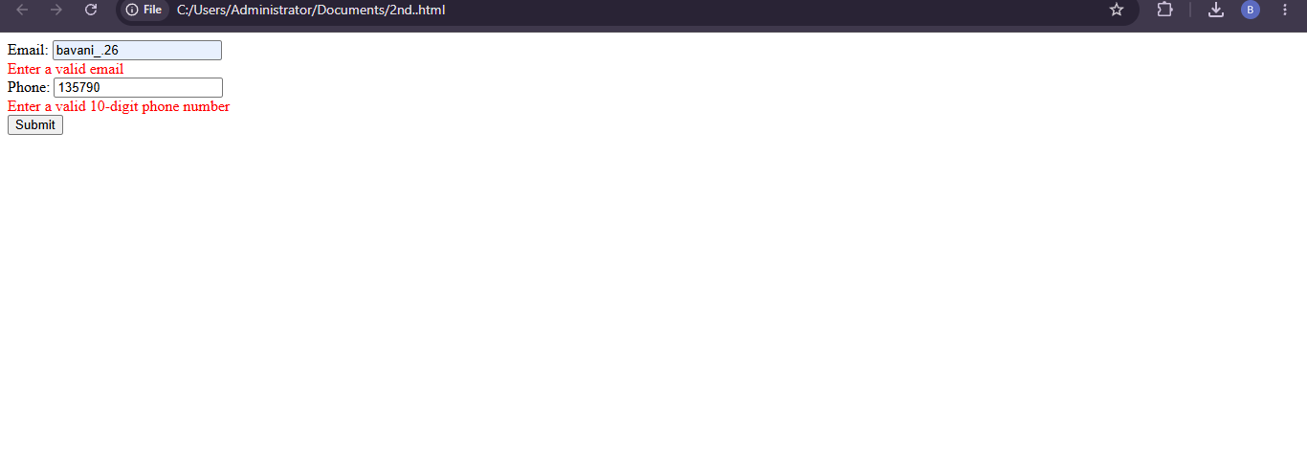Conclusion: Client-side validation improves convenience, regex checks formats, and server-side validation remains essential for security.

QUESTION 3 : CSS BOX MODEL, POSITIONING AND MEDIA QUERIES
Scenario: A webpage layout breaks when the browser window is resized. Some elements overflow, overlap, or leave unexpected gaps.

CSS Box Model
The CSS box model describes the space occupied by an HTML element. It has four components: content, padding, border, and margin. Content is the text or image area. Padding is the space between the content and border. Border surrounds the padding and content. Margin is the outer space separating an element from its neighbours.
With the default content-box model, a declared width applies only to the content, so padding and borders add to the final size. For example, a 300-pixel element with padding and borders can become wider than 300 pixels. The rule box-sizing: border-box makes the declared width include content, padding, and border, simplifying layout calculations.

CSS Positioning
Static is the default positioning mode and follows normal document flow. Relative positioning keeps the element's space in the flow but allows a visual offset. Absolute positioning removes an element from normal flow and positions it relative to its nearest positioned ancestor. Fixed positioning anchors an element to the viewport, while sticky positioning allows it to stick after reaching a scrolling threshold. Overuse of absolute or fixed positioning can cause overlap because those elements do not reserve normal space. Flexbox and Grid are usually safer for the main page structure.

Causes of layout breaking and media queries
Common causes include fixed widths larger than the viewport, images without size limits, excessive padding, long unbreakable text, and absolute positioning used for major layout sections. Media queries apply styles only when a condition is met, such as a maximum viewport width. A layout may use three columns on a desktop, two on a tablet, and one on a phone. This makes the structure respond to available space instead of forcing one design onto every device.

An example and best practices
The example uses border-box sizing, a flexible Grid, fluid images, and two breakpoints.
<!DOCTYPE html>
<html lang="en">
<head>
<meta charset="UTF-8">
<meta name="viewport" content="width=device-width, initial-scale=1.0">
<title>Stable Layout</title>
<style>
* { box-sizing: border-box; }
body { margin: 0; padding: 20px; font-family: Arial, sans-serif; }
.layout { display: grid; grid-template-columns: repeat(3, minmax(0, 1fr)); gap: 16px; }
.box { min-width: 0; padding: 18px; border: 2px solid #345; background: #edf3f8; overflow-wrap: anywhere; }
img { max-width: 100%; height: auto; }
@media (max-width: 800px) { .layout { grid-template-columns: repeat(2, minmax(0, 1fr)); } }
@media (max-width: 520px) { body { padding: 12px; } .layout { grid-template-columns: 1fr; } }
</style>
</head>
<body>
<h1>Responsive Information</h1>
<section class="layout">
<article class="box"><h2>Box One</h2><p>Content fits its container.</p></article>
<article class="box"><h2>Box Two</h2><p>Padding and borders are included in width.</p></article>
<article class="box"><h2>Box Three</h2><p>Columns adapt to screen size.</p></article>
</section>
</body>
</html>\

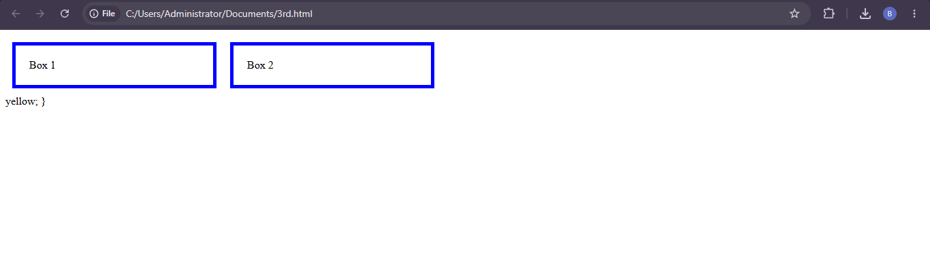
Expected result: The layout changes from three columns to two and then one as the screen narrows.
Conclusion: Understanding the box model and normal flow helps prevent layout errors; media queries and flexible sizing make layouts stable.

QUESTION 4 : DOM MANIPULATION AND DYNAMIC CONTENT
Scenario: A website needs to update a section of content after a user action without reloading the entire page.

The Document Object Model (DOM)
The Document Object Model is the browser's programming representation of an HTML document. The browser parses the HTML and creates a tree of nodes. Headings, paragraphs, forms, and buttons become elements that JavaScript can select and modify. For example, JavaScript can find a paragraph by its ID and replace its text. The DOM supports interactive menus, form messages, shopping carts, expandable sections, and many other dynamic features.

How JavaScript manipulates the DOM
JavaScript can select elements using getElementById(), querySelector(), and querySelectorAll(). It can update text through textContent, change attributes with setAttribute(), modify classes with classList, create elements using createElement(), and add them to the page. Event listeners connect those operations to user actions. textContent is a safe choice for plain text because it does not interpret the inserted value as HTML. Inserting untrusted input through innerHTML can create cross-site scripting risks.

An example of dynamic content updating
The example changes a status paragraph when a button is clicked. Only the paragraph changes; the browser does not reload the document.
<!DOCTYPE html>
<html lang="en">
<head><meta charset="UTF-8"><meta name="viewport" content="width=device-width, initial-scale=1.0"><title>DOM Example</title></head>
<body>
<h1>Student Portal</h1>
<p id="status">Click the button to view your status.</p>
<button id="updateButton" type="button">Check Status</button>
<script>
const button = document.getElementById("updateButton");
const status = document.getElementById("status");
button.addEventListener("click", function() {
status.textContent = "Your student profile is ready to view.";
});
</script>
</body>
</html>

The output and suggest improvements
When the page first loads, the original instruction appears. Clicking Check Status runs the event listener and changes the paragraph's textContent. The change is immediate and does not require a full page refresh. Performance and usability can be improved by updating only the required elements, reusing selected element references, displaying clear status messages, and handling loading or error states if data comes from a server. Use textContent for plain text and avoid inserting untrusted user data as HTML.
Expected result: Clicking the button changes the status message on the same page.
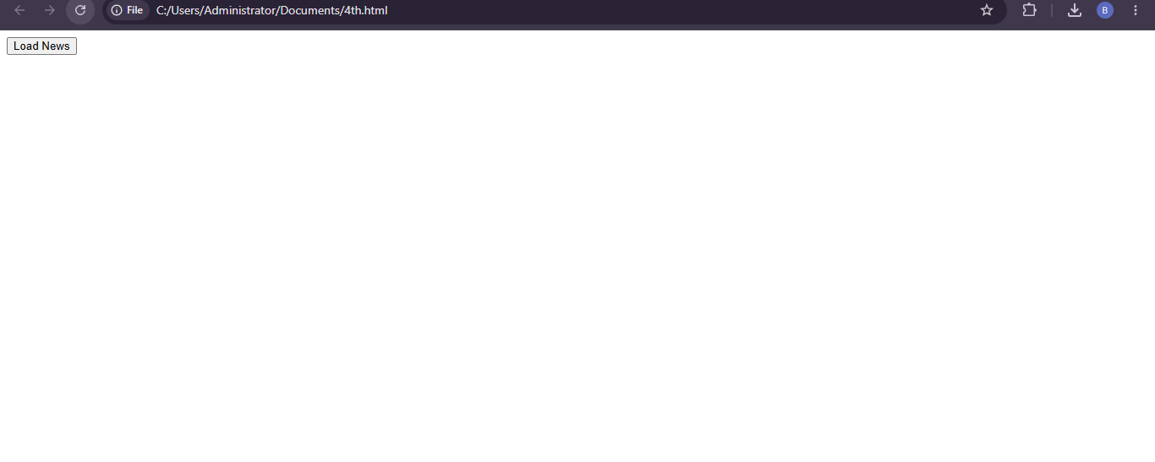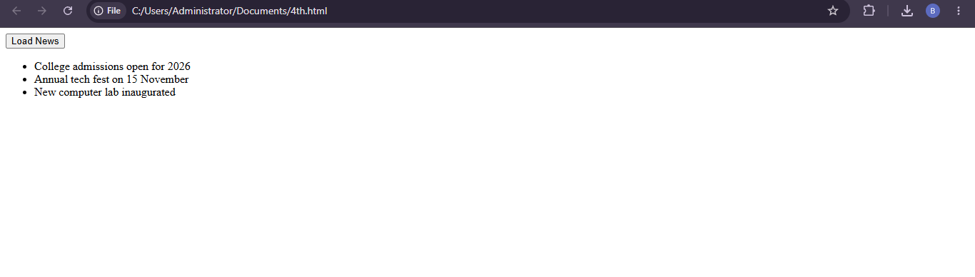
Conclusion: The DOM connects HTML with JavaScript, enabling developers to select elements, respond to events, and update content dynamically.

QUESTION 5 : RESPONSIVE LAYOUT FOR A COLLEGE WEBSITE
Scenario: A college website must display properly on desktops, tablets, and mobile phones.

The responsive layout approach
I would use mobile-first design. The default styles would arrange content in a single column suitable for a narrow screen. At wider sizes, media queries would add columns and increase spacing. The viewport meta tag ensures the browser uses the actual device width. Flexible layout methods prevent content from overflowing the viewport.

Media queries and flexible layouts
Media queries apply CSS rules when the viewport reaches a specified size. Grid is useful for arranging information cards, while Flexbox works well for the header and navigation because it aligns items in a row and can wrap them. The Grid expression repeat(auto-fit, minmax(230px, 1fr)) allows the browser to fit as many cards as practical into the available width.

A suitable program
The program contains a college header, navigation links, and three information cards that adjust to the available width.
<!DOCTYPE html>
<html lang="en">
<head>
<meta charset="UTF-8">
<meta name="viewport" content="width=device-width, initial-scale=1.0">
<title>College Website</title>
<style>
* { box-sizing: border-box; }
body { margin: 0; font-family: Arial, sans-serif; }
header { display: flex; flex-wrap: wrap; gap: 12px; justify-content: space-between;
align-items: center; padding: 18px; color: white; background: #183b63; }
nav { display: flex; flex-wrap: wrap; gap: 14px; }
nav a { color: white; text-decoration: none; }
main { padding: 20px; }
.cards { display: grid; grid-template-columns: repeat(auto-fit, minmax(230px, 1fr)); gap: 16px; }
.card { padding: 18px; background: #eef3f8; border-radius: 8px; }
@media (max-width: 480px) {
main { padding: 12px; }
header { align-items: flex-start; flex-direction: column; }
}
</style>
</head>
<body>
<header>
<strong>ABC College</strong>
<nav aria-label="Main navigation">
<a href="#home">Home</a><a href="#courses">Courses</a>
<a href="#admissions">Admissions</a><a href="#contact">Contact</a>
</nav>
</header>
<main id="home">
<h1>Welcome to ABC College</h1>
<section class="cards">
<article class="card"><h2>Courses</h2><p>Explore academic programmes.</p></article>
<article class="card"><h2>Admissions</h2><p>Learn how to apply.</p></article>
<article class="card"><h2>Campus</h2><p>Discover campus facilities.</p></article>
</section>
</main>
</body>
</html>
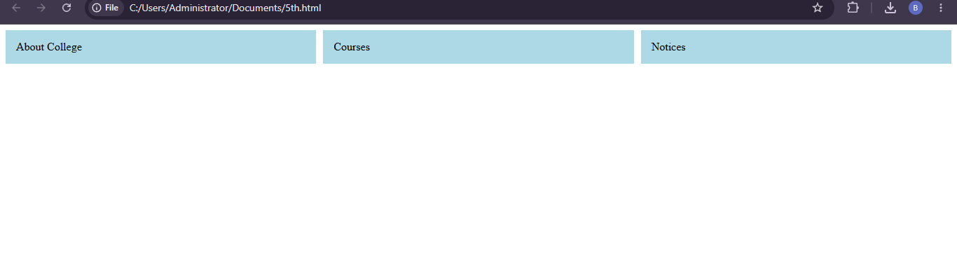

The result and testing
On a wide desktop, the cards appear in several columns. As the viewport narrows, Grid reduces the number of columns and the cards stack vertically on small screens. The header can wrap so the college name and navigation do not collide. Test the page at phone, tablet, and desktop widths, and verify that there is no horizontal scrollbar.
Conclusion: Media queries, Grid, Flexbox, and mobile-first styling help the college website remain readable across devices.

QUESTION 6 : CSS STYLING FOR PRODUCT CARDS
Scenario: An online shopping website has plain product cards. CSS colours, borders, shadows, and spacing can make them attractive and easier to scan.

The purpose of the CSS properties
Colours create visual hierarchy and distinguish the card from the page background. Borders define card edges, and border-radius creates rounded corners. Box-shadow adds depth. Padding provides space inside the card, while margin and gap separate cards from one another. Consistent use of these properties gives the page a more organized appearance.

Good design practices
Use enough contrast between the background and text. Product names should stand out from descriptions, and prices should be easy to find. Keep padding and gaps consistent across cards. Hover effects can provide feedback, but product details and buttons must remain visible without hovering. The layout should also adapt to smaller screens.
<!DOCTYPE html>
<html lang="en">
<head>
<meta charset="UTF-8">
<meta name="viewport" content="width=device-width, initial-scale=1.0">
<title>Styled Product Cards</title>
<style>
body { margin: 0; padding: 24px; font-family: Arial, sans-serif; background: #f3f5f8; }
.products { display: grid; grid-template-columns: repeat(auto-fit, minmax(220px, 1fr)); gap: 20px; }
.card { padding: 20px; background: white; border: 1px solid #d8dee8;
border-radius: 12px; box-shadow: 0 4px 12px rgba(0,0,0,0.08);
transition: transform 0.2s, box-shadow 0.2s; }
.card:hover { transform: translateY(-4px); box-shadow: 0 9px 20px rgba(0,0,0,0.14); }
.price { color: #176b3a; font-weight: bold; }
button { width: 100%; padding: 10px; color: white; background: #17365d;
border: 0; border-radius: 6px; cursor: pointer; }
</style>
</head>
<body>
<h1>Featured Products</h1>
<section class="products">
<article class="card"><h2>Headphones</h2><p>Wireless audio.</p><p class="price">₹2,499</p><button type="button">View Product</button></article>
<article class="card"><h2>Smart Watch</h2><p>Activity and notifications.</p><p class="price">₹3,999</p><button type="button">View Product</button></article>
<article class="card"><h2>Bluetooth Speaker</h2><p>Portable sound.</p><p class="price">₹1,799</p><button type="button">View Product</button></article>
</section>
</body>
</html>

How the styles improve the cards
The light page background makes the white cards stand out. The border defines the edge without looking too heavy, and the rounded corners create a softer appearance. The shadow separates each card visually from the background. Padding keeps the text away from the edges, while Grid and gap keep spacing consistent. The hover transition provides gentle feedback when a pointer is available.
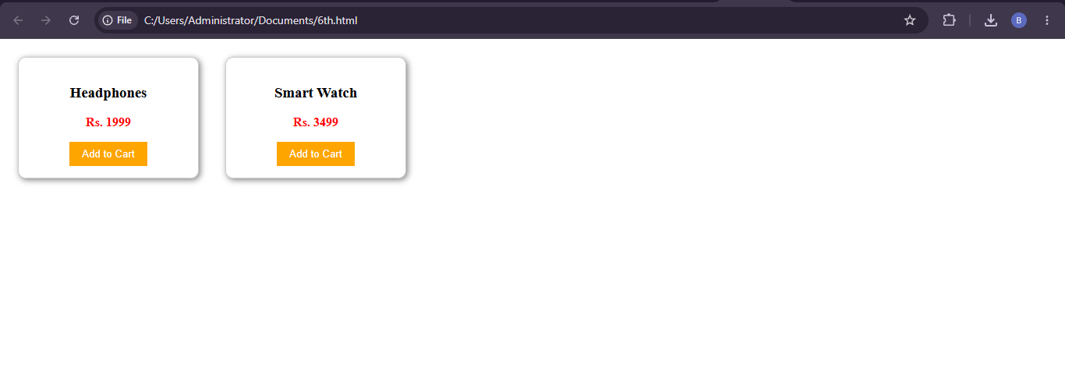

The result and further improvements
The page displays a responsive group of cards with clear product names, descriptions, prices, and buttons. Further improvements include using consistent product images with alternative text, adding keyboard focus styles, checking contrast, and avoiding excessive shadows or animation. Test the design on phones and larger screens.
Conclusion: Colour, borders, shadows, and spacing can make product cards clearer and more attractive without sacrificing usability.

QUESTION 7 : FIXING AN OVERLAPPING NAVIGATION MENU
Scenario: A navigation menu overlaps the content on smaller screens, making links difficult to use.

Possible causes of the overlap
Overlap can occur when navigation items have fixed widths, a row is not allowed to wrap, or the menu is absolutely positioned without reserving space. Fixed heights, excessive margins, and desktop-only dimensions can also force elements outside the viewport. A flexible layout and a breakpoint-specific arrangement can solve these issues.

CSS layout techniques to fix the problem
Flexbox can align the logo and navigation links and can wrap items when the row becomes narrow. A media query can change the menu from horizontal to vertical on mobile devices. Keeping the navigation in normal document flow allows the content below it to move down when the menu needs more height, instead of being covered by the menu.
<!DOCTYPE html>
<html lang="en">
<head>
<meta charset="UTF-8">
<meta name="viewport" content="width=device-width, initial-scale=1.0">
<title>Responsive Navigation</title>
<style>
* { box-sizing: border-box; }
body { margin: 0; font-family: Arial, sans-serif; }
header { display: flex; flex-wrap: wrap; justify-content: space-between;
align-items: center; gap: 12px; padding: 16px; background: #17365d; color: white; }
nav { display: flex; flex-wrap: wrap; gap: 16px; }
nav a { color: white; text-decoration: none; padding: 6px; }
main { padding: 20px; }
@media (max-width: 600px) {
header { align-items: flex-start; flex-direction: column; }
nav { flex-direction: column; gap: 4px; width: 100%; }
nav a { display: block; padding: 10px 0; }
}
</style>
</head>
<body>
<header>
<strong>My Website</strong>
<nav aria-label="Main navigation">
<a href="#home">Home</a><a href="#services">Services</a>
<a href="#about">About</a><a href="#contact">Contact</a>
</nav>
</header>
<main id="home">
<h1>Page Content</h1>
<p>The content begins below the navigation.</p>
</main>
</body>
</html>

How the program works
On larger screens, Flexbox places the site name and navigation on one row if space permits. flex-wrap allows items to move to a new line if necessary. At 600 pixels or below, the media query changes the header into a column and displays links vertically. The header remains in normal document flow, so the content moves down to make room.
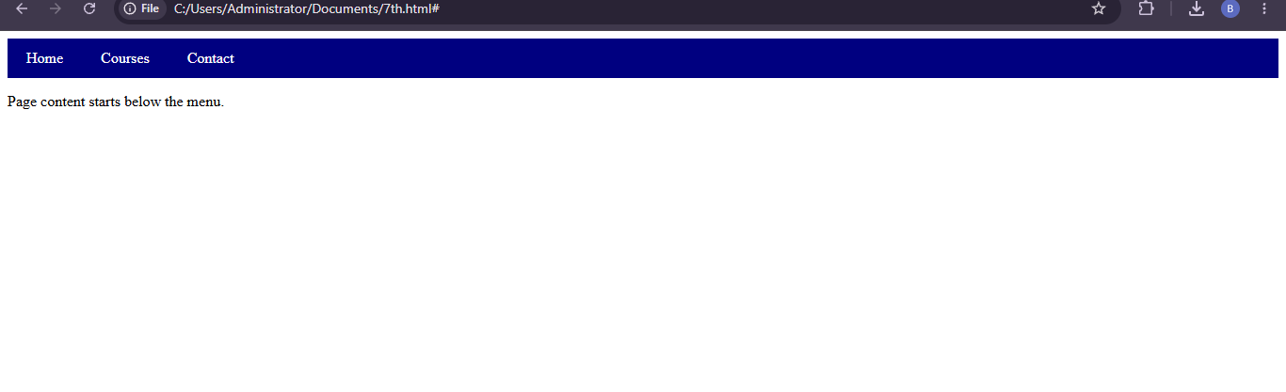

Testing and improvements
Test widths around the breakpoint and confirm that every link is visible and easy to select. Avoid fixed heights because a vertical menu may need extra space. If a collapsible menu is added, use a real button, update aria-expanded, and ensure that opening the menu does not hide essential content.
Expected result: The navigation fits smaller screens and no longer covers the page content.
Conclusion: Flexbox, wrapping, media queries, and normal document flow help prevent navigation overlap.

QUESTION 8 : JAVASCRIPT VALIDATION FOR A REGISTRATION FORM
Scenario: A registration form accepts empty fields. JavaScript must check required values before the form continues.

The validation requirements
A registration form may require a name, email address, and password. Empty values should be rejected because they create incomplete records. The program should trim extra spaces, check each required field, and display a clear message if any value is missing. It may also check email format and password length.

The submit event
The submit event occurs when the user presses the submit button or submits the form through the keyboard. JavaScript can listen for the event and inspect the fields. If a value is invalid, preventDefault() stops normal submission while an error is shown. If all checks pass, the program can continue to the server. The server must validate the data again.
<!DOCTYPE html>
<html lang="en">
<head><meta charset="UTF-8"><meta name="viewport" content="width=device-width, initial-scale=1.0"><title>Registration Form</title></head>
<body>
<h1>Create Account</h1>
<form id="signupForm">
<label for="fullName">Name:</label><input id="fullName" type="text"><br><br>
<label for="email">Email:</label><input id="email" type="email"><br><br>
<label for="password">Password:</label><input id="password" type="password"><br><br>
<p id="error" role="alert"></p>
<button type="submit">Register</button>
</form>
<script>
const form = document.getElementById("signupForm");
const error = document.getElementById("error");
form.addEventListener("submit", function(event) {
event.preventDefault();
const name = document.getElementById("fullName").value.trim();
const email = document.getElementById("email").value.trim();
const password = document.getElementById("password").value;

if (name === "" || email === "" || password === "")
error.textContent = "Please fill in all fields.";
else if (password.length < 8)
error.textContent = "Password must contain at least 8 characters.";
else
error.textContent = "All required fields are valid.";
});
</script>
</body>
</html>

Program Explanation
The program selects the form and message paragraph by ID. The submit listener pauses normal submission while the fields are checked. It reads and trims the name and email. If any field is empty, it asks the user to complete the form. If the password is shorter than eight characters, it displays a specific message. Otherwise, it reports that the client-side checks passed.
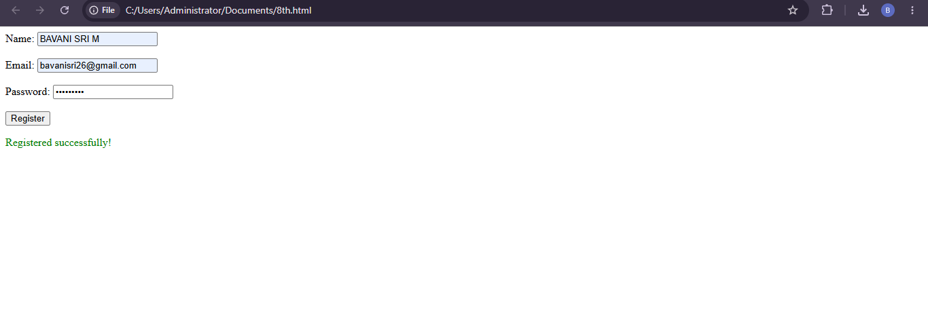

Improvements
Use required and type="email" attributes along with JavaScript. Display errors near the affected fields and focus the first invalid input. Use appropriate autocomplete attributes. Never display or log the password. In a real application, use HTTPS, validate data on the server, and store passwords only using a suitable password-hashing method.
Expected result: Empty fields and short passwords are identified before the form continues.
Conclusion: JavaScript validation helps prevent incomplete form input and improves user feedback, while server-side checks protect the application.

QUESTION 9 : INTERACTIVE WELCOME BUTTON
Scenario: An e-learning website requires a button that displays a welcome message when a student clicks it.

Required Interaction
An interactive button responds to a user action. Initially, the page displays a short instruction. After the student clicks the button, a welcome message appears. JavaScript handles the click event and updates the DOM, so the page does not need to reload.

Click Event Handling
The button is selected using getElementById(). The addEventListener() method registers a callback for the click event. When clicked, the callback changes a paragraph using textContent. This is appropriate because the message is plain text.
<!DOCTYPE html>
<html lang="en">
<head>
<meta charset="UTF-8">
<meta name="viewport" content="width=device-width, initial-scale=1.0">
<title>E-learning Welcome</title>
<style>
body { font-family: Arial, sans-serif; padding: 30px; }
button { padding: 12px 20px; color: white; background: #24558d;
border: 0; border-radius: 6px; cursor: pointer; }
button:focus-visible { outline: 3px solid #f0a000; outline-offset: 3px; }
</style>
</head>
<body>
<h1>Online Learning Portal</h1>
<p id="welcomeMessage">Click below to begin your learning journey.</p>
<button id="welcomeButton" type="button">Welcome</button>
<script>
const button = document.getElementById("welcomeButton");
const message = document.getElementById("welcomeMessage");
button.addEventListener("click", function() {
message.textContent = "Welcome to the e-learning portal! Happy learning.";
});
</script>
</body>
</html>

Program Output
When the page loads, the paragraph contains the initial instruction. Clicking Welcome runs the callback and replaces the text with “Welcome to the e-learning portal! Happy learning.” The update is immediate and the page remains loaded.
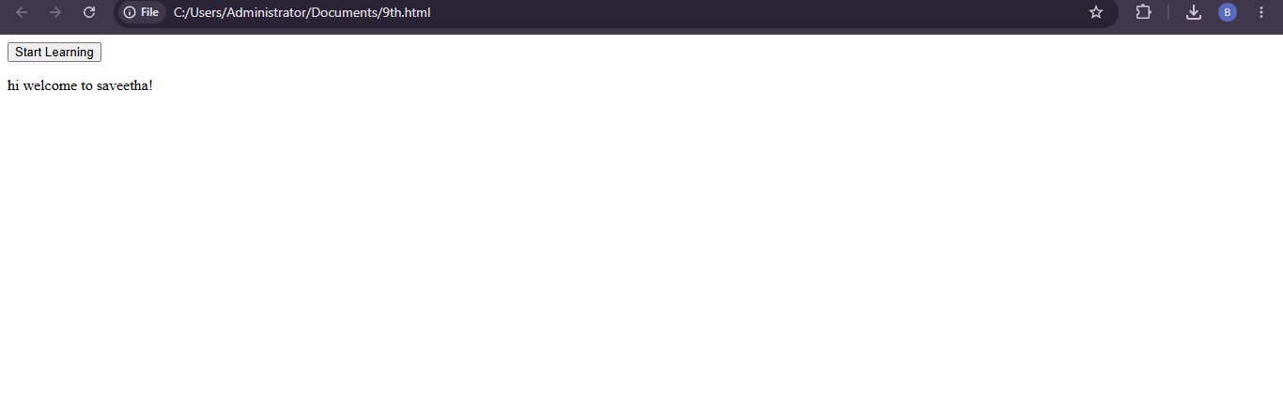
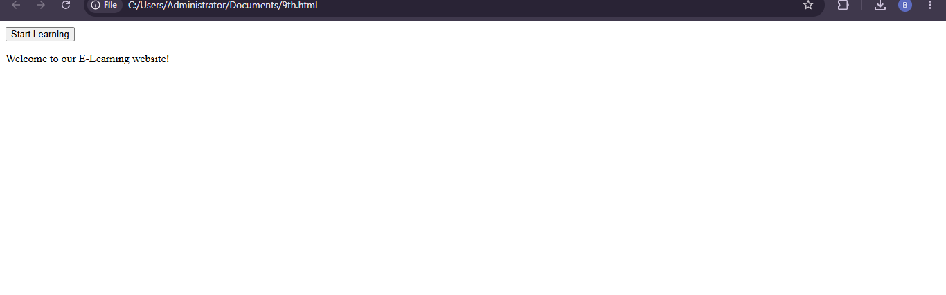

Improvements
The message can be personalized using a student's name if the application already knows it. Use a sufficiently large button, readable text, good contrast, and visible keyboard focus. If the button starts a longer operation, show progress or a status message. Keep type="button" when it is not intended to submit a form.
Expected result: Clicking Welcome displays the message on the same page.
Conclusion: JavaScript click events and DOM updates create a simple interactive feature for an e-learning website.

QUESTION 10 : DYNAMIC PRODUCT PRICE CALCULATION
Scenario: A shopping website needs to update the total price when the customer changes the quantity of a product.

Requirement and Calculation
A shopping cart should show the total amount for the selected quantity. The basic formula is Total Price = Unit Price × Quantity. If one notebook costs ₹50 and the customer selects four, the total is ₹50 × 4 = ₹200. When quantity changes, JavaScript should recalculate the amount and display it immediately.

JavaScript Events
The input event detects changes in a quantity field. JavaScript reads the value, converts it to a number, checks that it is within the allowed range, multiplies it by the unit price, and updates the total. A minimum and maximum quantity help prevent invalid values.
<!DOCTYPE html>
<html lang="en">
<head>
<meta charset="UTF-8">
<meta name="viewport" content="width=device-width, initial-scale=1.0">
<title>Price Calculator</title>
<style>
body { font-family: Arial, sans-serif; padding: 24px; }
.product { max-width: 420px; padding: 20px; border: 1px solid #ccc; border-radius: 10px; }
input { width: 80px; padding: 8px; }
.total { font-size: 1.2rem; font-weight: bold; color: #176b3a; }
</style>
</head>
<body>
<section class="product">
<h1>Notebook</h1>
<p>Price per item: ₹50</p>
<label for="quantity">Quantity:</label>
<input id="quantity" type="number" min="1" max="99" value="1">
<p class="total">Total: <span id="totalPrice">₹50.00</span></p>
<p id="message" role="status"></p>
</section>
<script>
const unitPrice = 50;
const quantityInput = document.getElementById("quantity");
const totalPrice = document.getElementById("totalPrice");
const message = document.getElementById("message");

function updateTotal() {
const quantity = Number(quantityInput.value);
if (!Number.isInteger(quantity) || quantity < 1 || quantity > 99) {
message.textContent = "Choose a quantity from 1 to 99.";
totalPrice.textContent = "—";
return;
}
message.textContent = "";
totalPrice.textContent = "₹" + (unitPrice * quantity).toFixed(2);
}

quantityInput.addEventListener("input", updateTotal);
updateTotal();
</script>
</body>
</html>

Program Explanation
The unit price is stored in unitPrice. The program selects the quantity field, total display, and message paragraph. updateTotal() converts the quantity to a number and checks that it is an integer from 1 to 99. If it is invalid, a message appears and the program avoids displaying a misleading total. If it is valid, the function multiplies unit price by quantity and displays the result. The input event runs the function whenever the quantity changes.
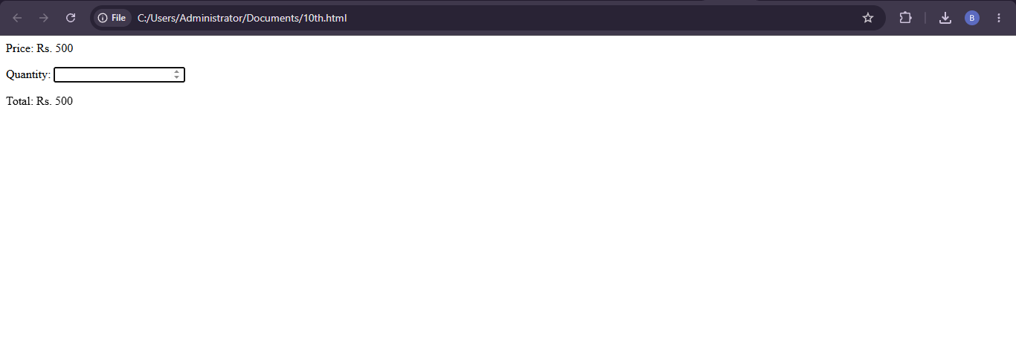
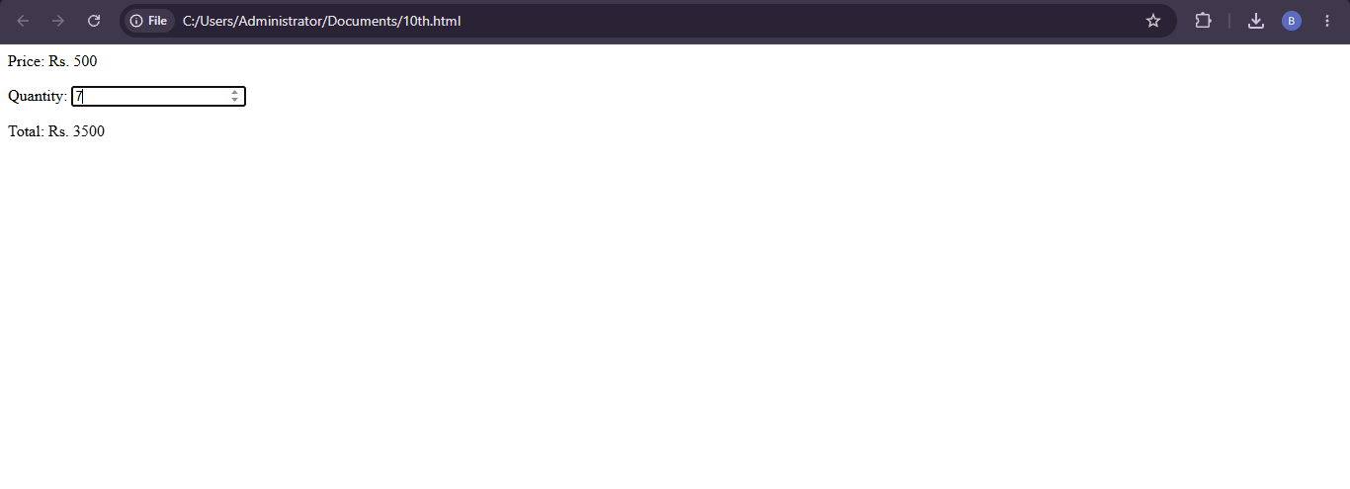
Conclusion: JavaScript events and arithmetic provide immediate price feedback. Server-side price verification is necessary before completing a purchase.

