Hospital Readmission Analytics and Prediction

Project 5 — Part 1: Multi-Source Data Pipeline
Course: Data Engineering and MLOps | Individual Project

1. Introduction and Problem Understanding
Hospital readmissions are a major driver of healthcare cost and a key indicator of care quality. This project builds a privacy-conscious data pipeline that ingests de-identified, publicly available hospital encounter data, enriches it with two additional, genuinely different data sources, cleans and integrates all three, stores the result in an analytical database, and surfaces admission and readmission patterns through an interactive dashboard.
Per the project's data-sources guideline, a data engineering pipeline is not judged by how many tables from one database it joins -- it is judged by how it collects heterogeneous data from different systems, keeps each source identifiable in its own raw zone, and integrates the useful information from each into a unified, curated dataset. This project therefore uses three genuinely different source types -- a file, a REST API, and a document/text source -- rather than a single downloaded CSV.

1.1 Objectives
- Prepare anonymized hospital records for analysis from multiple, genuinely different data sources.
- Keep each source segregated in its own raw zone before integration.
- Create a reproducible healthcare ETL and entity-matching workflow.
- Develop dashboards for admission and readmission patterns, including a source enriched by the API and document sources.
- Lay the groundwork for an operationalized readmission-risk model (Part 2).

2. Data Sources (Three Genuinely Different Types)
The pipeline ingests three sources, each with a different format and ingestion method, each kept in its own raw landing zone rather than merged immediately.
# | Source | Format | Ingestion method | Raw zone
1 | UCI Diabetes 130-US Hospitals dataset | CSV | File ingestion (Pandas) | data/raw/file_raw/
2 | NLM Clinical Tables ICD-9-CM API | JSON/HTTP | REST API connector | data/raw/api_raw/
3 | Synthetic per-specialty feedback notes | Free text | Document ingestion | data/raw/document_raw/

2.1 Why Each Source Adds Value
- Source 1 (File) is the core structured record: admission, diagnosis codes, procedures, medications, and the readmission label. Nothing downstream works without it.
- Source 2 (REST API) turns opaque ICD-9 codes (e.g. "428") into a human-readable clinical description ("Heart failure"). The primary file source only stores raw codes -- it cannot provide this on its own.
- Source 3 (Document) demonstrates unstructured-text ingestion and a keyword-derived risk feature, since the file source has no free-text field at all.

2.2 Access Information
- Source 1: Public, free, CC BY 4.0. https://archive.ics.uci.edu/dataset/296/diabetes+130-us+hospitals+for+years+1999-2008
- Source 2: Public, free, no API key required. Base URL: https://clinicaltables.nlm.nih.gov/api/icd9cm_dx/v3/search
- Source 3: Student-authored synthetic notes, created for this assignment (see Section 2.3 for the honesty note on scope).

2.3 Scope Note on Source 3 (Honesty Disclosure)
The UCI dataset is de-identified specifically so it contains no free-text clinical notes -- attaching real per-patient text is not possible without re-identifying data that was deliberately stripped for privacy. Source 3 is therefore a student-authored, illustrative set of discharge-experience notes written at the medical-specialty level (one representative note per specialty), used to demonstrate the document-ingestion pattern, keyword-based feature extraction, and the join/integration step. It is joined onto encounters via medical_specialty, not surrogate_key -- a deliberate granularity trade-off, disclosed here rather than hidden.

3. Data Architecture
Three sources are ingested independently into segregated raw zones, then the file source is cleaned, then all three are joined in an integration step before loading into the analytical mart.
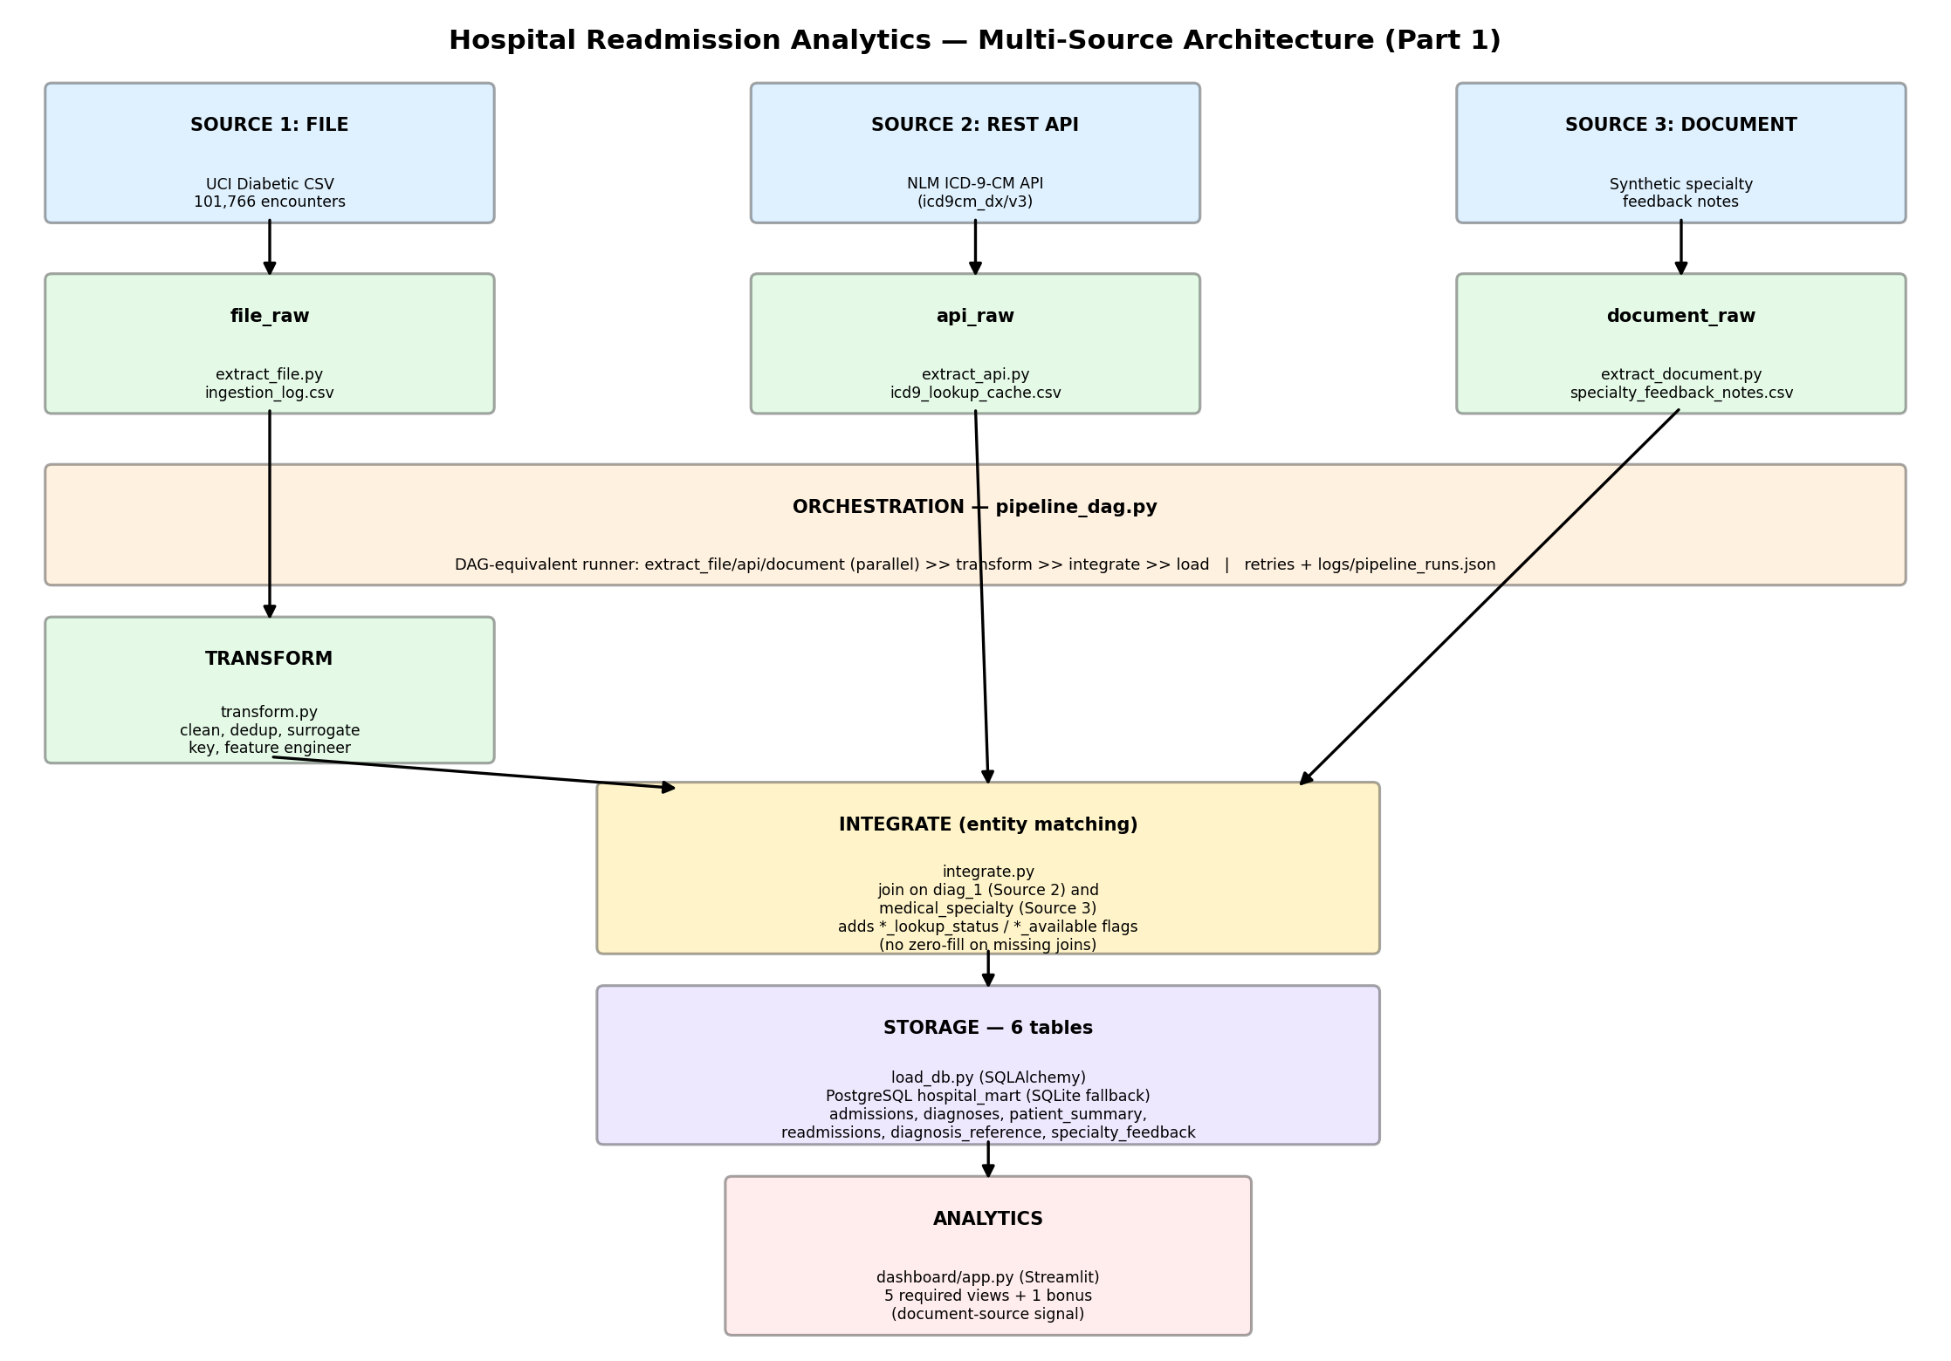
Figure 1: Multi-source pipeline architecture -- 3 sources through segregated raw zones, transform, integrate, storage, and analytics.

4. Ingestion Layer (3 Independent Extractors)

4.1 extract_file.py (Source 1)
Verifies the raw CSV exists and is readable, counts rows, and logs extraction timestamp/source/status/row-count to logs/ingestion_log.csv. Preserves an untouched raw copy in data/raw/file_raw/.

4.2 extract_api.py (Source 2)
Queries the NLM Clinical Tables ICD-9-CM API for the 40 most frequent diag_1 codes in the dataset (covering the large majority of encounters -- looking up all ~700+ distinct codes against a public rate-limited API was judged unnecessary to demonstrate the ingestion pattern, and is documented here as a scoping decision rather than a silent gap). Each lookup is retried up to twice; if the API is completely unreachable, the script falls back to a small offline reference table for the same codes, but this is always logged as FALLBACK_OFFLINE rather than presented as a live match.

4.3 extract_document.py (Source 3)
Writes the synthetic per-specialty feedback notes described in Section 2.3 to data/raw/document_raw/, and logs the extraction like the other two sources.

5. Orchestration Layer
Implemented in src/pipeline_dag.py. As permitted by the assignment ("an Apache Airflow DAG, or an approved equivalent ETL workflow"), a full Airflow installation was not used given the project timeline; this runner reproduces Airflow's core DAG semantics instead:
- Three independent extraction tasks (extract_file_task, extract_api_task, extract_document_task) with no dependency on each other.
- transform_task depends only on extract_file_task (it only cleans Source 1).
- integrate_task is gated on ALL FOUR upstream tasks succeeding (transform + both other extractions), since it joins all three sources.
- load_task depends on integrate_task.
- Per-task logging, retry-on-failure, and a persisted run history in logs/pipeline_runs.json.

6. Transformation Layer (Source 1)
Implemented in src/transform.py, applied only to the file source before integration:
- '?' replaced with proper null values.
- Encounters with a discharge disposition indicating death/hospice removed.
- Only the first encounter per unique patient retained (avoids repeated-patient bias).
- Exact duplicate rows removed.
- One-way-hashed surrogate_key replaces encounter_id / patient_nbr.
- Engineered features: length_of_stay, prior_admissions, diagnosis_count, medication_count, high_risk_flag.
- Rejected records logged with a reason to data/rejected/rejected_records.csv.

7. Integration and Missing-Data Handling
Implemented in src/integrate.py. This is the entity-matching step the data-sources guideline calls for: the three independently-cleaned sources are joined on two different common keys, and every joined feature carries an explicit status/flag column so a missing value's cause stays traceable -- no join result is ever silently zero-filled.
Join | Key | Cardinality
File <-> API | diag_1 (ICD-9 code) | many encounters -> 1 code description
File <-> Document | medical_specialty | many encounters -> 1 specialty note

7.1 Missing-Data Flags
Column | Meaning | Values
diag_1_lookup_status | Why diag_1_description is present/absent | MATCHED / FALLBACK_OFFLINE / NOT_FOUND / NOT_ATTEMPTED / API_UNREACHABLE_NO_FALLBACK
feedback_available | Whether the encounter's specialty has a Source-3 note | 1 / 0
risk_keyword_score | Keyword-based risk signal from Source 3 | integer if feedback_available=1, otherwise genuinely NULL (never 0)

This directly follows the guideline's own worked example: a missing LMS quiz score is kept missing with a Quiz_Attempted flag rather than replaced with zero, because the absence itself is informative and a genuine zero would misrepresent it. The same principle is applied here to both joins.

8. Storage Layer
Implemented in src/load_db.py using SQLAlchemy, targeting PostgreSQL (with an automatic local SQLite fallback using the same code path). Six tables make up the healthcare mart:
- admissions, diagnoses, patient_summary, readmissions -- the core analytical tables, built from the integrated (all three sources joined) dataset.
- diagnosis_reference -- the raw Source-2 cache, kept independently queryable rather than disappearing into the join.
- specialty_feedback -- the raw Source-3 notes, likewise kept independently queryable.
Full column-level definitions are provided in the Data Dictionary (Section 10).

9. Data Visualization
A Streamlit dashboard (dashboard/app.py) queries the healthcare mart directly and renders the five required views plus one bonus view demonstrating the document source. All charts below are generated from the actual integrated dataset (69,990 encounters).

9.1 Readmission Rate by Age Group
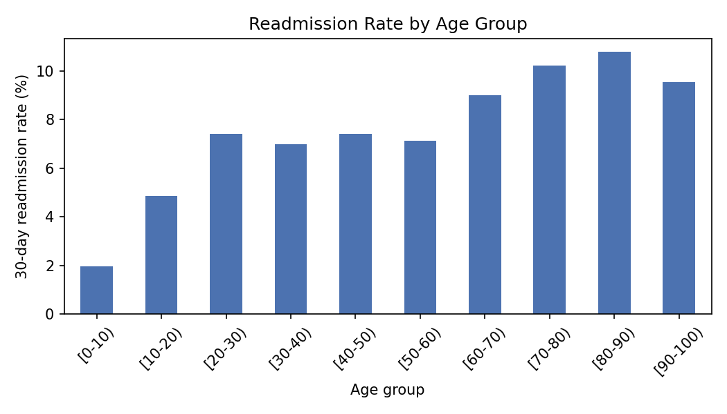
Readmission risk rises with age, consistent with clinical literature on age as a readmission risk factor.

9.2 Readmission Rate by Diagnosis (via the API source)
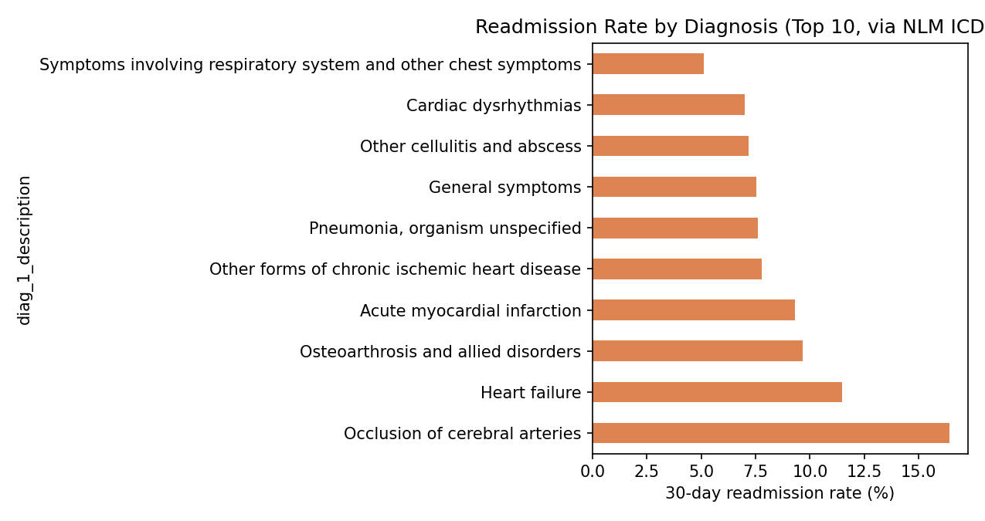
Diagnosis names here come from Source 2 (the NLM ICD-9-CM API) rather than raw codes -- this view would not be possible from the file source alone.

9.3 Length-of-Stay Distribution
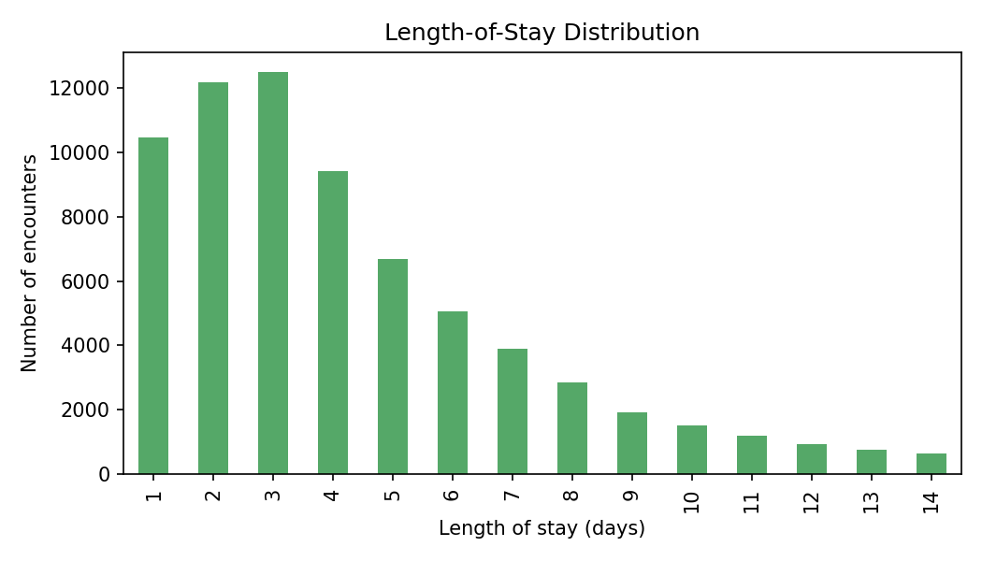
Most encounters cluster between 1 and 5 days, with a long tail out to the dataset's 14-day cap.

9.4 Admission Type Distribution
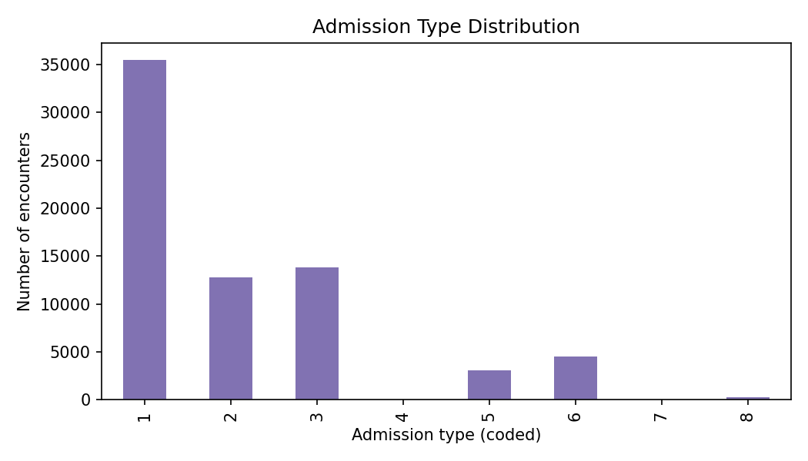
Coded admission types show the relative mix of how patients entered the hospital.

9.5 High-Risk Cohort
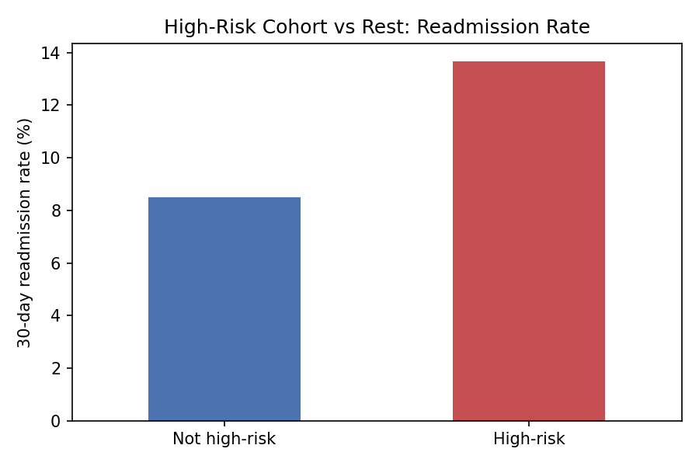
Encounters flagged high-risk (2+ prior admissions and 7+ diagnoses) show a materially higher 30-day readmission rate than the rest of the population.

9.6 Bonus: Document-Source Signal
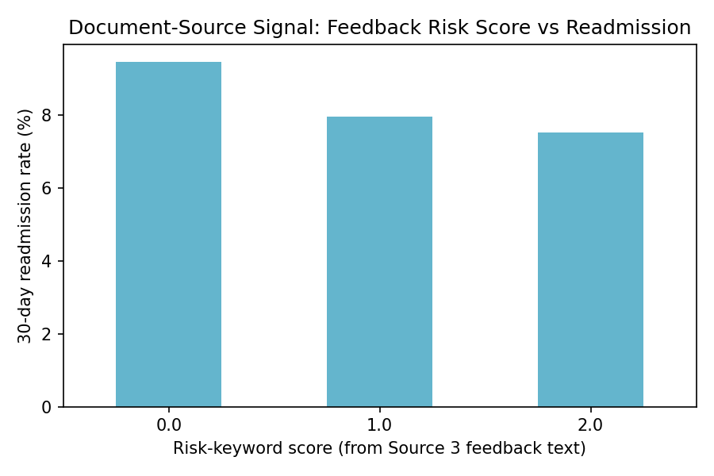
Using only encounters whose specialty has a Source-3 note (feedback_available=1), a higher keyword-derived risk score is associated with a lower observed readmission rate in this synthetic-note sample -- illustrating the integration mechanics rather than a claimed clinical finding, since the underlying notes are synthetic. Encounters with no matching note are excluded from this chart rather than scored as 0.

10. Data Dictionary (Summary)
Full definitions for all six tables are in docs/data_dictionary.md, included in the submission package. Key enriched columns:
Table | Enriched column | Source
diagnoses | diag_1_description, diag_1_lookup_status | Source 2 (API)
readmissions | risk_keyword_score, feedback_available | Source 3 (Document)
diagnosis_reference | icd9_code, description, lookup_status | Source 2 raw cache
specialty_feedback | medical_specialty, feedback_text | Source 3 raw notes

11. Execution Evidence
The pipeline was executed end-to-end via python pipeline_dag.py. Console/log output confirming a successful run across all three sources:
TASK SUCCESS: extract_file_task -> 101,766 rows (data/raw/file_raw/)
TASK SUCCESS: extract_api_task -> 40 ICD-9 codes cached (data/raw/api_raw/)
TASK SUCCESS: extract_document_task -> 14 specialty notes (data/raw/document_raw/)
TASK SUCCESS: transform_task -> 69,990 clean rows (31,776 rejected)
TASK SUCCESS: integrate_task -> 69,990 integrated rows
TASK SUCCESS: load_task -> 6 tables loaded
PIPELINE RUN SUCCESS

Integration-quality breakdown from logs/integration_log.csv for this run:
Metric | Value
diag_1_lookup_status = MATCHED / FALLBACK_OFFLINE | codes resolved (live or offline reference)
diag_1_lookup_status = NOT_ATTEMPTED | 23,627 rows (code outside top-40 lookup scope)
feedback_available = 1 | 33,073 rows
feedback_available = 0 (kept missing, not zero) | 36,917 rows

Full logs (logs/ingestion_log.csv, logs/integration_log.csv, logs/pipeline_runs.json) plus terminal and dashboard screenshots are included in the submission package.

12. Project Structure and Reproducibility
The full source code, per-source ingestion scripts, integration logic, database schema, sample tables, README with setup instructions, and this report are included in the submission package. Environment variables are used for the database connection string (DATABASE_URL) rather than hardcoded credentials.

13. Conclusion and Next Steps (Part 2 Preview)
Part 1 delivers a working, reproducible pipeline that ingests three genuinely different, segregated data sources, integrates them via explicit entity-matching keys with documented missing-data handling, and surfaces the result through an interactive analytics dashboard. Part 2 will extend this same foundation into an MLOps solution: training and comparing Logistic Regression, Random Forest, and XGBoost models to predict 30-day readmission, tracking experiments with MLflow, applying SHAP-based explainability, serving predictions via FastAPI, containerizing with Docker, and monitoring for data and model drift. The engineered high_risk_flag, diag_1_description category, and risk_keyword_score built in this phase are designed to feed directly into that modeling stage.

14. References
- UCI Machine Learning Repository -- Diabetes 130-US Hospitals for Years 1999-2008. https://archive.ics.uci.edu/dataset/296/
- NLM Clinical Table Search Service -- ICD-9-CM Diagnoses API. https://clinicaltables.nlm.nih.gov/apidoc/icd9cm_dx/v3/doc.html
- Strack, B. et al. (2014). Impact of HbA1c Measurement on Hospital Readmission Rates. BioMed Research International.

