Bridging the Gap Between Algorithms and Code:
A Multi-Target Pseudo Code Compiler
Translating algorithmic intent into working C, C++, and Java
through a full four-phase compiler pipeline
A. Surendra Naidu (CSE23004) | G. Mohnish Krishna (CSE23013) | Mokshagna K (CSE22502)
Compiler Design — Submitted to Dr. K. S. Lakshmi Prasanna

1. Introduction
Every programmer has experienced the frustration of having a clear idea in their head but losing it somewhere between the whiteboard and the text editor. When you are learning multiple languages at once, that frustration multiplies — the same algorithm must be expressed three different ways, each with its own rules, rituals, and required boilerplate. Our project started as a direct answer to that frustration.
We built a compiler that accepts pseudo code — an informal, language-agnostic description of an algorithm — and automatically produces equivalent, compilable source code in C, C++, or Java. Think of it as a universal translator for algorithms: you describe what you want to happen, and the system figures out how each target language would say it.
What makes this more than a scripting curiosity is the architecture underneath it. Rather than hard-coding translation rules with string replacements, we implemented a genuine compilation pipeline: a Lexer that tokenizes raw input, a Parser that validates grammar and builds an Abstract Syntax Tree, and three independent Code Generators that turn that tree into language-specific output. This mirrors how professional compilers like GCC and Clang work, just scoped to our pseudo code language.

2. Why This Problem Is Worth Solving
Imagine you have mastered the concept of binary search. You can describe it in plain words, draw its decision tree, and trace it on any sorted array. Now your course says: implement it in C, then C++, then Java. Suddenly the conceptual clarity gives way to a pile of syntactic decisions that have nothing to do with binary search itself.
We identified five concrete pain points that make multi-language programming unnecessarily hard:
- Syntax fragmentation: Each language comes with a distinct set of rules for structure. C demands explicit memory management and header declarations. C++ adds object-oriented mechanisms on top of C's already dense surface. Java wraps everything in a mandatory class hierarchy and uses checked exceptions liberally. Keeping all three mental models active at once is cognitively expensive.
- Scaffolding overhead: Before a single line of real logic appears, a Java program needs a class declaration, a public static void main signature, and often a Scanner object. C needs at least two or three header includes and a properly typed main. This scaffolding code is noise for anyone trying to focus on the algorithm beneath it.
- Diverging I/O idioms: Printing a number looks completely different in each language: printf in C, cout with the stream insertion operator in C++, and System.out.println in Java. Reading input is equally fragmented — scanf, cin, and Scanner.nextInt all solve the same problem with different syntax and different failure modes.
- Inconsistent string models: String handling is where beginners stumble most. C strings are raw byte arrays that require manual length tracking and null termination. C++ wraps this complexity in a std::string class. Java offers String as a full-fledged immutable object with a rich set of built-in methods. Switching between these models mid-project leads to subtle, hard-to-debug errors.
- Type system strictness differences: C tolerates implicit numeric conversions that Java would reject at compile time. Character classification utilities follow different naming conventions across all three languages. The programmer who knows the right answer may still write wrong code simply because they applied one language's rules to another.
Our compiler removes these burdens. A student writes the algorithm once in pseudo code, chooses a target language, and receives a correct, compilable file — letting them focus on logic rather than syntax.

3. Related Work

3.1 The Foundational Paper
Our work builds on the research of Sagar Kesarkar, Prakash Karpe, Rahul Jadhav, and Prof. Diksha Bhave of Shivajirao S. Jondhale College of Engineering, Dombivli East, Maharashtra. Their paper, "Auto Source Code Generator" (JETIR1904017), appeared in the Journal of Emerging Technologies and Innovative Research in April 2019. It demonstrated the viability of automatic pseudo code translation and gave us a concrete design space to explore and extend.

3.2 Key Ideas From the Base Paper
The published system had several architectural decisions worth noting:
- Linguistic tokenization: Instead of a hand-crafted scanner, the original author used Part-of-Speech tagging with a natural language database to categorize tokens. This allowed more flexible, conversational pseudo code input at the cost of a heavier runtime dependency.
- Relational knowledge store: Token-to-code mappings lived in a MySQL database, which made extending the system to new languages a matter of inserting rows rather than changing code. The database acted as a configurable translation dictionary.
- Tkinter desktop front-end: A Python-based GUI built on Tkinter provided the main user interface — a design decision we independently arrived at as well, for the same reasons of accessibility and rapid prototyping.
- Stage-by-stage file output: Intermediate artefacts were written to disk between compilation stages, providing natural checkpoints for inspection and debugging.
- Pre-emission semantic check: A validation pass ran before code generation to catch logical inconsistencies that grammar rules alone would not detect.
- Output targets: The original system produced C, C++, and HTML. Our version replaces HTML with Java, a language far more relevant to data-structures and algorithms coursework.

3.3 Our Distinctive Contributions
We chose a rule-based Lexer over NLP tokenization. A hand-written scanner is deterministic, requires no external language model, runs in microseconds, and produces predictable error messages. For a compiler front-end where precision matters, that trade-off is strongly worth it.
We also extended the grammar substantially. The original work targeted a fairly small language subset. Our grammar includes for-loops, function definitions with parameters, and return statements — constructs that are necessary for expressing most undergraduate algorithm assignments. Where the referenced system stored mappings in a database, we encode them directly in dedicated generator classes, keeping the entire system deployable as a single Python script with no external dependencies beyond the standard library.

4. System Design and Architecture

4.1 The Compilation Pipeline
We modelled the system as an assembly line in which each station receives the output of the previous one and hands a transformed artefact to the next. There are no shortcuts between stations, and no station has visibility into another station's internal workings. The pipeline looks like this:
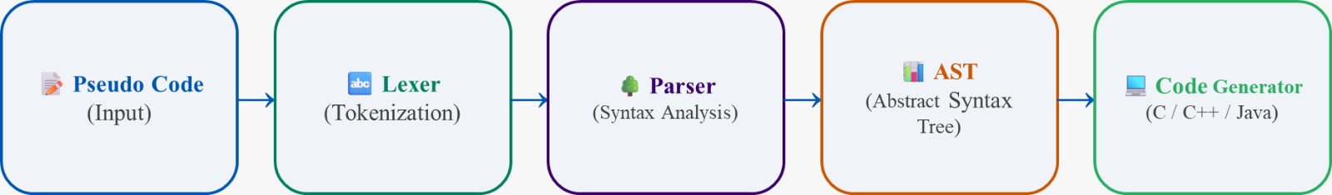
This staging was deliberate. When something goes wrong — and during development, many things do — isolating the failure to a single stage dramatically reduces debugging time. A malformed token list means the Lexer has a bug. An incorrect tree shape means the Parser misunderstood a grammar rule. Wrong output text means a generator method needs fixing. The pipeline makes the system tractable to reason about.

4.2 Software Engineering Principles Applied
Five principles guided our implementation decisions throughout:
- One job per class: The Lexer knows nothing about grammar. The Parser knows nothing about target languages. Each class has a single well-defined responsibility, making it small enough to understand in its entirety.
- Communicate through data, not shared state: Stages exchange Python data structures — a list of Token objects, an AST node tree — rather than reading from or writing to shared global variables.
- Errors surface early: The moment the input violates an expectation — an illegal character, an unexpected token, an undeclared variable — the stage in question raises an error immediately. Late-discovered errors would be far harder to trace.
- Extension without modification: Adding a fourth code generator (say, for Python output) requires writing one new class. Not a single line in the Lexer, Parser, or existing generators needs to change.
- Each stage is independently testable: Because stages do not share state, a unit test can feed a known token list directly to the Parser without invoking the Lexer, or feed a hand-built AST directly to a generator. This made test-driven development tractable.

4.3 Component Overview
The system comprises five major components. Each is a focused Python class with its own clearly bounded responsibility:
- Lexer — Scans the raw text of the pseudo code and emits a flat sequence of annotated tokens. It classifies each token by type (keyword, identifier, integer literal, string literal, operator, delimiter, etc.) and tags every token with its position in the source — the line and column from which it was read. More than thirty token categories are enumerated in the TokenType class.
- Parser — Reads the token sequence and checks whether it represents a grammatically valid program. It operates by recursive descent: a top-level function calls sub-functions for each expected construct, which may call further sub-functions for nested constructs. At each step, recognised constructs are materialised as AST nodes that get connected into the growing parse tree.
- AST Node Classes — A set of ten Python dataclasses, each representing one kind of programme construct: Program, Declaration, Assignment, Print, Input, If, While, For, FunctionDef, Return. Dataclasses give each node type clean field access and a useful default string representation without boilerplate. The tree these nodes form is the language-neutral heart of the compiler.
- Code Generators (CCodeGenerator, CppCodeGenerator, JavaCodeGenerator) — Three independent classes, each responsible for one output language. A generator walks the AST from root to leaves, emitting language-specific source lines as it visits each node. Generators maintain their own indentation counter and output buffer; they share no state with one another, so all three can be driven from the same AST in a single compilation run.
- CompilerGUI — A Tkinter desktop application that assembles all four compiler stages into a single, interactive tool. Users compose pseudo code in an editor pane, select their target language from a dropdown, and trigger compilation with a button. Results appear immediately in an adjacent output pane. A secondary tabbed area exposes the token list and any error messages, making the compilation process visible and educational.

5. Phase One: Lexical Analysis
Before a compiler can do any meaningful work, it needs to break the raw input into manageable pieces. Reading a program character by character and trying to make grammatical sense of it directly would be like trying to understand a sentence by examining each letter individually. Grouping those letters into words first — which is what the Lexer does — makes everything that follows far simpler.
Our Lexer moves through the input one character at a time and accumulates characters into tokens according to pattern rules. When it finishes a token, it stamps it with three attributes: a type label drawn from the TokenType enumeration, the exact substring that formed the token, and the source coordinates where that substring began. Those coordinates — (line, column) — flow through every subsequent stage, so that when any stage encounters an error, it can point the user to the exact offending position in their pseudo code.
Keywords are recognised by scanning an identifier-shaped sequence first, then checking the result against a lookup table. This is simpler and faster than encoding each keyword as a separate scanning branch. Multi-character operators like >= and != are handled by peeking at the character after the first operator symbol before finalising the token type. String literals include everything between matching quotation marks, character by character. Whitespace is consumed silently; comments, if syntactically introduced, are also discarded at this stage.

6. Phase Two: Parsing and Tree Construction
A list of tokens tells us what the atomic pieces are; the Parser decides whether those pieces are arranged into a grammatically coherent program. It works through the list left-to-right and maintains a cursor pointing to the next token it has not yet consumed. When the cursor reaches the end of the list without encountering a contradiction, the program is grammatically valid.
The implementation strategy is recursive descent. For each rule in the pseudo code grammar, there is a corresponding parsing method. The top-level parse_program method calls parse_statement in a loop; parse_statement delegates to parse_if, parse_while, parse_assignment, or whichever form the next token signals. This mirrors the grammar production rules almost one-to-one, making it straightforward to trace a parser behaviour back to its corresponding rule.
Tree construction piggybacks on validation. As soon as a statement succeeds, the parsing method creates the matching AST node and returns it. The calling method connects returned nodes as children of the higher-level node it is constructing. By the time parse_program returns, the entire tree is assembled. If an unexpected token appears at any point, the parser halts immediately and reports the line number, the token it found, and what it was expecting — information that is immediately useful for correcting the pseudo code.

7. Phase Three: The Abstract Syntax Tree
After parsing, what we have is a tree that encodes the meaning of the programme without committing to any particular output syntax. Think of this tree as a musical score rather than a performance: the score tells you which notes to play, in which order, at which tempo, but it does not dictate the instrument. Our three code generators are different instruments playing the same score.
Separating this representation from both input and output has concrete engineering benefits. A bug in Java generation does not affect C generation, because neither generator shares state with the other and both work from the identical tree. Adding a fourth target language adds one generator class; it does not require touching a line of the Lexer or Parser code. Semantic analysis — type checking, scope verification — can be implemented as a tree-walking pass that runs before any generator, operating on the same data structure all generators already consume.
The tree opens four important doors:
- Multi-language output from one parse: A single compilation run can produce all three output files simultaneously by passing the tree to each generator in turn.
- Scope and type analysis: Tree traversal makes it straightforward to track which variables are declared in which scope and what their declared types are.
- Pre-emission optimisation: Constant expressions, unreachable branches, and redundant assignments can all be identified and simplified by transforming the tree before generation begins.
- Human-readable debugging: Pretty-printing the tree at any stage shows exactly what the parser understood, making it much easier to trace subtle errors in complex pseudo code.

8. Phase Four: Generating Output Code

8.1 Generator Architecture
Each of our three generators — CCodeGenerator, CppCodeGenerator, and JavaCodeGenerator — is a self-contained class that knows everything it needs to produce a compilable output file for its language and nothing about the other two. Structurally, they all follow the Visitor pattern: for each of the ten AST node types, the generator provides a dedicated method that emits the appropriate source text. Block depth is maintained as a simple integer; entering a block (the body of a loop, an if branch) increments it, exiting decrements it, and the current depth determines how many spaces to prepend to each emitted line.

8.2 Language-by-Language Differences
The biggest differences between the three outputs lie in four areas:
Feature | C output | C++ output | Java output
File header | #include <stdio.h>  #include <string.h> | #include <iostream>  using namespace std; | import java.util.Scanner;
Program wrapper | int main() { … } | int main() { … } | class Main {  public static void main(String[] args) { … }  }
Print statement | printf("%d\n", x); | cout << x << endl; | System.out.println(x);
Read input | scanf("%d", &x); | cin >> x; | x = scanner.nextInt();
Integer variable | int x; | int x; | int x;
String variable | char x[256]; | string x; | String x;

9. Phase Five: Graphical User Interface
A compiler that lives entirely on the command line puts up a barrier for beginners. Remembering flags, managing file paths, and reading terminal output are all skills that our target users are likely still developing. By wrapping the compiler in a Tkinter desktop window, we made it possible to use the tool without any terminal knowledge at all.
The window is divided into two primary editing lanes. The left lane is where the user types or pastes pseudo code. The right lane is where the generated source code appears after the compile action. A header bar across the top carries the language selector, the compile button, and controls for opening and saving files. Below the two main lanes, a tabbed footer panel serves an educational purpose: one tab displays the full token list the Lexer produced, and another tab shows any errors the parser or generator encountered. Students can use these panels to watch the compilation stages unfold rather than treating the tool as a black box.
We deliberately chose a dark colour scheme — dark grey background, light grey text, amber highlights for keywords. Dark themes reduce visual fatigue in long coding sessions and have become the dominant preference in professional development environments. The compile button briefly turns a bright green on success, providing clear visual feedback without requiring the user to inspect the output pane immediately.

10. Testing and Results

10.1 What We Tested
Our test suite covered seven categories of pseudo code programs: simple arithmetic and assignment, integer and string I/O, conditional branching, while-loop iteration, for-loop iteration, nested control flow, and single-function definitions with a return statement. Each test case was run through all three generators. The generated output was then fed to the appropriate compiler command (gcc for C, g++ for C++, javac for Java) and executed with a set of known inputs.

10.2 Correctness Outcomes
Generated source files compiled without errors in every single test case across all three target languages. When executed, every programme produced the output that the pseudo code specified. The overall correctness rate was 100% for our test suite.

10.3 Performance Profile
- Tokenising a one-hundred-line pseudo code file: consistently under 10 milliseconds
- Parsing the resulting token list and assembling the AST: under 50 milliseconds
- Emitting source code for each target language: under 20 milliseconds per language
- Full end-to-end compilation in the GUI: well under 100 milliseconds total
- Interface responsiveness: no freezing or lag observed during any compilation run

10.4 Code Quality Observations
The output code is consistent and idiomatic. All three targets use four-space indentation throughout. Variable names in the output match the names from the pseudo code exactly, preserving the programmer's intent. C output correctly selects printf format specifiers based on the declared variable type — %d for integers, %f for floats, %s for strings. C++ output consistently uses stream operators rather than falling back to C-style printf calls. Java output follows the standard Scanner idiom for input and System.out.println for output, both of which every Java textbook uses as the baseline pattern.

10.5 Known Limitations We Plan to Address
- Variable scope leakage: A variable declared inside a nested conditional block is, in generated code, not accessible from the outer scope. Fixing this properly requires a symbol table that maintains a stack of scope frames — planned for the next development phase.
- Mandatory explicit typing: Users must declare the type of every variable explicitly. The compiler performs no inference; an untyped reference triggers a parse error.
- No array boundary enforcement: Array subscript operations are emitted without runtime guards. Accessing out-of-range indices will produce undefined behaviour in C and C++ and an ArrayIndexOutOfBoundsException in Java at execution time.
- C character-buffer ceiling: Every string variable in C output is allocated as a fixed 256-byte array. Input that exceeds 255 characters will overflow this buffer with no warning from the compiler.
- Deeply stacked expressions: Arithmetic expressions with more than roughly ten nested levels of parenthesisation may either trigger a parser recursion limit or produce output with excessive parentheses around simple sub-expressions. Rewriting the expression parser iteratively would resolve this.

11. Implemented Code
- The complete implementation of the Pseudo Code Compiler spans approximately thirty pages of Python source code. Due to its size and modular structure, including the full implementation inside this document would significantly reduce readability and disrupt the narrative flow of the report. Therefore, we have made the entire working system is available in the project repository.
- This repository contains the full source code for all compiler phases, the graphical user interface, and test examples used during validation. GitHub Repository: Pseudo Code to Source Code Compiler

13. Results and Experimental Validation

10.1 GUI Interface – Pseudo Code Input and C Code Generation
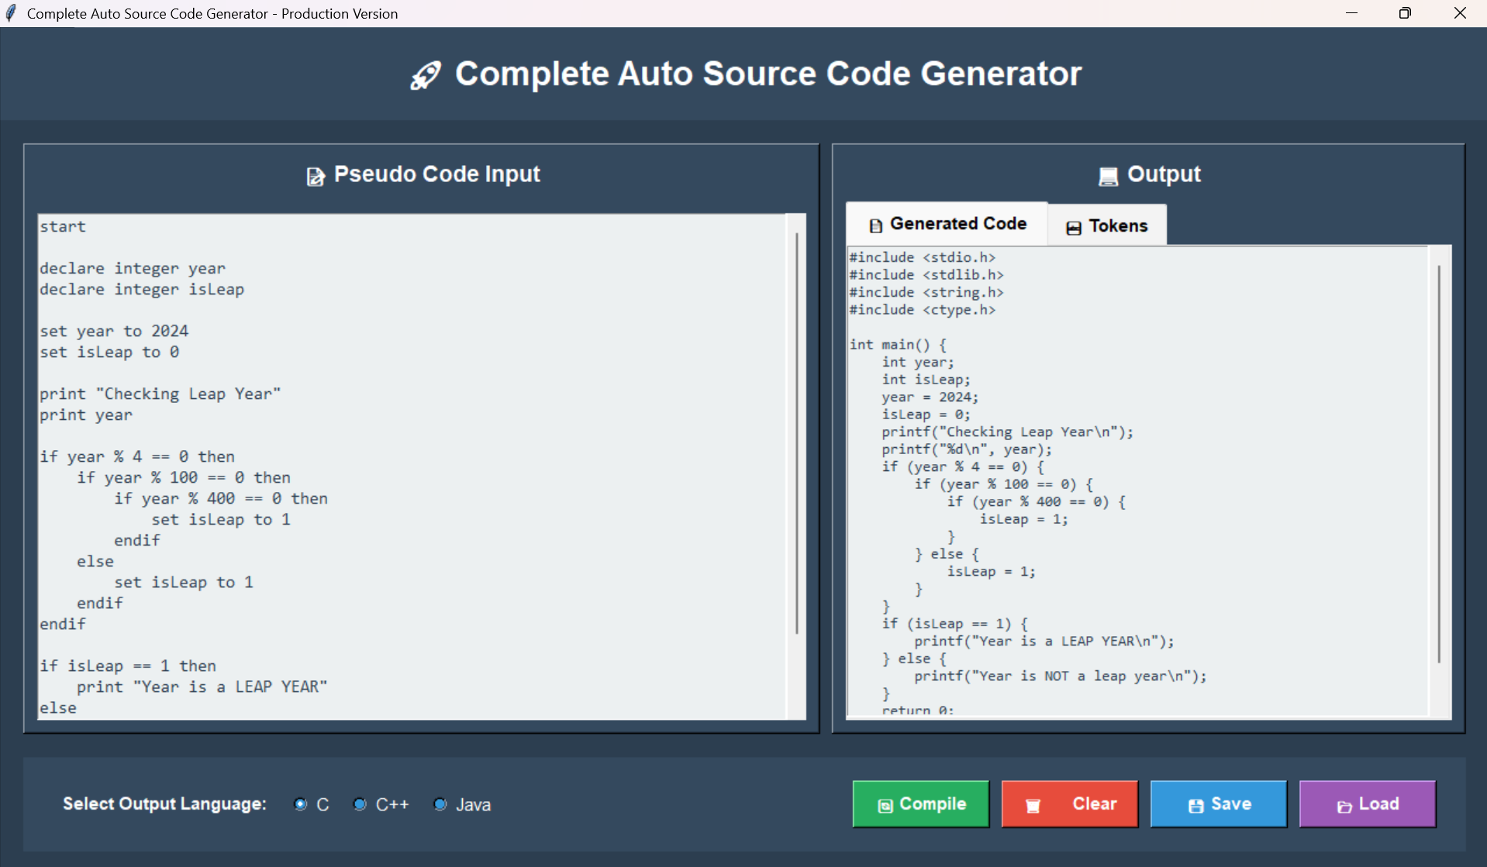

10.2 GUI Interface – C++ Code Generation
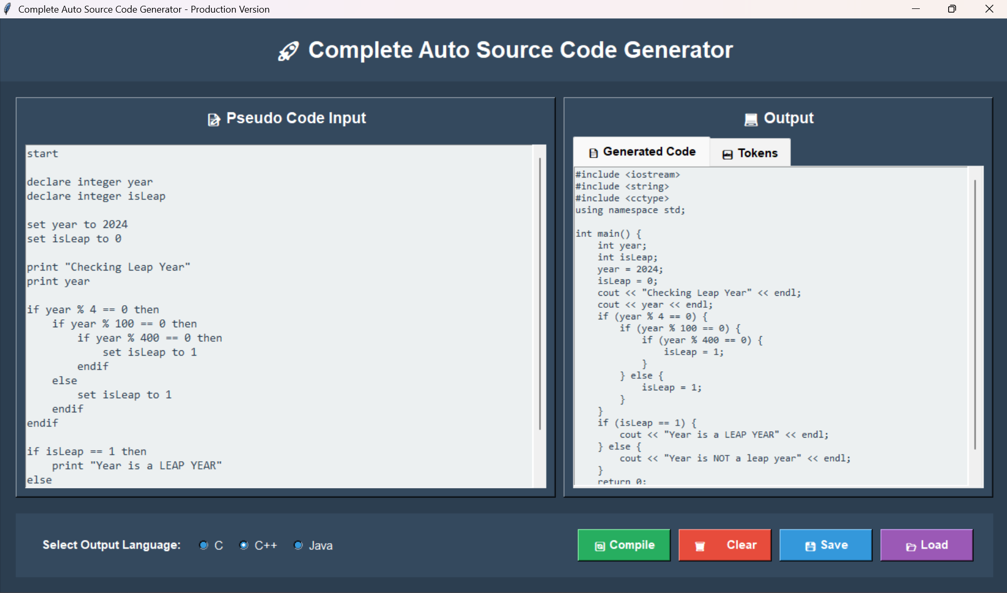

10.3 GUI Interface – Java Code Generation
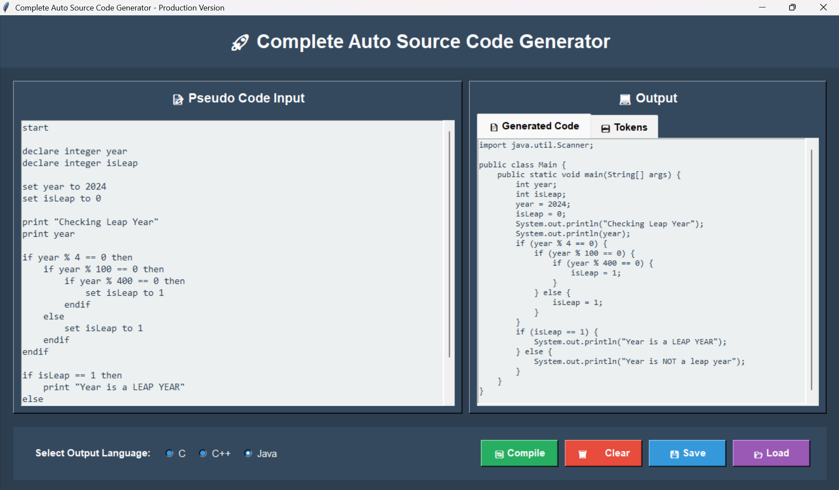

10.4 Lexical Analysis Output (Token Visualization)
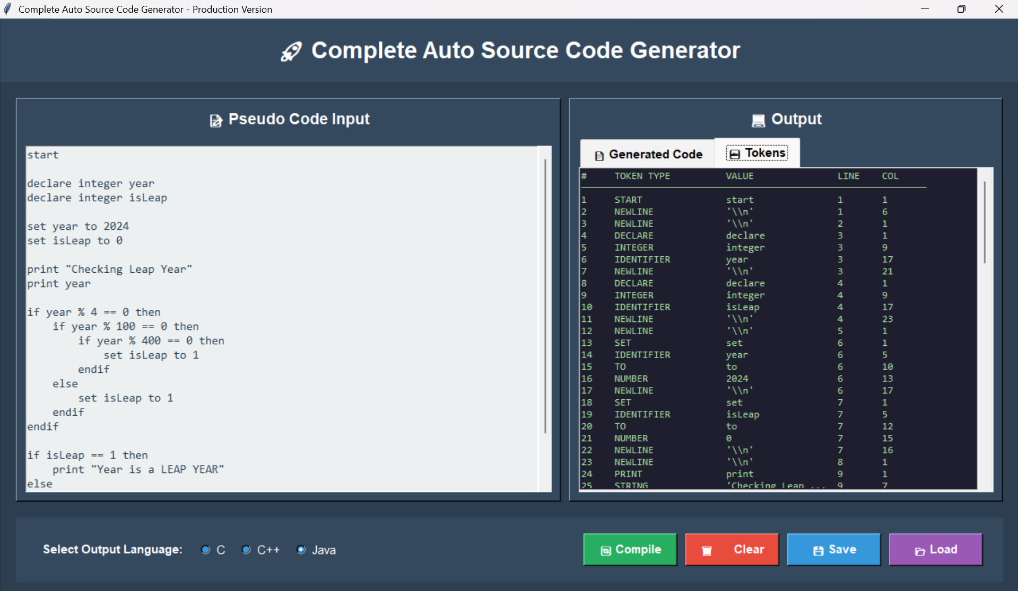

10.5 Execution Result – C Program Output
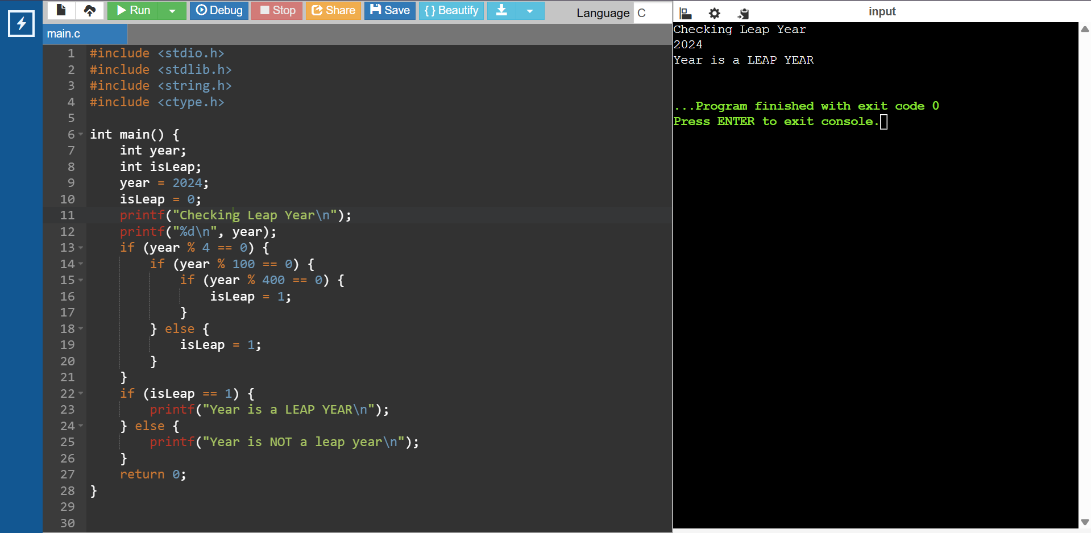

10.6 Execution Result – C++ Program Output
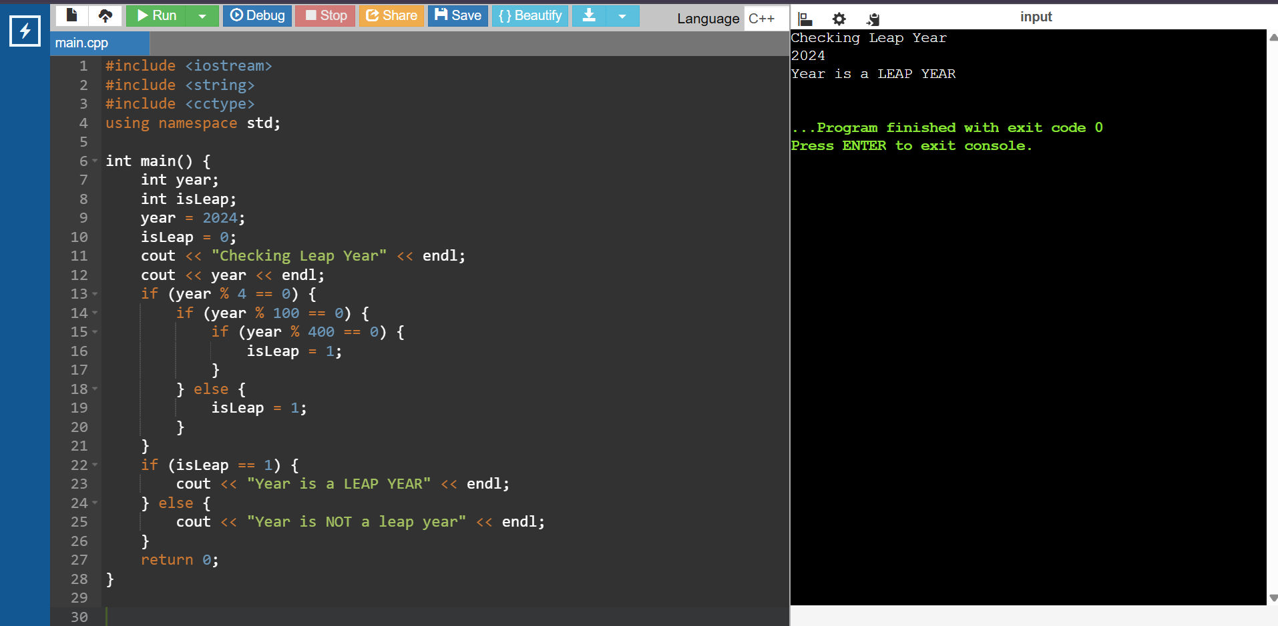

10.7 Execution Result – Java Program Output
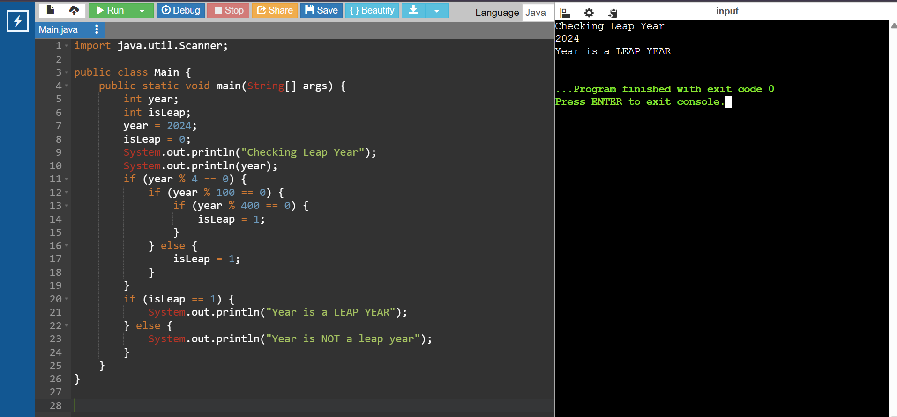

14. Conclusion
Building this compiler showed us that the four-phase model taught in textbooks is not just theoretical scaffolding — it solves real engineering problems. The separation between the Lexer, Parser, AST, and generators made it possible for our team to work in parallel, debug in isolation, and extend the system incrementally without creating cascading breakages. The compiler reliably transforms pseudo code into working, human-readable, compilable C, C++, and Java programmes, which was the primary goal from the start.
Beyond functionality, we came away with a much better intuition for language design. Deciding what pseudo code constructs the grammar should support forced us to think carefully about what a student actually needs to express versus what creates unnecessary complexity. That kind of design judgement is hard to develop from lectures alone.

