
Submitted by:
G Mohnish krishna Sai Kumar-AV.SC.U4CSE23013
Pallapothu Moulika-AV.SC.U4CSE23036

PaperInsight AI: An AI-Powered Research Assistant

Abstract:
Submitted to:
Dr.K.Ashwini

7th semester | CSE A
Fundamentals of Artificial Intelligence

Reviewing academic literature is slow and repetitive. Researchers read many papers, cross-reference their results and take notes by hand. PaperInsight AI is a locally hosted research assistant that automates much of this work while keeping manuscripts and datasets on the user's own computer. It parses PDF papers, splits them into chunks, converts the chunks into searchable vectors and stores them in an in-memory FAISS index. On top of this retrieval layer it offers grounded chat, an autonomous deep research agent, methodology debates and a tabular literature review.
This report presents the problem addressed, the objectives, the system architecture, the document-processing pipeline, the AI workflows, the backend and frontend design, the security model and the deployment method. The system was then tested with a sample set of eight papers. That set happened to be about traffic sign recognition, but the subject was chosen only as test data and is not part of the project itself.

1. Introduction

1.1 Problem Statement
Traditional research synthesis needs hours of reading, manual cross-referencing and note-taking. Commercial AI tools can shorten this, but most require uploading unpublished or proprietary documents to the cloud. Researchers working with sensitive material therefore need a tool that is both fast and private.

1.2 Objectives
- To build a research assistant that ingests academic PDFs and makes their content searchable.
- To answer questions strictly from the uploaded papers, so that hallucination is minimized.
- To automate multi-step tasks such as writing a research report or a literature review table.
- To keep processing local, with the language model reachable through either a direct provider API or a local proxy.
- To require no database setup, so that the application is portable and easy to start.

1.3 Scope
PaperInsight works on PDF papers supplied by the user, organized into projects. It is a single-user, locally run application. It is not tied to any research field. Any topic can be used, because a project is created simply from a topic name and a research goal.

2. Features
- Instant ingestion: parses, chunks and indexes academic PDFs in milliseconds.
- RAG-based chat: answers questions from the project's papers using semantic search.
- Autonomous deep research: a multi-agent workflow that plans, searches and writes a multi-section report.
- Methodology debates: sets arguments from different papers against each other to highlight conflicting results.
- Literature review: aggregates findings from all indexed papers into a structured table.
- History and export: saves research outputs per project and allows download as Markdown, with an Export Backup option.

3. System Architecture
PaperInsight uses a decoupled client-server design in which the browser frontend and the backend server communicate through RESTful JSON APIs. Figure 1 shows the complete project architecture, from the browser client through the backend services to local storage and the language model providers.
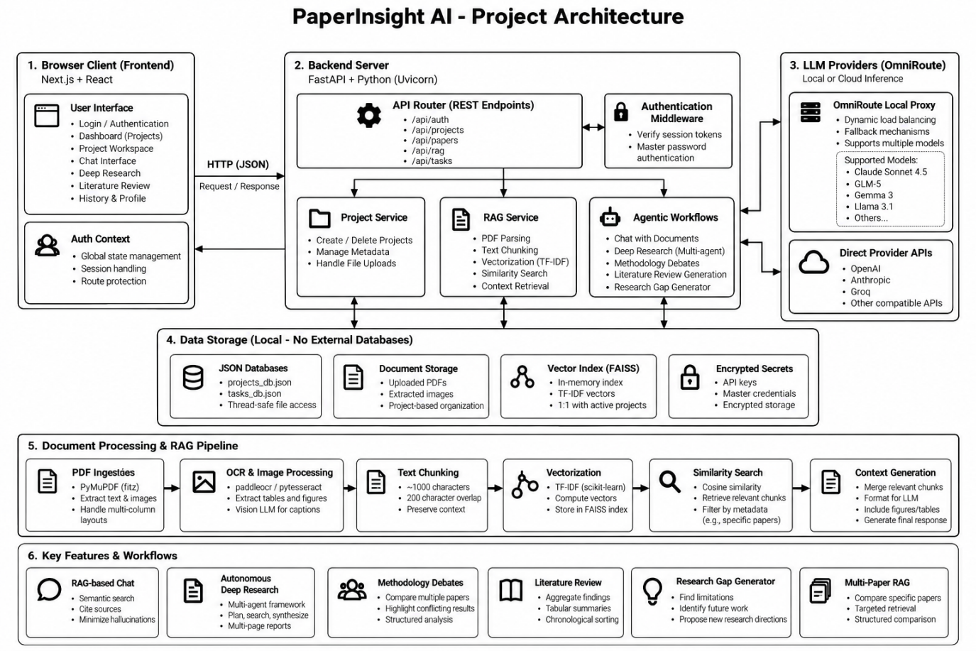
Figure 1: PaperInsight AI project architecture

3.1 Architecture Layers
Layer | Role
Browser client | Next.js and React interface with login, dashboard, project workspace, chat, deep research, literature review and history. An authentication context manages global state and route protection.
Backend server | FastAPI application served by Uvicorn. REST routers for authentication, projects, papers, RAG and tasks, protected by authentication middleware.
Services | Project service (create and delete projects, metadata, file uploads), RAG service (parsing, chunking, vectorization, search, context retrieval) and agentic workflows.
Data storage | Local only, with no external database: JSON files, stored PDF documents, an in-memory FAISS vector index and protected secrets.
LLM providers | A local OmniRoute proxy or direct provider APIs such as OpenAI, Anthropic and Groq.

3.2 Technology Stack
Layer | Technology
Frontend | Next.js 14+ (App Router), React 18, standard CSS3 with custom CSS variables
Backend | FastAPI (Python 3.10+), Uvicorn (ASGI)
Data persistence | Thread-safe JSON databases (projects_db.json, tasks_db.json, llm_settings.json)
Vector database | FAISS, in memory
Embedding engine | sentence-transformers/all-MiniLM-L6-v2 through langchain-huggingface
LLM orchestration | Custom agentic pipeline using asynchronous httpx requests

3.3 Request Flow
- The React frontend sends an HTTP request to the Next.js proxy, configured through rewrites in next.config.mjs.
- The proxy routes the request to the FastAPI server at http://localhost:8000/api/.
- Dependencies in security.py check for an active session token derived from the Master Password.
- The router passes the payload to the matching service: paper_service.py, project_service.py or rag_service.py.
- Heavy work such as deep research or embedding runs in background asyncio tasks or thread pools, so the main event loop is never blocked.

4. Document Processing and RAG Pipeline
The Retrieval-Augmented Generation (RAG) engine is the core of PaperInsight and is implemented in rag/parser.py, rag/chunker.py and rag/retriever.py.

4.1 PDF Ingestion
Academic PDFs are hard to parse because of multi-column layouts, equations and embedded charts. PaperInsight uses PyMuPDF (fitz) to go through each page, extract text blocks and keep a sensible reading order. Headers, footers and citation brackets are normalized. The specification states that a 50-page PDF can be extracted in under 150 ms.

4.2 Recursive Chunking
Text is split so that each piece fits the language model's context window and produces a meaningful embedding. The splitter tries paragraph breaks first, then sentences, then words. The overlap keeps context intact when an argument crosses a chunk boundary.
Parameter | Value
Method | RecursiveCharacterTextSplitter (LangChain)
chunk_size | 1200 characters
chunk_overlap | 250 characters

4.3 Semantic Embeddings
Chunks are converted into vectors with all-MiniLM-L6-v2, a six-layer BERT-based transformer designed for semantic similarity. It produces 384-dimensional vectors, runs on the local CPU (or a GPU if PyTorch is set up for one) and is only about 80 MB. It was chosen because it is lightweight while performing well on standard academic text retrieval.

4.4 FAISS Vector Search
Embedded chunks are added to an IndexFlatL2 FAISS index that uses Euclidean (L2) distance. A user question is embedded into the same space, and FAISS performs an exhaustive nearest-neighbour search (k = 5 or k = 10) over the project's chunks. Because the index is in memory and mapped to project identifiers, retrieval is very fast.

4.5 Note on the Architecture Diagram
The architecture diagram in Figure 1 and the written technical specification differ on a few implementation details. This report follows the written specification, which matches the code modules described above. The differences are listed so they can be confirmed against the final implementation.

Item | Architecture diagram | Written specification
Vectorization | TF-IDF (scikit-learn) | all-MiniLM-L6-v2 embeddings, 384 dimensions
Chunk size and overlap | About 1000 characters, 200 overlap | 1200 characters, 250 overlap
OCR and images | PaddleOCR / pytesseract, vision LLM captions | PyMuPDF text extraction only; vision parsing listed as future work
Secrets storage | Encrypted secrets | Local configuration files gated behind the session

5. Agentic AI Workflows

5.1 Deep Research Agent
The workflow in deep_research.py imitates a human researcher:
- Planning: an LLM acting as a senior academic planner returns a JSON outline covering the introduction, core arguments, counter-arguments and conclusion.
- Information gathering: for each planned section the agent queries FAISS for supporting evidence.
- Drafting: a synthesizer prompt combines the evidence and the section objective into academic prose.
- Assembly: the sections are joined into a formatted Markdown document and saved to tasks_db.json.

5.2 Methodology Debate Simulator
When papers disagree, the debate engine takes the retrieved chunks for a topic, asks the LLM to list arguments for and against a hypothesis, and produces a structured verdict. This helps a researcher see where the consensus lies.

5.3 Instant File Uploads
To keep the interface responsive during LLM rate limits, the upload path skips LLM metadata extraction and uses metadata taken from the file name. Embedding runs synchronously and returns at once. According to the specification, more than ten PDFs can be uploaded and indexed in under three seconds.

6. Backend Design

6.1 Asynchronous Processing
The backend uses asyncio for non-blocking input and output. Long tasks such as deep research are started with asyncio.create_task(). The immediate HTTP response contains a task_id, and the frontend polls the task endpoint for its status (pending, running or completed).

6.2 Thread-Safe JSON Storage
To stay portable and need no setup, the application stores data in flat JSON files instead of PostgreSQL or MongoDB. A threading.Lock() surrounds all disk operations in database/json_db.py, because the frontend may poll for status while a background thread updates the same task. Every update is flushed to disk, so state survives a crash or restart.

6.3 API Routers
Module | Endpoint | Purpose
api/projects.py | POST /api/project/create | Creates a workspace and an empty FAISS index
api/projects.py | GET /api/projects | Lists projects with paper counts
api/papers.py | POST /api/upload | Parses, chunks and embeds uploaded PDFs
api/papers.py | POST /api/paper/delete | Removes a paper and re-indexes FAISS
api/rag.py | POST /api/chat | Retrieves K=5 chunks and streams a grounded answer
api/tasks.py | GET /api/tasks/{id} | Returns the state of a background worker
api/llm_settings.py | GET /api/llm/settings | Exposes provider configuration and base URLs

7. Frontend Design
- State management: React useState and useEffect hooks manage state across the project page. An AuthContext in ClientLayout.js sends unauthenticated users to the login route.
- Theming: a ThemeContext switches between light and dark mode using the browser preference or a stored manual choice, and sets data-theme on the document root to avoid a flash on load.
- Styling: vanilla CSS with variables such as --bg, --ink, --sheet and --accent, Flexbox and Grid for responsive layout, and 150 ms transitions. No utility framework such as Tailwind is used.
- Typography: Hanken Grotesk for interface elements and Literata for long-form reading and Markdown rendering.
- Polling and optimistic updates: while a task runs, the page polls the backend every 2000 ms and shows live log lines. Deleting a project or paper removes it from the interface immediately while the backend finishes the request.

8. Security and Authentication
PaperInsight is built around local-first security because users may handle sensitive or proprietary research.
- Master Password: no cloud authentication is used. The user sets a Master Password at first launch and it is verified locally. A successful login creates a local session cookie that the backend checks on every /api request through Depends(require_session).
- API key protection: provider keys are kept locally and the LLM settings panel is available only within an active session. Keys are sent only to the chosen provider endpoint, either the provider's servers or a local OmniRoute proxy.

9. Deployment
- Start-Hidden.vbs: uses WScript.Shell to start the Uvicorn server and the Node.js frontend invisibly (WindowStyle = 0), so the application behaves like a desktop program and cannot be stopped by closing a terminal.
- PaperInsight.bat: a fallback launcher that installs dependencies on the first run (pip install and npm install) after checking for the venv and node_modules folders. Main Python dependencies are fastapi, uvicorn, pydantic, langchain, langchain-huggingface, faiss-cpu, pymupdf, httpx and python-multipart.
- Development mode: main.py calls uvicorn.run(reload=True), so the server restarts automatically when backend files change.

10. Testing with a Sample Dataset

10.1 Test Setup
To check that the system works end to end, a test project was created with a sample set of eight research papers. The papers happen to be about traffic sign recognition under blur and noise. This topic was chosen only to provide realistic academic PDFs and has no connection to the PaperInsight project itself. Any other subject would serve equally well.

10.2 Creating the Test Project
The dashboard lists projects and shows the active AI provider. A project is created by entering a topic and a research goal. For this test, the topic was a multi-modal approach to traffic sign recognition.
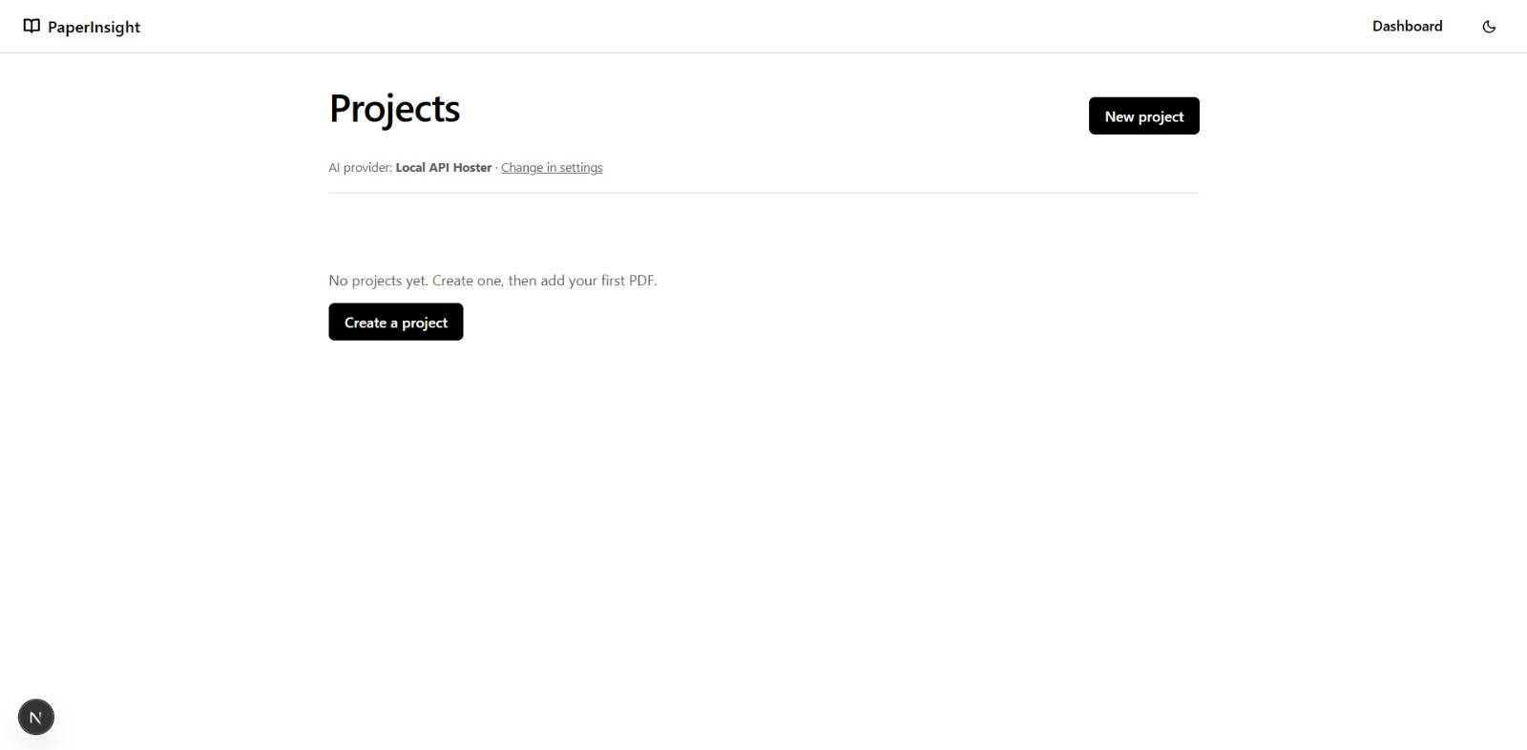
Figure 2: Project dashboard with no projects
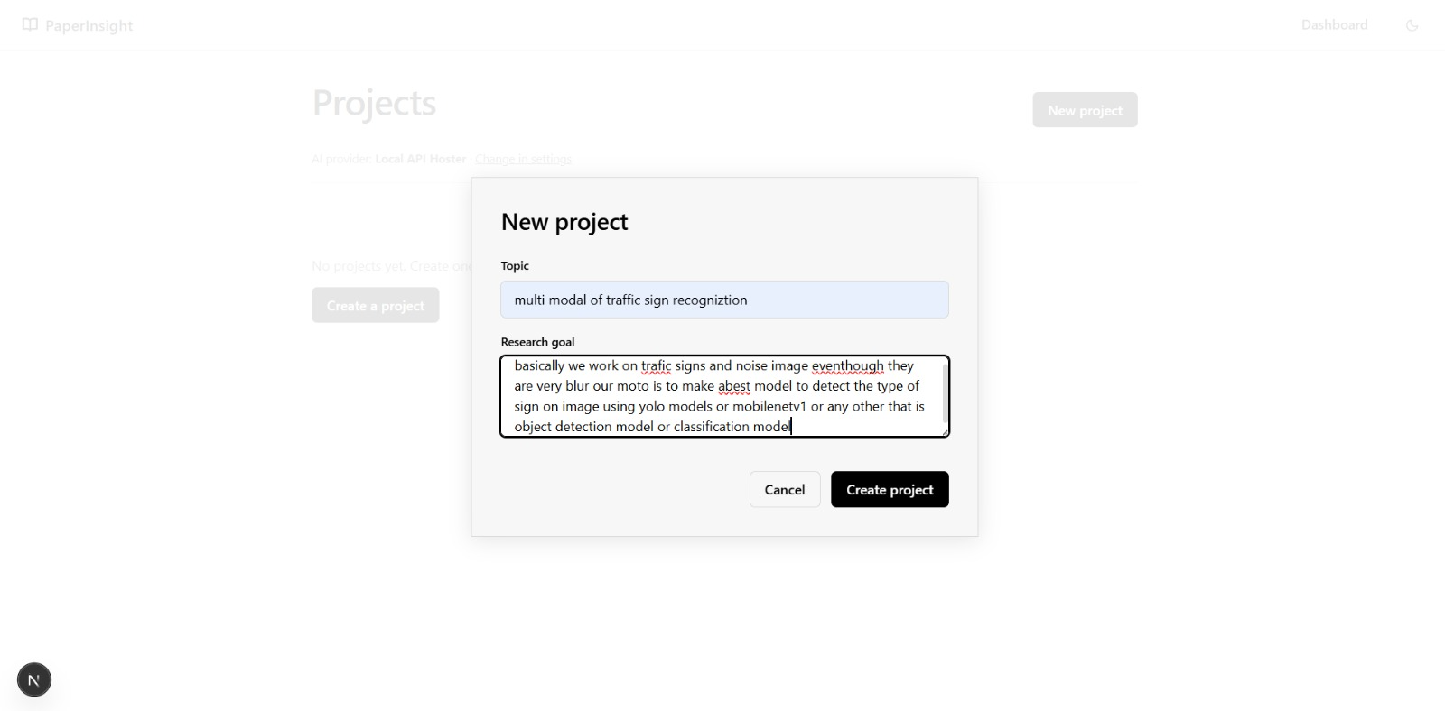
Figure 3: New project dialog with topic and research goal

10.3 Uploading and Indexing Papers
The workspace has a paper panel on the left and four tabs: Chat, Deep research, Literature review and History. Papers are added by dragging them in or by choosing files in a dialog. All eight test papers were selected and indexed.
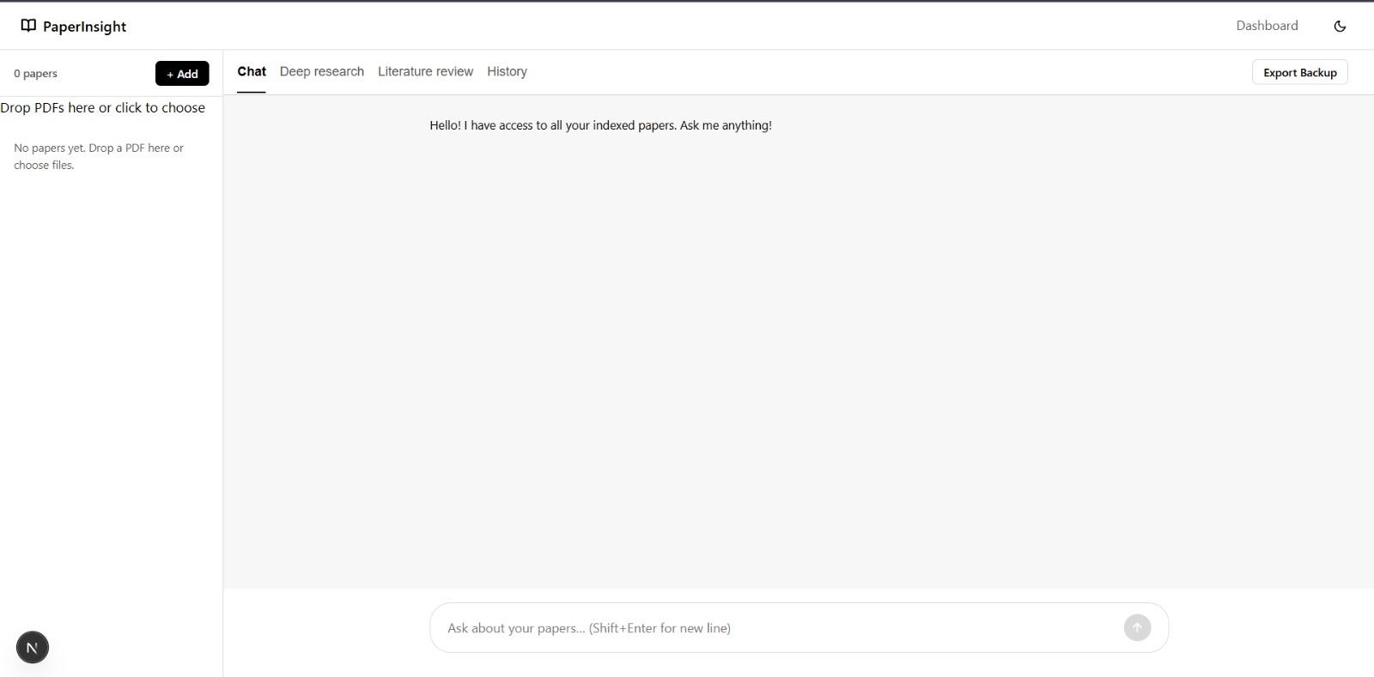
Figure 4: Project workspace before any papers are added
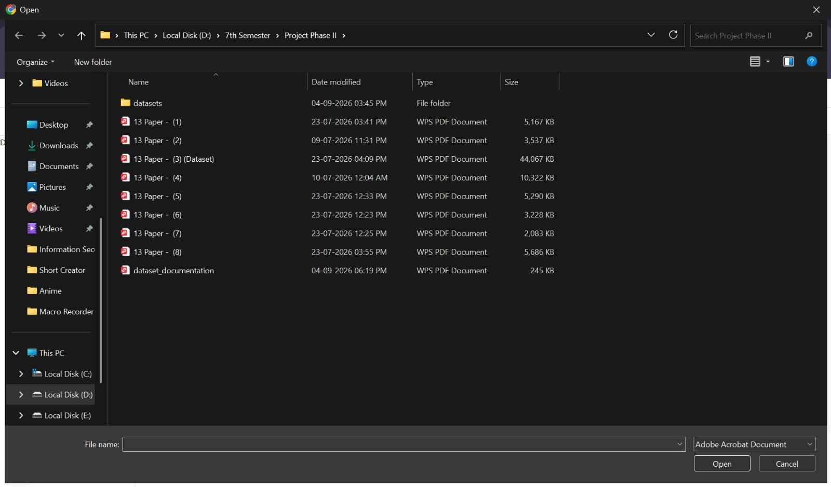
Figure 5: Choosing the PDF files to upload
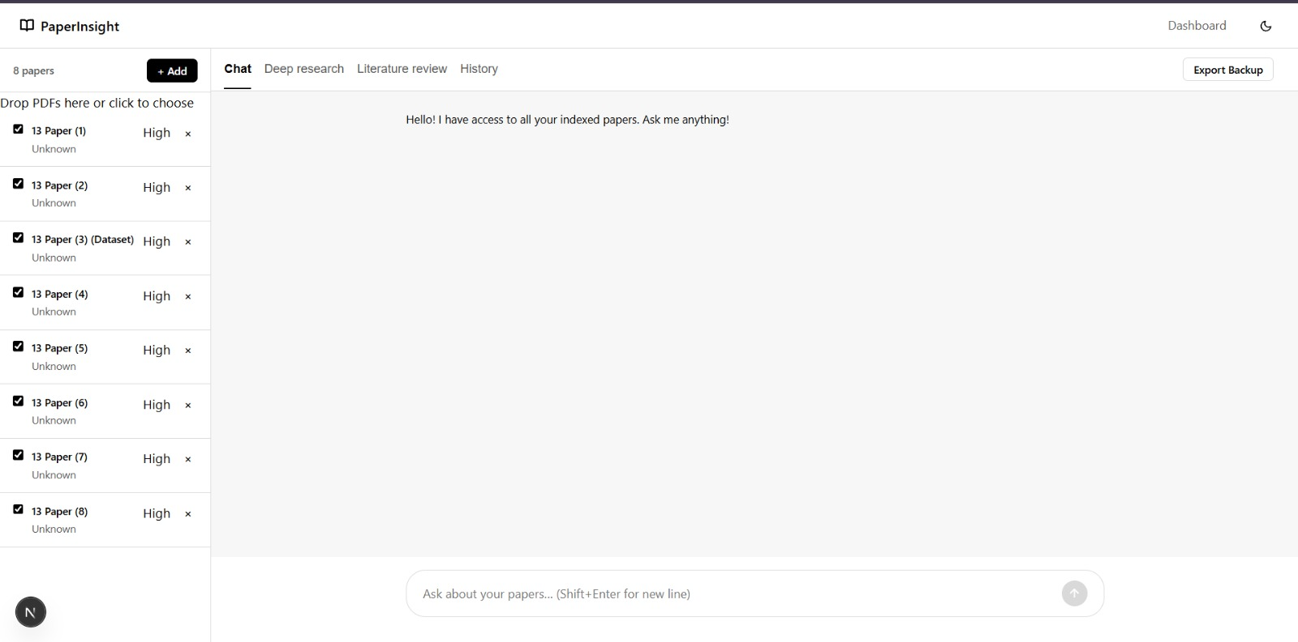
Figure 6: Eight papers indexed and ready for querying

10.4 Testing Grounded Chat
With four papers selected, a question about which models could be used for improvement returned a structured answer: a table of model families with reasons, practical tips, a starter configuration, a confidence score and the source file used. This confirms that retrieval, prompt construction, formatted output and source reporting all work together.
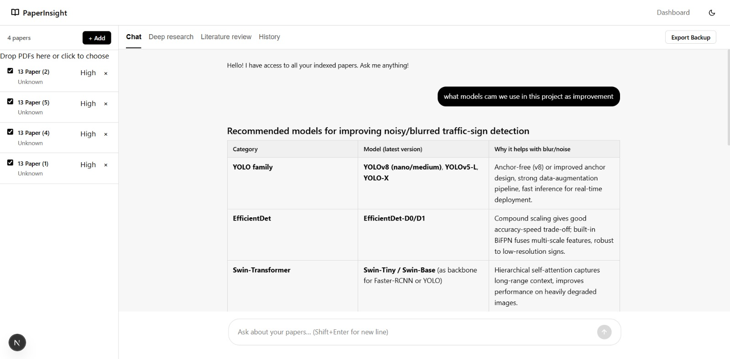
Figure 7: Chat answer with a formatted table
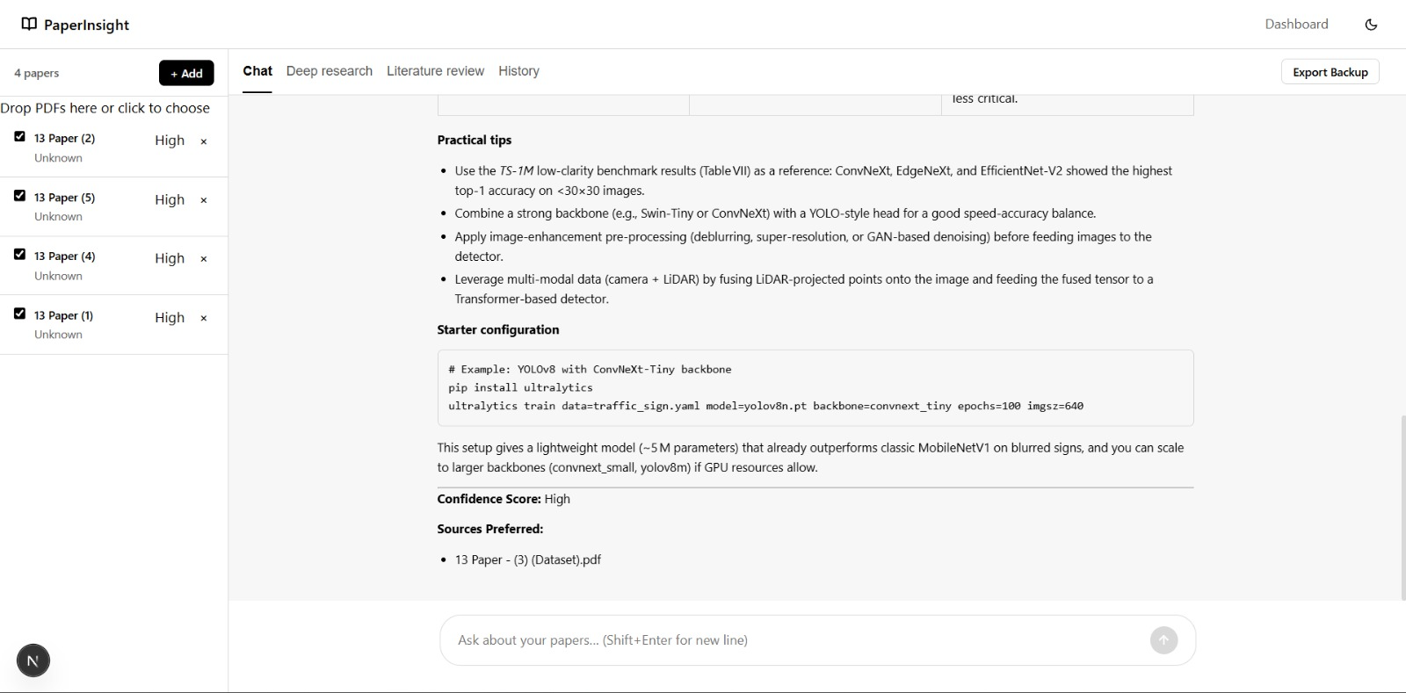
Figure 8: End of the chat answer with tips, confidence score and sources

10.5 Testing Deep Research
A research question was entered in the Deep research tab. The agent produced a four-point research plan, completed each point, synthesized a final report and offered options to download it as Markdown or save it to history. The step-by-step progress display worked as designed.
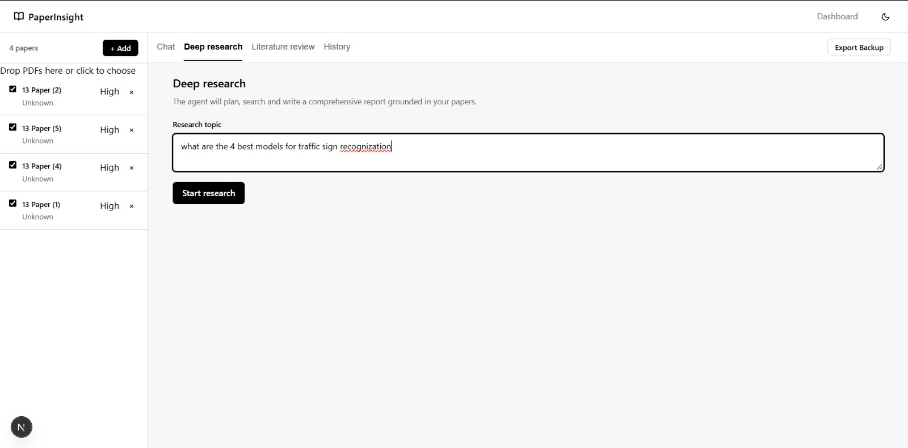
Figure 9: Deep research topic entry
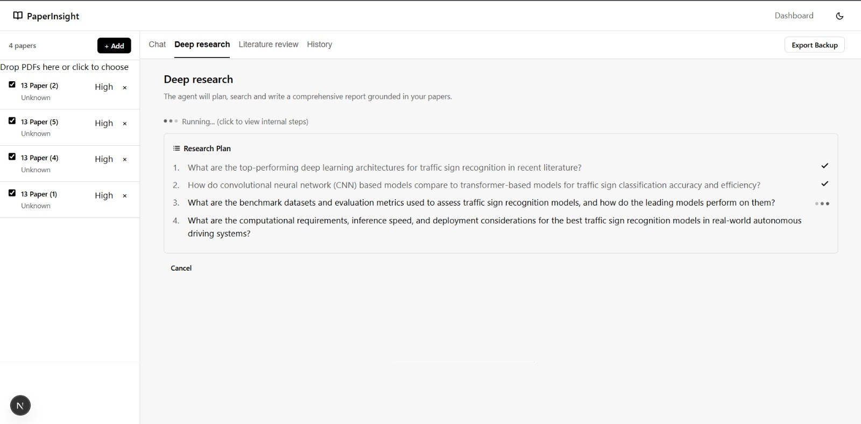
Figure 10: Research plan with steps being completed
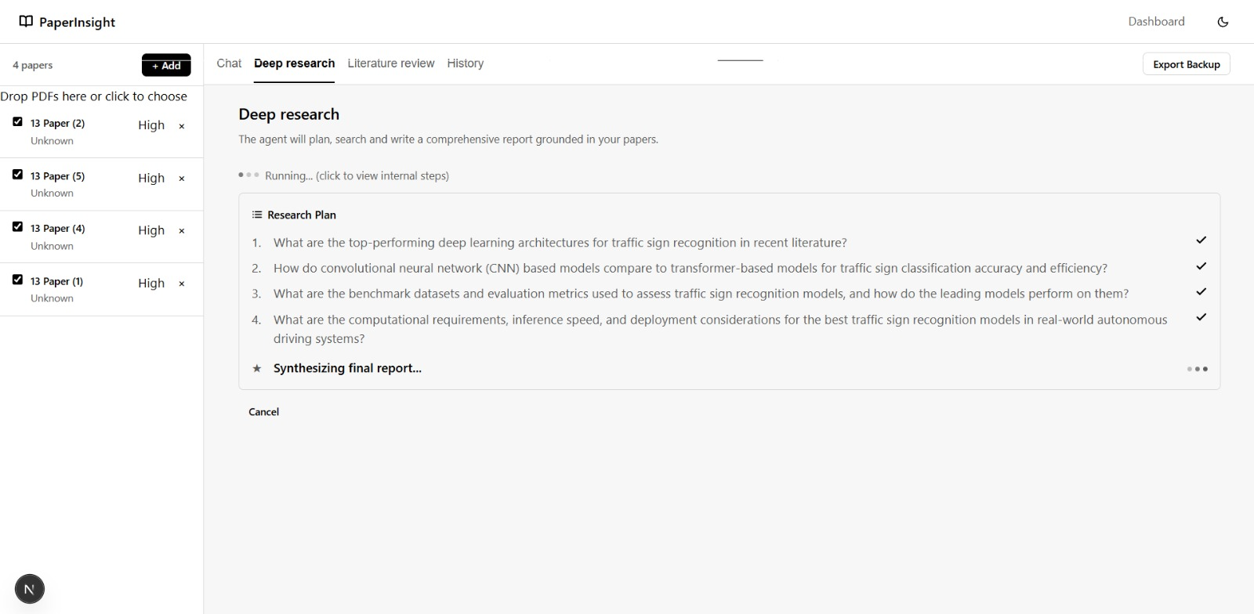
Figure 11: Final synthesis stage
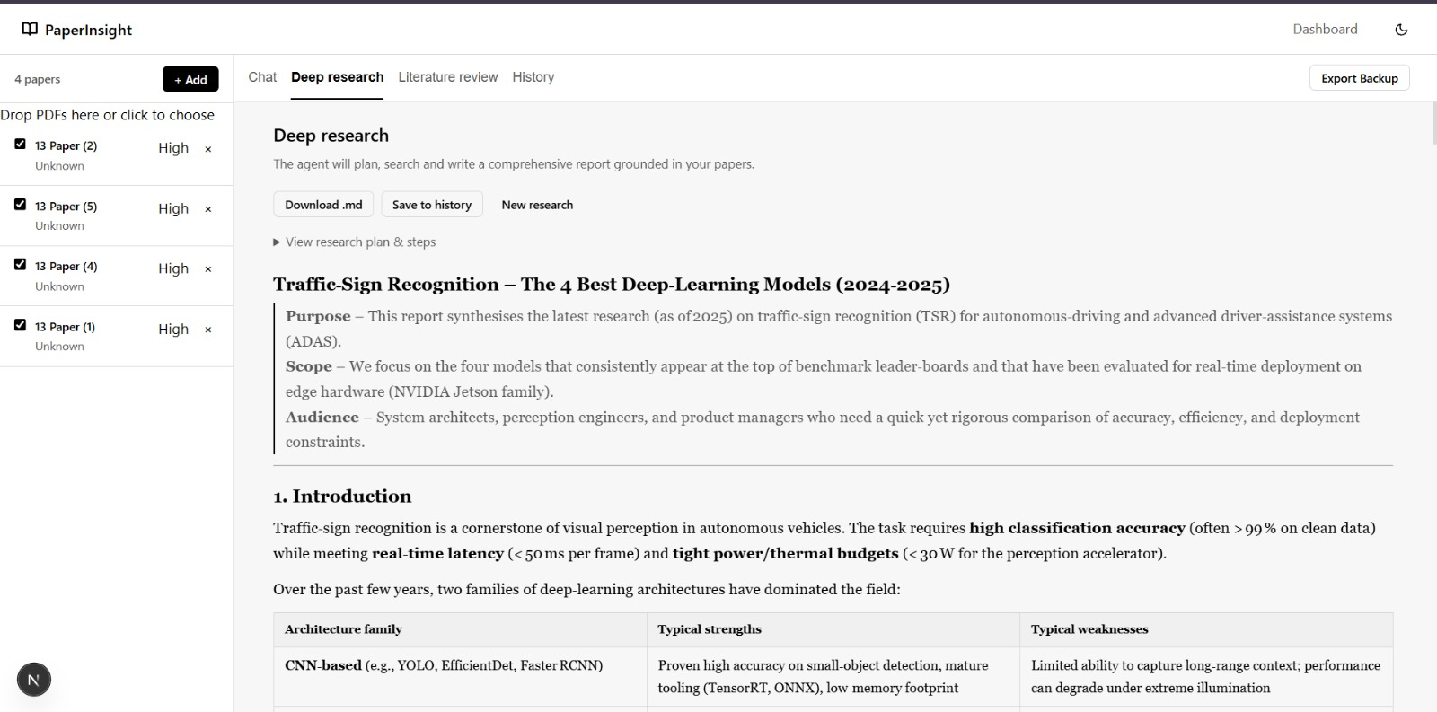
Figure 12: Generated report with download and save options

10.6 Testing Literature Review and History
The Literature review tab generated a table with serial number, title, year, authors, summary, methods and algorithms, limitations and research gaps for the selected papers. Both the deep research report and the literature review were stored under History and could be downloaded as Markdown.
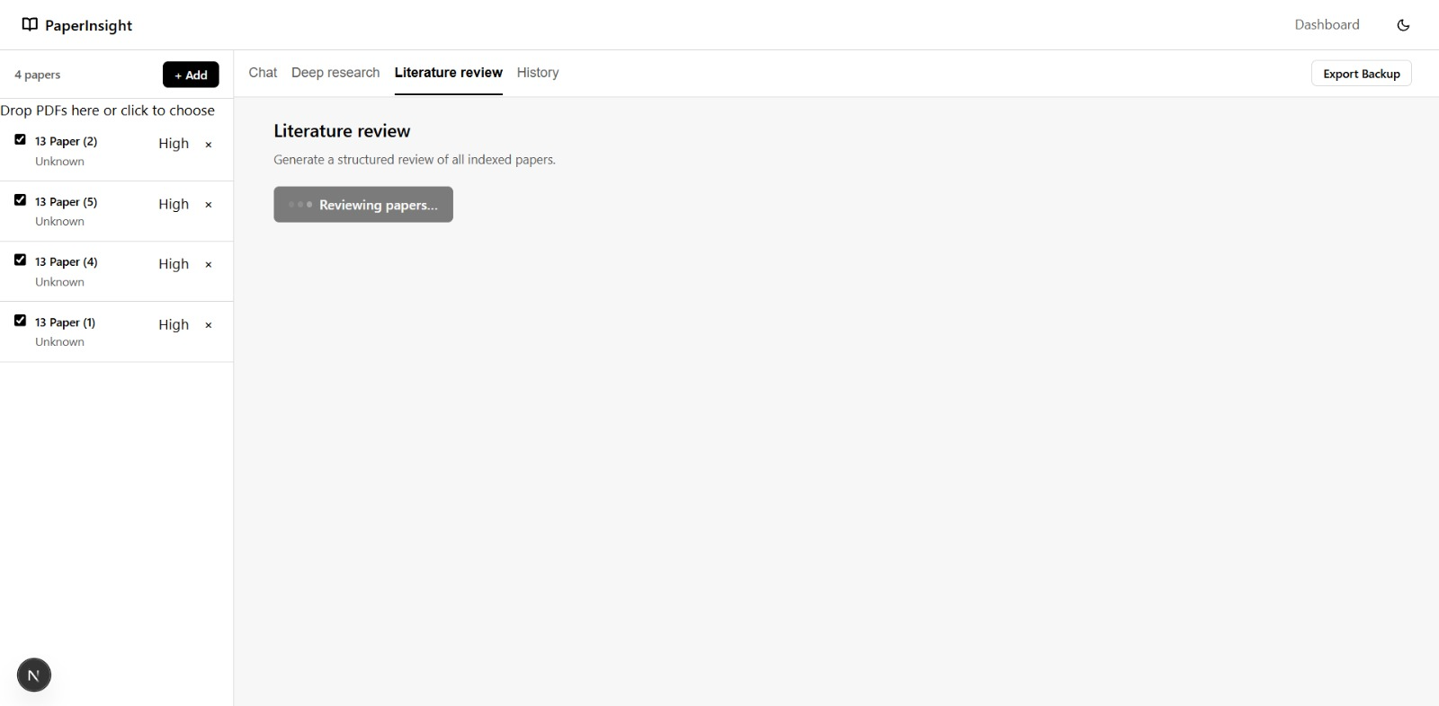
Figure 13: Literature review generation in progress
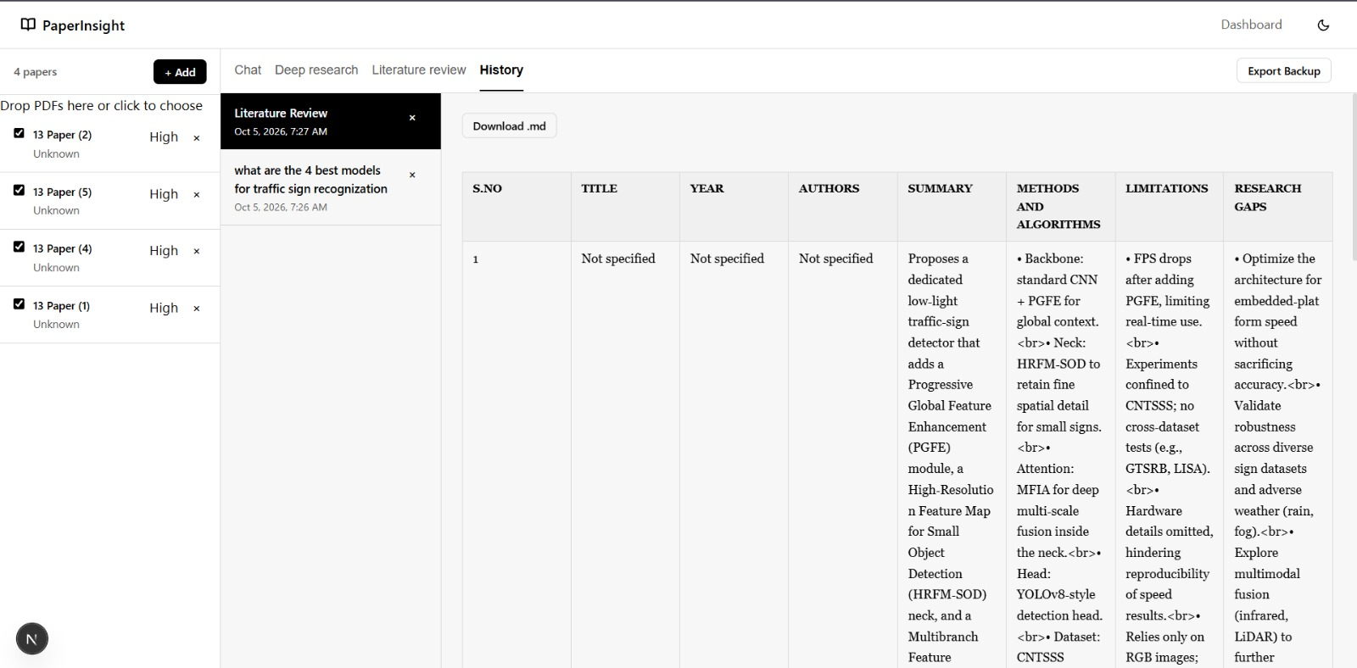
Figure 14: History view with the saved literature review

10.7 Test Summary
Feature | Test action | Observed result
Project creation | Entered topic and goal | Project workspace opened
PDF upload and indexing | Selected eight PDFs | All eight listed as indexed
Paper selection | Used four of the eight papers | Answers drawn from the selected set
RAG chat | Asked an open question | Formatted answer with confidence and sources
Deep research | Entered a research question | Plan, progress display and final report
Literature review | Generated review table | Structured table produced and saved
History and export | Opened saved items | Items viewable and downloadable as Markdown

11. Observations and Limitations
The following points were noted during testing.
- Missing metadata: the paper list shows "Unknown" under each paper, and the first literature review row reports title, year and authors as "Not specified". This follows from the design choice to skip LLM metadata extraction during upload and use file names instead.
- Table rendering: the literature review table shows raw <br> tags inside cells, so line breaks in the generated Markdown are not rendered as breaks.
- Source attribution: the chat answer listed only one source file although four papers were selected, so the attribution may be incomplete.
- Generated content needs checking: figures and commands in model output, such as performance numbers or configuration commands, come from the language model and should be verified against the source papers and tool documentation.
- Scalability: the in-memory FAISS index and JSON storage suit a personal library but not tens of thousands of papers.

12. Future Work
- Multi-modal parsing: use vision-language models so that charts and figures become searchable data.
- Graph RAG: extract entities such as models, metrics and authors into a knowledge graph for relational queries.
- LaTeX export: convert deep research reports into LaTeX templates for Overleaf or journal submission.
- Persistent vector stores: move to a disk-backed store such as ChromaDB or Milvus.
- Cross-project RAG: query several project indexes at once to link separate workspaces.
- Better metadata: extract title, year and authors in the background after upload without slowing it down.

13. Conclusion
PaperInsight AI turns unstructured academic PDFs into usable insight. By combining a small local embedding model with a configurable language model, it provides fast, private and grounded research assistance, including autonomous report writing and literature review. Testing with a sample set of eight papers confirmed that project creation, indexing, chat, deep research, literature review and history all work end to end. Resolving the metadata and rendering issues noted above would make it a stronger tool.

