PENETRATION TESTING REPORT
FOOTPRINTING & NETWORK SCANNING PHASES
CYBERSECURITY | NETWORKWALKS
Pentester Name (Cybersecurity Professional)
| Mohraiel Fady
Program / Batch
| B084-Networkwalks
Date
| 08 November 2026
Modules completed
| W2-PM1 (Multiple Kali Tools)
W2-PM4
W2-PM5 (Zenmap Scanning)
Client / Target
| 1. Networkwalks (secured written permission already)
2. My own local LAN Network
Permission secured from client?
| Yes
Phases covered
| Phase 1: Reconnaissance & Footprinting
Phase 2: Scanning & Network Discovery
Phase 3-5: In Progress

1. Liability Disclaimer
I have performed these activities only on the systems & devices where I had secured written permission or the devices/systems that I own myself. All these materials are for education and research purpose only. Do not use anything from here to break the law. The instructor, the authors and Networkwalks are not responsible for what you do with this knowledge. Every action you take is your own responsibility. Misuse can lead to criminal charges, heavy fines, loss of your job and a permanent record. In most countries unauthorised access is a crime even when nothing is damaged.
2. Introduction
This report covers footprinting the networkwalks.com domain using multiple Kali Linux tools (W2-PM1) and scanning my own local network with Windows IP configuration and footprinting/scanning techniques (W2-PM5). One module covers the footprinting phase and the other covers the scanning phase, so together they show how an attacker moves from gathering public information to mapping live hosts on a network. It is the Week 2 part of my ongoing internship program at Networkwalks.
All commands were run in Kali Linux (footprinting) and on a Windows PC (scanning). Every step below includes the exact command used, the result I observed, a screenshot as evidence, and a short note on why the finding matters from an attacker's point of view.
3. Tools Used
The table below lists each tool used in this report and its purpose.
Tool | Purpose
Kali Linux & Windows | Operating systems used for reconnaissance activities
WHOIS | Find domain registration details (owner, dates, name servers).
whatweb | Fingerprint web technologies (server, CMS, plugins, IP).
nslookup | Resolve the domain name to its IP address using DNS.
curl -I | Read the HTTP response headers of the website.
wafw00f | Detect whether a Web Application Firewall protects the site.
dnsrecon | Enumerate all DNS records (NS, MX, SPF, TXT, SRV).
theHarvester | Gather emails, subdomains, hosts, employee names, open ports and banners from different public sources.
Windows CMD (ipconfig) | Local IP address, subnet mask, DNS suffix, and network adapter identification.

4. Activities Performed
4.1 Footprinting & Reconnaissance
I performed reconnaissance against the networkwalks.com domain using Kali Linux tools: WHOIS, WhatWeb, Nslookup, Curl, Wafw00f, DNSRecon, and theHarvester. Each tool was used to collect a different type of information about the target.
First, I used WHOIS to obtain publicly available domain registration information and identify the domain’s name servers. The results provided information about the domain registration (Registry Domain ID: 2452319255_DOMAIN_COM-VRSN, Registrar: GoDaddy.com, LLC, Creation Date: 2019-11-06T22:51:46Z, Registry Expiry Date: 2027-11-06T22:51:46Z, Registrant Organization: Domains By Proxy, LLC, Name Servers: NS6135.HOSTGATOR.COM, NS6136.HOSTGATOR.COM, NS29.DOMAINCONTROL.COM, NS30.DOMAINCONTROL.COM).
I then used WhatWeb to attempt to identify technologies used by the website. Running `whatweb networkwalks.com` initiated target scanning.
Using Nslookup, I resolved the domain name to its IP address using DNS server 8.8.8.8. The result identified the IP address: 192.232.216.135.
I used Curl with the -I option (`curl -I https://networkwalks.com`) to inspect the HTTP response headers. The request returned an HTTP/2 200 OK response with Server: Apache, x-nginx-cache: WordPress, Content-Type: text/html; charset=UTF-8, Date: Sun, 08 Nov 2026 12:51:22 GMT, along with WordPress REST API endpoints (/wp-json/).
Next, I used Wafw00f (`wafw00f networkwalks.com`) to determine whether a Web Application Firewall was protecting the website. The result confirmed that the site https://networkwalks.com is behind ModSecurity (SpiderLabs) WAF.
I used DNSRecon (`dnsrecon -d networkwalks.com`) to enumerate DNS records. The scan returned 8 records including SOA (ns6135.hostgator.com / 50.87.144.87), NS records (ns6136.hostgator.com / 192.232.216.131 and ns6135.hostgator.com / 50.87.144.87), MX record (mail.networkwalks.com / 192.232.216.135), A record (192.232.216.135), TXT records (SPF v=spf1 +a +mx +ip4:50.87.144.87 and google-site-verification), and multiple SRV autodiscover records for cpanel email discovery.
Additionally, I executed theHarvester (`theHarvester -d microsoft.com -l 50 -b all`) to demonstrate open-source intelligence gathering across public search engines and APIs.
4.2 Network Scanning & Local Host Discovery
For the second activity, I performed local network identification on my Windows environment using Command Prompt. I executed the `ipconfig` command to inspect active Ethernet adapters, IP configuration, subnet masks, and network suffixes.
The `ipconfig` output identified the local system network configuration as follows:
• Ethernet adapter Ethernet:
- Media State: Media disconnected
- Connection-specific DNS Suffix: EGYPT.AAST.edu
• Ethernet adapter Ethernet 2:
- Connection-specific DNS Suffix: (Blank)
- Link-local IPv6 Address: fe80::416b:76d7:cd2a:5d45%8
- IPv4 Address: 192.168.56.1
- Subnet Mask: 255.255.255.0
- Default Gateway: (Unconfigured)
5. Risk Analysis / Impact
Based on the information collected during the footprinting and network scanning activities, I identified the following potential risks.
# | Risk / Finding | Evidence / Observation | Potential Impact | Risk Level
1 | HTTP technical information exposed | Curl returned HTTP response headers, revealing Apache server, WordPress cache header, and /wp-json/ REST API | May assist technology fingerprinting and target enumeration for custom exploit crafting | ● Low
2 | Server IP address identifiable | Nslookup resolved the domain networkwalks.com to 192.232.216.135 | Provides exact network location of target hosting infrastructure | ● Low
3 | WAF technology identifiable | Wafw00f identified ModSecurity (SpiderLabs) WAF | Reveals web application protection architecture, allowing attackers to attempt WAF bypass techniques | ● Low
4 | DNS infrastructure information exposed | DNSRecon enumerated 8 records including SOA, NS, MX, A, TXT (SPF), and cpanel SRV records | Exposes mail servers, name servers, hosting provider IP addresses, and email infrastructure | ● Medium
5 | Domain registration metadata publicly accessible | WHOIS lookup exposed registrar details, GoDaddy proxy privacy service, creation/expiry dates, and name servers | Assists in domain footprinting, social engineering, and monitoring domain registration life cycles | ● Low
6 | Local Virtual Network Adapter Configured | Windows ipconfig exposed IPv4 192.168.56.1 on virtual host-only network adapter and domain suffix EGYPT.AAST.edu | Reveals local internal IP structure and connected institutional domain suffix | ● Low
Risk level key: ● Critical ● Medium ● Low
The risks above are observations from the footprinting and scanning exercises, not confirmed vulnerabilities. The practical exercises primarily involved information gathering and host discovery. No exploitation or vulnerability validation was performed as part of these modules.
6. Recommendations
Based on the observations from these activities, I recommend the following security improvements:
• Review publicly exposed technology information: Organizations should regularly review what information about their web servers and backend structure is publicly visible.
• Review HTTP headers: HTTP response headers should be sanitized to remove unnecessary version and engine information.
• Review DNS records regularly: Ensure DNS records expose only required public services and hide internal management subdomains where applicable.
• Maintain WAF protection: Keep ModSecurity WAF properly updated and tuned to block active enumeration and exploit payloads.
• Network documentation & Isolation: Unused virtual network interfaces or test IP bindings should be isolated or disabled when not in active use.
7. Conclusion
During Week 2 of my Cybersecurity & Ethical Hacking internship, I completed practical activities covering footprinting, reconnaissance, and network scanning.
In the footprinting activity, I used Kali Linux tools to collect comprehensive reconnaissance data on target environments. I demonstrated how WHOIS provides domain ownership structure, Nslookup resolves IP addresses, Curl inspects HTTP header attributes, Wafw00f verifies firewall presence, DNSRecon map system DNS records, and theHarvester collects OSINT metrics.
In the network scanning phase, I used Windows IP configuration tools (`ipconfig`) to analyze local interface configurations, IP address assignments, and network subnets.
The exercises reinforced that information gathering is a fundamental stage in ethical hacking and penetration testing. Documenting findings accurately ensures that security risks can be identified and mitigated before unauthorized actors exploit them.
8. Evidences Collected
Screenshot 1: WHOIS Domain Footprinting (Part 1)
Screenshot 2: WHOIS Registrant & Tech Contact Details (Part 2)
Screenshot 3: WhatWeb Web Technology Fingerprinting
Screenshot 4: Nslookup Domain Name Resolution
Screenshot 5: Curl HTTP Response Headers Inspection
Screenshot 6: Wafw00f Web Application Firewall Detection
Screenshot 7: DNSRecon DNS Enumeration
Screenshot 8: theHarvester OSINT Reconnaissance
Screenshot 9: Windows Command Prompt IP Configuration (ipconfig)
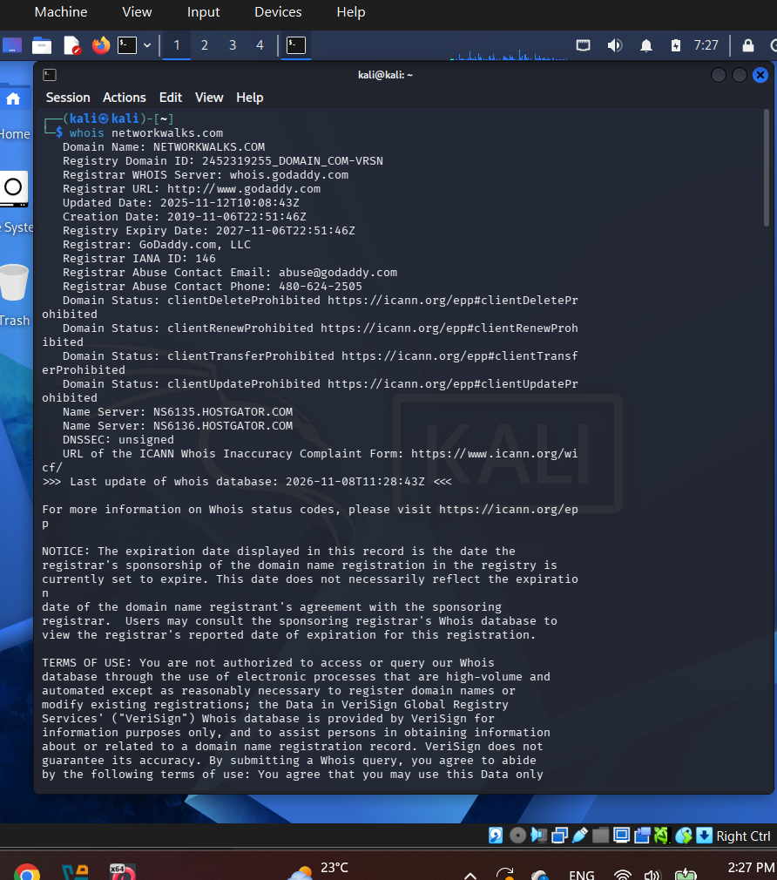
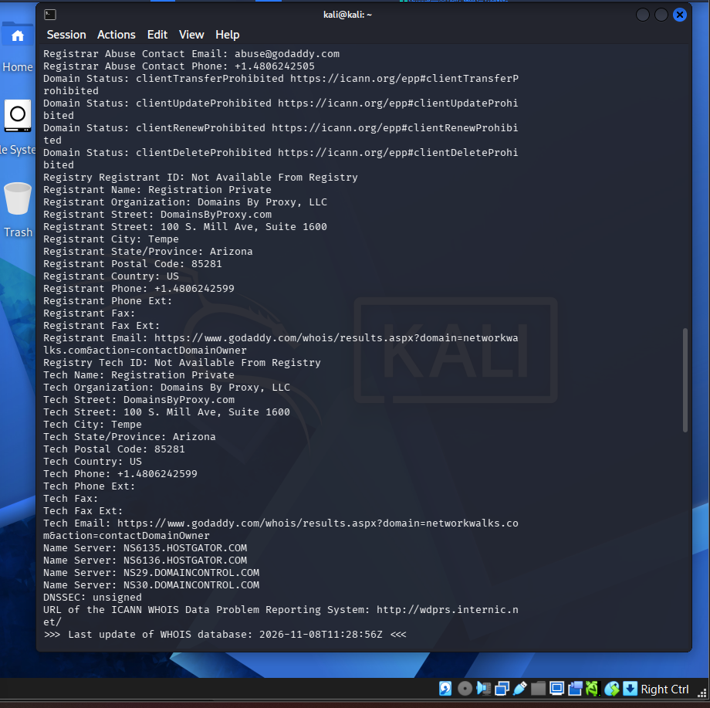
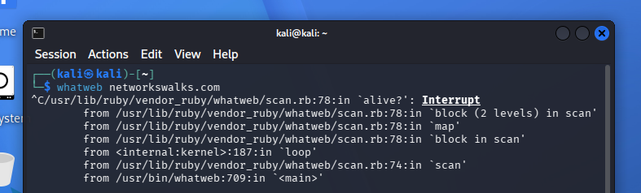

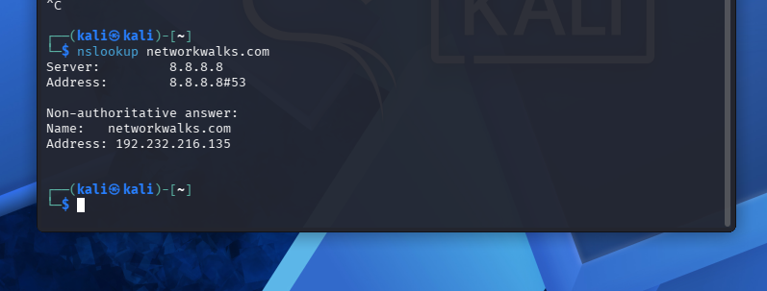
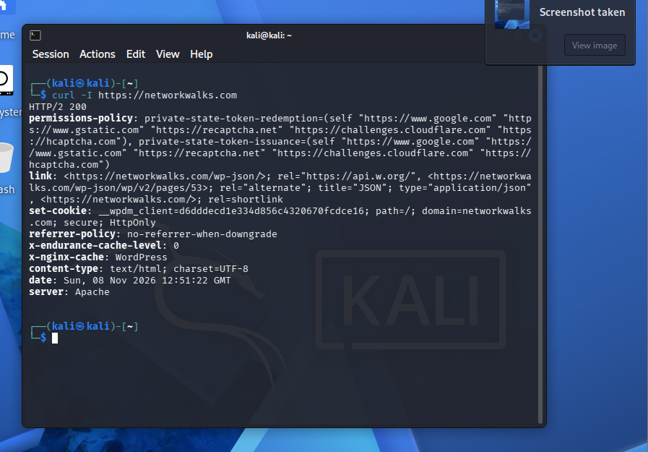
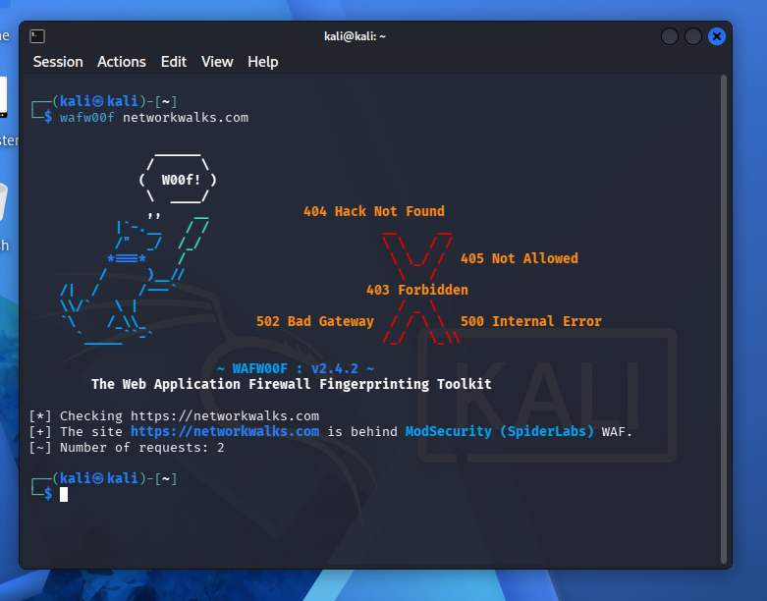
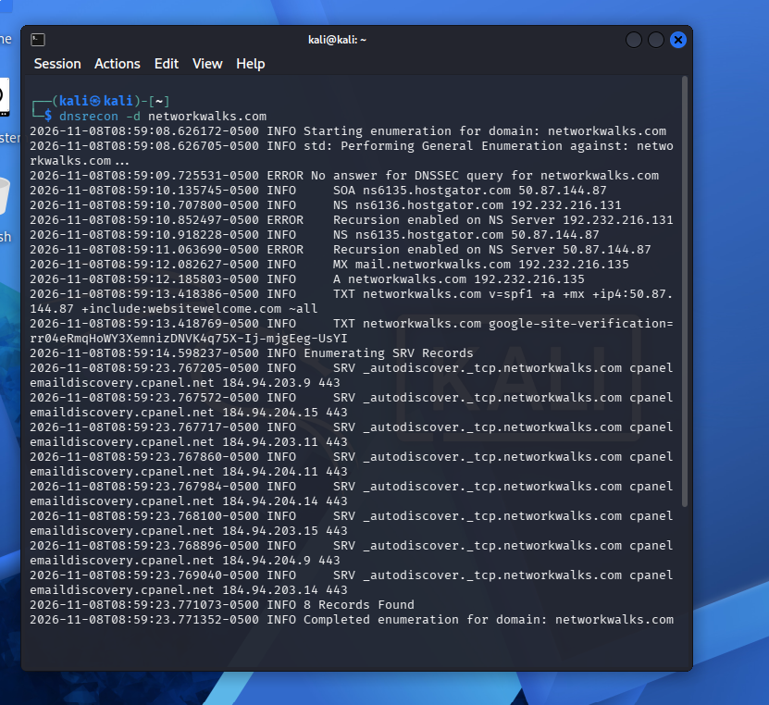
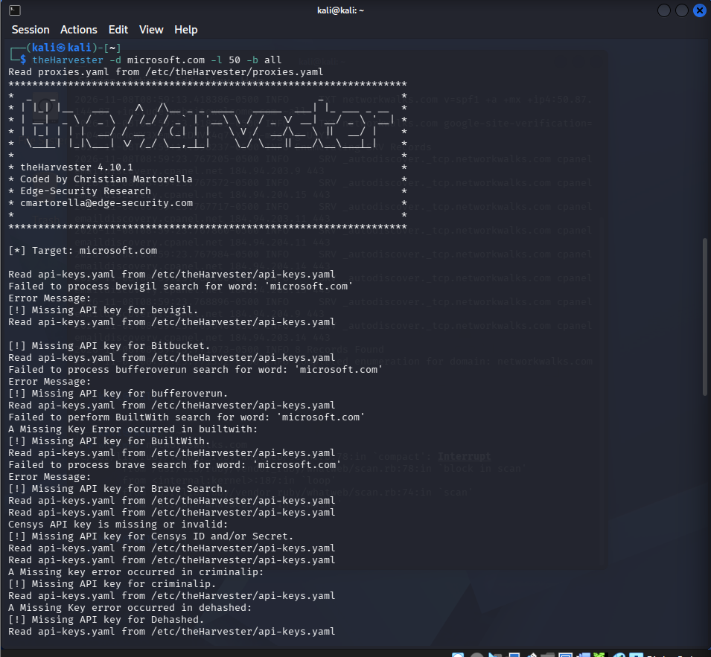
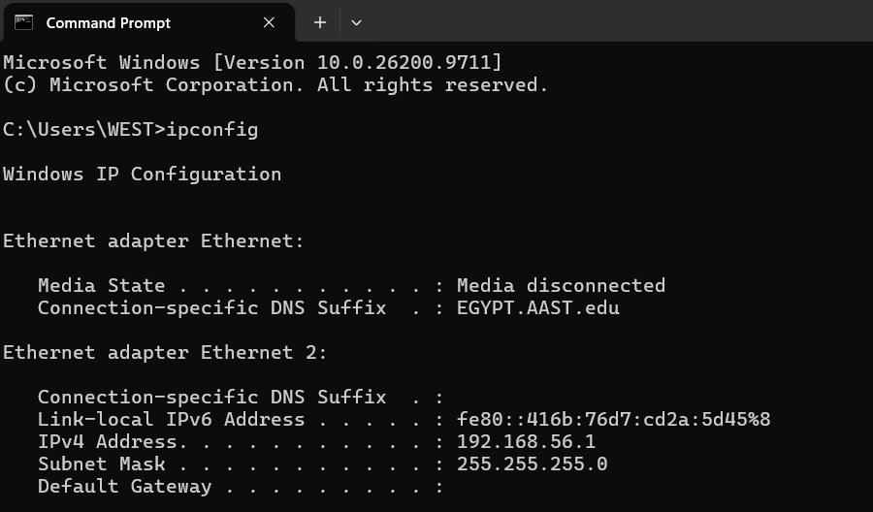
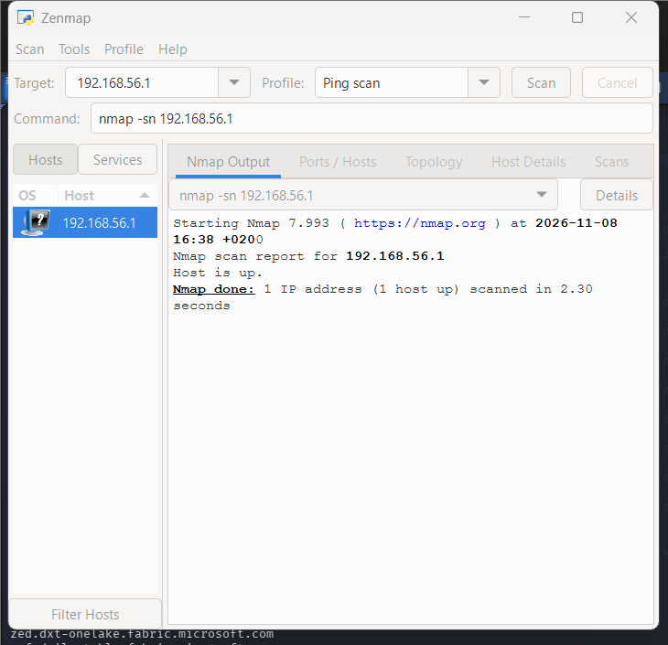
Project Information
| Program Name: Cybersecurity program at Networkwalks | Week: 02 | Repository: GitHub

