Cell Culture Laboratory Management Database
Report
Student name:Merna Mikheal Alkes
Student ID: 221001874
Instructor:Dr\Muhammad Elsayd
Supervisor:Esraa Magdy
Department:CBIO 204

1. Problem Statement, Scope, Assumptions, and Major Business Rules
Cell-culture laboratories manage interconnected information about biological materials, laboratory equipment, experiments, passages, contamination tests, researchers, and cryopreserved stocks. A relational database is needed to preserve these relationships, reduce duplicated information, support reliable retrieval, and maintain referential integrity. This project implements a MySQL database for laboratory management rather than clinical patient care.

Scope
The database stores nine base entities: RESEARCHER, INCUBATOR, MEDIA, CELL_LINE, EXPERIMENT, EXPERIMENT_RESEARCHER, PASSAGE, CONTAMINATION_TEST, and CRYOSTOCK. The related project also defines two views, a stored procedure, and a trigger. The scope excludes patient-identifying information, clinical diagnoses, billing, user authentication, instrument integration, and a graphical user interface.

Assumptions and Major business rules
- Each ID column declared as a primary key uniquely identifies one record in its table.
- A CELL_LINE may be referenced by zero or many EXPERIMENT and CRYOSTOCK records.
- RESEARCHER and EXPERIMENT have a many-to-many relationship resolved by EXPERIMENT_RESEARCHER, whose composite primary key prevents duplicate pairs.
- PASSAGE stores passage number, date, split ratio, and references to an experiment, media, and incubator.
- CONTAMINATION_TEST is linked to PASSAGE; deleting a passage cascades to its contamination tests.
- Deleting a MEDIA or INCUBATOR record sets the corresponding nullable PASSAGE foreign key to NULL.
- Deleting a CELL_LINE cascades to related EXPERIMENT and CRYOSTOCK records; deleting an EXPERIMENT cascades to its assignments and passages.
- The trigger rejects a CRYOSTOCK insert when VialCount is negative.
- The stored procedure returns active experiments for a supplied CellLineID.

2. Entities, Attributes, Identifiers, and Key Decisions
- The following list matches the entity names and attributes shown in the supplied ERD and the table definitions in 01-create_tables.sql.
Entity | Attributes and identifiers | Key decision
RESEARCHER | ResearcherID INT PK; FirstName VARCHAR(40) NOT NULL; LastName VARCHAR(40) NOT NULL; EmailAddress VARCHAR(100); OfficePhone VARCHAR(20) | Names are required; email and phone are optional.
INCUBATOR | IncubatorID INT PK; Model VARCHAR(40) NOT NULL; Location VARCHAR(50); Temperature FLOAT; CO2Percentage FLOAT | Stores equipment and culture conditions separately from passages.
MEDIA | MediaID INT PK; MediaName VARCHAR(50) NOT NULL; SerumType VARCHAR(30); BatchNumber VARCHAR(30); ExpirationDate DATE | Keeps media batch and expiry data in one inventory entity.
CELL_LINE | CellLineID INT PK; LineName VARCHAR(50) NOT NULL; Organism VARCHAR(40); TissueOrigin VARCHAR(50); BiosafetyLevel INT | Stores biological identity and biosafety information once.
EXPERIMENT | ExperimentID INT PK; Title VARCHAR(100) NOT NULL; StartDate DATE; Status VARCHAR(20); CellLineID INT FK | CellLineID links the experiment to its biological material.
EXPERIMENT_RESEARCHER | ExperimentID INT PK/FK; ResearcherID INT PK/FK; Role VARCHAR(30) | Associative entity resolving the researcher–experiment M:N relationship.
PASSAGE | PassageID INT PK; PassageNumber INT NOT NULL; PassageDate DATE; SplitRatio VARCHAR(10); ExperimentID, MediaID, IncubatorID INT FKs | Records passage events and resource references.
CONTAMINATION_TEST | TestID INT PK; TestDate DATE; ContaminantType VARCHAR(30); Result VARCHAR(10); PassageID INT FK | Stores quality-control tests for passages.
CRYOSTOCK | StockID INT PK; VialCount INT NOT NULL; FreezerLocation VARCHAR(50); FreezeDate DATE; CellLineID INT FK | Tracks frozen inventory and its cell-line source.

3. ER Diagram, Cardinality Ratios, and Participation Constraints
The supplied ERD is reproduced below. It contains the nine base tables and indicates the primary keys, foreign keys, relationship labels, and crow’s-foot cardinality notation. The two yellow objects in the ERD are views: vw_contamination_summary and vw_active_experiments.
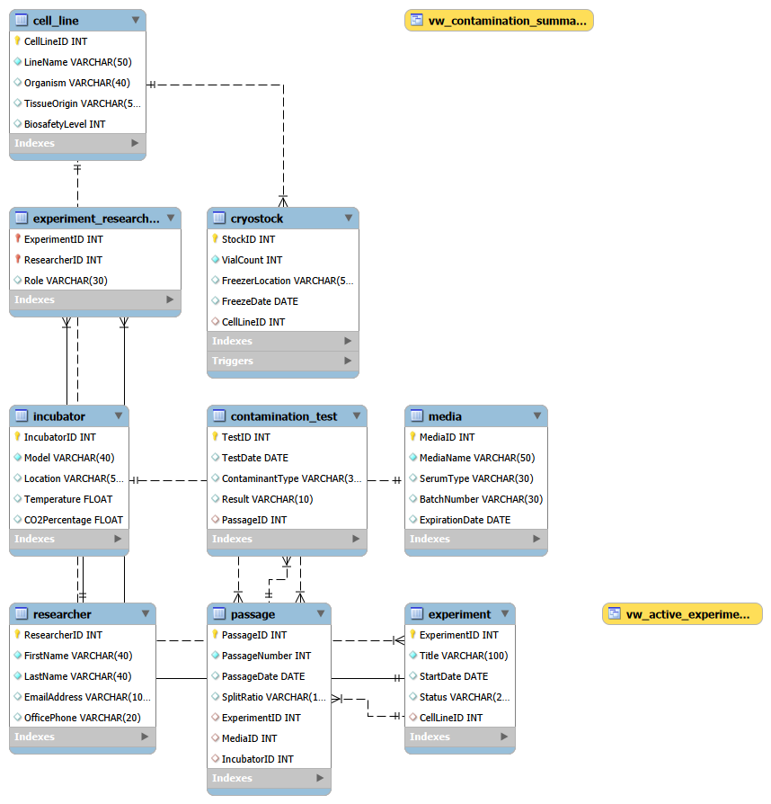

Relationship | Cardinality | Participation constraints from the SQL
CELL_LINE — EXPERIMENT | 1:N | A CELL_LINE may participate in zero or many experiments. EXPERIMENT.CellLineID is nullable in the SQL, so an experiment can technically have an optional cell-line reference; when populated, it references exactly one existing cell line.
CELL_LINE — CRYOSTOCK | 1:N | A CELL_LINE may have zero or many cryostocks. CRYOSTOCK.CellLineID is nullable, so the child participation is optional at the database level.
EXPERIMENT — PASSAGE | 1:N | An experiment may have zero or many passages. PASSAGE.ExperimentID is nullable in the SQL, so the passage-side participation is optional even though the business meaning normally expects a passage to be associated with an experiment.
PASSAGE — CONTAMINATION_TEST | 1:N | A passage may have zero or many tests. CONTAMINATION_TEST.PassageID is nullable, so a test row can technically be inserted without a passage reference; populated values must reference an existing passage.
MEDIA — PASSAGE | 1:N | A media row may be referenced by zero or many passages. PASSAGE.MediaID is nullable and ON DELETE SET NULL is defined.
INCUBATOR — PASSAGE | 1:N | An incubator may host zero or many passages. PASSAGE.IncubatorID is nullable and ON DELETE SET NULL is defined.
RESEARCHER — EXPERIMENT_RESEARCHER | 1:N | A researcher may have zero or many assignments; each assignment references at most one researcher.
EXPERIMENT — EXPERIMENT_RESEARCHER | 1:N | An experiment may have zero or many assignments; each assignment references at most one experiment. Together, the two 1:N relationships implement RESEARCHER M:N EXPERIMENT.

Participation note: the ERD expresses the intended business relationships, while the nullable foreign-key declarations mean that several child-side participations are optional in the current implementation. This distinction is documented rather than hidden.

4. Relational Schema and Integrity Constraints
The relational schema is defined by 01-create_tables.sql. Every base table has a primary key, and all declared foreign keys specify their referential actions. The SQL does not declare UNIQUE constraints, CHECK constraints, or DEFAULT values. This is important to report accurately: primary keys prevent duplicate identifiers, but fields such as EmailAddress, BatchNumber, Model, and LineName are not declared unique by the current script.
Table | Primary key | Foreign keys / referential actions | Other declared constraints
RESEARCHER | ResearcherID | None | FirstName, LastName NOT NULL
INCUBATOR | IncubatorID | None | Model NOT NULL
MEDIA | MediaID | None | MediaName NOT NULL
CELL_LINE | CellLineID | None | LineName NOT NULL
EXPERIMENT | ExperimentID | CellLineID → CELL_LINE; DELETE/UPDATE CASCADE | Title NOT NULL
EXPERIMENT_RESEARCHER | ExperimentID + ResearcherID | Both FKs; DELETE/UPDATE CASCADE | Composite PK
PASSAGE | PassageID | ExperimentID → EXPERIMENT CASCADE; MediaID → MEDIA SET NULL; IncubatorID → INCUBATOR SET NULL | PassageNumber NOT NULL
CONTAMINATION_TEST | TestID | PassageID → PASSAGE CASCADE | No UNIQUE/CHECK/NOT NULL beyond PK
CRYOSTOCK | StockID | CellLineID → CELL_LINE CASCADE | VialCount NOT NULL; negative values handled by trigger

CREATE TABLE CRYOSTOCK (
StockID INT PRIMARY KEY,
VialCount INT NOT NULL,
FreezerLocation VARCHAR(50),
FreezeDate DATE,
CellLineID INT,
FOREIGN KEY (CellLineID) REFERENCES CELL_LINE(CellLineID)
ON DELETE CASCADE ON UPDATE CASCADE
);

5. Normalization to at Least Third Normal Form
The design satisfies the core requirements of 1NF, 2NF, and 3NF. Normalization is evaluated against the attributes and keys implemented in the SQL.
Normal form | Explanation
1NF | Attributes are atomic: one researcher name component, one media batch, one passage date, one contaminant type, and one result per field. Repeated researcher assignments are represented as rows in EXPERIMENT_RESEARCHER rather than repeated columns.
2NF | All single-key tables have no partial dependencies. In EXPERIMENT_RESEARCHER, Role depends on the complete composite key (ExperimentID, ResearcherID), because the role describes a particular researcher’s assignment to a particular experiment.
3NF | Non-key attributes depend on the key of their own subject. Researcher contact data is stored in RESEARCHER, equipment conditions in INCUBATOR, media inventory in MEDIA, cell-line facts in CELL_LINE, and test results in CONTAMINATION_TEST. These facts are not duplicated in dependent tables.

The decomposition reduces update, insertion, and deletion anomalies. For example, changing a media expiration date requires one MEDIA update rather than changes to every passage that used that batch.

6. Implementation Details and Selected SQL Code
The implementation uses MySQL 8.0+. The scripts are executed in dependency order: 01-create_tables.sql, 02-load_data.sql, 03-views.sql, 04-triggers_procedures.sql, 05-queries.sql, followed by the testing statements. The first script drops and recreates CellCultureDB to support repeatable testing on a clean database.

Database initialization
DROP DATABASE IF EXISTS CellCultureDB;
CREATE DATABASE CellCultureDB;
USE CellCultureDB;

Foreign-key definition
FOREIGN KEY (CellLineID) REFERENCES CELL_LINE(CellLineID)
ON DELETE CASCADE ON UPDATE CASCADE

Representative many-to-many definition
PRIMARY KEY (ExperimentID, ResearcherID),
FOREIGN KEY (ExperimentID) REFERENCES EXPERIMENT(ExperimentID)
ON DELETE CASCADE ON UPDATE CASCADE,
FOREIGN KEY (ResearcherID) REFERENCES RESEARCHER(ResearcherID)
ON DELETE CASCADE ON UPDATE CASCADE

Advanced objects used by the project
CALL sp_GetActiveExperimentsByCellLine(1);
-- Trigger test case
INSERT INTO CRYOSTOCK (StockID, VialCount, FreezerLocation, FreezeDate, CellLineID)
VALUES (999, -1, 'Test location', CURRENT_DATE, 1);

7. Sample Data and Screenshots of Successful Execution
The load-data script provides laboratory examples for each base table. The report should describe the exact row counts after execution and include screenshots captured from MySQL Workbench.
Data category | Expected evidence
Researchers, incubators, media, cell lines | Sample records are visible in each of the four base tables.
Experiments and assignments | Experiments are linked to cell lines, and EXPERIMENT_RESEARCHER demonstrates multiple researcher assignments.
Passages and contamination tests | Passages contain passage numbers, dates, split ratios, and resource references; tests contain contaminant types and results.
Cryostocks | Cryostock rows show vial counts, freezer locations, freeze dates, and cell-line references.

Screenshot | Action | Evidence to show
Screenshot1 | Run 02-load_data.sql then SELECT COUNT(*) | Loaded rows in each table and associative assignments.
Screenshot 2 | SELECT * FROM vw_active_experiments | Only Status = Active experiments with cell-line information.
Screenshot 3 | SELECT * FROM vw_contamination_summary | Contamination results joined to passage and experiment context.
Screenshot 4 | CALL sp_GetActiveExperimentsByCellLine(1) | Active experiments associated with CellLineID 1.

Screenshot 1 — SELECT * FROM experiment
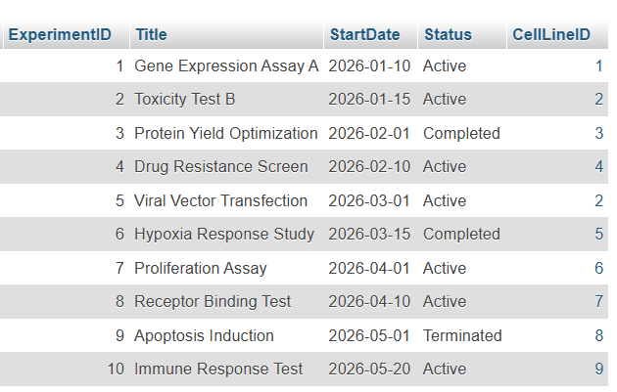
Screenshot 2 — SELECT * FROM vw_active_experiments
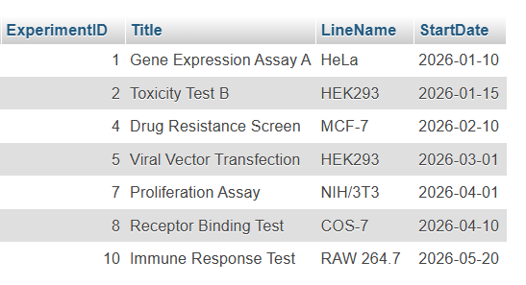

Screenshot 3– SELECT * FROM vw_contamination_summary
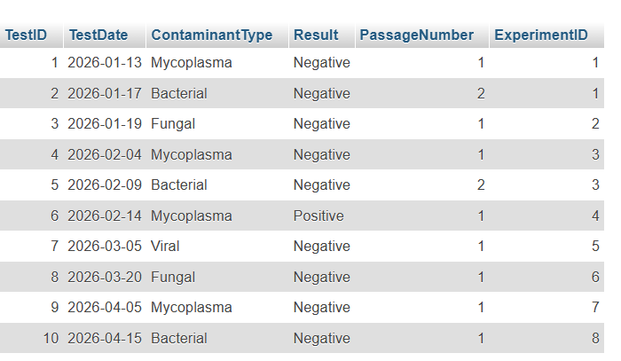
Screenshot 4 — CALL sp_GetActiveExperimentsByCellLine(1)
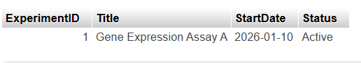

8. Views, Trigger, and Procedure: Purpose and Design
Object | Purpose | Contribution
vw_active_experiments | Joins EXPERIMENT with CELL_LINE and filters for active experiments. | Provides a reusable operational view of current studies with cell-line context.
vw_contamination_summary | Summarizes or joins contamination-test information with passage and experiment context. | Supports quality-control review without repeating the same joins in every query.
sp_GetActiveExperimentsByCellLine | Accepts a CellLineID parameter and returns active experiments for that cell line. | Encapsulates a parameterized retrieval operation for repeated use.
trg_check_cryostock_vials | Runs before CRYOSTOCK insertion and raises an error for negative VialCount. | Enforces an inventory rule at the database layer.

The exact view columns and procedure body should be read from 03-views.sql and 04-triggers_procedures.sql during the final defense. Their names and purposes above match the supplied ERD and report implementation description.

9. Test Cases, Results, Limitations, and Conclusion
Test case | Expected result | Final evidence
T1: clean setup | All nine tables and constraints are created. | -
T2: data load | Each required table contains the loaded sample records; the associative table contains multiple assignments. | Attach Screenshot 1.
T3: active view | vw_active_experiments returns only rows with Status = Active. | Attach Screenshot 2.
T4: contamination view | vw_contamination_summary returns contamination context linked to passages and experiments. | Attach Screenshot 3.
T5: procedure | The supplied CellLineID returns its active experiments. | Attach Screenshot 4.

Limitations
- The current create-tables script declares no UNIQUE constraints, so duplicate email addresses, batch numbers, or model names are possible.
- Several foreign-key columns are nullable, so the physical participation constraints are more permissive than the intended business interpretation.
- The schema has no explicit CHECK constraints for temperature, CO2Percentage, BiosafetyLevel, Result values, or non-negative VialCount; the trigger covers only the cryostock rule.
- The current project does not include authentication, audit logging, detailed freezer hierarchy, raw experimental observations, or a user interface.
- Successful execution screenshots must be added after running the scripts in MySQL Workbench.

Conclusion
The Cell Culture Laboratory Management Database is a normalized relational design that represents laboratory personnel, equipment, media, cell lines, experiments, passages, contamination tests, and cryostocks. The ERD and SQL schema support primary-key identification, foreign-key integrity, a many-to-many researcher assignment, reusable views, a parameterized procedure, and a trigger-based inventory rule. Once the student inserts personal details and authentic MySQL execution screenshots, the report will satisfy the written-report requirements.

