Generate MassBank Seed Records (.txt) for mb3dbtool

To generate new MassBank records or update existing ones, you need to run the stebantolib script.
This script converts your original .msp spectral files into MassBank-format .txt records, which are later imported automatically into PostgreSQL by the mb3dbtool service during deployment.
The generated .txt files form the massbank_records directory, which mb3dbtool reads and loads into the database.

Requirements
Before running the script, ensure:
- Python is installed
- You have the script folder (e.g., stebantolib)
- Your input .msp file is placed in the root directory of the project
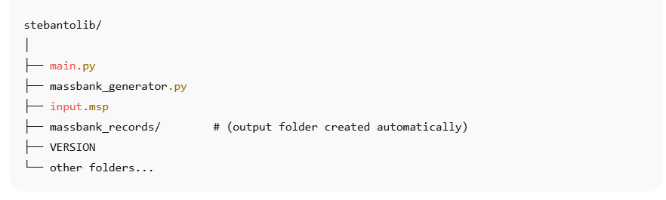
Example directory (your actual structure):

2. How the Script Works
The script:
- Reads your original .msp file
- Converts every record into the MassBank .txt record format
- Generates the output into a new directory named massbank_records/
- These .txt records will later be loaded by mb3dbtool into the PostgreSQL database

3. How to Run the Script

Step 1 — Place Your Input File
Put your original MSP file in the project root (same folder as main.py):

Step 2 — Open terminal and Run the script

Step 4 — Result
A folder named massbank_records/ will be created, containing all generated .txt MassBank records.
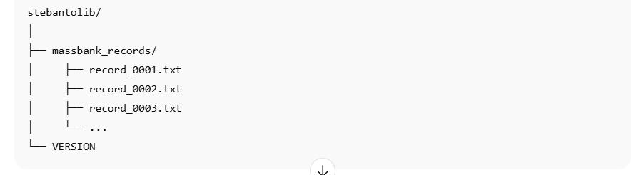
Important !!
These generated files are now ready to be used in the future by the deployment process. They can be:
- Copied into MassBank3/data/MassBank-data/
OR
- Pushed to a GitHub repository referenced by MB_GIT_REPO

Overview of Massbank
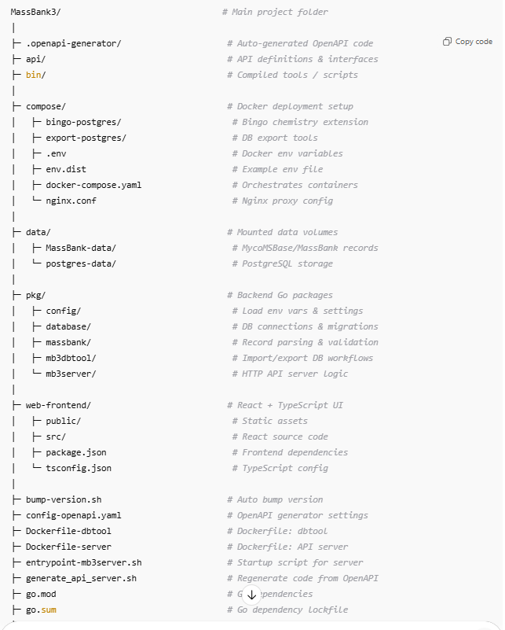

Connect to the Remote Server via SSH

Step 1 — Open terminal

Step 2 — Run SSH command and enter password

clone the project

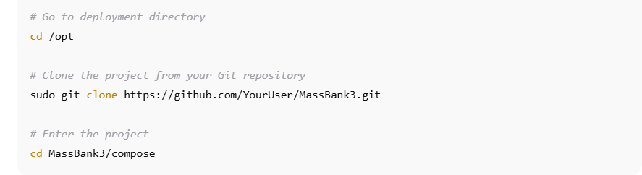
Option A — Clone the repository directly on the server

Option B — Move the project from your local machine to the server

Configuration of Environment Variables

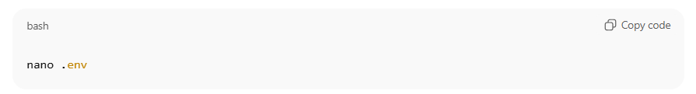
Step 1 — Update .env values from localhost → your server address
Change the following variables from localhost to the server IP or domain:
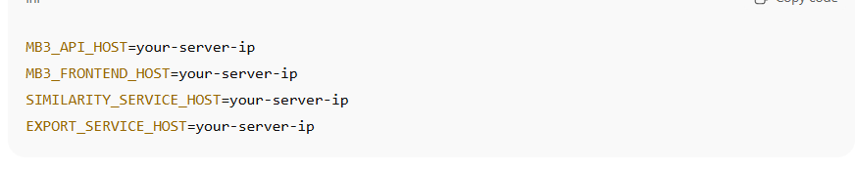
Example:

What the mb3dbtool service does
mb3dbtool is responsible for:
- Initializing the PostgreSQL database
- Removing existing indexes
- Reading MassBank record .txt files
- Validating records
- Importing records into PostgreSQL
- Updating metadata
- Rebuilding indexes
- Finalizing the database
This happens automatically on container startup, when MB_DB_INIT=true.

Choose HOW mb3dbtool receives MassBank records
You have two supported options:

Option 1 — Load MassBank Data from GitHub Repository

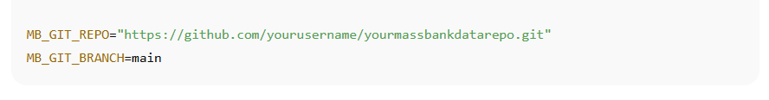
Important:

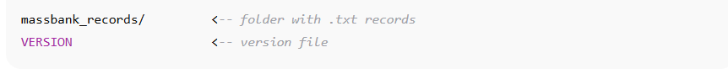
Your GitHub repo must contain this structure:

Option 2 — Upload Data Locally to /data/MassBank-data/
By default, the system loads records from the local folder:
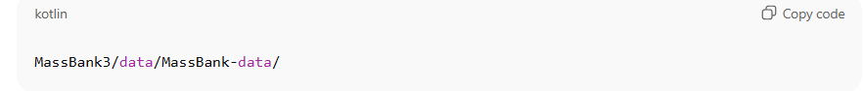
Place your MassBank/MycoMSBase .txt record folders into:
The structure should look like:
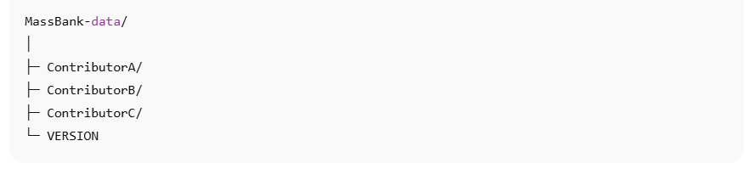
important !!!!!
The VERSION file must always be present inside the MassBank-data

Open Ports and Start Docker Compose
Before deploying, ensure that port 8080 is open on your server firewall.
After that, start the system using:

