Desk Booking System - Architecture Documentation

System Architecture Diagram
This document provides a comprehensive view of the Desk Booking System architecture, organized into logical layers for better understanding.

High-Level Architecture Overview

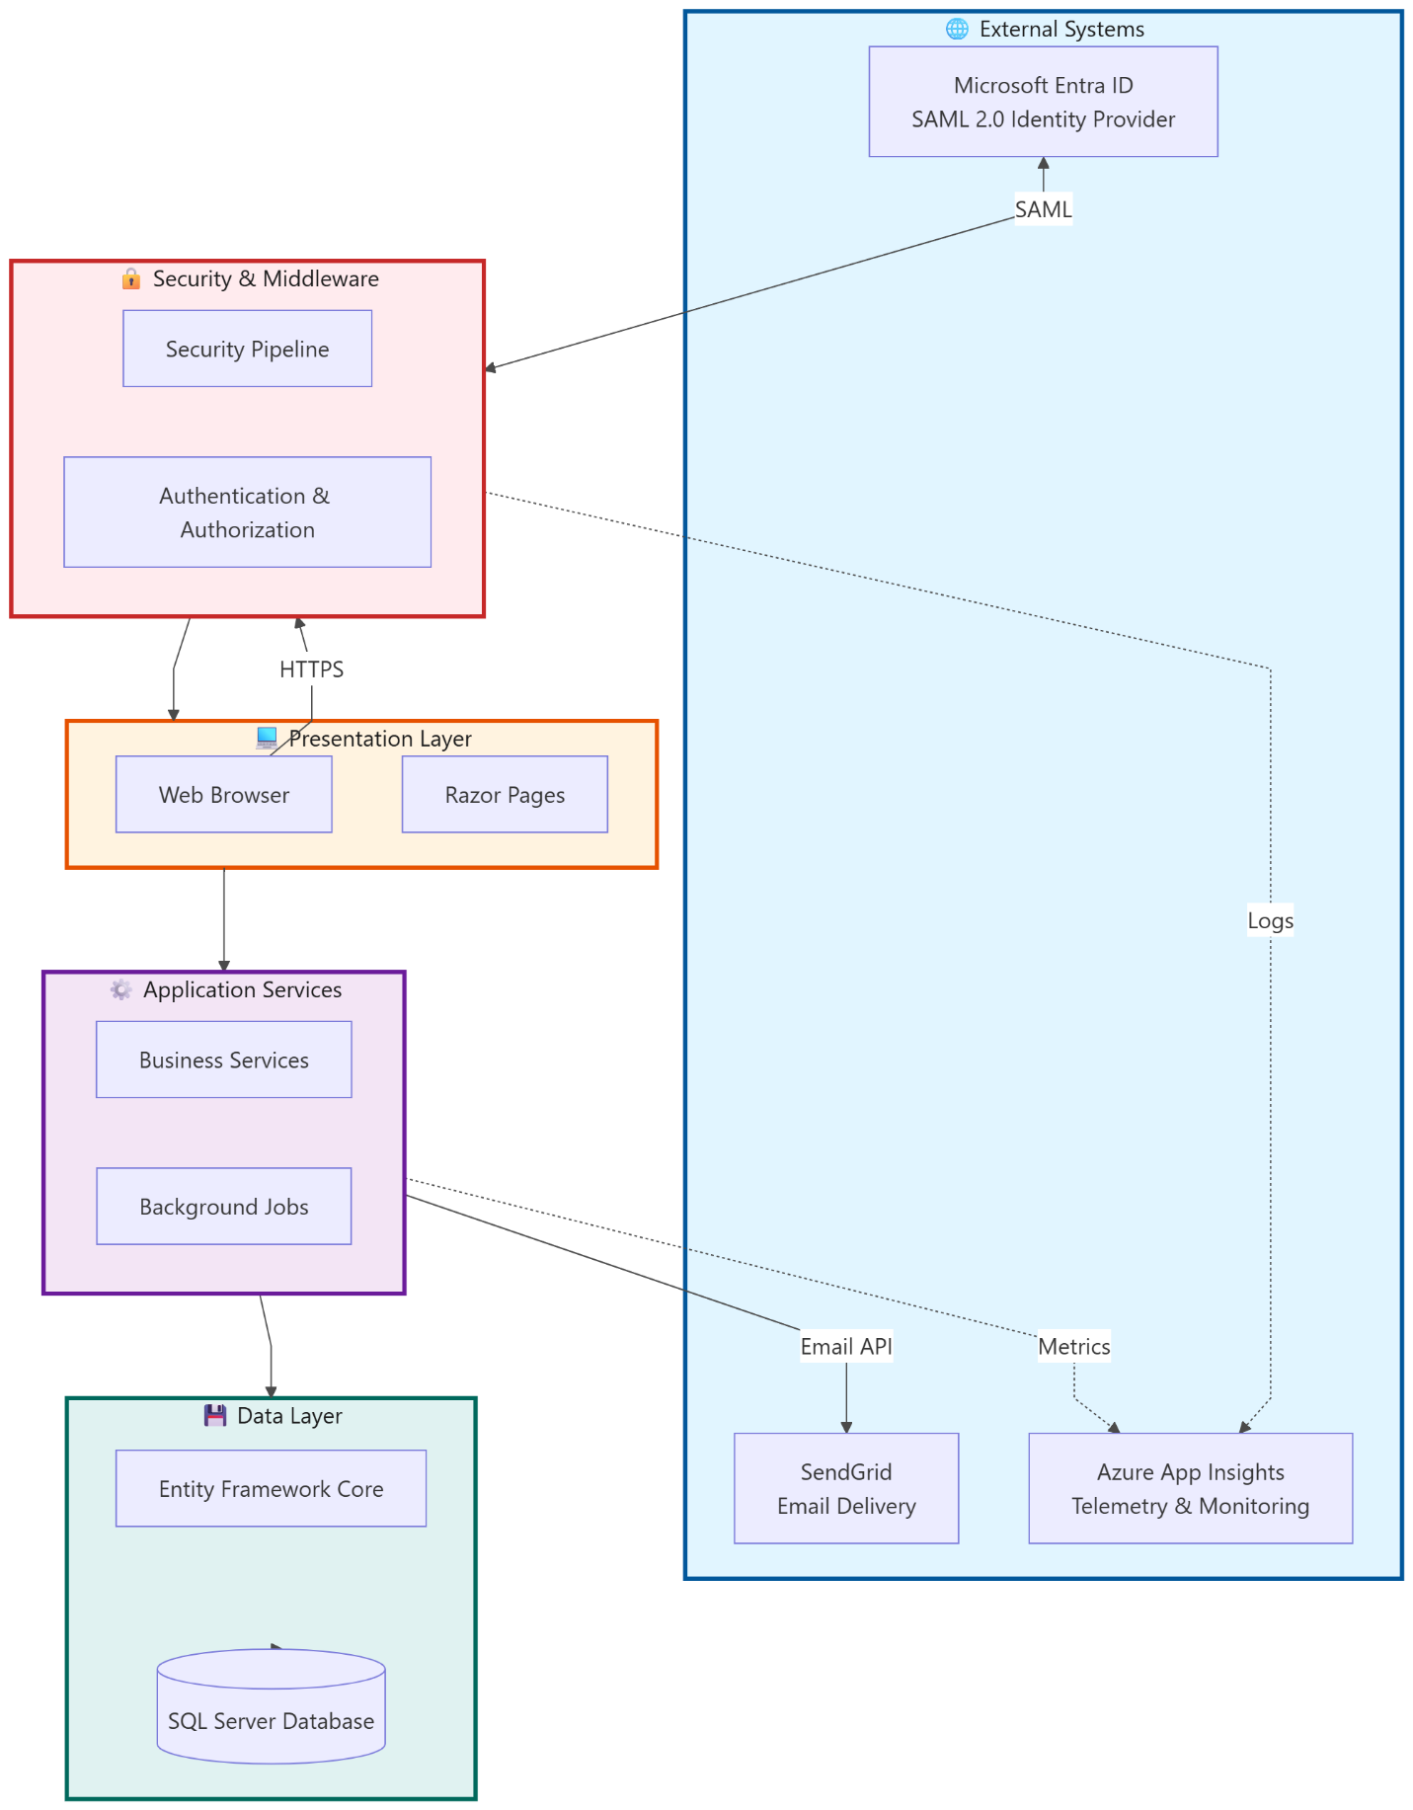

Detailed Layer Architecture

1. Security & Middleware Pipeline
Security Features:
- Security Headers: CSP, HSTS, X-Frame-Options, X-Content-Type-Options
- Rate Limiting: Global (100/min), Login (5/5min), API (60/min), Search (30/min), Upload (10/min)
- Authentication: ASP.NET Core Identity + SAML 2.0 SSO
- Authorization: Role-based (Admin, User) + Policy-based (BookingOwner)

2. SAML Authentication Flow

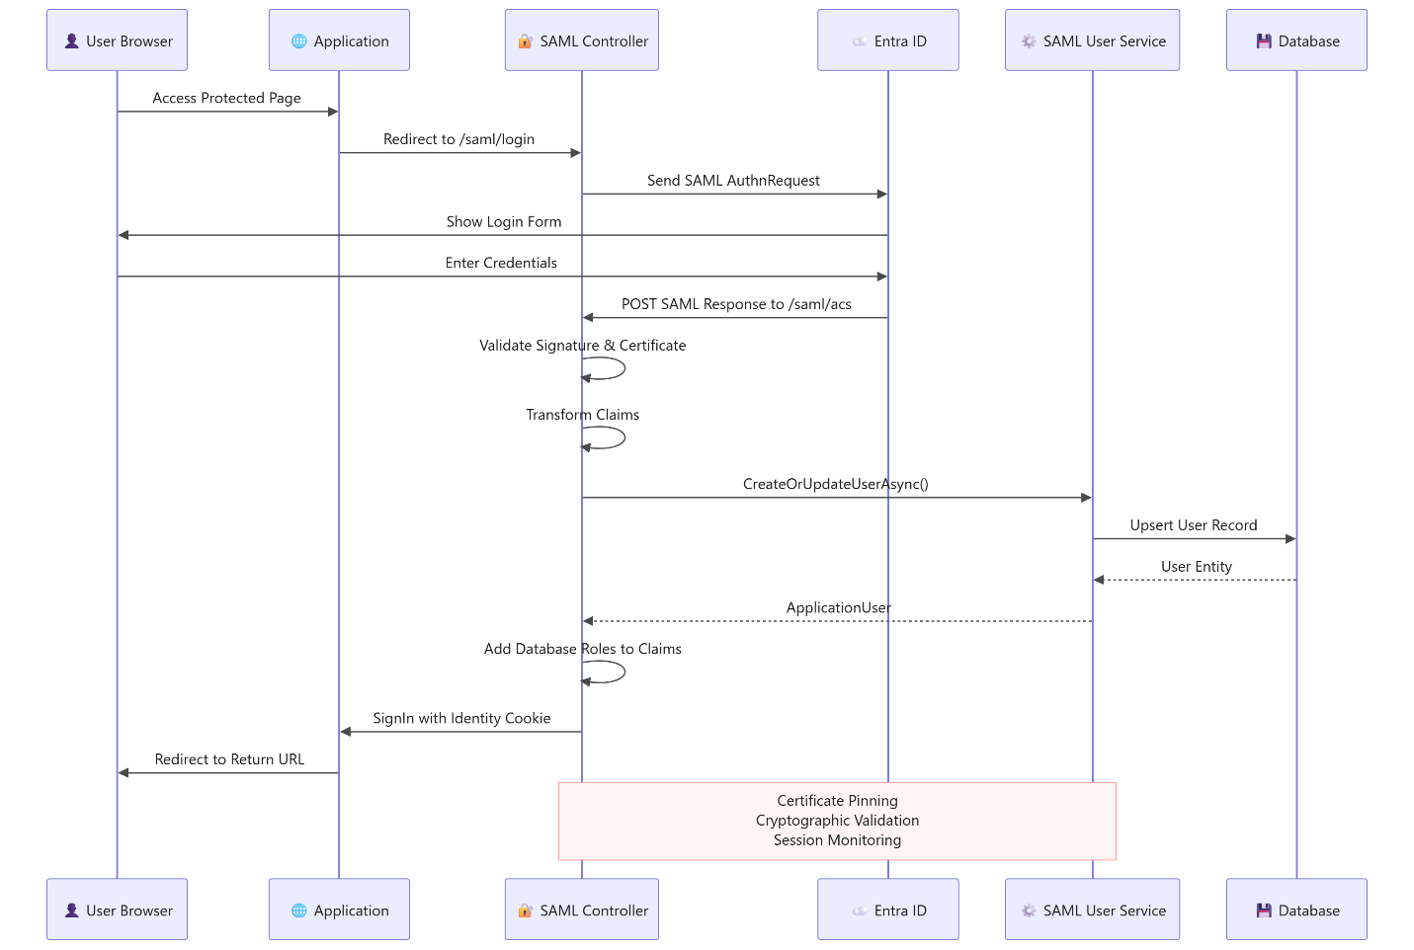

3. Application Services Architecture
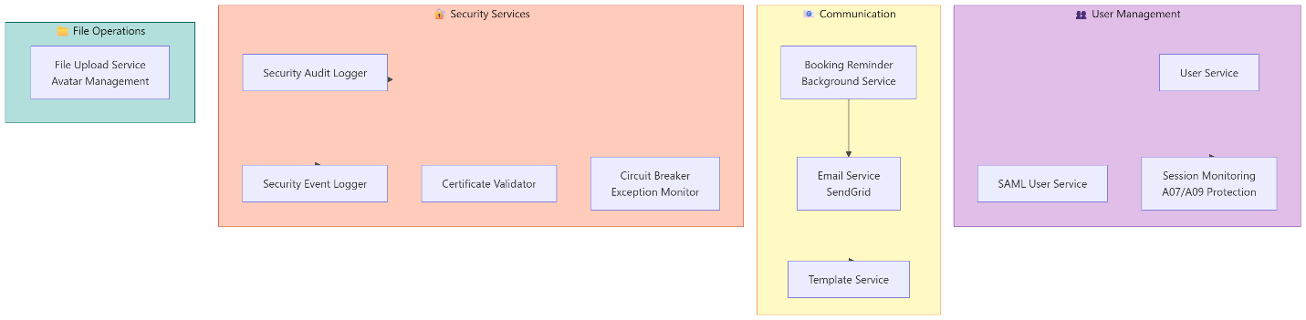
Service Responsibilities:
Service | Purpose | Key Features
SAML User Service | User provisioning from SAML | Auto-create/update users, claim mapping
Session Monitoring | Track auth events | Concurrent session detection, lockout logging
Email Service | Send notifications | Confirmation, cancellation, reminders
Booking Reminder | Daily scheduler | Sends emails at configured time (default 8 AM UTC)
Security Audit | Compliance logging | OWASP A09 - audit trail for all changes
Circuit Breaker | Resilience pattern | Prevents cascading failures in external services

4. Data Model & Relationships
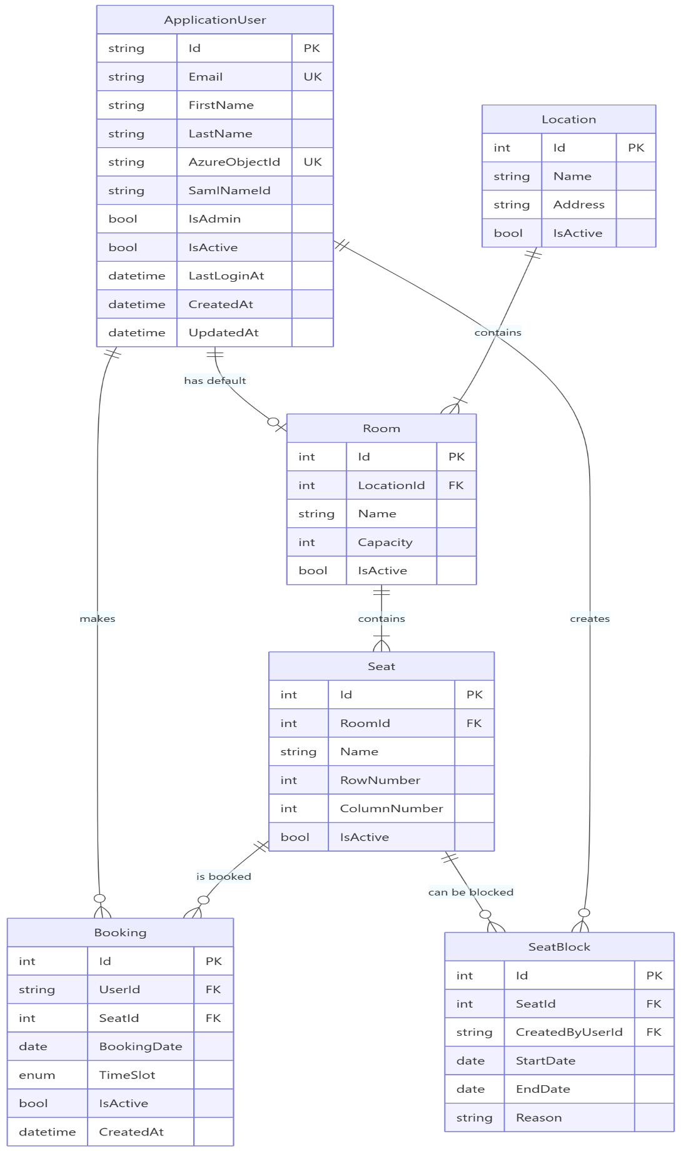
Time Slot Options:
- FullDay: 8 AM - 6 PM
- Morning: 8 AM - 1 PM
- Afternoon: 1 PM - 6 PM
Unique Constraints:
- One booking per seat per date per time slot
- Email addresses are unique
- Azure Object IDs are unique

5. Razor Pages Structure
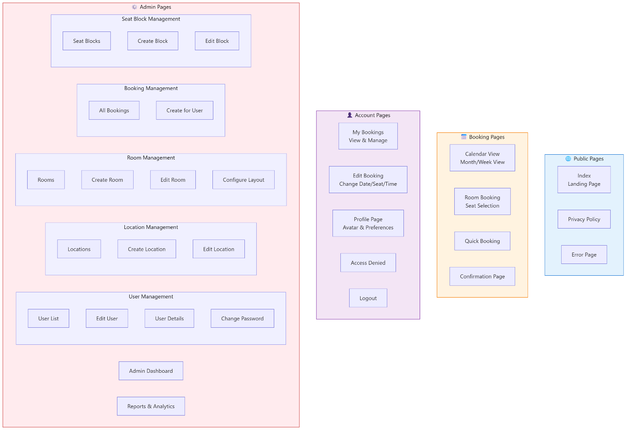

6. Exception Handling Strategy
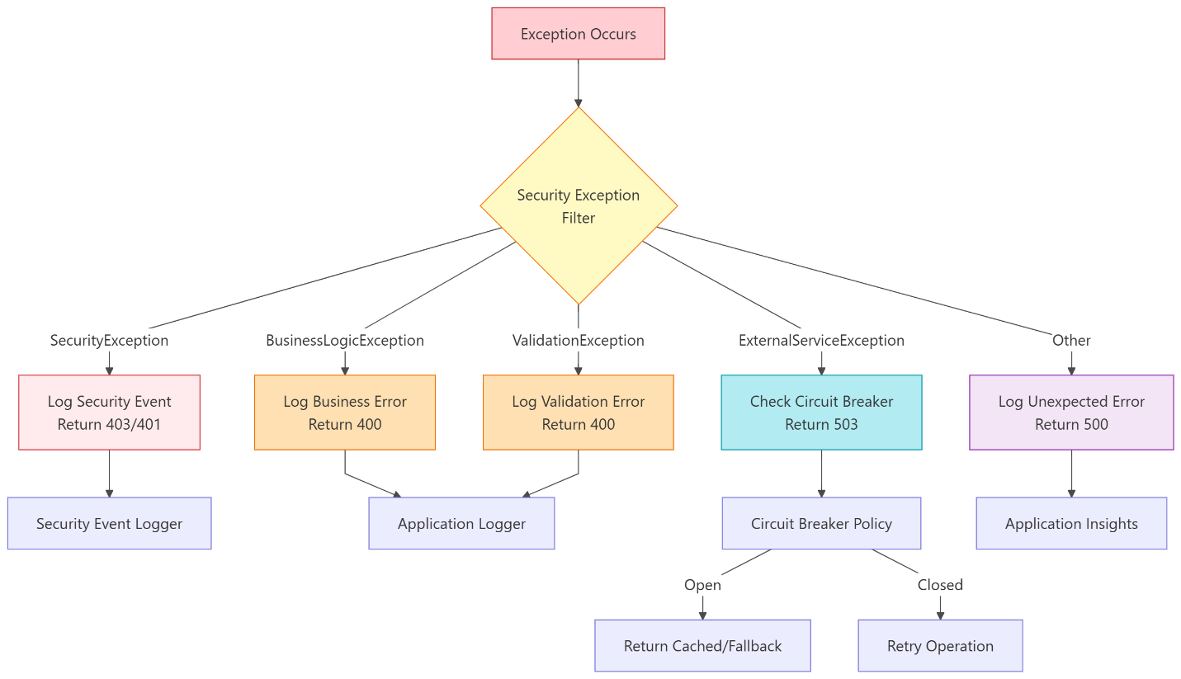
Exception Types:
Exception | HTTP Status | Logged To | Action
SecurityException | 403/401 | SecurityEventLogger | Block & alert
BusinessLogicException | 400 | Application logs | Return error message
ValidationException | 400 | Application logs | Return validation errors
ExternalServiceException | 503 | Circuit breaker | Retry or fallback
Unhandled | 500 | Application Insights | Full stack trace

7. Background Services
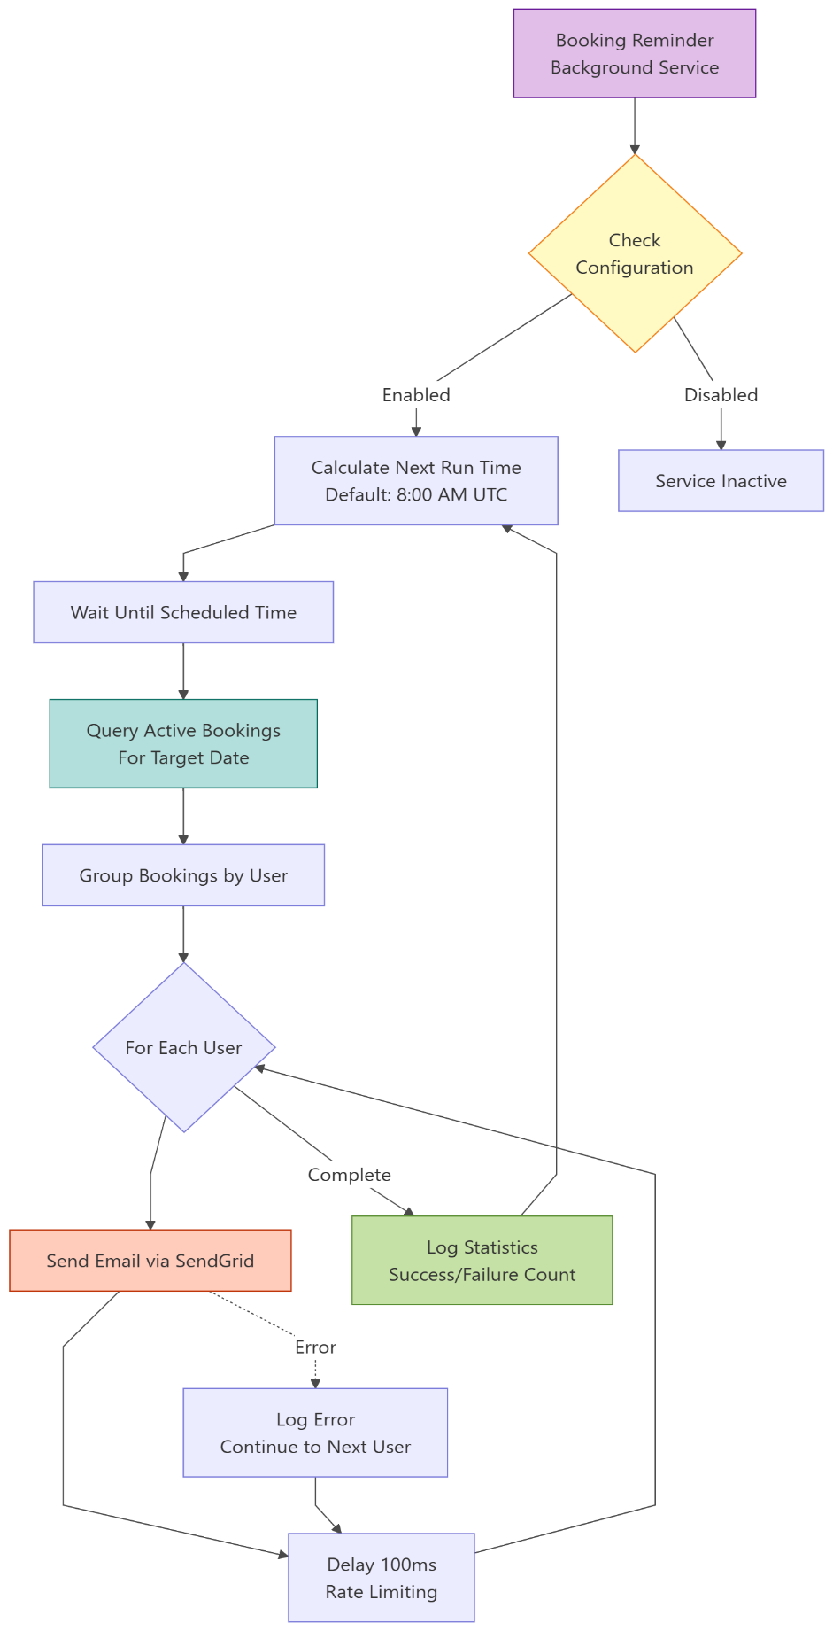
Configuration:
{
"EmailReminder": {
"Enabled": true,
"SendTimeUtc": "08:00",
"SendReminderDaysBefore": 1
}
}

8. Rate Limiting Configuration
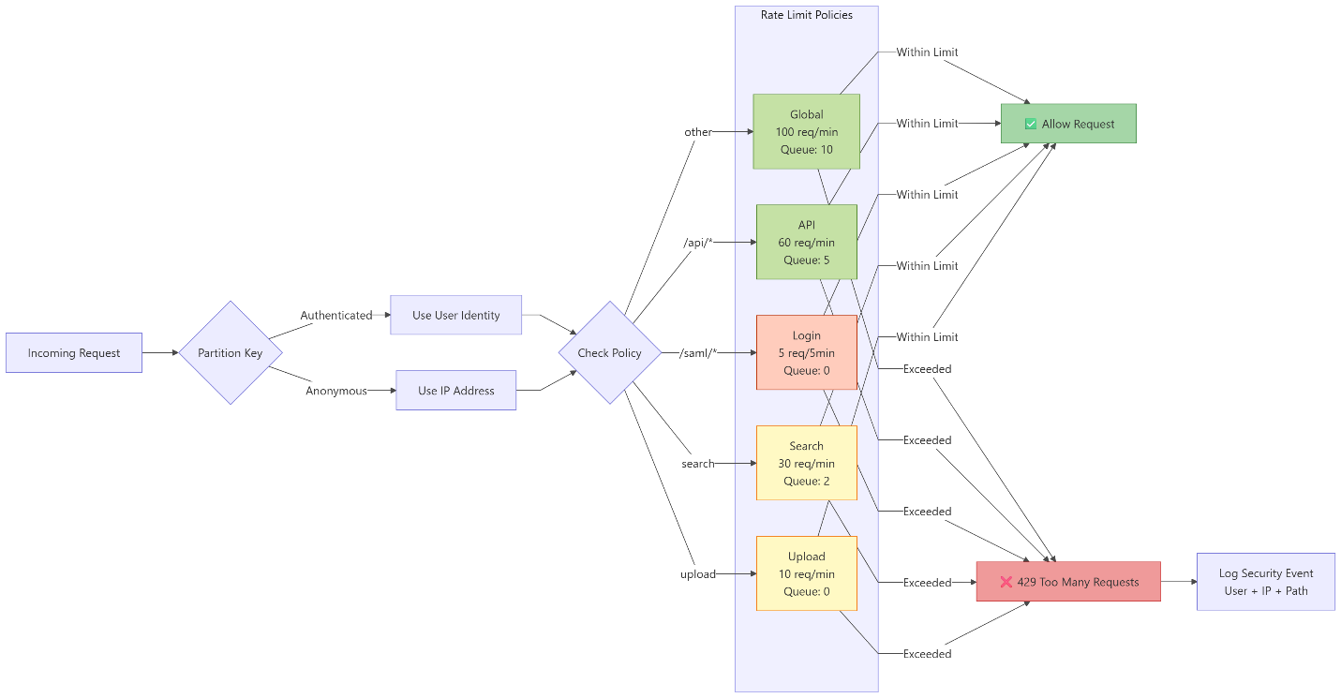

Technology Stack Summary
Layer | Technologies
Frontend | Razor Pages, HTML5, CSS3, JavaScript, Bootstrap 5
Backend | ASP.NET Core 8, C# 12
Authentication | ASP.NET Core Identity, SAML 2.0 (ITfoxtec.Identity.Saml2)
Database | Entity Framework Core 8, SQL Server / Azure SQL
Email | SendGrid API
Monitoring | Azure Application Insights, ILogger
Caching | IMemoryCache
Security | Rate Limiting, CORS, CSP, HSTS, Certificate Pinning
Background | IHostedService, BackgroundService
Validation | Data Annotations, FluentValidation patterns
Testing | (Recommended: xUnit, Moq, EF Core InMemory)

Key Design Patterns
- Repository Pattern: Abstracted through EF Core DbContext
- Service Layer: Business logic separated from presentation
- Dependency Injection: Constructor injection throughout
- Circuit Breaker: For external service resilience
- Claims Transformation: SAML claims mapped to application claims
- Audit Trail: Automatic tracking via AuditableEntity base class
- Middleware Pipeline: Layered security processing
- Background Services: For scheduled tasks

Security Checklist
- ✅ HTTPS enforced with HSTS
- ✅ Rate limiting on all endpoints
- ✅ SAML 2.0 SSO with certificate pinning
- ✅ Role-based and policy-based authorization
- ✅ SQL injection prevention (parameterized queries)
- ✅ XSS prevention (output encoding)
- ✅ CSRF protection (anti-forgery tokens)
- ✅ Secure cookie configuration
- ✅ Content Security Policy headers
- ✅ Session timeout management
- ✅ Account lockout policy
- ✅ Comprehensive security logging
- ✅ PII sanitization in logs
- ✅ Input validation and sanitization
- ✅ Concurrent session detection

Getting Started

Prerequisites
- .NET 8 SDK
- SQL Server or Azure SQL Database
- SendGrid account (for emails)
- Microsoft Entra ID tenant (for SAML)
- Azure subscription (for production deployment)

Configuration
Key configuration areas in appsettings.json:
- ConnectionStrings:DefaultConnection
- Saml2 configuration
- SendGrid:ApiKey
- ApplicationInsights:ConnectionString
- EmailReminder settings
- RateLimiting policies

Development Setup
- Clone repository
- Configure appsettings.Local.json (git-ignored)
- Run migrations: dotnet ef database update
- Seed roles and initial data
- Configure SAML certificates
- Run application: dotnet run

Document Version: 1.0
Last Updated: 2025
Maintained By: Development Team

