وزارة التعليم العالي و البحث العلمي
Universite Badji Mokhtar-Annaba  Faculté des Sciences de l’Ingéniorat  Département d’Informatique |  | جامعة باجي مختار – عنابـــــــــــــــة  كلية علــــــــــــوم الهندســـــــــة  قسم الإعــــــــــــــلام الآلــــــــــــــي

Mémoire présenté en vue d'obtenir le diplôme de
licence académique

Pharmacy Drug Management System

Field: Mathematics-Computer Science
Stream: Computer Science
Specialty: Computer Science

Prepared by: Boulahbal Mohssen

Supervised by: Mr. Benchalel Amir.
Year: 2022-2023

Acknowledgments

I would like to express my gratitude to my supervisor, Mr. Benchalel Amir, for his support and assistance throughout this project. I would also like to thank my co-workers, Hakim, Rafik, Mahdi and Wissam, for their valuable contribution and cooperation in carrying out this work. Their expertise and commitment greatly contributed to the success of this project. Finally, a big thank you to my family and friends for their constant support and encouragement.

Table of Contents

Acknowledgments 2
Table of Contents 3
List of Figures 3
Introduction 4
1. Contexte du projet 4
2. Problematic 4
3. Motivations 4
4. Objectives 5
5. Content of the brief 5
Chapitre 1 : General information on web technologies 5
Summary : 5
1. Backend Development with SQL and PHP : 5
2. Frontend Development with HTML, CSS, Bootstrap, and jQuery : 5
3. Product Management System : 6
4. Dynqmic and static website : 6
Conclusion : 7

List of Figures

Figure 1: Dynamic and Static Page Workflow.

Introduction

The management of psychotropic drugs in pharmacies is crucial for ensuring the safe and effective use of these medications. Psychotropic drugs are a class of medications that have a profound impact on the central nervous system and are commonly used to treat mental illnesses such as anxiety, depression, and schizophrenia. However, these drugs also have a high potential for abuse and can cause serious adverse effects if not used properly. Pharmacies play a key role in the management of psychotropic drugs by dispensing these medications to patients and ensuring that they are used safely and appropriately. To achieve this goal, pharmacies need to have effective stock management systems that allow them to track and monitor the availability of these drugs. In this memoir , I propose the development of a web-based application for stock management of psychotropic drugs in pharmacies. This application aims to provide pharmacies with an efficient and reliable tool to manage their stock of psychotropic drugs, track their usage, and ensure that they are dispensed safely and appropriately to patients. The proposed web application will have several features such as real-time inventory management, drug expiration tracking, and prescription validation. It will also have a user-friendly interface that can be accessed from any device with an internet connection, making it easy for pharmacists to manage their stock of psychotropic drugs from anywhere. Overall, the development of this web application is expected to improve the management of psychotropic drugs in pharmacies, reduce the risk of drug abuse and adverse effects, and ensure the safe and effective use of these medications by patients.

Context
Psychotropic drugs are substances that affect the central nervous system and are used to treat various mental illnesses. Due to their potential for abuse and misuse, these drugs are strictly regulated, and pharmacies must comply with certain procedures to manage and dispense them safely.

Problematic
Currently, the verification of prescription details and patient eligibility is done manually by checking a register, which is prone to errors and can lead to serious consequences, including legal issues for the pharmacy. Additionally, the management of drug transactions is time-consuming and inefficient, leading to delays and possible stock shortages.

Motivation
The development of a web-based application for managing and tracking psychotropic drugs will streamline the process of managing these drugs in pharmacies. By automating the verification process, reducing the possibility of errors, and maintaining an accurate record of drug transactions, this software will improve the safety and efficiency of managing psychotropic drugs in pharmacies. This will benefit both the pharmacy and the patients, ensuring that they receive the right medication in a timely and secure manner.

Objectives
The aim of this project is to develop a web-based application for managing and tracking psychotropic drugs in pharmacies. This software will simplify the process of verifying prescription details, checking patient eligibility, and maintaining an accurate record of drug transactions. The ultimate goal is to improve the safety and efficiency of managing psychotropic drugs in pharmacies .

Content of the brief
This memoir will provide a detailed description of the development process of the web-based application for managing and tracking psychotropic drugs. It will cover the design, implementation, and testing phases of the software development life cycle. Additionally, it will highlight the features of the application and how they address the current challenges faced by pharmacies in managing psychotropic drugs. Finally, the memoir will discuss the impact of this software on the pharmacy and the potential for future improvements.

Chapter 1 : General information on web technologies

Summary:
In this chapter, I have attempted to provide a general overview of the basic technologies required for the understanding and development of websites. It covers the difference between static and dynamic web pages, as well as the role of HTML, CSS, and JavaScript in frontend development. Additionally, it highlights the importance of backend development, which involves the use of PHP and SQL to manage data and database design. This chapter serves as a foundation for the subsequent chapters in the report, providing a necessary understanding of the underlying technologies for the creation of modern websites.

Backend Development with SQL and PHP :
Backend development plays a crucial role in the development of a web application. In the case of the Pharmacy Drug Management System website, the backend development involves the use of SQL and PHP to manage and store data. SQL is used to design and create a database for the website, while PHP is used to connect the website to the database and handle the processing of data.

Frontend Development with HTML, CSS, Bootstrap, and jQuery :
Frontend development is responsible for creating the user interface and designing the visual aspects of a website and involves the use of HTML, CSS, Bootstrap, and jQuery to create an intuitive and user-friendly interface. HTML and CSS are used to structure and style the content, while Bootstrap provides pre-designed templates and components to speed up the development process. jQuery is used to add interactivity and dynamic features to the website.

Product Management System :
The Product Management System is a web-based application designed to simplify and streamline the process of managing products. This system provides a centralized platform for businesses to manage their product inventory, pricing, and availability in real-time. With this system, businesses can easily track and update product information, set pricing rules, and monitor inventory levels to ensure that their products are always available to customers. The Product Management System is a powerful tool for businesses looking to increase their efficiency, reduce errors, and improve customer satisfaction.

Dynqmic and static website :
A static website is a website composed of static web pages and operating without a database. There are static website generators like Jekyll or Hugo, but a dynamic web page is a web page generated on demand, as opposed to a static web page. The content of a dynamic web page can therefore vary depending on information (time, user's name, form filled in by the user, etc.) that is only known at the time of its consultation. Conversely, the content of a static web page is a priori identical to each consultation.

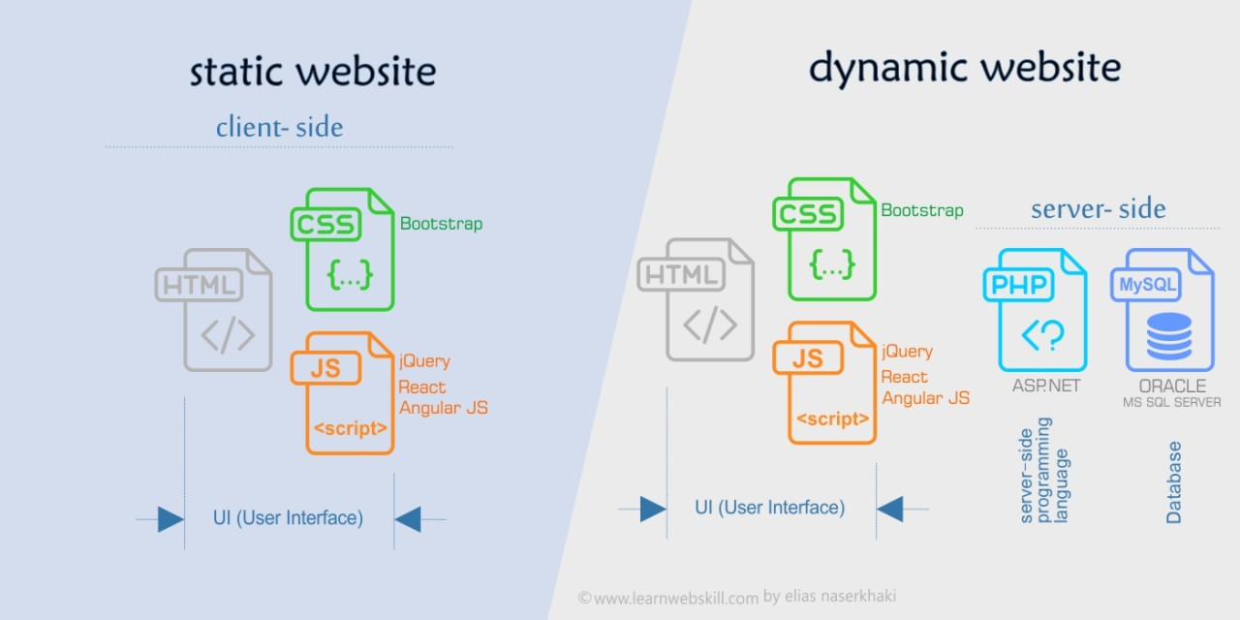

Figure 1: Dynamic and Static Page Workflow

Conclusion
In this chapter, we have provided a general overview of the web technologies that will be necessary for the development of our website. We discussed the differences between static and dynamic web pages, the importance of HTML and CSS, and the role of JavaScript in adding interactivity to our site. In the next chapter, we will dive deeper into the development process by using UML to model and plan the different components of our website. By doing so, we hope to ensure that our website is both functional and user-friendly.

