|  |  |  |
| --- | --- | --- |
| **وزارة التعليم العالي و البحث العلمي** | | |
| **Universite Badji Mokhtar-Annaba**  Faculté des Sciences de l’Ingéniorat  Département d’Informatique |  | **جامعة باجي مختار – عنابـــــــــــــــة**  كلية علــــــــــــوم الهندســـــــــة  قسم الإعــــــــــــــلام الآلــــــــــــــي |

Mémoire présenté en vue d'obtenir le diplôme de   
**licence académique**

**Pharmacy Drug Management System**

**Field:** Mathematics-Computer Science

**Stream:** Computer Science

**Specialty:** Computer Science

**Prepared by:** Boulahbal Mohssen

**Supervised by: Mr.** Benchalel Amir

**Year : 2022-2023**

# Acknowledgments

I would like to express my gratitude to my supervisor, Mr. Benchalel Amir, for his support and assistance throughout this project. I would also like to thank my co-workers, Hakim, Rafik, Mahdi and Wissam, for their valuable contribution and cooperation in carrying out this work. Their expertise and commitment greatly contributed to the success of this project. Finally, a big thank you to my family and friends for their constant support and encouragement.

# Table des matières

Acknowledgments 2

Table des matières 3

Tables des figures 4

Introduction 6

1. Context 7

2. Problematic 7

3. Motivation 7

4. Objectives 8

5. Content of the brief 8

Chapter 1 : General inforamtion on web technologies 8

Summary: : 8

1. Backend Development with SQL and PHP : 9

2. Frontend Development with HTML, CSS, Bootstrap, and jQuery : 9

3. Product Management System : 9

4. Dynqmic and static website : 9

Conclusion 10

Chapitre 2 : Desing 11

Introduction 11

Use Case Diagram: 11

2 Activity Diagram: 13

3 Class Diagram: 15

4. Data dictionary : 17

5 Functional Architecture of the Website 20

Chapitre 3 : Presentation of the project 22

1 Login page 22

2 Sinup page 24

3 Dashbord page 27

4 Inventory page 28

5 Profail page 32

5 Prescrition page 35

Conclusion : 36

In summary : 38

# Tables des figures

Figure 1: Dynamic and Static Page Workflow…………………………………….. 9

Figure 2 : Use Case Digram ……………………………………………………….11

Figure 3 : Adding New Medication ……………………………………………….12

Figure 4 : Adding New prescition ………………………………………………...13

Figure 5: class digram …………………………………………………………….14

Figure 6: login page …………………………………………………………….. ..21

Figure 7 : login code ……………………………………………………………... 22

Figure 8 : signup page …………………………………………………………….23

Figure 9: signup code ……………………………………………………………..24

Figure 10: Dashboard page ……………………………………………………….25

Figure 11 : Prediction code ……………………………………………………….26

Figure 12 : medication page add mudication …………………………………….27

Figure 13  : Update medication …………………………………………………...27

Figure 14 : Search and print and export ………………………………………….28

Figure 15 : add medication code…………………………………………………. 29

Figure 16 : Profail page ………………………………………………………….. 30

Figure 17: similler mudication in use ?………………………………………….. 31

Figure 18: simillerty code ………………………………………………………..32

Figure 19 :Prescription page……………………………………………………... 33

Figure 20 :Prescription code ……………………………………………………...34

# Introduction

The management of psychotropic drugs in pharmacies is crucial for ensuring the safe and effective use of these medications. Psychotropic drugs are a class of medications that have a profound impact on the central nervous system and are commonly used to treat mental illnesses such as anxiety, depression, and schizophrenia. However, these drugs also have a high potential for abuse and can cause serious adverse effects if not used properly. Pharmacies play a key role in the management of psychotropic drugs by dispensing these medications to patients and ensuring that they are used safely and appropriately. To achieve this goal, pharmacies need to have effective stock management systems that allow them to track and monitor the availability of these drugs. In this memoire, we propose the development of a web-based application for stock management of psychotropic drugs in pharmacies. This application aims to provide pharmacies with an efficient and reliable tool to manage their stock of psychotropic drugs, track their usage, and ensure that they are dispensed safely and appropriately to patients. The proposed web application will have several features such as real-time inventory management, drug expiration tracking, and prescription validation. It will also have a user-friendly interface that can be accessed from any device with an internet connection, making it easy for pharmacists to manage their stock of psychotropic drugs from anywhere. Overall, the development of this web application is expected to improve the management of psychotropic drugs in pharmacies, reduce the risk of drug abuse and adverse effects, and ensure the safe and effective use of these medications by patients.

## Context

Psychotropic drugs are substances that affect the central nervous system and are used to treat various mental illnesses. Due to their potential for abuse and misuse, these drugs are strictly regulated, and pharmacies must comply with certain procedures to manage and dispense them safely.

## Problematic

Currently, the verification of prescription details and patient eligibility is done manually by checking a register, which is prone to errors and can lead to serious consequences, including legal issues for the pharmacy. Additionally, the management of drug transactions is time-consuming and inefficient, leading to delays and possible stock shortages.

## Motivation

The development of a web-based application for managing and tracking psychotropic drugs will streamline the process of managing these drugs in pharmacies. By automating the verification process, reducing the possibility of errors, and maintaining an accurate record of drug transactions, this software will improve the safety and efficiency of managing psychotropic drugs in pharmacies. This will benefit both the pharmacy and the patients, ensuring that they receive the right medication in a timely and secure manner.

## Objectives

The aim of this project is to develop a web-based application for managing and tracking psychotropic drugs in pharmacies. This software will simplify the process of verifying prescription details, checking patient eligibility, and maintaining an accurate record of drug transactions. The ultimate goal is to improve the safety and efficiency of managing psychotropic drugs in pharmacies .

## Content of the brief

This memoir will provide a detailed description of the development process of the web-based application for managing and tracking psychotropic drugs. It will cover the design, implementation, and testing phases of the software development life cycle. Additionally, it will highlight the features of the application and how they address the current challenges faced by pharmacies in managing psychotropic drugs. Finally, the memoir will discuss the impact of this software on the pharmacy and the potential for future improvements.

# Chapter 1 : General inforamtion on web technologies

## Summary :

In this chapter, I have attempted to provide a general overview of the basic technologies required for the understanding and development of websites. It covers the difference between static and dynamic web pages, as well as the role of HTML, CSS, and JavaScript in frontend development. Additionally, it highlights the importance of backend development, which involves the use of PHP and SQL to manage data and database design. This chapter serves as a foundation for the subsequent chapters in the report, providing a necessary understanding of the underlying technologies for the creation of modern websites.

## 1. Backend Development with SQL and PHP :

Backend development plays a crucial role in the development of a web application. In the case of the Pharmacy Drug Management System website, the backend development involves the use of SQL and PHP to manage and store data. SQL is used to design and create a database for the website, while PHP is used to connect the website to the database and handle the processing of data. The chapter provides an overview of the database design and implementation process, including the creation of tables, fields, and relationships.

## 2. Frontend Development with HTML, CSS, Bootstrap, and jQuery :

Frontend development is responsible for creating the user interface and designing the visual aspects of a website. For the Pharmacy Drug Management System website, frontend development involves the use of HTML, CSS, Bootstrap, and jQuery to create an intuitive and user-friendly interface. HTML and CSS are used to structure and style the content, while Bootstrap provides pre-designed templates and components to speed up the development process. jQuery is used to add interactivity and dynamic features to the website.

## 3. Product Management System :

The Product Management System is a web-based application designed to simplify and streamline the process of managing products. This system provides a centralized platform for businesses to manage their product inventory, pricing, and availability in real-time. With this system, businesses can easily track and update product information, set pricing rules, and monitor inventory levels to ensure that their products are always available to customers. The Product Management System is a powerful tool for businesses looking to increase their efficiency, reduce errors, and improve customer satisfaction.

## 4. Dynqmic and static website :

Le e-commerce ou commerce électronique regroupe l’ensemble des transactions commerciales s’opérant à distance par le biais d’interfaces électroniques et digitales.  
Le e-commerce englobe essentiellement les transactions commerciales s’effectuant sur Internet à partir des différents types de terminaux (ordinateurs, tablettes, Smartphones, consoles, TV connectées). Le [m-commerce](https://www.definitions-marketing.com/definition/m-commerce/) est alors une composante du e-commerce.

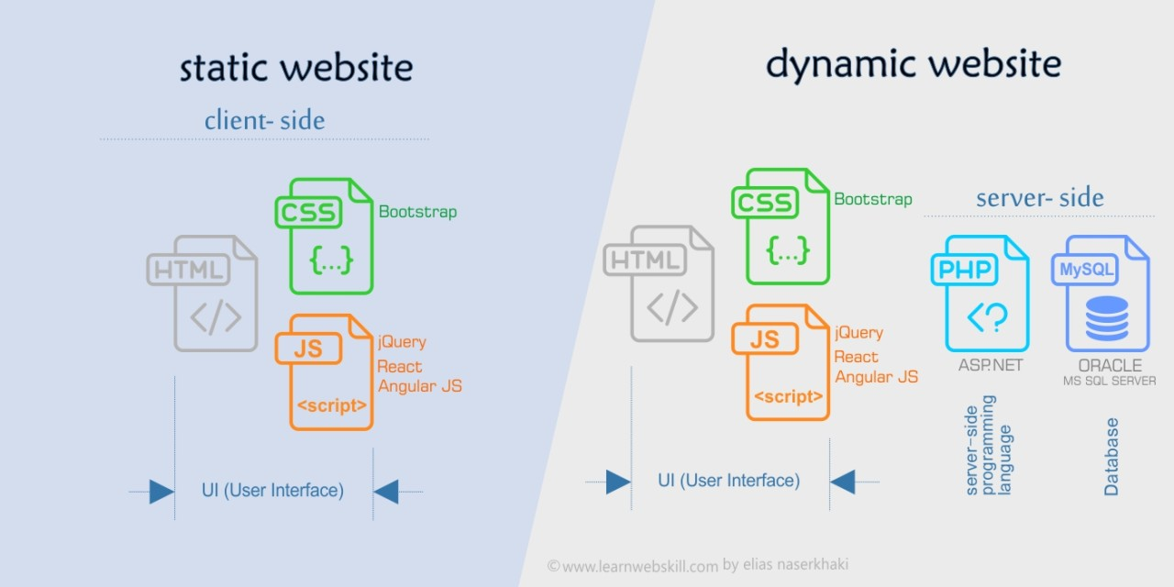

Figure 1: Dynamic and Static Page Workflow

## Conclusion

In this chapter, we have provided a general overview of the web technologies that will be necessary for the development of our website. We discussed the differences between static and dynamic web pages, the importance of HTML and CSS, and the role of JavaScript in adding interactivity to our site. In the next chapter, we will dive deeper into the development process by using UML to model and plan the different components of our website. By doing so, we hope to ensure that our website is both functional and user-friendly.

# Chapitre 2 : Visualizing Conception

## **Introduction**

This chapter focuses on designing the functional architecture of the web-based application for managing and tracking psychotropic drugs in pharmacies using UML (Unified Modeling Language). The objectives are to analyze requirements, conceptualize usage contexts, create UML diagrams, and refine the architecture.

## Use Case Diagram:

Owner :

* Login: Allows users to authenticate and access the system.
* Manage Dashboard: Enables authorized users to manage and view the dashboard, which provides an overview of important information and displays key metrics.
* Manage Patient Profiles: Allows authorized users to manage and view patient profiles, including details, demographics, medical history, and past treatments.
* Manage Sales Transactions: Enables authorized users to manage sales transactions, including adding new clients or products, recording patient purchases, and modifying prescriptions.
* Manage Inventory: Allows authorized users to manage the inventory, including adding, updating, and deleting products.
* Manage Users and Permissions: Restricted to admin users, allows the creation of new users, assigning roles, and managing user permissions.

For Salesperson:

* Login: Allows the salesperson to authenticate and access the system.
* View Dashboard: Enables the salesperson to view the dashboard, providing an overview of important information and key metrics.
* View Patient Profiles: Allows the salesperson to view patient profiles, including details, demographics, and medical history.
* View Sales Transactions: Enables the salesperson to view sales transactions, including patient purchases and prescription details.
* View Inventory: Allows the salesperson to view the inventory, including the list of available products.

This use case diagram provides a concise representation of the main functionalities and interactions within the system, distinguishing between different user roles and their respective actions.

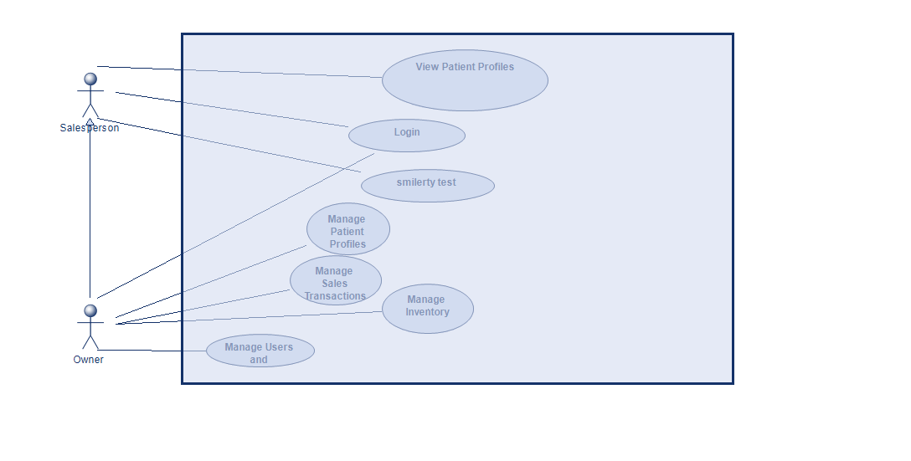

**Figure 2 : Use Case Digram**

## 2 Activity Diagram:

The activity diagram "Record Dispensation" illustrates the process of recording the dispensation of a psychotropic medication. It focuses on two main activities: adding a new medication to the inventory and adding a new prescription.

Description:

* Adding New Medication: This activity involves the pharmacist checking the inventory to determine if the medication is already available. If the medication is not present, the pharmacist adds the new medication to the inventory by providing details such as the medication name and available quantity.
* Adding New Prescription: Once the medication is available in the inventory, the pharmacist proceeds to add a new prescription. This activity includes entering relevant prescription details such as the patient's information, prescribed medication, lot number, etc. The prescription is then linked to the dispensation of the medication.

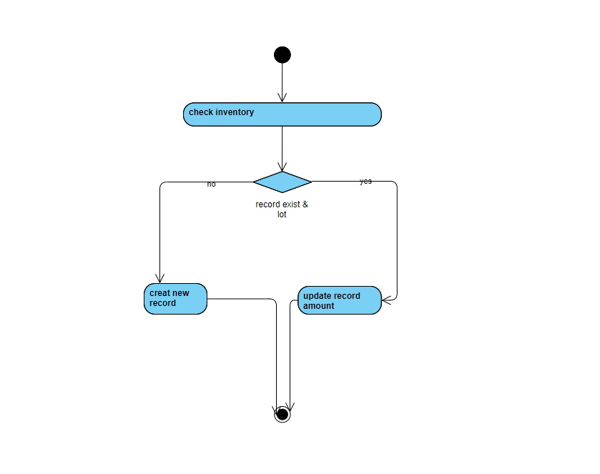

**Figure 3 : Adding New Medication**

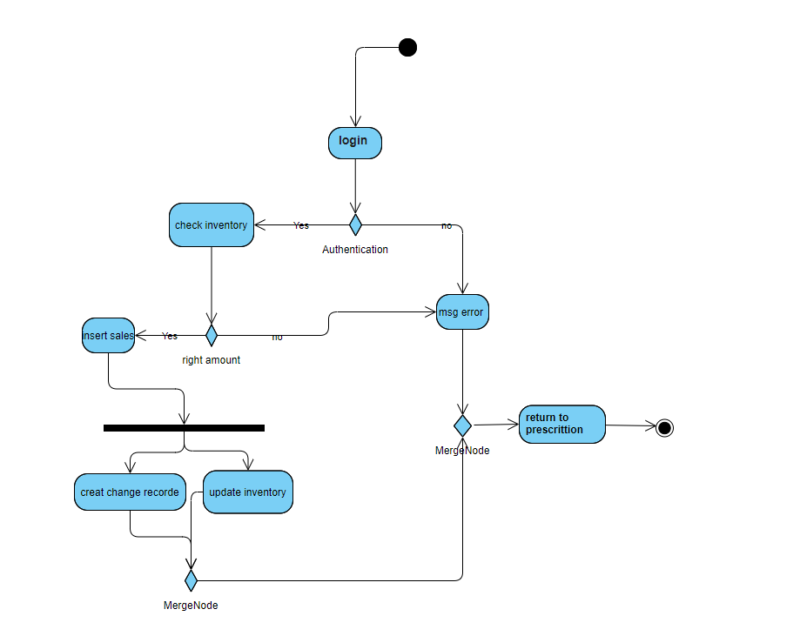**Figure 4 : Adding New Prescription**

## 3 Class Diagram:

The class diagram is used to create the database and store the data entered on the website. It represents the structure and relationships between the different classes in the system.

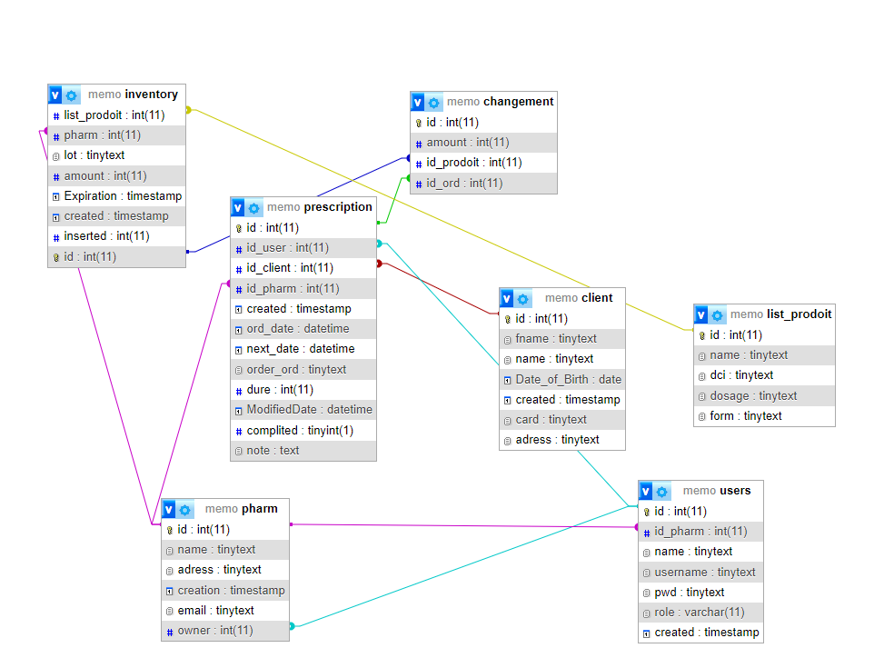

**Figure 5: class digram**

## 4. **Data dictionary** :

**Table changement :**

| Attribute | Type | Size |
| --- | --- | --- |
| id | int | 11 |
| amount | int | 11 |
| id_prodoit | int | 11 |
| id_ord | int | 11 |

**Table client :**

| Attribute | Type | Size |
| --- | --- | --- |
| id | int | 11 |
| fname | tinytext |  |
| name | tinytext |  |
| Date_of_Birth | date |  |
| created | timestamp |  |
| card | tinytext |  |
| address | tinytext | NOT NULL |

**Table inventory :**

| Attribute | Type | Size |
| --- | --- | --- |
| list_prodoit | int | 11 |
| pharm | int | 11 |
| lot | tinytext |  |
| amount | int | 11 |
| Expiration | timestamp | NULL |
| created | timestamp | NOT NULL |
| inserted | int | 11 |
| id | int | 11 |

**Table list_prodoit :**

| Attribute | Type | Size |
| --- | --- | --- |
| id | int | 11 |
| name | tinytext |  |
| dci | tinytext |  |
| dosage | tinytext |  |
| form | tinytext |  |

**Table Prescription :**

| Attribute | Type | Size |
| --- | --- | --- |
| id | int(11) | 11 |
| id_user | int(11) | 11 |
| id_client | int(11) | 11 |
| id_pharm | int(11) | 11 |
| created | timestamp |  |
| ord_date | datetime |  |
| next_date | datetime |  |
| order_ord | tinytext |  |
| dure | int(11) | 11 |
| ModifiedDate | datetime |  |
| complited | tinyint(1) |  |
| note | text |  |

**Table Pharm :**

| Attribute | Type | Size |
| --- | --- | --- |
| id | int(11) | 11 |
| name | tinytext |  |
| address | tinytext |  |
| creation | timestamp |  |
| email | tinytext |  |
| owner | int(11) | 11 |

## 5 Functional Architecture of the Website

The functional architecture of the website illustrates the core components and their interactions that enable the system to deliver its intended functionalities. This chapter provides an overview of the functional modules that form the foundation of the website and contribute to a seamless user experience.

1. User Management Module:
   * Responsible for user registration, authentication, and access control.
   * Enables users to create accounts, log in, and manage their profile information.
   * Implements role-based access control to ensure appropriate permissions for different user types.
2. Patient Information Module:
   * Handles the storage and retrieval of patient details and demographics.
   * Allows healthcare providers to access and view patient information securely.
   * Supports updating and maintaining accurate patient records.
3. Medical History Module:
   * Manages and displays the medical history and past treatments of patients.
   * Provides healthcare providers with a comprehensive overview of a patient's medical background.
   * Facilitates informed decision-making and continuity of care.
4. Product Comparison Module:
   * Enables users to check for similar products in use.
   * Enhances the ability to make informed choices and optimize treatment plans.
5. Reporting and Analytics Module:
   * Generates reports and analytics based on aggregated data from patient records.
   * Provides insights into treatment outcomes, medication usage, and overall system performance.
   * Supports data-driven decision-making and quality improvement initiatives.

The functional architecture of the website ensures the efficient management of patient information, facilitates comprehensive medical history tracking, enables product comparison for personalized care, and empowers healthcare providers with valuable reporting and analytics capabilities.

## **Conclusion :**

In conclusion, Chapter 2 focused on designing the web-based application using UML, including use case, activity, and class diagrams. These visual representations provide a solid foundation for the development

of a robust and user-friendly system for managing and tracking psychotropic drugs in pharmacies. The next chapter will cover the implementation phase, bringing the design to life.

# Chapitre 3 : Presentation of the project

The major objective of this chapter is to present the final project. This is the implementation phase of the website

## 1 Login page

The login page serves as the initial gateway for users to access the system. Its primary functions are:

1. Authentication: The login page verifies the credentials provided by users, ensuring that only authorized individuals can access the system.
2. Username and Password Verification: It validates the username and password entered by users, confirming their accuracy and authenticity.
3. Access Rights Granting: Based on the assigned user roles, the login page grants appropriate access rights to ensure that users can only perform actions within their authorized scope.

The login page acts as a crucial security checkpoint, ensuring that only authenticated users with valid credentials can proceed further into the system.

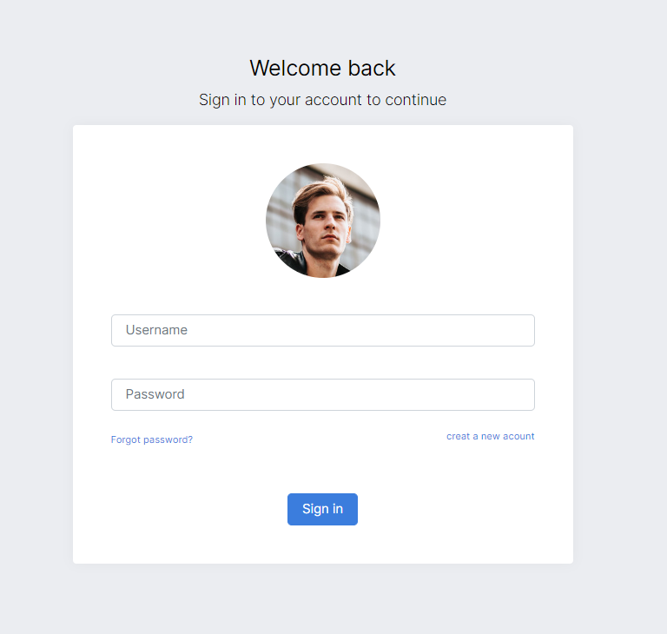

**Figure 6: login page**

Explanation :

1. The provided figuer a login page that authenticates users based on their credentials. It follows these steps:
2. Session Configuration: Sets the session duration and starts the session.
3. Check User Status: If the user is already logged in, they are redirected to the "products.php" page.
4. Handle Form Submission: Retrieves the username and password from the submitted form.
5. Validate Form Inputs: Checks if the username or password fields are empty. If so, an error message is stored in the session.
6. Connect to Database: Establishes a connection to the database using the included "coon.php" file. If the connection fails, an error message is stored in the session.
7. Verify User: Executes a SQL query to retrieve user data based on the provided username.
8. Check Password: Compares the stored password hash with the submitted password using password_verify(). If they match, session variables are set and the user is redirected to the "index.php" page. Otherwise, an error message is stored in the session.

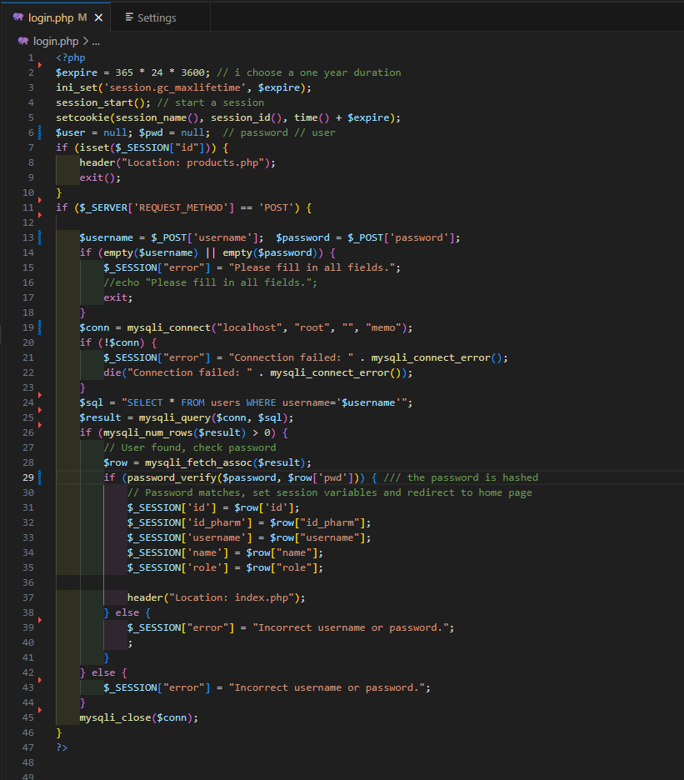 **Figure 7 : login code**

## 2 Sinup page

The signup page serves as a registration form for new users to create an account and gain access to the system. It provides a straightforward and secure way for individuals to join the platform.

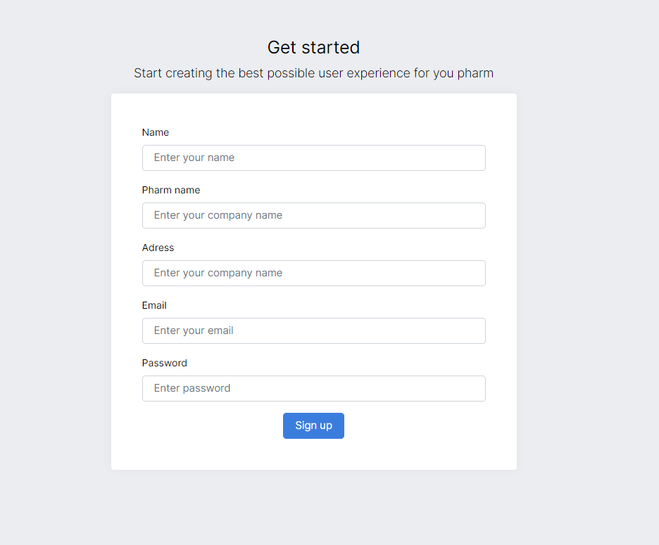 **Figure 8 : signup page**

Explanation:

The signup page allows new users to create an account and gain access to the system. The process involves the following steps:

1. Session Management: The session is initiated to track the user's login status and prevent access to the signup page for already authenticated users.
2. Form Submission: When the registration form is submitted, the user input is retrieved from the form fields, including username, pharmacy name, email, password, and address.
3. Input Validation: The user input is validated to ensure that all required fields are filled, the email address is in the correct format, and the password meets the minimum length requirement.
4. Database Connection: A connection is established with the database to store the user information.
5. User Validation: The username and email address are checked to ensure they are not already in use by existing users.
6. Password Hashing: The password is securely hashed using the default algorithm provided by the PHP password_hash() function.
7. Database Insertion: The pharmacy details are inserted into the "pharm" table, and the user's information is inserted into the "users" table. The user is assigned the role of "owner" for the pharmacy.
8. Redirecting: Upon successful registration, the user is redirected to the login page to access the system.

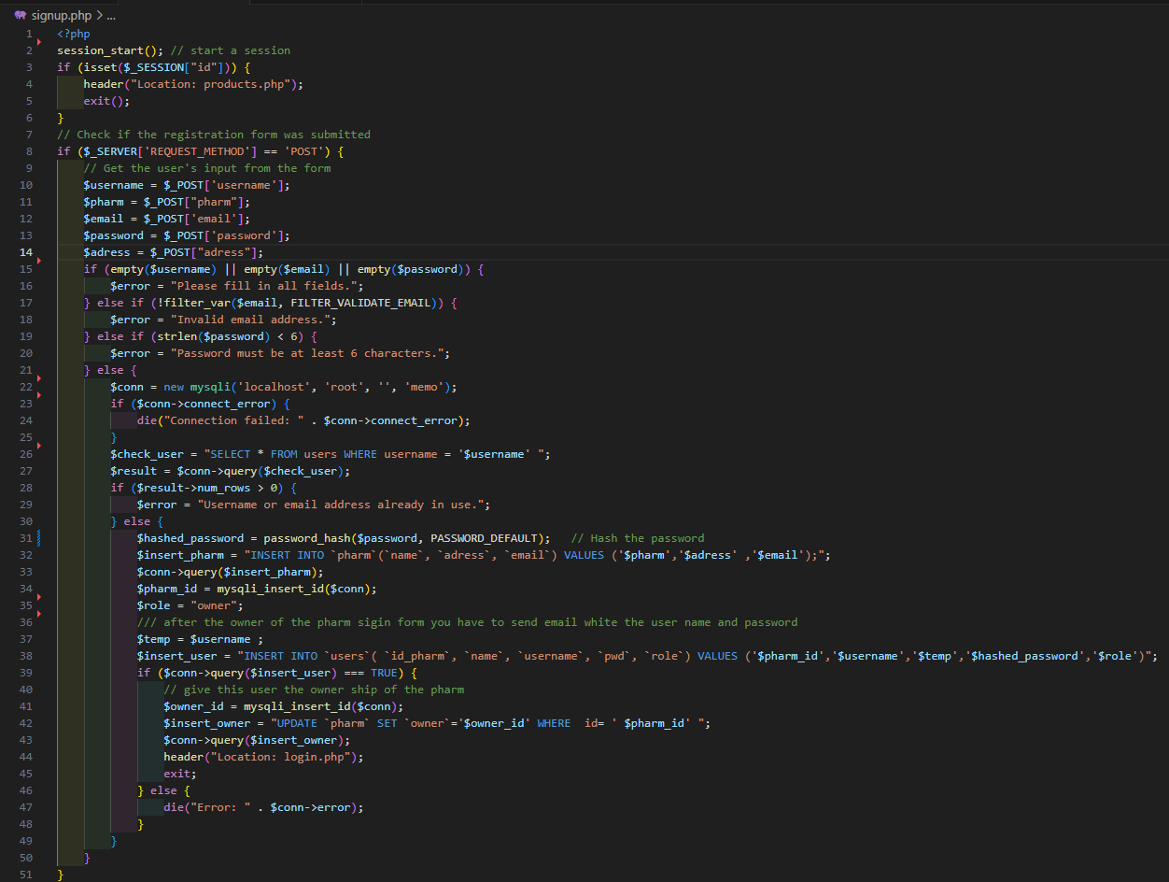

**Figure 9: signup code**

## 3 Dashbord page

The dashboard page serves as a central hub, providing an overview of important information, quick access to key features, and prediction of products needed. It displays summary data, including key metrics such as total sales, pending orders, and inventory status. Users can easily navigate to essential functionalities such as inventory management, sales transactions, customer management, and more. Additionally, the dashboard utilizes predictive algorithms to suggest the medications or products that are likely to be in high demand based on historical data and trends. This helps optimize inventory management and ensure timely availability of products to meet customer demands.

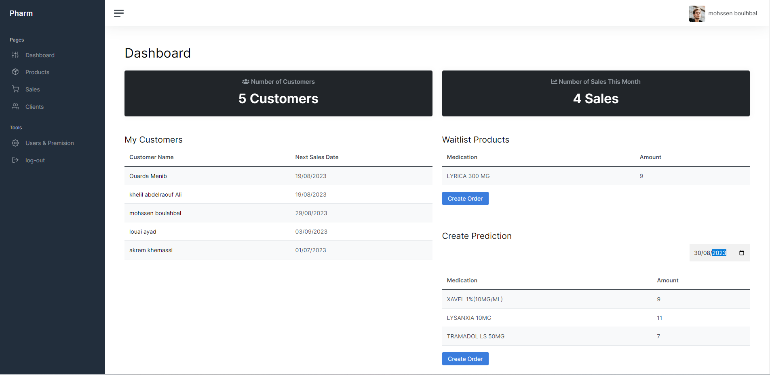**Figure 10: Dashboard page**

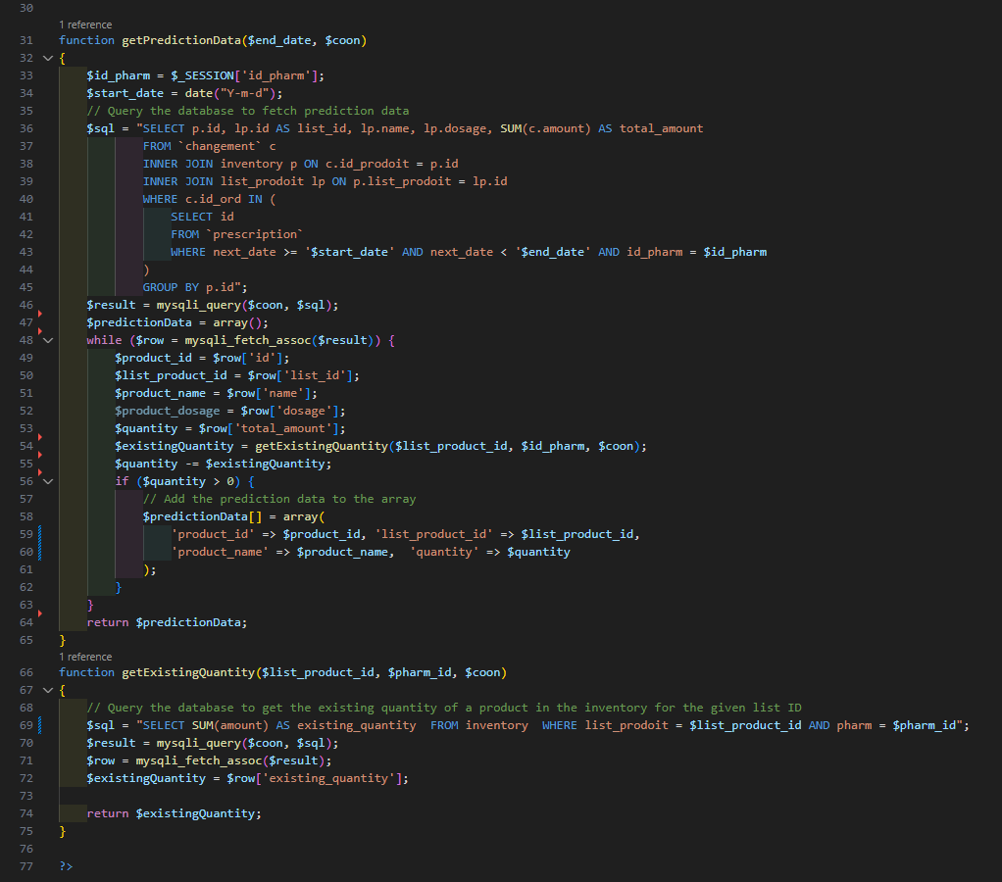

**Figure 11 : Prediction code**

## 4 Inventory page

The inventory page plays a vital role in streamlining inventory management processes, optimizing stock control, and facilitating efficient decision-making related to product availability and expiration. It empowers users with necessary tools to maintain an accurate and up-to-date inventory, ultimately contributing to the smooth operation of the system

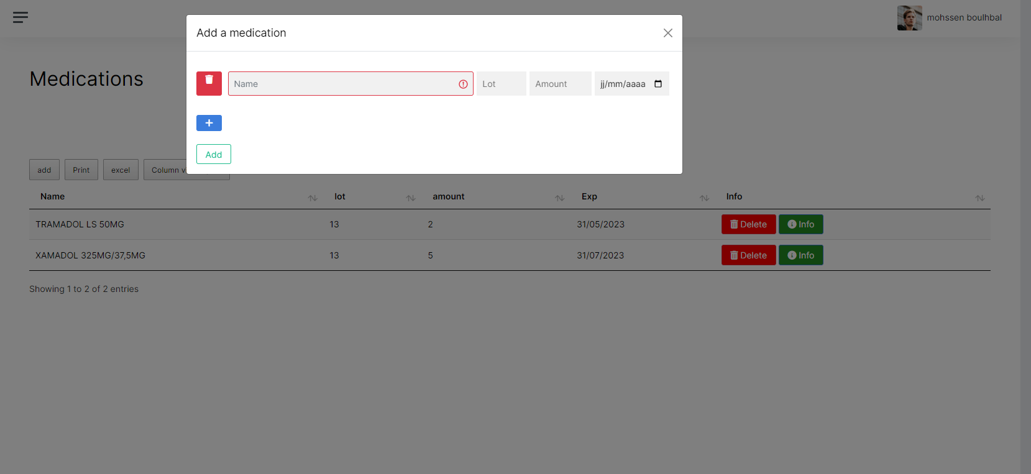**Figure 12 : add medication**

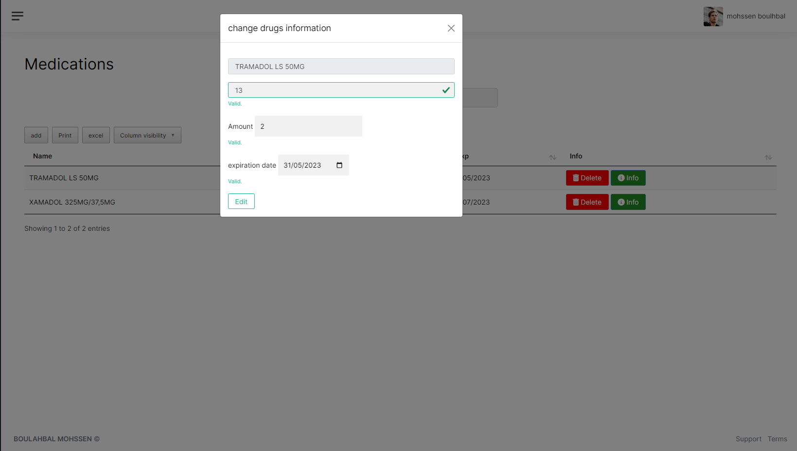**Figure 13  : Update medication**

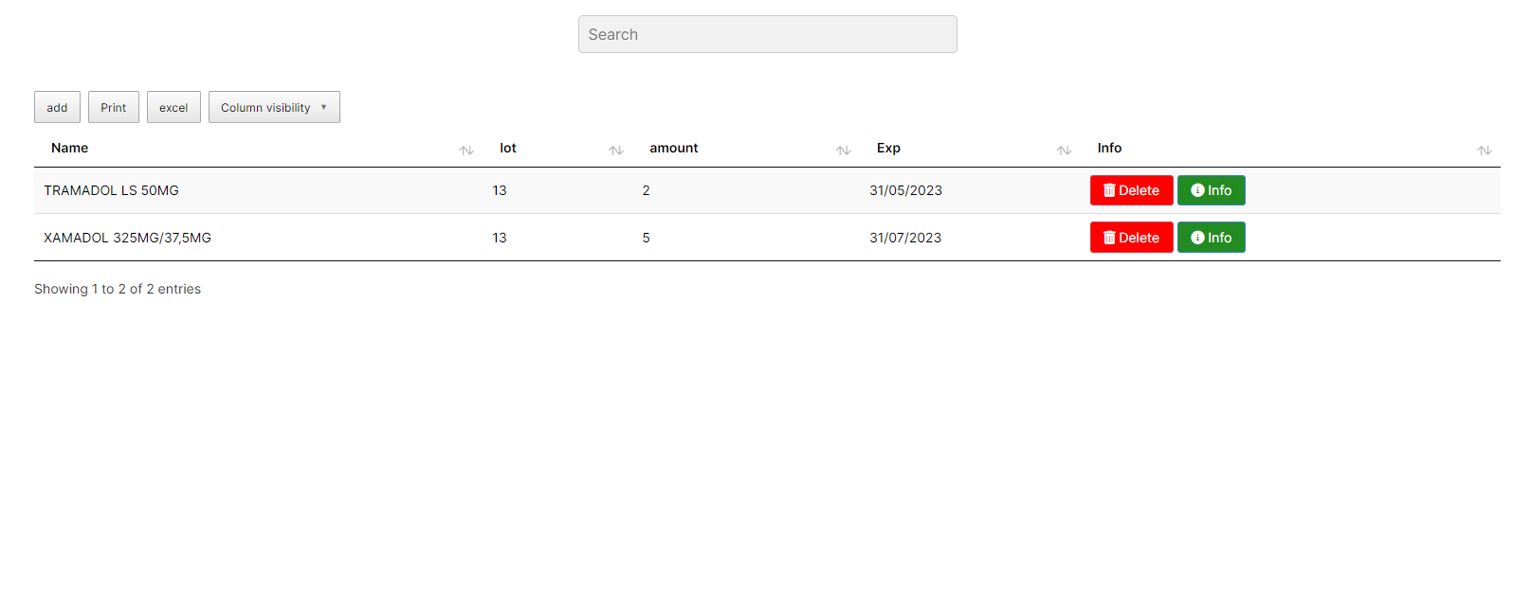**Figure 14 : Search and print and export**

Inventory Display:

* + The page presents a comprehensive view of the current inventory, including the list of products, their quantities, and other relevant details.
  + Users can easily browse and search for specific products within the inventory.

1. Adding New Products:
   * Users have the ability to add new products to the inventory by providing essential information such as product name, dosage, form, lot number, and initial quantity.
   * The system ensures that all necessary fields are filled out to avoid any missing or incomplete data.
2. Updating Inventory:
   * The page enables users to update the inventory by modifying product details, such as quantity, lot number, and expiration date.
   * Users can easily adjust inventory levels based on received shipments, sales, or any other relevant activities.
3. Inventory Reports:
   * The page provides options to generate detailed reports on inventory status, including stock levels, expiration dates, and product availability.
   * Users can export these reports for further analysis or sharing with relevant stakeholders.

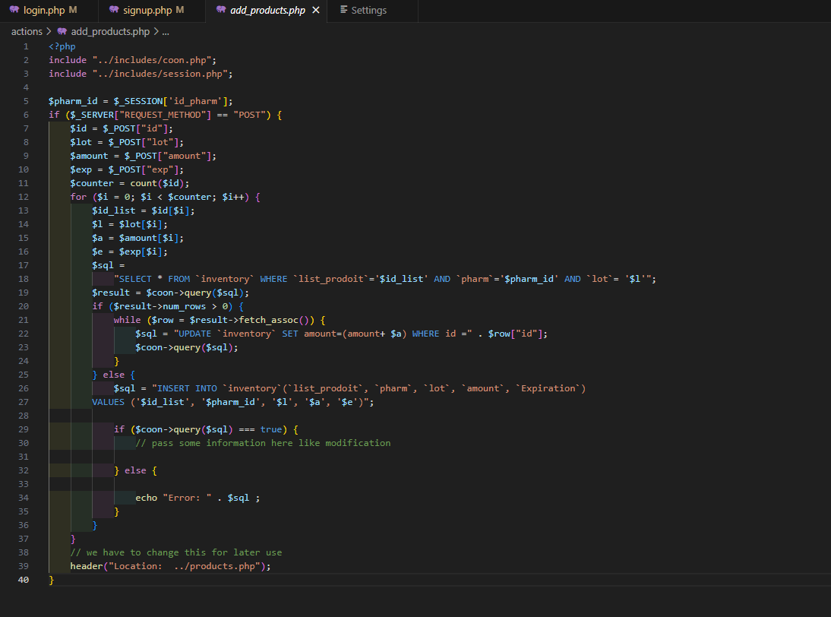

**Figure 15 : add medication code**

## 5 Profail page

The profile page serves as a centralized hub for managing account information and accessing crucial patient data. It offers a range of functionalities:

1. Display Patient Details and Demographics: The profile page presents comprehensive information about the patient, including personal details and demographics. This allows healthcare providers to have a complete understanding of the patient's background and relevant information.
2. Show Medical History and Past Treatments: Healthcare professionals can access and review the patient's medical history and past treatments. This feature provides valuable insights into previous diagnoses, procedures, and medications, aiding in effective decision-making and continuity of care.
3. Check for Similar Products in Use: The profile page includes a functionality to check for any similar products currently being used by the patient. This helps healthcare providers identify potential conflicts or adverse effects that may arise from combining multiple medications. By ensuring medication safety, this feature promotes patient well-being and minimizes risks.

The profile page acts as a comprehensive repository of patient information, facilitating efficient and informed healthcare delivery. It empowers healthcare providers to make accurate assessments, track treatment progress, and optimize patient care.

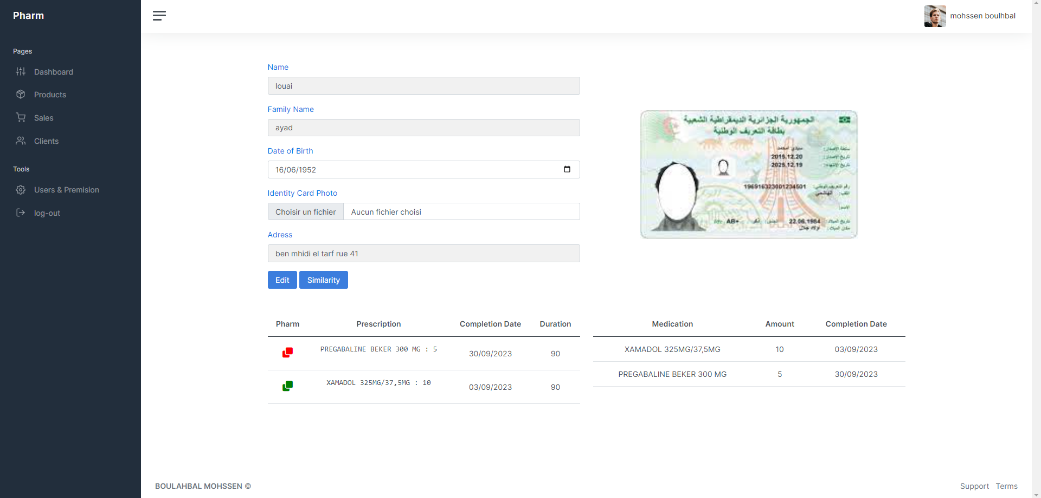

**Figure 16 : Profail page**

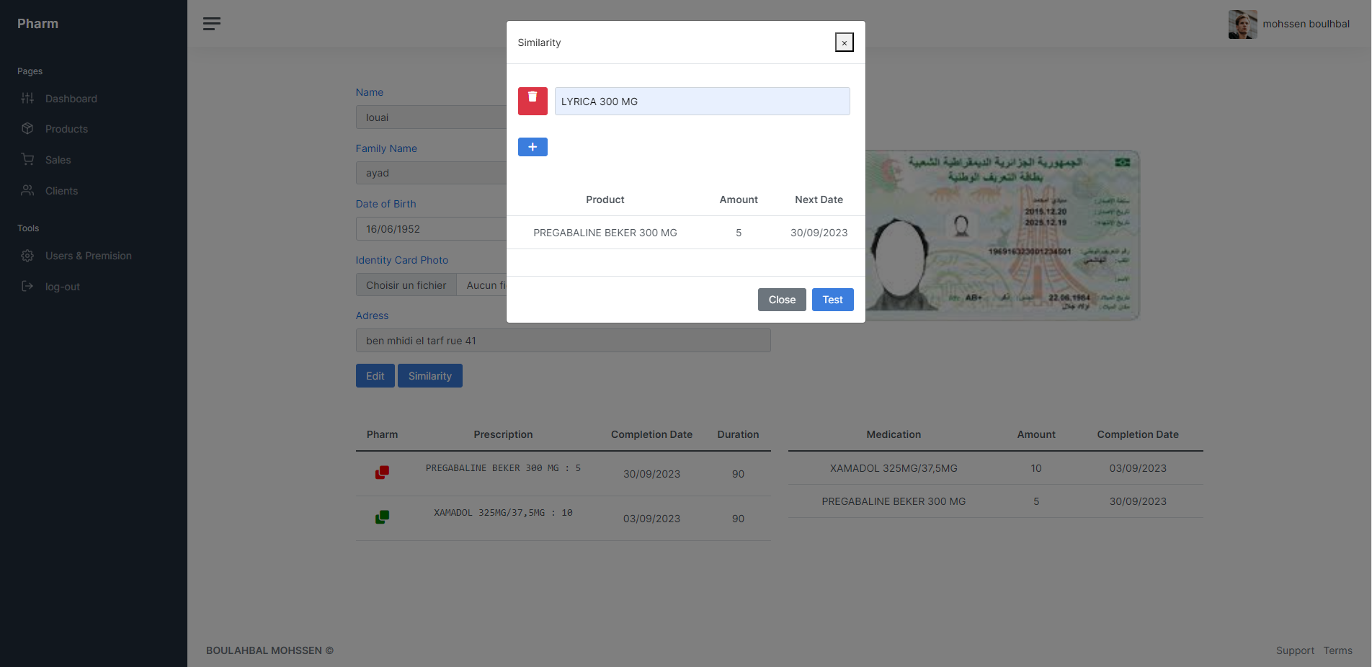**Figure 17: similler mudication in use**

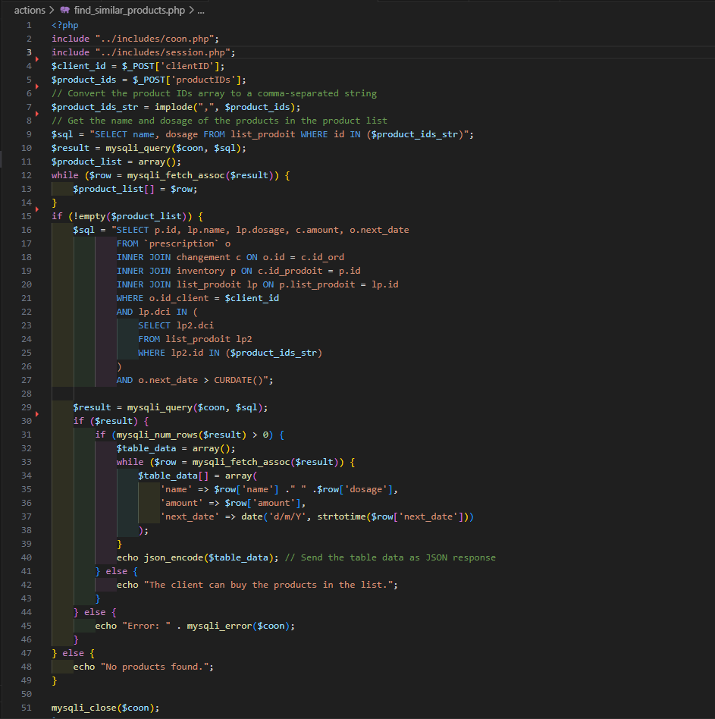**Figure 18: simillerty code**

## 5 Prescrition page

The Sales Transaction Page is designed to enable Sales Checkers to verify prescription details, ensuring the accuracy and validity of the medication. It allows them to review key information such as medication name, dosage, prescribing physician, and validity. The page includes sub-functions that facilitate this process.

Prescription Details: The page displays the extracted information from the prescription, presenting essential details such as the drug name, dosage, and instructions. This allows Sales Checkers to have a comprehensive view of the prescribed medication.

Verification Checks: The system performs validation checks on the prescription to ensure its validity and compliance with regulations. It verifies important aspects such as the authenticity of the prescription, proper dosage, and any potential interactions or contraindications.

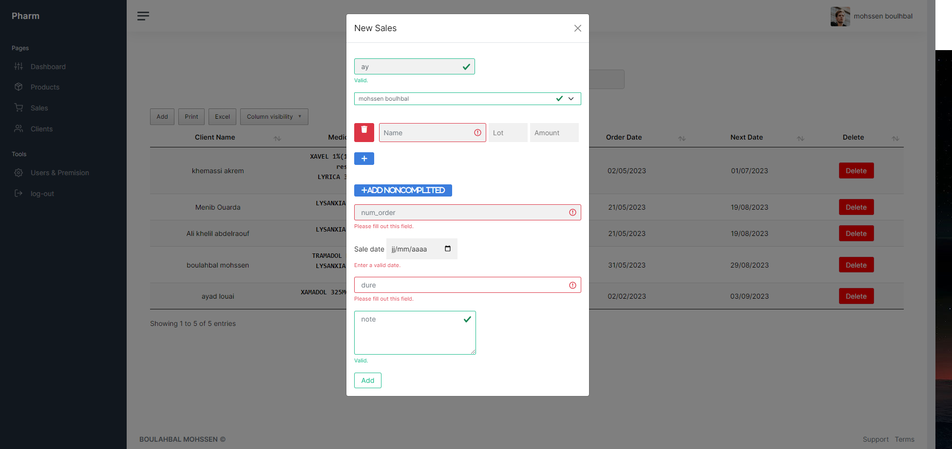**Figure 19 :Prescription page**

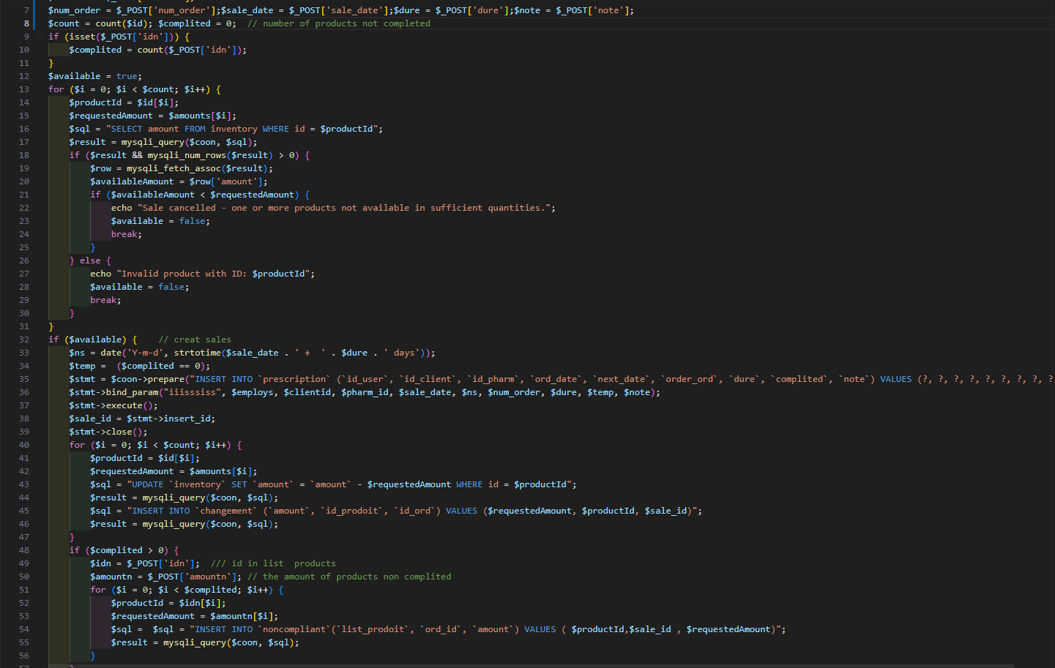**Figure 20 :Prescription code**

## Conclusion :

Chapter 3 presents the functional architecture of the website. It encompasses the login page, profile page, inventory page, pages collectively provide essential functionalities for inventory management in the pharmacy, such as user authentication, patient profile display, sales tracking, product management, and user administration. The development of this web-based application aims to streamline inventory processes, improve efficiency, ensure compliance with regulations, and enhance the overall management of psychotropic drugs in pharmacies."

1. Project Overview:

The development of a web-based application for stock management of psychotropic drugs in pharmacies is of utmost importance due to the following reasons:

1. Safety and Effective Use: Psychotropic drugs are powerful medications used to treat mental illnesses. Ensuring their safe and effective use is vital to prevent adverse effects and promote patient well-being. The web application will enable pharmacies to track and monitor drug availability, ensuring safe dispensing to patients.
2. Compliance and Regulation: Psychotropic drugs are subject to strict regulations to prevent abuse and misuse. Manual verification of prescriptions and patient eligibility is prone to errors and can lead to legal issues. The application automates the verification process, ensuring compliance and reducing errors.
3. Efficiency and Time-saving: Manual management of drug transactions is time-consuming and inefficient, causing delays and potential stock shortages. The web application streamlines processes, automates tasks, and maintains accurate records, saving time and improving efficiency.
4. Improved Record Keeping: The application provides real-time inventory management, drug expiration tracking, and prescription validation. It maintains comprehensive records of drug transactions, enabling pharmacists to have an up-to-date overview of their stock and make informed decisions.

Accessibility and User-Friendliness: The proposed web application features a user-friendly interface accessible from any internet-connected device. This accessibility allows pharmacists to conveniently manage their psychotropic drug stock, even remotely, enhancing flexibility and efficiency.

## In summary :

he development of a web-based application for stock management of psychotropic drugs in pharmacies aims to improve patient safety, comply with regulations, enhance efficiency, and provide a reliable tool for pharmacists. By automating processes and maintaining accurate records, the application contributes to the safe and effective use of psychotropic drugs while minimizing associated risks.

1. Reference
2. Mahmoud, E. A., Khater, A. S., Shaban, M., & Ismail, I. M. (2017). Design and implementation of a web-based pharmacy inventory management system. International Journal of Pharmaceutical Sciences and Research, 8(8), 3375-3382.
3. Rasha, M., Abdelhakim, A., & Nashat, M. (2017). Web-based pharmaceutical inventory management system for community pharmacies. International Journal of Computer Science and Information Security, 15(6), 209-218.
4. [https://en.wikipedia.org/wiki/Similarity_search#:~:text=The%20most%20general%20approach%20to,scalability%20in%20the%20search%20domain](https://en.wikipedia.org/wiki/Similarity_search" \l ":~:text=The most general approach to,scalability in the search domain).
5. <https://www.php.net/manual/>
6. [https://stackoverflow.com/questions/60174/how-can-i-prevent-sql-injection-in-ph](https://stackoverflow.com/questions/60174/how-can-i-prevent-sql-injection-in-php)p
7. <https://github.com/teamalgoritma/community/discussions/652> ["Web-

Key words [ based application", "Inventory management", "Pharmacies", "Psychotropic drugs", "Stock control", "User authentication", "User registration", "Patient details", "Medical history", "Treatment management", "Prescription validation", "Security measures", "User roles and permissions", "Real-time inventory management", "Drug expiration tracking", "User-friendly interface", "Database management", "Data validation", "Access rights", "Compliance and regulations"]