User Guide
  - VitalSigns Monitor and Patient Simulator - operating the programs
Project | VitalSigns Monitor
Document | User Guide
Document ID | VSM-USR-001
Version | 1.1
Date | 1 November 2026
Prepared by | Mohsen Mazaheri
Status | Draft for review

Revision history
Version | Date | Author | Change
1.0 | 1 Nov 2026 | Mohsen Mazaheri | First issue, based on software version 0.1.0
1.1 | 1 Nov 2026 | Mohsen Mazaheri | Alarm manager, audit log, alarm sounds and CI (software version 0.2.0)

Synthetic data only - not a medical device. The programs show synthetic signals from a simulator. Do not use them for diagnosis, treatment or monitoring of people.

Contents
1. Introduction 4
1.1 What the system does 4
1.2 Intended use 4
1.3 The three programs 4
2. Safety notice 4
3. Quick start 4
4. Patient Simulator 5
4.1 Header and status LEDs 5
4.2 LCD screen 5
4.3 Heart-rate group (ECG · HEART RATE) 6
4.4 SpO2 group 6
4.5 Scenario keys 6
4.6 OUTPUT panel 6
4.7 FAULT INJECTION panel 7
4.8 POWER key 7
4.9 Start-up options 7
5. Monitor 7
5.1 Connection bar 8
5.2 Alarm banner 8
5.3 ECG panel 8
5.4 Numeric tiles 8
5.5 Footer 8
5.6 Start-up option 9
6. Alarms 9
6.1 Priorities and colours 9
6.2 Alarm list 10
6.3 Behaviour 10
6.4 Alarm sounds 10
6.5 Event log 11
7. Exercises 11
8. Console simulator 12
9. Using a serial connection 12
10. Troubleshooting 12
11. Glossary 13

1. Introduction

1.1 What the system does
VitalSigns Monitor is a desktop program that shows the vital signs of a patient, as a bedside monitor does: a moving ECG trace, the heart rate, the oxygen saturation (SpO2) and alarms. The data come from the Patient Simulator, a second program that looks and works like a bench-top patient simulator: you set the heart rate and SpO2 with knobs, run scripted scenarios and simulate faults such as a pulled cable.

1.2 Intended use
- Learning, demonstration and software testing.
- Reproducing alarm situations and connection faults without hardware.
The system is not intended for clinical use of any kind.

1.3 The three programs
Program | Purpose
VitalSignsMonitor | The monitor: receives data, shows ECG, HR, SpO2, alarms and link statistics
VitalSignsPatientSimulator | Patient simulator with a front panel: knobs, keys, LEDs, LCD, output and fault injection
VitalSignsSimulator | The same simulator as a console program, controlled with command-line options

2. Safety notice
Read before use. All signals are generated by software. The numbers and curves do not describe a real person. The alarm limits are fixed teaching values. Never connect the programs to real patient equipment and never use them for medical decisions.
Both programs show this permanently: the monitor in its footer ("SYNTHETIC DATA - NOT A MEDICAL DEVICE - NOT FOR CLINICAL USE"), the simulator on its front panel ("SYNTHETIC SIGNALS ONLY · NOT A MEDICAL DEVICE · FOR SOFTWARE TESTING").

3. Quick start
- Start VitalSignsPatientSimulator. It switches on, starts a synthetic patient and opens a TCP server on 127.0.0.1, port 5555. The LCD shows the ECG it generates.
- Start VitalSignsMonitor.
- In the monitor's connection bar keep TCP, host 127.0.0.1 and port 5555, then click Connect.
- The status lamp turns green, the ECG starts to sweep and HR and SpO2 appear after about one second. On the simulator the LINK LED lights up and the LCD shows "1 monitor connected".
- Turn the heart-rate knob on the simulator or press a preset and watch the monitor follow.

4. Patient Simulator
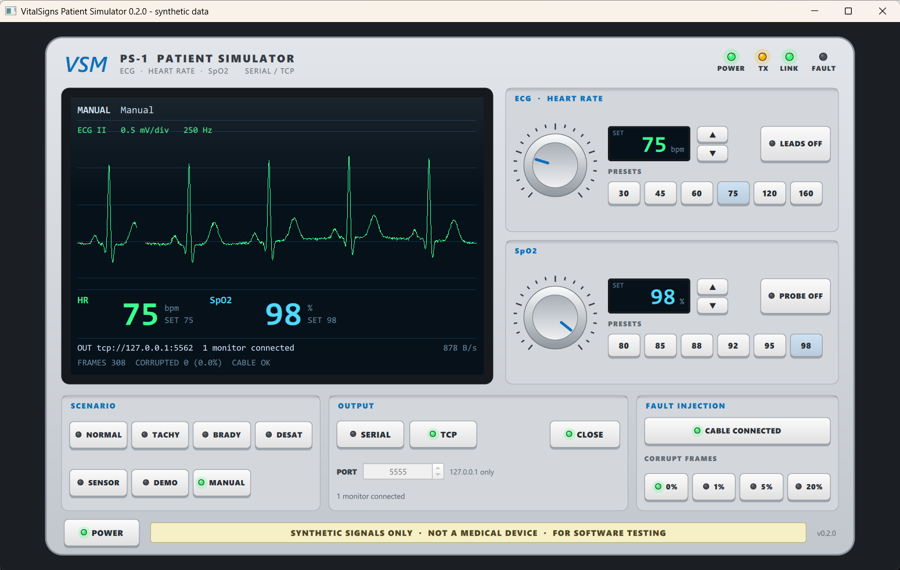
Figure 1 - Front panel of the Patient Simulator
The front panel is drawn at a fixed design size and scales with the window, so it always keeps its proportions.

4.1 Header and status LEDs
LED | Meaning
POWER (green) | The simulated device is switched on and generating signals
TX (amber) | Blinks while frames are being sent
LINK (green) | At least one receiver is connected (TCP: a monitor is connected; serial: the port is open)
FAULT (red) | A fault is active: cable unplugged, frame corruption switched on, or an output error

4.2 LCD screen
- Top line: the active scenario (for example SCENARIO DEMO), its current phase and the elapsed scenario time (mm:ss). In manual mode it shows MANUAL.
- ECG area: the ECG the device generates (lead II, 0.5 mV per division, sample rate 250 Hz). With leads off it shows "LEADS OFF" and a flat line.
- Numbers: current HR (bpm) and SpO2 (%) with the set value below ("SET 75"). A sensor that is off shows "---" and "SENSOR OFF".
- Output line: where the data go (for example tcp://127.0.0.1:5555), the output state and the data rate in bytes per second; for a serial port also the line load (LOAD, shown in warning colour above 80 %).
- Statistics line: frames sent, frames corrupted (with percentage) and the cable state.
- Error line: the last output error, if any (for example a serial port that cannot be opened).

4.3 Heart-rate group (ECG · HEART RATE)
- Knob: drag up or down, or use the mouse wheel. Range 20 to 250 bpm, step 1.
- SET display with ▲ and ▼ keys: change the target by 1 bpm.
- PRESETS: 30, 45, 60, 75, 120 and 160 bpm.
- LEADS OFF: simulates detached ECG electrodes. Press again to reattach.
The simulated heart rate does not jump: it moves towards the new target at 3 bpm per second, as a real patient would.

4.4 SpO2 group
- Knob, SET display and ▲▼ keys as above. Range 50 to 100 %.
- PRESETS: 80, 85, 88, 92, 95 and 98 %.
- PROBE OFF: simulates a detached finger probe.
SpO2 changes by 0.5 % per second.

4.5 Scenario keys
A scenario changes the patient automatically through timed phases. When the last phase ends, the scenario starts again. The LED of the active key is lit.
Key | Scenario | Phases (duration)
NORMAL | normal | Normal sinus rhythm, HR 75, SpO2 98 (60 s)
TACHY | tachycardia | Normal (20 s), Tachycardia HR 145 (40 s), Severe tachycardia HR 165 (30 s)
BRADY | bradycardia | Normal (20 s), Bradycardia HR 44 (40 s)
DESAT | desaturation | Normal (20 s), Desaturation SpO2 87 (30 s), Severe desaturation SpO2 82 (30 s)
SENSOR | sensor-off | Normal (15 s), ECG leads off (10 s), Normal (15 s), SpO2 probe off (10 s)
DEMO | demo | Normal, Tachycardia, Recovery, Desaturation, Severe desaturation, Recovery, Bradycardia, ECG leads off, SpO2 probe off (165 s in total)
MANUAL | - | Stops the scenario and holds the current values
Touching any patient control (knob, ▲▼, preset, LEADS OFF, PROBE OFF) while a scenario runs switches the simulator to manual mode, as bench-top simulators do.

4.6 OUTPUT panel
- SERIAL / TCP select the interface.
- SERIAL: choose the PORT (the ↻ key refreshes the list) and the BAUD rate (9600 to 230400; 115200 is the default). Format 8 data bits, no parity, 1 stop bit.
- TCP: choose the port (default 5555). The server accepts connections from this computer only (127.0.0.1) and sends the same data to every connected monitor.
- OPEN / CLOSE opens or closes the selected output. The LCD shows the result; an error appears in the error line.

4.7 FAULT INJECTION panel
- CABLE CONNECTED / CABLE UNPLUGGED: simulates pulling the cable. Frames are still generated and numbered but not sent. After 3 s the monitor reports "No data from device"; when the cable is plugged in again it counts the missing frames.
- CORRUPT FRAMES 0 % / 1 % / 5 % / 20 %: that share of the frames is sent with a damaged byte. The monitor detects them with the CRC and drops them.

4.8 POWER key
Switches the simulated device on or off. When it is off, nothing is generated or sent and the LCD is dark.

4.9 Start-up options
The simulator can also be started from a command prompt:
Option | Meaning
--port 5555 | TCP port at start-up
--serial COM5 | Start with the serial output on this port instead of TCP
--baud 115200 | Baud rate for --serial
--scenario demo | Start with a scenario (normal, tachycardia, bradycardia, desaturation, sensor-off, demo)

5. Monitor
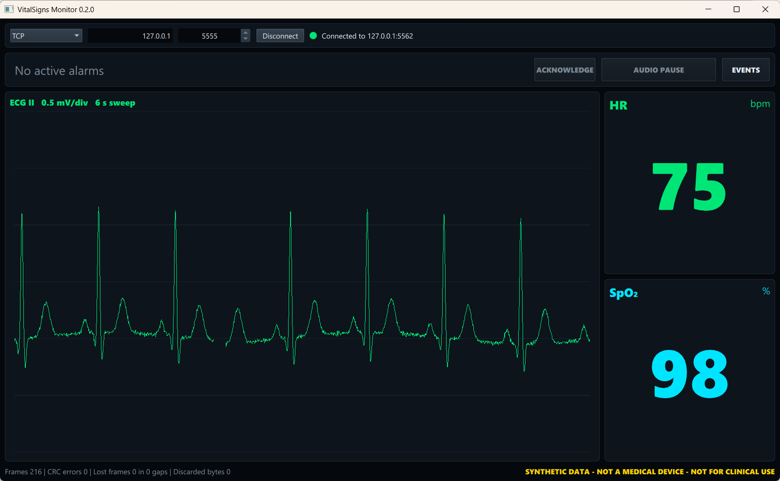
Figure 2 - The monitor with normal values

5.1 Connection bar
Element | Function
TCP / Serial | Selects the connection type
Host and port (TCP) | Address of the simulator; default 127.0.0.1 and 5555
Port, ↻ and baud rate (Serial) | Serial port, refresh of the port list, baud rate 9600 / 57600 / 115200 / 230400
Connect / Disconnect | Starts or ends the session; the settings are locked while connected
Status lamp | Grey = not connected, green = connection open, yellow = connecting or retrying (a silent link is reported by the status text and the alarm)
Status text | For example "Connected to tcp://127.0.0.1:5555", "Connected ... - no data", "Disconnected ... - retrying"
Error text (red) | The last error, for example an invalid port
If the connection breaks, the monitor tries again every 2 seconds until you click Disconnect.

5.2 Alarm banner
The banner below the connection bar shows the most important alarm in the colour of its priority. If there are more alarms, "+N more" is shown next to it. Without alarms it reads "No active alarms". An unacknowledged high-priority alarm flashes. The banner also holds three keys:
Key | Function
ACKNOWLEDGE | Stops the sound and the flashing for the current alarms and removes latched alarms
AUDIO PAUSE | Stops the sound for 2 minutes; the key shows the time left (AUDIO PAUSED 1:58). Press again to end the pause
EVENTS | Opens the window with all current alarms and the event log

5.3 ECG panel
The ECG (lead II) is drawn from left to right and overwrites the old trace, like a monitor sweep. When the electrodes are off, the panel shows "LEADS OFF".

5.4 Numeric tiles
- HR in bpm (green) and SpO2 in % (cyan).
- When a value is outside its limits, the number and the tile border take the colour of the alarm priority.
- A missing value is shown as "---", never as an old number. "PROBE OFF" appears under SpO2 when the probe is detached.

5.5 Footer
The left side shows the link statistics:
Field | Meaning
Frames | Valid frames received
CRC errors | Frames dropped because the checksum was wrong
Lost frames ... in ... gaps | Frames that never arrived, and how many interruptions caused them
Discarded bytes | Bytes skipped while searching for the next valid frame
The right side shows the permanent notice "SYNTHETIC DATA - NOT A MEDICAL DEVICE - NOT FOR CLINICAL USE".

5.6 Start-up option
VitalSignsMonitor --connect 127.0.0.1:5555 connects automatically at start-up. --no-sound turns the alarm sounds off (the visual signals stay), and --audit-dir <folder> selects the folder of the audit log.

6. Alarms
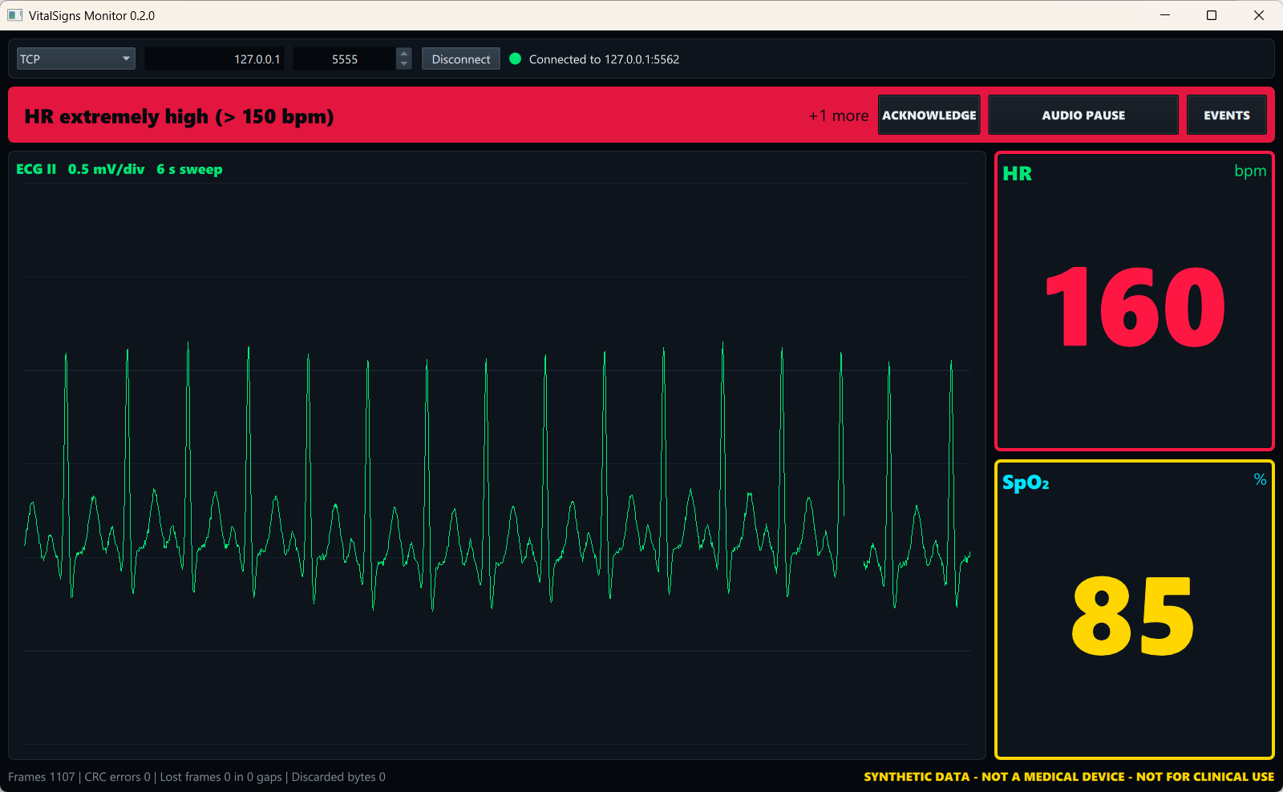
Figure 3 - Heart-rate alarm of high priority

6.1 Priorities and colours
Priority | Colour | Used for
High | Red | Life-threatening values (critical limits)
Medium | Yellow | Values outside the normal limits, lost device link
Low | Light blue | Technical problems with sensors

6.2 Alarm list
Code | Condition | Priority | Message on screen
HR_CRITICAL_HIGH | HR > 150 bpm | High | HR extremely high (> 150 bpm)
HR_HIGH | HR > 120 bpm | Medium | HR high (> 120 bpm)
HR_LOW | HR < 50 bpm | Medium | HR low (< 50 bpm)
HR_CRITICAL_LOW | HR < 40 bpm | High | HR extremely low (< 40 bpm)
SPO2_LOW | SpO2 < 90 % | Medium | SpO2 low (< 90 %)
SPO2_CRITICAL_LOW | SpO2 < 85 % | High | SpO2 critically low (< 85 %)
ECG_LEADS_OFF | Electrodes detached | Low | ECG leads off
SPO2_PROBE_OFF | Probe detached | Low | SpO2 probe off
DEVICE_LINK_LOST | No valid data for 3 s | Medium | No data from device

6.3 Behaviour
- Only the most severe alarm of each parameter is shown: HR 160 gives "HR extremely high", not also "HR high".
- Medium and low alarms end by themselves when the condition is gone.
- High alarms latch: when the condition ends, the alarm stays visible and audible and the banner adds "ENDED - ACKNOWLEDGE", so that a short critical event cannot go unnoticed. The number in the tile always shows the present value and colour.
- Acknowledged alarms stay visible, steady and silent while the condition lasts. If the alarm comes back later or gets worse, it sounds again.
- Audio pause: a new medium or high alarm ends the pause early; a new low alarm does not. The key is off when nothing is unacknowledged, because a pause in advance would hide the next alarm. Visual signals keep running during the pause.
- Disconnect clears all alarms, also latched ones, because the next session may be another patient.
- When the link is lost, HR and SpO2 are cleared to "---" and the sensor alarms are hidden, because the last sensor state is no longer known.
- The limits cannot be changed in version 0.2.0.

6.4 Alarm sounds
Each priority has its own melody: high 10 pulses every 6 s, medium 3 pulses every 8 s, low 2 pulses every 20 s. The most urgent unacknowledged alarm decides which one plays. Without an audio device the monitor stays silent and the visual signals keep working.

6.5 Event log
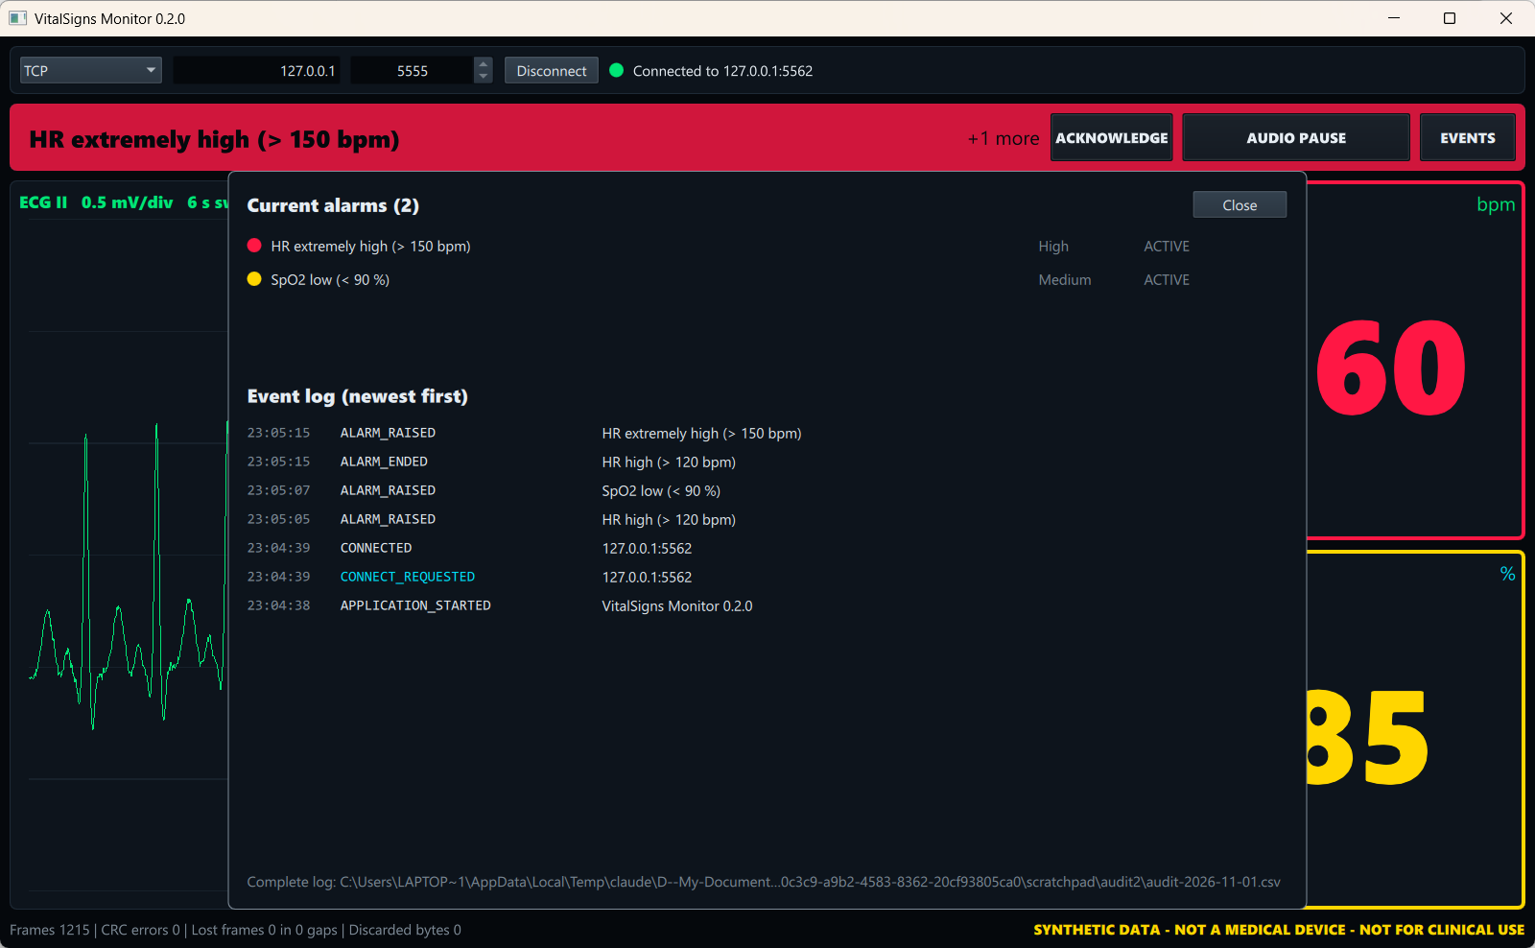
Figure 4 - Current alarms and event log
EVENTS lists the current alarms and the latest events, newest first. Operator actions are shown in cyan. The complete log is a CSV file with one file per day, shown at the bottom of the window. On Windows it is in %LOCALAPPDATA%\Mohsen Mazaheri\VitalSigns Monitor\audit. The columns are time_utc, event, actor (operator or system), code, priority and detail. The log holds no patient data. If the file cannot be written, a red message appears in the connection bar and the monitor keeps running.

7. Exercises
Action on the simulator | Expected result on the monitor
HR preset 160 | Red alarm "HR extremely high (> 150 bpm)" once HR passes 150 (it rises 3 bpm per second)
HR preset 45 | Yellow "HR low (< 50 bpm)"
SpO2 preset 85 | Yellow "SpO2 low (< 90 %)"; at 84 and below red "SpO2 critically low"
LEADS OFF | HR shows "---", flat ECG, "LEADS OFF", light-blue alarm "ECG leads off"
PROBE OFF | SpO2 shows "---", "PROBE OFF", light-blue alarm "SpO2 probe off"
CABLE UNPLUGGED | After 3 s yellow "No data from device", values "---"; after plugging in, "Lost frames" counts the gap
CORRUPT 5 % | "CRC errors" rises, the display keeps running
DEMO scenario | Most situations above one after another in about three minutes
HR preset 160, wait for the red alarm, then preset 75 | Below 150 the red alarm stays with "ENDED - ACKNOWLEDGE" while the tile turns yellow, then green
On the monitor: ACKNOWLEDGE | Sound and flashing stop; a latched alarm disappears
On the monitor: AUDIO PAUSE during an alarm | Sound stops, the key counts down from 2:00, the banner keeps flashing
AUDIO PAUSE, then SpO2 preset 85 | The pause ends as soon as the new SpO2 alarm starts
On the monitor: EVENTS | All of the above appears in the event log with its time

8. Console simulator
VitalSignsSimulator --scenario demo
VitalSignsSimulator --scenario tachycardia --port 5556
VitalSignsSimulator --serial COM5 --baud 115200 --corrupt 0.02
Options:
Option | Default | Meaning
--scenario, -s | demo | normal, tachycardia, bradycardia, desaturation, sensor-off or demo
--port, -p | 5555 | TCP port
--serial | - | Serial port instead of TCP
--baud | 115200 | Serial baud rate
--rate | 250 | ECG sample rate in Hz
--corrupt | 0 | Share of corrupted frames (0.02 = 2 %)
The program prints phase changes and the output state. Stop it with Ctrl+C.

9. Using a serial connection
A serial connection needs either two real serial ports connected with a null-modem cable, or a virtual COM-port pair such as com0com (see the Installation Guide).
- On the simulator choose SERIAL, port COM5 (one end of the pair), baud 115200, and press OPEN.
- On the monitor choose Serial, port COM6 (the other end), baud 115200, and click Connect.
At 115200 baud the simulator uses only part of the line; the LCD shows the line load.

10. Troubleshooting
Problem | Possible cause | What to do
Monitor stays at "Connecting ..." or "retrying" | Simulator not running, output closed, or another port | Start the simulator, press OPEN in TCP mode, check that both use the same port
"Connected ... - no data" | Simulator switched off or cable unplugged in the simulator | Press POWER, set CABLE CONNECTED
Simulator: port 5555 cannot be opened | Another program (or a second simulator) uses the port | Close the other program or use another port, for example --port 5556, in both programs
Serial port list is empty | No serial ports or no virtual pair installed | Install com0com or connect a USB-serial adapter, then press ↻
Many CRC errors | Corruption switched on, or wrong baud rate | Set CORRUPT FRAMES to 0 %, use the same baud rate on both sides
A program does not start (missing DLL) | Qt libraries not found | Start it from Qt Creator or use the deployed folder (see the Installation Guide)
No alarm sound | Audio device missing or muted, or the program runs with --no-sound | Check the Windows sound settings; start without --no-sound
"Audit log cannot be written" | The folder is not writable | Choose another folder with --audit-dir
From Qt Creator the simulator closes when the monitor starts | Qt Creator setting | Set "Stop applications before building" to "Same Application" (Installation Guide, section 6)

11. Glossary
Term | Explanation
bpm | Beats per minute
ECG lead II | A standard view of the heart's electrical activity
SpO2 | Share of oxygen-carrying haemoglobin in the blood, measured at the finger
Tachycardia / bradycardia | Heart rate too fast / too slow
Desaturation | Fall of SpO2
CRC | Checksum that detects damaged frames
Frame | One data packet of the device protocol
Latched alarm | An alarm that stays after its condition ended, until it is acknowledged
Acknowledge | The operator confirms having seen an alarm; its sound stops
Audit log | A permanent record of alarms, operator actions and connection events

