Trajectories of point-based spatial analysis: a systematic review of methods, application domains and case-study geographies, 1977–2026
Mohsen Roohani
Affiliation to be completed

Highlights
- Systematic review of 223 studies applying point-based spatial
analysis across nine application domains.
- Four convergent trajectories: description → inference,
planar → constrained, statistics → learning,
single → combined methods.
- Point process models overtook kernel density estimation as the modal
analytical framework after 2015.
- Machine-learning components appear in 26% of studies published since
2020, but in none before 2006.
- Evidence is geographically concentrated: five countries supply 54% of
case studies; low-income countries supply 1.2%.

Abstract
Background. Point-based spatial analysis — the family of methods that treats the recorded locations of individual events as realisations of a spatial point process — underpins evidence in public health, ecology, criminology, transport safety, seismology and archaeology. These literatures have developed largely in parallel, and no synthesis has established whether they are converging on a common methodological core.
Objectives. To characterise how point-based spatial analysis has developed over five decades, and to map its methods, application domains and case-study geographies.
Methods. We conducted a systematic review following PRISMA 2020. Fourteen structured queries were issued to a federated bibliographic index spanning Semantic Scholar, PubMed, Scopus and arXiv on 28 July 2026, returning 278 records. After duplicate removal and eligibility assessment, 223 studies were included. Each was coded for method family, application domain, case-study country and temporal dimension. Synthesis was narrative and quantitative, with trajectories analysed by publication period.
Results. Included studies span 1977–2026; 58% were published from 2020 onward. Parametric point process models were the most widely used family (73 studies, 33%), overtaking kernel density estimation (66, 30%) as the modal analytical framework after 2015. Three-quarters of studies (75%) combined two or more method families, and network-constrained formulations appeared in 13%. Machine-learning components were absent before 2006 but appeared in 26% of studies published since 2020. Public health (46 studies) and ecology (45) dominated, but methodological exchange between domains was substantial. Case studies covered 49 countries, with pronounced concentration: the United States, China, the United Kingdom, Japan and Brazil together supplied 54% of country-attributable studies, high-income countries 56%, and low-income countries 1.2%.
Conclusions. Point-based spatial analysis is converging on a shared inferential core built on point process models, but the convergence is uneven and its empirical base is geographically narrow. Priorities are transparent reporting of bandwidth, edge-correction and null-model choices; explicit treatment of geocoding uncertainty; and deliberate investment in under-represented geographies.
Keywords: spatial point process; point pattern analysis; kernel density estimation; scan statistic; linear network; spatio-temporal modelling; systematic review; PRISMA

Introduction
A great deal of what is known about where things happen rests on datasets of individual, georeferenced events: the residence of a person at diagnosis, the stem of a tree in a mapped plot, the location of a burglary, a crash, an earthquake epicentre, an ignition, a potsherd. The statistical machinery for analysing such data — spatial point pattern analysis — was formalised in the 1970s (Ripley 1977) and consolidated through a sequence of monographs that remain the field's reference texts (Diggle 2013; Illian et al. 2008; Baddeley et al. 2015; Wiegand & Moloney 2013). Its central idea is simple and unusually general: treat the observed configuration of points as one realisation of a stochastic process, and ask what that realisation implies about the process that generated it.
That generality is the source of both the field's reach and its fragmentation. The same second-order summary function that a plant ecologist uses to detect conspecific aggregation (Haase 1995; Perry et al. 2006; Law et al. 2009) is used by a criminologist to test whether burglaries cluster along a street network (Khalid et al. 2017), and by a seismologist to characterise aftershock triggering (Ogata & Zhuang 2006). Yet these communities cite different methodological literatures, adopt different software, and report different diagnostics. Domain-specific reviews exist — for point pattern analysis in ecology (Velazquez et al. 2016; Ben-Said 2021), for scan statistics in low- and middle-income country health research (Aboushady et al. 2025), for point patterns on linear networks (Baddeley et al. 2020), for self-exciting processes (Reinhart 2017; Bernabeu et al. 2024) — but each looks along a single axis. Whether the field as a whole is converging on shared methodology, or diverging into mutually unintelligible dialects, has not been established systematically.
This matters for three reasons. First, methodological choices that are well-understood in one domain are repeatedly rediscovered in another: the sensitivity of kernel density estimates to bandwidth, established in crime mapping two decades ago (Chainey et al. 2008; Chainey 2014; Hart & Zandbergen 2014), resurfaces as a novel concern in violence-prevention research (Zewdie et al. 2025). Second, methods that resolve known pathologies — network-constrained estimation for events confined to roads (Okabe et al. 2009; Baddeley et al. 2020), inhomogeneous summary functions for environmentally heterogeneous landscapes (Law et al. 2009; Wiegand et al. 2007) — diffuse slowly and unevenly. Third, if the empirical base is drawn from a narrow set of countries, then what the field believes about spatial processes is conditioned on where it happens to have looked.
We therefore ask four questions. (Q1) Which method families constitute point-based spatial analysis, and how has their relative use changed over time? (Q2) Do method families remain siloed within application domains, or is there systematic cross-domain exchange? (Q3) Is there evidence of methodological maturation — greater temporal explicitness, greater methodological breadth, uptake of statistical learning? (Q4) What is the geography of the evidence base, and how is it distributed across world regions and national income groups?
Our contribution is a cross-domain, quantitative synthesis of 223 studies spanning 1977–2026, with a reproducible coding framework, a complete extraction dataset, and analysis code released alongside the manuscript.

Methods

Protocol and reporting
The review was conducted and is reported in accordance with the PRISMA 2020 statement. The protocol, eligibility criteria and coding frame were specified before synthesis and are distributed with the review dataset (protocol/). The review was not prospectively registered; this is noted as a limitation in Section ?.

Eligibility criteria
Eligibility was defined on a Population–Concept–Context frame (Table 2). We included studies that analysed georeferenced event locations using at least one point-based spatial statistic or point process model, in any application field, geography or period. We excluded: analyses conducted exclusively on areal or lattice aggregates, raster surfaces, or extended line/polygon objects; purely temporal point process contributions with no spatial component; accessibility, travel-time and site-suitability models applying no point pattern statistic; books, monographs, theses, book reviews, correction notices and conference abstracts without full text; and records whose indexed metadata were absent or corrupted.
The distinction between point-based and areal analysis was applied strictly and is the single most consequential judgement in the review. A study that computed Getis–Ord G_i* on municipality-level ignition counts was excluded; a study that computed the same statistic on network segments carrying individual crash locations was included. This boundary is recorded per record in the extraction dataset so that readers may re-draw it.

Information sources and search strategy
Searches were executed on 28 July 2026 against a federated bibliographic index covering Semantic Scholar, PubMed, Scopus and arXiv. Fourteen structured queries (Table 1) were constructed on a method x domain matrix, so that each principal method family and each principal application domain was addressed by at least one query. Queries were natural-language rather than Boolean, reflecting the retrieval interface; the exact strings are reported verbatim to support replication.
We were unable to obtain native Scopus or Web of Science exports, and no citation-chaining or hand-searching of reference lists was performed. The implications are addressed in Section ?.

Selection process
Records were de-duplicated on normalised titles and on manual identification of preprint/journal pairs and correction notices. Titles and abstracts were then screened against the eligibility criteria, and an inclusion decision plus a free-text exclusion reason recorded for every record. The complete decision log, including all excluded records with reasons, is provided as Supplementary Table S2.

Data extraction and coding framework
For each included study we extracted: authorship, year, source title, publication type, citation count, primary method family, all method families applied, application domain, case-study country, and whether the analysis had an explicit temporal dimension.
Method families (Table 3) were coded into eleven categories spanning kernel density estimation; second-order distance statistics (Ripley's K, L, the pair correlation function g, and the F, G and J functions); nearest-neighbour indices; scan statistics; local indicators of spatial association applied to points; parametric point process models; spatio-temporal and self-exciting processes; network-constrained analysis; co-location and marked pattern methods; machine-learning point models; and other approaches. A study's primary family is its dominant analytical approach; all families record every approach applied, so studies contribute to more than one family where appropriate.
Case-study countries were assigned only where a specific national study area was identifiable from the record. Methodological contributions, simulation studies and multi-country analyses were coded as not attributable, multiple, or not specified, and excluded from country-level analyses. Countries were grouped into world regions and into World Bank-style income groups for the equity analysis.

Synthesis
Synthesis was narrative, supported by descriptive quantitative analysis. Temporal trajectories were computed as annual counts smoothed with a three-year centred moving average, and as compositional shares restricted to years with an adequate publication base. Maturation indicators were compared across four periods (≤2005, 2006–2012, 2013–2019, 2020–2026). Method co-occurrence was analysed as a weighted graph over the all families coding. Because the review synthesises methodological practice rather than treatment effects, no meta-analysis of effect sizes and no risk-of-bias assessment was appropriate; we instead report structured descriptors of methodological completeness.
All analyses were performed in Python 3.11 (pandas, numpy, networkx, matplotlib). Code and data are available as described under Data availability.

Results

Study selection
The 14 queries returned 278 records. Four were duplicates, leaving 274 for screening. Fifty-one records were excluded, most commonly because no point-based statistic was applied to event locations (n=30), because the publication type was ineligible (n=18), or because the bibliographic record was insufficient or corrupted (n=3). This left 223 included studies (Figure 1).
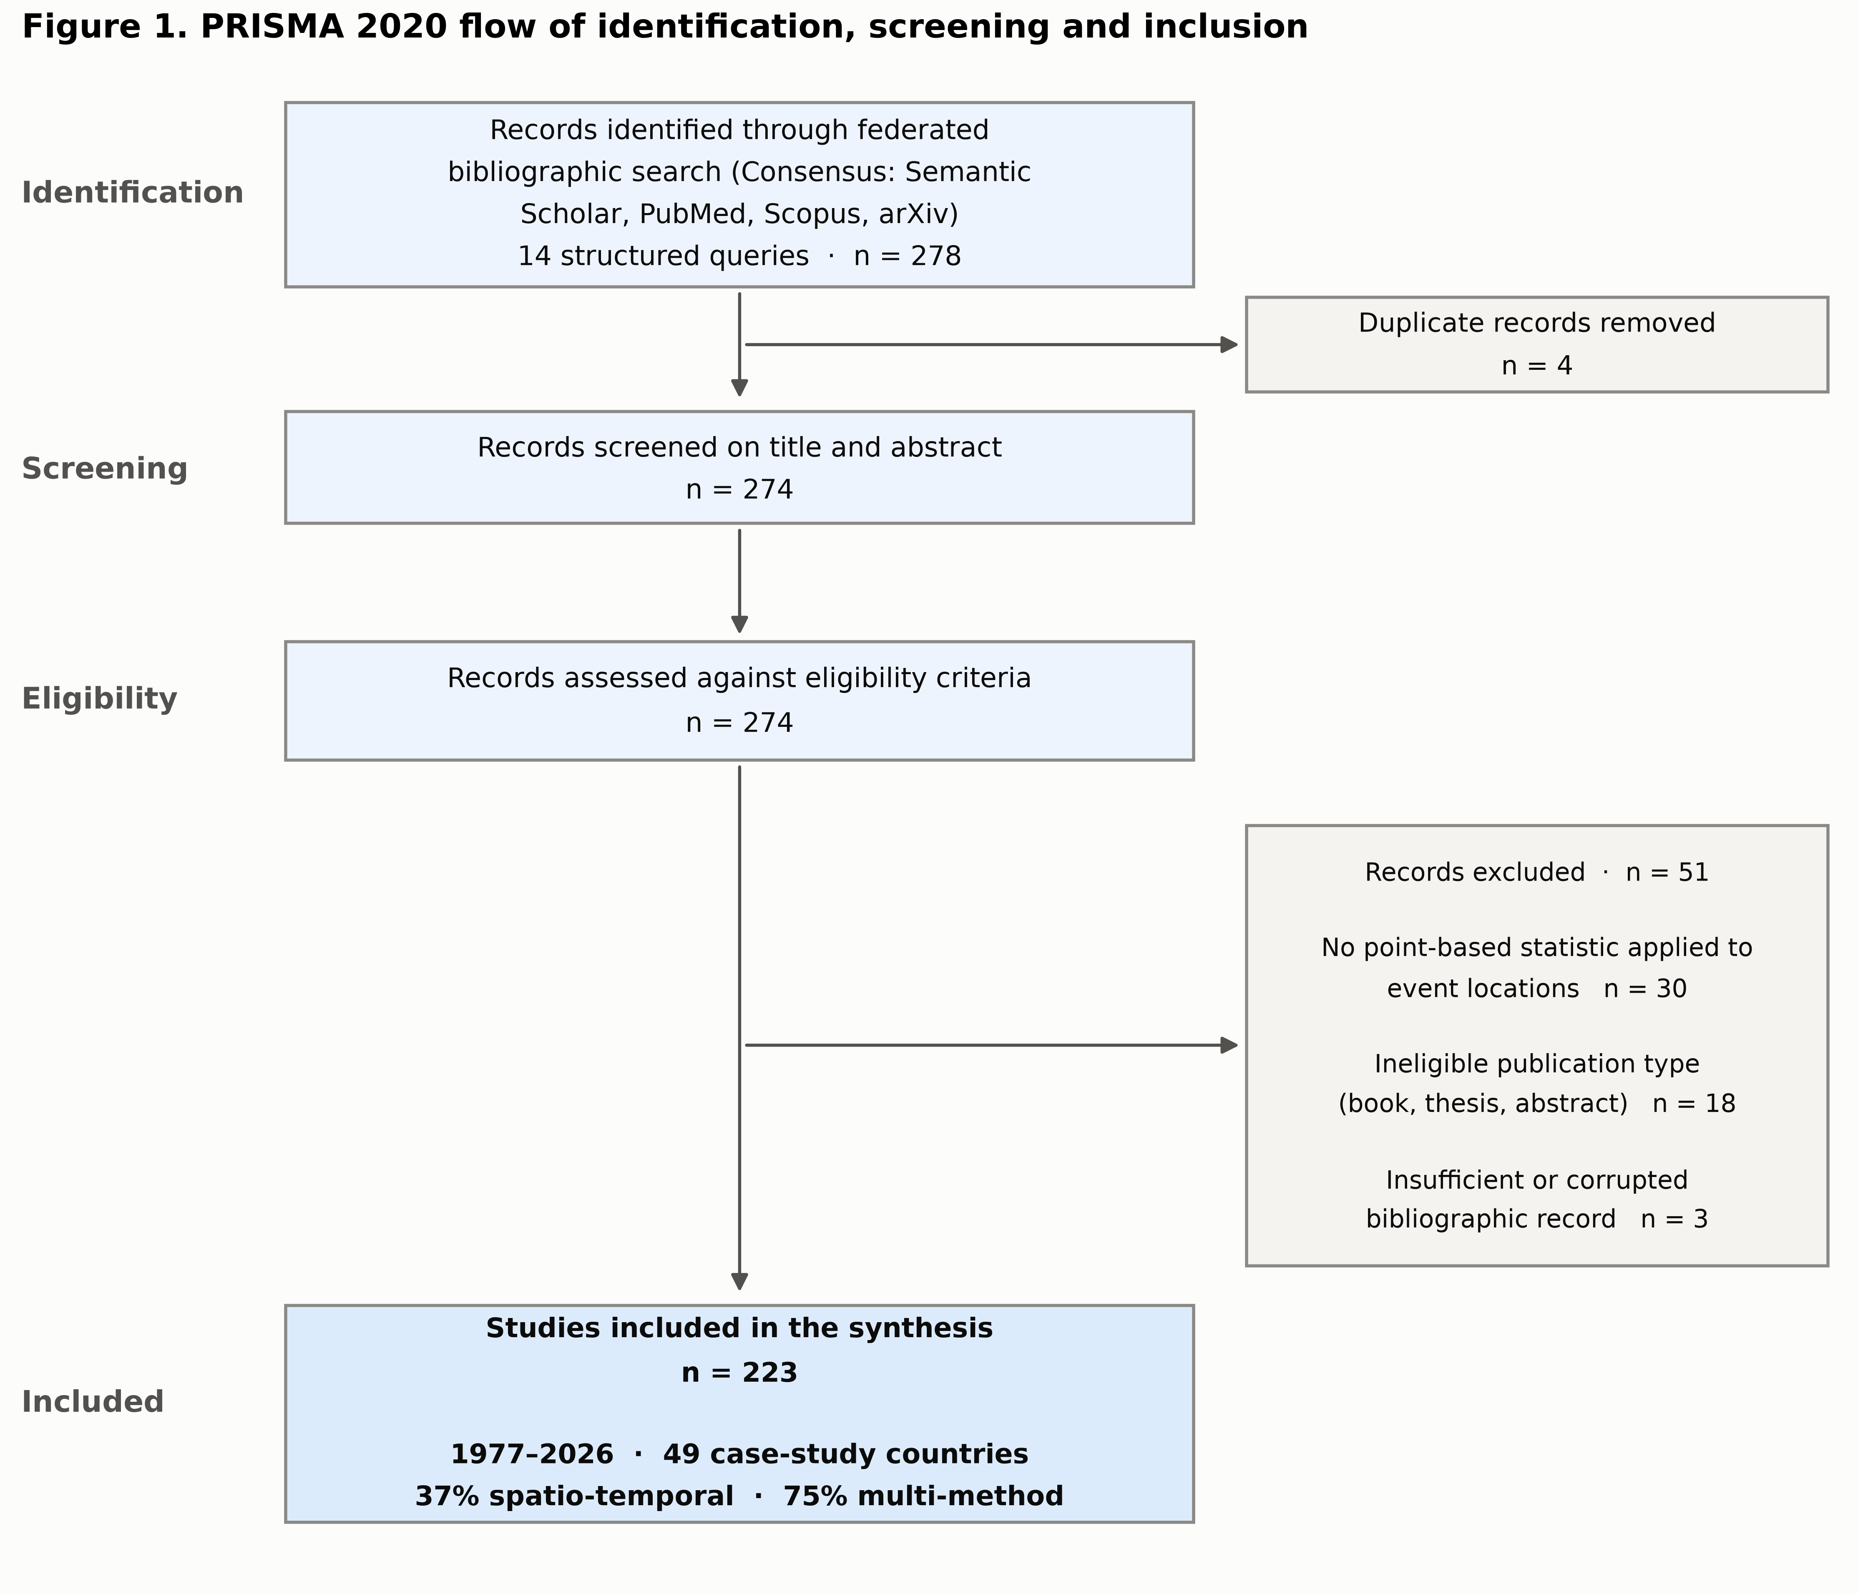
Figure 1. PRISMA 2020 flow of identification, screening and inclusion.

Characteristics of the evidence base
Included studies span 1977 to 2026, with a median publication year of 2021; 129 studies (57.8%) appeared from 2020 onward (Table 6). Journal articles predominate, with conference papers and preprints concentrated in the machine-learning literature. The median citation count is 18 (IQR 3–71), reflecting a mixture of recent applications and a small number of heavily cited methodological anchors.
Two structural features stand out. First, 168 studies (75.3%) applied two or more method families, indicating that point-based analysis is typically practised as a toolkit rather than as a single test. Second, only 83 studies (37.2%) modelled an explicit temporal dimension, so the majority of the field remains purely spatial despite the wide availability of time-stamped event data.

Q1 — Method families and their changing composition
Parametric point process models are the most widely applied family (73 studies, 32.7% of the corpus), followed by kernel density estimation (66, 29.6%), spatio-temporal and self-exciting processes (57, 25.6%), second-order distance statistics (53, 23.8%) and machine-learning point models (51, 22.9%) (Table 3).
The temporal trajectory (Figure 2) shows three phases. Before about 2002 the literature is thin and dominated by second-order distance statistics developed in plant ecology (Haase 1995; Perry et al. 2006). From the mid-2000s the field expands rapidly, initially through kernel density estimation and scan statistics, which were carried into practice by accessible software and a strong applied demand in crime mapping (Chainey et al. 2008; Nakaya & Yano 2010) and disease surveillance (Takahashi et al. 2008; Coleman et al. 2009). From roughly 2015 the composition shifts again: point process models and, subsequently, machine-learning formulations take an increasing share, while the relative weight of purely descriptive density mapping declines.
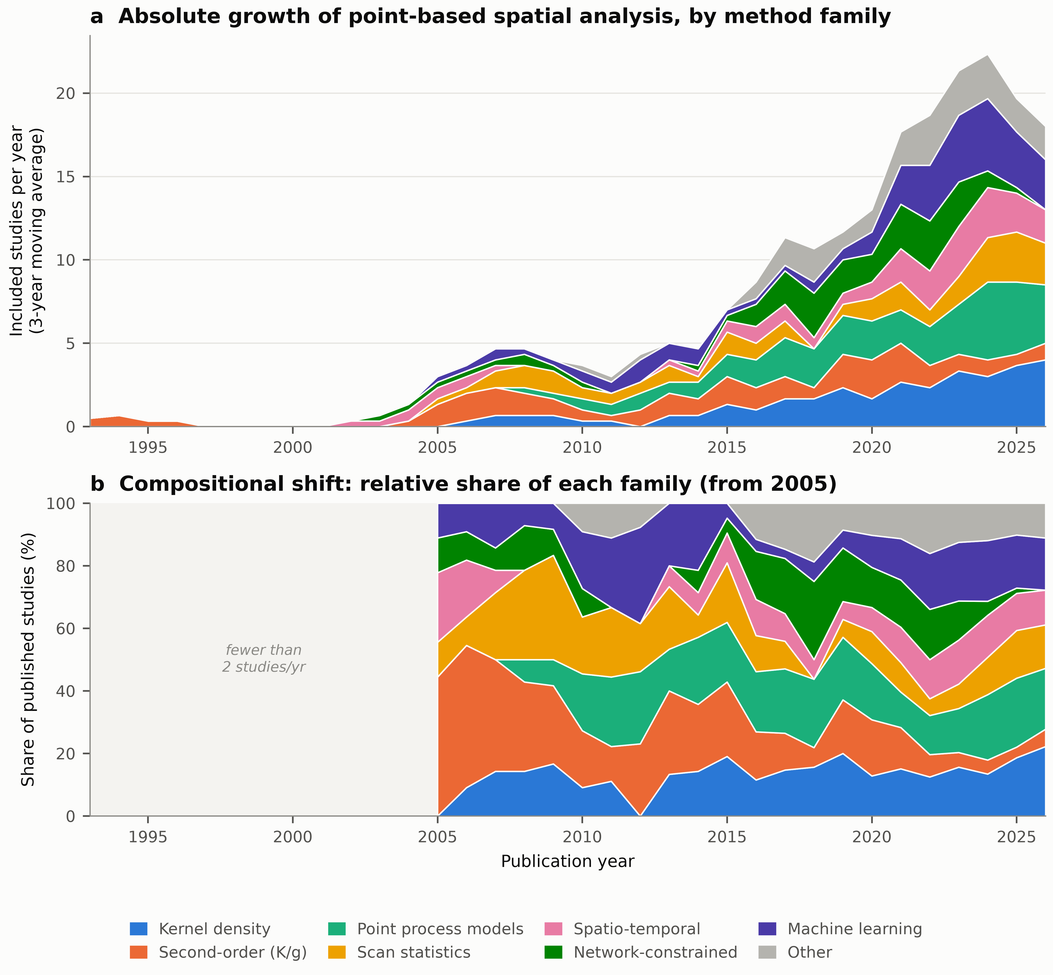
Figure 2. Growth and compositional change of point-based spatial analysis. (a) Annual number of included studies by primary method family, three-year centred moving average. (b) Relative share of each family, restricted to years with at least two studies per year.

The substantive reading is a movement from description to inference. Kernel density estimation answers “where is the intensity high?”; a fitted log-Gaussian Cox process answers “what covariates explain the intensity, with what uncertainty, and does residual clustering remain?” (Diggle et al. 2013; Li et al. 2012; Johnson et al. 2019; Konstantinoudis et al. 2018). The displacement is partial rather than total: kernel estimation persists because it remains the natural exploratory first step and the natural communication device, and it is increasingly used inside inferential workflows — as an intensity estimate for an inhomogeneous null model, or as a covariate surface — rather than as a terminal result.

Q2 — Cross-domain exchange
Method use is strongly but not exclusively structured by domain (Figure 3; Table 4). Scan statistics are overwhelmingly a public-health technology (21 of 25 studies with scan statistics as the primary family). Second-order distance statistics are concentrated in ecology (22 of 31). Network-constrained methods are concentrated in road safety (12 of 23) and urban geography (6 of 23). Spatio-temporal processes are concentrated in seismology (14 of 23).
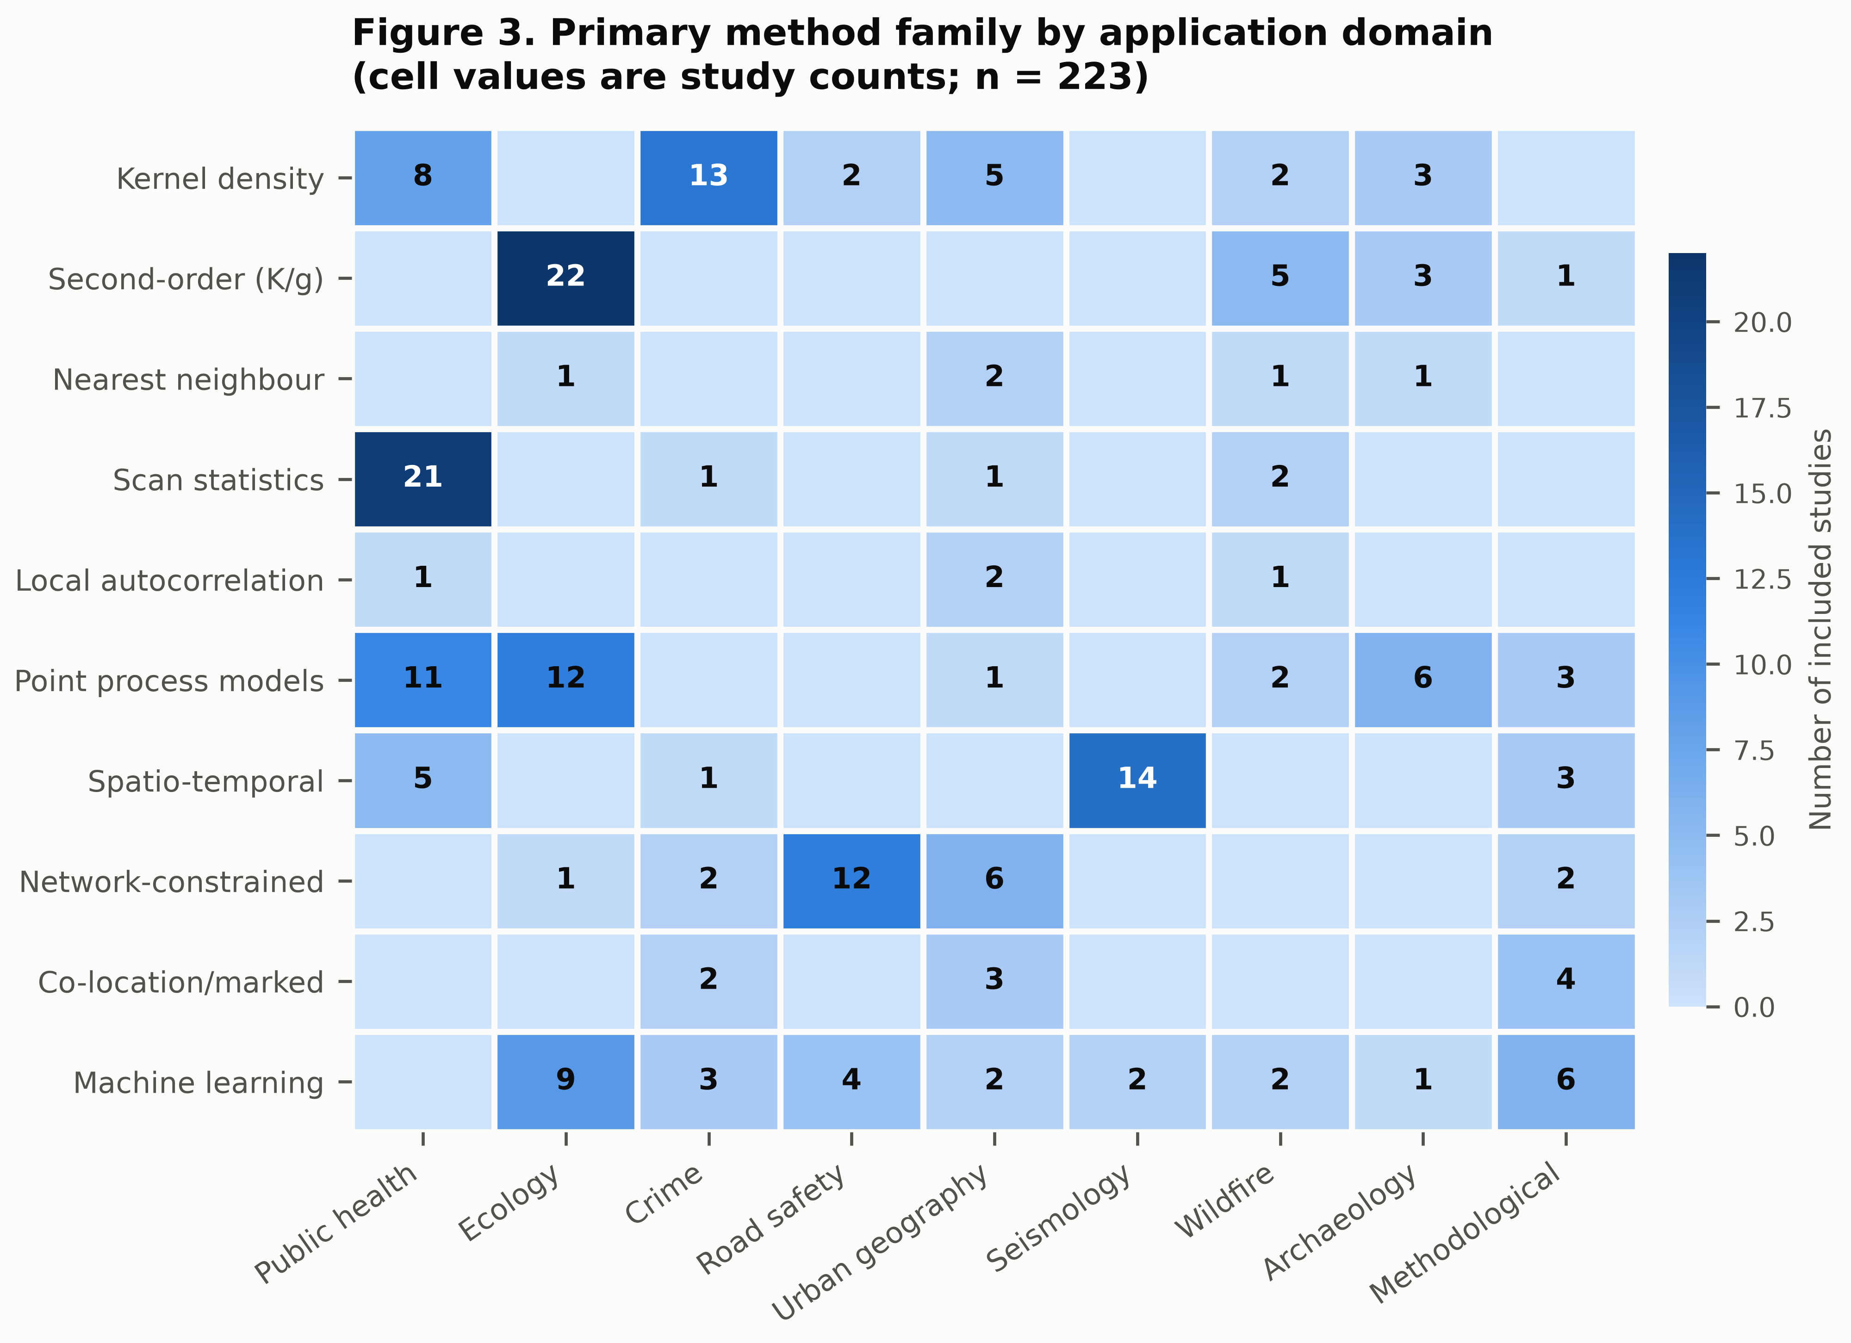
Figure 3. Primary method family by application domain; cell values are study counts (n=223).

Yet the off-diagonal cells are substantial, and they are where the methodological action is. Network-constrained estimation originated in transport and crime analysis (Okabe et al. 2009; Yamada & Thill 2007) but now appears in roadside plant ecology (Spooner et al. 2004) and in retail agglomeration analysis (Morioka et al. 2021; Morioka et al. 2022). Self-exciting processes moved from seismology (Ogata & Zhuang 2006; Schoenberg 2003) into crime forecasting (Zhu et al. 2021) and epidemic modelling (Reinhart 2017). Presence-only species distribution modelling was reformulated as inhomogeneous Poisson point process estimation (Renner et al. 2015; Phillips et al. 2009; Elith et al. 2011; Merow et al. 2016), importing an entire inferential apparatus from spatial statistics into ecology. Co-location statistics developed in economic geography (Leslie & Kronenfeld 2011) have been applied to crime–facility association (Wang et al. 2017) and, via bivariate K functions, to co-localisation in super-resolution microscopy (Liu et al. 2024). In the opposite direction, network-constrained co-location methods have been carried back into urban analytics (Liu et al. 2021).
The co-occurrence structure (Figure 4) shows a densely connected core. The strongest pairings are between point process models and spatio-temporal formulations, between kernel density estimation and second-order statistics, and between machine learning and spatio-temporal processes. Nearest-neighbour indices and local autocorrelation statistics sit peripherally: they are frequently used, but as adjuncts, typically to corroborate a density surface rather than as primary inference.
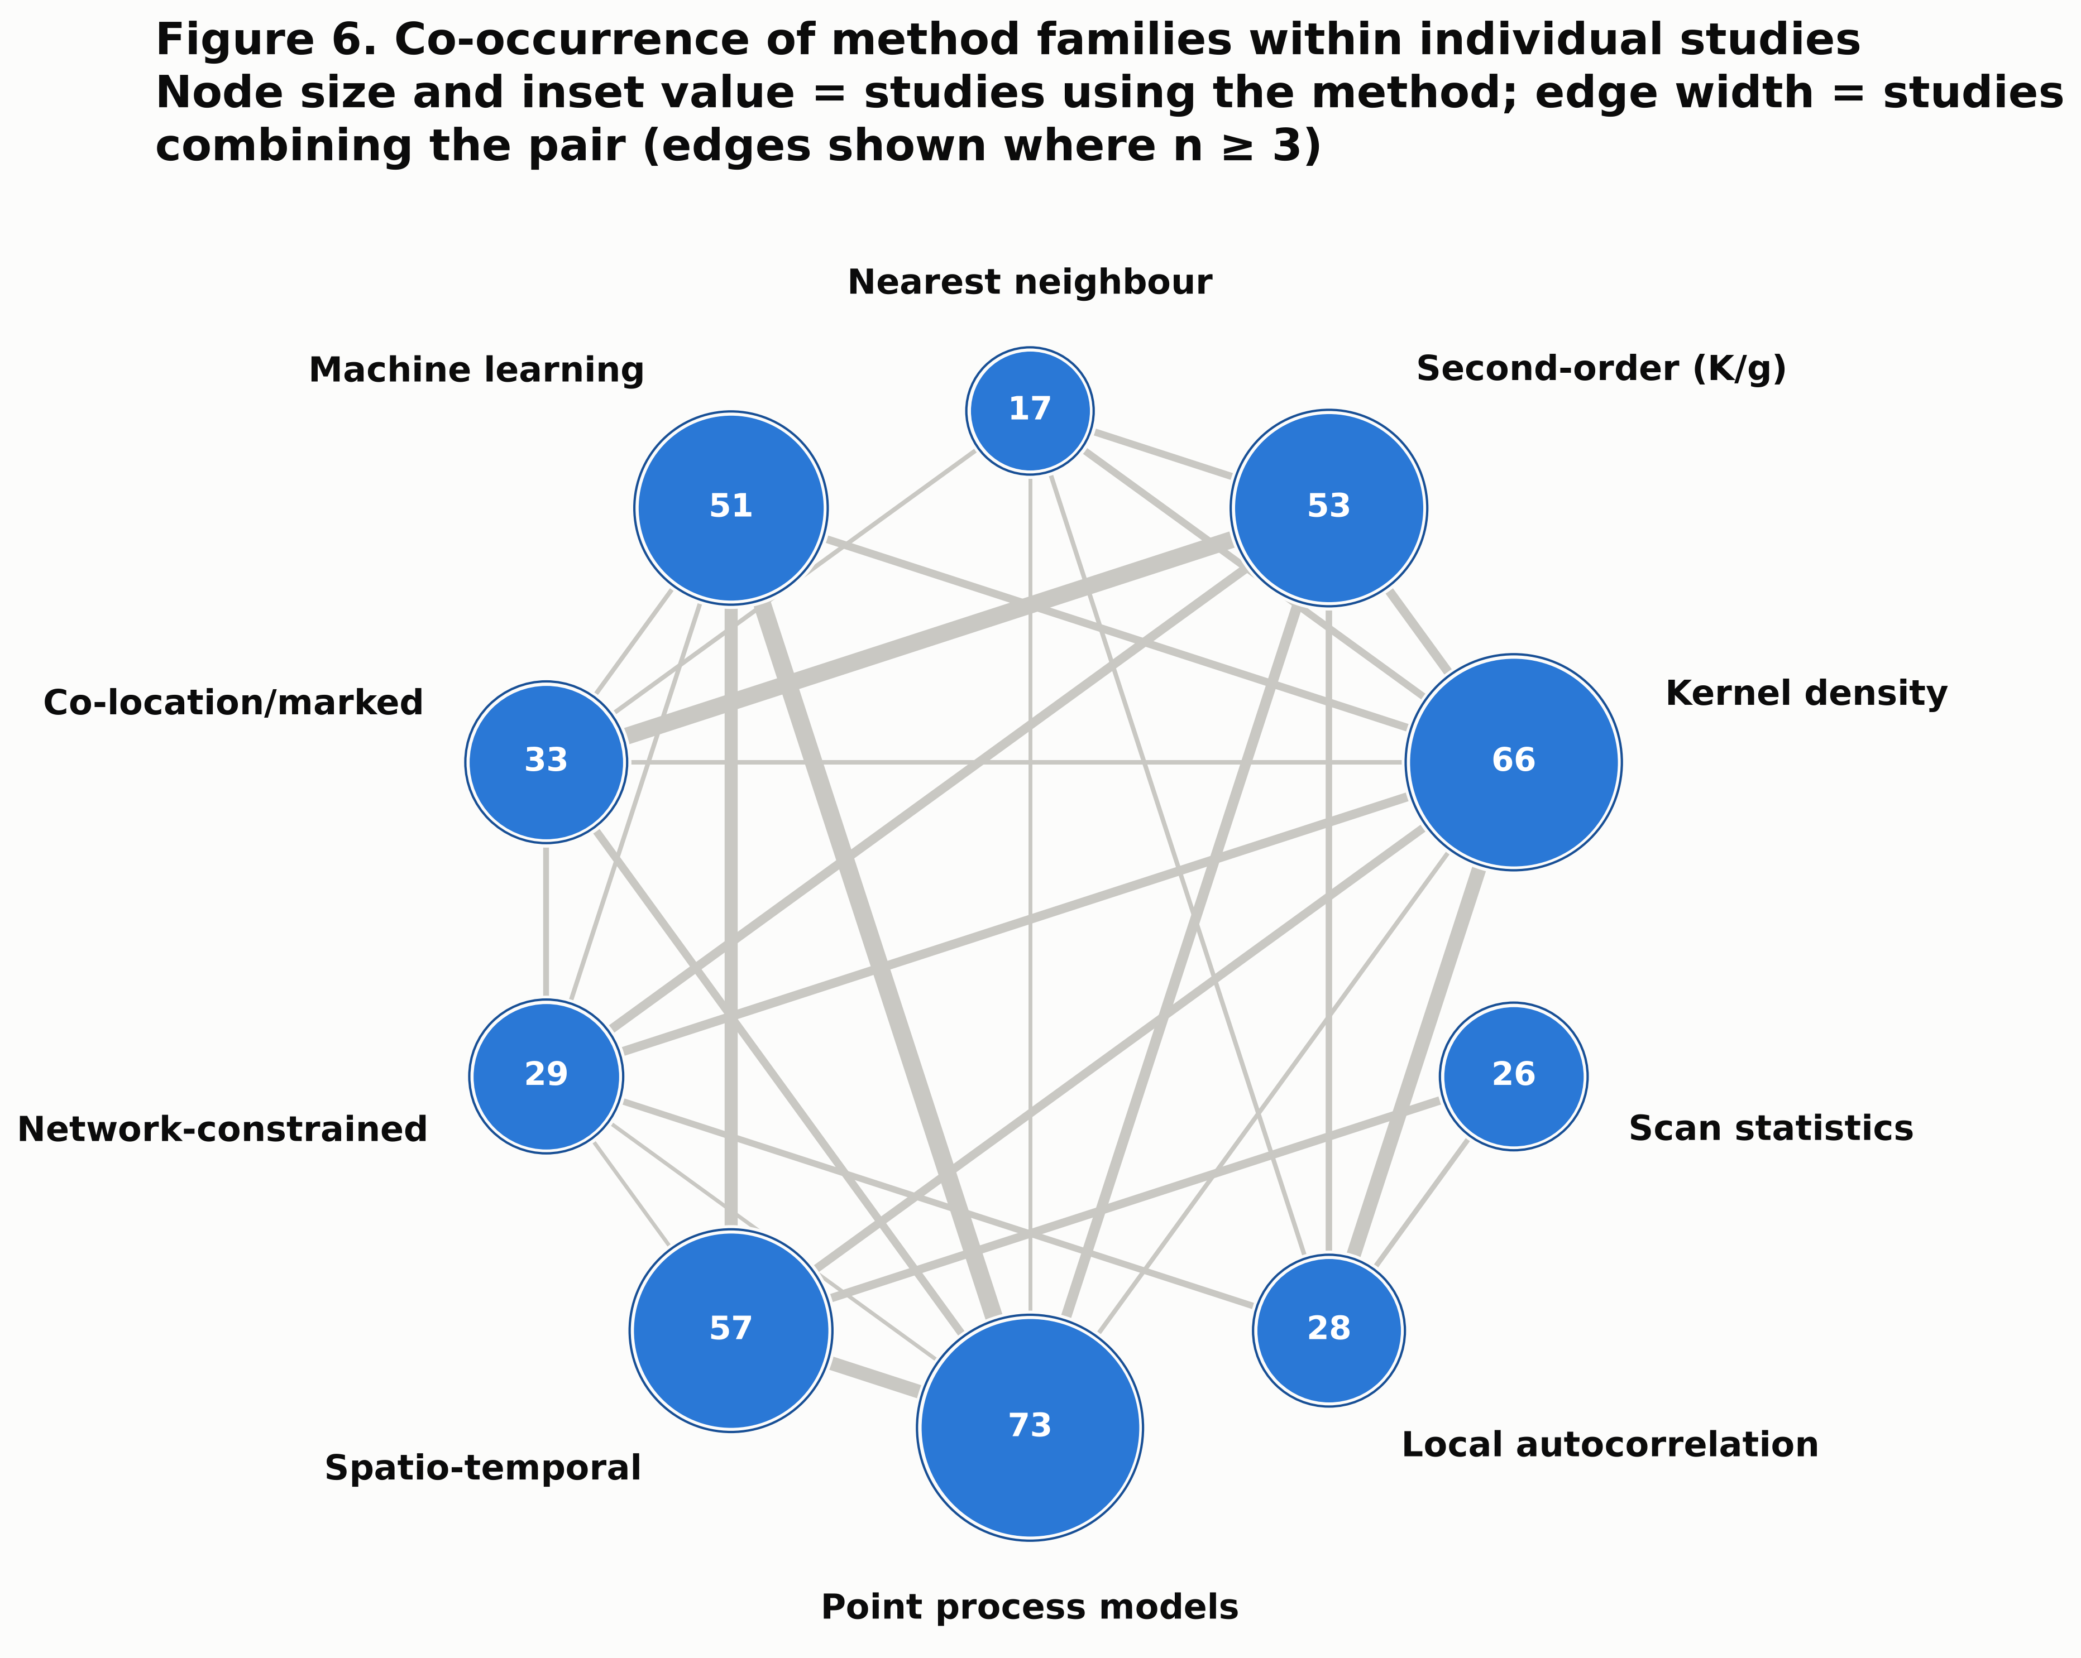
Figure 4. Co-occurrence of method families within individual studies. Node size and inset value give the number of studies applying the family; edge width gives the number of studies combining the pair (edges shown where n≥3).

Q3 — Methodological maturation
Three indicators were tracked across four periods (Figure 5). Methodological breadth rose sharply and then plateaued: 57% of pre-2006 studies combined two or more families, rising to 83% in 2006–2012 and settling at 74–75% thereafter. Uptake of statistical learning is the clearest secular trend: absent before 2006, present in 17% of 2006–2012 studies, 21% in 2013–2019 and 26% from 2020.
The spatio-temporal indicator behaves differently, and instructively. It was high in the small pre-2006 group (43%, n=7 — dominated by seismological and surveillance contributions where time is intrinsic), fell to 24% in 2006–2012 as the field expanded through purely spatial hotspot mapping, and has since recovered to 43%. The dip is an expansion artefact rather than a regression: rapid growth in cross-sectional applied mapping temporarily diluted a temporally explicit core that has since re-established itself.
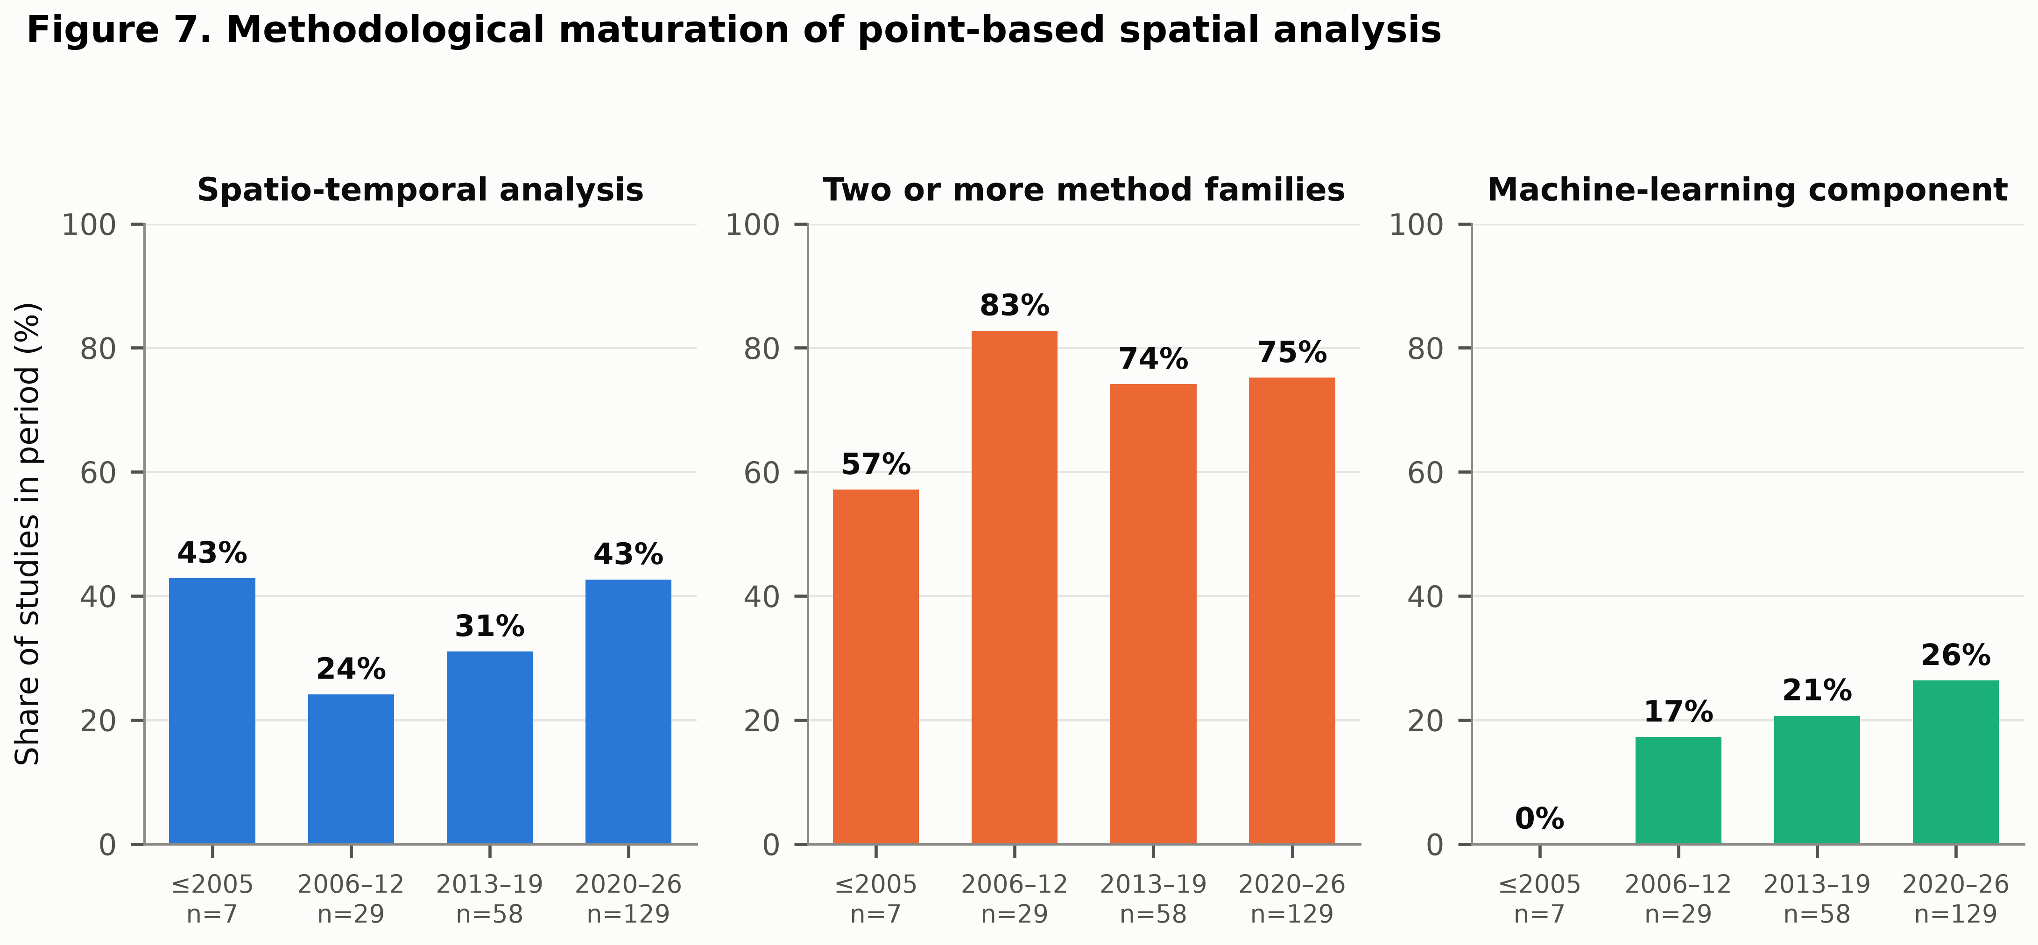
Figure 5. Methodological maturation across four publication periods.

Domain-level trajectories (Figure 6) show that growth is not uniform. Public health accelerates sharply from 2015 and again around 2020, the latter clearly attributable to COVID-19 surveillance (Desjardins et al. 2020). Ecology grows earlier and has plateaued since about 2020. Urban geography and seismology are the steepest recent risers, the former driven by point-of-interest datasets and the latter by neural point process forecasting (Stockman et al. 2023; Zlydenko et al. 2023).
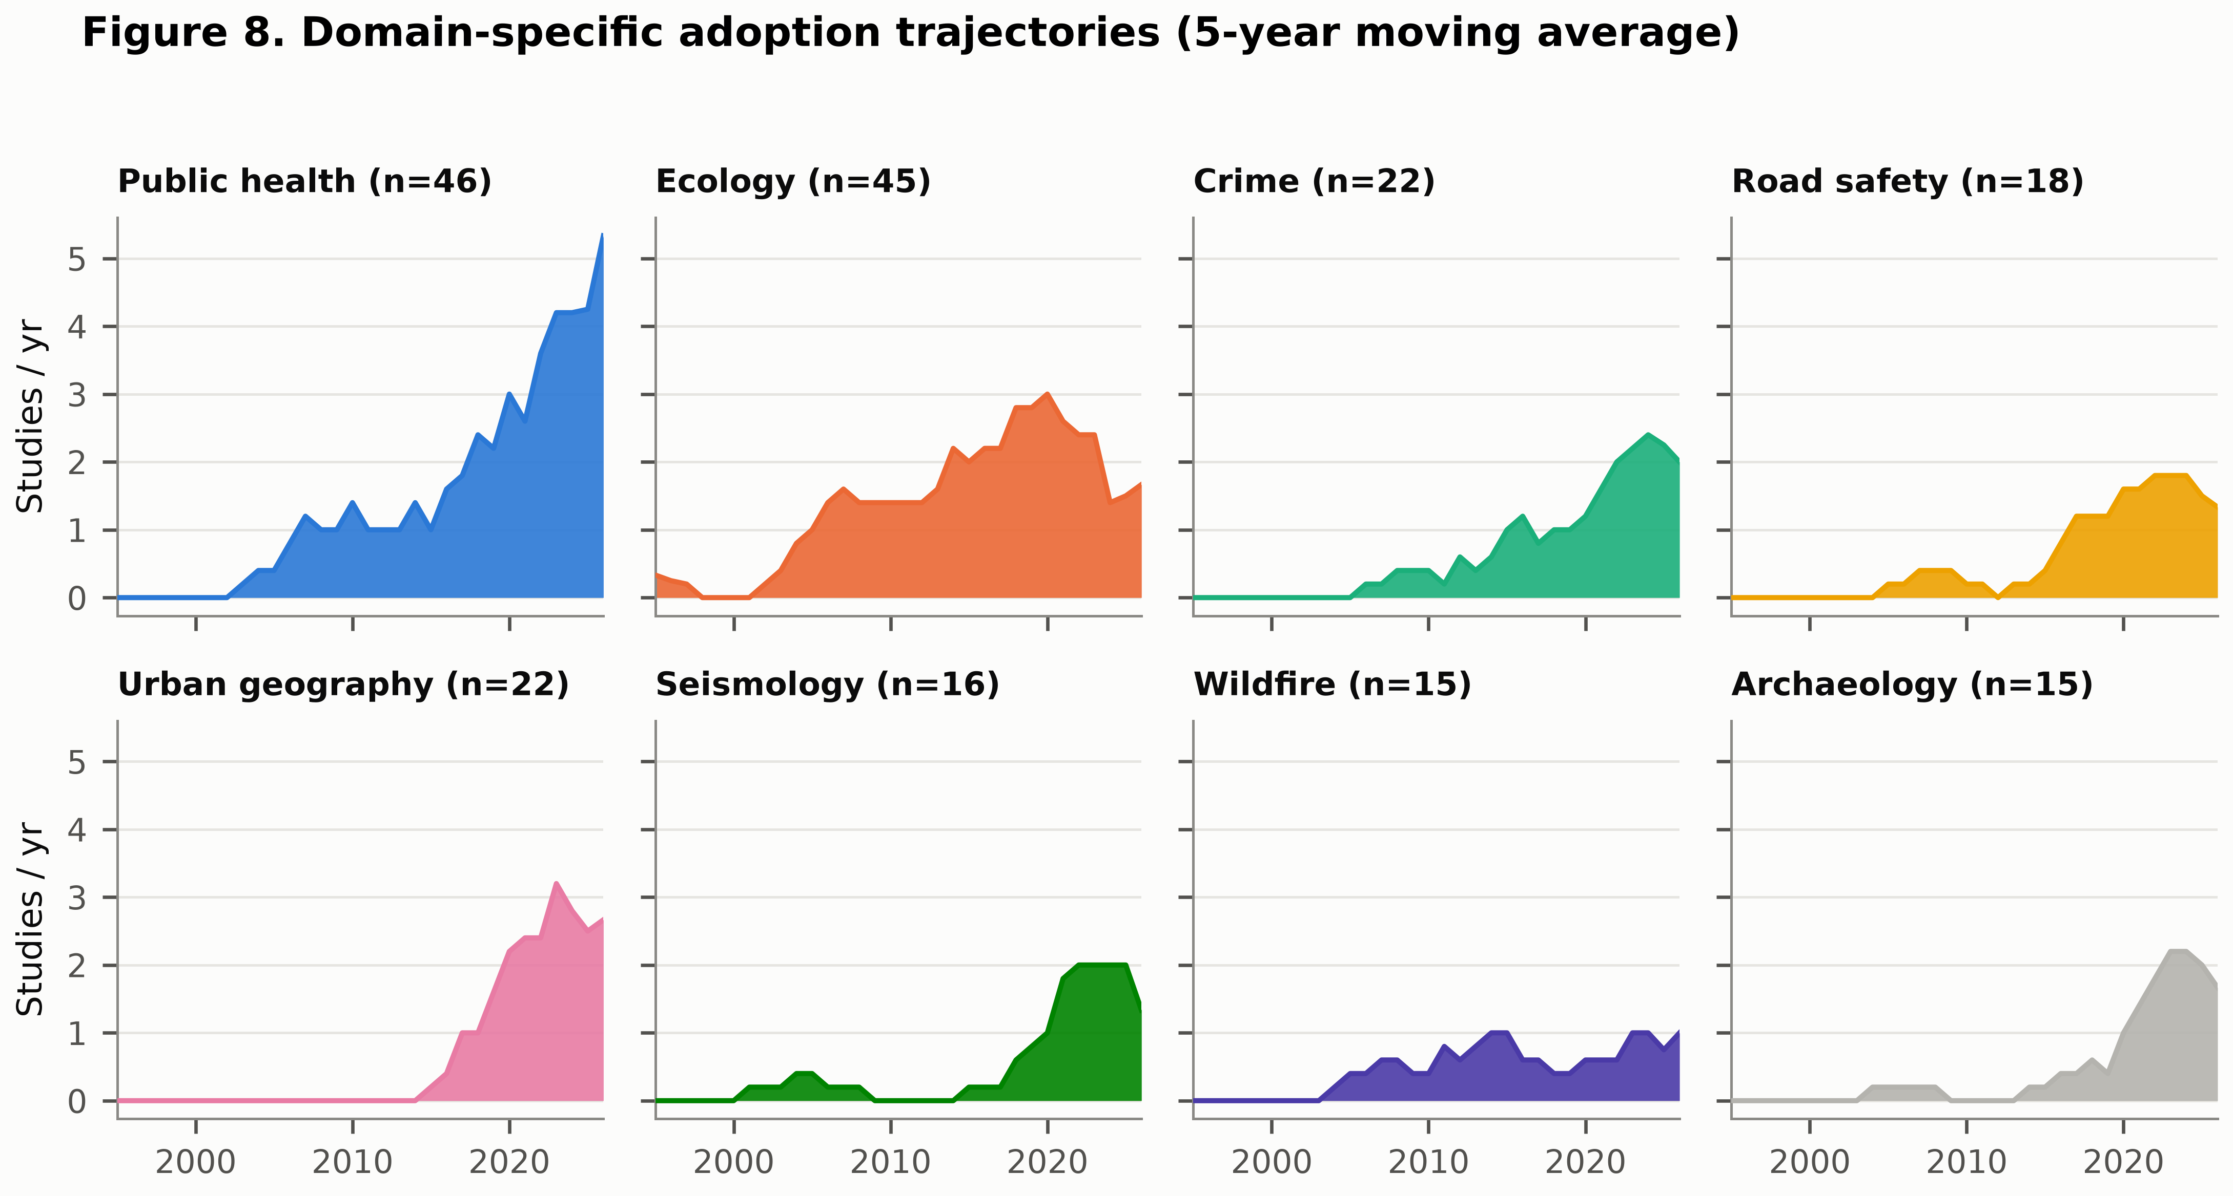
Figure 6. Domain-specific adoption trajectories, five-year moving average.

Q4 — The geography of the evidence base
Of 223 included studies, 163 could be attributed to a single case-study country, covering 49 countries (Figure 7; Table 5). The distribution is highly concentrated. The United States (32 studies), China (26), the United Kingdom (13), Japan (10) and Brazil (7) together account for 88 studies — 54% of all country-attributable work. Thirty countries are represented by a single study.
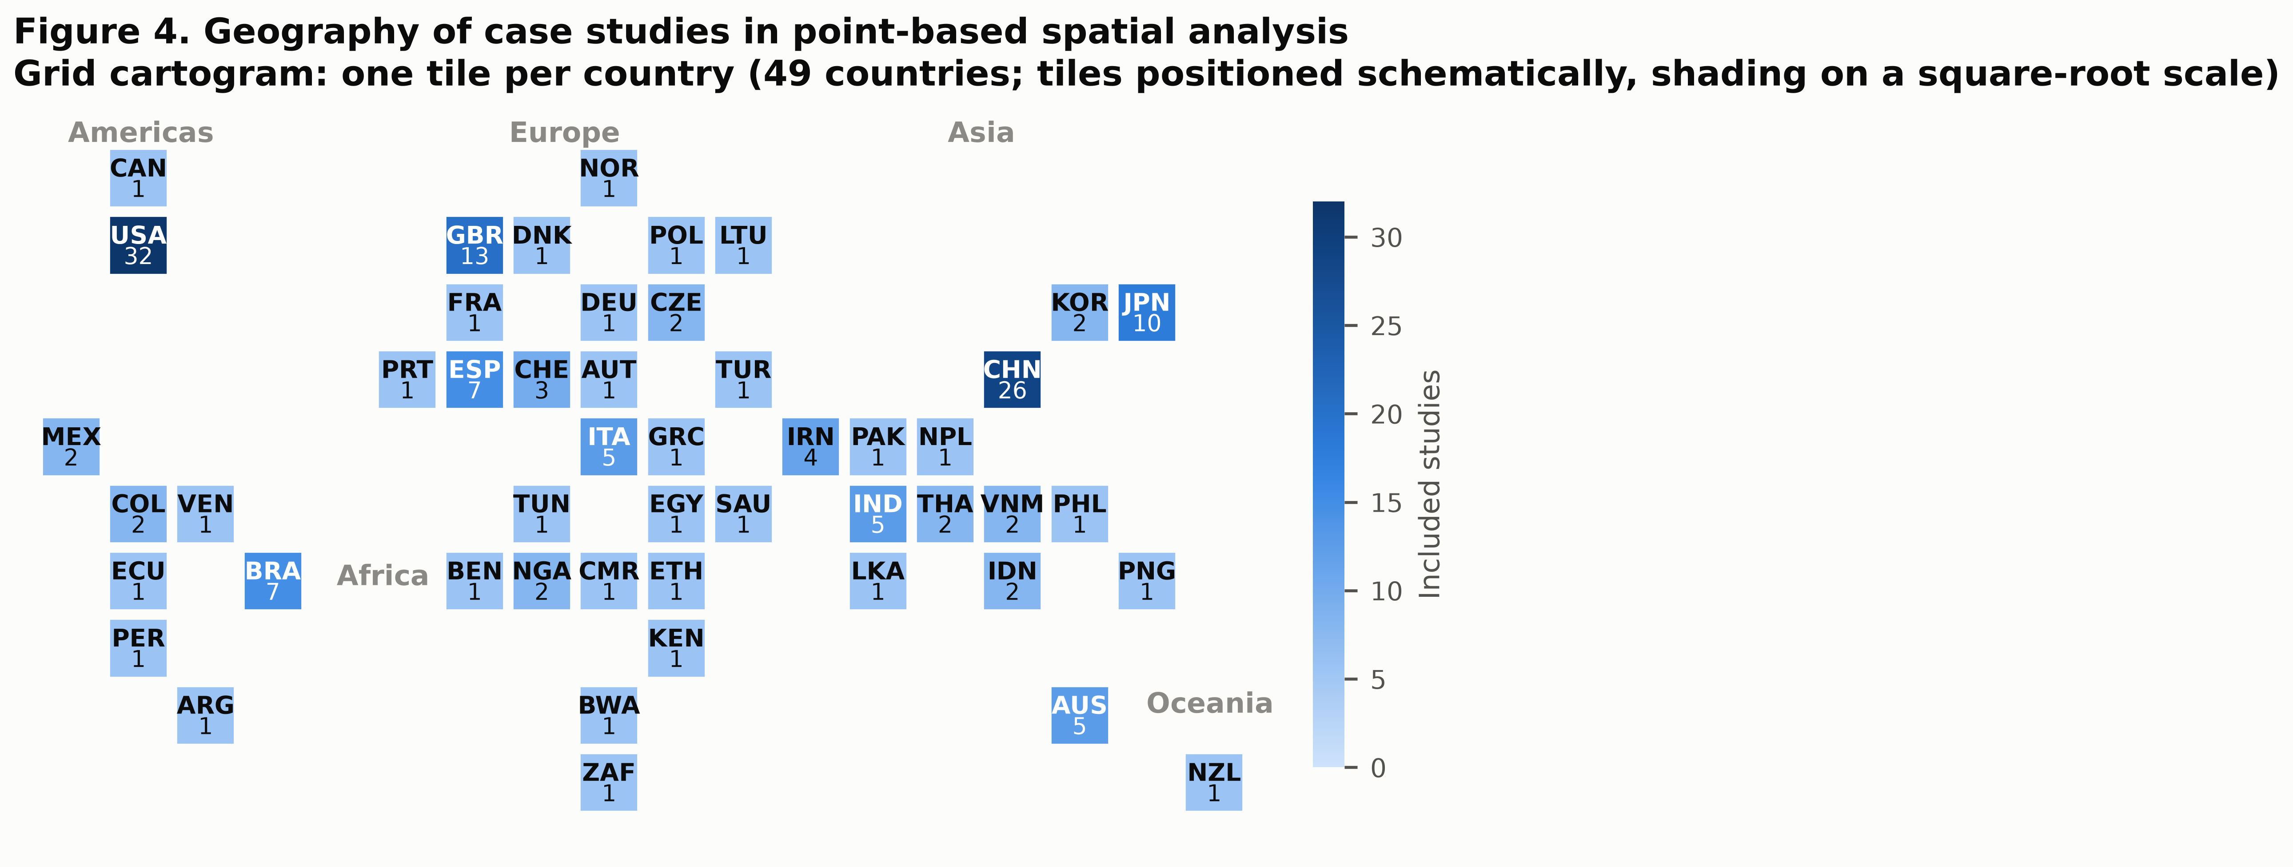
Figure 7. Geography of case studies. Grid cartogram with one tile per country; tiles are positioned schematically rather than by projected coordinates so that every country remains legible. Shading is on a square-root scale.

Regionally, Europe (39), Eastern Asia (38) and Northern America (33) dominate; Sub-Saharan Africa contributes 8 studies and Northern Africa 2, so the African continent supplies 6.1% of country-attributable work (Figure 8a). By income group, 56% of attributable studies are set in high-income countries and 1.2% (n=2) in low-income countries.
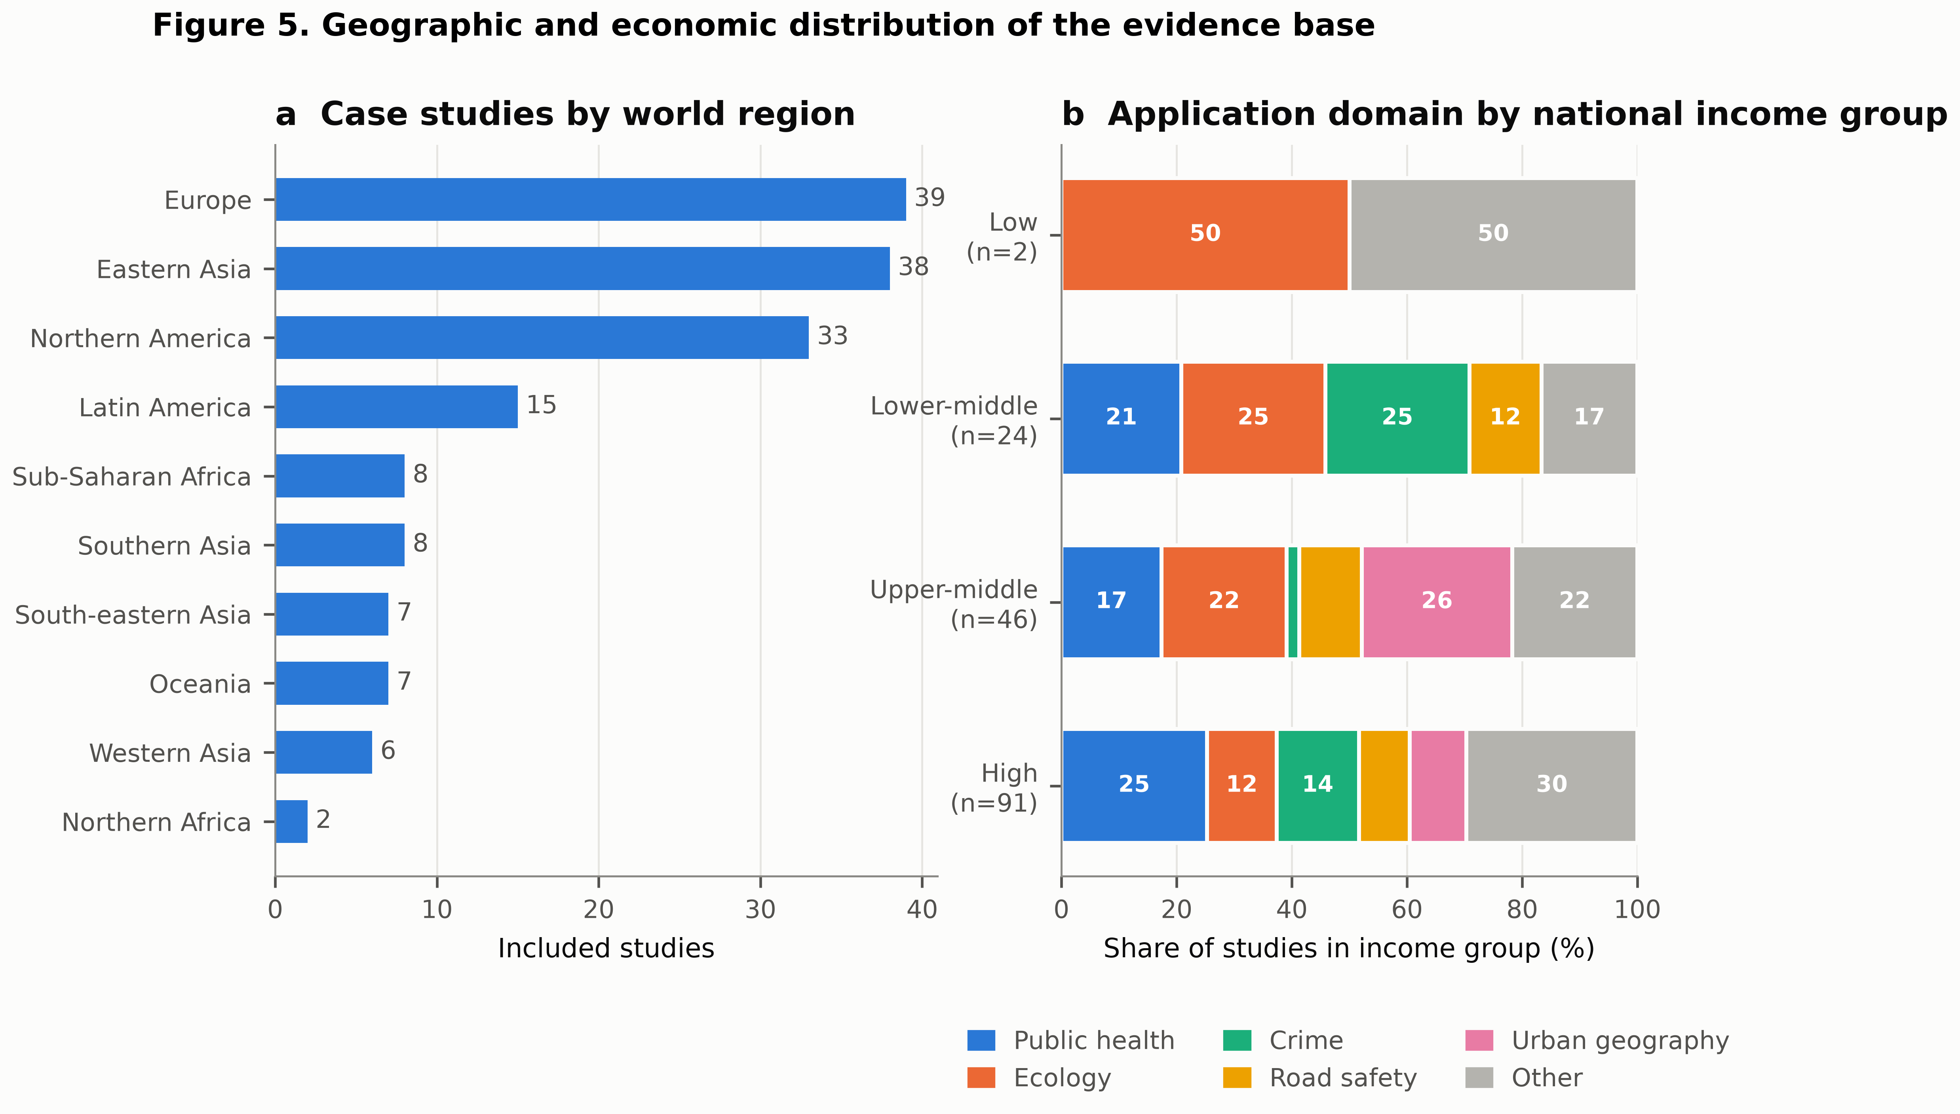
Figure 8. Geographic and economic distribution of the evidence base. (a) Case studies by world region. (b) Application domain composition by national income group.

The composition of research also shifts with income (Figure 8b). In high-income settings the portfolio is broad, with ecology, public health, crime and urban applications all substantially represented. In lower-middle and low-income settings the portfolio narrows towards public health and, to a lesser extent, road safety — a pattern consistent with donor-funded disease surveillance driving the available georeferenced data (Coleman et al. 2009; Gachohi et al. 2022; Tewara et al. 2018; Cuadros et al. 2018). Point-based methods are being applied in these settings, and often creatively under severe data constraints (Babagana-Kyari et al. 2025; Mfundisi et al. 2019; Mejri et al. 2026; Afolayan et al. 2022), but across a markedly narrower range of questions.

Discussion

Four trajectories, one shift
Read together, the results describe four trajectories that are facets of a single movement: point-based spatial analysis is becoming a model-based, domain-constrained, computationally learned enterprise.
From description to inference. The displacement of kernel density estimation by point process models as the modal framework is the field's central methodological event. It changes the object of study from a smoothed surface to a parameterised intensity with quantified uncertainty, and it makes covariate effects, residual diagnostics and model comparison available (Diggle et al. 2013; Renner et al. 2015; Merow et al. 2016).
From planar to constrained domains. Thirteen per cent of studies already work on linear networks, and the methodological literature is unambiguous that applying planar statistics to network-constrained events is not a minor approximation but a source of qualitatively wrong conclusions (Okabe et al. 2009; Baddeley et al. 2020; Rakshit et al. 2017). The choice of distance metric on the network is itself consequential (Rakshit et al. 2017).
From statistics to learning. Neural point processes now provide flexible conditional intensities that outperform parametric baselines in forecasting settings (Chen et al. 2020; Zhou et al. 2021; Stockman et al. 2023; Zlydenko et al. 2023). The most interesting contributions are hybrids that retain an interpretable kernel while learning its shape (Cheng et al. 2025; Muir & Ross 2023; Mateu & Jalilian 2022), rather than replacements of the statistical framework outright.
From single methods to combined workflows. Three-quarters of studies combine families, and the standard modern workflow — estimate intensity, test against an inhomogeneous null, fit a parametric or learned model, validate on held-out data — is now visible across domains that do not cite each other.

What the trajectories leave unresolved
Three problems recur across the corpus and are not being resolved by the methodological shift.
Bandwidth and scale remain under-reported and consequential. The sensitivity of kernel estimates to bandwidth has been demonstrated repeatedly (Chainey 2014; Hart & Zandbergen 2014; Amatulli et al. 2007), and shown to change substantive conclusions: data-driven bandwidths spanning 46–48{,}450 ft produced intervention effects that were detectable only within a narrow band, with larger bandwidths reversing the apparent sign of an effect (Zewdie et al. 2025). Bandwidth selection is a substantive modelling decision and should be reported and justified as one.
Positional uncertainty is systematically ignored. Geocoding error, address aggregation and confidentiality-driven displacement all perturb the input to every method reviewed here. Where this has been studied, effects are material: preprocessing strategy interacts with spatial support and degrades hotspot prediction markedly once a substantial fraction of records is displaced (Wang et al. 2026), and network-constrained models that ignore location uncertainty misattribute accident intensity to intersections (Briz-Redon 2023). Very few applied studies propagate this uncertainty.
Null models are frequently mis-specified. Testing against complete spatial randomness in an environment that is manifestly inhomogeneous guarantees rejection and tells the analyst nothing (Law et al. 2009; Wiegand et al. 2007; Velazquez et al. 2016). The same logic drives the sampling-bias literature in presence-only modelling, where the background sample defines the null and materially determines conclusions (Phillips et al. 2009; Fourcade et al. 2014; Yackulic et al. 2013; El-Gabbas & Dormann 2018). Scan statistics carry an analogous hazard: the most likely cluster is systematically inflated by absorbing neighbouring low-risk regions unless the likelihood is restricted (Tango 2021; Tango & Takahashi 2012), and reported cluster size depends on user-selected reporting rules (Han et al. 2016).

The geography gap
The concentration of case studies is severe enough to qualify the field's empirical claims. Fifty-four per cent of country-attributable work comes from five countries, and two studies in this corpus are set in low-income countries. Because point-based analysis requires georeferenced individual event data, the distribution of studies largely tracks the distribution of address-level administrative data infrastructure, not the distribution of the processes being studied. Wildfire, road-traffic injury and vector-borne disease — three of the domains best served by these methods — have burdens concentrated precisely where the evidence is thinnest.
The consequence is not only inequitable but technical. Methods are being tuned, and defaults established, on dense, well-geocoded, high-income datasets. Whether bandwidth heuristics, edge corrections and background sampling schemes transfer to sparse, coarsely geocoded, participatory or satellite-derived point data is largely untested. The studies here that work under exactly those constraints — household-survey CKDu mapping in Nigeria (Babagana-Kyari et al. 2025), anthrax hotspot delineation in Kenya (Gachohi et al. 2022), clinic-based HIV prevalence mapping in South Africa and Tanzania (Cuadros et al. 2018), satellite-derived fire clustering in Tunisia (Mejri et al. 2026) — are the ones best placed to answer that question, and are correspondingly valuable.

Reproducibility and software
A distinct strand of the corpus consists of software and reproducibility contributions: spatstat and the R ecosystem (Baddeley et al. 2015; Baddeley et al. 2026; Gonzalez & Moraga 2023), scan statistic implementations (Otani & Takahashi 2021), and Bayesian point process packages (Watson 2024; Palmi-Perales et al. 2025; Naylor et al. 2023). Their prominence is consistent with the observation that methodological diffusion in this field tracks software availability more closely than it tracks publication: kernel density estimation and circular scan statistics spread rapidly because they shipped in accessible tools, whereas network-constrained and inhomogeneous methods diffused more slowly despite being better specified for common data. Investment in usable implementations is therefore a methodological intervention, not a service activity.

Limitations
Four limitations bear on interpretation.
First, and most importantly, retrieval was not exhaustive. Searches were run against a federated index rather than native Scopus or Web of Science exports, queries were natural-language rather than Boolean, and no citation chaining or hand-searching was performed. The corpus should therefore be read as a large, systematically assembled and fully documented sample of the literature, not as its complete enumeration. Because retrieval is relevance-ranked, highly cited and recent work is likely over-represented relative to older or lower-profile studies; the sharp post-2015 growth reported here is real but its magnitude is probably overstated.
Second, screening and coding were performed by a single reviewer without duplicate independent assessment, so inter-rater reliability could not be estimated. The point-based/areal boundary in particular required judgement. All decisions and reasons are published per record (Supplementary Table S2) so that they can be audited and revised.
Third, coding relied on titles and abstracts rather than full texts. Abstracts under-report methodological detail, so secondary methods, software and parameter choices are certainly undercounted; the “all families” counts are lower bounds. Fields not reliably present in abstracts — software, bandwidth, edge correction, sample size — were not extracted, which is why no quantitative methodological-quality appraisal is reported.
Fourth, the review was not prospectively registered, and bibliographic records lack volume, issue, page and DOI fields, which the retrieval index does not expose.

A research agenda
Five priorities follow directly from the findings.
- Report the decisions that determine the answer. Bandwidth and
its selection rule, edge correction, the null model, and the
background or population-at-risk specification should be reported as
standard, as effect-size and confidence-interval reporting is
elsewhere.
- Propagate positional uncertainty. Geocoding error and
privacy-driven displacement should be modelled, not assumed away
(Wang et al. 2026; Briz-Redon 2023).
- Default to the constrained domain where events are
constrained. For crashes, street crime and roadside ecology, network
formulations should be the default and planar analysis the choice
requiring justification (Baddeley et al. 2020; Rakshit et al. 2017).
- Build interpretable hybrids. The productive frontier couples
neural flexibility with retained, inspectable kernel structure
(Cheng et al. 2025; Mateu & Jalilian 2022), and should be evaluated on calibration
and transferability, not only on predictive scores.
- Invest deliberately in under-represented geographies. This
means data infrastructure and method validation under sparse and
noisy geocoding, not only additional case studies.

Conclusions
Across 223 studies and five decades, point-based spatial analysis has moved from a descriptive toolkit applied to mapped plots into a model-based inferential framework applied to administrative, sensor and survey data at scale. Four trajectories — description to inference, planar to constrained, statistics to learning, single method to combined workflow — are visible simultaneously in domains that largely do not cite one another, which is strong evidence of genuine convergence on a shared methodological core rather than parallel invention.
That convergence is incomplete in two specific ways. Methodologically, the decisions that most affect conclusions — bandwidth, edge correction, null model, positional uncertainty — remain the least consistently reported. Empirically, the evidence base is drawn overwhelmingly from a handful of high-income, data-rich countries, so the field's defaults have been calibrated on conditions that do not hold where many of the relevant processes are most consequential. Closing those two gaps, rather than adding further estimators, is where the next decade of value lies.

Data and code availability
The complete extraction dataset (223 included studies with all coded fields), the full decision log including excluded records with reasons, the PRISMA counts, and all analysis and figure-generation code are distributed with this manuscript in the accompanying repository.

Declaration of competing interest
The author declares no competing interests.

Funding
This research received no specific grant from any funding agency.

Declaration of generative AI use
Bibliographic retrieval, record coding, quantitative synthesis and figure generation were carried out with computational assistance. All eligibility decisions and their reasons are published per record for independent audit.

Table 1. Search strategy: query identifiers, natural-language query strings issued to the federated bibliographic index, and record yield at each stage.
ID | Query string | Retrieved | Included | Yield (%)
S01 | point pattern analysis spatial point process methods review | 20 | 14 | 70
S02 | kernel density estimation hotspot mapping crime incidents | 20 | 20 | 100
S03 | spatial scan statistic disease cluster detection SaTScan | 20 | 20 | 100
S04 | Ripley's K function spatial pattern forest tree species distribution | 20 | 20 | 100
S05 | spatio-temporal point process earthquake ETAS self-exciting model | 20 | 19 | 95
S06 | network constrained point pattern analysis road traffic accidents street network | 20 | 15 | 75
S07 | log-Gaussian Cox process spatial epidemiology disease risk mapping | 20 | 17 | 85
S08 | point of interest POI spatial clustering urban vitality retail location | 20 | 12 | 60
S09 | wildfire ignition point pattern analysis spatial clustering | 20 | 15 | 75
S10 | archaeological site distribution spatial point pattern analysis settlement | 20 | 15 | 75
S11 | co-location quotient bivariate marked point pattern cross-K function | 19 | 14 | 74
S12 | deep learning neural spatio-temporal point process event prediction | 19 | 11 | 58
S13 | presence-only species distribution model point process MaxEnt sampling bias | 20 | 19 | 95
S14 | kernel density hotspot analysis health facility disease mapping Africa sub-Saharan GIS | 20 | 12 | 60
Total |  | 278 | 223 | 80
Note: Searches were executed on 28 July 2026 against a federated index spanning Semantic Scholar, PubMed, Scopus and arXiv. Yield is the proportion of records retrieved by a query that met all eligibility criteria; records retrieved by more than one query are attributed to the first query that returned them.

Table 2. Eligibility criteria applied at record screening.
Dimension | Inclusion criterion | Exclusion criterion
Population | Studies analysing georeferenced event locations (points) in any application field | Studies analysing only areal/lattice aggregates, raster surfaces or extended (line, polygon) objects
Concept | Application or development of at least one point-based spatial statistic or point process model | Purely temporal point processes; accessibility, travel-time or suitability models with no point pattern statistic
Context | Any geography, spatial scale and time period | None
Publication type | Peer-reviewed journal article, conference paper, or preprint with a full abstract | Books, monographs, theses, book reviews, correction notices and conference abstracts without full text
Language | English-language abstract available | None
Reporting | Sufficient information in the record to code method family, application domain and study area | Records with no indexed abstract or with corrupted metadata

Table 3. Taxonomy of point-based method families, with usage, recency and citation profile across the 223 included studies.
Method family | Scope | Primary n | Any use n | % of studies | Median year | Median cites | % ST
Parametric point process models | Inhomogeneous Poisson, Cox and log-Gaussian Cox, cluster and Gibbs processes; presence-only intensity models | 36 | 73 | 32.7 | 2020 | 24 | 27
Kernel density estimation | Smooths event locations into a continuous intensity surface; planar, adaptive and space–time variants | 33 | 66 | 29.6 | 2022 | 15 | 41
Spatio-temporal point processes | Separable and non-separable space–time intensity models; self-exciting Hawkes and ETAS formulations | 23 | 57 | 25.6 | 2022 | 14 | 98
Second-order distance statistics | Ripley's K, L, pair correlation g, and the empty-space F, nearest-neighbour G and J functions | 31 | 53 | 23.8 | 2018 | 18 | 17
Machine-learning point models | Neural point processes, density-based clustering, maximum-entropy and ensemble intensity learners | 30 | 51 | 22.9 | 2022 | 26 | 41
Co-location and marked patterns | Cross-K, co-location quotient, mark correlation and multitype/bivariate summary functions | 10 | 33 | 14.8 | 2019 | 18 | 15
Network-constrained analysis | Density and second-order statistics computed with shortest-path or other network metrics on linear networks | 23 | 29 | 13.0 | 2021 | 25 | 31
Local association on points | Getis–Ord G_i* and local Moran's I applied to event locations or point-derived densities | 4 | 28 | 12.6 | 2021 | 20 | 25
Scan statistics | Kulldorff circular, elliptic and flexibly shaped spatial and space–time scan statistics | 25 | 26 | 11.7 | 2020 | 40 | 46
Nearest-neighbour indices | Average nearest-neighbour ratio, Clark–Evans index and dispersion indices | 6 | 17 | 7.6 | 2021 | 11 | 24
Other approaches | Spectral, tessellation-based, fractal and graph-analytic descriptions of point configurations | 2 | 10 | 4.5 | 2021 | 8 | 20
Note: “Primary” counts studies whose dominant analytical approach falls in the family; “any use” counts every study applying the family, so column totals exceed 223. % ST is the share of studies in that family with an explicit temporal dimension.

Table 4. Cross-tabulation of primary method family by application domain (study counts).
Method family | Health | Ecol. | Crime | Urban | Meth. | Road | Seism. | Fire | Arch. | Micro. | Env. | Other | Total
Kernel density estimation | 8 | 0 | 13 | 5 | 0 | 2 | 0 | 2 | 3 | 0 | 0 | 0 | 33
Second-order distance statistics | 0 | 22 | 0 | 0 | 1 | 0 | 0 | 5 | 3 | 0 | 0 | 0 | 31
Nearest-neighbour indices | 0 | 1 | 0 | 2 | 0 | 0 | 0 | 1 | 1 | 1 | 0 | 0 | 6
Scan statistics | 21 | 0 | 1 | 1 | 0 | 0 | 0 | 2 | 0 | 0 | 0 | 0 | 25
Local association on points | 1 | 0 | 0 | 2 | 0 | 0 | 0 | 1 | 0 | 0 | 0 | 0 | 4
Parametric point process models | 11 | 12 | 0 | 1 | 3 | 0 | 0 | 2 | 6 | 0 | 1 | 0 | 36
Spatio-temporal point processes | 5 | 0 | 1 | 0 | 3 | 0 | 14 | 0 | 0 | 0 | 0 | 0 | 23
Network-constrained analysis | 0 | 1 | 2 | 6 | 2 | 12 | 0 | 0 | 0 | 0 | 0 | 0 | 23
Co-location and marked patterns | 0 | 0 | 2 | 3 | 4 | 0 | 0 | 0 | 0 | 1 | 0 | 0 | 10
Machine-learning point models | 0 | 9 | 3 | 2 | 6 | 4 | 2 | 2 | 1 | 0 | 0 | 1 | 30
Other approaches | 0 | 0 | 0 | 0 | 1 | 0 | 0 | 0 | 1 | 0 | 0 | 0 | 2
Total | 46 | 45 | 22 | 22 | 20 | 18 | 16 | 15 | 15 | 2 | 1 | 1 | 223

Table 5. Twenty most frequently studied countries, with world region, income group and leading application domain.
Country | Studies | Region | Income group | Median year | Leading domain
United States | 32 | Northern America | High | 2018 | Public health and epidemiology
China | 26 | Eastern Asia | Upper-middle | 2022 | Urban and economic geography
United Kingdom | 13 | Europe | High | 2022 | Public health and epidemiology
Japan | 10 | Eastern Asia | High | 2020 | Urban and economic geography
Brazil | 7 | Latin America | Upper-middle | 2019 | Ecology, forestry and biodiversity
Spain | 7 | Europe | High | 2019 | Road safety and transport
Australia | 5 | Oceania | High | 2011 | Ecology, forestry and biodiversity
India | 5 | Southern Asia | Lower-middle | 2023 | Crime and policing
Italy | 5 | Europe | High | 2020 | Seismology
Iran | 4 | Western Asia | Lower-middle | 2021 | Ecology, forestry and biodiversity
Switzerland | 3 | Europe | High | 2018 | Public health and epidemiology
Czech Republic | 2 | Europe | High | 2013 | Public health and epidemiology
Colombia | 2 | Latin America | Upper-middle | 2024 | Road safety and transport
Thailand | 2 | South-eastern Asia | Upper-middle | 2025 | Public health and epidemiology
South Korea | 2 | Eastern Asia | High | 2018 | Public health and epidemiology
Vietnam | 2 | South-eastern Asia | Lower-middle | 2019 | Road safety and transport
Indonesia | 2 | South-eastern Asia | Lower-middle | 2020 | Seismology
Nigeria | 2 | Sub-Saharan Africa | Lower-middle | 2023 | Public health and epidemiology
Mexico | 2 | Latin America | Upper-middle | 2022 | Ecology, forestry and biodiversity
Ethiopia | 1 | Sub-Saharan Africa | Low | 2022 | Archaeology and heritage
Note: 49 distinct countries appear across 163 of the 223 included studies; the remainder are methodological contributions, simulation studies or multi-country analyses with no single case-study country.

Table 6. Characteristics of the 223 included studies.
Characteristic | n (%)
Total included studies | 223 (100.0)
{Publication period}
1977–2005 | 7 (3.1)
2006–2012 | 29 (13.0)
2013–2019 | 58 (26.0)
2020–2026 | 129 (57.8)
{Document type}
Article | 190 (85.2)
Review | 16 (7.2)
Conference | 8 (3.6)
Preprint | 9 (4.0)
{Temporal dimension}
Purely spatial | 140 (62.8)
Spatio-temporal | 83 (37.2)
{Methodological breadth}
Single method family | 55 (24.7)
Two method families | 125 (56.1)
Three or more | 43 (19.3)
{Geographic attribution}
Single case-study country | 163 (73.1)
Multi-country | 23 (10.3)
Not attributable / simulation | 37 (16.6)
{National income group (attributable studies)}
High income | 91 (55.8)
Upper-middle income | 46 (28.2)
Lower-middle income | 24 (14.7)
Low income | 2 (1.2)
{Citation impact}
Median citations (IQR) | 18 (3–70)
Note: Percentages within the income-group block are computed over the subset of studies attributable to a single country.

References
Aboushady A, et al. (2025). The use of SaTScan software to map spatiotemporal trends and detect disease clusters: a systematic review. Communications Medicine. https://consensus.app/papers/details/c14b5498b9b45a1292b81b996685a424/
Afolayan A, et al. (2022). GIS-Based Spatial Analysis of Accident Hotspots: A Nigerian Case Study. Infrastructures. https://consensus.app/papers/details/6c32eddac4185773b3c1b50732e1070c/
Amatulli G, Perez-Cabello F, de la Riva J (2007). Mapping lightning/human-caused wildfires occurrence under ignition point location uncertainty. Ecological Modelling. https://consensus.app/papers/details/cf3d8343919b5ca3b84bac55eb3c4e94/
Babagana-Kyari M, et al. (2025). Mapping the Spatial Prevalence of Disease Using a Community-Centric Approach with Hexagonal Grid Tessellation: A Case of CKDu Incidences in Northern Yobe State, Nigeria. GET Journal of Biosecurity and One Health. https://consensus.app/papers/details/c2643ad6198c57f99ac7a5abe190d5b0/
Baddeley A, Rubak E, Turner R (2015). Spatial Point Patterns: Methodology and Applications with R. CRC Press. https://consensus.app/papers/details/96b253f607975e998468c8fc0f609ce3/
Baddeley A, Nair G, Rakshit S, McSwiggan G, Davies TM (2020). Analysing point patterns on networks - A review. Spatial Statistics. https://consensus.app/papers/details/baf74bb0373d5cffb173cab7cc4108df/
Baddeley A, Rubak E, Turner R (2026). The Impact of R on Statistical Science for Spatial Point Processes. Australian \& New Zealand Journal of Statistics. https://consensus.app/papers/details/5deeea53d9635661bd7aef7be5fb5b83/
Ben-Said M (2021). Spatial point-pattern analysis as a powerful tool in identifying pattern-process relationships in plant ecology: an updated review. Ecological Processes. https://consensus.app/papers/details/12b3ea59c8225761954746893054ee6e/
Bernabeu A, Zhuang J, Mateu J (2024). Spatio-Temporal Hawkes Point Processes: A Review. Journal of Agricultural, Biological and Environmental Statistics. https://consensus.app/papers/details/27e6d524438c5aee82c9a0a5b80dbfb6/
Briz-Redon A (2023). Dealing with location uncertainty for modeling network-constrained lattice data. Spatial Statistics. https://consensus.app/papers/details/56e92cf8149252ea83c4721616c5f1f9/
Chainey S, Tompson L, Uhlig S (2008). The Utility of Hotspot Mapping for Predicting Spatial Patterns of Crime. Security Journal. https://consensus.app/papers/details/75c159c3ce6b51e194da3b3d785c0230/
Chainey S (2014). Examining the influence of cell size and bandwidth size on kernel density estimation crime hotspot maps for predicting spatial patterns of crime. Bulletin of the Geographical Society of Liege. https://consensus.app/papers/details/da7bddee9ce4582c874c67ff0ace8a66/
Chen RTQ, Amos B, Nickel M (2020). Neural Spatio-Temporal Point Processes. ICLR. https://consensus.app/papers/details/658228a09d6c57b2a67745b5813b86fc/
Cheng X, Xie Y, Zhu S (2025). Deep spatio-temporal point processes: Advances and new directions. arXiv. https://consensus.app/papers/details/249f46c328ba5b8aacdd8e8ad6aaeffc/
Coleman M, Coleman M, Mabuza AM, et al. (2009). Using the SaTScan method to detect local malaria clusters for guiding malaria control programmes. Malaria Journal. https://consensus.app/papers/details/d7705a56605350909031c4e9abd8bc8a/
Cuadros DF, et al. (2018). Capturing the spatial variability of HIV epidemics in South Africa and Tanzania using routine healthcare facility data. International Journal of Health Geographics. https://consensus.app/papers/details/4fcade3bad1955dc8196a3365e354927/
Desjardins MR, Hohl A, Delmelle EM (2020). Rapid surveillance of COVID-19 in the United States using a prospective space-time scan statistic: Detecting and evaluating emerging clusters. Applied Geography. https://consensus.app/papers/details/5a18b3b2d1cf5c30a8e6fcd8718c8a02/
Diggle PJ (2013). Statistical Analysis of Spatial and Spatio-Temporal Point Patterns. CRC Press. https://consensus.app/papers/details/1e10d5bf3e875fd9a64ddec8e08353ad/
Diggle PJ, Moraga P, Rowlingson B, Taylor BM (2013). Spatial and spatio-temporal log-Gaussian Cox processes: extending the geostatistical paradigm. Statistical Science. https://consensus.app/papers/details/7c7ebcc0f421509791b1c9a4e68c0b40/
El-Gabbas A, Dormann CF (2018). Improved species-occurrence predictions in data-poor regions: using large-scale data and bias correction with down-weighted Poisson regression and Maxent. Ecography. https://consensus.app/papers/details/509c7857bcc152629e6a619f280dd2b7/
Elith J, et al. (2011). A statistical explanation of MaxEnt for ecologists. Diversity and Distributions. https://consensus.app/papers/details/39bb7550f6595c5aa20a8aff8d980532/
Fourcade Y, et al. (2014). Mapping Species Distributions with MAXENT Using a Geographically Biased Sample of Presence Data: A Performance Assessment of Methods for Correcting Sampling Bias. PLoS ONE. https://consensus.app/papers/details/e43b04f3bde0589c992283eaa88bd96c/
Gachohi J, et al. (2022). Anthrax hotspot mapping in Kenya support establishing a sustainable two-phase elimination program targeting less than 6\% of the country landmass. Scientific Reports. https://consensus.app/papers/details/07fee521a9cf522da1c90c335bfbdadf/
Gonzalez JA, Moraga P (2023). Non-Parametric Analysis of Spatial and Spatio-Temporal Point Patterns. R Journal. https://consensus.app/papers/details/da3cf1dd945d534c9a4a9de86ed8b2cc/
Haase P (1995). Spatial pattern analysis in ecology based on Ripley's K-function: Introduction and methods of edge correction. Journal of Vegetation Science. https://consensus.app/papers/details/f4affe2a07b350d88fe77e1b419f197a/
Han J, Zhu L, Kulldorff M, et al. (2016). Using Gini coefficient to determining optimal cluster reporting sizes for spatial scan statistics. International Journal of Health Geographics. https://consensus.app/papers/details/be0c6c2f636053a6aac64d5b5c4b7939/
Hart T, Zandbergen P (2014). Kernel density estimation and hotspot mapping: examining the influence of interpolation method, grid cell size, and bandwidth on crime forecasting. Policing: An International Journal. https://consensus.app/papers/details/e947e50e1d5651b4b51eced8a20032de/
Illian J, Penttinen A, Stoyan H, Stoyan D (2008). Statistical Analysis and Modelling of Spatial Point Patterns. Wiley. https://consensus.app/papers/details/a15569581d035188aef9cf15320dbc75/
Johnson O, Diggle P, Giorgi E (2019). A spatially discrete approximation to log-Gaussian Cox processes for modelling aggregated disease count data. Statistics in Medicine. https://consensus.app/papers/details/e8ad3a72c1335c4aa5a85c9615e2bef5/
Khalid S, Shoaib F, Qian T, et al. (2017). Network Constrained Spatio-Temporal Hotspot Mapping of Crimes in Faisalabad. Applied Spatial Analysis and Policy. https://consensus.app/papers/details/211499f1159d58a5861f59e342337fb9/
Konstantinoudis G, Schuhmacher D, Rue H, Spycher BD (2018). Discrete versus continuous domain models for disease mapping. Spatial and Spatio-temporal Epidemiology. https://consensus.app/papers/details/36c0e47dfc4f5acf8c8160fe89a75f00/
Law R, Illian J, Burslem DFRP, et al. (2009). Ecological information from spatial patterns of plants: insights from point process theory. Journal of Ecology. https://consensus.app/papers/details/08e63bc6456a5ddf901f41b932992e54/
Leslie TF, Kronenfeld BJ (2011). The Colocation Quotient: A New Measure of Spatial Association Between Categorical Subsets of Points. Geographical Analysis. https://consensus.app/papers/details/b55021cd28485956b9472f8f8fa220d0/
Li Y, Brown P, Gesink DC, Rue H (2012). Log Gaussian Cox processes and spatially aggregated disease incidence data. Statistical Methods in Medical Research. https://consensus.app/papers/details/1aa4d482f13c5246aba8eef7ad3f6887/
Liu W, Deng M, et al. (2021). Discovery of statistically significant regional co-location patterns on urban road networks. International Journal of Geographical Information Science. https://consensus.app/papers/details/320e5e1047d35ec5b2871ed9622b8b64/
Liu X, et al. (2024). KCBC - a correlation-based method for co-localization analysis of super-resolution microscopy images using bivariate Ripley's K functions. Journal of Applied Statistics. https://consensus.app/papers/details/124645b372d25de48b294577f29dfc02/
Mateu J, Jalilian A (2022). Spatial point processes and neural networks: A convenient couple. Spatial Statistics. https://consensus.app/papers/details/97e8c780d64558a3af5ae8c4e614ddf2/
Mejri I, et al. (2026). An integrated, simulation-based framework linking satellite fire patterns and wireless sensor network planning in Tunisia. Scientific Reports. https://consensus.app/papers/details/7c466f7970975ef790cea7ebca441762/
Merow C, et al. (2016). Improving niche and range estimates with Maxent and point process models by integrating spatially explicit information. Global Ecology and Biogeography. https://consensus.app/papers/details/3e4fed48af335d3f8e6edc2f29a32868/
Mfundisi KB, et al. (2019). Application of spatial analysis tools to assess the dynamics in utilization of public health facilities in northern Botswana. Conference proceedings. https://consensus.app/papers/details/270d51d309665893ac479ea06c51161f/
Morioka W, Okabe A, et al. (2021). An exact statistical method for analyzing co-location on a street network and its computational implementation. International Journal of Geographical Information Science. https://consensus.app/papers/details/8c4b41e5dd8750a4af74bdc34a6d8cab/
Morioka W, Okabe A, et al. (2022). A statistical method for analyzing agglomeration zones of co-location between diverse facilities on a street network. Transactions in GIS. https://consensus.app/papers/details/fe7863e97e845bb79df2de3b54ba4eb0/
Muir JB, Ross ZE (2023). A Deep Gaussian Process Model for Seismicity Background Rates. Geophysical Journal International. https://consensus.app/papers/details/01f9bb4644f35f5ba136aaaf9e023003/
Nakaya T, Yano K (2010). Visualising Crime Clusters in a Space-time Cube: An Exploratory Data-analysis Approach Using Space-time Kernel Density Estimation and Scan Statistics. Transactions in GIS. https://consensus.app/papers/details/10c5e0ce7d905a058cbce19955b3d713/
Naylor M, et al. (2023). Bayesian modeling of the temporal evolution of seismicity using the ETAS.inlabru package. Frontiers in Applied Mathematics and Statistics. https://consensus.app/papers/details/977d3b4e8dce57d4810d2f08a449b33f/
Ogata Y, Zhuang J (2006). Space-time ETAS models and an improved extension. Tectonophysics. https://consensus.app/papers/details/f10dedf4273e5cd790a2800fa8a166c3/
Okabe A, Satoh T, Sugihara K (2009). A kernel density estimation method for networks, its computational method and a GIS-based tool. International Journal of Geographical Information Science. https://consensus.app/papers/details/fe295b42d87a5909ab15a110a6213524/
Otani T, Takahashi K (2021). Flexible Scan Statistics for Detecting Spatial Disease Clusters: The rflexscan R Package. Journal of Statistical Software. https://consensus.app/papers/details/915ed19984005154b233b9aafa66d35c/
Palmi-Perales F, et al. (2025). Bayesian inference for case-control point pattern data in spatial epidemiology with the inlabru R package. arXiv. https://consensus.app/papers/details/a1e6588d2de55de285b685dd59c62142/
Perry GLW, Miller BP, Enright NJ (2006). A comparison of methods for the statistical analysis of spatial point patterns in plant ecology. Plant Ecology. https://consensus.app/papers/details/0be5ecf1c4b05ab18ae75d724fc9c35f/
Phillips SJ, et al. (2009). Sample selection bias and presence-only distribution models: implications for background and pseudo-absence data. Ecological Applications. https://consensus.app/papers/details/3a6f06eb499e55aa85ef3841d0fe91eb/
Rakshit S, Nair G, Baddeley A (2017). Second-order analysis of point patterns on a network using any distance metric. Spatial Statistics. https://consensus.app/papers/details/504a97db4f3e57fbb4658390ad2c425a/
Reinhart A (2017). A Review of Self-Exciting Spatio-Temporal Point Processes and Their Applications. Statistical Science. https://consensus.app/papers/details/a517a8a864f451f4a6b6ed77239f02cd/
Renner IW, et al. (2015). Point process models for presence-only analysis. Methods in Ecology and Evolution. https://consensus.app/papers/details/b1e29647640254328201d2cf3823e79a/
Ripley BD (1977). Modelling Spatial Patterns. Journal of the Royal Statistical Society Series B. https://consensus.app/papers/details/f742dddb4cee56058da8a9679687dcca/
Schoenberg FP (2003). Multidimensional Residual Analysis of Point Process Models for Earthquake Occurrences. Journal of the American Statistical Association. https://consensus.app/papers/details/aa2271977094502d8ab5565e6524034b/
Spooner PG, Lunt ID, Okabe A, Shiode S (2004). Spatial analysis of roadside Acacia populations on a road network using the network K-function. Landscape Ecology. https://consensus.app/papers/details/c400cde7c03757caaf18c818d9e83206/
Stockman S, Lawson DJ, Werner MJ (2023). Forecasting the 2016-2017 Central Apennines Earthquake Sequence With a Neural Point Process. Earth's Future. https://consensus.app/papers/details/f8461a147d0b52d5bbe76810ae8e9961/
Takahashi K, Kulldorff M, Tango T, Yih K (2008). A flexibly shaped space-time scan statistic for disease outbreak detection and monitoring. International Journal of Health Geographics. https://consensus.app/papers/details/17bf5ba4d7405f89895fcd5bd037b584/
Tango T, Takahashi K (2012). A flexible spatial scan statistic with a restricted likelihood ratio for detecting disease clusters. Statistics in Medicine. https://consensus.app/papers/details/a4b1655f4d5153dca3d6f52bdd8aaa4a/
Tango T (2021). Spatial scan statistics can be dangerous. Statistical Methods in Medical Research. https://consensus.app/papers/details/5a0193621b2c5c3ea2855fd60be4d1b6/
Tewara MA, et al. (2018). Small-area spatial statistical analysis of malaria clusters and hotspots in Cameroon; 2000-2015. BMC Infectious Diseases. https://consensus.app/papers/details/35e091e5f18c5299ada6dd96e3b627db/
Velazquez E, Martinez I, Getzin S, Moloney KA, Wiegand T (2016). An evaluation of the state of spatial point pattern analysis in ecology. Ecography. https://consensus.app/papers/details/2aa4b445c57054339b1c50ffdfddf768/
Wang F, Hu Y, Wang S, Li X (2017). Local Indicator of Colocation Quotient with a Statistical Significance Test: Examining Spatial Association of Crime and Facilities. The Professional Geographer. https://consensus.app/papers/details/f77cf766f268535390c94bdbff2022c4/
Wang Z, et al. (2026). The Impact of Geocoding Uncertainty on Crime Hotspot Prediction. Transactions in GIS. https://consensus.app/papers/details/2d4331cc49da55aa9c68a5a8eaefd700/
Watson SI (2024). Twenty ways to estimate the Log Gaussian Cox Process model with point and aggregated case data: the rts2 package for R. arXiv. https://consensus.app/papers/details/5d3697d2a1d55dc18e56f0389e45d977/
Wiegand T, Gunatilleke S, Gunatilleke N, Okuda T (2007). Species Associations in a Heterogeneous Sri Lankan Dipterocarp Forest. The American Naturalist. https://consensus.app/papers/details/cfe2a90597a5526cbd02a0eb900674c9/
Wiegand T, Moloney KA (2013). Handbook of Spatial Point-Pattern Analysis in Ecology. CRC Press. https://consensus.app/papers/details/3088ecd1c0895d1786382ffe3f706949/
Yackulic CB, et al. (2013). Presence-only modelling using MAXENT: when can we trust the inferences?. Methods in Ecology and Evolution. https://consensus.app/papers/details/b7641aedbf0853a7bf908b72d6b9276c/
Yamada I, Thill JC (2007). Local Indicators of Network-Constrained Clusters in Spatial Point Patterns. Geographical Analysis. https://consensus.app/papers/details/fe8c103229da515db921eda2de6990d6/
Zewdie HY, et al. (2025). Kernel Density Bandwidth Specification in Neighborhood Violence Prevention Research. Journal of Urban Health. https://consensus.app/papers/details/ebbc4e04ca335e76ad7f26fdf1aee325/
Zhou Z, Yang X, Rossi R, Zhao H, Yu R (2021). Neural Point Process for Learning Spatiotemporal Event Dynamics. Proceedings of Machine Learning Research (L4DC). https://consensus.app/papers/details/177c5f4019435b8e9b414e825b4e716c/
Zhu S, et al. (2021). Imitation Learning of Neural Spatio-Temporal Point Processes. IEEE Transactions on Knowledge and Data Engineering. https://consensus.app/papers/details/2a0388cdb39353febb58d45ad0f8f409/
Zlydenko O, et al. (2023). A neural encoder for earthquake rate forecasting. Scientific Reports. https://consensus.app/papers/details/f1a146007d165f849db770f36face15f/

