Day 4 - Dynamic Frontend

Components - Hekto Web

Introduction:

This document provides a detailed overview of the E-commerce Furniture Website project. The platform focuses on selling furniture items and includes features like dynamic routing, reusable components, add-to-cart functionality, real-time notifications, checkout processes, and real-time stock updates integrated with Sanity CMS.

# Key Features and Functionalities

1. Search Functionality:

* A fully functional search bar allows users to search for products dynamically by name or tags.
* Instant filtering displays relevant results as the user types.

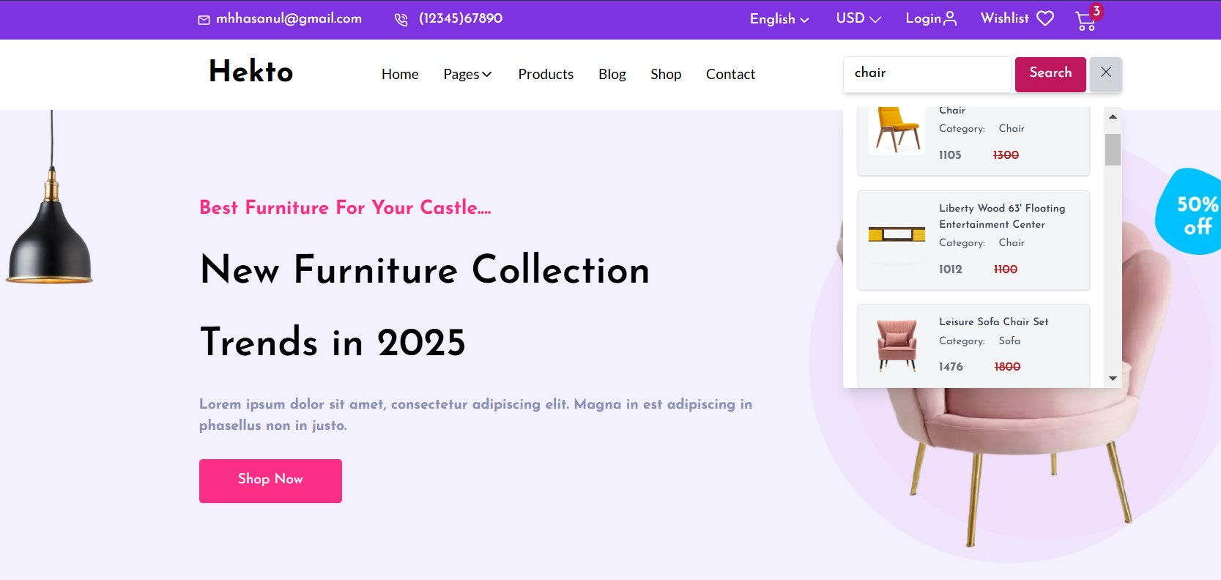

By MOHSIN ALI

## 2. Dynamic Routing for Product Details

* Implemented dynamic routing using Next.js.
* Each product has its own detail page displaying:

○ Product Name

○ Description

○ Price

○ Availability (Stock Status)

○ Images

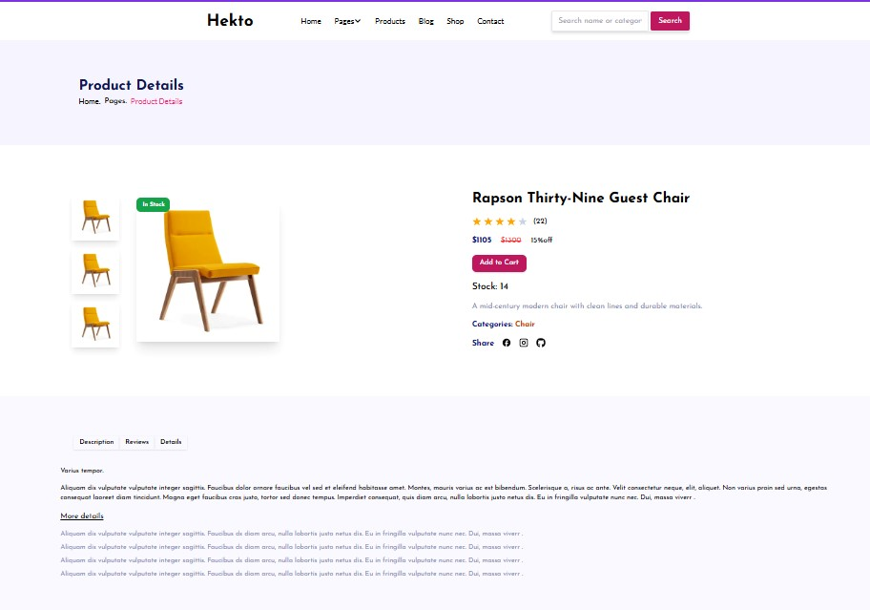

## 3. Reusable Components

* Built modular and reusable components to ensure scalability and maintainability.
* Examples include:

○ ProductCard Component

○ Navbar Component

○ Footer Component

## Add-to-Cart Functionality

* Users can add products to their cart dynamically.
* Features include:

○ Display of total items and price in the cart.

○ Quantity adjustment for products directly in the cart.

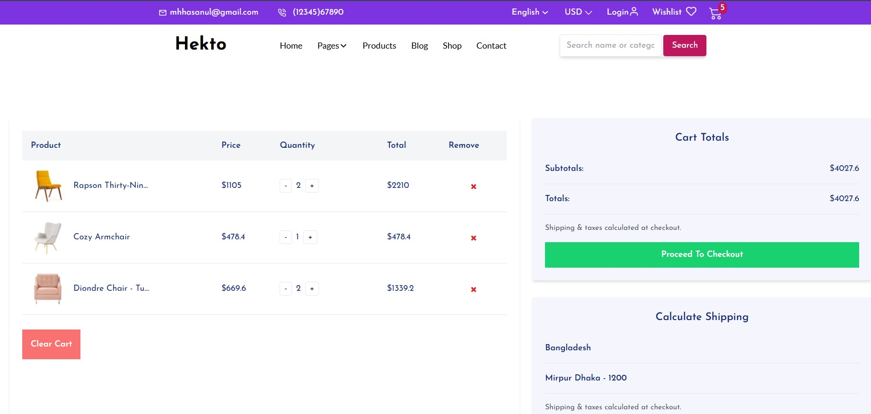

By MOHSIN ALI

## Real-Time Notifications

* Integrated toast notifications to enhance user experience.
* Notifications include:

○ Confirmation of items added to the cart.

○ Alerts for errors (e.g., adding out-of-stock items).

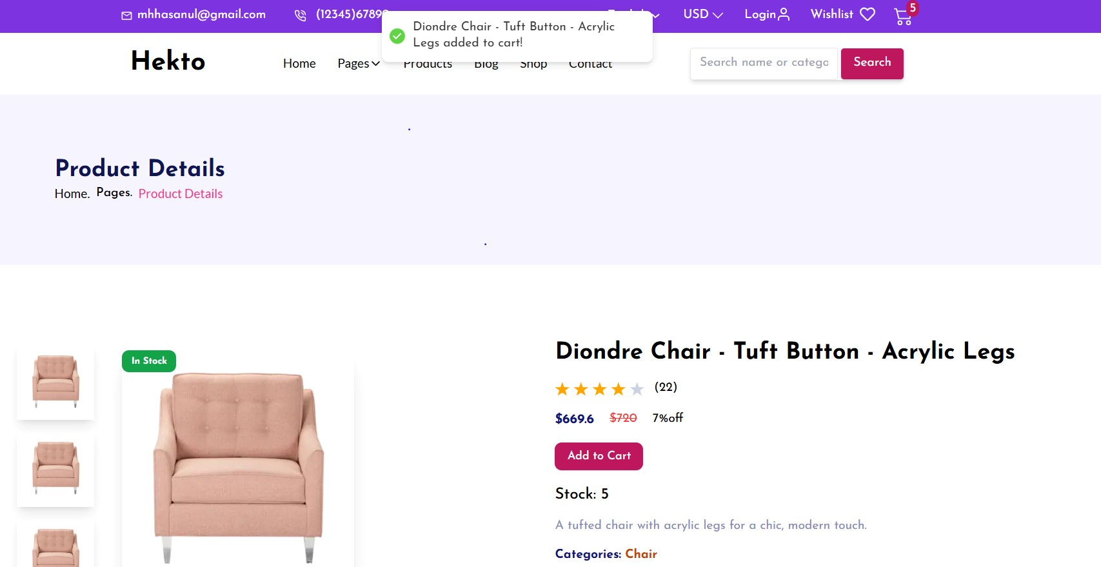

## 7. Real-Time Stock Updates

* Implemented stock management integrated with Sanity CMS.
* Features include:

○ Real-time stock updates in the backend whenever a product is added to the cart.

○ Preventing users from adding out-of-stock items to their cart. ○

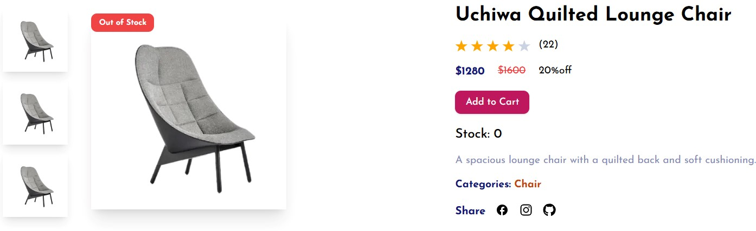

By MOHSIN ALI

## Checkout Page

● A multi-step checkout page was designed, including:

○ Billing and shipping address forms.

○ Mock payment gateway integration.

○ Order summary before confirmation.

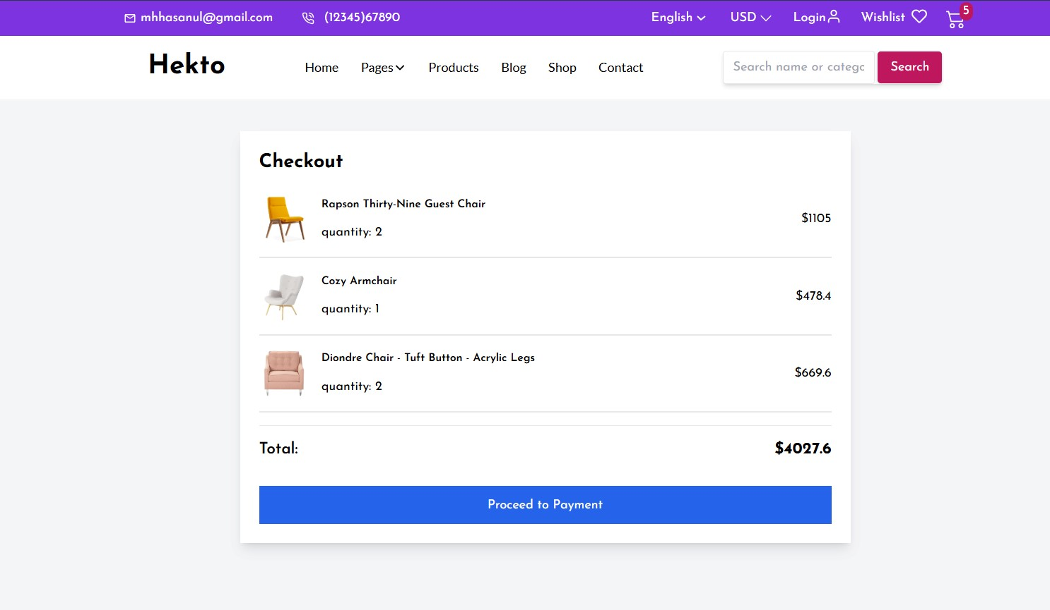

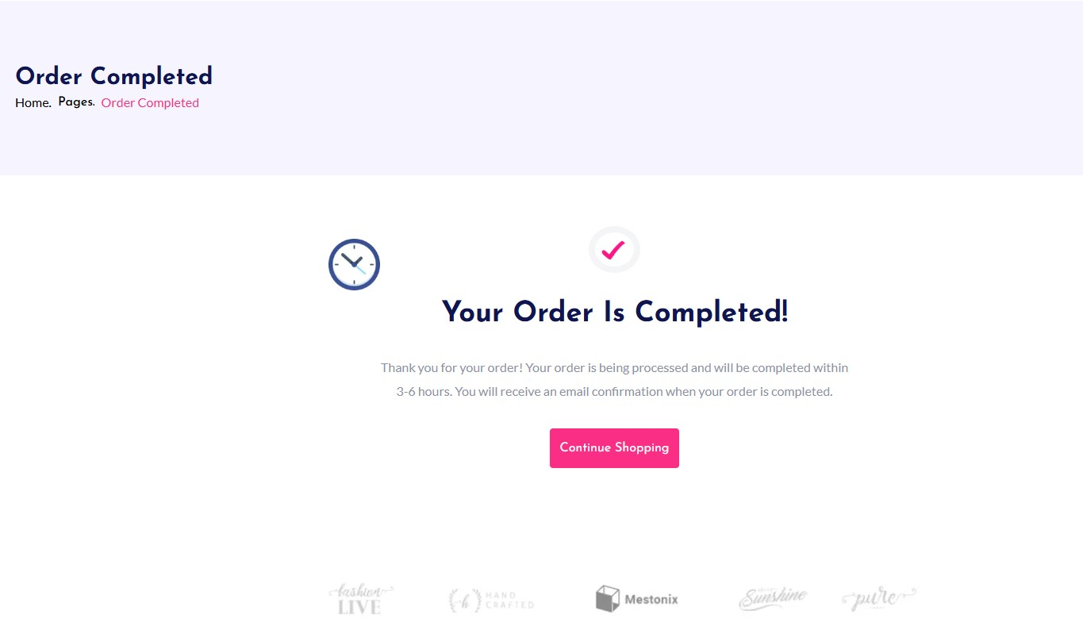

By MOHSIN ALI

# FAQ Page

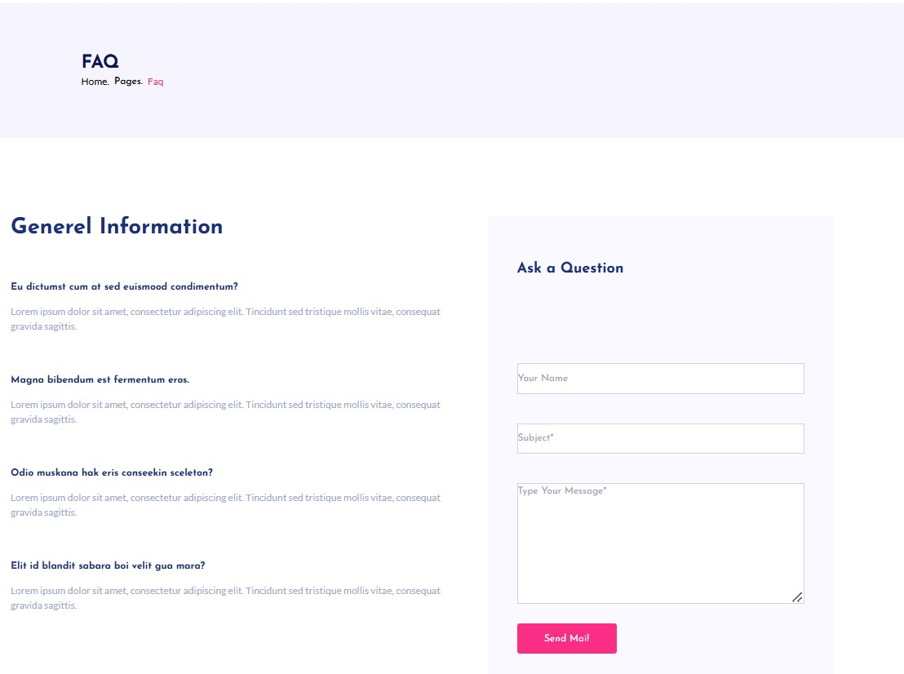

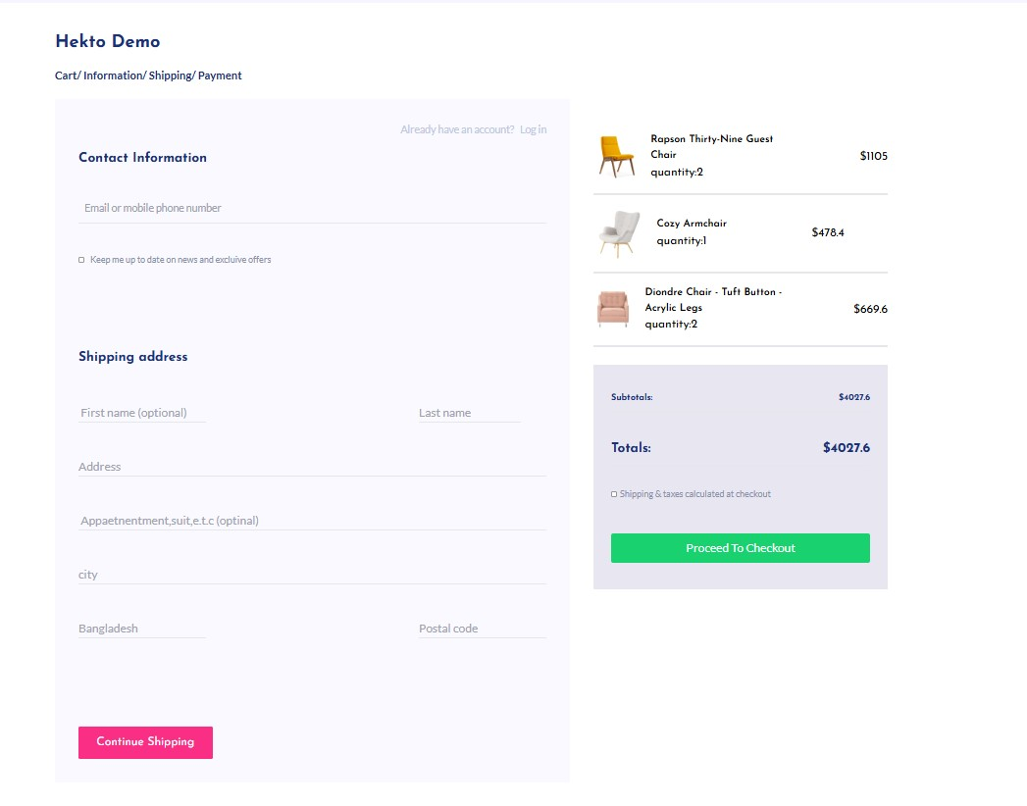

Tools and Technologies Used

* Frontend: Next.js, Tailwind CSS
* Backend CMS: Sanity (for dynamic content management)
* State Management: React Context API
* Notifications: React Toastify

## Conclusion

The E-commerce Furniture Website successfully demonstrates the integration of advanced frontend and backend features, emphasizing real-time functionality and user experience. The use of dynamic routing, reusable components, and real-time stock management with Sanity CMS showcases a professional and scalable approach to modern web development.

Final Checklist

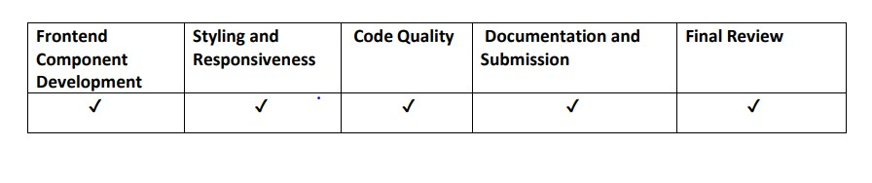

By MOHSIN ALI