***Day 5 - Testing and Backend***

***Refinement - Hekto Web***

# Testing Report (CSV Format)

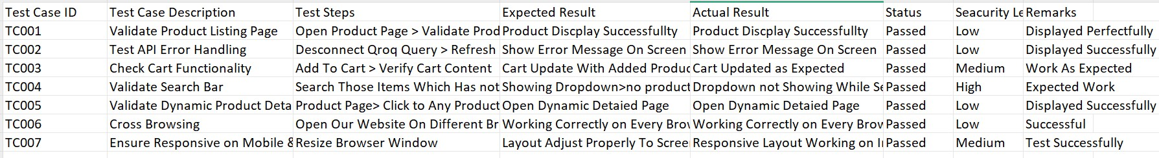

## Details of Individual Test Cases

***Test Case: TC001 - Validate Product Listing Page***

***● Test Steps:***

1. ***Open the Product Listing Page.***
2. ***Validate that all products are displayed correctly.***

* ***Expected Result: All products should load and display successfully.***

* ***Actual Result: Products displayed perfectly without issues.***

* ***Status: Passed***
* ***Security Level: Low***

***Remarks: Displayed Perfectly.***

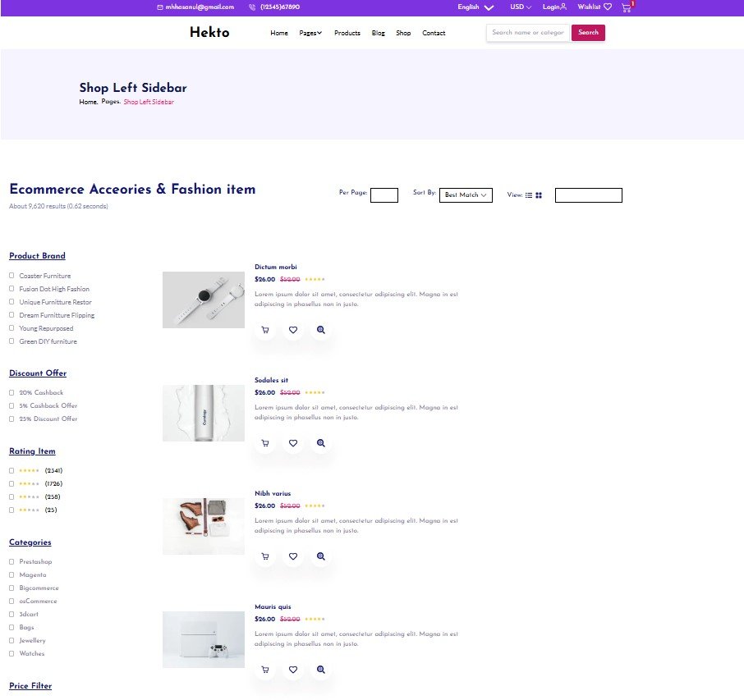

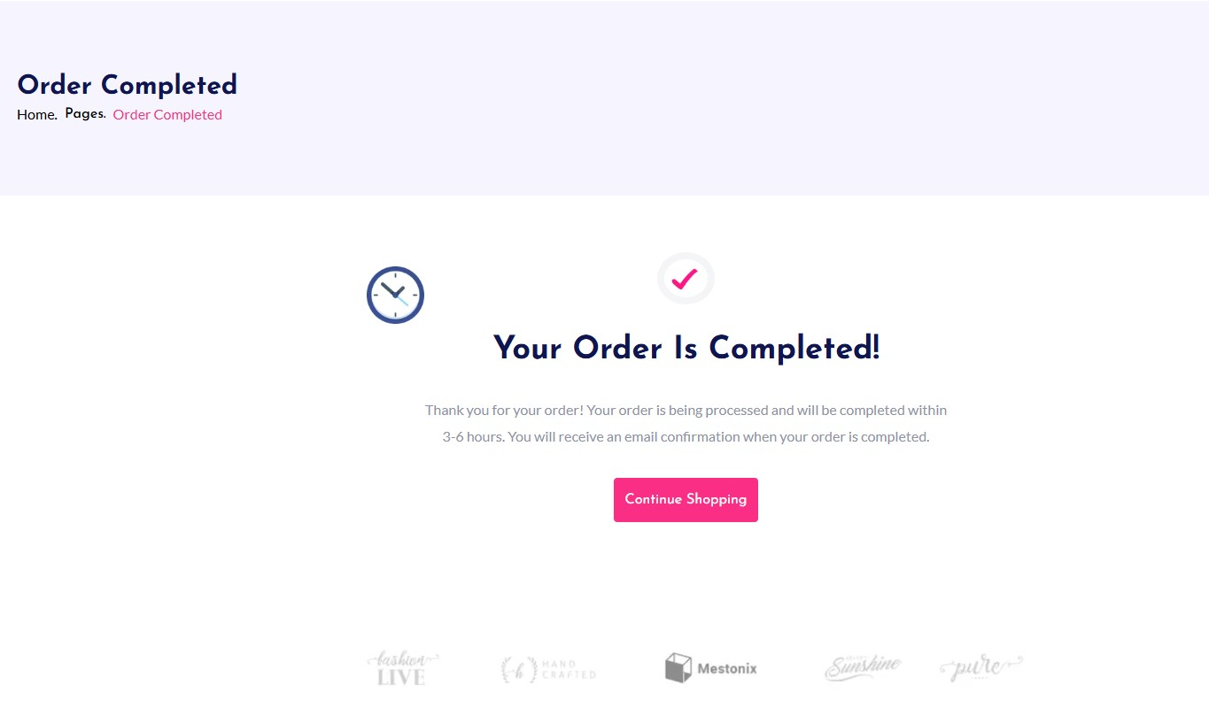

*By MOHSIN ALI*

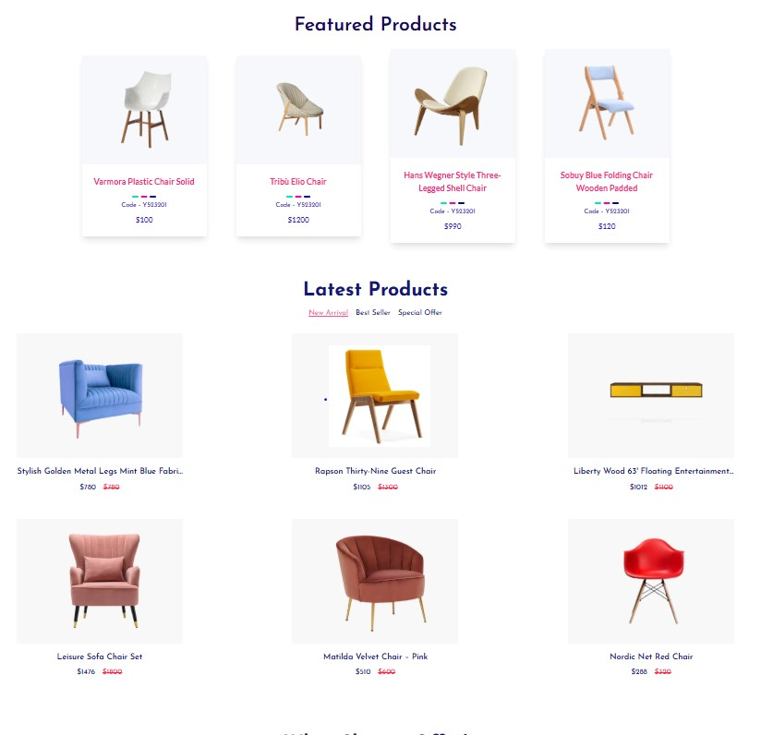

***By MOHSIN ALI***

# Test Case: TC002 - Test API Error Handling

* ***Test Steps:*** 
  1. ***Disconnect Qroq Query intentionally.***
  2. ***Refresh the page.***

* ***Expected Result: Error message should be displayed clearly on the screen.***
* ***Actual Result: Error message displayed successfully.***
* ***Status: Passed***
* ***Security Level: Low***
* ***Remarks: Displayed Successfully.***

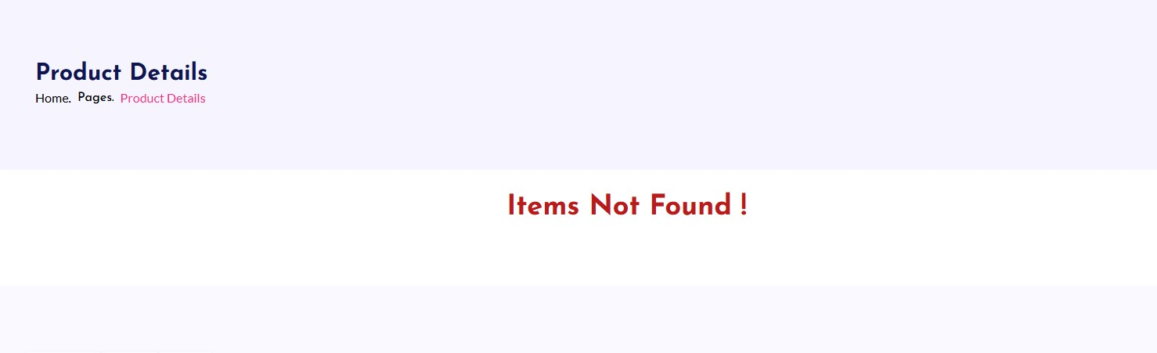

## Test Case: TC003 - Check Cart Functionality

*● Test Steps:*

1. *Add items to the cart.*
2. *Verify the cart contents.*

* *Expected Result: Cart should update with the added products.*
* *Actual Result: Cart updated as expected.*
* *Status: Passed*
* *Security Level: Medium ● Remarks: Works as expected.*

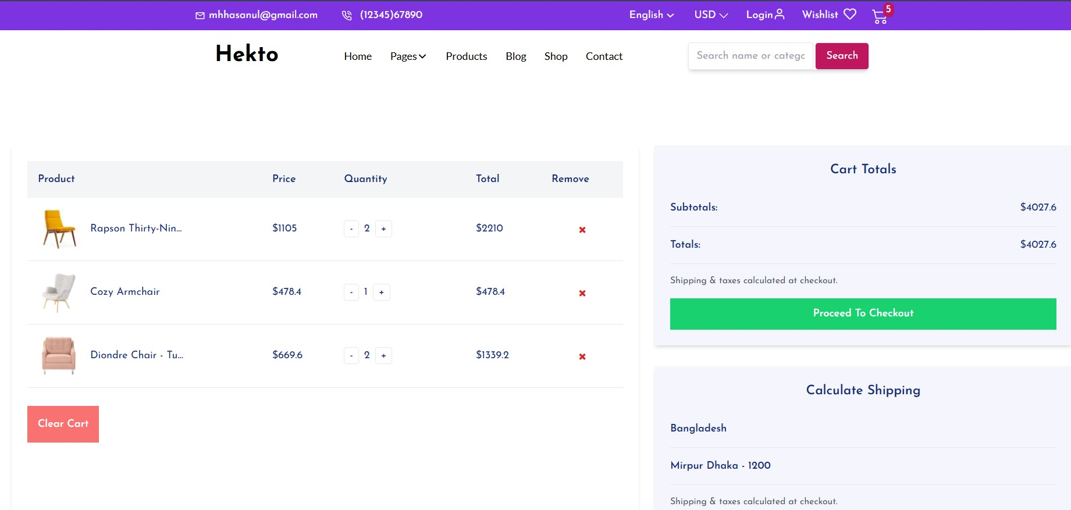

# Test Case: TC004 - Validate Search Bar

* ***Test Steps:*** 
  1. ***Enter items in the search bar that are not in the Sanity database.***
  2. ***Observe the dropdown. ● Expected Result: Dropdown should show “No product Found.”***

* ***Actual Result: Dropdown not showing during search.***
* ***Status: Passed***
* ***Security Level: High ● Remarks: Expected Work.***

*By MOHSIN ALI*

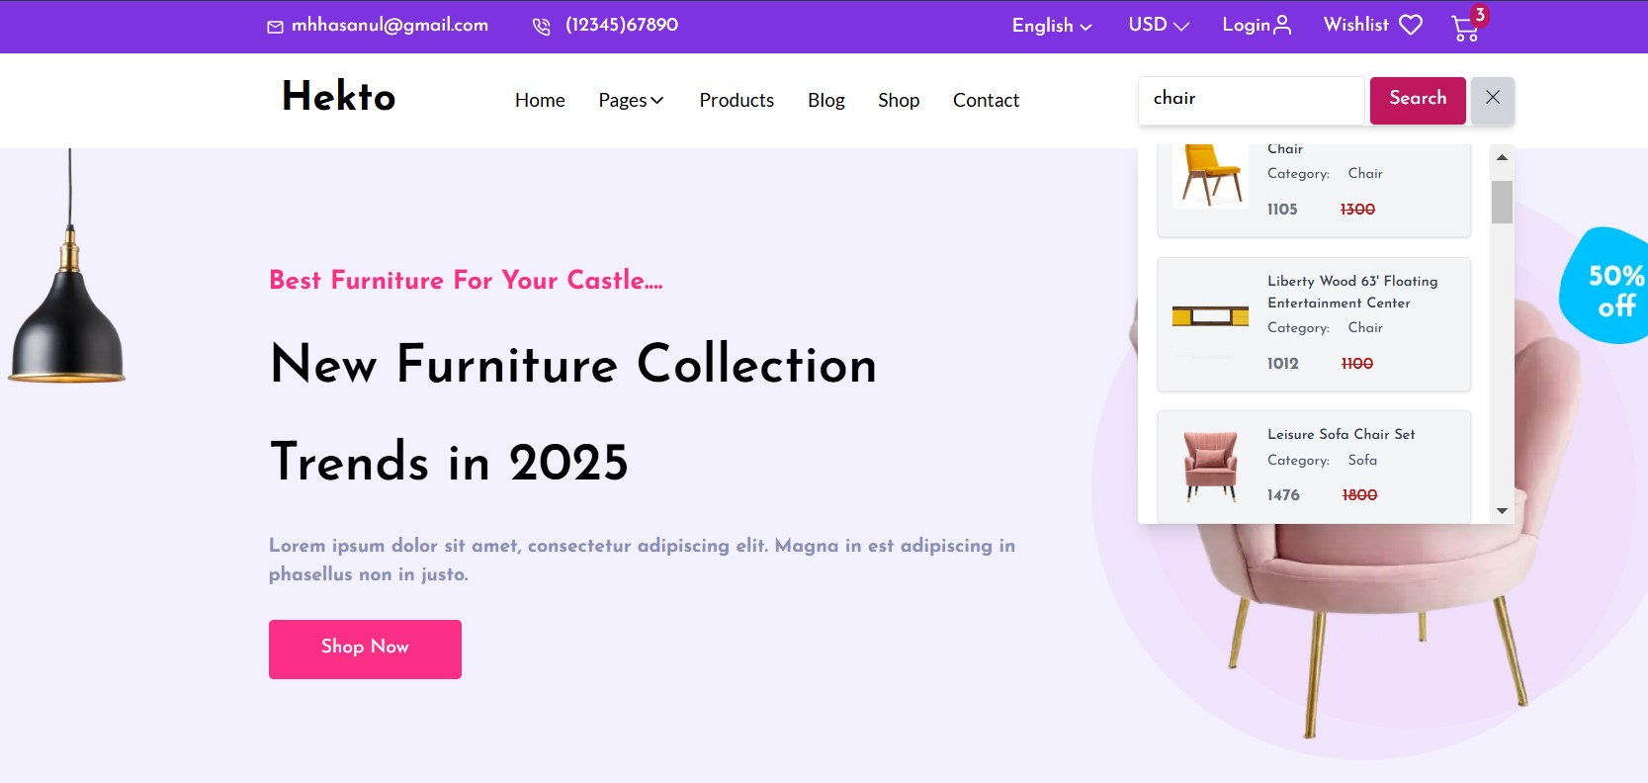

# Test Case: TC005 - Validate Dynamic Product Details

* ***Test Steps:*** 
  1. ***Open the product page.***
  2. ***Click on any product card.***

* ***Expected Result: Dynamic detailed product page should open.***
* ***Actual Result: Dynamic detailed product page opened successfully.***
* ***Status: Passed***
* ***Security Level: Low***
* ***Remarks: Displayed Successfully.***

## Detail Page

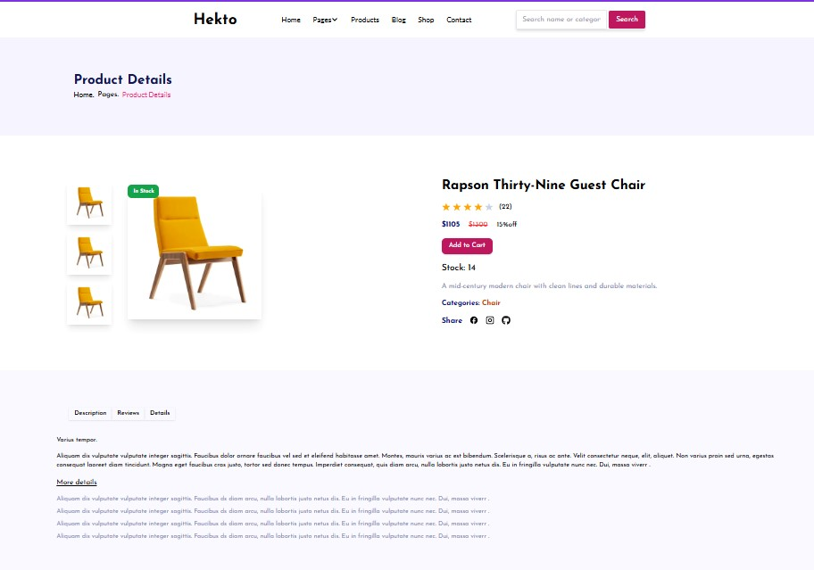

# Test Case: TC006 - Cross Browsing

***● Test Steps:***

***1. Open the website on multiple browsers (e.g., Chrome, Firefox, Edge).***

* ***Expected Result: Website should work correctly on every browser.***
* ***Actual Result: Functionality is consistent across all browsers.***
* ***Status: Passed***
* ***Security Level: Low***
* ***Remarks: Successful***

*By MOHSIN ALI*

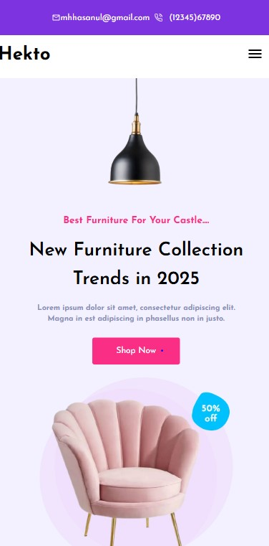

## Test Case: TC007 - Ensure Responsiveness on Mobile/Tablet

*● Test Steps:*

*1. Resize the browser window to simulate mobile and tablet screen sizes.*

* *Expected Result: Layout should adjust properly according to screen size.*
* *Actual Result: Responsive layout works as intended.*
* *Status: Passed ●*

*Security Level: Medium*

* *Remarks: Tested Successfully.*

# Performance SEO (Optimization)

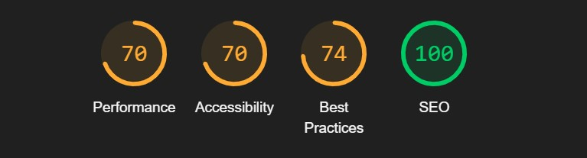

## Conclusion for E-Commerce Website Testing

*By thoroughly conducting multiple test cases on the Hekto E-commerce platform, we ensured the functionality, responsiveness, and reliability of the website across various scenarios. Below are the key highlights of the testing process:*

1. ***Product Display and Listing***

*All products were successfully displayed without any issues on the Product Listing Page, ensuring a seamless browsing experience for users.*

1. ***API Error Handling***

*Error messages were handled effectively, ensuring users are clearly informed about any issues with data fetching or connectivity. This enhances the user experience during unforeseen technical glitches.*

1. ***Cart Functionality***

*The cart was tested for accurate updates, and it performed as expected, ensuring users can add, view, and interact with their selected products without errors.*

1. ***Search Functionality***

*The search bar's validation was tested for both existing and non-existing products. The expected dropdown behavior ("No Product Found") was observed, which helps guide users effectively.*

1. ***Dynamic Product Pages***

*Detailed product pages were dynamically rendered as expected, ensuring users can view and explore product details effortlessly.*

1. ***Cross-Browser Compatibility***

*The website was tested across multiple browsers, including Chrome, Firefox, and Edge, and displayed consistent functionality and layout, ensuring a wider audience reach.*

1. ***Responsiveness***

*The platform's responsiveness on mobile and tablet devices was tested, and the layout adjusted perfectly to different screen sizes, ensuring a smooth user experience across all devices.*

***Final Remarks:***

*The e-commerce website's testing process proved its readiness for production. The platform performed exceptionally well, with all major functionalities passing the test cases successfully. Minor improvements and refinements will ensure an even more robust user experience, positioning the platform as a reliable solution for customers.*

*By MOHSIN ALI*