Software requirements Specification

|  |  |
| --- | --- |
| **Name** | **Roll Number** |
| Mohsin Ashraf | 15140094 |
| Mushood Hanif | 14140062 |
| Mehwish Hameed | 15140107 |
| Rida Yaqoob | 14140044 |

Contents

**Introduction** 3

**Purpose** 3

**Document Convention** 3

**Scope** 3

**User Classes** 4

**Operating Environment** 4

**System Features** 4

**Benchmark Datasets** 4

**Framework Configuration** 4

**Display Comparative Results** 4

**Data Requirements** 5

# **Introduction**

This document is to represent the software requirements specifications for NICO (Nature-Inspired CNN Optimizer). This product will help machine learning enthusiasts and data scientists to optimize a CNN of their choosing for a dataset of their choosing to provide the best results after training.

## **Purpose**

This paperwork will describe the functional and non-functional requirements of our project also including use-cases that will define the actions a user must be able to perform if it’s on our system. This document is meant for developers only.

## **Document Convention**

Functional requirements would be numbered using a hierarchical flow, and superscripting numbers would be used to denote requirements that are the basis of a use-case.

# **Scope**

The interface for this project is used to only help users interact with the results of our research thereby giving it the essence of a product. The following feature tree defines our scope.

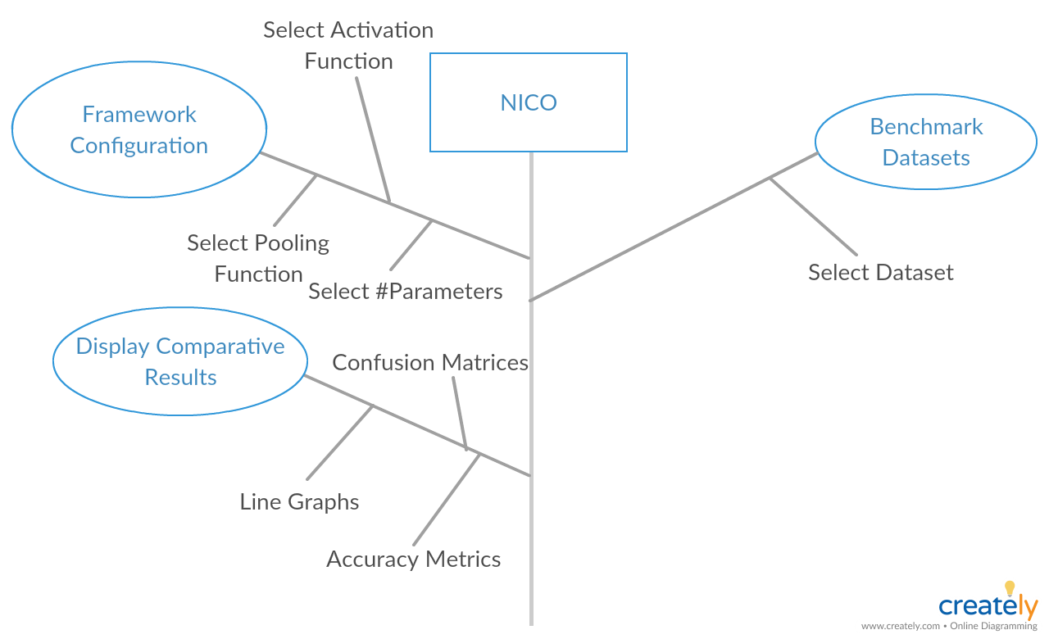

# **User Classes**

The following would benefit from our product:

* Data scientists
* Teachers
* Students
* Machine learning enthusiasts
* Researchers

# **Operating Environment**

Operating System: Windows 10

Platform: Web App

Browser: Google Chrome

# **System Features**

## **Benchmark Datasets**

**FR-01:** The system shall allow the user to select a benchmark dataset provided from an on-screen dropdown menu.

## **Framework Configuration**

**FR-02** The system shall allow the user to select an activation function for the CNN framework.

**FR-03** The system shall allow the user to select a pooling function for the CNN framework.

**FR-04** The system shall allow the users to select the number of parameters to optimize in the CNN framework.

## **Display Comparative Results**

**FR-05** The system shall compare, contrast and display the results with the help of line graphs, confusion matrices and accuracy metrics.