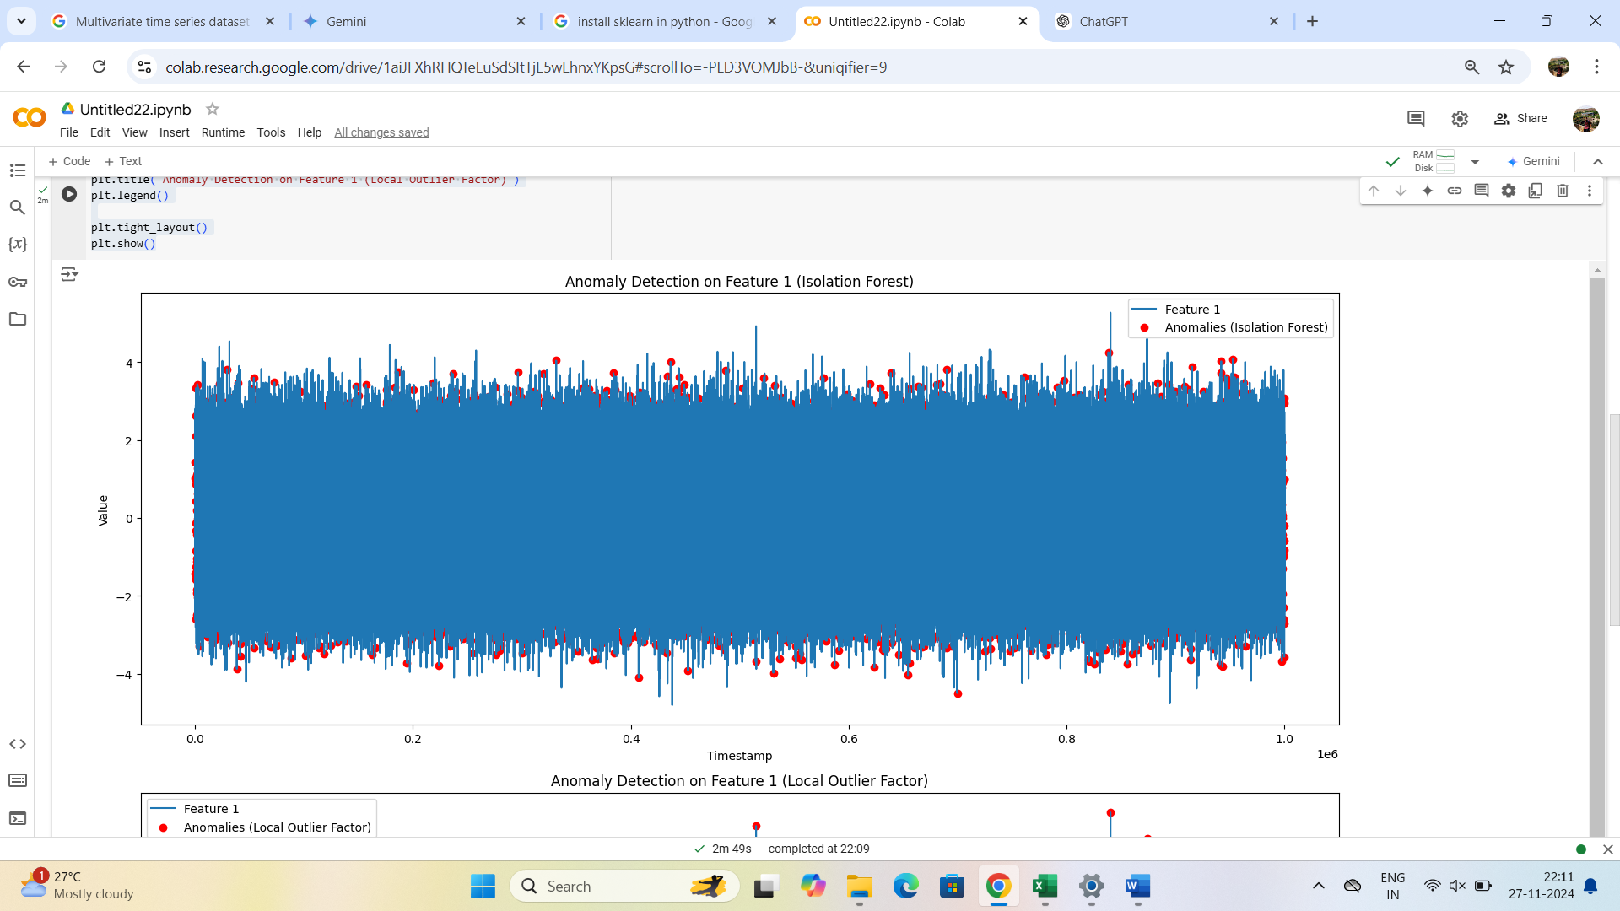

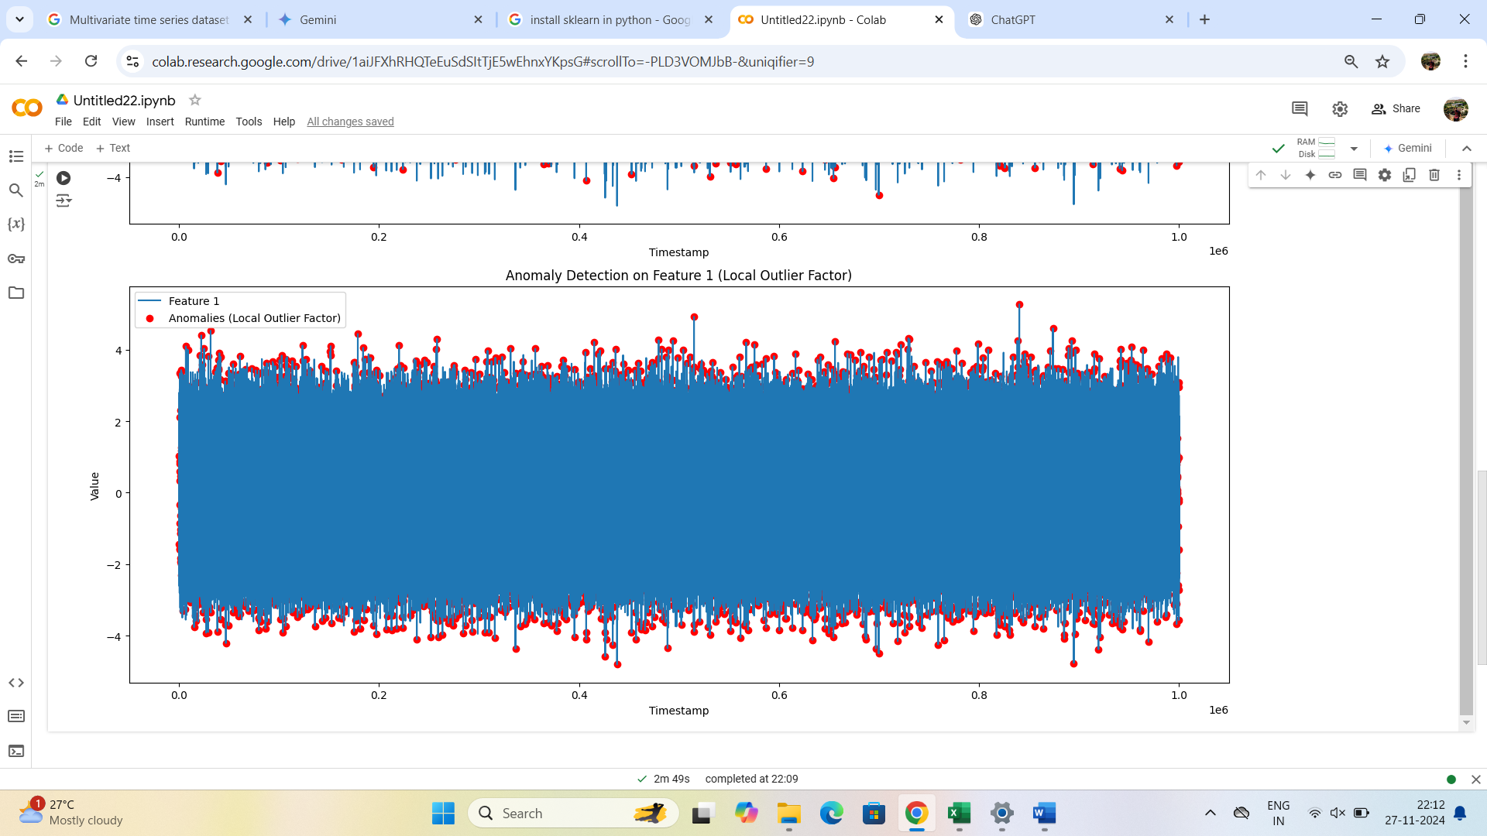

***CODE USED TO CREATE DATASET:***

import pandas as pd

import numpy as np

def generate_multivariate_time_series(num_rows, num_features, freq='h'):

# Check for potential overflow and adjust frequency if needed

if num_rows * (24 if freq == 'h' else 1) > 2**63: # Approximate max safe integer value

freq = 'D' # Change to daily frequency for example

# Generate random data for each feature

data = np.random.randn(num_rows, num_features)

# Create a time index

index = pd.date_range(start='2023-01-01', periods=num_rows, freq=freq)

# Create a DataFrame with the generated data and time index

df = pd.DataFrame(data, index=index, columns=[f'feature_{i}' for i in range(num_features)])

return df

# Set the desired number of rows and features

# Adjust num_rows based on your needs and potential overflow

num_rows = 1000000 # Adjust as needed for 1GB (might need adjustment)

num_features = 5

# Generate the dataset

df = generate_multivariate_time_series(num_rows, num_features)

# Save the dataset to a CSV file

df.to_csv('D:\multivariate_time_series_data.csv')

***CODE USED FOR ANOMALY DETECTION:***

import pandas as pd

import numpy as np

from sklearn.ensemble import IsolationForest

from sklearn.neighbors import LocalOutlierFactor

import matplotlib.pyplot as plt

# Load the dataset

df = pd.read_csv('your_dataset.csv.csv')

features = ['feature_0', 'feature_1', 'feature_2','feature_3','feature_4',]

# Prepare the data

X = df[features].values

# Isolation Forest

clf_iso = IsolationForest(contamination=0.01)

clf_iso.fit(X)

y_pred_iso = clf_iso.predict(X)

df['anomaly_iso'] = y_pred_iso

# Local Outlier Factor

clf_lof = LocalOutlierFactor(n_neighbors=20, contamination=0.01)

y_pred_lof = clf_lof.fit_predict(X)

df['anomaly_lof'] = y_pred_lof

# Visualize the anomalies (e.g., for 'feature_1')

plt.figure(figsize=(15, 12))

# Isolation Forest

plt.subplot(2, 1, 1)

plt.plot(df.index, df['feature_1'], label='Feature 1')

plt.scatter(df[df['anomaly_iso'] == -1].index, df[df['anomaly_iso'] == -1]['feature_1'], color='red', label='Anomalies (Isolation Forest)')

plt.xlabel('Timestamp')

plt.ylabel('Value')

plt.title('Anomaly Detection on Feature 1 (Isolation Forest)')

plt.legend()

# Local Outlier Factor

plt.subplot(2, 1, 2)

plt.plot(df.index, df['feature_1'], label='Feature 1')

plt.scatter(df[df['anomaly_lof'] == -1].index, df[df['anomaly_lof'] == -1]['feature_1'], color='red', label='Anomalies (Local Outlier Factor)')

plt.xlabel('Timestamp')

plt.ylabel('Value')

plt.title('Anomaly Detection on Feature 1 (Local Outlier Factor)')

plt.legend()

plt.tight_layout()

plt.show()