IP Servidor: 192.168.10.3
DNS Servidor: 127.0.0.1

DNS:

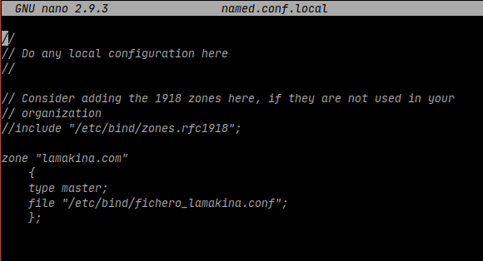

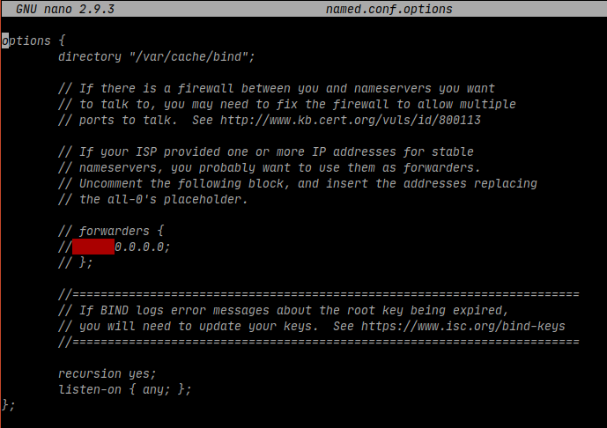

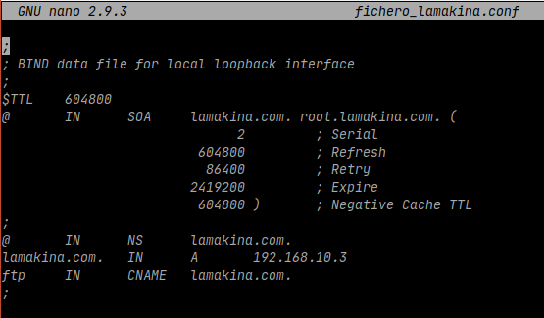
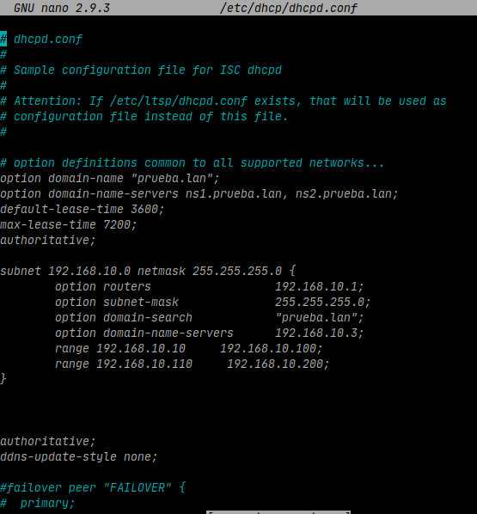
DHCP:

FTP:

useradd -g ftp -d /var/www/html/carpetaFTP pepe

chown pepe.ftp /var/www/html/carpetaFTP -R

passwd pepe

pepe
pepe

ftp 192.168.10.3

CLIENTE:

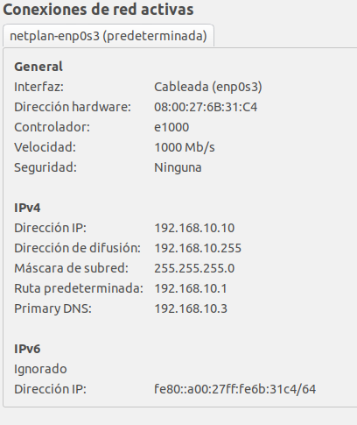
DHCP:

DNS:

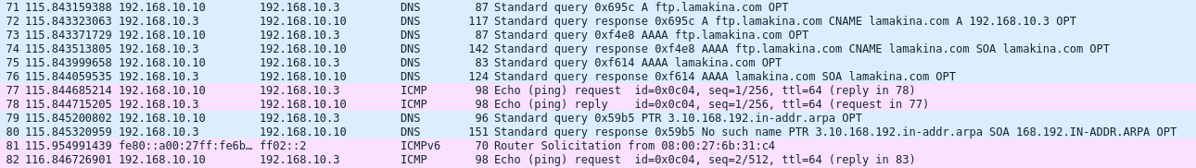

FTP:

