Chapter 4: System Design
4.1 Introduction
The preceding chapter established what Beaker Breakers Studio must do. This chapter establishes how the system will be built to do it. Its purpose is to convert the elicited functional and non-functional requirements into a coherent technical architecture, a decomposition into modules with defined responsibilities, a normalised data model, and a set of interface contracts that together form a specification sufficient for implementation to begin.
The design presented here is a proposed design. Except where explicitly stated otherwise, the components described have not yet been implemented; the chapter describes intended structure and behaviour rather than completed work. Where a design decision constrains what the system will and will not attempt, that constraint is stated openly rather than deferred, because several of the constraints — particularly around chemical simulation fidelity and augmented-reality device support — materially shape the scope of the implementation that follows.
The chapter is organised so that it may be read as a single technical argument. It proceeds from design objectives, to overall architecture and the architectural pattern selected to realise it, to component and module decomposition, then to the design of the central subsystem (the virtual chemistry laboratory) and the supporting subsystems that surround it, and finally to the cross-cutting concerns of data, interfaces, security, performance, error handling and accessibility. The virtual laboratory is treated throughout as the core of the system; the artificial-intelligence assistant, safety subsystem, readiness assessment, gamification and augmented reality are designed as supporting subsystems that add value to that core without displacing it.
4.2 Design Objectives
The following objectives were derived from the requirements specification and were used as evaluation criteria whenever a design decision admitted more than one reasonable option.
Objective | Design Implication
Usability | The interface must be operable by secondary-level students with limited prior exposure to laboratory software. Interaction is therefore step-guided rather than open-ended, and every screen provides an explicit next action.
Educational effectiveness | The system is designed to teach rather than merely to display. Feedback is corrective and explanatory, assessment gates precede practice, and the AI assistant is constrained so that it does not supply answers where doing so would remove the learning.
Safety | Safety is enforced structurally, not advisorily: certification gates experiment access, hazard information is attached to chemicals as data, and unsafe actions are detected against declared rules rather than left to student judgement.
Performance | Interactive laboratory actions must feel immediate. Rendering runs client-side, validation of a step is a lightweight rule evaluation rather than a physics computation, and long-running work (AI generation, report compilation) is performed asynchronously.
Scalability | The application layer is stateless so that instances may be added horizontally. Session state, leaderboards and cached AI responses are held in an external cache rather than in process memory.
Maintainability | Experiments are authored as data against a shared framework rather than coded individually, so that adding the thirtieth experiment costs approximately what adding the third costs.
Security | Authentication is token-based, authorisation is enforced server-side on every request, and no client-submitted score or verdict is trusted.
Accessibility | The interface targets ordinary school hardware and connections. Augmented reality is optional, and every AR-only capability has a non-AR equivalent path.
Modularity | Subsystems communicate through defined service interfaces so that the AI provider, notification channel or storage backend can be replaced without redesigning the laboratory.
Extensibility | The experiment framework, badge criteria and safety rules are configuration-driven, allowing content growth without schema change.
Table 4.1: Design objectives and their principal implications for the design.
4.3 Overall System Architecture
Beaker Breakers Studio is designed as a distributed client–server system organised into three principal layers, with external services attached to the application layer through adapter interfaces. Figure 4.1 presents the overall architecture.
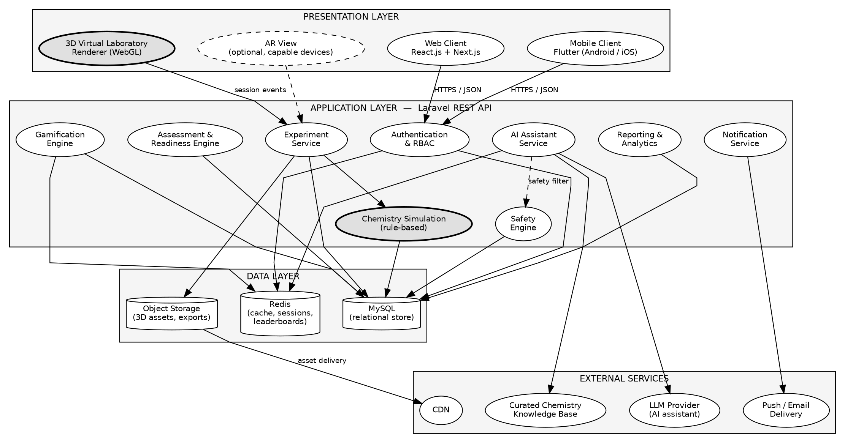
Figure 4.1: Overall system architecture of Beaker Breakers Studio.
The presentation layer contains the clients through which all users interact with the system. The web client serves students, teachers and administrators from any modern browser, while the mobile client provides the same student functionality on Android and iOS. Within the presentation layer, the three-dimensional virtual laboratory renderer is a distinct concern: it executes in the client and is responsible for drawing the laboratory scene, handling direct manipulation of equipment and chemicals, and maintaining the transient visual state of an experiment in progress. The augmented-reality view is an optional alternative presentation of that same scene, drawn only on devices that support it.
The application layer holds all business logic and is the only layer permitted to reach the data layer. It is decomposed into services aligned to the system’s functional areas. The experiment service coordinates laboratory sessions and delegates the evaluation of each student action to the chemistry simulation component. The safety engine holds hazard data and safety rules and is consulted both during experiments and by the AI assistant. The assessment and readiness engine administers quizzes and computes readiness verdicts. The gamification engine reacts to events emitted by other services rather than being called directly by the client, which keeps reward logic in one place. The AI assistant service mediates all contact with the external language model.
The data layer separates three kinds of storage according to their access characteristics. The relational database is the authoritative record for all structured entities. The cache holds data that is either short-lived or expensive to recompute — session tokens, leaderboard orderings and previously generated AI responses. Object storage holds the large binary assets of the laboratory, principally three-dimensional models and textures, which are delivered to clients through a content delivery network rather than through the application server.
Two aspects of the architecture deserve particular attention because they are deliberate and consequential. First, the AI assistant service does not return a language-model response directly to the client: every response passes through the safety filter before delivery, which is why the safety engine appears as a dependency of the AI service in Figure 4.1. Second, the augmented-reality view is drawn as an optional presentation-layer element rather than as a separate subsystem, because it consumes the same experiment definitions and the same session endpoints as the standard laboratory; this decision is examined further in Section 4.13.
4.4 Architectural Pattern
Four candidate patterns were considered against the requirements: a three-tier architecture, a layered architecture, a modular monolith, and a distributed microservice architecture. The selection was made on the basis of the system’s actual characteristics rather than on architectural fashion.
Pattern | Assessment Against This System
Microservices | Rejected. The system has a single deployment target (one school platform), a small development team, and no subsystem whose scaling profile differs sharply enough from the others to justify independent deployment. The operational overhead of service discovery, distributed transactions and independent pipelines would consume effort that the project needs for the laboratory itself.
Client–server | Necessary but insufficient on its own. The system is unavoidably client–server because rendering must occur on the client while authoritative state must reside on the server; however, this describes the deployment relationship rather than the internal organisation of the server.
Layered architecture | Adopted internally. Strict layering — presentation, application, data — with downward-only dependencies gives the separation of concerns the maintainability objective requires.
Three-tier architecture | Selected. It is the concrete realisation of the layered approach across the physical deployment, and it matches the system exactly: a rendering client, a stateless application tier, and a persistent data tier.
Table 4.2: Evaluation of candidate architectural patterns.
The selected architecture is therefore a three-tier client–server architecture with a layered, modular application tier. This combination is well suited to a virtual chemistry laboratory for three specific reasons. First, the computational load divides naturally along the tier boundary: three-dimensional rendering and immediate interaction feedback belong on the client where they incur no network latency, while validation, scoring and persistence belong on the server where they cannot be tampered with. Second, the educational integrity of the system depends on the server remaining authoritative — a design in which the client could report its own scores would render assessment and certification meaningless. Third, a stateless application tier permits the horizontal scaling described in Section 4.20 without introducing session affinity.
Within the application tier, modules are organised by functional area rather than by technical role, so that the safety engine, for example, owns its rules, its evaluation logic and its data access together. This reduces the coupling that arises when a single change to safety policy must be traced through separate controller, service and repository layers scattered across the codebase.
4.5 System Components
Table 4.3 lists the major components of the system and the responsibility each holds. The decomposition follows the principle that a component owns exactly one area of the system’s behaviour and exposes it through a defined interface.
Component | Primary Responsibility
Authentication | Verifies credentials, issues and validates access tokens, and enforces role-based authorisation on every protected request.
Student Management | Maintains student profiles, class membership, and the aggregate learning record surfaced on the student dashboard.
Teacher Management | Maintains teacher profiles and the teacher-to-class assignments that bound every teacher action.
Experiment Management | Stores and serves experiment definitions, their steps, and their equipment, chemical and safety requirements; coordinates laboratory sessions.
3D Laboratory Engine | Client-side component that loads the scene, renders equipment and chemicals, and translates user manipulation into candidate experiment actions.
Chemistry Simulation | Evaluates a submitted action against the authored rule for the current step and returns the resulting observation and outcome.
AI Assistant | Assembles experiment context, retrieves supporting material, obtains a language-model response, and screens it before delivery.
Safety Engine | Holds hazard data, personal protective equipment requirements and safety rules; evaluates actions for unsafe conditions and screens AI output.
Assessment Engine | Generates and grades safety quizzes and readiness assessments and records attempts.
Gamification Engine | Consumes completion and safe-practice events and awards points, levels, badges and leaderboard positions.
AR Component | Optional client-side alternative presentation of the laboratory scene on capable devices.
Notification | Dispatches in-application, push and email messages arising from assignments, achievements and announcements.
Reporting and Analytics | Aggregates session, assessment and progress data into the views required by teachers and administrators.
Data Access Layer | Provides the single controlled path from application services to persistent storage.
Table 4.3: Major system components and their responsibilities.
4.6 Module-Level Design
This section specifies each module in terms of its purpose, inputs, processing, outputs and dependencies. To avoid repetition, behaviour already described at component level in Section 4.5 is not restated; the emphasis here is on data flow and inter-module interaction.
4.6.1 Authentication Module
Aspect | Specification
Purpose | Establishes and maintains verified user identity and enforces role boundaries.
Inputs | Credentials at login; access token on every subsequent request.
Processing | Verifies the credential against the stored password hash, issues a signed token carrying the user identifier and role, and on each protected request validates the token and evaluates the caller’s role against the required permission.
Outputs | Authenticated session token, or an authentication (401) or authorisation (403) rejection.
Dependencies | Database (User); Cache (token state). Every other module depends on this one for caller identity.

4.6.2 Student Management Module
Aspect | Specification
Purpose | Maintains the student record and the aggregated learning state presented to the student.
Inputs | Profile updates; aggregated events from Progress Tracking and Gamification.
Processing | Reads and updates the student profile; assembles the dashboard view by combining progress, achievements, certification status and assigned experiments.
Outputs | Student profile and dashboard payload.
Dependencies | Authentication; Progress Tracking; Gamification; Experiment Management.

4.6.3 Teacher Management Module
Aspect | Specification
Purpose | Maintains teacher records and the class assignments that scope all teacher access.
Inputs | Teacher profile data; class assignment records.
Processing | Resolves the set of classes a teacher is assigned to and supplies that set as an authorisation filter to every teacher-facing query.
Outputs | Teacher profile; authorised class scope.
Dependencies | Authentication; Student Management; Reporting and Analytics.

4.6.4 Experiment Management Module
Aspect | Specification
Purpose | Owns experiment definitions and coordinates the lifecycle of a laboratory session.
Inputs | Experiment identifier; session creation and step submission requests.
Processing | Serves experiment definitions and their associated requirements; creates a session only after the certification and readiness gates return permission; records step completion; finalises the session and requests evaluation of the result.
Outputs | Experiment definition; session state; completed Result record.
Dependencies | Safety Engine and Assessment Engine (entry gates); Chemistry Simulation (action validation); Gamification (completion event); Database.

4.6.5 Virtual Laboratory Module
Aspect | Specification
Purpose | Presents the laboratory and converts direct manipulation into structured experiment actions.
Inputs | Experiment definition and asset references; user input (selection, placement, measurement).
Processing | Loads the scene and its assets; maintains transient visual state; packages each user manipulation as a structured action and submits it for server-side validation; renders the returned observation.
Outputs | Structured action submissions; rendered scene and observation feedback.
Dependencies | Experiment Management (definitions, session endpoints); Object storage (assets); Safety Engine (warning display).

4.6.6 AI Assistant Module
Aspect | Specification
Purpose | Provides contextual educational guidance without undermining assessment.
Inputs | Student question; current session, step and experiment context.
Processing | Builds a context bundle from the active session; retrieves supporting passages from the curated knowledge base; requests a completion from the language model under a constraining system instruction; screens the draft through the safety filter; logs the exchange.
Outputs | Screened educational response; logged AIInteraction record.
Dependencies | Experiment Management (context); Safety Engine (screening); Knowledge base; external language-model provider; Cache.

4.6.7 Safety Management Module
Aspect | Specification
Purpose | Holds safety knowledge and enforces it during experimentation and AI interaction.
Inputs | Chemical and equipment references; candidate student actions; draft AI responses.
Processing | Returns hazard and protective-equipment data for requested materials; evaluates a candidate action against the declared safety rules for the experiment; screens AI drafts for unsafe guidance.
Outputs | Hazard information; safety warnings with severity; screening verdicts.
Dependencies | Database (SafetyRule, Chemical); consumed by Virtual Laboratory, AI Assistant, Assessment Engine and Gamification.

4.6.8 Readiness Assessment Module
Aspect | Specification
Purpose | Determines whether a student is prepared to perform a selected experiment.
Inputs | Student identifier; experiment identifier; submitted assessment answers.
Processing | Checks prerequisites and certification status; generates a theory and safety assessment drawn from the experiment’s question bank; grades the attempt server-side; evaluates the score against the configured readiness criteria.
Outputs | Readiness verdict (permitted or not permitted) with per-area gap feedback; stored Attempt record.
Dependencies | Experiment Management; Safety Engine; Database (Assessment, Question, Attempt).

4.6.9 Gamification Module
Aspect | Specification
Purpose | Reinforces sustained and safe learning behaviour through structured rewards.
Inputs | Completion events; safe-practice events; assessment outcomes.
Processing | Applies the configured award rules idempotently, updates the cumulative point total and level, evaluates badge criteria, and updates the leaderboard ordering.
Outputs | Updated Progress record; Achievement records; leaderboard position.
Dependencies | Experiment Management; Safety Engine; Assessment Engine; Cache; Notification.

4.6.10 Progress Tracking Module
Aspect | Specification
Purpose | Maintains the longitudinal record of what a student has done and how well.
Inputs | Session results; assessment attempts; certification events.
Processing | Aggregates per-experiment outcomes into cumulative counters and per-dimension performance summaries used by dashboards and readiness reporting.
Outputs | Progress record; experiment history; dimension summaries.
Dependencies | Experiment Management; Assessment Engine; Database.

4.6.11 AR Module
Aspect | Specification
Purpose | Offers an augmented-reality presentation of the laboratory on capable devices.
Inputs | Device capability report; selected experiment; camera and motion input.
Processing | Detects capability; if supported, initialises tracking, anchors the scene to a detected surface and maps device interaction onto the same structured actions used by the standard laboratory; if unsupported, returns control to the standard presentation.
Outputs | Anchored scene and interaction events, or a capability-based fallback signal.
Dependencies | Virtual Laboratory (scene and action contract); Experiment Management; device AR framework.

4.6.12 Administration Module
Aspect | Specification
Purpose | Provides institution-level management of users, content and configuration.
Inputs | Administrative commands; content and rule definitions.
Processing | Performs create, read, update and delete operations on users, experiments, chemicals, equipment, safety rules and assessments; applies configuration changes; writes every operation to the audit log.
Outputs | Updated records; audit entries; administrative reports.
Dependencies | Authentication; Experiment Management; Safety Engine; Reporting; Database.

4.6.13 Reports and Analytics Module
Aspect | Specification
Purpose | Converts accumulated operational data into the summaries teachers and administrators act on.
Inputs | Query parameters (class, cohort, date range); authorised scope from the caller’s role.
Processing | Executes scoped aggregate queries, applies caching to expensive aggregations, and formats results for on-screen display or export.
Outputs | Analytical views and exportable report files.
Dependencies | Teacher Management (scope); Progress Tracking; Assessment Engine; Database; Cache.

4.7 Virtual Chemistry Laboratory Design
The virtual laboratory is the central component of the system and the one against which the remaining subsystems are justified. Its design is described here in terms of what it represents, how the student interacts with it, and — importantly — what it does not attempt.
4.7.1 Scope of Simulation
The laboratory is designed as a guided, scripted simulation rather than as a computational chemistry solver. The system does not model reaction kinetics, thermodynamics or molecular behaviour from first principles, and no claim of physically accurate chemical simulation is made. Instead, each experiment is authored as an ordered sequence of steps in which the expected student action and the corresponding observation are declared in advance by the content author. When a student performs an action, the simulation component compares it against the declared expectation for the current step and returns the authored observation if it matches, or corrective feedback if it does not.
This is a deliberate design decision with a clear justification. A first-principles chemical solver is neither achievable within the scope of a Bachelor’s final-year project nor necessary for the educational objective, which is for students to learn correct procedure, correct observation and correct safety practice. The scripted approach additionally guarantees pedagogical determinism: every student who follows the correct procedure observes the outcome the curriculum expects, which a stochastic or approximate solver could not guarantee.
4.7.2 Scene, Equipment and Chemical Objects
The laboratory scene is composed of a bench environment onto which the equipment and chemical objects declared by the active experiment are instantiated. Equipment and chemicals exist in the data model as first-class entities (Section 4.14) carrying a reference to their visual asset, so that the same beaker or the same reagent may be reused across many experiments without duplication. Chemical objects additionally carry hazard classification, which the safety engine reads when generating warnings.
4.7.3 Interaction and State Management
Interaction is direct: the student selects an item, places it, combines it with another, or performs a measurement. Each such manipulation is packaged by the client as a structured action and submitted to the server. This division is essential to the integrity of the system — the client renders and proposes, while the server validates and records. Session state is therefore held authoritatively in the ExperimentSession record, with the client maintaining only transient visual state. Because the completed-step list is persisted server-side after every accepted action, a student who refreshes the page, loses connectivity or changes device resumes at the step they had reached rather than restarting.
4.7.4 Measurement, Observation and Completion
Measurement actions return authored values associated with the step rather than computed quantities, consistent with the scope defined in Section 4.7.1. Observations returned by the simulation component are appended to the session’s observation record, which forms part of the final Result and is available to the student and to their teacher afterwards. When the final step is accepted, the session is finalised: the result is scored, the performance dimensions described in Section 4.11 are computed, and a completion event is emitted to the gamification engine.
4.7.5 Reset and Retry
A session may be reset at any point before completion, which clears the completed-step list and returns the scene to its initial state. Because the virtual laboratory consumes no physical materials, retry is unlimited by design — the ability to fail safely and repeat is one of the principal educational advantages the system offers over a physical laboratory, and the design does not restrict it. Rewards, however, are not re-issued on repeat completion; this is enforced by the idempotency rule described in Section 4.12.
4.8 Chemistry Experiment Design
The requirement to provide thirty or more experiments makes the representation of an individual experiment the single most important structural decision in the system. Developing each experiment as bespoke code would produce thirty largely similar implementations, none of which could be maintained independently of the others. The design therefore treats an experiment as data interpreted by a single reusable framework.
4.8.1 Generic Experiment Structure
Element | Description
Experiment ID | Unique identifier used by sessions, assessments and assignments.
Title | Display name of the experiment.
Objective | The learning intent, shown to the student before the experiment begins.
Theory | Background chemistry, used both for display and as source material for the readiness assessment.
Required chemicals | References to Chemical entities, each carrying its own hazard classification.
Required equipment | References to Equipment entities and their visual assets.
Safety requirements | References to the SafetyRule entities that govern this experiment, including protective-equipment requirements.
Procedure | The ordered list of ExperimentStep records, each declaring its instruction, expected action and expected observation.
Expected observations | The authored outcome associated with each step, returned when the step is performed correctly.
Assessment criteria | The question bank and pass thresholds used by the readiness and post-experiment assessments.
Learning outcomes | The curriculum outcomes the experiment addresses, used in teacher reporting.
Table 4.4: Generic structure of an experiment definition.
4.8.2 The Reusable Experiment Framework
Every experiment in the library is an instance of the structure in Table 4.4. The virtual laboratory, the simulation component, the safety engine and the assessment engine are all written against this structure rather than against any particular experiment. Consequently, adding a new experiment is a content-authoring activity: the author defines the metadata, selects the required equipment and chemicals from the existing catalogues, writes the ordered steps with their expected actions and observations, attaches the applicable safety rules, and supplies the question bank.
Three consequences follow, and they are the reason this approach was chosen. First, effort per experiment is approximately constant rather than growing with library size. Second, a correction to shared behaviour — for example, a change to how measurement steps are validated — applies to the entire library at once. Third, the library can be extended after the project is complete by staff who are competent in chemistry but not in software development, which is a precondition for the system remaining useful beyond the project’s lifetime.
4.9 AI Assistant Design
The AI assistant provides contextual educational guidance during experimentation. Its design is governed by two constraints that are as important as its capabilities: it must not fabricate chemistry, and it must not supply answers where doing so would remove the learning that an assessment is designed to measure.
4.9.1 Processing Pipeline
Figure 4.6 in Section 4.16.3 presents the interaction sequence in full. In summary, a student query is processed in six stages. The context builder first identifies where the student is — the active session, the current step, and the experiment definition. Relevant passages are then retrieved from a curated chemistry knowledge base. The query, the context and the retrieved passages are assembled into a prompt under a system instruction that defines the assistant’s educational role and its prohibitions. The language model returns a draft. The safety filter screens that draft. Only then is the response returned to the student, and the exchange is logged as an AIInteraction record.
4.9.2 Constraining the Assistant
Three mechanisms are combined to reduce hallucination and prevent unsafe guidance, because no one of them is sufficient alone.
Mechanism | Purpose
Retrieval-augmented generation | The model is supplied with authored passages from the curated knowledge base and with the current experiment definition, and is instructed to ground its answer in that material. This constrains the answer to content the institution controls rather than to the model’s unverified prior knowledge.
Curated chemistry knowledge base | The retrieval corpus is limited to material reviewed for curriculum alignment and correctness, so that grounding has something correct to ground in.
Rule-based safety layer | A deterministic filter, independent of the model, screens every draft response against the safety rules before delivery. Because this layer is rule-based rather than probabilistic, its behaviour does not vary with model output.
Table 4.5: Mechanisms constraining AI assistant output.
4.9.3 Educational Boundaries
The system instruction directs the assistant to explain concepts, clarify procedure, describe what an observation means, and identify where a student’s reasoning has gone wrong. It directs the assistant to withhold direct answers to active assessment questions, offering instead a hint that redirects the student toward the relevant principle. Where a student asks a question that falls outside chemistry education, or that requests guidance on obtaining or handling hazardous materials outside the virtual environment, the assistant is instructed to decline and the safety filter enforces that refusal independently of the model’s compliance.
It should be stated plainly that these are mitigations rather than guarantees. A language model may still produce an incorrect statement that passes both grounding and screening. The design therefore treats the assistant as a support to the teacher rather than a replacement for one: assessment outcomes, certification and readiness verdicts are computed by deterministic system logic, not by the language model, so that an AI error cannot alter a student’s formal record.
4.10 Safety System Design
Safety in this system is treated as enforced structure rather than as displayed advice. The subsystem is built from a hazard data store, a rule set, a detection path and a certification process, and it distinguishes carefully between four concepts that are frequently conflated.
4.10.1 Four Distinct Safety Concepts
Concept | Definition and Role in the System
Safety information | Passive reference data attached to chemicals and equipment — hazard classification, handling notes and required protective equipment. It is available on demand and imposes no gate.
Safety warning | An active, contextual interruption raised at the moment a student attempts or approaches an unsafe action. It carries a severity and describes the specific risk.
Safety assessment | A graded quiz measuring whether the student has understood the safety material for a given tier or experiment. It produces a score and a pass or fail outcome.
Safety certification | A durable record issued only after all required safety assessments have been passed. It is the credential that gates experiment access and is visible to the student and the assigned teacher.
Table 4.6: Distinction between safety information, warnings, assessment and certification.
4.10.2 Hazard Data and Rules
Every Chemical entity carries a hazard classification and handling requirements, and every Equipment entity carries its own usage constraints. Safety rules are held as SafetyRule records, each with a rule code, a description, a severity and a machine-evaluable condition. Rules are associated with experiments, so that an experiment declares which rules govern it rather than the rule set being global and undifferentiated.
4.10.3 Unsafe-Action Detection
Detection operates within the bounds of what the scripted laboratory can observe. When a student submits an action, the safety engine evaluates it against the rules attached to the current experiment and step. Because both the action vocabulary and the rules are declared, the engine can reliably detect the classes of unsafe behaviour that have been authored — for example, combining a declared incompatible pair, omitting a required protective-equipment selection, or performing a step out of its mandated order. It cannot detect unsafe behaviour that has not been declared as a rule, and the design does not claim otherwise. Detected violations raise a warning, are recorded against the session, and are reported to the gamification engine so that safe practice can be reinforced positively.
4.10.4 Certification
Certification is organised into sequential tiers, each with its own material and assessment, and each unlocked only by passing the tier before it. On passing the final tier the system issues a Certification record carrying a unique identifier, the per-tier scores and the issue timestamp. This record is permanent and is the gate consulted by the experiment service before any laboratory session is created.
4.11 Readiness Assessment Design
Readiness assessment answers a narrower question than certification: not "is this student trained in laboratory safety generally?" but "is this student prepared for this particular experiment now?" The workflow is shown below.
Stage | Action
1. Experiment Selection | Student selects an experiment from the library.
2. Prerequisite Check | System verifies valid safety certification and any prerequisite experiments declared by this experiment.
3. Theory Assessment | Questions drawn from the experiment’s theory and procedure question bank are presented.
4. Safety Assessment | Questions covering the hazards, protective equipment and safety rules specific to this experiment are presented.
5. Score Evaluation | Answers are graded server-side and per-area scores are computed.
6. Readiness Decision | Scores are evaluated against the configured criteria; a verdict is produced with per-area gap feedback.
7. Experiment Access | A session is created if the verdict permits; otherwise the student receives targeted feedback and may re-attempt.
Table 4.7: Readiness assessment workflow.
Readiness criteria are configurable rather than fixed in code. An administrator may set the overall pass threshold, set a separate and higher threshold for the safety component, specify which experiments require readiness assessment at all, and define prerequisite chains. This configurability matters because the appropriate threshold is a pedagogical judgement belonging to the institution, not a software constant.
The same six performance dimensions used in post-experiment evaluation — procedural accuracy, safety compliance, reagent management, time efficiency, conceptual understanding and error recovery — provide the vocabulary for readiness feedback, so that a student who is refused access is told which dimension was deficient rather than simply being given a number. Where a student has insufficient history for a dimension to be meaningful, the system reports that the data is insufficient rather than reporting a low score.
4.12 Gamification Design
The gamification subsystem is designed to reinforce thorough and safe practice. This intent shapes the award rules directly: points are awarded for completing an experiment correctly, for passing safety assessments, and for demonstrating safe handling, and are not awarded for speed. Time efficiency is measured as a performance dimension but is deliberately excluded from the reward calculation, because rewarding speed in a laboratory context would teach precisely the wrong behaviour.
Element | Design
Points | Awarded on qualifying events with values configured per event type; stored cumulatively on the Progress record.
Levels | Derived from cumulative points against configured thresholds. Levels never decrease, so a student’s standing cannot regress.
Badges | Defined as Badge records carrying machine-evaluable criteria. Earning one creates an Achievement record linking the student to the badge with a timestamp.
Achievements | The join between student and badge; each badge is earnable once, enforced by a uniqueness constraint on the pair.
Progress indicators | Derived views over the Progress record — experiments completed, certification tier reached, per-dimension summaries.
Leaderboards | Ordered by cumulative points within a class. Exposure is limited to display name, level and point total; no assessment scores or safety history are shown.
Table 4.8: Gamification elements and their design.
4.12.1 Storage and Update
Gamification state is stored in two places for two different reasons. The authoritative record — cumulative points, level, and earned achievements — resides in the relational database, because it is durable data that must survive restarts and be auditable. The leaderboard ordering is additionally maintained in the cache as a sorted structure, because ranking queries are read very frequently and are expensive to recompute from the relational store on each request; the cache can be rebuilt from the database at any time and is therefore treated as derived rather than authoritative.
Updates are event-driven: the gamification engine subscribes to completion, assessment and safe-practice events rather than being invoked directly by the client. Every award is applied idempotently, keyed on the student and the originating event, so that a repeated experiment or a retried request cannot inflate a student’s total.
4.13 Augmented Reality Design
The augmented-reality subsystem is designed as an optional enhancement targeted at compatible mid-range mobile devices. It is not a precondition for any learning outcome, and no functionality is available exclusively through it.
4.13.1 Architecture and Workflow
The AR component reuses the experiment definitions, the three-dimensional assets and the structured action contract of the standard laboratory; it substitutes only the presentation and input mechanism. On entry the component queries the device for AR capability. If the device provides a supported AR framework and the user grants camera permission, the component initialises tracking, detects a horizontal surface, anchors the laboratory scene to it, and thereafter maps device-space interaction onto the same structured actions that the standard laboratory submits. Server-side validation, scoring and persistence are identical in both modes, because the server is unaware of which presentation produced the action.
4.13.2 Device Compatibility and Fallback
AR availability depends on the device providing a supported tracking framework, an adequate rear camera and motion sensors, and sufficient processing capacity. Because these conditions cannot be assumed across the target school population, capability detection occurs before any AR-specific resource is loaded, and an unsupported device, a denied camera permission or a tracking failure all resolve to the same outcome: the student continues in the standard three-dimensional laboratory with no loss of functionality and no error state. This fallback is a design requirement rather than an error path, and is treated as such in Section 4.21.
4.13.3 Performance Considerations
AR rendering is the most demanding client-side workload in the system and mid-range devices are the design target. Three measures are therefore applied: assets used in AR are supplied at reduced polygon count and texture resolution relative to their desktop equivalents; only the equipment and chemicals declared by the active experiment are instantiated, rather than a full laboratory environment; and scene complexity is capped so that the frame budget remains achievable. It is acknowledged that AR performance will vary across devices and that the system cannot guarantee a uniform experience.
4.14 Database Design
The system uses a relational database, chosen because the data is highly structured, strongly interrelated and subject to integrity constraints that must be enforced centrally — a certification record must reference a real student, and an attempt must reference a real assessment. The schema is normalised to third normal form, with two deliberate and documented exceptions noted at the end of this section.
4.14.1 Major Entities
Entity | Key Attributes | Keys and Relationships
User | name, email, passwordHash, role, isActive, createdAt | PK userId. Email unique. Generalisation of Student and Teacher.
Student | classId, totalPoints, level, enrolledAt | PK/FK userId → User. FK classId → ClassGroup.
Teacher | subject, employeeRef | PK/FK userId → User. Many-to-many with ClassGroup.
ClassGroup | name, academicYear | PK classId. One-to-many with Student.
Experiment | title, objective, theory, difficulty, prerequisiteId, isActive | PK experimentId. Self-referencing FK prerequisiteId → Experiment.
ExperimentStep | stepIndex, instruction, expectedAction, expectedObservation | PK stepId. FK experimentId. Unique (experimentId, stepIndex).
Equipment | name, description, assetRef | PK equipmentId. Many-to-many with Experiment.
Chemical | name, formula, hazardClass, handlingNotes | PK chemicalId. Many-to-many with Experiment.
SafetyRule | ruleCode, description, severity, condition | PK ruleId. Many-to-many with Experiment. ruleCode unique.
Assessment | type, passMark, experimentId | PK assessmentId. FK experimentId.
Question | text, options, correctIndex, area | PK questionId. FK assessmentId.
Attempt | score, passed, answers, attemptedAt | PK attemptId. FK studentId, assessmentId.
ExperimentSession | startedAt, completedAt, stepsCompleted, status | PK sessionId. FK studentId, experimentId.
Result | score, observations, dimensionScores, rewarded | PK resultId. FK sessionId, unique (one result per session).
Progress | experimentsCompleted, points, level, updatedAt | PK progressId. FK studentId, unique (one record per student).
Badge | code, name, description, criteria | PK badgeId. code unique.
Achievement | earnedAt | PK achievementId. FK studentId, badgeId. Unique (studentId, badgeId).
AIInteraction | query, response, contextRef, createdAt | PK interactionId. FK sessionId, studentId.
Certification | certificateId, tierScores, issuedAt | PK certificationId. FK studentId, unique. certificateId unique.
Table 4.9: Major database entities, attributes and keys.
4.14.2 Constraints and Normalisation Notes
- Referential integrity is enforced at the database level. Records that constitute an academic history — attempts, results and certifications — use restrictive delete rules so that they cannot be silently removed by deleting a parent record.
- Uniqueness constraints carry business rules directly: one Progress record and at most one Certification per student, one Result per session, and one Achievement per student-badge pair, which is what makes each badge earnable only once.
- The reward flag on Result enforces award idempotency (Section 4.12) at the data layer rather than relying solely on application logic.
- Two documented denormalisations are accepted for performance. Cumulative points and level are stored on Student and Progress although they are derivable from the achievement and result history, because recomputing them on every dashboard load would be costly. Both are updated within the same transaction as the underlying award, so they cannot drift.
- Semi-structured fields — expectedAction, answers, dimensionScores, criteria — are stored as JSON. These are structures whose shape varies legitimately between experiments and badge types, and modelling each variant as its own table would produce a schema that changes whenever content is authored.
4.15 Entity Relationship Diagram
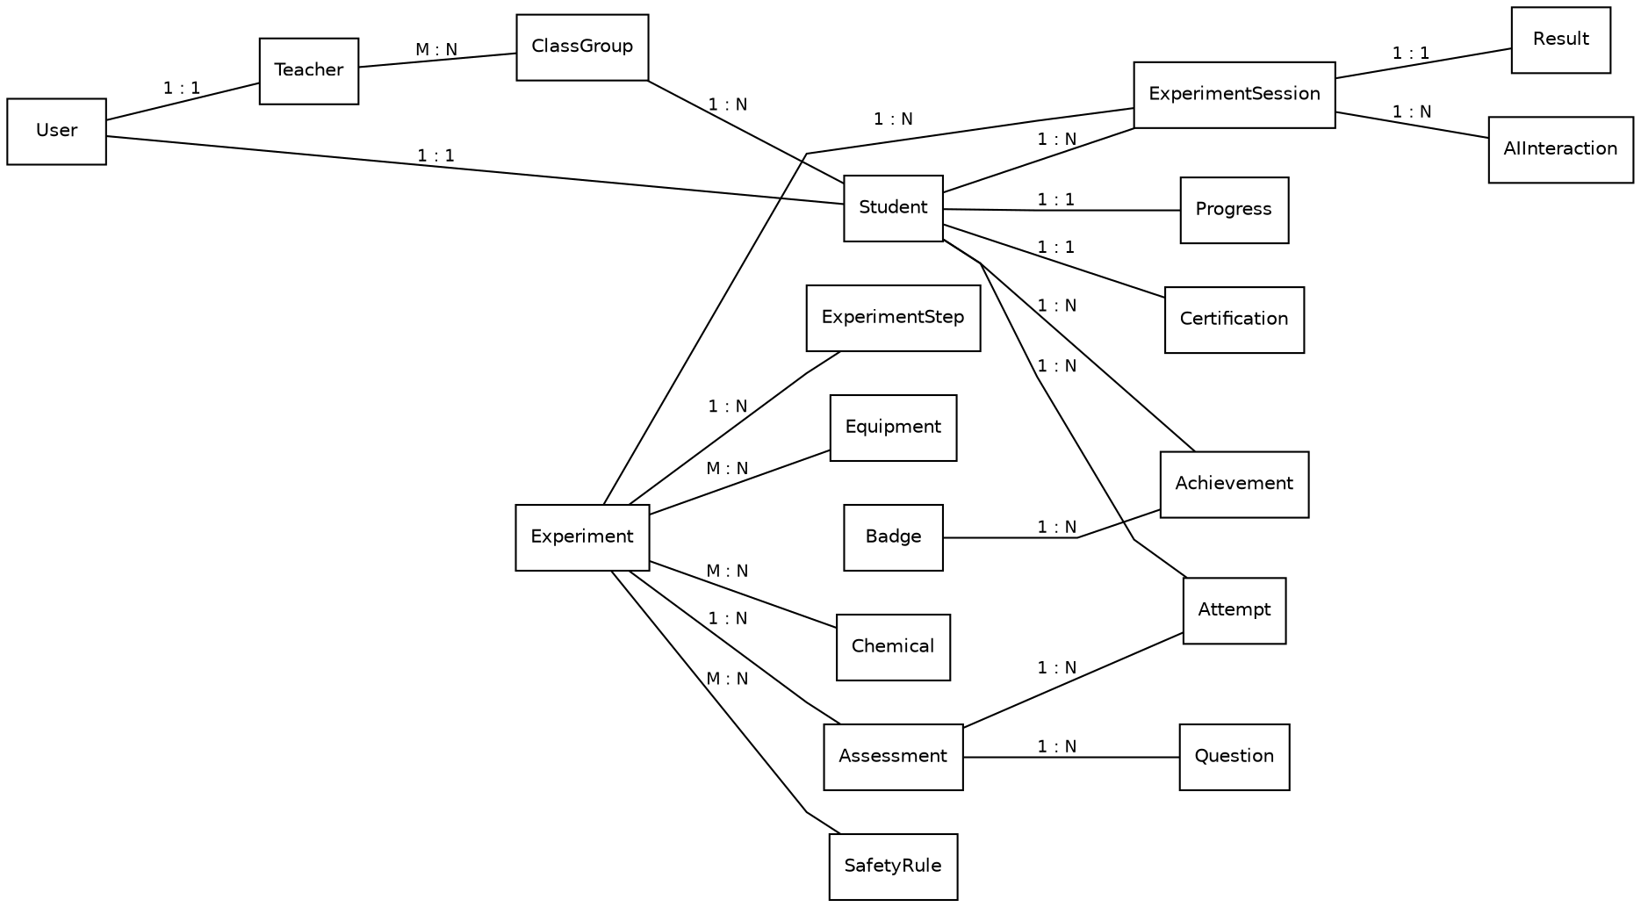
Figure 4.2: Entity relationship diagram of the Beaker Breakers Studio database.
The diagram is organised around three clusters that correspond to the system’s three concerns. The identity cluster establishes who the user is: User generalises Student and Teacher, students belong to a ClassGroup, and teachers are associated with class groups through a many-to-many relationship that reflects the reality of a teacher taking several classes and a class being taught by more than one teacher.
The content cluster establishes what may be learned. Experiment is the aggregate root: it owns its ordered ExperimentStep records, and it references the Equipment, Chemical and SafetyRule catalogues through many-to-many relationships so that shared items are defined once and reused across the library. Assessment and its Question set hang from Experiment, which is what allows readiness assessment to be experiment-specific.
The activity cluster records what actually happened. ExperimentSession is the central record, referencing both the student who performed it and the experiment performed; it produces exactly one Result and may accumulate many AIInteraction entries. Attempt records assessment activity, linking a student to an assessment. Progress, Achievement and Certification hold the durable consequences of that activity. The one-to-one cardinality on Progress and Certification is the structural expression of the rules that a student has a single progress record and at most one certification.
4.16 UML Design
4.16.1 Use Case Diagram
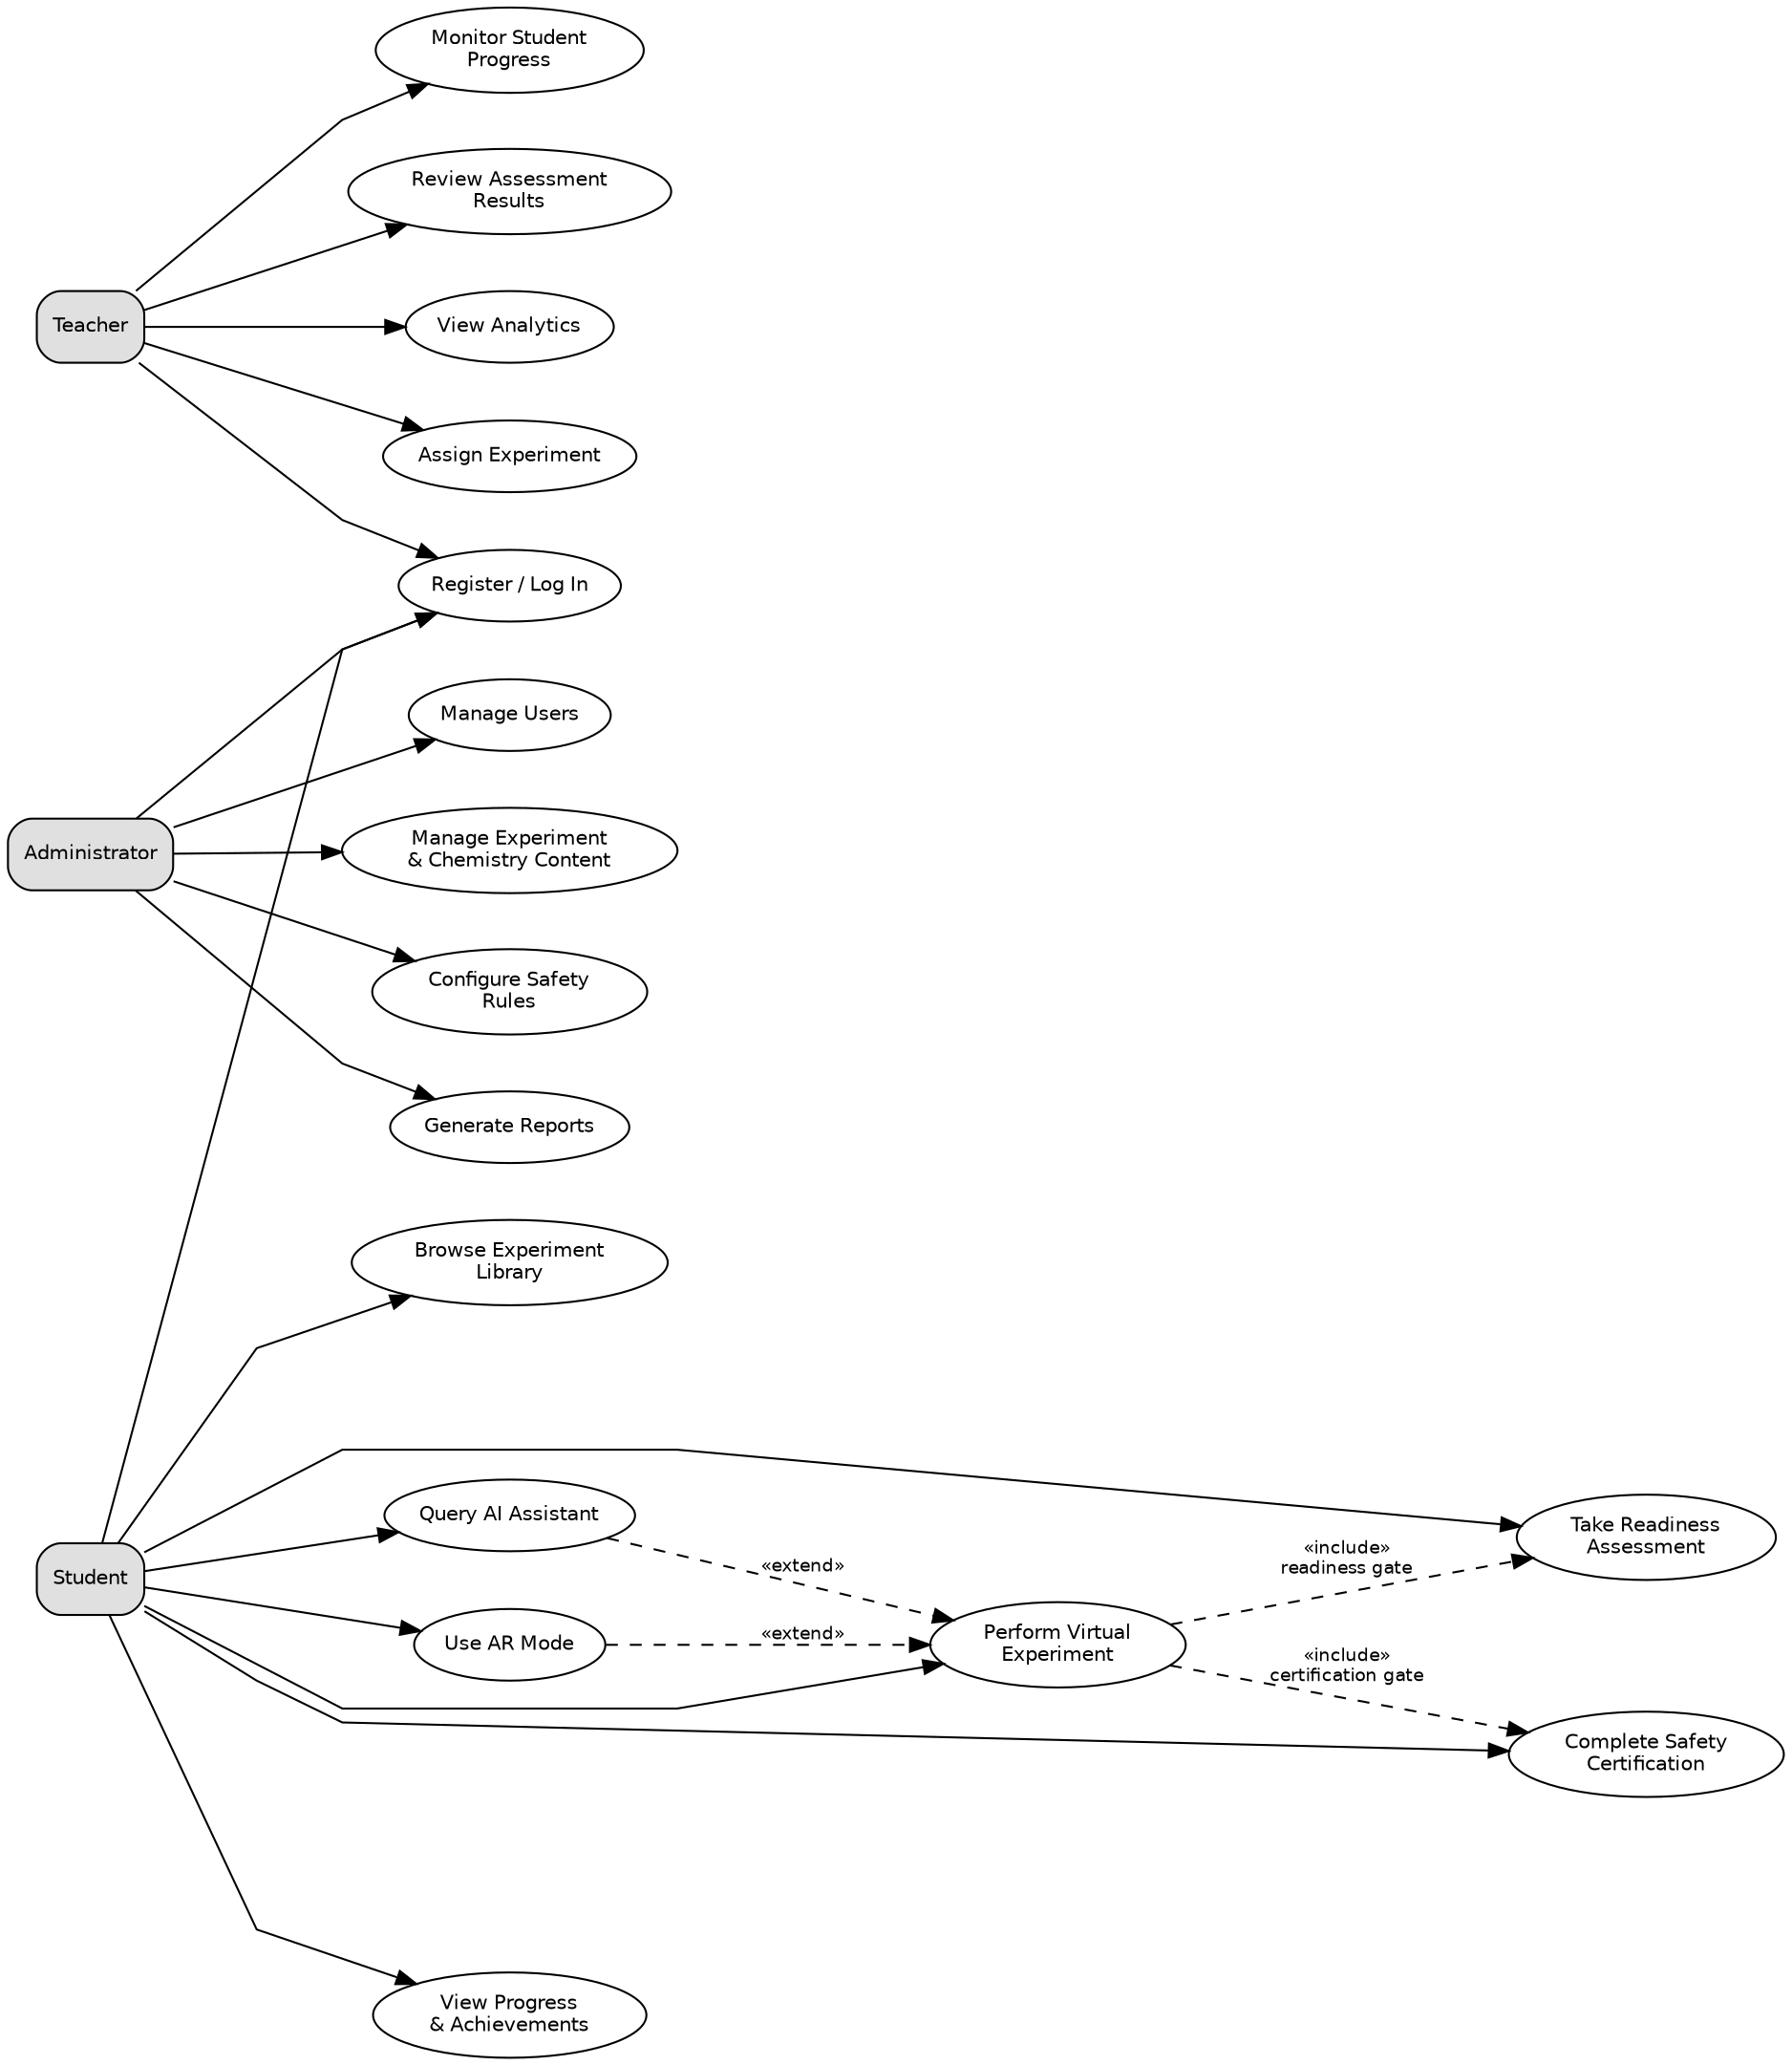
Figure 4.3: Use case diagram showing actors and major system use cases.
Three actors are identified, corresponding exactly to the three user roles defined for the system: Student, Teacher and Administrator. No further actors are introduced, and there is no anonymous public actor, because accounts are created institutionally rather than through public self-registration.
The student use cases describe the learning path from library browsing through certification, readiness assessment, experimentation and progress review. Two include relationships are shown on "Perform Virtual Experiment" because they are mandatory preconditions rather than optional additions: an experiment cannot be performed without valid safety certification and, where the experiment requires it, a passed readiness assessment. "Query AI Assistant" and "Use AR Mode" are modelled as extend relationships, since both add capability to experimentation without being required for it. Teacher use cases centre on assignment, monitoring and review within their assigned classes, while administrator use cases cover user, content, safety-rule and reporting management.
4.16.2 Class Diagram
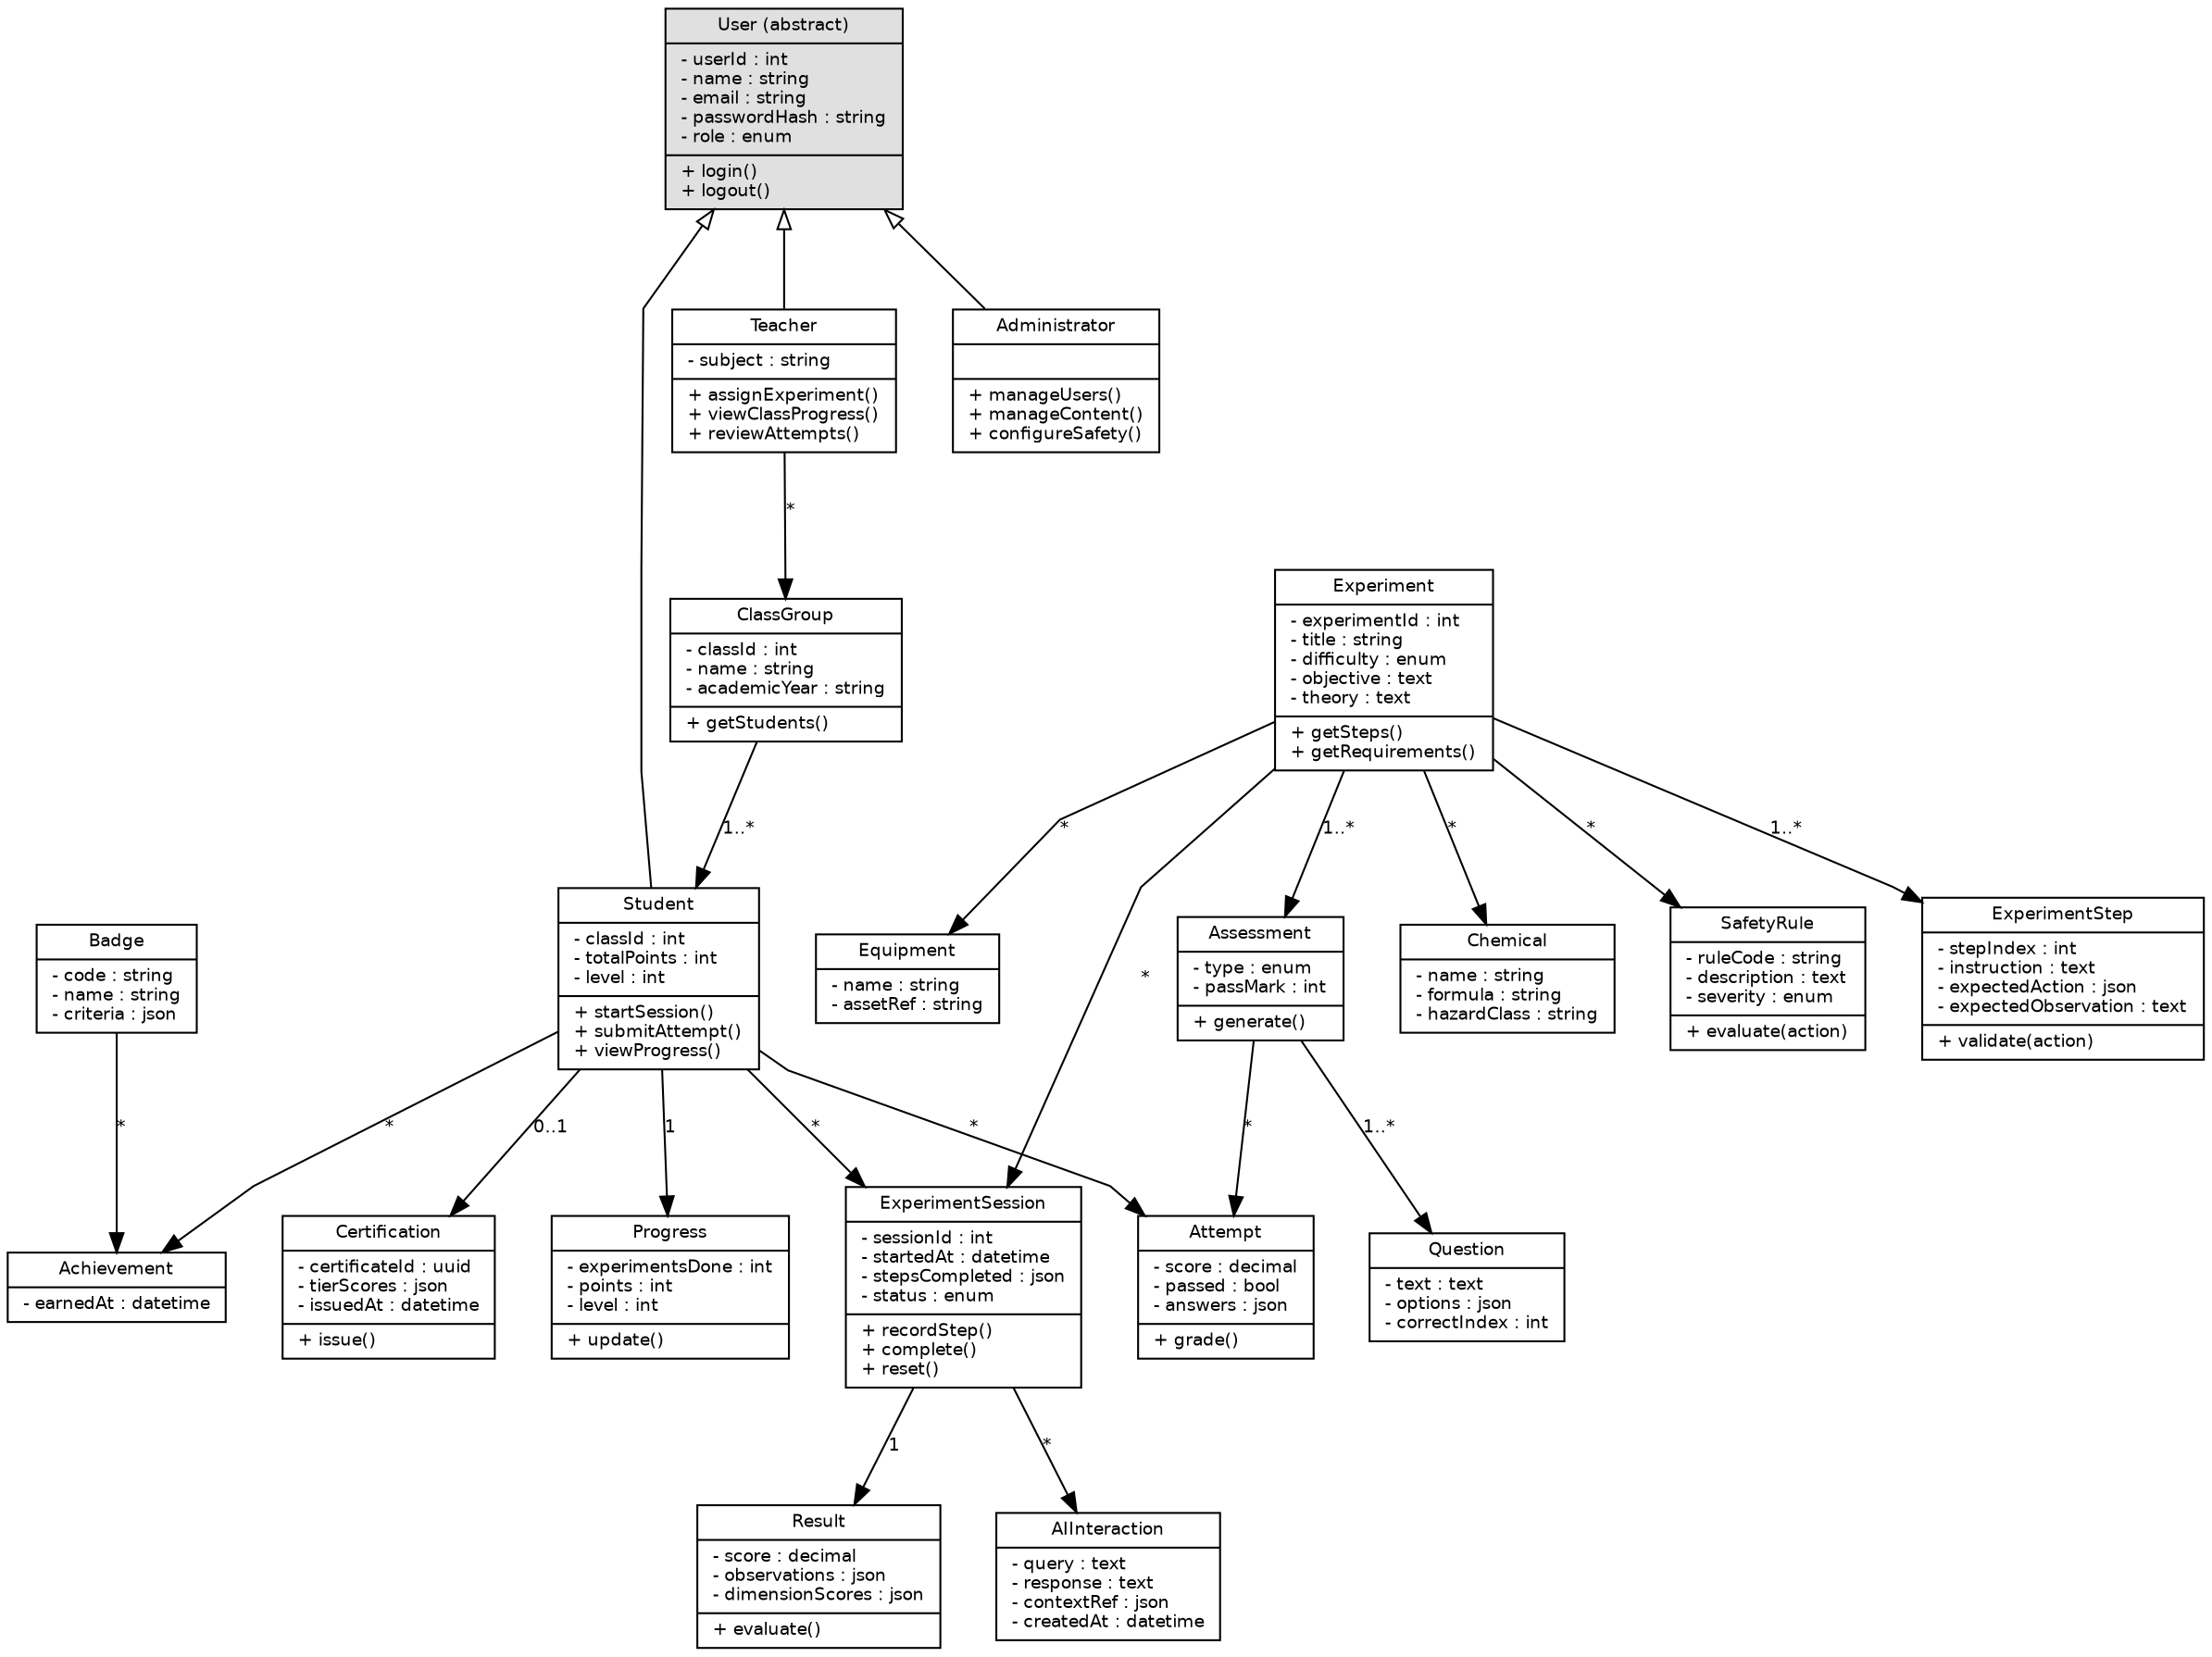
Figure 4.4: Class diagram of the principal system classes.
The class diagram realises in code structure what the entity relationship diagram expresses in data structure, and the two are deliberately consistent: every persistent entity in Figure 4.2 appears here as a class, and the multiplicities match. User is modelled as an abstract superclass with Student, Teacher and Administrator as specialisations, which localises authentication behaviour while allowing role-specific operations.
Composition is used where the lifetime of the part is bound to the whole: an ExperimentStep has no meaning without its Experiment, a Question has none without its Assessment, and a Result has none without its ExperimentSession. Association is used elsewhere, notably between Experiment and the Equipment, Chemical and SafetyRule catalogues, whose members exist independently and are shared. The operations shown are limited to those that carry domain meaning — validate, grade, evaluate, issue, recordStep — rather than routine accessors.
4.16.3 Sequence Diagrams
Three sequences are presented, selected because each crosses several subsystem boundaries and therefore specifies interaction that no single module description can convey.
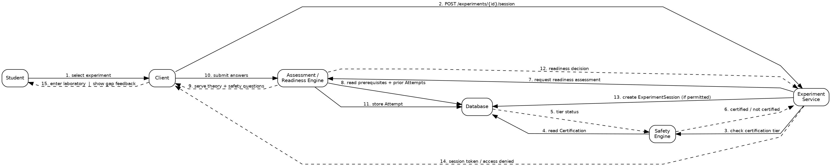
Figure 4.5: Sequence diagram — readiness assessment and experiment session creation.
Figure 4.5 shows the two gates that precede laboratory access. The experiment service consults the safety engine for certification status before anything else, then delegates to the readiness engine, which draws on prerequisites and prior attempts to compose the assessment. Grading occurs server-side, and the session is created only after the readiness decision permits it. The final message is deliberately dual: the student either enters the laboratory or receives targeted gap feedback, and both are normal outcomes rather than one being an error.
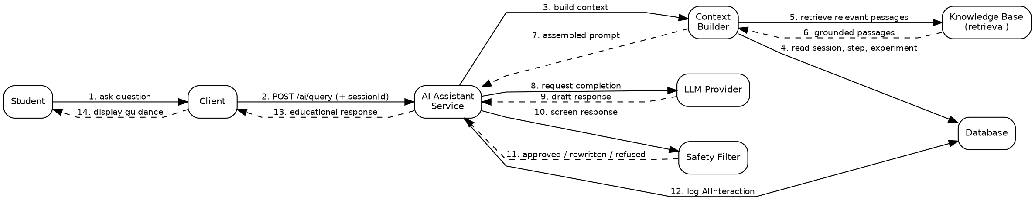
Figure 4.6: Sequence diagram — AI assistant query processing.
Figure 4.6 makes the constraint mechanisms of Section 4.9 concrete. The context builder reads the live session so that the assistant knows where the student actually is; retrieval supplies grounded material; and, critically, the language model’s draft is returned to the AI service rather than to the client, passing through the safety filter before delivery. The interaction is logged regardless of outcome, which supports both teacher oversight and later review of assistant quality.
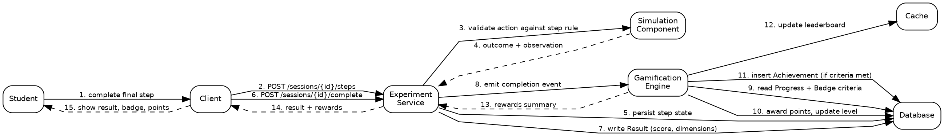
Figure 4.7: Sequence diagram — experiment completion and reward award.
Figure 4.7 shows the boundary between the experiment and gamification subsystems. The experiment service validates the final step, writes the result, and then emits a completion event; it does not itself compute rewards. The gamification engine reads the badge criteria, applies awards, and updates the leaderboard in the cache. This separation is what allows reward rules to change without modifying the laboratory.
4.16.4 Activity Diagrams
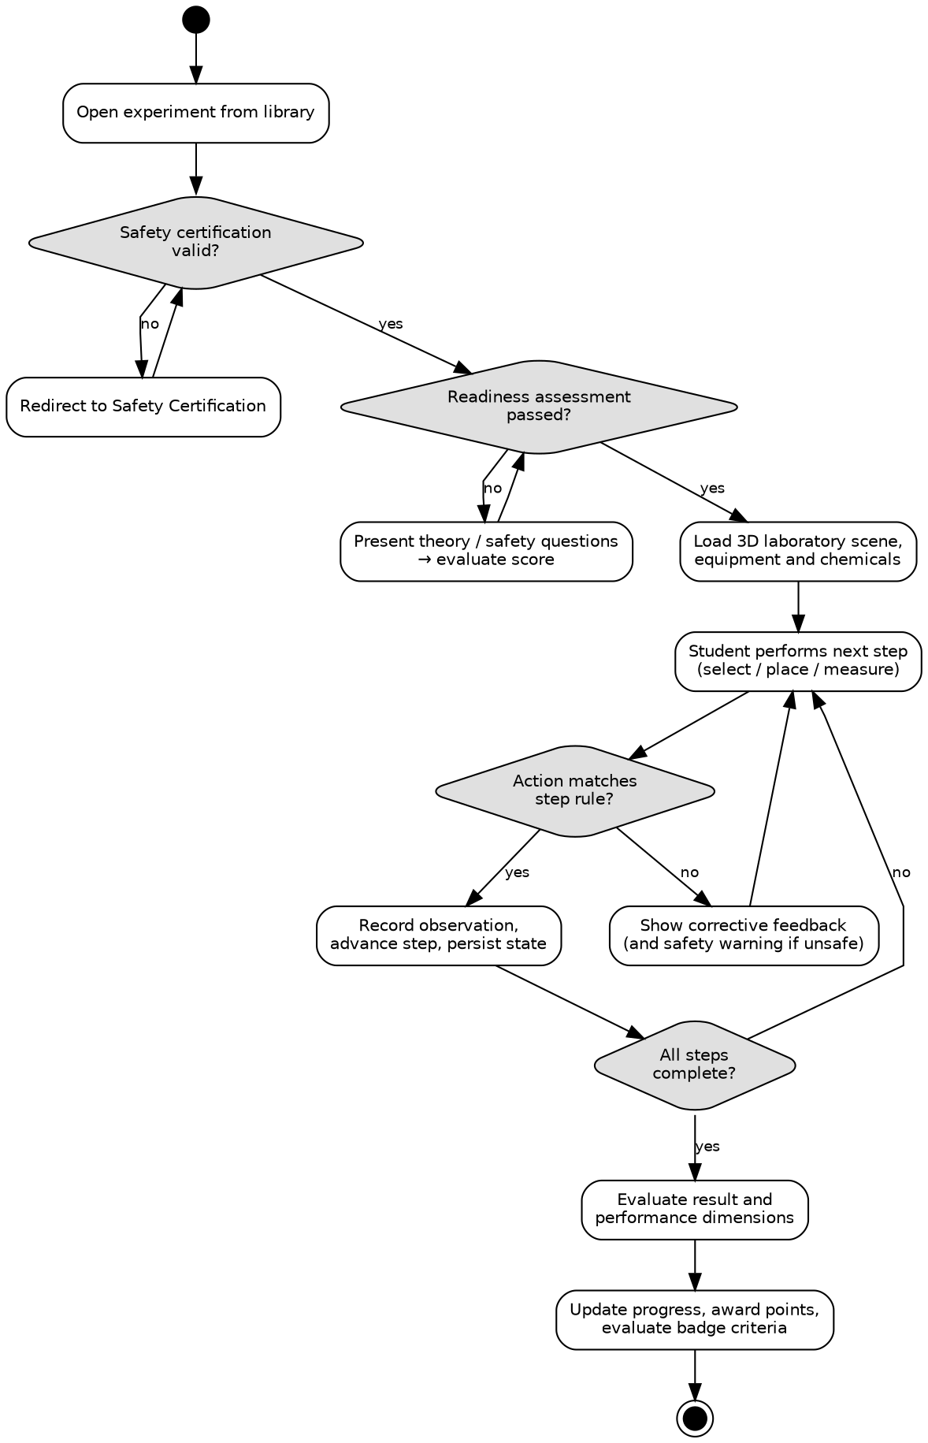
Figure 4.8: Activity diagram — performing a virtual experiment.
Figure 4.8 presents the complete experiment activity, including both gates and the per-step validation loop. Two aspects are notable. First, an incorrect action does not terminate the activity: it produces corrective feedback and returns control to the same step, which is the mechanism by which the system teaches through failure. Second, evaluation and reward occur only after all steps are complete, so partial progress does not yield partial rewards.
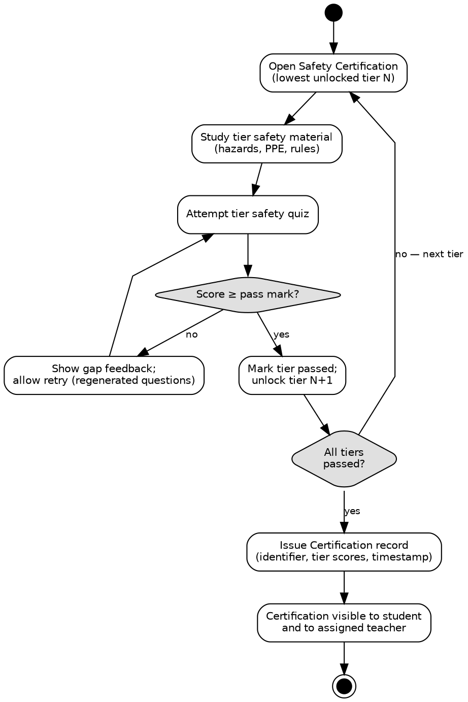
Figure 4.9: Activity diagram — safety certification.
Figure 4.9 shows the tiered certification loop. Tiers are traversed strictly in sequence, a failed tier returns the student to the same tier with regenerated questions rather than advancing them, and the Certification record is issued only when the final tier is passed. The loop back from the tier decision to tier selection is what makes the process sequential rather than parallel.
4.16.5 Component Diagram
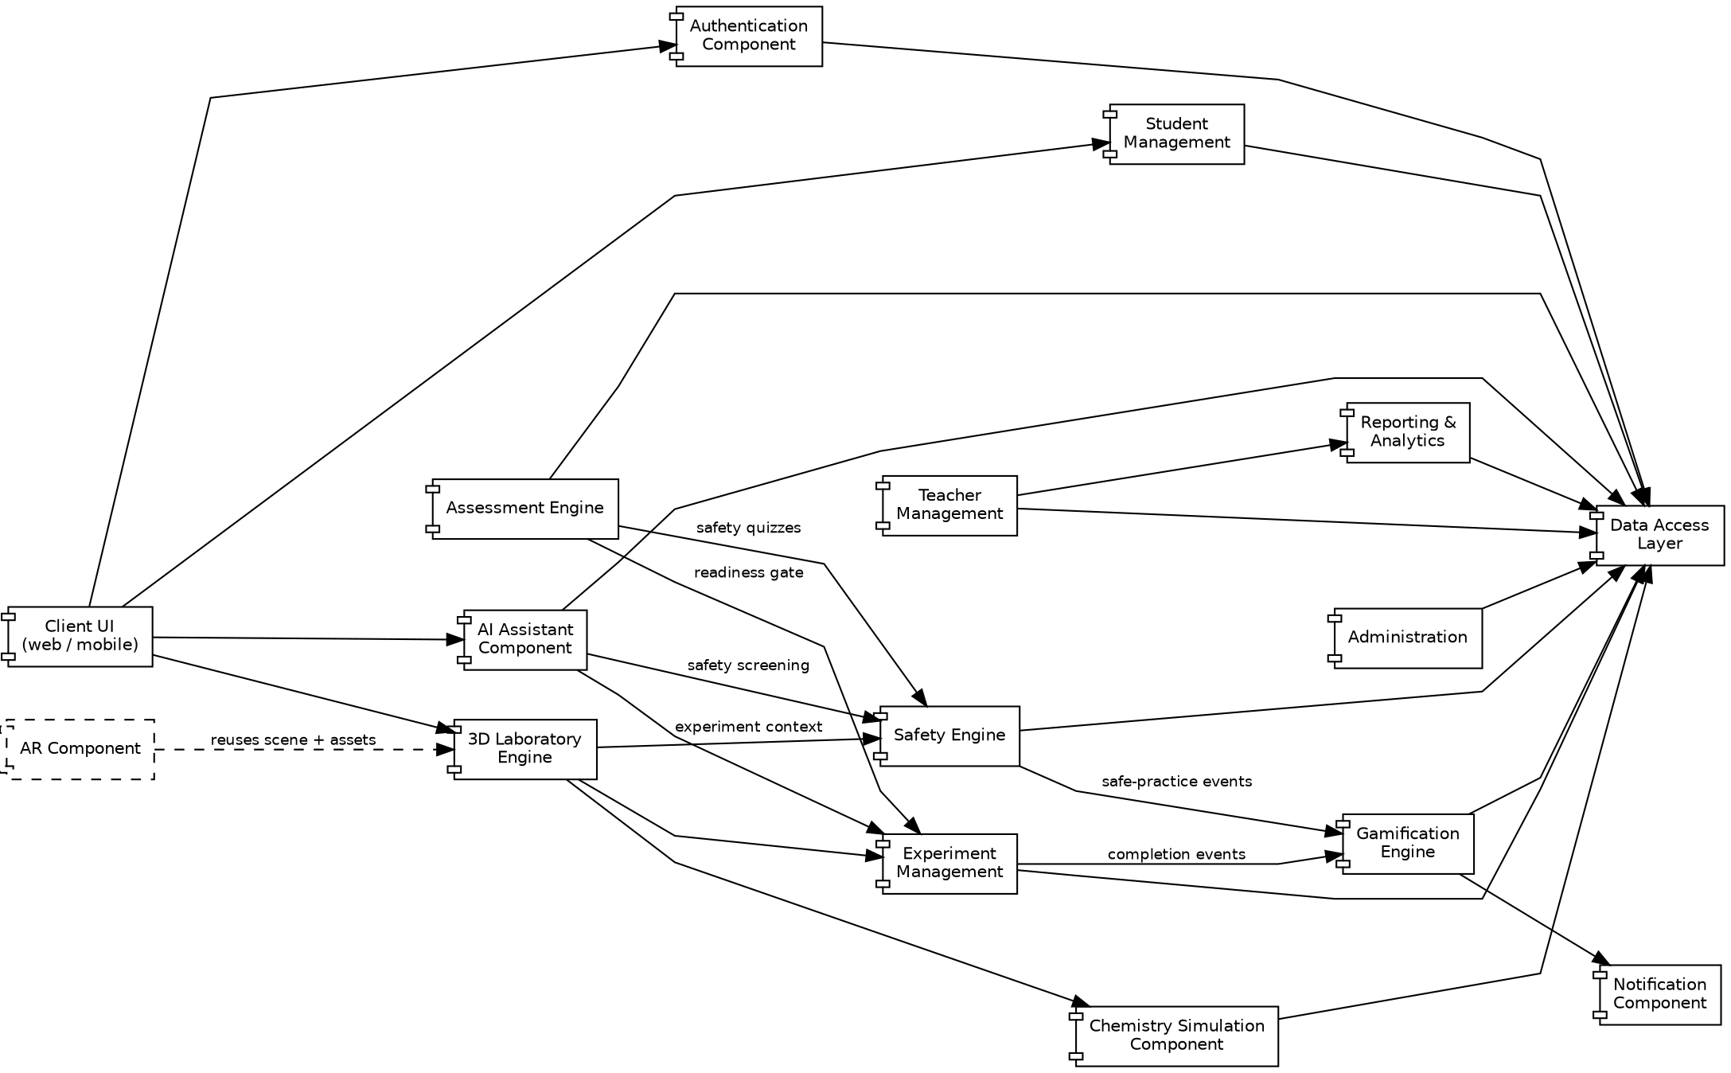
Figure 4.10: Component diagram showing components and their dependencies.
The component diagram shows dependency direction, which the layered architecture requires to be acyclic. Several relationships are worth drawing attention to. The AR component depends on the 3D laboratory engine rather than replacing it, which is the structural expression of the design decision in Section 4.13. The AI assistant depends on the safety engine, not the reverse, so that safety screening cannot be bypassed. The gamification engine is depended upon by the experiment and safety engines through events but does not itself depend on them, which keeps reward logic isolated. All persistence passes through the data access layer, so no component holds its own database connection.
4.16.6 Deployment Diagram
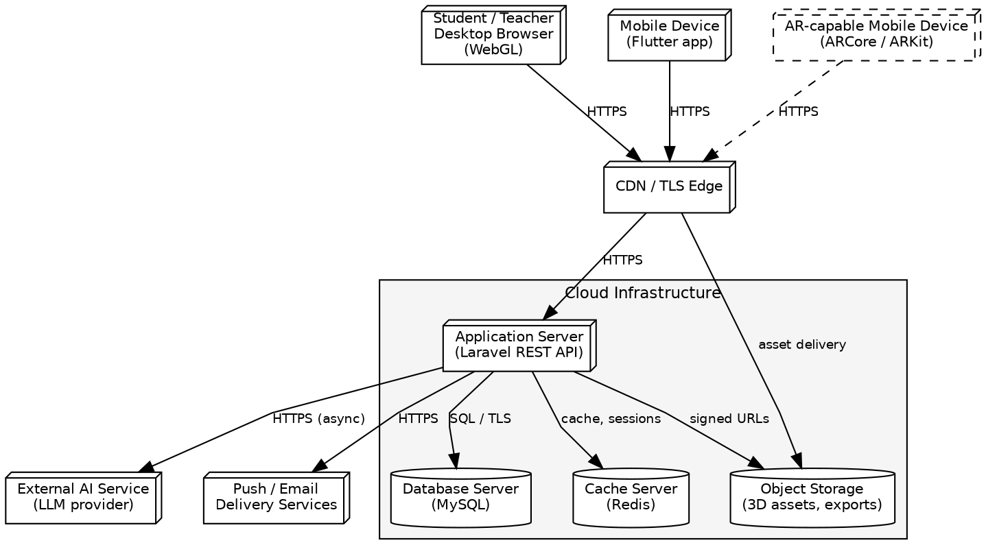
Figure 4.11: Deployment diagram showing the distribution of components across nodes.
Deployment separates four kinds of node. Client devices — desktop browsers, mobile devices and AR-capable mobile devices — execute the presentation layer and the rendering workload. A content delivery and TLS edge terminates encryption, serves cached three-dimensional assets close to the user, and forwards application requests. The cloud infrastructure holds the stateless application server together with the database, cache and object storage nodes. External services — the language-model provider and the push and email delivery services — are reached only by the application server, never directly by clients, which keeps provider credentials server-side. The AR-capable device is shown with a dashed connection to indicate that it is an optional deployment target rather than a required one.
4.17 API and Interface Design
Communication between clients and the application layer uses a REST interface over HTTPS with JSON payloads. Every endpoint other than authentication requires a valid token, and every endpoint evaluates the caller’s role before acting. The endpoints below are representative of each functional area rather than exhaustive.
Area | Representative Endpoints | Notes
Authentication | POST /auth/login  POST /auth/logout  GET /auth/me | Issues and revokes the access token; returns the authenticated profile.
Experiments | GET /experiments  GET /experiments/{id} | Library listing with filters; full definition including steps, requirements and safety rules.
Experiment sessions | POST /experiments/{id}/session  POST /sessions/{id}/steps  POST /sessions/{id}/complete  POST /sessions/{id}/reset | Session creation is subject to the certification and readiness gates. Step submission returns the validated observation.
Assessments | GET /experiments/{id}/readiness  POST /experiments/{id}/readiness  POST /assessments/{id}/attempt | Serves and grades readiness and safety assessments; grading is server-side only.
AI assistant | POST /ai/query | Accepts a question with session context; returns a screened response.
Safety | GET /safety/chemicals/{id}  GET /safety/rules?experimentId=  GET /safety/certification | Hazard data, applicable rules and current certification status.
Progress | GET /progress  GET /progress/history | Cumulative progress and per-experiment history for the authenticated student.
Gamification | GET /gamification/summary  GET /gamification/leaderboard | Points, level and achievements; class leaderboard limited to display fields.
Teacher | GET /teacher/classes  GET /teacher/students/{id}/progress  POST /teacher/assignments  GET /teacher/analytics | All teacher endpoints are scoped server-side to the caller’s assigned classes.
Administration | GET/POST/PUT/DELETE /admin/users  GET/POST/PUT /admin/experiments  PUT /admin/safety-rules  GET /admin/reports | Administrative operations; each write is recorded in the audit log.
Table 4.10: Representative API endpoints by functional area.
Two conventions apply throughout. Standard HTTP status codes carry outcome semantics — 200 for success, 201 for creation, 401 for missing or invalid authentication, 403 for an authorised user attempting an action outside their role or scope, 422 for validation failure and 404 for a missing resource. And no endpoint accepts a client-computed score, verdict or reward; such values are always derived server-side from submitted answers or actions.
4.18 User Interface Design
The interface is designed for secondary-level students who may have limited prior experience of laboratory software, and for teachers and administrators who need dense information quickly. These are different needs, and the design addresses them differently: student screens are guided and visual, while teacher and administrator screens are tabular and information-dense.
Screen | Purpose and Key Design Considerations
Login / Register | Role-appropriate entry with inline validation. Errors are generic to avoid disclosing which field was wrong.
Student Dashboard | Orientation point: current progress, certification status, assigned experiments and next recommended action.
Experiment Library | Filterable catalogue with difficulty and topic indicators; locked experiments are visibly distinguished with the reason stated.
Experiment Details | Objective, theory, required equipment and chemicals, and safety requirements shown before entry so the student knows what is expected.
Virtual Laboratory | The primary working surface: scene view, current-step instruction, progress indicator and persistent access to the AI assistant and safety information.
AI Assistant | Non-modal panel adjacent to the laboratory so that asking a question does not interrupt the experiment.
Safety Warning | Contextual interruption proportionate to severity; states the specific risk and the correct action rather than a generic caution.
Readiness Assessment | Clear framing that this is a gate, with per-area feedback on failure so the student knows what to revise.
Results | Outcome, recorded observations, per-dimension performance and any rewards earned.
Progress Dashboard | Longitudinal view: experiments completed, dimension trends and certification tier reached.
Badges and Achievements | Earned and unearned badges with criteria shown, so that rewards are goals rather than surprises.
Teacher Dashboard | Class overview, students requiring attention, assignment controls and analytics entry points.
Administrator Dashboard | User, content and safety-rule management, system configuration and reporting.
Table 4.11: Principal user interface screens.
Three principles apply across all screens. Every screen states the user’s current position and offers an explicit next action, so that a student is never left uncertain about what to do. Feedback is immediate and specific: an incorrect action produces an explanation rather than a rejection. And the laboratory retains a consistent frame — instruction, scene, progress and assistance always occupy the same regions — so that attention can remain on the chemistry rather than on the interface.
4.19 Security Design
Concern | Design Measure
Authentication | Token-based authentication. A signed token is issued on successful login, carried on subsequent requests and validated on each one; tokens expire and are invalidated on logout and on password change.
Authorisation | Enforced server-side on every protected request. The client never determines what a user may do; it only reflects what the server permits.
Role-based access control | Three roles with disjoint permissions. Teacher access is further scoped to assigned classes, so that role alone is not sufficient authority.
Password protection | Passwords are stored only as salted hashes produced by an adaptive hashing function. Plaintext passwords are never stored, logged or returned.
Session and token security | Tokens are transmitted only over TLS and stored by clients in the most restrictive mechanism the platform provides. Expiry is enforced server-side.
Transport security | All traffic uses HTTPS; plaintext requests are redirected rather than served.
API security | Rate limiting on authentication endpoints to impede brute-force attempts; consistent generic error responses that do not disclose whether an account exists.
Input validation | All input is validated server-side against declared rules regardless of any client-side validation, which is treated as a usability feature only.
Database security | Parameterised queries through the data access layer to prevent injection; least-privilege database credentials; the database is not directly reachable from clients.
Privacy | Student data is used for educational purposes only and is not shared with third parties. AI queries transmitted to the external provider carry experiment context but not personal identifiers.
Audit logging | Administrative actions, authentication events and certification issuance are written to an append-only audit log recording actor, action, target and timestamp.
Table 4.12: Security design measures.
4.20 Performance and Scalability Design
The system must support many students working concurrently, with the heaviest load occurring when a whole class enters the laboratory simultaneously. The design addresses this through work placement, caching and query discipline rather than through hardware alone.
- 3D asset optimisation: models are supplied at polygon counts and texture resolutions appropriate to the target hardware, with reduced variants for mobile and AR presentation.
- Asset loading: assets are requested only for the equipment and chemicals declared by the active experiment, are loaded progressively so that interaction can begin before the scene is fully detailed, and are served from the content delivery network rather than the application server.
- Caching: session tokens, leaderboard orderings and previously generated AI responses are held in the cache. AI response caching is particularly effective because many students ask similar questions at the same step of the same experiment.
- Database indexing: indexes are defined on the foreign keys and filter columns that carry the recurring query load — sessions by student, attempts by student and assessment, and progress by class.
- Pagination: all collection endpoints are paginated, so that a large class or a long experiment history cannot produce an unbounded response.
- API optimisation: related data is retrieved eagerly where a view is known to need it, avoiding the repeated per-row queries that would otherwise arise when rendering class-wide tables.
- Asynchronous AI requests: language-model calls are issued without blocking the laboratory interaction, so that a slow response degrades assistance rather than the experiment itself.
- Cloud scalability: because the application tier is stateless, additional instances may be added behind the load balancer without session affinity.
- Efficient storage: large binary assets reside in object storage rather than the database, keeping the relational store small and its backups fast.
- Mobile and AR performance: reduced asset variants, capped scene complexity and capability-based feature reduction as described in Section 4.13.3.
No performance figures are quoted here. Throughput and latency targets belong to the requirements specification, and measured results can only be reported after implementation and testing.
4.21 Error Handling and Validation
Condition | Designed Response
Invalid login | Generic failure message that does not indicate which credential was wrong; failed attempts counted and rate-limited.
Invalid assessment response | Rejected with field-level validation feedback; the attempt is not graded until the submission is well-formed.
Experiment error (invalid step action) | Treated as a learning event, not a system error: corrective feedback is returned, the step remains active, and the student retries.
Invalid or out-of-order user action | Rejected with an explanation of the expected action; a safety warning is raised additionally if the action violates a safety rule.
AI service failure or timeout | The assistant returns a pre-authored fallback message for the current step. The experiment remains fully usable; assistance degrades but the laboratory does not.
Database failure | The request fails with a server error and is logged; no partial write is committed, as multi-step operations are transactional.
Network failure | Client retries idempotent requests; unsent step submissions are queued and the student resumes from the last persisted step on reconnection.
Unsupported AR device | Not treated as an error. Capability detection precedes AR initialisation and the student continues in the standard laboratory (Section 4.13.2).
Missing experiment data | The experiment is withheld from the library rather than presented and failing on entry; the administrator is alerted through the reporting interface.
Table 4.13: Error conditions and designed responses.
4.22 Accessibility and Usability Design
- Responsive layout: the interface adapts from desktop to tablet and mobile, since school access may come through any of these.
- Readable typography: type sizes and contrast are chosen for legibility on low-cost displays and projected classroom screens.
- Clear instruction: each laboratory step states one action in plain language, avoiding compound instructions that are easy to perform partially.
- Accessible controls: interactive targets are sized for touch as well as pointer input, with adequate spacing to reduce mis-taps.
- Keyboard and mouse interaction: laboratory actions that can be performed by direct manipulation are also reachable through a step-selection control, so that interaction does not depend solely on precise dragging.
- Mobile support: full student functionality is available on mobile; the interface reorganises rather than removing capability.
- Visual feedback: every accepted action produces immediate visible acknowledgement, and every rejected action produces an explanation.
- Alternative interaction: AR is always optional, and colour is never the only channel carrying meaning — status is conveyed by label or icon in addition to colour.
4.23 Design Constraints and Assumptions
The following constraints and assumptions bound the design. They are stated explicitly because they determine what the implementation can reasonably be expected to deliver.
4.23.1 Constraints
- Chemical reactions are represented through authored step definitions and are not simulated at molecular or kinetic level. The system does not claim physically accurate chemical simulation (Section 4.7.1).
- Measurement values returned during an experiment are authored rather than computed from a physical model.
- Augmented reality is available only on devices providing a supported tracking framework with adequate camera, sensors and processing capacity; a uniform AR experience across devices cannot be guaranteed.
- Unsafe-action detection is limited to conditions that have been declared as safety rules; undeclared unsafe behaviour cannot be detected.
- AI assistant behaviour is bounded by the configured model and the curated knowledge base. Grounding and screening reduce but do not eliminate the possibility of an incorrect response.
- Internet connectivity is required for authentication, session persistence, AI assistance and cloud-delivered assets.
- The system is scoped to secondary-level chemistry; other subjects and levels are outside this design.
4.23.2 Assumptions
- Students have access to a device meeting the minimum client requirements and to a network connection sufficient for asset loading.
- Accounts are created institutionally by an administrator; there is no public self-registration.
- Experiment content and safety rules are authored and reviewed by qualified subject staff before publication.
- The external language-model provider and delivery services remain available under terms compatible with educational use.
- Each student is assigned to exactly one class group at a time.
4.24 Chapter Summary
This chapter has converted the requirements of Beaker Breakers Studio into an implementable technical design. A three-tier client–server architecture with a layered, modular application tier was selected on the basis of the system’s actual characteristics: rendering must occur on the client, authority must remain on the server, and the deployment target is a single platform rather than an estate of independently scaled services.
The virtual chemistry laboratory was designed as the central component and, deliberately, as a guided scripted simulation rather than a computational chemistry solver — a decision justified both by feasibility within the project scope and by the pedagogical determinism it guarantees. Around that core, the supporting subsystems were designed to reinforce rather than dilute it: the safety subsystem enforces certification as a structural gate and distinguishes information, warning, assessment and certification as separate concepts; the readiness assessment applies configurable, experiment-specific criteria before laboratory access; the AI assistant is constrained by retrieval grounding, a curated knowledge base and an independent rule-based safety filter, and is excluded from any role in computing formal records; gamification rewards thoroughness and safe practice rather than speed; and augmented reality is an optional presentation of the same scene, with fallback treated as a design requirement rather than an error path.
The data model was normalised and aligned entity-for-entity with the class diagram and the module descriptions, with its two denormalisations documented and justified. The interface design specifies a REST contract in which no client-supplied score or verdict is trusted, and the security, performance, error-handling and accessibility designs address the cross-cutting concerns that no single module owns. The reusable experiment framework of Section 4.8 is what makes the thirty-experiment requirement tractable, reducing each additional experiment to a content-authoring task rather than a development task.
Taken together, the architecture, module decomposition, database schema, interface contracts and subsystem designs presented in this chapter constitute a specification sufficient for implementation to begin. The implementation of that design, and its subsequent testing and evaluation, are the subject of the chapters that follow.

