Beaker Breakers Studio
AI-Powered Gamified Virtual Chemistry Laboratory Portal
with Augmented Reality for Secondary Schools
Team ID – DCS-SP23-01
BSCS / BSSE
Session: 2023–2027
Project Supervisor: Dr. Waqas Ahmed
Co-Supervisor: Ms. Mehk Fatima
Submitted By
Rabail Mehboob BSCS012313003
Syed Mohsin Abbas BSSE012313006
Department of Computer Science
The University of Chenab, Gujrat

STATEMENT OF SUBMISSION
We hereby declare that all the work presented in the project “Beaker Breakers Studio: AI-Powered Gamified Virtual Chemistry Laboratory Portal with Augmented Reality for Secondary Schools” is the result of the effort performed by us under the supervision of Ms. Mehk Fatima. The objective of this project is to provide secondary school students with a safe, accessible and interactive environment in which practical chemistry can be learned without dependence on a physical laboratory, and to give teachers objective evidence of each student's readiness for real laboratory work.

_______________________________
Project Office Supervisor

PROOFREADING CERTIFICATE
It is to certify that I have read the document meticulously and circumspectly. I am convinced that the resultant project does not contain any spelling, punctuation or grammatical mistakes as such. All in all, I find this document well organised and I am in no doubt that its objectives have been successfully met.

_______________________________
Dr. Waqas Ahmed
(Supervisor)

ACKNOWLEDGEMENT
In the name of ALLAH, the most kind and most merciful.
We would like to thank our parents, who supported us throughout this work both financially and morally, and our friends, who were present whenever we needed help in overcoming the difficulties we faced.
We would also like to thank our project supervisor, Ms. Mehk Fatima, for her guidance and for encouraging us to work hard and to work carefully. We found her very helpful in discussing the design and requirement issues encountered in this work, and her critical comments led us to reconsider and improve several parts of the system. We are equally grateful to our co-supervisor, Dr. Waqas Ahmed, for his review of the system architecture and of the artificial intelligence integration.
We further thank the students who attended our open house demonstration at The University of Chenab and shared their own school experiences of practical chemistry with us. Their responses confirmed that the problem we set out to address is both real and widely shared.
Finally, we thank our seniors from earlier batches and our faculty members, who guided us at every step. Without their help we would not have been able to come this far.

ABSTRACT
Practical work is central to the learning of chemistry at secondary level, yet a large proportion of schools are unable to provide it. Laboratories are expensive to establish and to maintain, reagents are consumed on every trial, hazardous substances carry real risk for young students, and in many schools no functioning laboratory exists at all. The result is that a significant number of students complete their secondary education having studied chemistry entirely in theory.
Beaker Breakers Studio is an AI powered, gamified virtual chemistry laboratory portal with augmented reality support, designed for secondary schools. The system will provide no fewer than thirty curriculum aligned experiments that a student performs step by step in a virtual environment. Before any experiment can be opened, the student must complete a mandatory four tier safety training programme, each tier requiring a score of at least eighty percent, after which a digital safety certificate is issued. During an experiment an AI assistant, presented through an avatar, will provide contextual guidance at each step through the Gemini API, and will fall back to pre authored guidance if the service is unavailable. Experiments may additionally be viewed in an augmented reality story telling mode using an ordinary smartphone camera, with an automatic simulated presentation on devices that do not support it.
The system will evaluate each student across six performance dimensions and will allow a teacher to generate an AI readiness report classifying the student as Not Ready, Approaching Readiness, or Ready for Real Lab. A gamification layer of experience points, badges, rank levels, class leaderboards and daily missions is designed to reward thorough and safe practice rather than speed. Teachers will monitor their classes, assign experiment tasks and broadcast notifications, while administrators will manage enrolment, classes, the experiment library, certificates and school wide reporting.
The platform will be built on a three tier architecture consisting of React and Next.js web clients, a Flutter mobile application, a Laravel REST API application tier, and a MySQL and Redis data tier hosted on cloud infrastructure. Beaker Breakers Studio therefore offers schools that cannot afford or safely operate a physical chemistry laboratory a practical, affordable and verifiable means of delivering practical chemistry education.

TABLE OF CONTENTS
Table of Contents
1. Introduction 1
1.1 Statement of the Problem 1
1.2 Scope of the Project 2
1.3 Aims and Objectives of the Project 2
1.4 Nature of the End Product 2
2. Literature Review 4
2.1 Review of Related Technologies 4
2.1.1 Virtual Laboratory Simulation 4
2.1.2 Augmented Reality 4
2.1.3 Large Language Models and the Gemini API 4
2.1.4 Gamification in Education 4
2.1.5 Three Dimensional Rendering in the Browser 5
2.1.6 Progressive Web Application Technology 5
2.1.7 Cloud Infrastructure and Real Time Communication 5
2.2 Review of Related Projects 5
2.2.1 Labster 5
2.2.2 PhET Interactive Simulations 5
2.2.3 PraxiLabs 5
2.2.4 OLabs 6
2.2.5 Mobile Chemistry Games 6
2.2.6 Comparative Analysis 6
3. Requirement Specifications 10
3.1 Requirement gathering procedure 10
3.1.1 System Identification: 10
3.1.2 System Scope 10
3.1.3 Requirement Elicitation: 11
3.2 Requirements 15
3.2.1 Intended User 15
3.2.2 Functional Requirements 15
3.2.3 Non-Functional requirements 21
3.2.4 Hardware Requirements 22
3.2.5 Software Requirements 23
4. System Design 25
4.1 Designing Tools and Languages 25
4.2 System Design 26
4.2.1 Flow Chart 27
4.2.2 System Context Diagram 28
4.2.3 Use Case Diagrams 29
4.2.4 Use Case Descriptions 35
4.2.5 Class Diagram 48
4.2.6 Sequence Diagrams 49
4.2.7 Block Diagram 50
4.2.8 Component Diagram 51
4.2.9 Deployment Diagram 52
4.2.10 Activity Diagrams 52
4.2.11 State Machine Diagrams 57
4.2.12 Data Flow Diagrams 60
4.2.13 Entity Relationship Diagram 62
4.2.14 Data Dictionary 63
4.2.15 User Interface Design and Wireframes 65
4.2.16 User Experience Measure 81
4.3 Design Decisions and Rationale 82
4.4 Design Traceability 83
4.5 Summary 84

TABLE OF FIGURES
Figure 1 System flow chart 27
Figure 2 System context diagram 28
Figure 3 Use case diagram: authentication and account access 30
Figure 4 Use case diagram: safety certification 30
Figure 5 Use case diagram: performing a virtual experiment 31
Figure 6 Use case diagram: teacher class management 32
Figure 7 Use case diagram: AI readiness reporting 33
Figure 8 Use case diagram: gamification, missions and leaderboard 34
Figure 9 Use case diagram: administration and reporting 35
Figure 10 Class diagram 48
Figure 11 Sequence diagram: readiness check and experiment session creation 49
Figure 12 Sequence diagram: AI assistant query 49
Figure 13 Sequence diagram: experiment completion and reward award 50
Figure 14 Block diagram of the system architecture 50
Figure 15 Component diagram showing the components of each tier and their interfaces 51
Figure 16 Deployment diagram showing the nodes on which the system will run 52
Figure 17 Activity diagram with swimlanes: safety certification 53
Figure 18 Activity diagram with swimlanes: performing a virtual experiment 54
Figure 19 Activity diagram with swimlanes: augmented reality experiment session 55
Figure 20 Activity diagram with swimlanes: AI readiness report generation 56
Figure 21 Activity diagram with swimlanes: teacher task assignment 57
Figure 22 State machine diagram: task lifecycle 58
Figure 23 State machine diagram: safety certification 59
Figure 24 Data flow diagram, Level 0 60
Figure 25 Data flow diagram, Level 1 61
Figure 26 Entity relationship diagram 62
Figure 27 Navigation map of the student, teacher and administrator interfaces 67
Figure 28 Wireframe S-17: Administrator management screens for students, teachers and classes 68
Figure 29 Wireframe S-16: Administrator dashboard 69
Figure 30 Wireframe S-15: Notifications screen for teachers and administrators 69
Figure 31 Wireframe S-14: Teacher safety review screen 70
Figure 32 Wireframe S-13: Teacher task assignment screen 71
Figure 33 Wireframe S-12: Teacher AI readiness reports screen 71
Figure 34 Wireframe S-11: Teacher class monitor screen 72
Figure 35 Wireframe S-10: Teacher dashboard 73
Figure 36 Wireframe S-09: Student augmented reality mode screen 73
Figure 37 Wireframe S-08: Student profile screen 74
Figure 38 Wireframe S-07: Student leaderboard screen 75
Figure 39 Wireframe S-06: Student safety training screen 75
Figure 40 Wireframe S-05: Student knowledge quiz screen 76
Figure 41 Wireframe S-04: Student experiment runner screen 77
Figure 42 Wireframe S-03: Student experiment detail screen 77
Figure 43 Wireframe S-02: Student experiment library screen 78
Figure 44 Wireframe S-01: Student home dashboard 79
Figure 45 Error and edge-case states with the corresponding system behaviour 79
Figure 46 Administrator student onboarding flow 81
Figure 47 Screen navigation map with wireframe identifiers 81
Figure 48 Wireframe S-18: Administrator certificates and reports screen 81

TABLE OF TABLES
Table 1 Comparison of Beaker Breakers Studio with existing platforms. 6
Table 2 Principal findings of the structured survey (N = 13). 12
Table 3 Feature preferences reported by survey respondents (N = 13). 12
Table 4 Intended users of the proposed system. 15
Table 5 Functional requirements for authentication and account management. 15
Table 6 Functional requirements for safety certification. 16
Table 7 Functional requirements for experiment management. 17
Table 8 Functional requirements for experiment management. 17
Table 9 Functional requirements for augmented reality mode. 18
Table 10 Functional requirements for gamification, leaderboard and missions 18
Table 11 Functional requirements for AI readiness reporting. 19
Table 12 Functional requirements for teacher class management. 19
Table 13 Functional requirements for administration and reporting. 20
Table 14 Non-functional and security requirements. 21
Table 15 Hardware requirements for development, deployment and end-user access. 23
Table 16 Software requirements for development and deployment. 23
Table 17 Design tools and languages. 25
Table 18 The twenty eight use cases, grouped by functional area. 29
Table 19 Use case description, UC-01 Log In. 35
Table 20 Use case description, UC-02 Safety Certification. 36
Table 21 Use case description, UC-02.1 Attempt Tier Assessment. 36
Table 22 Use case description, UC-02.2 Receive Safety Certificate. 37
Table 23 Use case description, UC-03 Perform Virtual Experiment. 37
Table 24 Use case description, UC-04 AR Mode Session. 38
Table 25 Use case description, UC-05 Generate AI Readiness Report. 38
Table 26 Use case description, UC-06 Assign Task. 39
Table 27 Use case description, UC-06.1 Track Task Status. 39
Table 28 Use case description, UC-07 Reset Password. 40
Table 29 Use case description, UC-08 Browse Experiment Library. 40
Table 30 Use case description, UC-09 Take Knowledge Quiz. 41
Table 31 Use case description, UC-10 Earn Rewards. 41
Table 32 Use case description, UC-11 Daily Missions and Streaks. 42
Table 33 Use case description, UC-12 View Leaderboard. 42
Table 34 Use case description, UC-13 View Own Readiness Status. 42
Table 35 Use case description, UC-14 Monitor Class. 43
Table 36 Use case description, UC-15 Broadcast Notification. 43
Table 37 Use case description, UC-16 Review Class Reports. 44
Table 38 Use case description, UC-17 Manage User Accounts. 44
Table 39 Use case description, UC-18 Bulk Import Students. 45
Table 40 Use case description, UC-19 Manage Classes. 45
Table 41 Use case description, UC-20 Configure Experiment Library. 45
Table 42 Use case description, UC-21 Manage Certificate Registry. 46
Table 43 Use case description, UC-22 Generate Analytics and Export Reports. 46
Table 44 Use case description, UC-25 Receive AI Step Guidance. 47
Table 45 Use case description, UC-26 Verify Student Certificates. 47
Table 46 Use case description, UC-27 Record Audit Entry. 47
Table 47 Data dictionary for the nineteen entities of the design. 63
Table 48 Human computer interaction principles applied to the interface design. 65
Table 49 User experience measures and their verification. 81
Table 50 Key design decisions and their rationale. 82
Table 51 Mapping of design figures to the requirements of Chapter 3. 83

Introduction

Introduction
Chemistry education at secondary level depends heavily on practical laboratory work. Understanding a reaction is not the same as having performed it: students learn procedure, observation, measurement and, most importantly, safe handling only by carrying out experiments themselves. In a large proportion of schools, however, that opportunity does not exist. Laboratories are costly to build and to run, chemical reagents are consumed on every attempt, hazardous substances present genuine risk to young students, and many schools operate without any functioning laboratory at all.
Advances in artificial intelligence and augmented reality now make it possible to address this gap through software. This project proposes Beaker Breakers Studio, an AI powered gamified virtual chemistry laboratory portal for secondary schools, which integrates an augmented reality story telling mode, a game mode, real time AI guidance and mandatory safety certification into a single institutional platform that is accessible to schools, teachers and students irrespective of their physical resources or location.

Statement of the Problem
Most secondary schools fail to provide adequate practical chemistry education. The causes are consistent across institutions and are summarised below.
- Safety risks associated with chemicals, fire and fumes restrict laboratory access for junior students, who are frequently excluded from practical work altogether.
- The high cost and limited availability of chemical reagents restrict how often students may attempt an experiment.
- Legal restrictions on the storage and handling of hazardous substances further limit what a school may keep on its premises.
- Where laboratory resources are limited, students observe passively rather than experimenting actively, and equipment is shared among several students at a time.
- A failed experiment cannot be repeated, because the materials have been consumed; students therefore rarely get a second attempt from which to learn.
- Safety training is informal and there is no formal mechanism for verifying that a student is competent to handle apparatus and reagents before being allowed to do so.
- Schools in under resourced and rural regions frequently have no laboratory at all, producing an educational gap that leaves their students permanently behind.
Existing virtual laboratory platforms such as Labster, PhET, PraxiLabs and OLabs address parts of this problem but remain inadequate for the setting considered here, because they lack AI driven assessment, formal safety certification, gamification and dedicated school management capability, and because none is priced or localised for Pakistani secondary schools. A detailed comparison is presented in Chapter 2.

Scope of the Project
This project involves the development of a web based and mobile virtual chemistry laboratory portal for secondary schools, with role based access for students, teachers and administrators. The system will provide curriculum aligned experiments, an augmented reality story telling mode, mandatory safety certification, performance evaluation and a controlled gamification layer.
The scope is limited strictly to virtual chemistry experimentation at secondary level. It explicitly excludes physical laboratory infrastructure, university level practicals, integration with third party school management systems, and expansion beyond chemistry into other subjects. All development will remain within these defined boundaries in order to ensure completion within the nine month project timeline.

Aims and Objectives of the Project
The following objectives define the core deliverables of Beaker Breakers Studio.
- To develop an AI guidance system using API based models that teaches students step by step, detects errors in real time and gives instant corrective feedback.
- To build a four tier interactive safety training module that certifies students before they are permitted to access any experiment.
- To create an AI driven readiness prediction system that analyses student performance history and informs teachers whether a student is ready for a real laboratory.
- To design a gamification engine with points, badges, rank levels, leaderboards and challenge missions that keeps students motivated and engaged.
- To develop an augmented reality mode that allows students to understand virtual chemistry experiments overlaid on their real physical environment using any ordinary smartphone camera, without requiring expensive hardware.
- To make the platform accessible on all common devices, including computers, tablets and smartphones.

Nature of the End Product
The completed Beaker Breakers Studio system will comprise the following deliverable components.
- A web application built with React and Next.js, providing the primary student and teacher interface, accessible from any modern browser on a desktop or laptop computer.
- A cross platform mobile application built with Flutter and Dart for Android and iOS, supporting both Game Mode and AR Mode.
- A Laravel RESTful API backend serving both the web and mobile clients, with MySQL database storage and Redis caching.
- A school administrator panel built on Filament, providing institution level management of student records, class assignments, experiment libraries and safety certificates.
- A digital safety certificate, automatically generated and issued upon successful completion of all four safety training tiers, stored in the student's profile and available for teacher review.
- AI readiness reports generated on demand by teachers, powered by the Gemini API, providing a structured assessment of each student's readiness for real laboratory access.
- An AR experiment experience accessible through the mobile application using the device camera and motion sensors, featuring a three dimensional avatar AI assistant that appears in the student's real world environment.

Literature Review

Literature Review
This chapter reviews the technologies on which Beaker Breakers Studio will be built and the existing platforms that address, wholly or in part, the problem stated in Chapter 1. The purpose of the review is twofold: to establish that each technology selected is mature enough to be relied upon within the project timeline, and to identify precisely what existing platforms do not provide, which in turn defines the contribution of this work.

Review of Related Technologies

Virtual Laboratory Simulation
Virtual laboratories present laboratory apparatus and procedures through software so that experiments may be carried out without physical materials. Comparative reviews of hands on, simulated and remote laboratories report that simulated laboratories are effective for teaching procedure and conceptual understanding, particularly where physical access is limited (Ma and Nickerson, 2006; Potkonjak et al., 2016). Studies comparing real and virtual experimentation further indicate that virtual work can enhance conceptual understanding when used alongside or in place of physical practicals (Zacharia, 2007). This body of work supports the central premise of the present project.

Augmented Reality
Augmented reality overlays computer generated content onto a live view of the real environment (Azuma, 1997). Reviews of augmented reality in education report improved engagement and spatial understanding, while also noting cost and device capability as recurring constraints (Wu et al., 2013). ARCore for Android and ARKit for iOS are the two production quality frameworks that operate on ordinary mid range smartphones without specialist hardware, and are therefore the appropriate choice for a school setting.

Large Language Models and the Gemini API
Large language models are capable of natural language explanation, question answering and structured summarisation. Gemini is a family of multimodal models exposed through a hosted API (Google DeepMind, 2024). Because the model is accessed as a service, no model training or hosting is required within the project, which places AI assisted guidance within reach of a final year project. The model will be used in this system for step guidance and for readiness report generation only; it will not be used to compute any score, verdict or certificate, for reasons set out in Chapter 4.

Gamification in Education
Gamification is the use of game design elements in non game contexts (Deterding et al., 2011). Systematic reviews report that gamification can improve motivation and engagement, while cautioning that outcomes depend on which behaviours the reward structure reinforces (Hamari et al., 2014; Subhash and Cudney, 2018). This caution directly informed the design decision, described in Chapter 4, to reward safe and thorough practice rather than speed.

Three Dimensional Rendering in the Browser
WebGL allows hardware accelerated three dimensional rendering inside a standard browser without any plug in or installation. This is significant for the target setting, because it permits a visual laboratory to run on ordinary school computers without administrative installation rights.

Progressive Web Application Technology
Progressive web application techniques allow content to be cached locally and served when connectivity is intermittent. Given that the target schools frequently operate on limited bandwidth, this capability will be used to cache experiment content so that a student is not disconnected from their work by a temporary network failure.

Cloud Infrastructure and Real Time Communication
Cloud hosting provides elastic capacity without capital expenditure on servers, which is essential to a per school subscription model. Real time communication through WebSocket services allows a teacher's class monitoring view to update as students work, rather than requiring manual refreshing.

Review of Related Projects
Four established platforms address the same problem domain, and casual mobile chemistry games occupy an adjacent space. Each is reviewed below, followed by a comparative analysis.

Labster
Labster provides a large catalogue of high fidelity virtual laboratory simulations across the sciences, and is used principally at university level. Its simulations are detailed and pedagogically well developed. It is, however, priced and designed for higher education, is not aligned to a secondary school syllabus, and offers neither smartphone based augmented reality nor formal safety certification.

PhET Interactive Simulations
PhET provides free, research based interactive simulations widely used in chemistry and physics teaching, with documented effectiveness in classroom settings (Moore et al., 2014). PhET simulations illustrate individual concepts rather than complete laboratory procedures, and the platform provides no institutional portal, no student record, no assessment and no safety component.

PraxiLabs
PraxiLabs offers three dimensional virtual laboratories in chemistry, biology and physics, targeted primarily at colleges and universities. It includes an assistant character and provides institutional accounts, but does not offer curriculum alignment for secondary boards in Pakistan, formal safety certification, or AI based readiness assessment.

OLabs
OLabs provides online laboratories aligned to the Indian secondary curriculum for Classes 9 to 12, using an inquiry based pedagogy (Nedungadi et al., 2015). It is the closest existing platform to the present project in terms of educational level. It nevertheless lacks augmented reality, real time AI guidance, gamification and any safety certification mechanism, and it is aligned to a different national curriculum.

Mobile Chemistry Games
A number of casual mobile applications present chemistry as a puzzle or mixing game. They are engaging and are designed for personal use rather than for a school, so they carry no institutional portal, no student record, no teacher view and no safety component. They are included in the comparison below because they demonstrate that game mechanics alone, without curriculum alignment and assessment, do not meet the need identified in Chapter 1.

Comparative Analysis
The following table compares the reviewed platforms against the capabilities required by the problem stated in Chapter 1. A tick indicates that the capability is present, a cross that it is absent, and the word Partial that it is present only in a limited form.

Table 1 Comparison of Beaker Breakers Studio with existing platforms.
Feature | Labster | PhET | PraxiLabs | OLabs | Mobile Games | Beaker Breakers Studio
Target level | University | K-12 and University | College | Class 9 to 12 | Personal use | Secondary school
Dedicated school portal per institution | No | No | Partial | Partial | No | Yes
Game Mode with levels and progression | No | No | No | No | Partial | Yes
AR Mode using a smartphone camera | No | No | No | No | No | Yes
Three dimensional avatar AI assistant | No | No | Partial | No | No | Yes
Real time AI guidance from a language model | No | No | No | No | No | Yes
Six dimension performance scoring | No | No | No | No | No | Yes
AI readiness prediction for a real laboratory | No | No | No | No | No | Yes
Four tier safety certification | No | No | No | No | No | Yes
Digital safety certificate | No | No | No | No | No | Yes
Gamification with points, badges and ranks | Partial | No | Partial | No | Partial | Yes
Class leaderboard | No | No | No | No | No | Yes
Teacher live dashboard | Yes | No | Yes | Partial | No | Yes
Mobile application for Android and iOS | Partial | Partial | Yes | Yes | Yes | Yes
Chemistry focused scope | No | No | No | No | Partial | Yes
Local curriculum alignment | No | No | No | No (Indian curriculum) | No | Yes
Access model | Paid | Free | Freemium | Free | Mixed | Institutional

The comparison establishes the contribution of this project. No reviewed platform combines augmented reality, real time AI guidance, formal safety certification and AI readiness prediction at secondary school level with local curriculum alignment. It is this combination, rather than any single feature, that distinguishes Beaker Breakers Studio.

Requirement Specifications

Requirement Specifications
This chapter presents the requirements that Beaker Breakers Studio will be built to satisfy. It first describes how those requirements were gathered, and then states them. Because the system has not yet been implemented, every requirement is expressed as an obligation on the system that will be built rather than as a description of behaviour that already exists. The verb "shall" denotes a binding requirement, "should" a recommendation that is not binding, and "will" a statement about the future system or its environment.

Requirement gathering procedure

System Identification:
Chemistry is a compulsory subject at secondary level and its syllabus assumes that students will carry out practical work. In practice the availability of that practical work varies greatly between schools. A student in a well-resourced urban school may perform experiments regularly, while a student in an under-resourced school may complete the entire syllabus without ever handling apparatus. The quality of a student’s practical science education therefore depends less on the student than on the school they happen to attend.
We propose the system "Beaker Breakers Studio": a virtual chemistry laboratory portal in which the experiment, the safety training, the guidance and the assessment will all be delivered through software. Because the laboratory will be virtual, it will consume no reagents, will present no physical hazard, and will allow an experiment to be repeated without limit. Because it will be delivered over the internet to ordinary computers and smartphones, it will not require a school to construct or staff a laboratory in order to offer practical chemistry.

System Scope
The system will be intended for secondary schools teaching chemistry at Class 9 and Class 10 level, and may also be used by colleges and coaching centres delivering the same syllabus. It will serve three classes of user within an institution: students, who will perform experiments; teachers, who will monitor, assign and assess; and administrators, who will manage enrolment, classes and institutional reporting.
The system will be of particular value to institutions that do not have a functioning chemistry laboratory, for which it will provide a complete practical alternative. It will also be of value to institutions that do have a laboratory, for which it will serve as preparation before laboratory sessions, as revision afterwards, and as a means of verifying that a student is safety-competent before being given access to real reagents.
The scope will be limited strictly to virtual chemistry experimentation at secondary level. It will exclude physical laboratory infrastructure, university-level practicals, integration with third-party school management systems, and expansion beyond chemistry into other subjects. The system will not simulate chemical reactions from first principles; reaction outcomes and measured values will be authored in advance as part of each experiment definition.

Requirement Elicitation:
Requirements for this system were elicited from four sources: the direct personal experience of the project team, an informal validation exercise carried out at a university open house, a structured online survey of students, and an analysis of existing platforms.
- Direct experience of the project team
The problem addressed by this project was first identified through our own schooling. During Class 10 and Class 12, practical chemistry was not delivered in the manner the syllabus assumes. Experiments that appeared in the textbook and in examination papers were either demonstrated once to the whole class or not performed at all, and individual hands-on access to apparatus and reagents was rare. We therefore sat practical examinations on procedures we had read about but had limited opportunity to carry out ourselves. This experience is the origin of the project and the reason the virtual laboratory, rather than any of the supporting subsystems, will be treated as the central component of the system.
- Validation at the university open house
Because a problem identified from personal experience may not generalise, we sought to establish whether other students had encountered the same difficulty. The opportunity arose at an open-house event held at The University of Chenab, Gujrat, at which we presented this project. Approximately thirty to thirty-five visitors to our stand were asked whether they had faced the same difficulty in obtaining practical chemistry experience when they were in Class 9, together with follow-up questions inviting them to describe what they had actually experienced. The responses were consistent: respondents confirmed the difficulty and described laboratories that existed but were seldom used, apparatus shared among large groups, experiments demonstrated by a teacher rather than performed by students, and in several cases no laboratory access at all.
This exercise was an informal qualitative validation rather than a controlled study. Respondents were self-selected visitors to a project stand, and their answers were recorded as descriptive statements rather than measured quantities. No numerical finding is claimed from it.
- Structured online survey
To obtain evidence in a form that could be counted, a structured survey was prepared and distributed online. The instrument contained nineteen questions arranged in five sections covering the respondent’s background, their experience of chemistry practicals, safety provision at their school, the devices and internet connection available to them, and their reaction to the proposed system. Questions about the proposed system were deliberately placed last, so that describing the solution could not influence the answers about the problem.
Thirteen responses were received over a three-day collection period in September 2026. Respondents were students at college or university level who had completed Class 10 within the preceding years, drawn from large cities, smaller towns and one rural area. The principal findings are summarised below.
Table 2 Principal findings of the structured survey (N = 13).
Finding | Result
Students who personally performed an experiment only once or twice in the year, or never | 9 of 13
Experiments most commonly carried out by the teacher while students watched | 7 of 13
Schools where a laboratory existed but was rarely used, or where students were not permitted to use it | 9 of 13
Students who felt "not prepared at all" or only "slightly prepared" for a real laboratory | 10 of 13
Students who never received any certificate or written record of safety training | 11 of 13
Students who reported an unsafe incident during a practical | 5 of 13
Most frequently cited reason for limited practicals: chemicals or materials unavailable | 8 of 13
Second most cited reason: insufficient time in the syllabus | 6 of 13
Students who considered a mandatory safety test before unlocking experiments acceptable or desirable | 12 of 13
Respondents were also asked which features of the proposed system would be useful to them. The ranking obtained is recorded below and has been used to inform the priority assigned to each requirement in Section 3.2.
Table 3 Feature preferences reported by survey respondents (N = 13).
Feature | Selected by
Repeating a failed experiment as many times as desired | 7 of 13
Receiving a hint from an AI assistant when stuck | 6 of 13
Safety training with a certificate at the end | 6 of 13
Performing an experiment step by step on screen | 5 of 13
Seeing the experiment in 3D through the phone camera (augmented reality) | 3 of 13
The teacher being able to see the student’s progress | 3 of 13
Points, badges and a class leaderboard | 2 of 13
Two findings from this ranking were taken seriously rather than set aside. Augmented reality, which is a distinguishing feature of the proposed system, was selected by only three respondents, and gamification by only two. Neither feature has been removed, because both address objectives that students do not necessarily articulate for themselves, but both have been classified as desirable rather than mandatory in Section 3.2, and the core experiment and safety functions have been prioritised above them.
Free-text answers identified a need that the closed questions had not captured. One respondent wrote that students "are not allowed to do practicals in our free time, no consultant is available", indicating a demand for supervised practice outside timetabled class hours. Another wrote that the software "should be offline", which conflicts with the assumption that a network connection will always be available and is recorded as a constraint to be reviewed. A third wrote of being "afraid of using chemicals because they never taught us how to use", which supports the decision to gate experiment access behind completed safety training.
The limitations of this survey are stated plainly. Thirteen responses constitute a small sample from which proportions cannot be generalised to the wider student population, respondents were self-selected rather than randomly drawn, and some were known personally to the project team, which introduces a risk of favourable bias. The survey is therefore reported as supporting evidence consistent with the other three elicitation sources, and no statistical claim is made from it.
- Analysis of existing platforms
The platforms reviewed in Chapter 2 were examined to determine which parts of the problem are already solved and which are not. This analysis established that virtual experimentation itself is well served by existing products, but that safety certification, real-time AI guidance, readiness assessment, smartphone-based augmented reality and local curriculum alignment are not. These gaps became the distinguishing requirements of the proposed system.
Taken together, the four sources define the problems that the proposed system will be required to solve:
- Students who have no access, or only shared and infrequent access, to practical chemistry work.
- The impossibility of repeating a failed experiment once reagents have been consumed.
- The absence of any formal verification that a student is safety-competent before handling real apparatus.
- The absence of objective evidence from which a teacher may judge whether a student is prepared for real laboratory work.
- The absence of any means for a student to practise outside timetabled class hours.
- The inequality in practical science education between well-resourced and under-resourced schools.

Requirements
The requirements below state what the system will be built to do. Each functional requirement carries a priority: Mandatory (M) requirements are those without which the system would be unacceptable; Desirable (D) requirements add significant value but their absence would not render the system unusable; Optional (O) requirements will be implemented if the schedule permits.

Intended User
Table 4 Intended users of the proposed system.
User Class | Characteristics
Student | Aged 13 to 18. Basic familiarity with smartphones or school computers will be assumed; no prior experience of laboratory software will be required. English reading ability at approximately Class 8 level. Many will operate on a shared device and on a limited connection. Students will perform experiments, complete safety certification and earn rewards.
Teacher | Chemistry subject teacher with moderate digital proficiency, who will use the system several times weekly to monitor classes, assign experiment tasks, generate readiness reports and verify safety certificates.
Administrator | School information-technology administrator or principal, familiar with administrative software, who will use the system weekly to manage enrolment, classes, the experiment library, certificates and school-level reporting.
System Maintainer | Technical operator who will be responsible after deployment for backups, monitoring and updates on the cloud infrastructure.

Functional Requirements
The functional requirements are grouped by functional area. Each states an obligation on the system that will be built.
Authentication and Account Management
Table 5 Functional requirements for authentication and account management.
ID | Requirement | Pri
FR-01.1 | The system shall provide role-based login for Student, Teacher and Administrator, and shall direct each role to its own dashboard. | M
FR-01.2 | The system shall authenticate requests using signed access tokens valid for 24 hours from issue. | M
FR-01.3 | The system shall provide email-based password reset using single-use tokens that shall expire 60 minutes after issue. | M
FR-01.4 | The system shall reject further login attempts from an address after 5 failed attempts within 15 minutes. | M
FR-01.5 | The system shall permit only the Administrator to create, edit, suspend and delete user accounts, and shall retain a deleted account in a recoverable state for 30 days. | M
FR-01.6 | The system shall not provide any means by which a person may create an account without administrator action. | M
Safety Certification
Table 6 Functional requirements for safety certification.
ID | Requirement | Pri
FR-02.1 | The system shall present safety instruction and assessment in four sequential tiers: Basic Lab Rules, Chemical Handling, Fire and Heat Safety, and First Aid and Emergency. | M
FR-02.2 | The system shall make a tier available to a student only after the preceding tier has been passed with a score of at least 80 percent. | M
FR-02.3 | The system shall prevent a student from opening any experiment until Tier 1 has been passed. | M
FR-02.4 | The system shall select tier assessment questions at random from the question bank of that tier on each attempt. | M
FR-02.5 | The system shall compute every assessment score on the server and shall not accept a score computed by the client. | M
FR-02.6 | The system shall permit a student to reattempt a failed tier assessment without limit. | M
FR-02.7 | The system shall issue a digital safety certificate bearing a unique identifier, the four tier scores and the date of issue, once all four tiers have been passed. | M
FR-02.8 | The system shall not issue a certificate to a student whose score in any tier is below 80 percent, and shall not delete or revoke an issued certificate. | M
FR-02.9 | The system shall display an issued certificate on the student profile and to the teacher assigned to that student’s class. | M
Experiment Management
Table 7 Functional requirements for experiment management.
ID | Requirement | Pri
FR-03.1 | The system shall provide a library of no fewer than 30 chemistry experiments aligned to the Class 9 and Class 10 curriculum. | M
FR-03.2 | The system shall permit a student to filter the experiment library by difficulty and by topic. | D
FR-03.3 | The system shall prevent a student from opening an experiment whose prerequisite experiment has not been completed, and shall display the reason. | M
FR-03.4 | The system shall present experiment steps in their declared order and shall require each step to be completed before the next is presented. | M
FR-03.5 | The system shall record the completion of each step to persistent storage at the time of completion, and shall restore completed steps when a student resumes an incomplete experiment. | M
FR-03.6 | The system shall display the governing chemical equation and an explanatory note for each experiment. | M
FR-03.7 | The system shall present contextual AI guidance for the current step within 2 seconds, or within 200 milliseconds where that guidance has been cached. | M
FR-03.8 | The system shall permit a student to repeat a completed experiment without limit. | M
Knowledge Assessment
Table 8 Functional requirements for experiment management.
ID | Requirement | Pri
FR-04.1 | The system shall make an experiment’s knowledge quiz available only after all steps of that experiment have been completed. | M
FR-04.2 | The system shall indicate whether each submitted answer is correct or incorrect immediately, and shall present an explanatory note where the answer is incorrect. | M
FR-04.3 | The system shall award the experience points of an experiment once only, upon the first score of at least 80 percent. | M
FR-04.4 | The system shall record every quiz attempt with its score, the answers submitted and the time of submission. | M
FR-04.5 | The system shall permit a student to reattempt a failed quiz, presenting the questions in a different order on each attempt. | M

Augmented Reality Mode
Table 9 Functional requirements for augmented reality mode.
ID | Requirement | Pri
FR-05.1 | The system shall provide augmented reality presentation for no fewer than 4 experiments. | D
FR-05.2 | The system shall request camera permission before initiating augmented reality presentation. | M
FR-05.3 | The system shall detect a horizontal surface within 3 seconds on a supported device under normal indoor lighting, and shall anchor the experiment overlay to that surface. | D
FR-05.4 | The system shall present a clearly labelled simulated presentation within 1 second where the device is unsupported, camera permission is refused, or no surface is detected. | M
FR-05.5 | The system shall provide the same experiment controls in the simulated presentation as in the live presentation. | M
FR-05.6 | The system shall release all camera and motion sensor resources when augmented reality presentation ends. | M
Gamification, Leaderboard and Missions
Table 10 Functional requirements for gamification, leaderboard and missions
ID | Requirement | Pri
FR-06.1 | The system shall award experience points on completion of an experiment according to its difficulty, and on the passing of a safety tier. | D
FR-06.2 | The system shall not award experience points for the speed at which a student completes an experiment or a quiz. | M
FR-06.3 | The system shall provide no fewer than 60 distinct badges, each of which shall be awarded to a given student no more than once. | D
FR-06.4 | The system shall assign a student to one of 8 rank levels according to cumulative experience points, and shall not reduce a student’s points or rank level under any operation. | D
FR-06.5 | The system shall record consecutive days of activity and shall award a badge at 7, 30 and 100 consecutive days. | O
FR-07.1 | The system shall present a class leaderboard showing only display name, avatar, rank level and cumulative experience points. | D
FR-07.2 | The system shall reflect a change in experience points on the leaderboard within 2 seconds of the awarding event. | D
FR-07.3 | The system shall present 3 daily missions to each student, replacing them at midnight Pakistan Standard Time. | O
AI Readiness Reporting
Table 11 Functional requirements for AI readiness reporting.
ID | Requirement | Pri
FR-08.1 | The system shall compute six performance dimensions for each student: procedural accuracy, safety compliance, reagent management, time efficiency, conceptual understanding and error recovery. | M
FR-08.2 | The system shall generate a readiness report on a teacher’s request and shall present it within 5 seconds. | M
FR-08.3 | The system shall classify the subject of a readiness report as Not Ready, Approaching Readiness, or Ready for Real Lab. | M
FR-08.4 | The system shall decline to generate a report for a student who has completed fewer than 3 experiments, and shall state the reason. | M
FR-08.5 | The system shall record each generated report with the teacher, the student, the six dimension values, the classification and the time of generation. | M
FR-08.6 | The system shall present to a student their own dimension values and classification, and shall not present those of any other student. | M

Teacher Class Management
Table 12 Functional requirements for teacher class management.
ID | Requirement | Pri
FR-09.1 | The system shall restrict every teacher action to students of a class to which that teacher is formally assigned, and shall reject any other request. | M
FR-09.2 | The system shall present to a teacher, for each student of an assigned class, the cumulative experience points, the number of experiments completed, the safety certification status and the most recent activity time. | M
FR-09.3 | The system shall update the teacher class view within 5 seconds of an event affecting a displayed value. | D
FR-09.4 | The system shall permit a teacher to assign an experiment task to an individual student, a group, or an entire assigned class, with a due date, and shall reject a due date that is not in the future. | M
FR-09.5 | The system shall record the state of each task assignment as Assigned, In Progress, Completed or Overdue, and shall change that state without teacher intervention when the governing condition occurs. | M
FR-09.6 | The system shall deliver notification of a newly assigned task to each targeted student within 60 seconds. | M
FR-09.7 | The system shall permit a teacher to broadcast a notification of type task, reminder, safety alert or announcement to an assigned class, limited to 500 characters with markup removed. | D

Administration and Reporting
Table 13 Functional requirements for administration and reporting.
ID | Requirement | Pri
FR-10.1 | The system shall permit the Administrator to create and modify classes and to assign students and teachers to them. | M
FR-10.2 | The system shall accept bulk creation of student accounts from a delimited file of no more than 500 rows, completing within 60 seconds. | D
FR-10.3 | The system shall create no account from a bulk file in which any row fails validation, and shall report each failing row individually. | M
FR-10.4 | The system shall permit the Administrator to enable or disable an experiment for a specified class with immediate effect. | D
FR-10.5 | The system shall maintain a school-wide register of issued safety certificates and shall permit its export. | M
FR-10.6 | The system shall generate school-level analytics comprising the certification rate, the experiment completion rate and the distribution of readiness classifications. | D
FR-10.7 | The system shall export a generated report in portable document format or delimited text within 10 seconds. | D
FR-10.8 | The system shall record every administrative account operation, certificate issue and report export as an entry that shall not subsequently be modified or deleted, and shall retain such entries for no less than 7 years. | M

Non-Functional requirements
The non-functional requirements state the qualities the system will be required to exhibit and the constraints under which it will operate.
Table 14 Non-functional and security requirements.
ID | Requirement
NFR-01 | The system shall return a response to a server request within 300 milliseconds at the 95th percentile, excluding requests to the external AI service.
NFR-02 | The web portal shall achieve first contentful paint within 3 seconds over a 4 megabit per second connection.
NFR-03 | The system shall be hosted on cloud infrastructure and shall be available in no less than 99.5 percent of each calendar month.
NFR-04 | The system shall serve 1000 concurrent authenticated users without exceeding the response time stated in NFR-01.
NFR-05 | The system shall not lose any recorded student progress, experience points, badge award or certificate as a consequence of a page refresh, a session expiry or a network interruption.
NFR-06 | The system shall present pre-authored guidance and shall permit every experiment to be completed when the external AI service is unavailable.
NFR-07 | A student who has not previously used the system shall be able to complete login, Tier 1 safety training and a first experiment without assistance from another person.
NFR-08 | All web interfaces shall conform to the Web Content Accessibility Guidelines 2.1 at conformance level AA.
NFR-09 | The portal shall operate correctly on Chrome 90 and later, Firefox 88 and later, Safari 14 and later, and Edge 90 and later.
NFR-10 | Automated test coverage shall be no less than 70 percent overall and 100 percent for authentication, score computation, reward award and safety certification logic.
NFR-11 | The system shall operate on a client device having 3 gigabytes of memory and a browser supporting hardware-accelerated 3D rendering.
NFR-12 | Augmented reality surface detection shall complete within 3 seconds on at least 5 tested Android models and 2 tested iOS models.
SR-01 | The system shall store passwords only as salted hashes produced by an adaptive hashing function with a work factor of no less than 12.
SR-02 | The system shall conduct all communication over TLS 1.3 or later.
SR-03 | The system shall reject with an authentication error any request to a protected function that does not carry a valid access token.
SR-04 | The system shall enforce role-based access control on the server, and shall reject with an authorisation error any request outside the permissions of the caller’s role.
SR-05 | The system shall expire a user session after 24 hours of inactivity and shall invalidate all tokens of a user whose password is changed or whose account is suspended.
SR-06 | The system shall encrypt student personally identifiable information while stored.
SR-07 | The system shall validate every input on the server irrespective of any validation performed by the client.
SR-08 | The system shall not present to a student the score, safety history, readiness classification or assessment record of any other student.
SR-09 | The system shall not present or generate content relating to the acquisition or handling of hazardous substances outside the virtual environment.
SR-10 | The system shall create a recoverable copy of all retained data at intervals not exceeding 24 hours and shall retain each copy for no less than 30 days.

Hardware Requirements
This project will not involve any custom-built or embedded hardware. The hardware referred to below will be ordinary, commercially available computing equipment: the development machines used by the project team, cloud server capacity rented for deployment, and the everyday computers and smartphones on which students and teachers will use the system. Requirements are therefore stated as minimum and recommended specifications rather than as a bill of materials.
Table 15 Hardware requirements for development, deployment and end-user access.
Component | Minimum | Recommended
Development machine | Intel Core i5, 8 GB RAM, 256 GB SSD | Intel Core i7 or i9, 16 GB RAM, 512 GB SSD
Web server (cloud) | 2 vCPU, 4 GB RAM, 50 GB storage | 4 vCPU, 8 GB RAM, 100 GB SSD
Student or teacher computer | 3 GB RAM with a WebGL-capable browser | 4 GB RAM or above
Mobile device (standard mode) | Android 6.0 or iOS 11, 2 GB RAM | Android 8.0 or later, or iOS 13 or later, 4 GB RAM
Mobile device (AR mode) | Android 7.0 with ARCore or iOS 11 with ARKit; rear camera and gyroscope required | Android 9.0 or later, or iOS 14 or later, 4 GB RAM, good rear camera
Network | 2 Mbps for standard mode; 5 Mbps for AR mode | 4G LTE or Wi-Fi for optimal AI response time

The survey reported in Section 3.1.3 confirmed that this specification is realistic for the intended users. Of thirteen respondents, all reported access to at least one suitable device, most commonly a smartphone, and all reported either home broadband or 4G mobile data. No respondent reported having no internet access. The sample is small, and this finding will be re-examined if the system is piloted in a rural school, where connectivity may differ.

Software Requirements
Table 16 Software requirements for development and deployment.
Software | Version | Purpose
Laravel (PHP) | 11.x | REST API backend and administration panel
React.js with Next.js | 18.x / 14.x | Web frontend with server-side rendering
Flutter with Dart | 3.x | Cross-platform mobile application for Android and iOS
MySQL | 8.0 or later | Primary relational database
Redis | 7.x | Caching, sessions, queues and leaderboards
Node.js | 20 LTS | Build tooling and server-side rendering server
ARCore / ARKit | Latest | Augmented reality surface detection and tracking
Gemini API | Latest | AI step guidance and readiness classification
ElevenLabs API | Latest | Avatar voice synthesis
AWS S3 with Cloudflare CDN | Latest | Asset storage and content delivery
Firebase Cloud Messaging | Latest | Push notifications to mobile devices
SendGrid | v3 API | Transactional email delivery
Pusher | Latest | Real-time events for live class monitoring
Git with GitHub | Latest | Version control and team collaboration
Visual Studio Code | Latest | Primary development environment

System Design

This chapter translates the requirements of Chapter 3 into a design for the system that will be built. It states the tools and languages that will be used and presents the models that specify how the system will be structured and how it will behave. Because the system has not yet been implemented, every model in this chapter describes intended structure and behaviour rather than observed behaviour. Every requirement identifier cited in a figure, a table or the text refers to the numbering established in Chapter 3, and Section 4.4 records the mapping between each figure and the requirements it realises.

Designing Tools and Languages
The tools below have been selected for the design and will be used during implementation. The reason for each choice is given alongside it, because several of the choices follow directly from requirements stated in Chapter 3.
Table 17 Design tools and languages.
Tool or Language | Purpose and reason for selection
Laravel 11 (PHP 8.2) | Will form the application tier: the REST interface, business logic and the administration panel. Server side computation of every score is required by FR-02.5 and SR-07, which makes a server framework rather than a client only design mandatory.
React 18 with Next.js 14 | Will form the web presentation tier. Server side rendering will support the first contentful paint target of NFR-02.
Flutter 3 with Dart | Will form the mobile presentation tier. A single codebase will serve both Android and iOS, which NFR-12 requires to be tested on five Android and two iOS models.
MySQL 8.0 | Will store all structured data. The entities of Section 4.2.13 are strongly relational, and the integrity of certificates and audit entries under FR-02.8 and FR-10.8 depends on transactional guarantees.
Redis 7 | Will hold sessions, cached AI responses, queues and the leaderboard. FR-07.2 requires a points change to appear on the leaderboard within 2 seconds, and FR-03.7 allows cached guidance to be served within 200 milliseconds.
ARCore and ARKit | Will provide surface detection and tracking for augmented reality presentation, which FR-05.3 requires to complete within 3 seconds.
Gemini API | Will provide step guidance under FR-03.7 and readiness classification under FR-08.3, as an external service rather than a model trained by the project.
ElevenLabs API | Will synthesise the avatar voice used alongside written step guidance.
Pusher, Firebase Cloud Messaging and SendGrid | Will provide real time class events under FR-09.3, push notification delivery under FR-09.6, and transactional email under FR-01.3.
AWS S3 with Cloudflare CDN | Will store and deliver experiment assets, keeping large media off the application server.
Figma | Has been used to prepare the wireframes presented in Section 4.2.15.
Graphviz and Mermaid | Have been used to prepare the design diagrams in this chapter. Both are text based, so every figure has a source file that can be placed under version control and regenerated.

System Design
This section presents the design models. Structural models are given first, followed by the use case specifications, the behavioural models, the data design and finally the interface design. Each figure is followed by an explanation of what it shows and of the design decisions it records.

Flow Chart
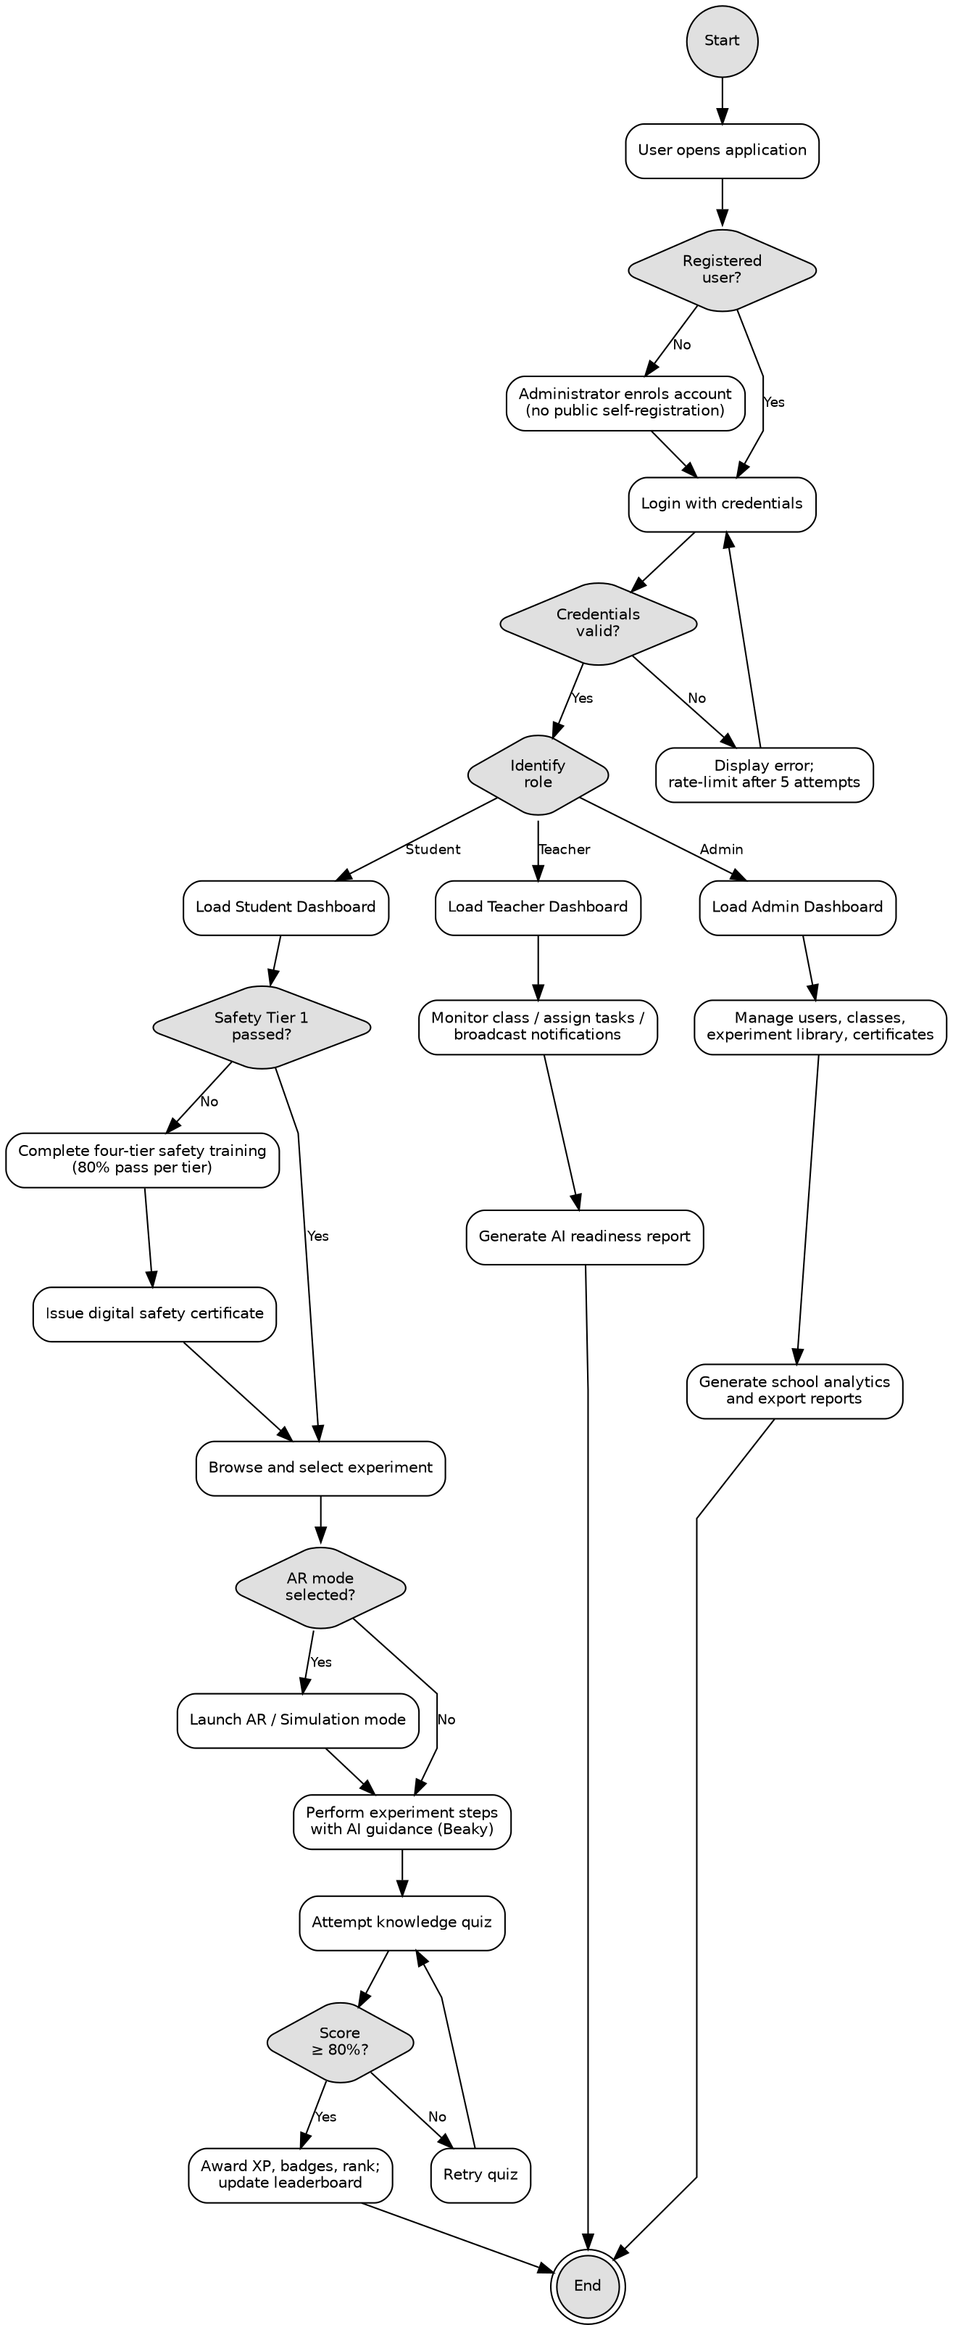
Figure 1 System flow chart
The flow chart presents the overall workflow that the system will follow, from the point at which a user opens the application to the completion of their role specific task. Processing will begin with authentication. Accounts will be created by the administrator rather than through public registration (FR-01.6), so an unregistered user will first need to be enrolled. After authentication the system will identify the role and load the corresponding dashboard (FR-01.1). For a student, the safety certification gate will be evaluated before any experiment is permitted to open (FR-02.3). Once certified, the student will select an experiment and perform it either in the standard view or in augmented reality, complete its steps with AI guidance, and then take the knowledge quiz. A score of at least 80 percent will award experience points and update the leaderboard (FR-04.3); a lower score will return the student to the quiz (FR-04.5). Teacher and administrator paths lead to their monitoring, assignment and management functions.

System Context Diagram
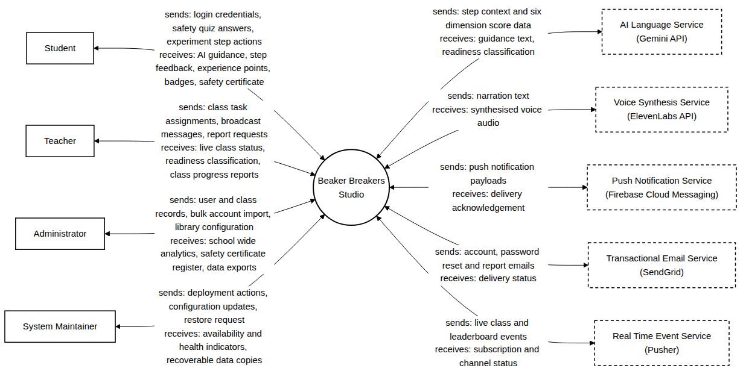
Figure 2 System context diagram
The context diagram fixes the boundary of the system and identifies every party that will exchange information across it. Four human user classes will interact with the system: Student, Teacher, Administrator and System Maintainer. Five external services will be invoked by the system: the Gemini API for guidance and classification, ElevenLabs for voice synthesis, Firebase Cloud Messaging for push notifications, SendGrid for email, and Pusher for real time class updates. Cloud storage and the content delivery network are not drawn as external parties, because Section 4.2.9 places them inside the system's own deployment. The device augmented reality frameworks are likewise not drawn, since they act as platform capabilities rather than as systems exchanging data with Beaker Breakers Studio.

Use Case Diagrams
Twenty eight use cases have been identified across the ten functional areas of Section 3.2.2. They are listed below by functional area so that coverage can be checked at a glance, and are then presented as seven diagrams, one for each functional grouping. Each relationship in these diagrams carries on the arrow the Chapter 3 identifier that justifies it.
Table 18 The twenty eight use cases, grouped by functional area.
Functional area | Use cases
Authentication and account access | UC-01 Log In, UC-07 Reset Password, UC-17 Manage User Accounts
Safety certification | UC-02 Safety Certification, UC-02.1 Attempt Tier Assessment, UC-02.2 Receive Safety Certificate, UC-21 Manage Certificate Registry, UC-26 Verify Student Certificates
Experiment and assessment | UC-03 Perform Virtual Experiment, UC-04 AR Mode Session, UC-08 Browse Experiment Library, UC-09 Take Knowledge Quiz, UC-25 Receive AI Step Guidance
Gamification and engagement | UC-10 Earn Rewards, UC-11 Daily Missions and Streaks, UC-12 View Leaderboard
Readiness reporting | UC-05 Generate AI Readiness Report, UC-13 View Own Readiness Status
Teacher class management | UC-06 Assign Task, UC-06.1 Track Task Status, UC-14 Monitor Class, UC-15 Broadcast Notification, UC-16 Review Class Reports
Administration and reporting | UC-18 Bulk Import Students, UC-19 Manage Classes, UC-20 Configure Experiment Library, UC-22 Generate Analytics and Export Reports, UC-27 Record Audit Entry

Because login and password reset behave identically for all three primary roles, actor generalisation has been applied throughout the use case model: Student, Teacher and Administrator each inherit those two use cases from a general Registered User actor rather than being connected to them three times. Generalisation has not been applied anywhere else, since no other use case is shared by all three roles.
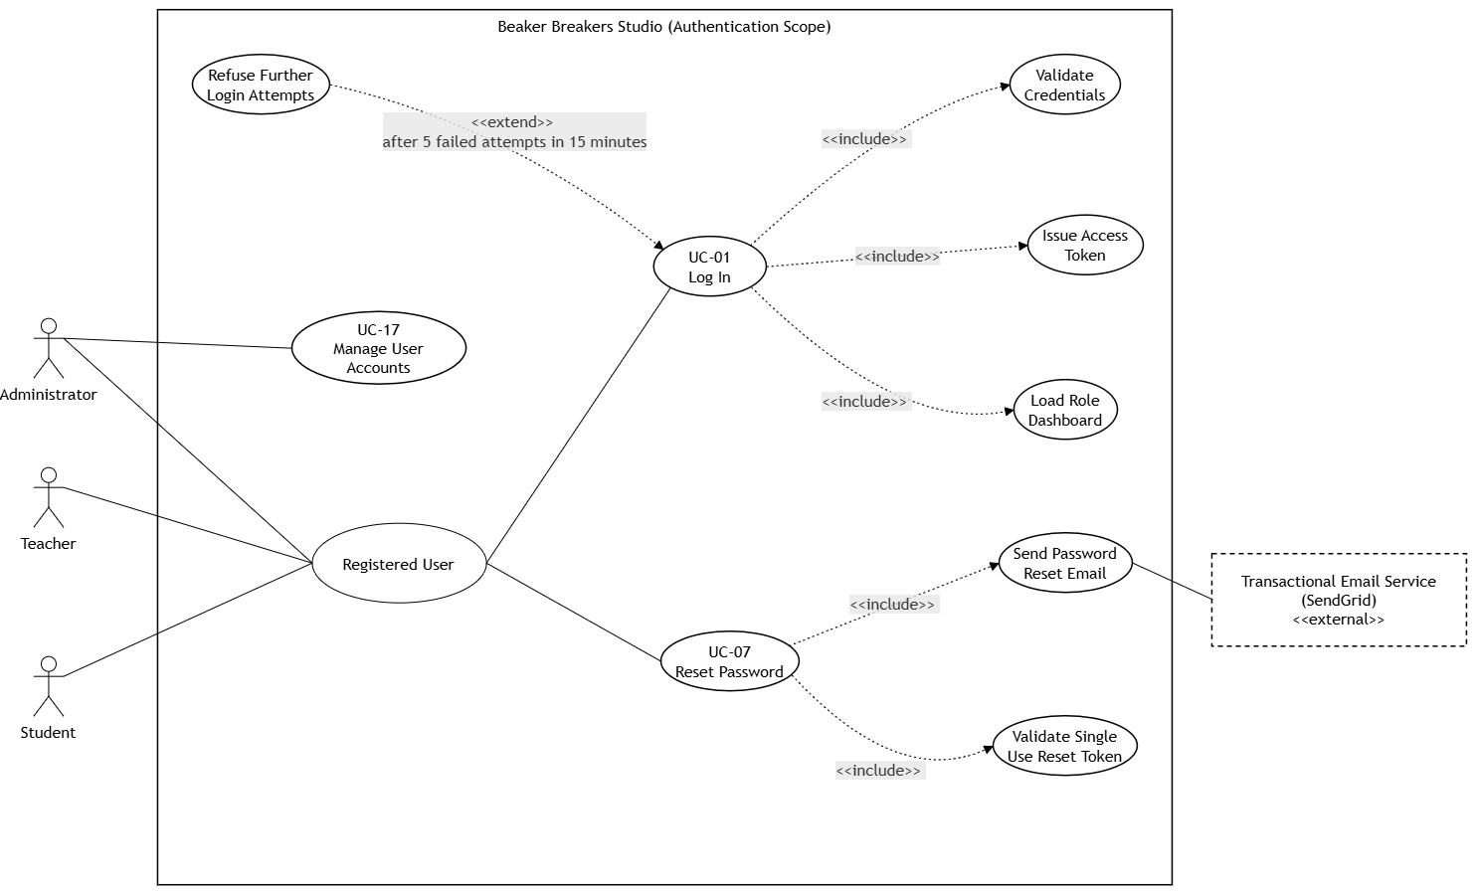
Figure 3 Use case diagram: authentication and account access
Logging in includes credential validation (FR-01.1), token issue (FR-01.2) and loading the dashboard of the role (FR-01.1). The lockout after five failed attempts in fifteen minutes is drawn as an extend rather than an include, because FR-01.4 makes it conditional. Password reset includes sending the reset email and validating the single use token, both under FR-01.3. Account management appears here, associated only with the Administrator, because FR-01.5 and FR-01.6 together mean that no account can come into existence by any other route; the absence of a registration use case is itself part of the design.
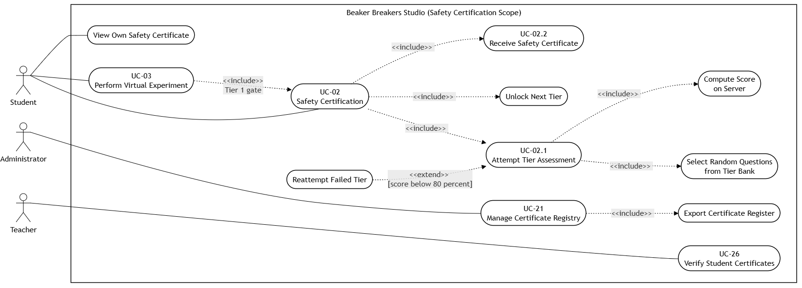
Figure 4 Use case diagram: safety certification
Safety certification includes the tier assessment (FR-02.1), unlocking the next tier (FR-02.2) and issuing the certificate (FR-02.7). The assessment in turn includes random selection from the tier bank (FR-02.4) and server side scoring (FR-02.5). Reattempting a failed tier extends the assessment under FR-02.6, guarded on a score below 80 percent. The certificate is visible to the student and, separately, to the teacher assigned to that student's class; FR-02.9 gives two distinct goals to two distinct actors, so these are drawn as two use cases rather than one shared one. A note records FR-02.8, which forbids both issuing a certificate when any tier falls below the threshold and revoking one once issued.
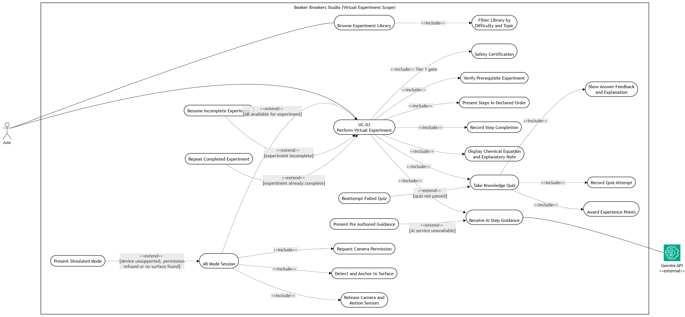
Figure 5 Use case diagram: performing a virtual experiment
This is the largest use case in the system. Performing an experiment includes the Tier 1 gate (FR-02.3), the prerequisite check (FR-03.3), ordered step presentation (FR-03.4), step recording (FR-03.5), the chemical equation and note (FR-03.6), AI step guidance (FR-03.7) and the knowledge quiz (FR-04.1). Three behaviours extend it rather than being included: resuming an incomplete experiment, repeating a completed one (FR-03.8), and the augmented reality session (FR-05.1). Pre authored guidance extends AI guidance on the condition that the external service is unavailable, which is how NFR-06 enters the use case model.
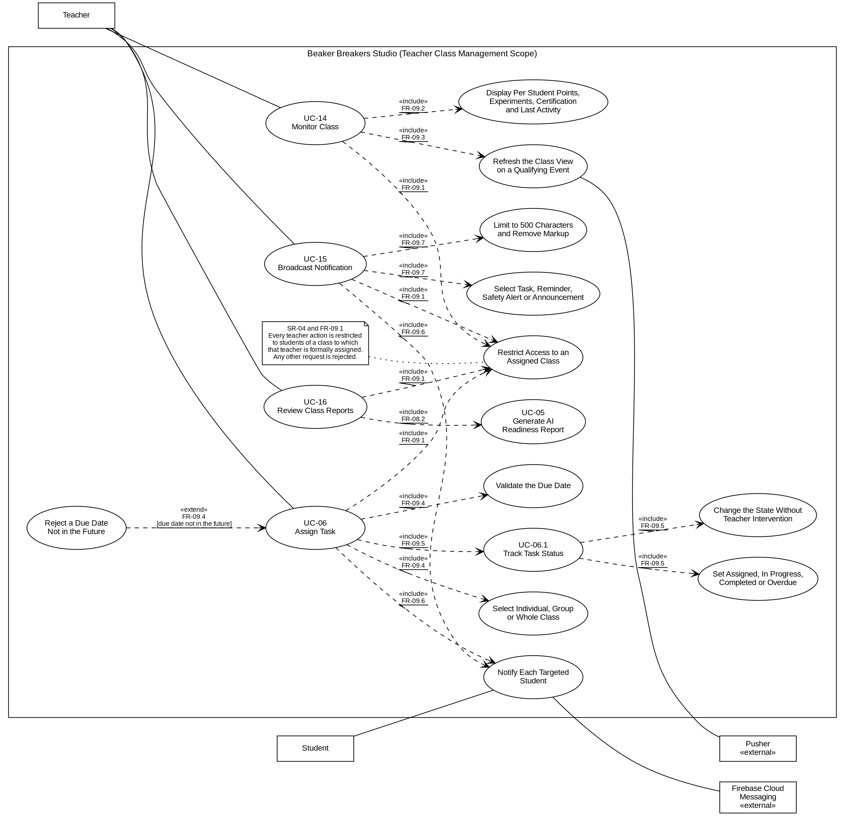
Figure 6 Use case diagram: teacher class management
All four teacher use cases include a single shared use case that restricts access to an assigned class. This is how FR-09.1 and SR-04 appear in the model: the constraint is drawn once and included four times rather than written as a note that an implementer might overlook. Assigning a task includes target selection and due date validation (FR-09.4), notification of each targeted student (FR-09.6) and task status tracking (FR-09.5). The Student appears as a secondary actor on the notification use case, because the student receives the notification rather than initiating it.
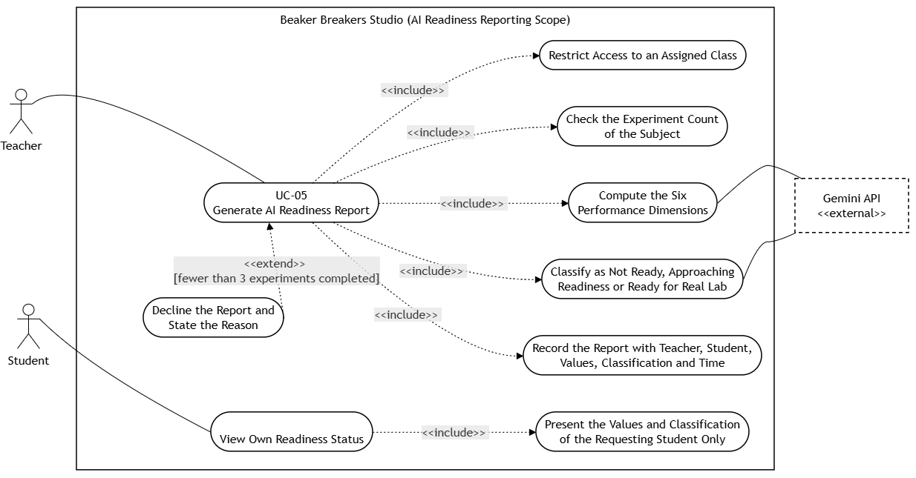
Figure 7 Use case diagram: AI readiness reporting
Generating a readiness report includes the class scoping check (FR-09.1), the eligibility check on the number of experiments completed (FR-08.4), computation of the six performance dimensions (FR-08.1), classification (FR-08.3) and recording of the report (FR-08.5). Declining the report extends it, guarded on the subject having completed fewer than three experiments. The separate student facing use case realises FR-08.6 and SR-08, which together mean a student may see their own values and classification and never those of another student.

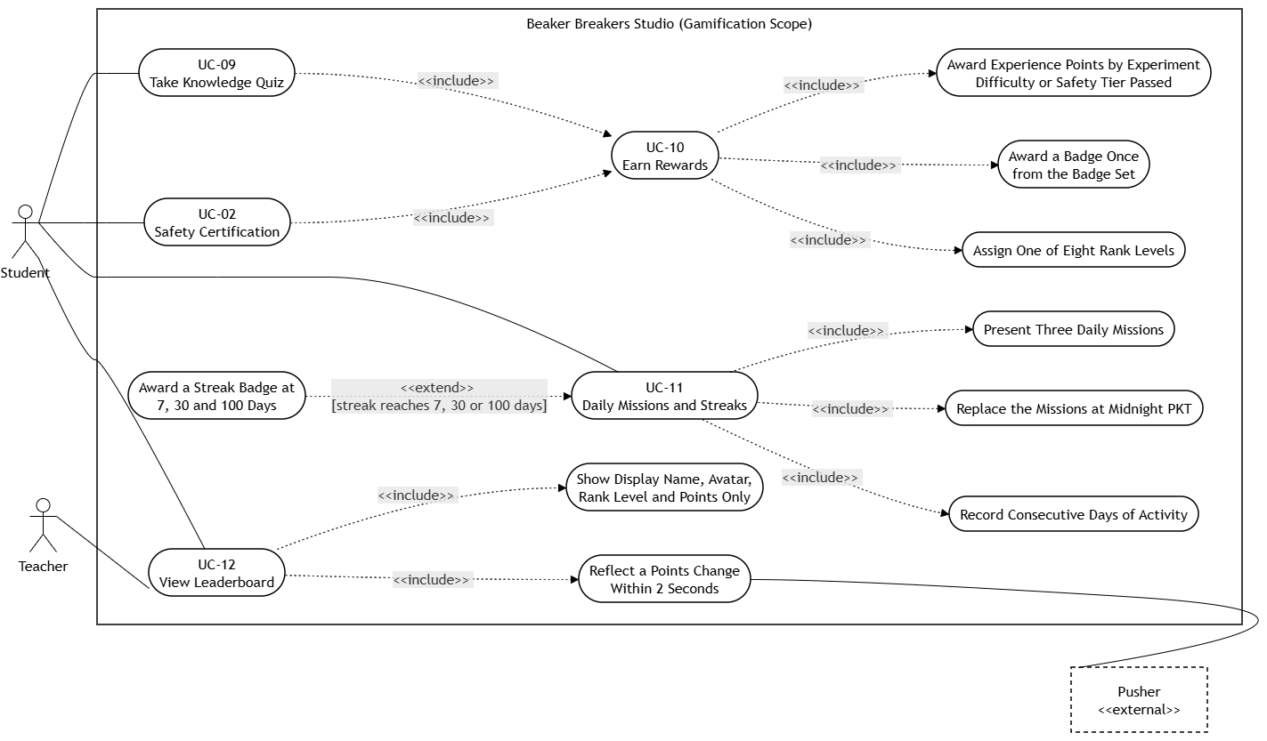

Figure 8 Use case diagram: gamification, missions and leaderboard
Earning rewards carries no direct actor association. It is included by the knowledge quiz under FR-04.3 and by safety certification under FR-06.1, because rewards are a consequence of those activities rather than something a student sets out to do. Daily missions and streaks include mission presentation and the midnight replacement (FR-07.3) and the recording of consecutive days (FR-06.5), with the streak badge extending on the 7, 30 and 100 day thresholds. A note records FR-06.2 and FR-06.4: points are never awarded for speed and are never reduced.
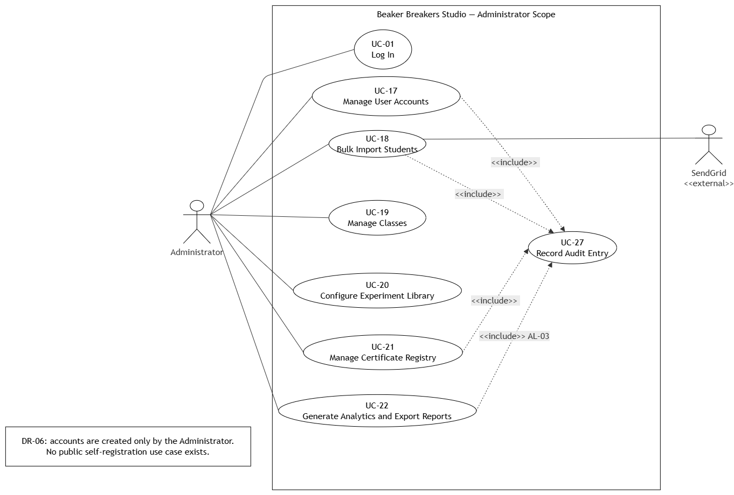
Figure 9 Use case diagram: administration and reporting
Four use cases include the audit entry, because FR-10.8 makes an immutable record an unconditional consequence of every administrative account operation, certificate issue and report export rather than a separate task the administrator chooses to perform. Bulk import includes the 500 row limit (FR-10.2) and row validation (FR-10.3), with the all or nothing failure behaviour of FR-10.3 drawn as an extend guarded on any row failing.

Use Case Descriptions
Each of the twenty eight use cases is specified below in a standard six field format. The Actor field names the party that initiates the use case, the Preconditions field states what must already be true before it begins, the Main Flow field gives the normal sequence of steps, the Alternate Flow field gives the behaviour where the normal sequence cannot be followed, the Postconditions field states what is true once it ends, and the Related Requirements field lists the Chapter 3 requirements the use case realises.
Table 19 Use case description, UC-01 Log In.
Field | Description
Actor | Student, Teacher, Administrator
Preconditions | The user holds an account created by a school administrator.
Main Flow | 1. User opens the application and enters school identifier and password. 2. System validates the credentials. 3. System issues an access token. 4. System loads the dashboard belonging to the user role.
Alternate Flow | If the credentials are invalid, the system displays a message that does not indicate which credential was wrong. After five failed attempts within fifteen minutes, further attempts from that address are refused.
Postconditions | The user is authenticated and the correct role dashboard is displayed.
Related Requirements | FR-01.1, FR-01.2, FR-01.4

Table 20 Use case description, UC-02 Safety Certification.
Field | Description
Actor | Student
Preconditions | The student is authenticated.
Main Flow | 1. Student opens Safety Training. 2. System presents the lowest tier not yet passed. 3. Student studies the tier material and starts the assessment. 4. System presents questions selected at random from the tier bank. 5. Student submits answers. 6. System computes the score on the server. 7. On a score of 80 percent or above the tier is marked passed and the next tier is unlocked. 8. When all four tiers are passed the system issues the safety certificate.
Alternate Flow | On a score below 80 percent the system displays the result and offers a further attempt with a fresh selection of questions. The number of attempts is not limited.
Postconditions | The tier is recorded as passed, or the certificate is issued if this was the fourth tier.
Related Requirements | FR-02.1 to FR-02.9

Table 21 Use case description, UC-02.1 Attempt Tier Assessment.
Field | Description
Actor | Student
Preconditions | The student is authenticated and the tier being attempted is the lowest tier not yet passed.
Main Flow | 1. Student starts the assessment for the tier. 2. System selects the questions at random from the question bank of that tier. 3. Student answers the questions and submits them. 4. System computes the score on the server. 5. System records the attempt with its score and the time of submission.
Alternate Flow | On a score below 80 percent the tier is not marked as passed and a further attempt is offered with a fresh selection of questions. The number of attempts is not limited.
Postconditions | The attempt is recorded, and the tier is marked as passed where the score is at least 80 percent.
Related Requirements | FR-02.4, FR-02.5, FR-02.6

Table 22 Use case description, UC-02.2 Receive Safety Certificate.
Field | Description
Actor | Student
Preconditions | The student has passed all four safety tiers, each with a score of at least 80 percent.
Main Flow | 1. System detects that the fourth tier has been passed. 2. System generates a certificate bearing a unique identifier, the four tier scores and the date of issue. 3. System stores the certificate against the student profile. 4. System makes the certificate visible to the student and to the teacher assigned to that student's class.
Alternate Flow | No certificate is generated if the score in any tier is below 80 percent.
Postconditions | The certificate exists, is displayed on the student profile, and is recorded in the school wide register.
Related Requirements | FR-02.7, FR-02.8, FR-02.9, FR-10.5

Table 23 Use case description, UC-03 Perform Virtual Experiment.
Field | Description
Actor | Student
Preconditions | The student is authenticated and has passed Safety Tier 1.
Main Flow | 1. Student selects an experiment from the library. 2. System verifies that any prerequisite experiment has been completed. 3. System presents the first step. 4. Student completes each step in turn while the AI assistant provides guidance. 5. System records the completion of each step. 6. When all steps are complete the knowledge quiz is unlocked.
Alternate Flow | If the AI service does not respond, pre authored guidance is presented and the experiment remains completable. If the student leaves and returns, completed steps are restored.
Postconditions | The experiment is recorded as complete and the knowledge quiz becomes available.
Related Requirements | FR-03.1 to FR-03.8, NFR-05, NFR-06

Table 24 Use case description, UC-04 AR Mode Session.
Field | Description
Actor | Student
Preconditions | The student is authenticated and has selected an AR enabled experiment.
Main Flow | 1. Student taps Launch AR. 2. System checks whether the device supports augmented reality. 3. System requests camera permission. 4. System scans for a flat surface and anchors the experiment overlay to it. 5. Student performs the experiment using the rotate, guidance, and exit controls. 6. On exit the system stops the camera stream and releases device resources.
Alternate Flow | Where the device is unsupported, permission is refused, or no surface is detected, the system presents the clearly labelled Simulation AR view within one second. The same controls are available and the experiment remains complete.
Postconditions | The experiment is performed and all camera resources are released.
Related Requirements | FR-05.1 to FR-05.6

Table 25 Use case description, UC-05 Generate AI Readiness Report.
Field | Description
Actor | Teacher
Preconditions | The teacher is authenticated and the subject student belongs to a class assigned to that teacher.
Main Flow | 1. Teacher opens AI Readiness and selects a student. 2. System verifies the class assignment. 3. System verifies that the student has completed at least three experiments. 4. System computes the six performance dimensions. 5. System submits the dimension data to the AI service. 6. System records the returned classification and presents the report.
Alternate Flow | If the student belongs to another class the request is refused and the refusal is logged. If fewer than three experiments have been completed the system explains the data requirement and generates no report. If the AI service does not respond the teacher is offered a retry.
Postconditions | A readiness report is stored and displayed, or the reason for not generating one is shown.
Related Requirements | FR-08.1 to FR-08.6, FR-09.1

Table 26 Use case description, UC-06 Assign Task.
Field | Description
Actor | Teacher
Preconditions | The teacher is authenticated and the target students belong to a class assigned to that teacher.
Main Flow | 1. Teacher opens Task Assignment and selects an experiment, a target, and a due date. 2. System validates the due date and the class assignment. 3. System creates the task and one assignment record per targeted student. 4. System notifies each targeted student. 5. System advances the state of each assignment as the student works. 6. Teacher follows the states on the class dashboard.
Alternate Flow | A due date that is not in the future is rejected with a validation message. A target outside the teacher assigned class is refused and the refusal is logged.
Postconditions | The task is created, the students are notified, and the states are visible to the teacher.
Related Requirements | FR-09.1 to FR-09.7

Table 27 Use case description, UC-06.1 Track Task Status.
Field | Description
Actor | Teacher
Preconditions | A task has been assigned to one or more students of a class to which the teacher is assigned.
Main Flow | 1. Teacher opens the task. 2. System displays the state of the task for each targeted student. 3. System updates the state as Assigned, In Progress, Completed or Overdue as the governing condition occurs.
Alternate Flow | The state changes without any teacher action when the student begins the task, completes it, or the due date passes.
Postconditions | The current state of the task is recorded against each targeted student.
Related Requirements | FR-09.5, FR-09.1

Table 28 Use case description, UC-07 Reset Password.
Field | Description
Actor | Student, Teacher, Administrator
Preconditions | The user holds an account and has access to the email address registered against it.
Main Flow | 1. User requests a password reset. 2. System issues a single use token and sends it to the registered email address. 3. User opens the link and submits a new password. 4. System validates the token, stores the new password as a salted hash, and invalidates all existing tokens of that user.
Alternate Flow | A token that is older than 60 minutes, or that has already been used, is rejected and the user is invited to request a new one.
Postconditions | The password is changed and all previous sessions of that user are ended.
Related Requirements | FR-01.3, SR-01, SR-05

Table 29 Use case description, UC-08 Browse Experiment Library.
Field | Description
Actor | Student
Preconditions | The student is authenticated.
Main Flow | 1. Student opens the experiment library. 2. System presents the experiments available to the class of that student. 3. Student applies a filter by difficulty or by topic. 4. System presents the filtered list.
Alternate Flow | An experiment that is locked is shown with the reason, which is either the safety tier that has not been passed or the prerequisite experiment that has not been completed.
Postconditions | The student has selected an experiment, or has left the library without selecting one.
Related Requirements | FR-03.1, FR-03.2, FR-03.3, FR-02.3, FR-10.4

Table 30 Use case description, UC-09 Take Knowledge Quiz.
Field | Description
Actor | Student
Preconditions | All steps of the experiment have been completed.
Main Flow | 1. Student opens the quiz. 2. System presents the questions. 3. Student submits answers. 4. System grades the submission on the server and shows whether each answer was correct, with an explanation where it was not. 5. On a first score of 80 percent or above the system awards the experience points of that experiment and updates the leaderboard.
Alternate Flow | On a score below 80 percent the attempt is recorded and a further attempt is offered with the questions in a different order. No further points are awarded on a repeat pass.
Postconditions | The attempt is recorded and, on a first pass, the reward is awarded.
Related Requirements | FR-04.1 to FR-04.5, FR-07.2

Table 31 Use case description, UC-10 Earn Rewards.
Field | Description
Actor | Student (secondary, the reward is awarded by the system)
Preconditions | The student has completed an experiment with a quiz score of at least 80 percent, or has passed a safety tier.
Main Flow | 1. System receives the completion event. 2. System awards experience points according to the difficulty of the experiment or the tier passed. 3. System evaluates the badge criteria and awards any badge that has been earned. 4. System recalculates the rank level from the cumulative experience points.
Alternate Flow | Where the experience points of that experiment have already been awarded, no further points are awarded for it.
Postconditions | The points, any badge and the rank level of the student are updated, and none of them is ever reduced.
Related Requirements | FR-04.3, FR-06.1, FR-06.2, FR-06.3, FR-06.4

Table 32 Use case description, UC-11 Daily Missions and Streaks.
Field | Description
Actor | Student
Preconditions | The student is authenticated.
Main Flow | 1. System presents three daily missions to the student. 2. Student completes the activity required by a mission. 3. System records the activity and updates the count of consecutive days of activity.
Alternate Flow | The missions are replaced at midnight Pakistan Standard Time, whether or not they were completed. A streak badge is awarded when the count of consecutive days reaches 7, 30 or 100.
Postconditions | The mission state and the streak count of the student are recorded.
Related Requirements | FR-07.3, FR-06.5, FR-06.3

Table 33 Use case description, UC-12 View Leaderboard.
Field | Description
Actor | Student, Teacher
Preconditions | The user is authenticated and belongs to, or is assigned to, the class whose leaderboard is requested.
Main Flow | 1. User opens the leaderboard of the class. 2. System presents the display name, avatar, rank level and cumulative experience points of each student in that class. 3. System reflects any change in points within 2 seconds of the awarding event.
Alternate Flow | No further information about any student is presented, in particular no score, safety history, readiness classification or assessment record.
Postconditions | The leaderboard is displayed and no record is altered.
Related Requirements | FR-07.1, FR-07.2, SR-08

Table 34 Use case description, UC-13 View Own Readiness Status.
Field | Description
Actor | Student
Preconditions | The student is authenticated and a readiness report has been generated for that student.
Main Flow | 1. Student opens their readiness status. 2. System presents the six dimension values computed for that student and the classification derived from them.
Alternate Flow | Where no report has yet been generated, the system states that the report is not yet available.
Postconditions | The student has seen their own values and classification, and no record is altered.
Related Requirements | FR-08.6, FR-08.1, FR-08.3, SR-08

Table 35 Use case description, UC-14 Monitor Class.
Field | Description
Actor | Teacher
Preconditions | The teacher is authenticated and is formally assigned to the class being monitored.
Main Flow | 1. Teacher opens the class view. 2. System presents, for each student of the class, the cumulative experience points, the number of experiments completed, the safety certification status and the most recent activity time. 3. System updates the view within 5 seconds of an event that affects a displayed value.
Alternate Flow | A request for a class to which the teacher is not assigned is rejected with an authorisation error.
Postconditions | The class view is displayed and no record is altered.
Related Requirements | FR-09.1, FR-09.2, FR-09.3, SR-04

Table 36 Use case description, UC-15 Broadcast Notification.
Field | Description
Actor | Teacher
Preconditions | The teacher is authenticated and is formally assigned to the class being addressed.
Main Flow | 1. Teacher selects the class and the notification type, which is task, reminder, safety alert or announcement. 2. Teacher writes the message. 3. System removes any markup and limits the message to 500 characters. 4. System delivers the notification to every student of the class.
Alternate Flow | A message longer than 500 characters is refused until it is shortened. A request for a class to which the teacher is not assigned is rejected.
Postconditions | The notification is recorded and delivered to each targeted student.
Related Requirements | FR-09.7, FR-09.6, FR-09.1

Table 37 Use case description, UC-16 Review Class Reports.
Field | Description
Actor | Teacher
Preconditions | The teacher is authenticated and is formally assigned to the class whose reports are requested.
Main Flow | 1. Teacher opens the reports of the class. 2. System presents the progress of the class together with the readiness reports already generated for its students. 3. Teacher may request a new readiness report for an individual student.
Alternate Flow | A request for a class to which the teacher is not assigned is rejected with an authorisation error.
Postconditions | The reports are displayed, and any newly requested report is recorded.
Related Requirements | FR-09.1, FR-08.2, FR-08.5, SR-04

Table 38 Use case description, UC-17 Manage User Accounts.
Field | Description
Actor | Administrator
Preconditions | The administrator is authenticated.
Main Flow | 1. Administrator creates, edits, suspends or deletes a user account. 2. System applies the change. 3. System writes an audit entry recording the operation, the actor and the time.
Alternate Flow | A deleted account is retained in a recoverable state for 30 days before it is removed. No account can be created by any route other than this use case.
Postconditions | The account reflects the change, and an immutable audit entry exists.
Related Requirements | FR-01.5, FR-01.6, FR-10.8, SR-04

Table 39 Use case description, UC-18 Bulk Import Students.
Field | Description
Actor | Administrator
Preconditions | The administrator is authenticated.
Main Flow | 1. Administrator opens Student Management and uploads a delimited file of up to 500 rows. 2. System validates every row. 3. System creates the accounts and sends a welcome message to each new student. 4. System writes an audit entry for the operation.
Alternate Flow | If any row fails validation no account is created from the file, and the system reports each failing row individually.
Postconditions | The accounts exist and the operation is recorded in the audit log.
Related Requirements | FR-10.2, FR-10.3, FR-10.8

Table 40 Use case description, UC-19 Manage Classes.
Field | Description
Actor | Administrator
Preconditions | The administrator is authenticated.
Main Flow | 1. Administrator creates or modifies a class. 2. Administrator assigns students and teachers to that class. 3. System records the assignments.
Alternate Flow | A teacher who is not assigned to a class acquires no access to its students, since every teacher action is scoped by this assignment.
Postconditions | The class and its assignments are recorded, and the scope of each assigned teacher is established.
Related Requirements | FR-10.1, FR-09.1, SR-04

Table 41 Use case description, UC-20 Configure Experiment Library.
Field | Description
Actor | Administrator
Preconditions | The administrator is authenticated and the class to be configured exists.
Main Flow | 1. Administrator selects a class. 2. Administrator enables or disables an experiment for that class. 3. System applies the change with immediate effect.
Alternate Flow | An experiment disabled for a class does not appear in the library of the students of that class, and an experiment already in progress is allowed to finish.
Postconditions | The experiment library visible to the class reflects the change.
Related Requirements | FR-10.4, FR-03.1

Table 42 Use case description, UC-21 Manage Certificate Registry.
Field | Description
Actor | Administrator
Preconditions | The administrator is authenticated.
Main Flow | 1. Administrator opens the school wide register of issued safety certificates. 2. System presents every certificate issued within the school. 3. Administrator exports the register. 4. System writes an audit entry recording the export.
Alternate Flow | No certificate may be deleted or revoked from the register by any operation.
Postconditions | The register is displayed or exported, and an audit entry exists for any export.
Related Requirements | FR-10.5, FR-02.8, FR-10.7, FR-10.8

Table 43 Use case description, UC-22 Generate Analytics and Export Reports.
Field | Description
Actor | Administrator
Preconditions | The administrator is authenticated.
Main Flow | 1. Administrator requests the school analytics. 2. System computes the certification rate, the experiment completion rate and the distribution of readiness classifications. 3. Administrator exports the report in portable document format or as delimited text. 4. System writes an audit entry recording the export.
Alternate Flow | An export that cannot be completed within 10 seconds is reported as a failure rather than returned incomplete.
Postconditions | The analytics are displayed, the export file is produced, and an immutable audit entry exists.
Related Requirements | FR-10.6, FR-10.7, FR-10.8

Table 44 Use case description, UC-25 Receive AI Step Guidance.
Field | Description
Actor | Student (primary), AI language service (secondary)
Preconditions | The student is performing an experiment and a step is currently presented.
Main Flow | 1. System sends the context of the current step to the AI language service. 2. Service returns guidance for that step. 3. System presents the guidance to the student with avatar narration, within 2 seconds, or within 200 milliseconds where the guidance has been cached.
Alternate Flow | Where the service does not respond within the limit, or is unavailable, the pre authored guidance held for that step is presented instead and the experiment remains completable.
Postconditions | Guidance for the current step has been presented by one route or the other.
Related Requirements | FR-03.7, NFR-06

Table 45 Use case description, UC-26 Verify Student Certificates.
Field | Description
Actor | Teacher
Preconditions | The teacher is authenticated and is formally assigned to the class of the student whose certificate is being verified.
Main Flow | 1. Teacher opens the profile of a student of an assigned class. 2. System presents the safety certificate of that student, with its unique identifier, the four tier scores and the date of issue.
Alternate Flow | Where no certificate has been issued, the system states which tiers remain to be passed. A request for a student outside an assigned class is rejected.
Postconditions | The certificate status of the student has been displayed to the teacher.
Related Requirements | FR-02.9, FR-02.7, FR-09.1, SR-04

Table 46 Use case description, UC-27 Record Audit Entry.
Field | Description
Actor | System (invoked by an administrative operation)
Preconditions | An administrative account operation, a certificate issue or a report export has taken place.
Main Flow | 1. System captures the actor, the type of action, the reference of the target and the time of the operation. 2. System writes the entry to the audit log. 3. System retains the entry for no less than 7 years.
Alternate Flow | No entry may be modified or deleted after it has been written, by any user or by any operation.
Postconditions | An immutable audit entry exists for the operation that invoked this use case.
Related Requirements | FR-10.8

Class Diagram
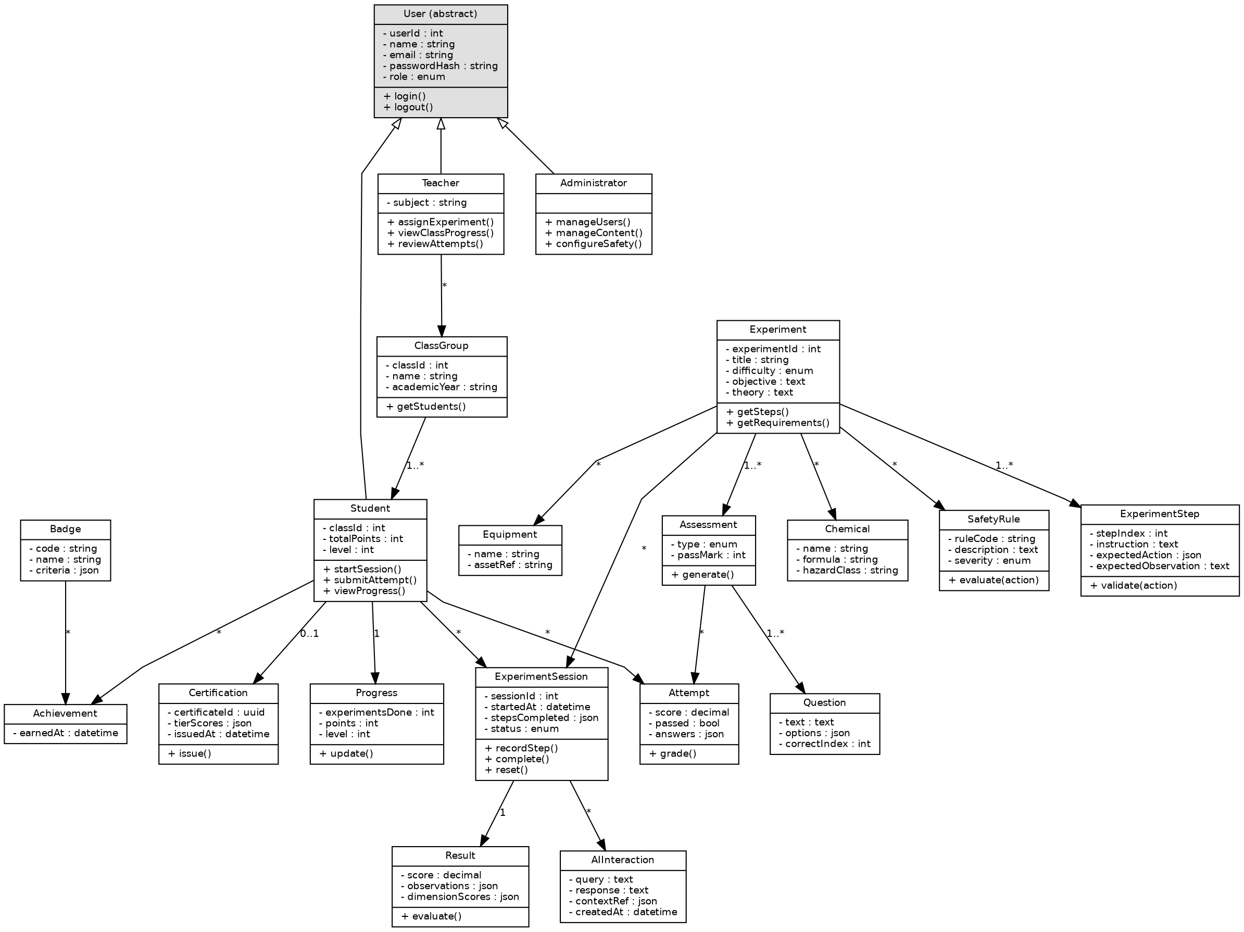
Figure 10 Class diagram
The class diagram defines the principal classes of the system, their attributes and operations, and the relationships between them. User is an abstract class specialised by Student, Teacher and Administrator, so that authentication behaviour is defined once while role specific operations remain with each subclass. Composition is used where a part cannot exist without its whole: an experiment step has no meaning apart from its experiment, a question none apart from its assessment, and a result none apart from its session. Association is used for the equipment, chemical and safety rule catalogues, whose members exist independently and are shared across many experiments. ClassGroup links students to the teachers assigned to them, which is the relationship on which the class scoping rule of FR-09.1 depends.

Sequence Diagrams
Three sequences are presented. Each has been chosen because it crosses several subsystem boundaries and therefore specifies interaction that no single class could convey.
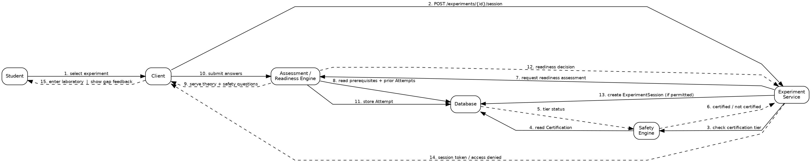
Figure 11 Sequence diagram: readiness check and experiment session creation
This sequence enforces the two gates that precede laboratory access. The experiment service first asks the safety engine whether the student is certified (FR-02.3), then requests a readiness decision, and creates an experiment session only if both permit it. Grading takes place on the server as required by FR-02.5, so the client never supplies its own score.
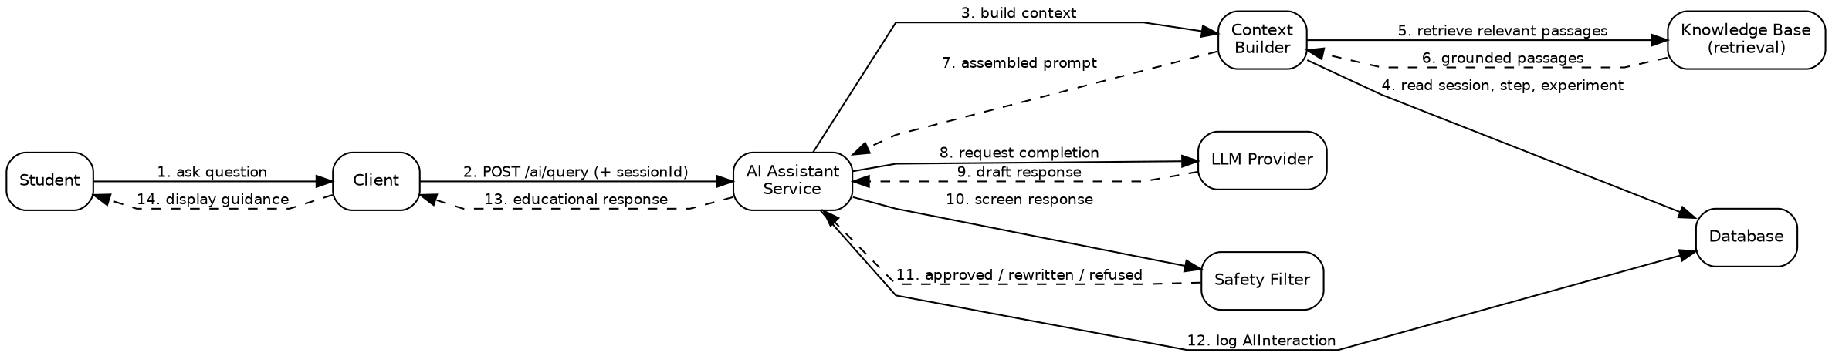
Figure 12 Sequence diagram: AI assistant query
This sequence shows how AI guidance is constrained. Context is built from the live session, supporting material is retrieved from a curated knowledge base, and the response is returned to the AI service rather than directly to the student, so that it is screened before delivery. If the model does not respond within the limit of FR-03.7, pre authored guidance is shown instead under NFR-06, and the experiment remains completable.
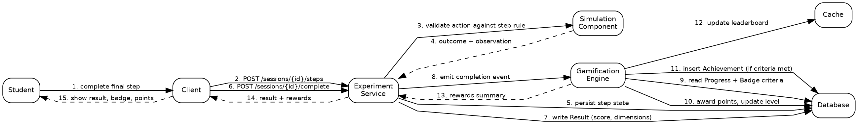
Figure 13 Sequence diagram: experiment completion and reward award
This sequence separates the experiment subsystem from the gamification subsystem. The experiment service writes the result and emits a completion event but does not compute rewards itself. The gamification engine applies the award exactly once, as FR-04.3 requires, and updates the leaderboard in the cache to meet FR-07.2. This separation allows the reward rules to change without any change to the laboratory.

Block Diagram
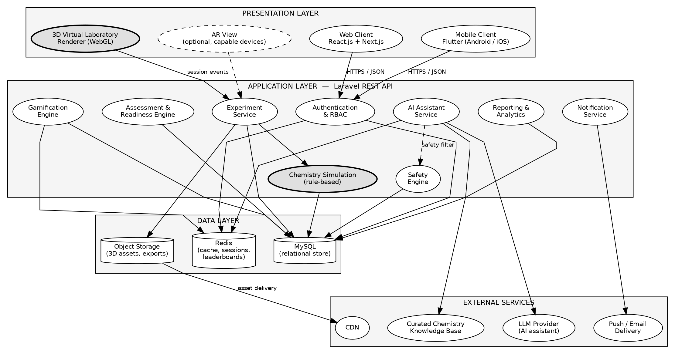
Figure 14 Block diagram of the system architecture
The system will follow a three tier architecture. The presentation tier will contain the web and mobile clients, the virtual laboratory renderer and the optional augmented reality view. The application tier will hold all business logic and will be the only tier permitted to reach the data tier. The data tier will separate the relational store, the cache and object storage according to how each will be accessed. External services will be attached to the application tier only, so that no provider credential will ever reach a client device, which is a direct consequence of SR-06 and SR-07.

Component Diagram
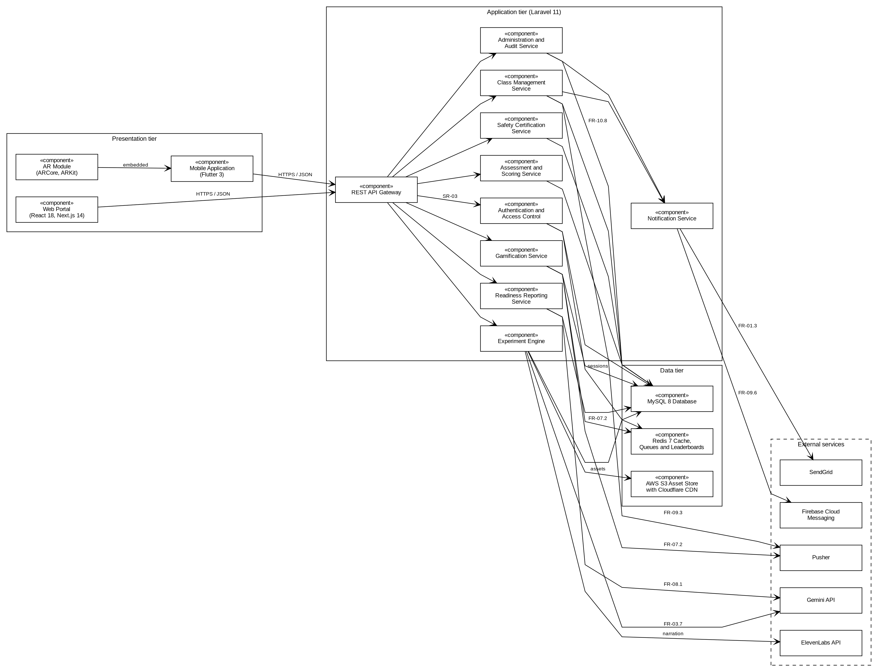
Figure 15 Component diagram showing the components of each tier and their interfaces
The component diagram decomposes the application tier into ten components, one for each functional area of Section 3.2.2 together with a gateway and a notification component. Every client request will enter through the REST API gateway, which will delegate to the authentication and access control component before any other component is reached, as SR-03 requires. Two decisions are visible here that the layered diagram could not show. First, the gamification component reaches the cache directly, because FR-07.2 requires a points change to be reflected on the leaderboard within 2 seconds and a relational read would not meet that target reliably. Second, the notification component is the only component that holds credentials for Firebase Cloud Messaging and SendGrid, so the class management and administration components raise notifications through it rather than calling those services themselves.

Deployment Diagram
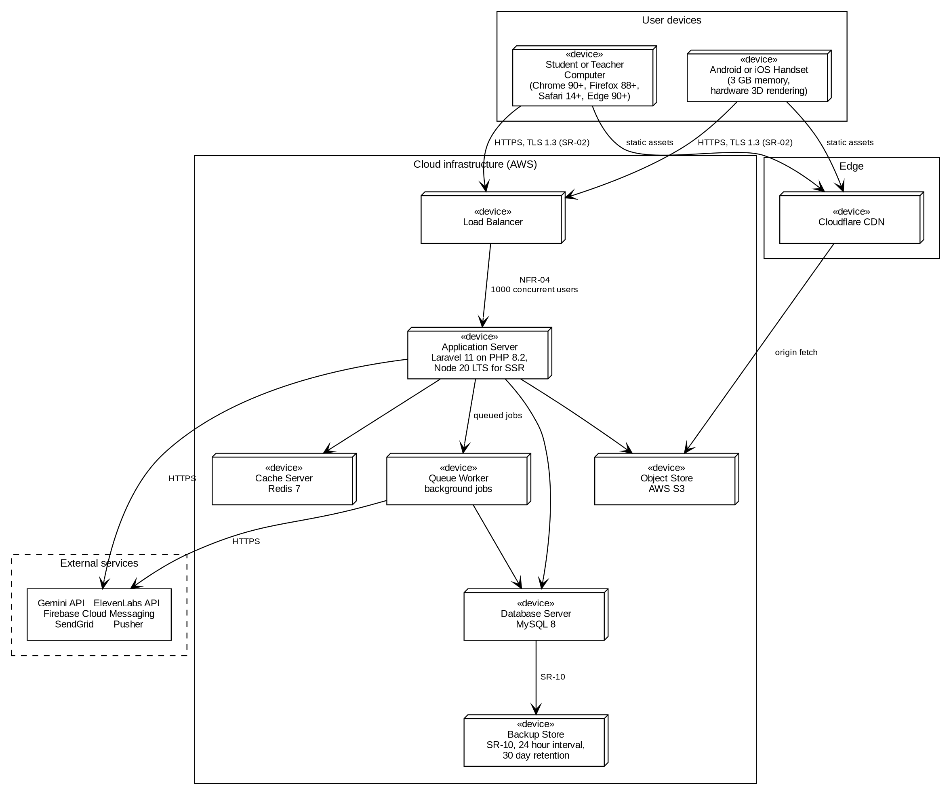
Figure 16 Deployment diagram showing the nodes on which the system will run
The deployment view maps the components onto the machines that will host them. Client devices are those specified in Table 3.14 of Chapter 3. All traffic between a client and the system will use TLS 1.3 or later under SR-02. The application server will sit behind a load balancer, which is what will allow the 1000 concurrent authenticated users of NFR-04 to be served without exceeding the response time of NFR-01. A separate queue worker will carry background work such as notification dispatch and report generation, so that a slow external call cannot block a user request. Static experiment assets will be served from object storage through the content delivery network rather than from the application server. The backup store realises SR-10, which requires a recoverable copy at intervals of no more than 24 hours, retained for no less than 30 days.

Activity Diagrams
Activity diagrams are presented for the five workflows that carry the most decision logic. All five are drawn with swimlanes, so that responsibility for every action is visible. An action placed in a particular partition is a claim about which participant performs it, which is why server side scoring appears in the system partition and never in the student partition.
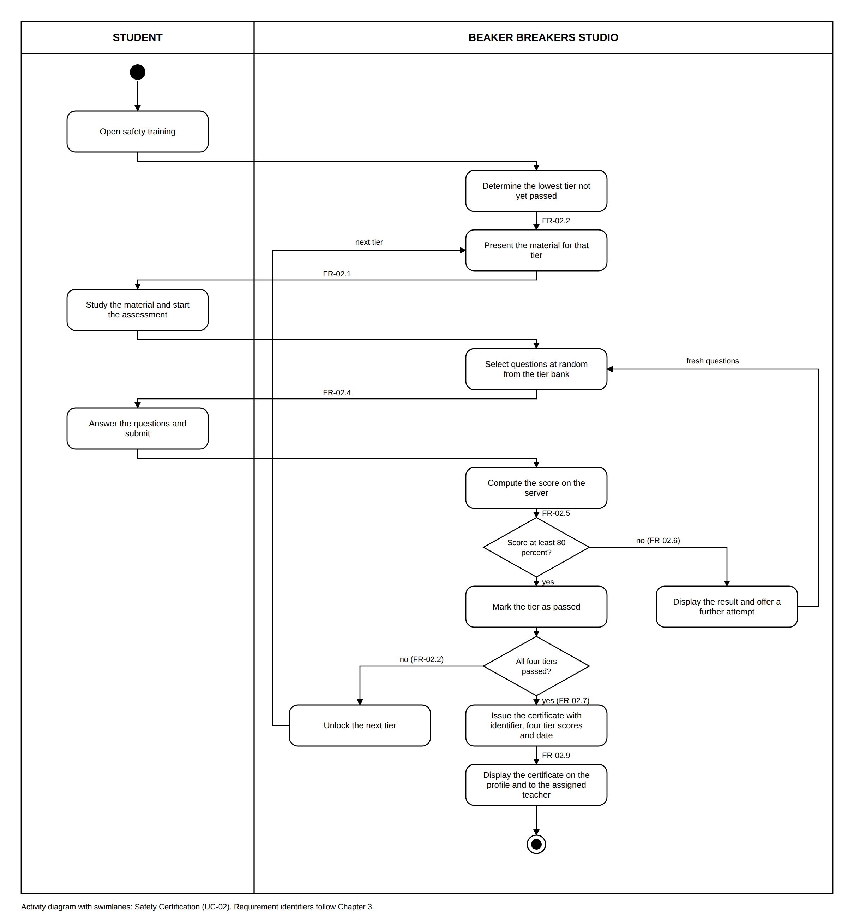
Figure 17 Activity diagram with swimlanes: safety certification
Tiers are traversed strictly in sequence. A score below 80 percent returns the student to the same tier with a fresh randomised selection of questions, which is FR-02.4 and FR-02.6 acting together rather than a simple retry. A passed tier returns to the material for the next tier under FR-02.2. The certificate is issued only once the fourth tier is passed (FR-02.7) and is then displayed on the profile and to the assigned teacher (FR-02.9).
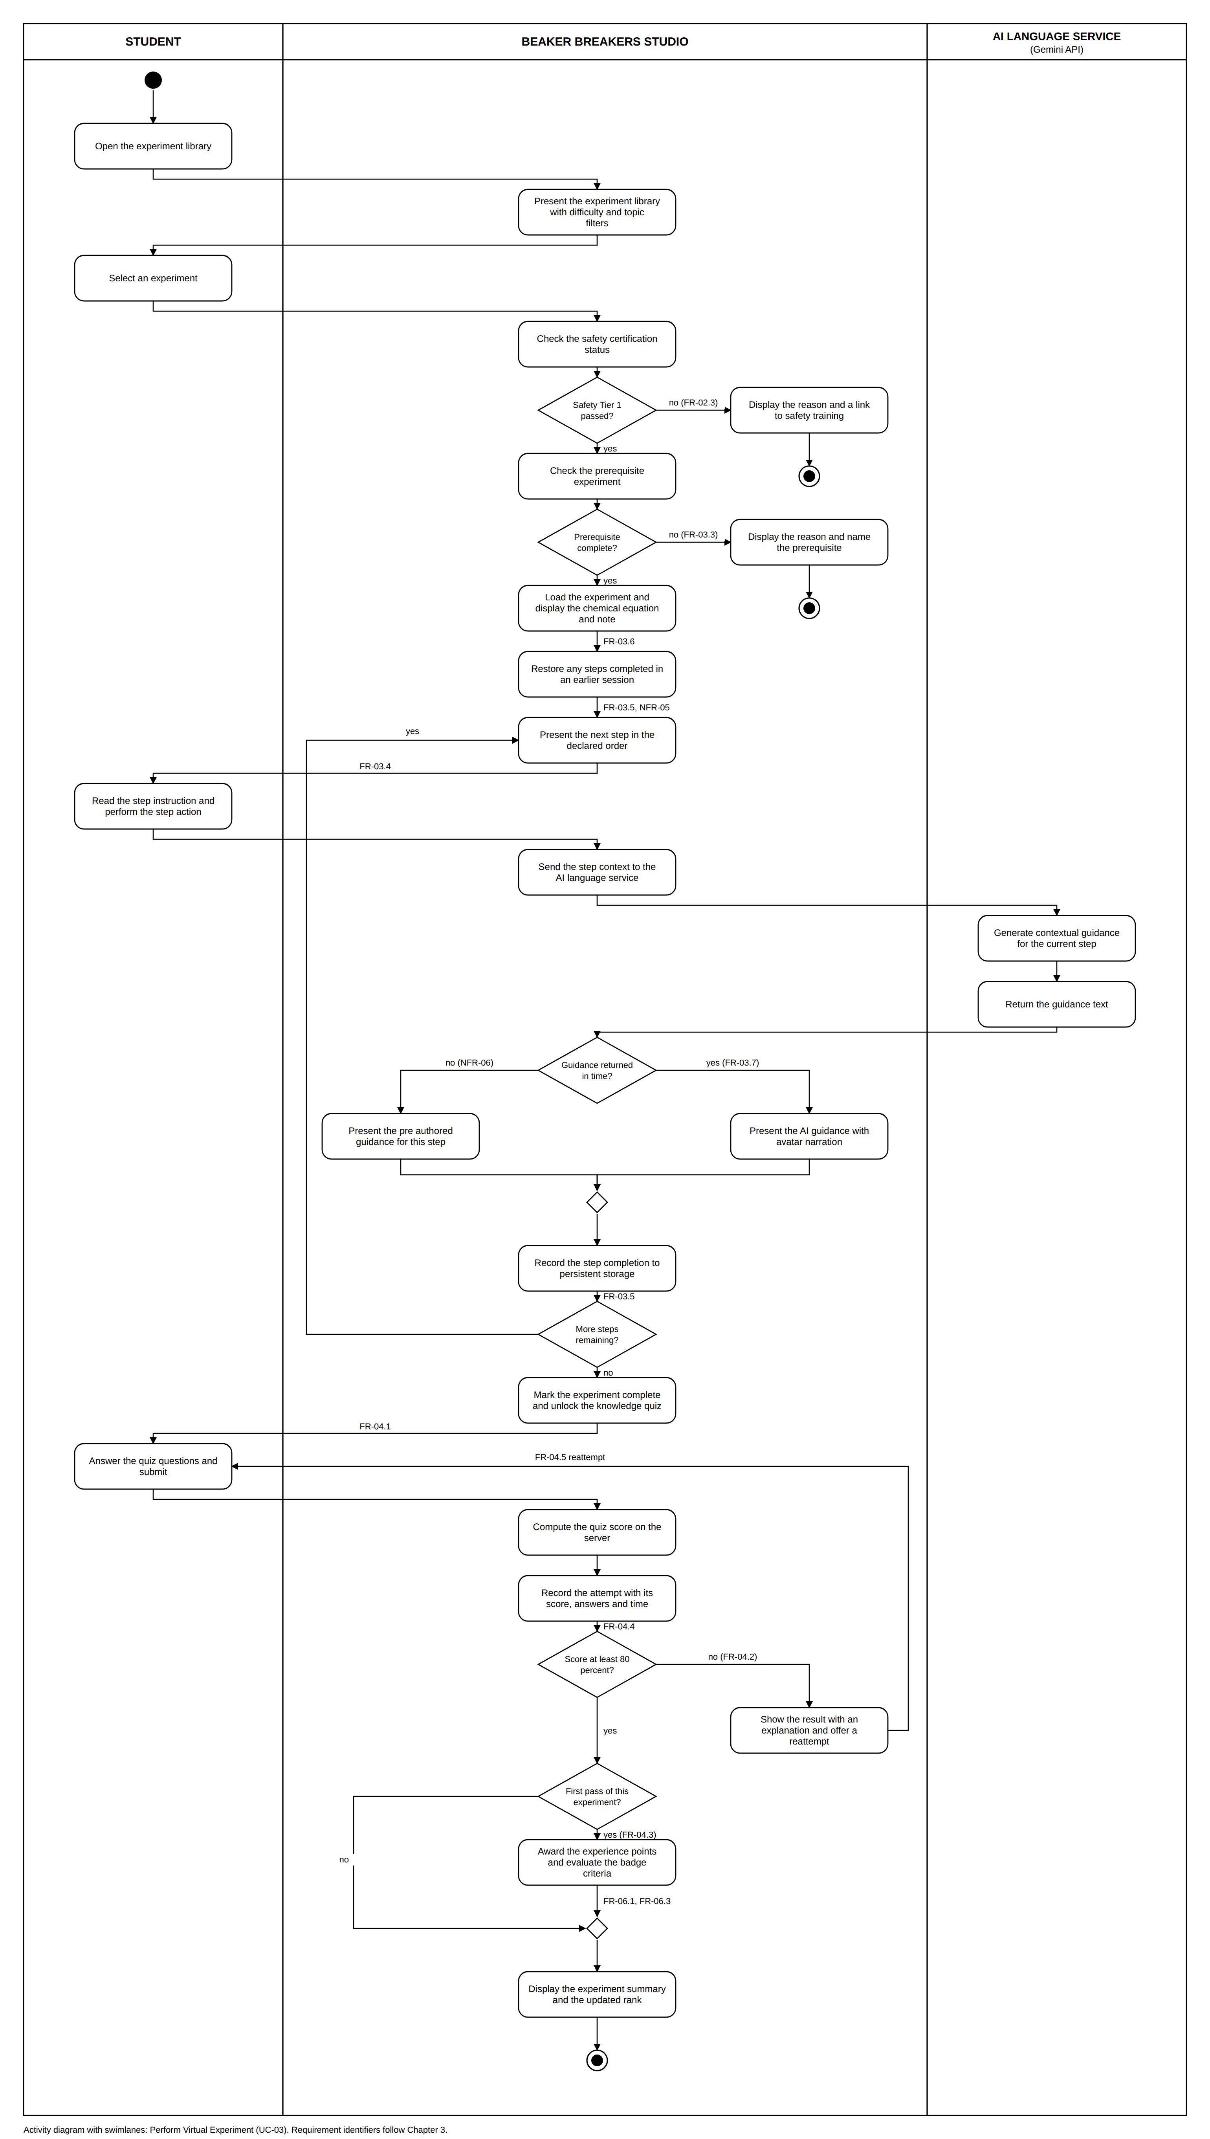
Figure 18 Activity diagram with swimlanes: performing a virtual experiment
Three partitions are used, because the AI language service is a genuine third participant. Both entry gates appear at the start: the Tier 1 gate of FR-02.3 and the prerequisite check of FR-03.3, each with its own termination rather than a return to the main flow. The guidance decision shows the fallback of NFR-06, with both branches rejoining at a merge so that the experiment continues either way. The step loop records each completion to persistent storage at the time it occurs (FR-03.5, NFR-05). Experience points are awarded only on a first pass at 80 percent or above, which is the model of FR-04.3.
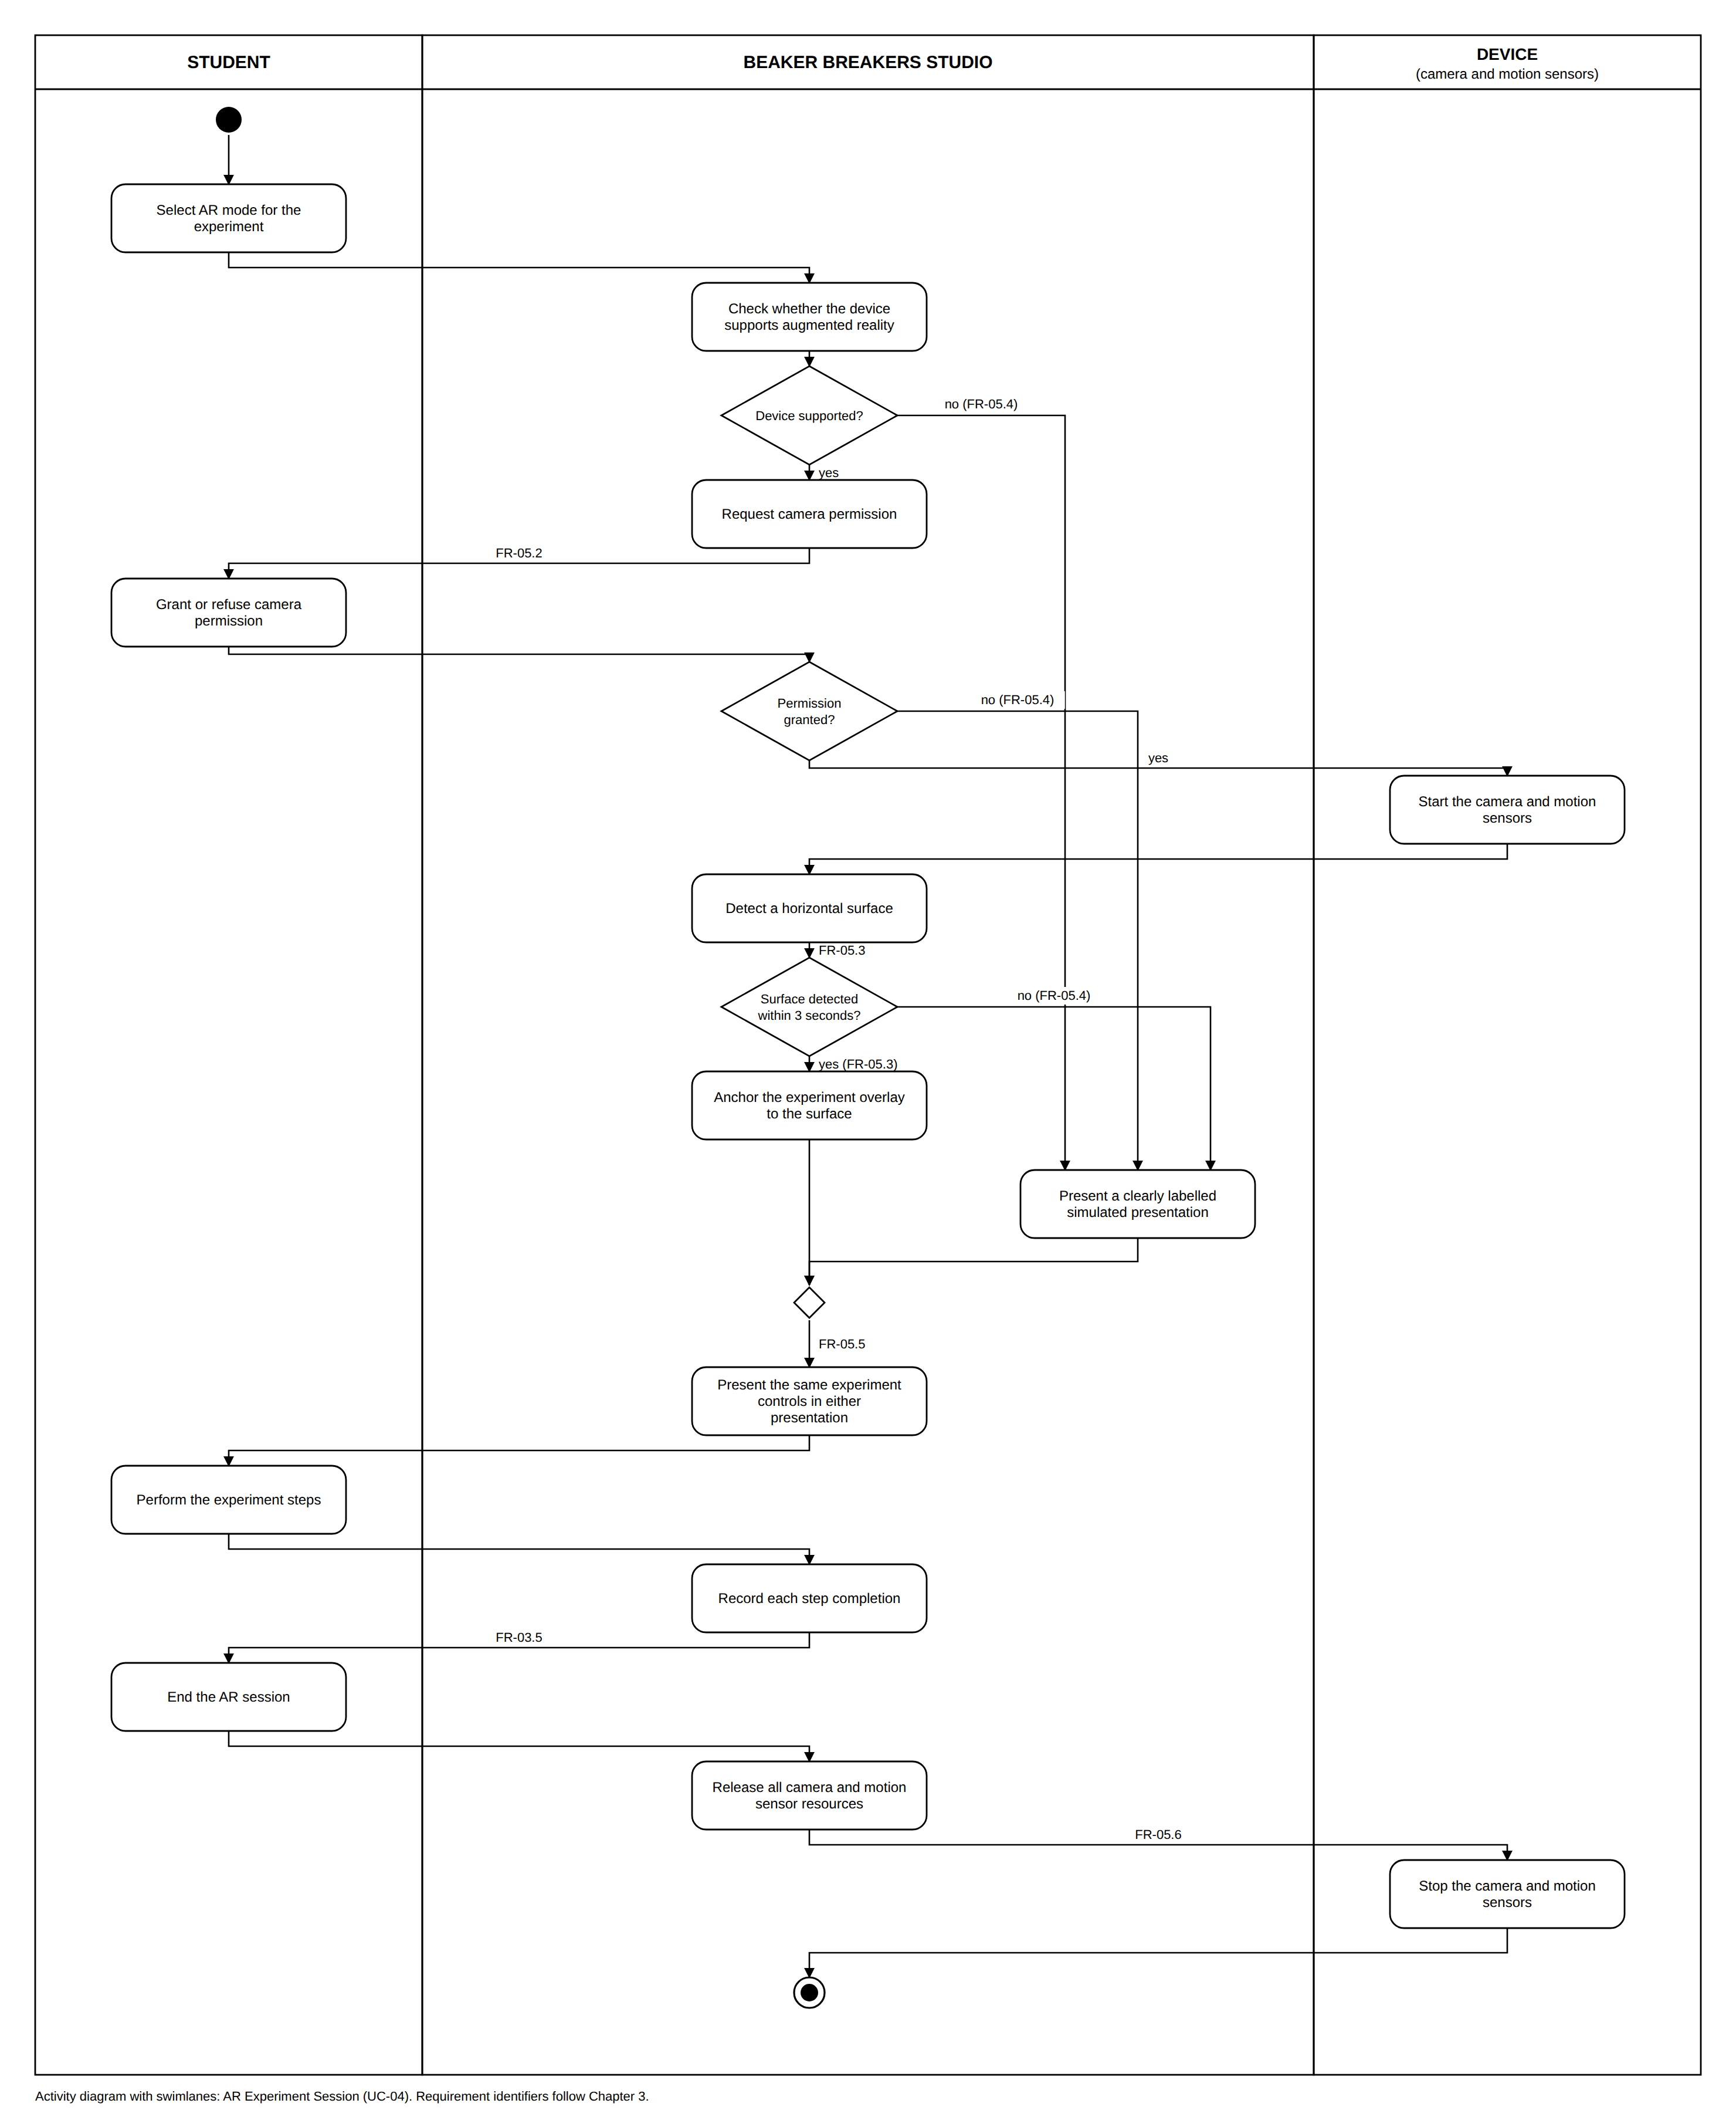
Figure 19 Activity diagram with swimlanes: augmented reality experiment session
The device is drawn as its own partition, because the camera and motion sensors are a separate participant rather than part of the system. Three conditions, an unsupported device, a refused camera permission and a failure to detect a surface, all lead to the same simulated presentation. FR-05.4 names exactly those three conditions, so they converge on one action rather than each having its own ending, and no student is excluded by the limitations of their device. After the merge, FR-05.5 gives both presentations the same controls, and FR-05.6 releases the camera and sensor resources when the session ends.
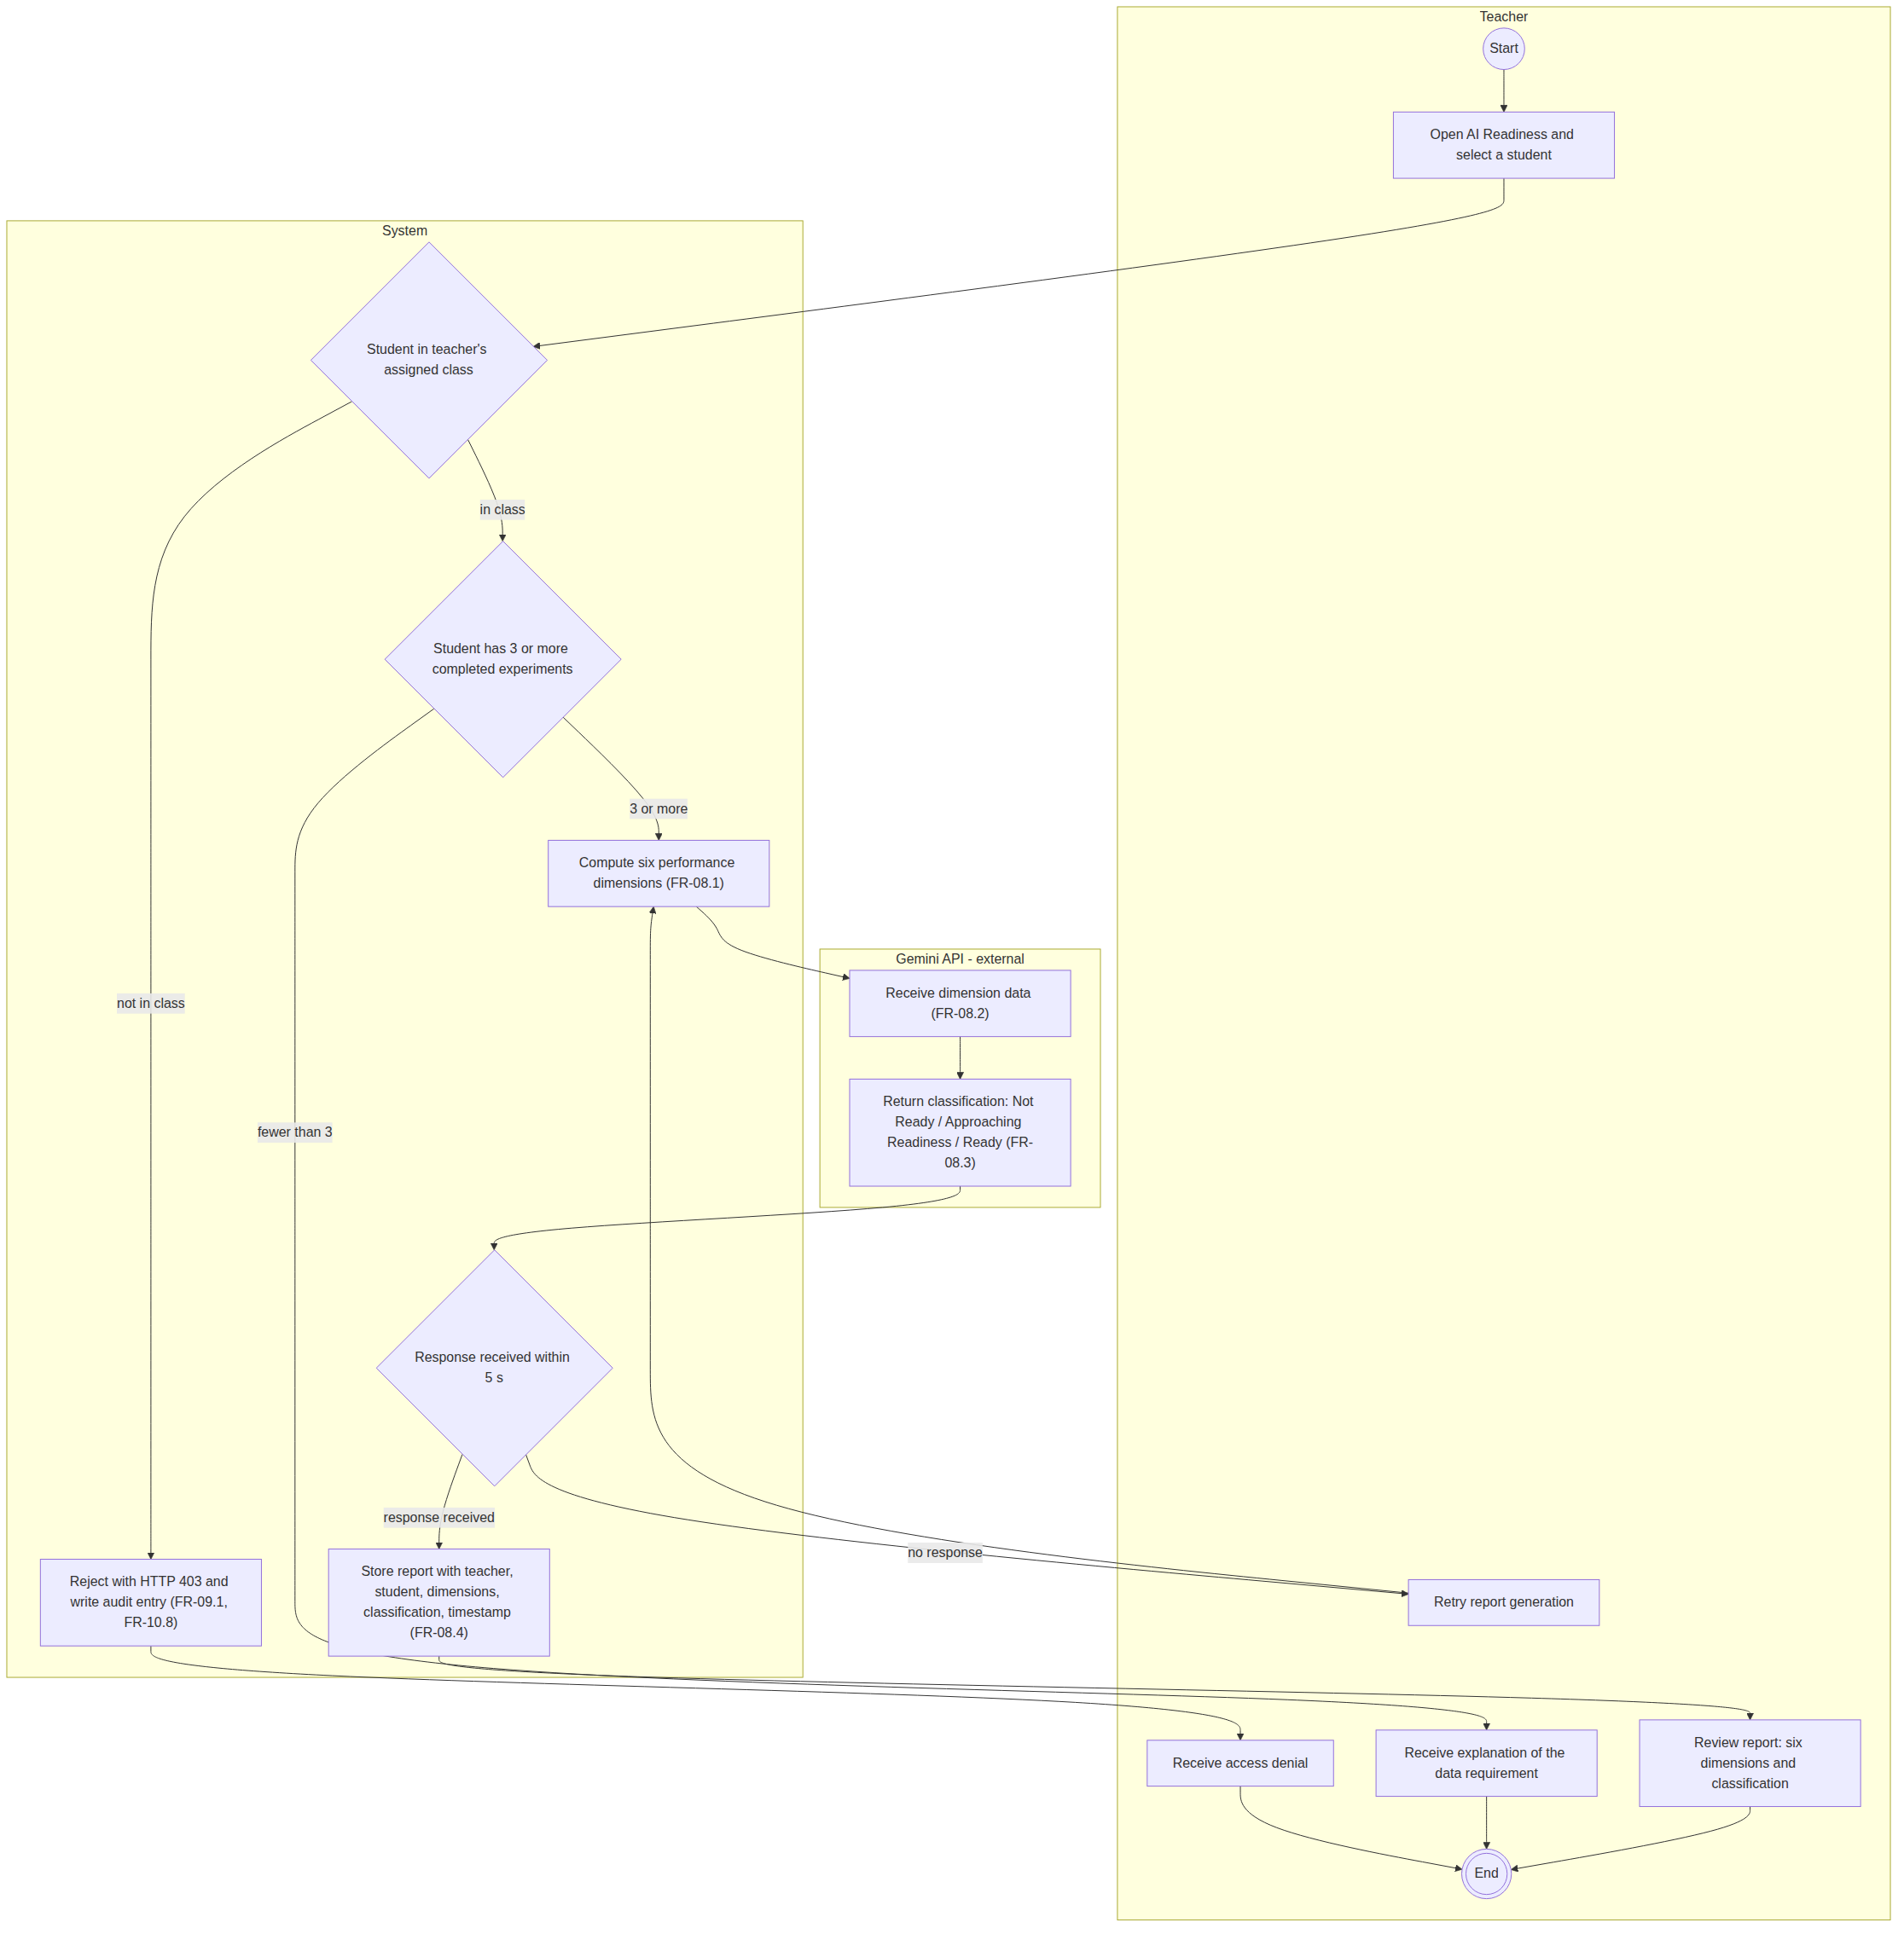
Figure 20 Activity diagram with swimlanes: AI readiness report generation
The partition boundary makes one design decision visible that a single lane diagram could not: the readiness classification is produced outside the system, by the Gemini API, while the six dimension values on which it depends are computed inside the system (FR-08.1). The authorisation check of FR-09.1 and the minimum data check of FR-08.4 both take place before any request is sent to the external service, so an ineligible request never leaves the system boundary.
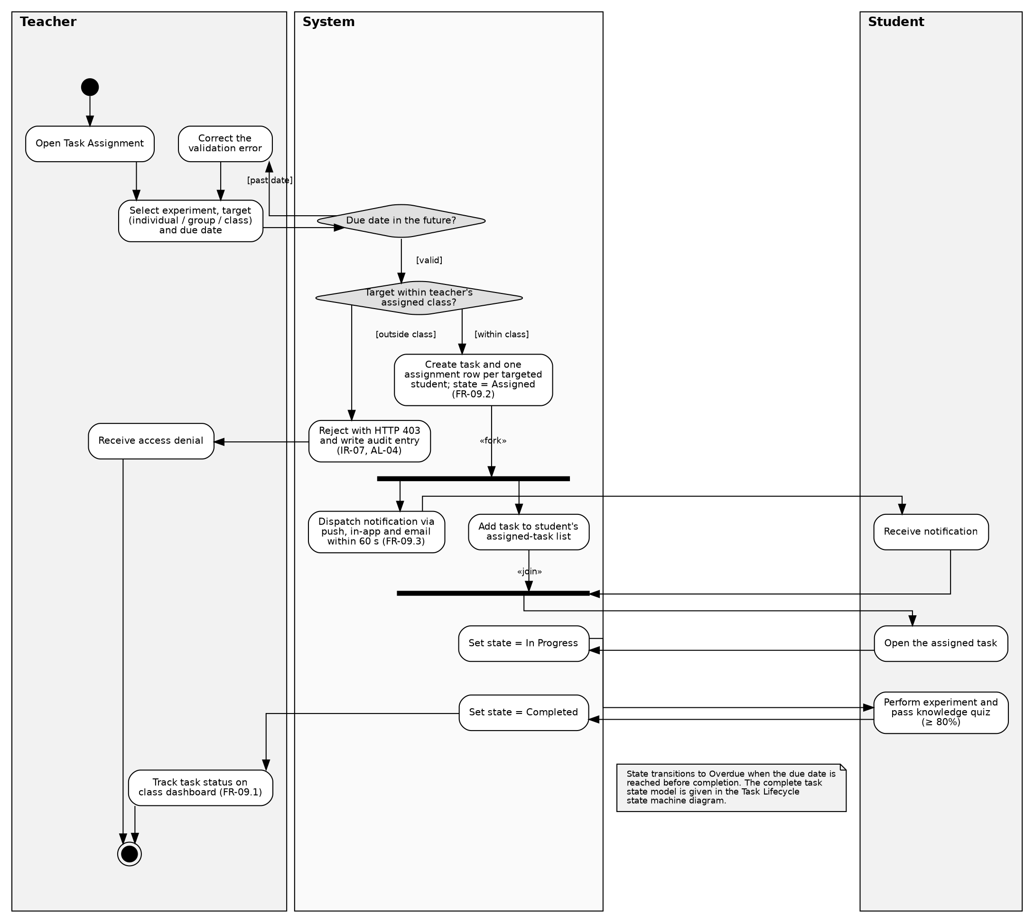
Figure 21 Activity diagram with swimlanes: teacher task assignment
This is the workflow in which partitions add most, because the task passes between the teacher, the system and the student. The fork and join lie within the system partition, since both concurrent actions, dispatching the notification under FR-09.6 and adding the task to the student's list, are performed by the system. Task state then changes without teacher intervention as the student acts, as FR-09.5 requires.

State Machine Diagrams
Two entities in the system hold a state that changes over time in response to events rather than through a single linear workflow. Each is specified with a state machine, because the set of permitted transitions is itself a requirement.
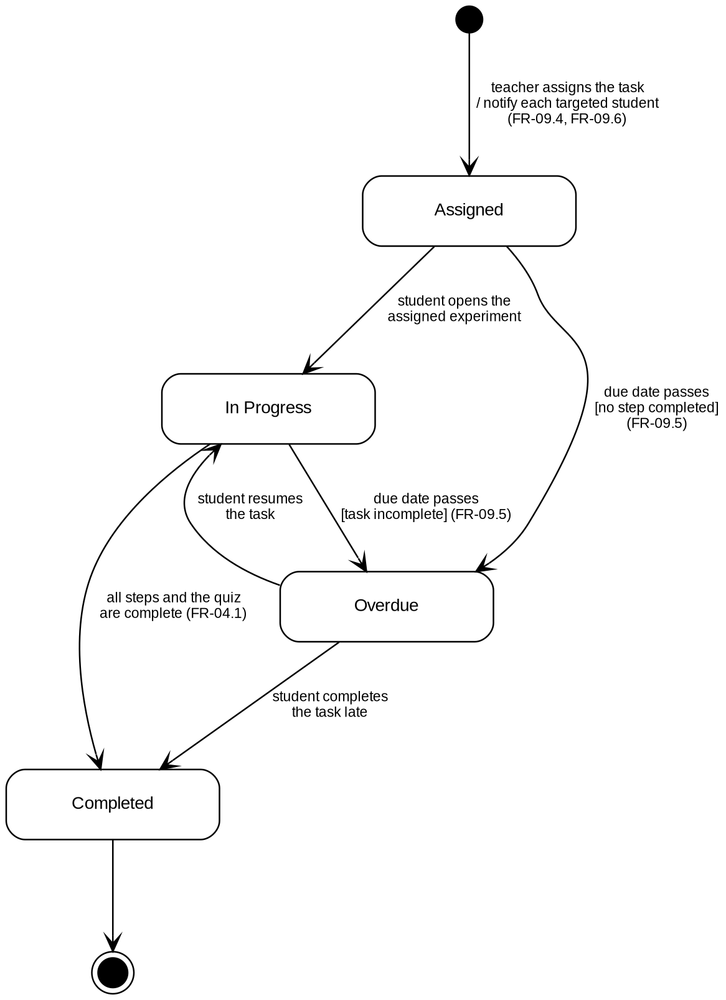
Figure 22 State machine diagram: task lifecycle
FR-09.5 names four states: Assigned, In Progress, Completed and Overdue. The two transitions triggered by the due date passing fire with no teacher action, which is what that requirement means by a state that changes without teacher intervention when the governing condition occurs. Overdue is not a terminal state: a student may resume a task or complete it late, so transitions out of Overdue are drawn rather than leaving it as a dead end.
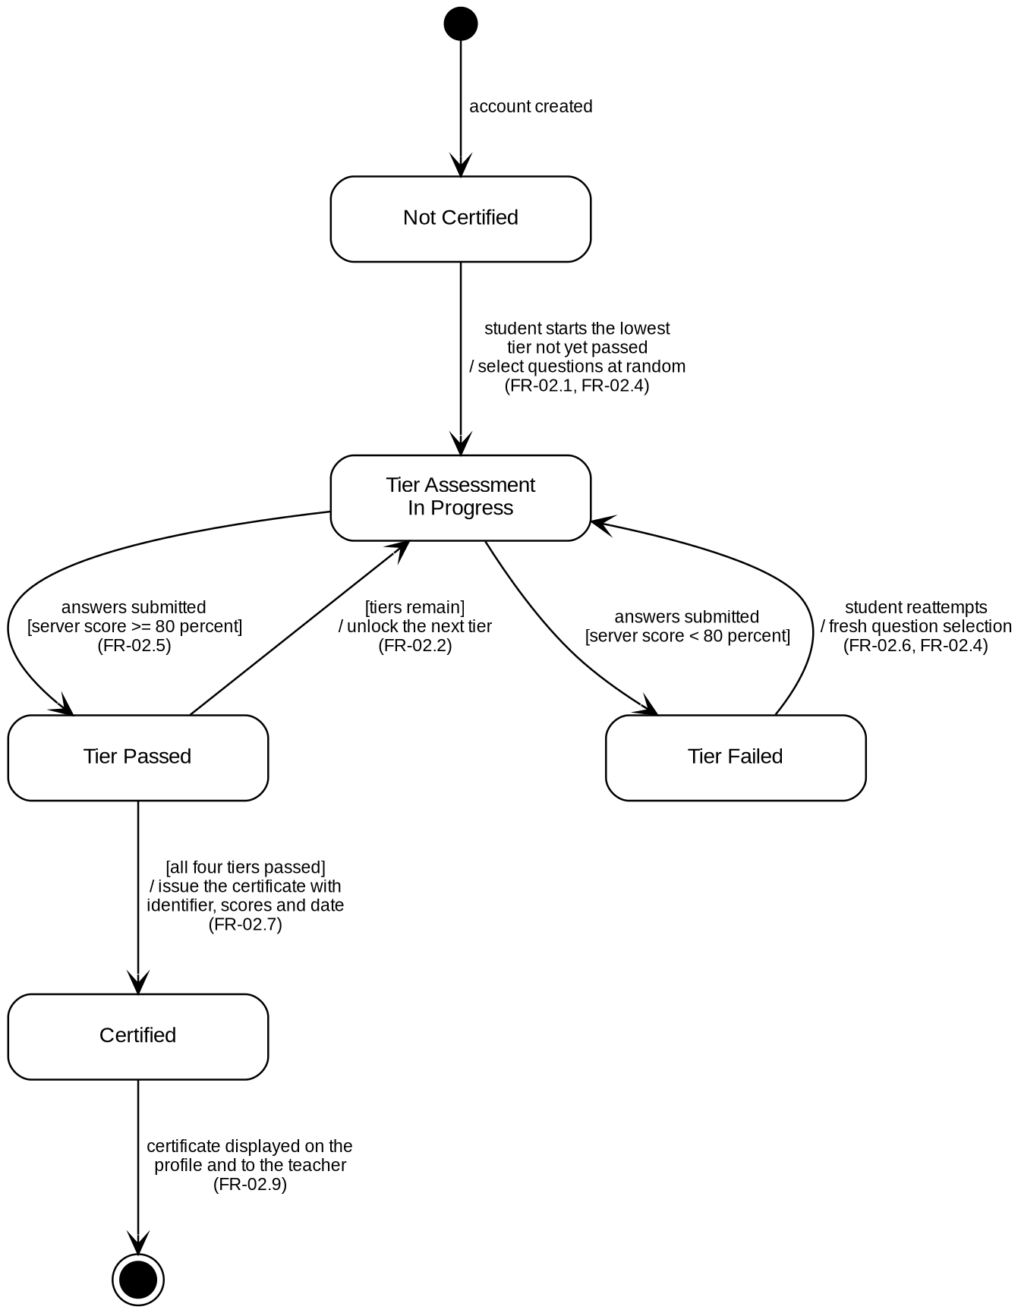
Figure 23 State machine diagram: safety certification
Five states are used: Not Certified, Tier Assessment In Progress, Tier Passed, Tier Failed and Certified. The four tiers follow identical rules, so one tier loop models all four rather than the diagram carrying eight near identical states. The guard on the transition from Tier Passed carries the progression, returning to the assessment while tiers remain and exiting to Certified when all four have been passed (FR-02.7). Certified has no transition back, which is the state machine expression of FR-02.8: an issued certificate is never revoked.

Data Flow Diagrams
The data flow diagrams model the system as processes, data stores and the flows between them, independently of the object oriented structure shown earlier. Standard structured analysis notation is used: circles represent processes, rectangles represent external entities, and open rectangles represent data stores.
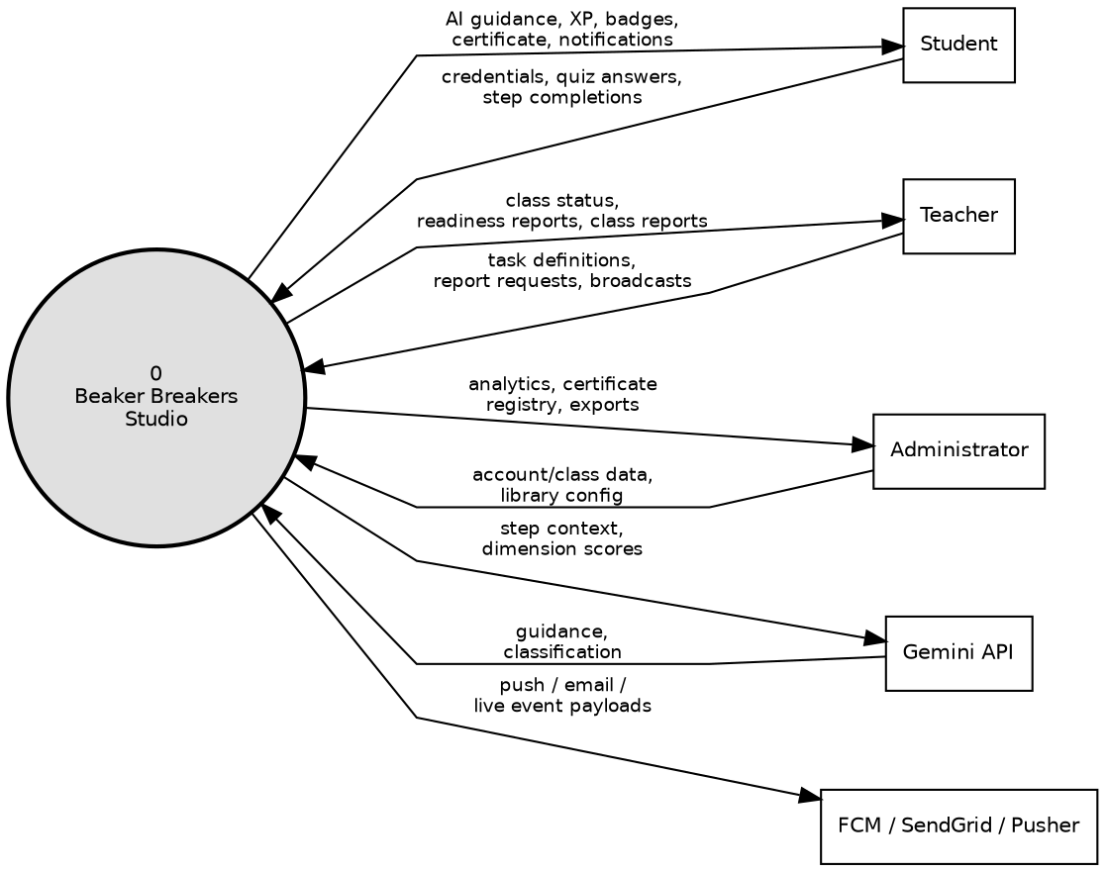
Figure 24 Data flow diagram, Level 0
At Level 0 the whole system is represented as a single process, showing only the data it exchanges with each external entity. This level fixes the system boundary in data terms and is the reference against which Level 1 is balanced.
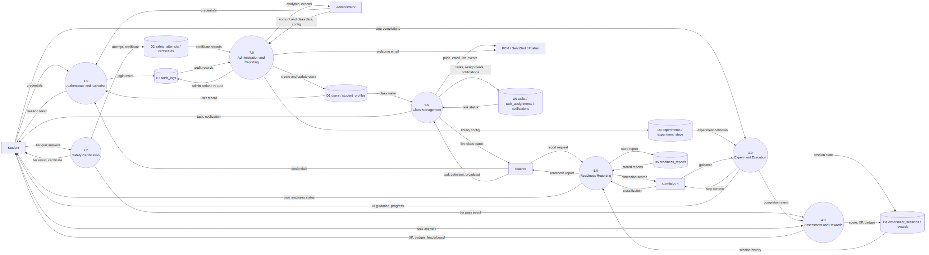
Figure 25 Data flow diagram, Level 1
Level 1 decomposes that single process into seven processes aligned to the functional areas of Chapter 3, together with seven data stores. Every flow that crosses the boundary at Level 0 reappears at Level 1, so the two levels are balanced. The diagram also observes the standard rules of data flow modelling: no flow passes directly between two external entities, between two data stores, or between an external entity and a data store; every process has at least one input and at least one output; and every data store is both written to and read from, with each read drawn from the store to the process that consumes it.

Entity Relationship Diagram
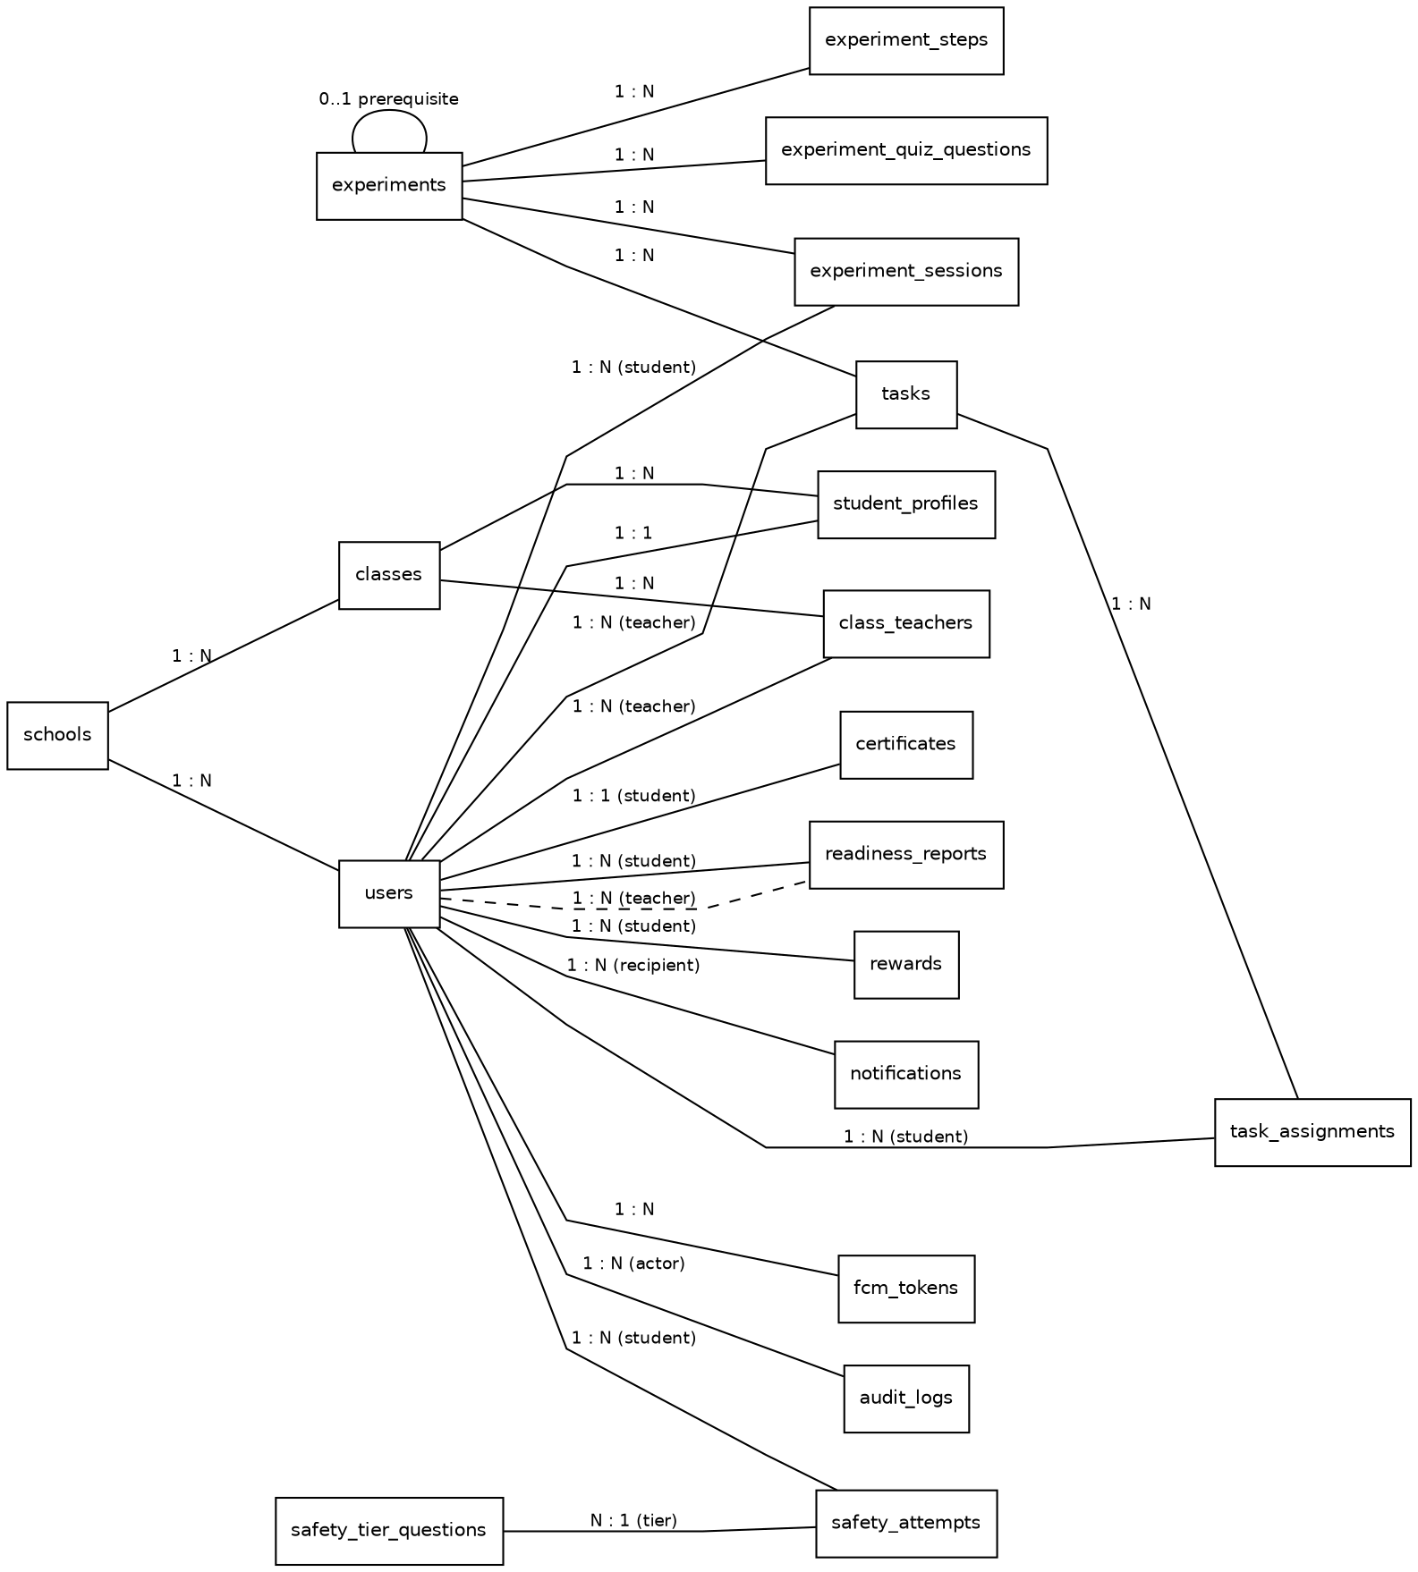
Figure 26 Entity relationship diagram
Nineteen entities are modelled, in three groups. The identity group establishes who each user is and which class they belong to. The content group establishes what may be learned: experiments, their steps, their quiz questions and the safety tier questions. The activity group records what each student has done: sessions, attempts, certificates, readiness reports and rewards. Two cardinalities carry requirements directly. The one to one cardinality between a user and a certificate expresses the rule that a student holds at most one safety certificate, which follows from FR-02.7. The self referencing relationship on experiments carries the prerequisite rule of FR-03.3. The audit log entity supports the permanent record required by FR-10.8.

Data Dictionary
The dictionary below records the purpose of each entity and its principal attributes. Primary keys are shown as PK and foreign keys as FK. Attributes that exist in order to satisfy a specific requirement carry that requirement identifier.
Table 47 Data dictionary for the nineteen entities of the design.
Entity | Purpose | Principal attributes
SCHOOLS | The institution that licenses the system. | school_id PK, name, district, licence_start, licence_end, student_cap
USERS | Every account in the system, of any role. | user_id PK, school_id FK, role, display_name, email, password_hash (SR-01), status, created_at, last_login_at
STUDENT_PROFILES | Learning state that applies only to a student. | profile_id PK, user_id FK, class_id FK, total_points, rank_level (FR-06.4), current_streak_days (FR-06.5)
CLASSES | A teaching group within a school. | class_id PK, school_id FK, title, grade_level, academic_year
CLASS_TEACHERS | The assignment of a teacher to a class. | class_teacher_id PK, class_id FK, user_id FK, assigned_at (FR-09.1)
EXPERIMENTS | An experiment in the library. | experiment_id PK, title, topic, difficulty, prerequisite_experiment_id FK (FR-03.3), chemical_equation (FR-03.6), explanatory_note, ar_available (FR-05.1), base_points
EXPERIMENT_STEPS | An ordered step within an experiment. | step_id PK, experiment_id FK, step_order (FR-03.4), instruction_text, preauthored_guidance (NFR-06)
EXPERIMENT_QUIZ_QUESTIONS | A knowledge quiz question for an experiment. | question_id PK, experiment_id FK, prompt, options, correct_option, explanation (FR-04.2)
EXPERIMENT_SESSIONS | One attempt by one student at one experiment. | session_id PK, user_id FK, experiment_id FK, presentation_mode, started_at, completed_at, steps_completed (FR-03.5)
SAFETY_TIER_QUESTIONS | A question in one of the four safety tier banks. | question_id PK, tier_number (FR-02.1), prompt, options, correct_option
SAFETY_ATTEMPTS | One attempt by one student at one safety tier. | attempt_id PK, user_id FK, tier_number, score (FR-02.5), passed, attempted_at (FR-02.6)
CERTIFICATES | The safety certificate issued to a student. | certificate_id PK, user_id FK, certificate_reference, tier1_score, tier2_score, tier3_score, tier4_score, issued_on (FR-02.7)
READINESS_REPORTS | A generated readiness report about a student. | report_id PK, subject_user_id FK, requesting_user_id FK, procedural_accuracy, safety_compliance, reagent_management, time_efficiency, conceptual_understanding, error_recovery (FR-08.1), classification (FR-08.3), generated_at (FR-08.5)
REWARDS | An experience point award or a badge award. | reward_id PK, user_id FK, reward_type, badge_code, points_awarded, source_session_id FK, awarded_at (FR-04.3, FR-06.3)
TASKS | A task created by a teacher for an experiment. | task_id PK, created_by_user_id FK, class_id FK, experiment_id FK, due_at (FR-09.4), created_at
TASK_ASSIGNMENTS | The task as it reaches one individual student. | assignment_id PK, task_id FK, user_id FK, state (FR-09.5), state_changed_at
NOTIFICATIONS | A message delivered to a user. | notification_id PK, user_id FK, notification_type (FR-09.7), body, created_at, read_at
FCM_TOKENS | A device registration for push delivery. | token_id PK, user_id FK, device_token, platform, registered_at (FR-09.6)
AUDIT_LOGS | The permanent record of administrative actions. | audit_id PK, actor_user_id FK, action_type, target_reference, occurred_at (FR-10.8)

Three design rules govern the schema. Passwords are stored only as salted hashes produced by an adaptive hashing function, never in any recoverable form, under SR-01. Student personally identifiable information is encrypted at rest under SR-06. Rows in AUDIT_LOGS and CERTIFICATES are written once and never updated or deleted, which is enforced at the application tier and reflected in the absence of any modification timestamp on either entity (FR-02.8, FR-10.8).

User Interface Design and Wireframes
The interface will be used by secondary students with limited prior experience of laboratory software, and by teachers and administrators who need dense information quickly. The survey reported in Section 3.1.3 informed several of the decisions below: respondents most frequently asked for the software to explain procedures clearly and to be simple enough for everyone to understand.
The interface design applies established human computer interaction principles. The table below records each principle, the design decision that applies it, and the requirement that the decision serves where one exists.
Table 48 Human computer interaction principles applied to the interface design.
Principle | How it is applied | Requirement
Visibility of system status | Every screen states the user's current position and the step reached. The laboratory shows which step of how many is active, and the safety area shows which tiers have been passed. | FR-02.2, FR-03.4
Match between system and the real world | Apparatus, reagents and procedures carry the names used in the Class 9 and Class 10 curriculum rather than internal identifiers. The governing chemical equation is shown alongside each experiment. | FR-03.6
User control and freedom | Navigation is persistent and the back control always returns to the previous screen rather than to the home screen. A student may leave an experiment and resume it with completed steps restored. | FR-03.5, NFR-05
Consistency and standards | The laboratory keeps a fixed layout, with instruction, scene, progress and assistance always in the same regions, so attention remains on the chemistry rather than on the interface. | NFR-07
Error prevention | Actions that cannot succeed are disabled with the reason shown rather than failing after the attempt. A locked experiment states the prerequisite or the missing tier instead of simply refusing to open. | FR-02.3, FR-03.3
Recognition rather than recall | The experiment library is browsable with filters by difficulty and topic, so a student selects from what is shown rather than remembering a name. | FR-03.2
Flexibility and efficiency of use | Teachers reach class monitoring, assignment and reports from a single dashboard, and the class view updates without a manual refresh. | FR-09.2, FR-09.3
Aesthetic and minimalist design | The leaderboard shows only display name, avatar, rank level and points, so that comparison between students is limited to what the requirement permits. | FR-07.1
Help users recognise and recover from errors | An incorrect quiz answer produces an explanation rather than a bare rejection, and a failed tier offers a further attempt immediately. | FR-04.2, FR-04.5
Accessibility | All web interfaces conform to WCAG 2.1 Level AA. Colour is never the only indicator of meaning; status is also shown by a label or an icon. Controls are sized for touch as well as for a mouse. | NFR-08
Responsiveness across devices | The interface adapts from desktop to tablet to mobile, since students will use whichever device is available to them. | NFR-09, NFR-11

The navigation map below shows every screen that will be provided and every permitted transition between them, grouped by role. Three properties of the map follow from requirements rather than from preference. No path leads from a student screen to a teacher or administrator screen, which is the interface level expression of the role based access control required by SR-04. The experiment library is reachable from the student dashboard but the experiment screen itself is not, because FR-02.3 makes the safety gate unavoidable. Account creation appears only within the administrator area, because FR-01.6 permits no other route.
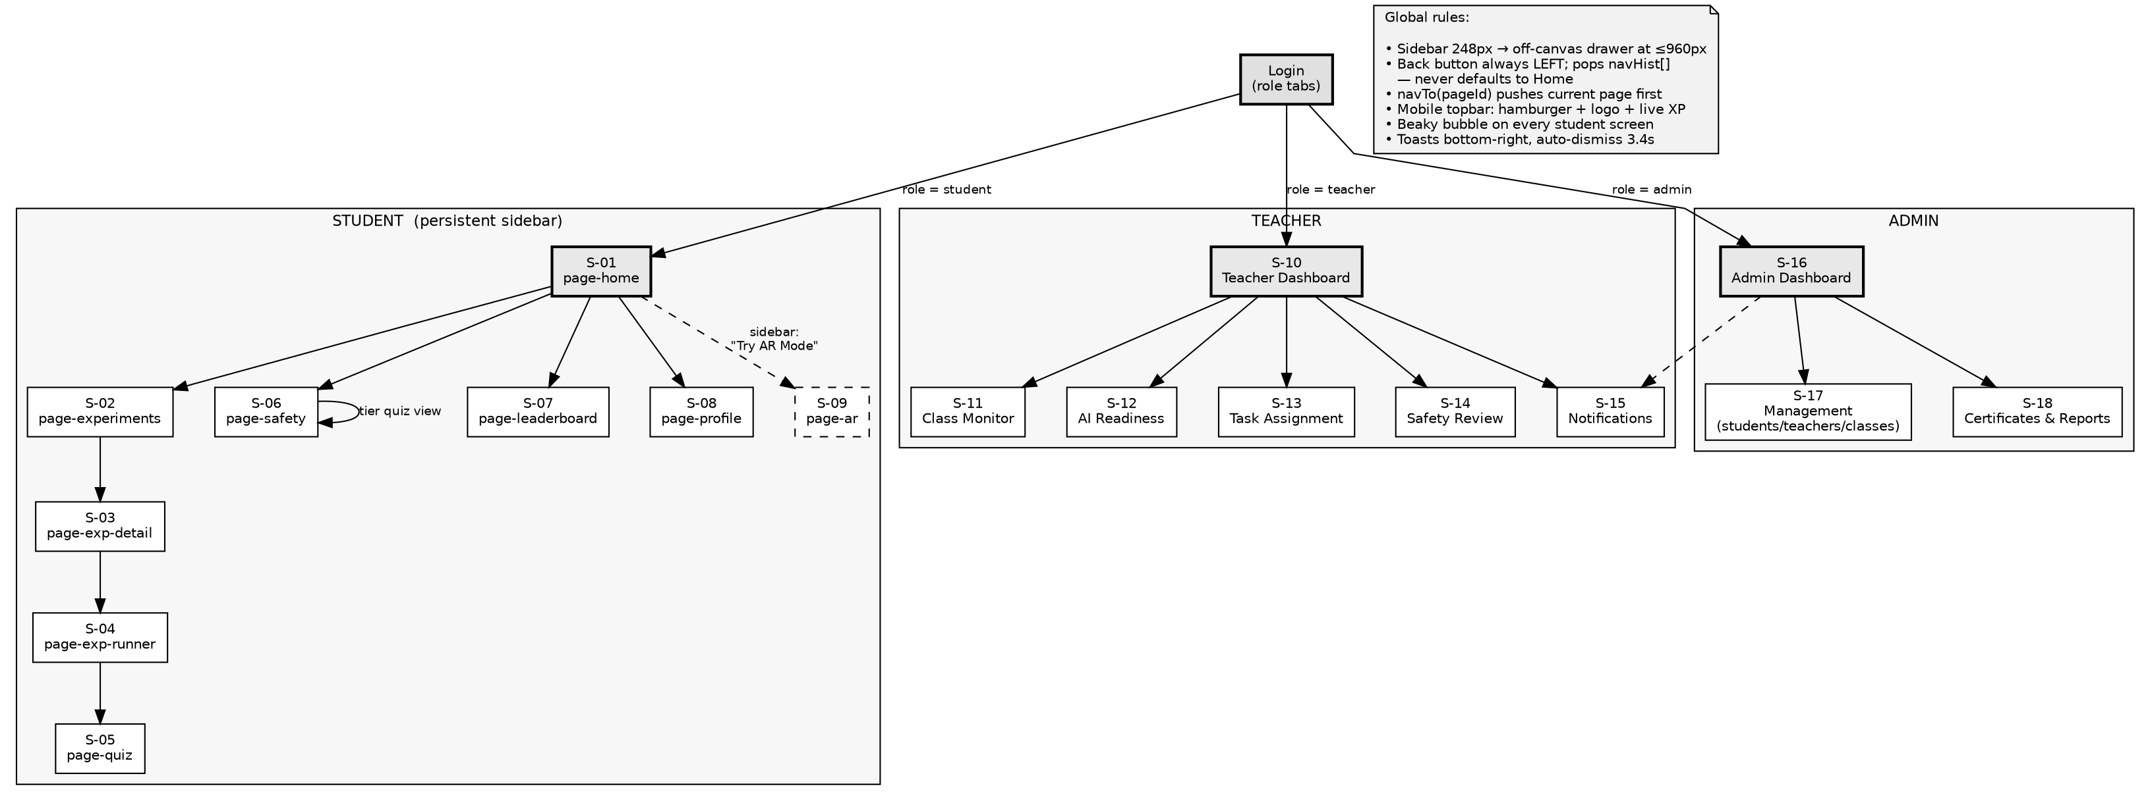
Figure 27 Navigation map of the student, teacher and administrator interfaces
The wireframes below define the layout of each principal screen before any visual styling is applied. They fix the position of every region, the controls each screen carries and the error states the user may encounter, so that the interface can be built against a settled layout rather than being designed during implementation.

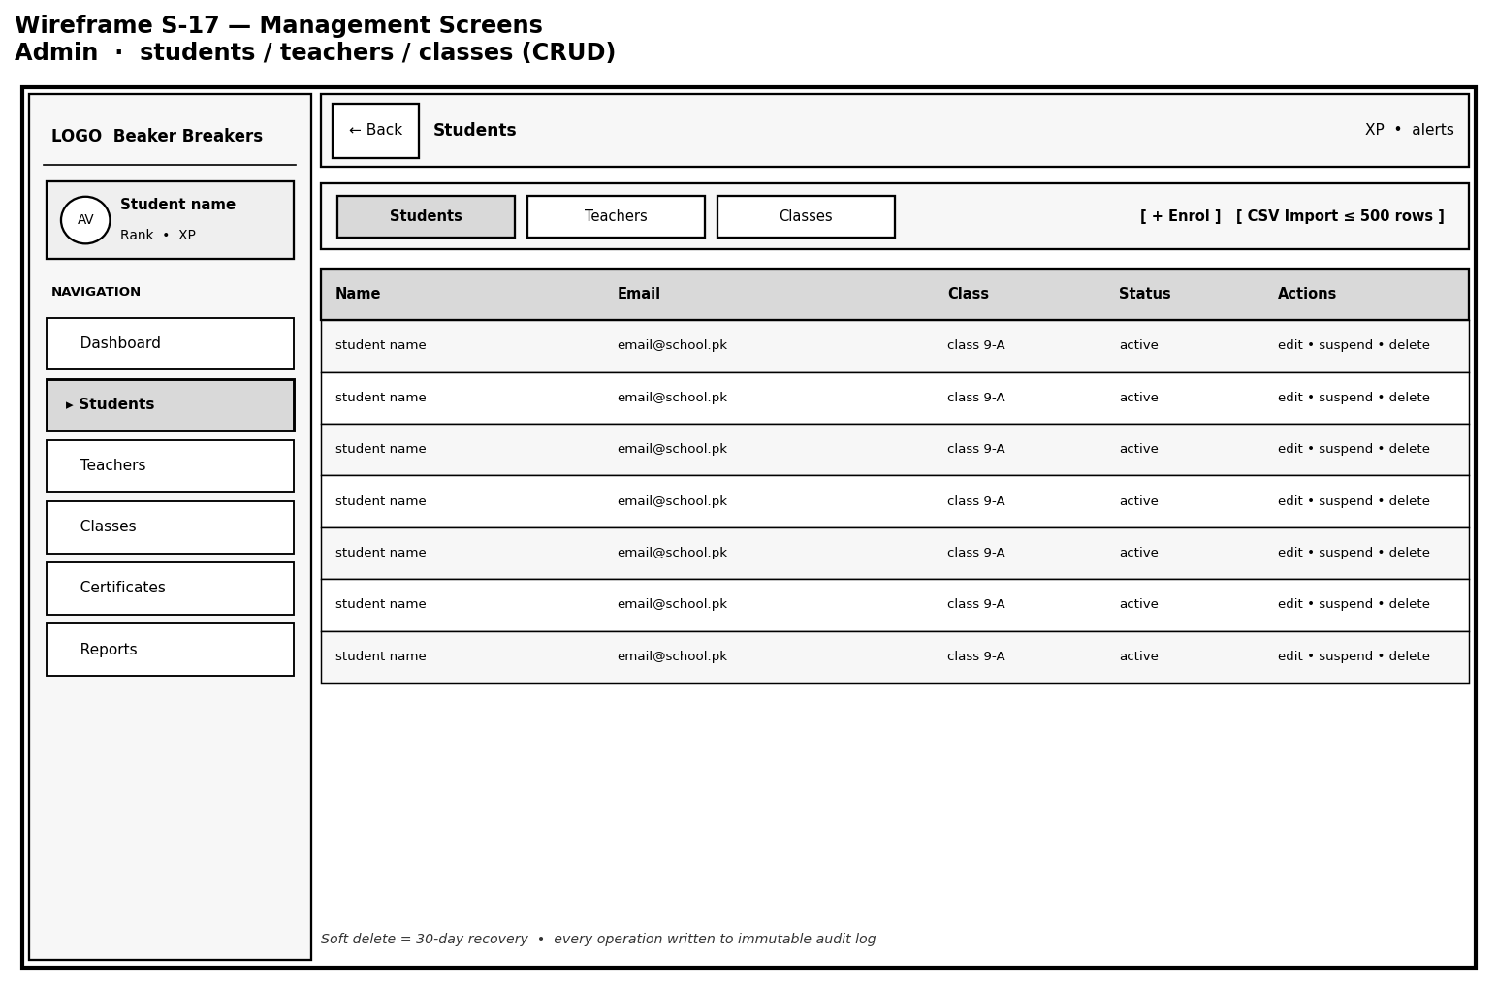
Figure 28 Wireframe S-17: Administrator management screens for students, teachers and classes
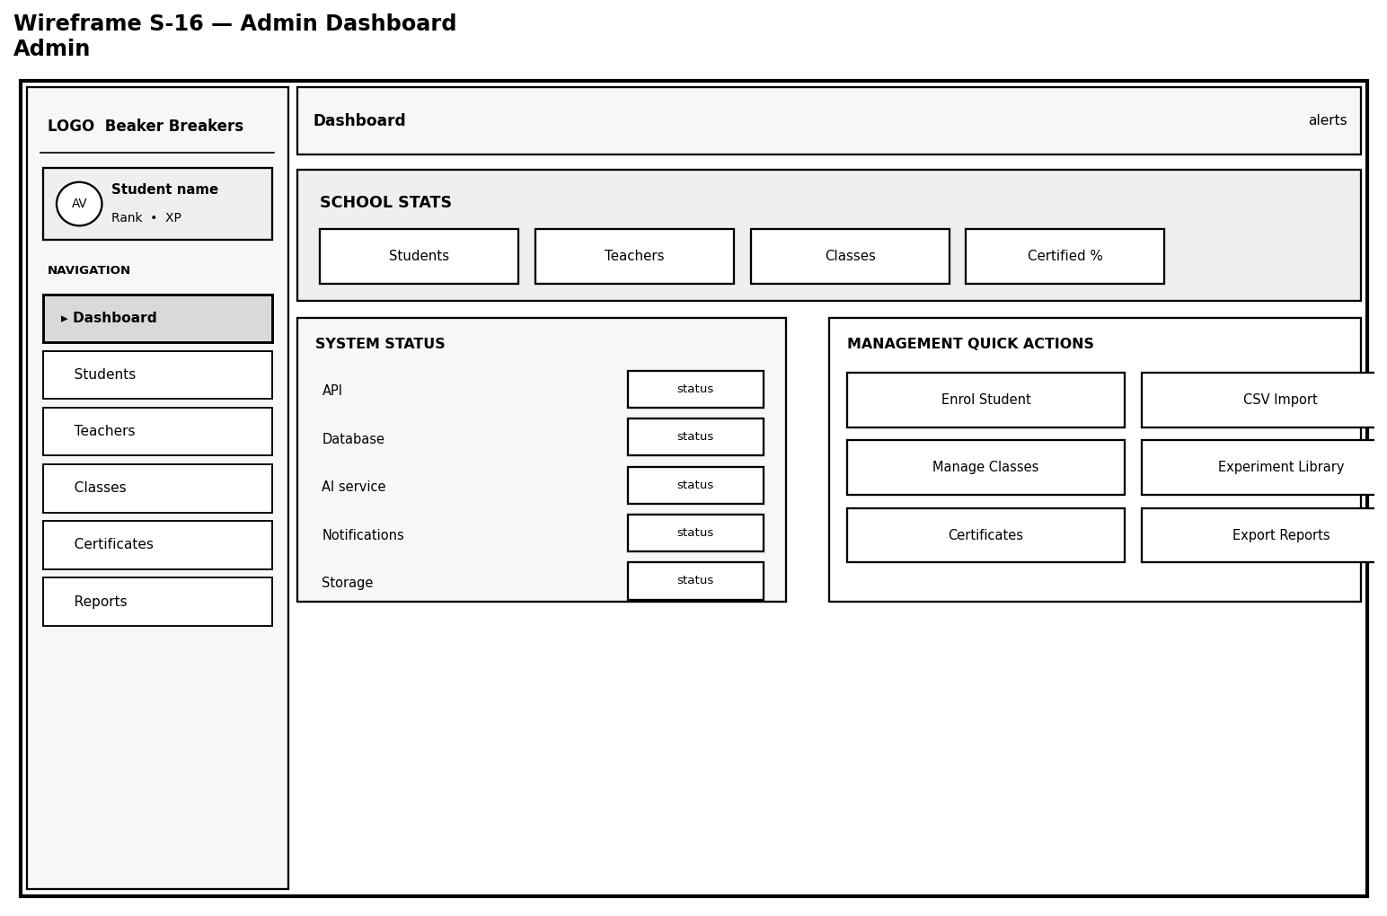
Figure 29 Wireframe S-16: Administrator dashboard
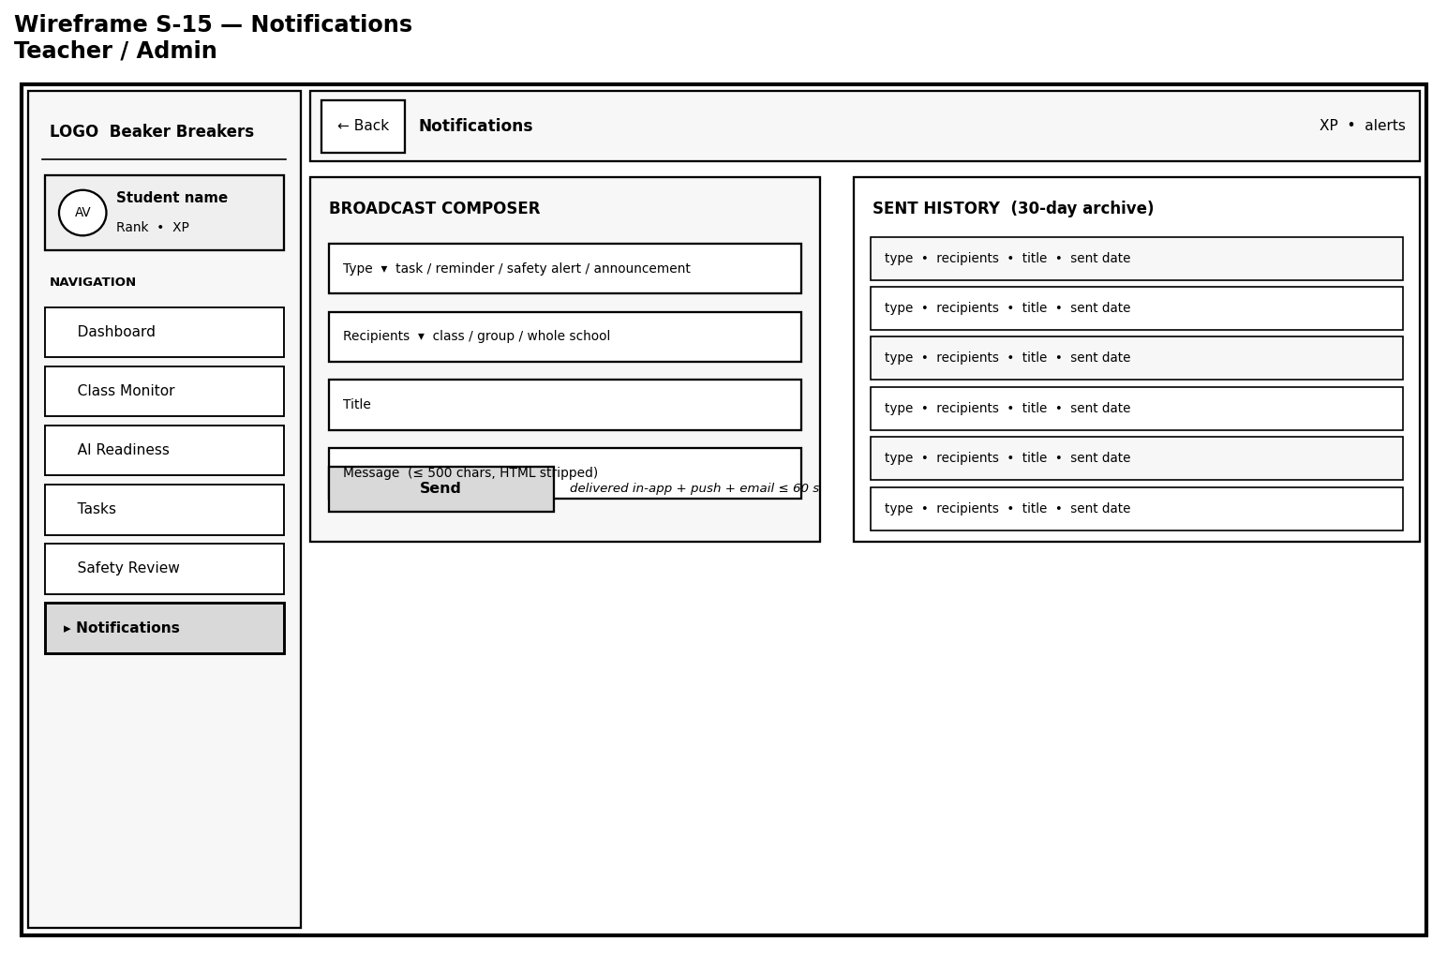
Figure 30 Wireframe S-15: Notifications screen for teachers and administrators
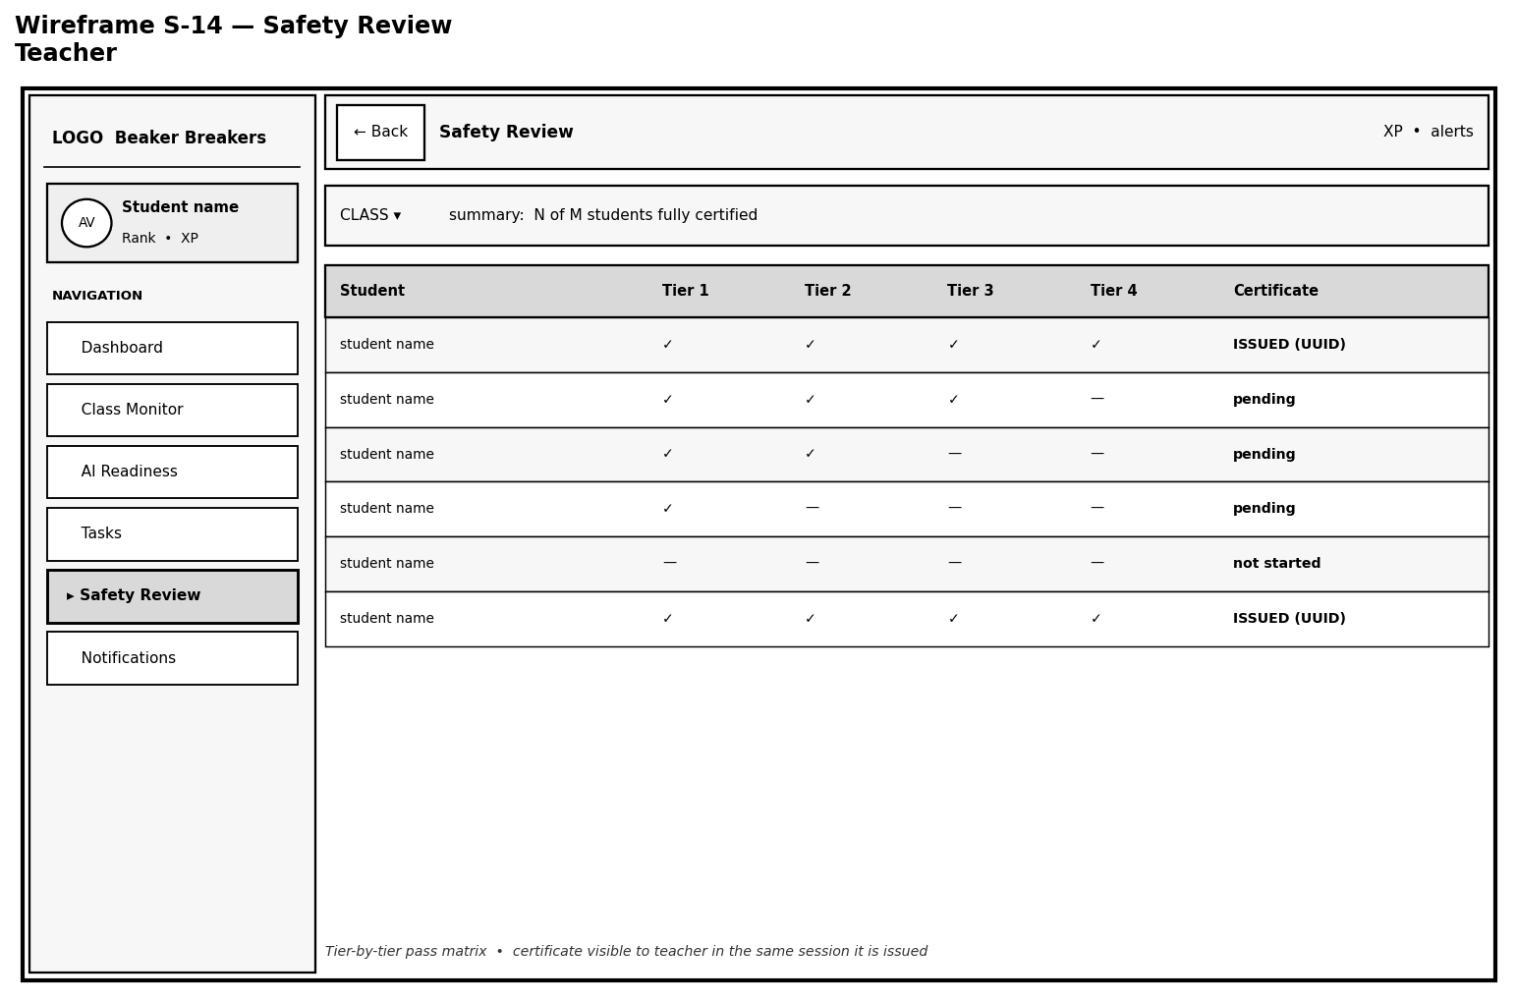
Figure 31 Wireframe S-14: Teacher safety review screen
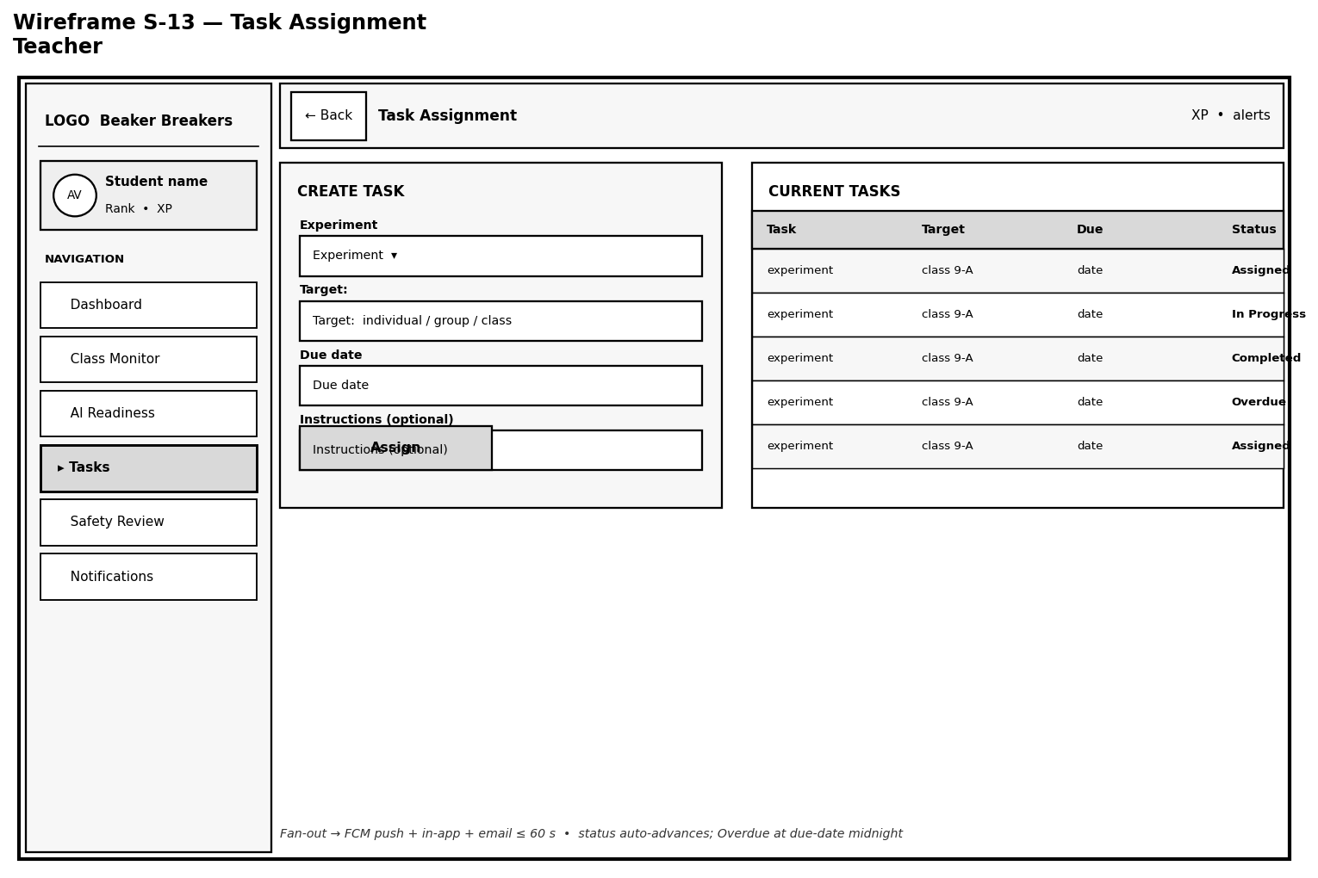
Figure 32 Wireframe S-13: Teacher task assignment screen
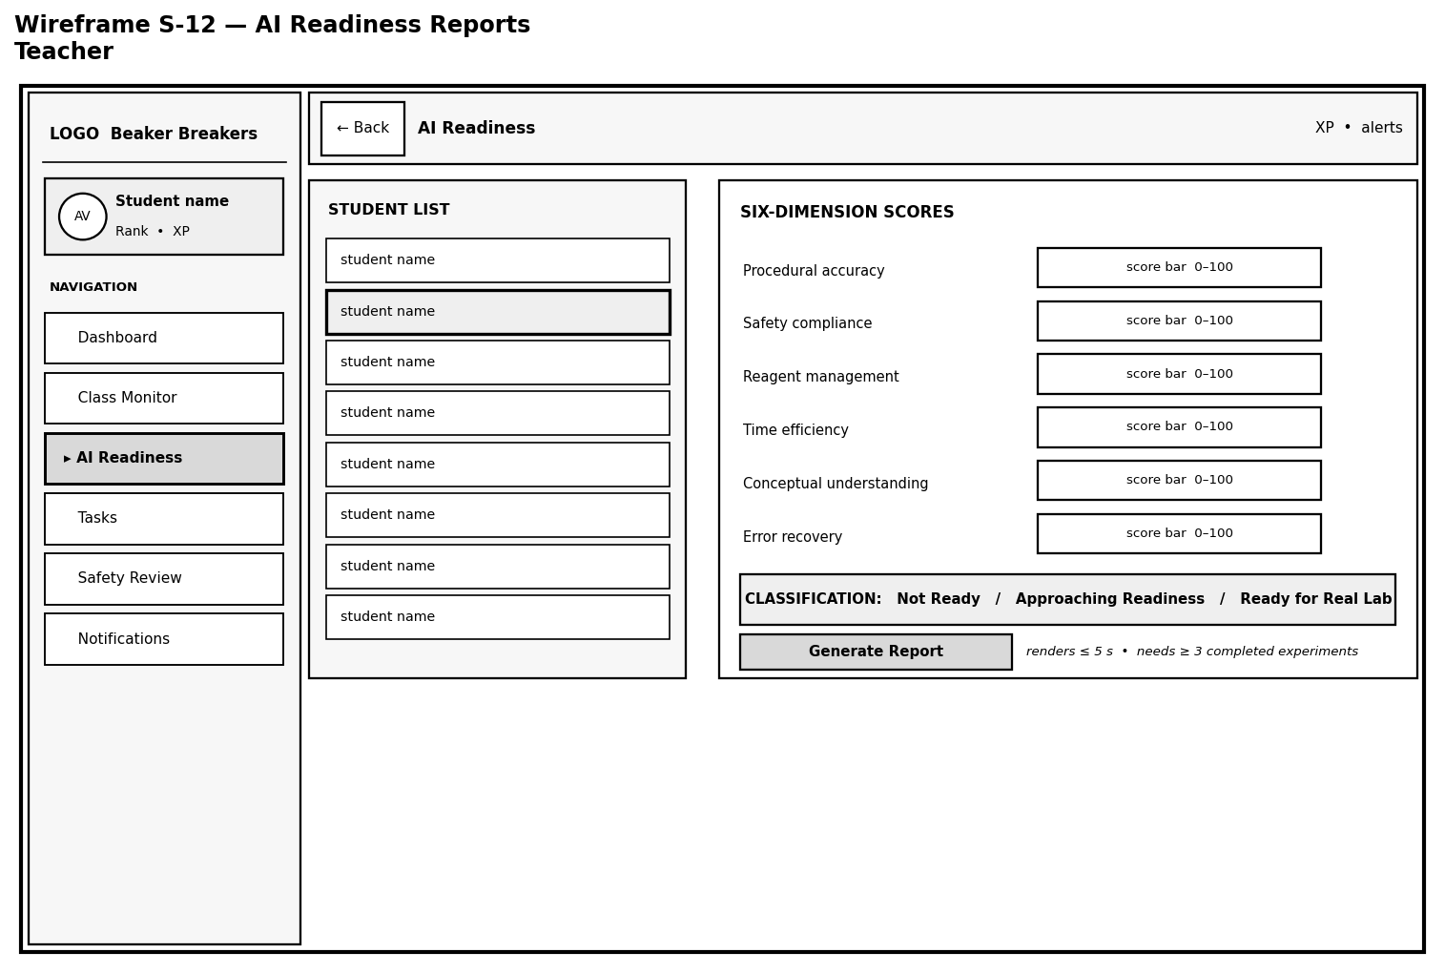
Figure 33 Wireframe S-12: Teacher AI readiness reports screen
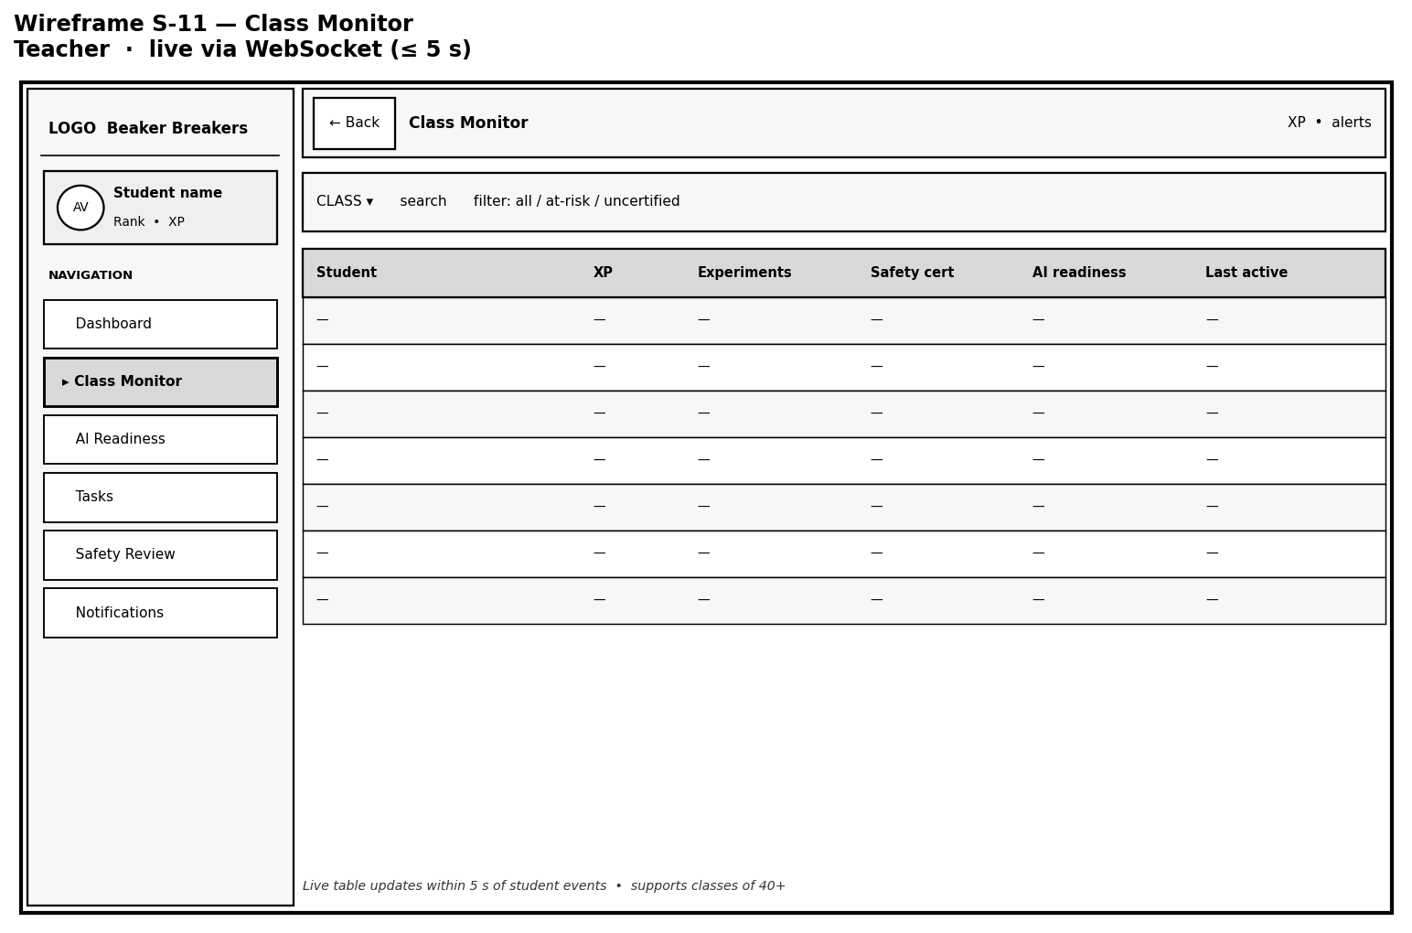
Figure 34 Wireframe S-11: Teacher class monitor screen
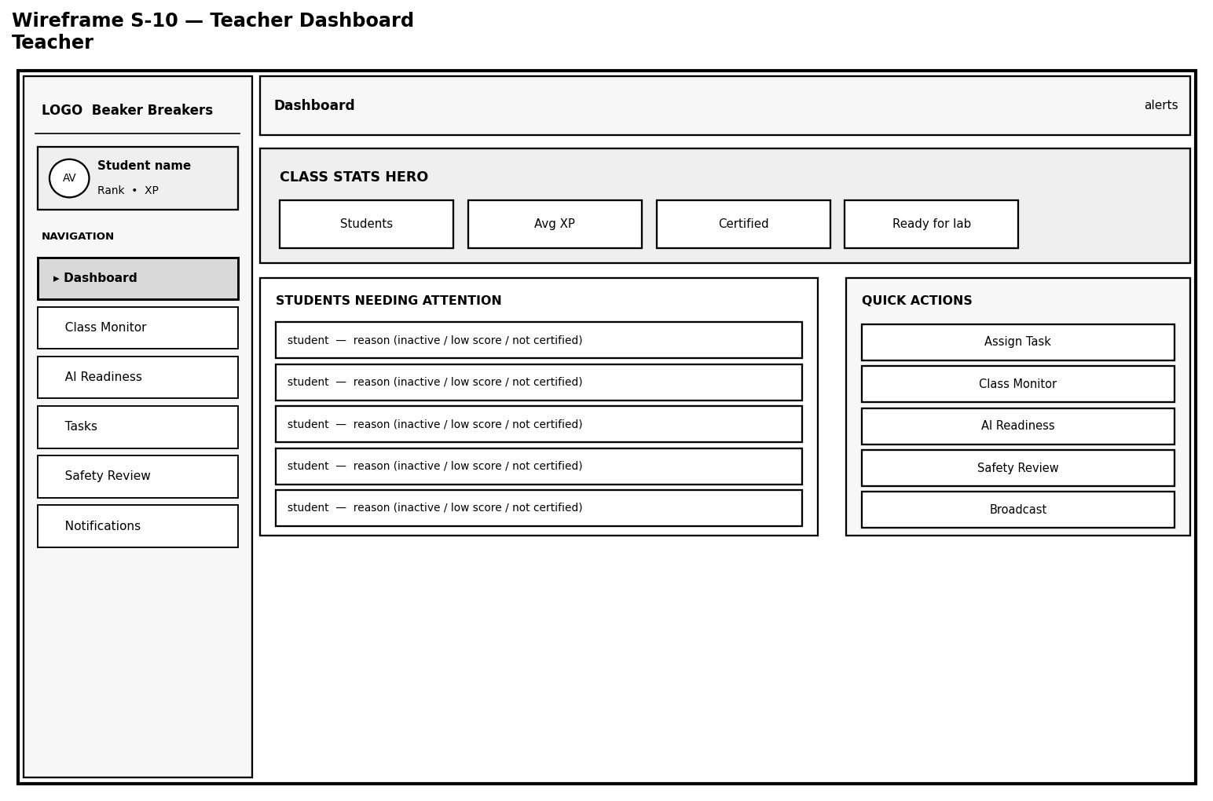
Figure 35 Wireframe S-10: Teacher dashboard
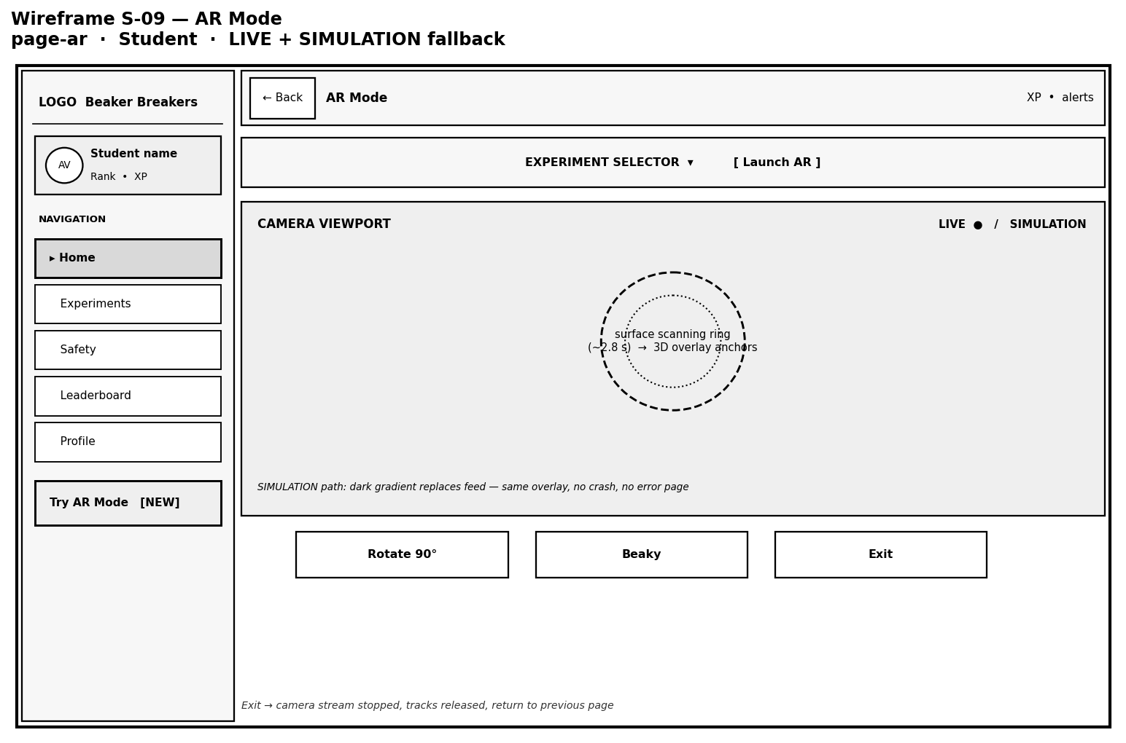
Figure 36 Wireframe S-09: Student augmented reality mode screen
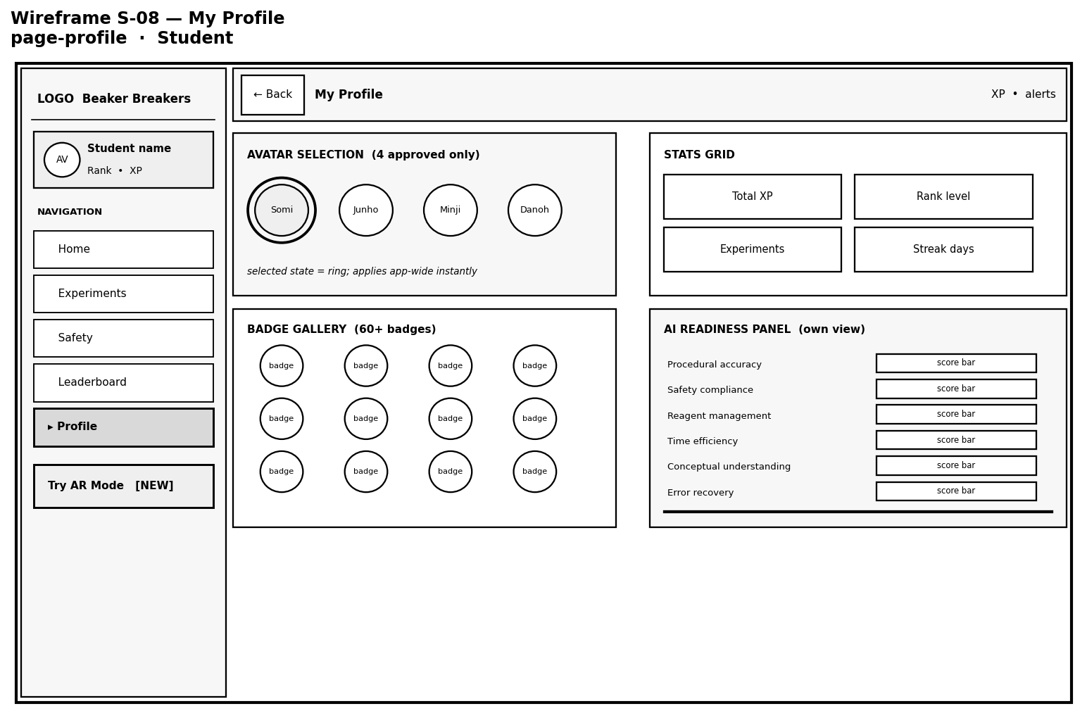
Figure 37 Wireframe S-08: Student profile screen
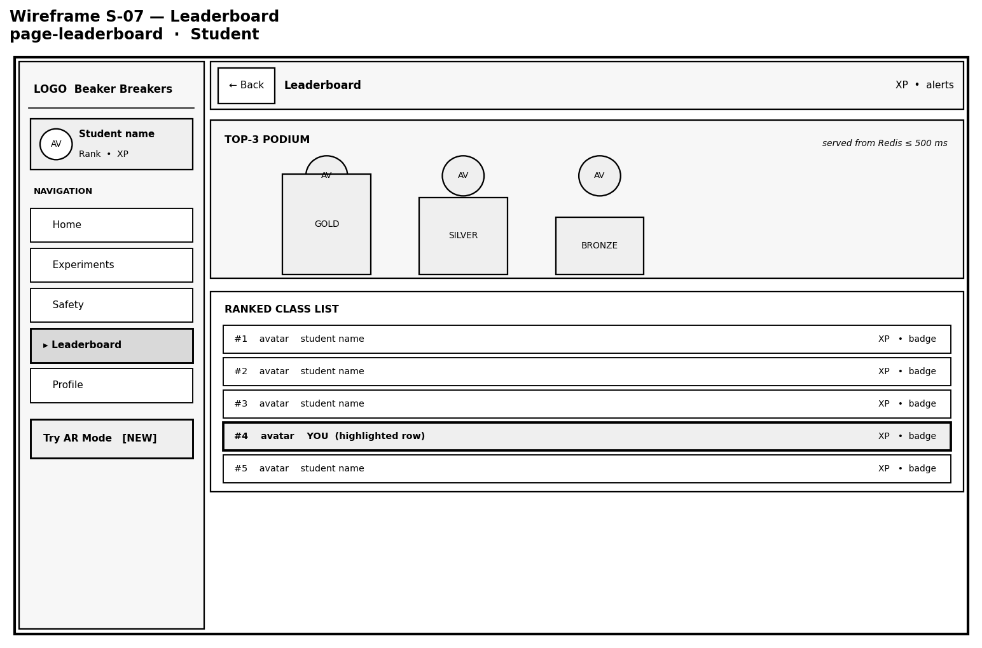
Figure 38 Wireframe S-07: Student leaderboard screen
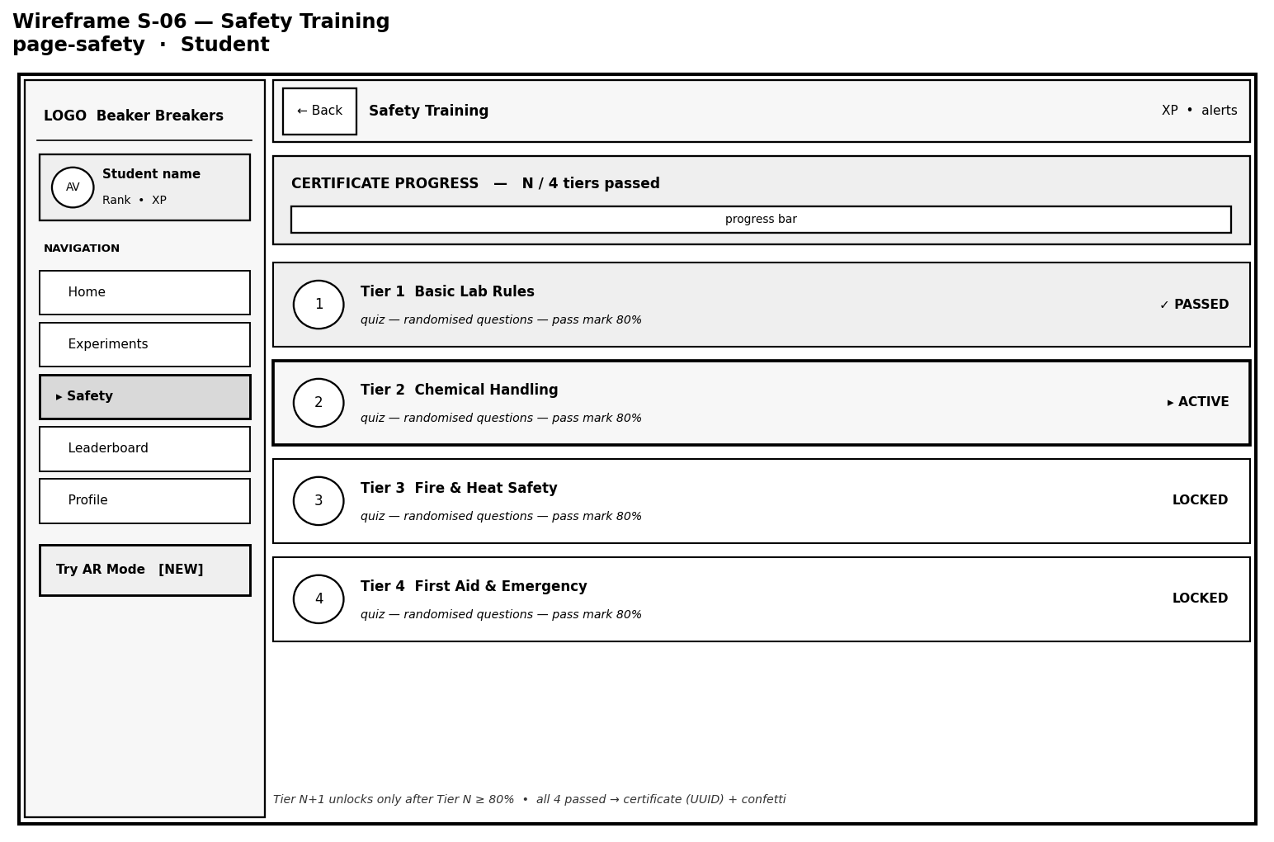
Figure 39 Wireframe S-06: Student safety training screen
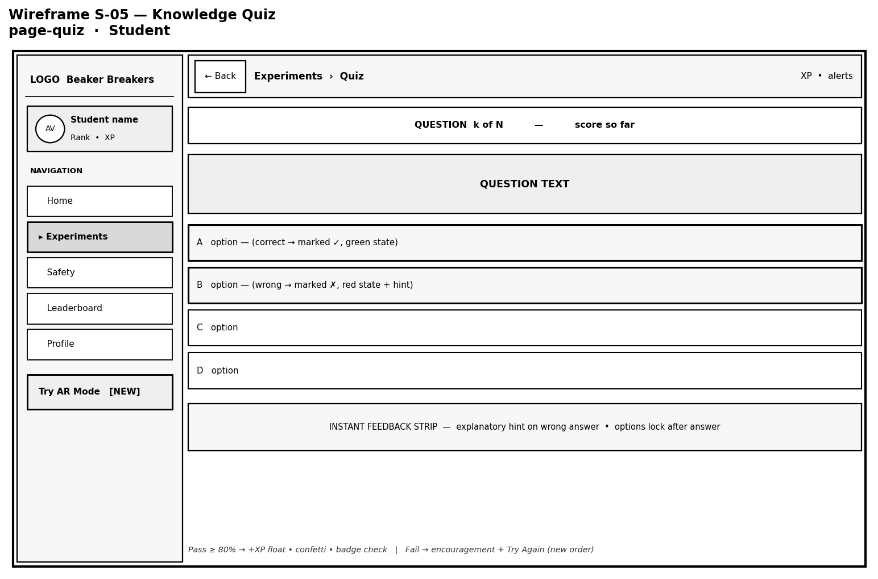
Figure 40 Wireframe S-05: Student knowledge quiz screen
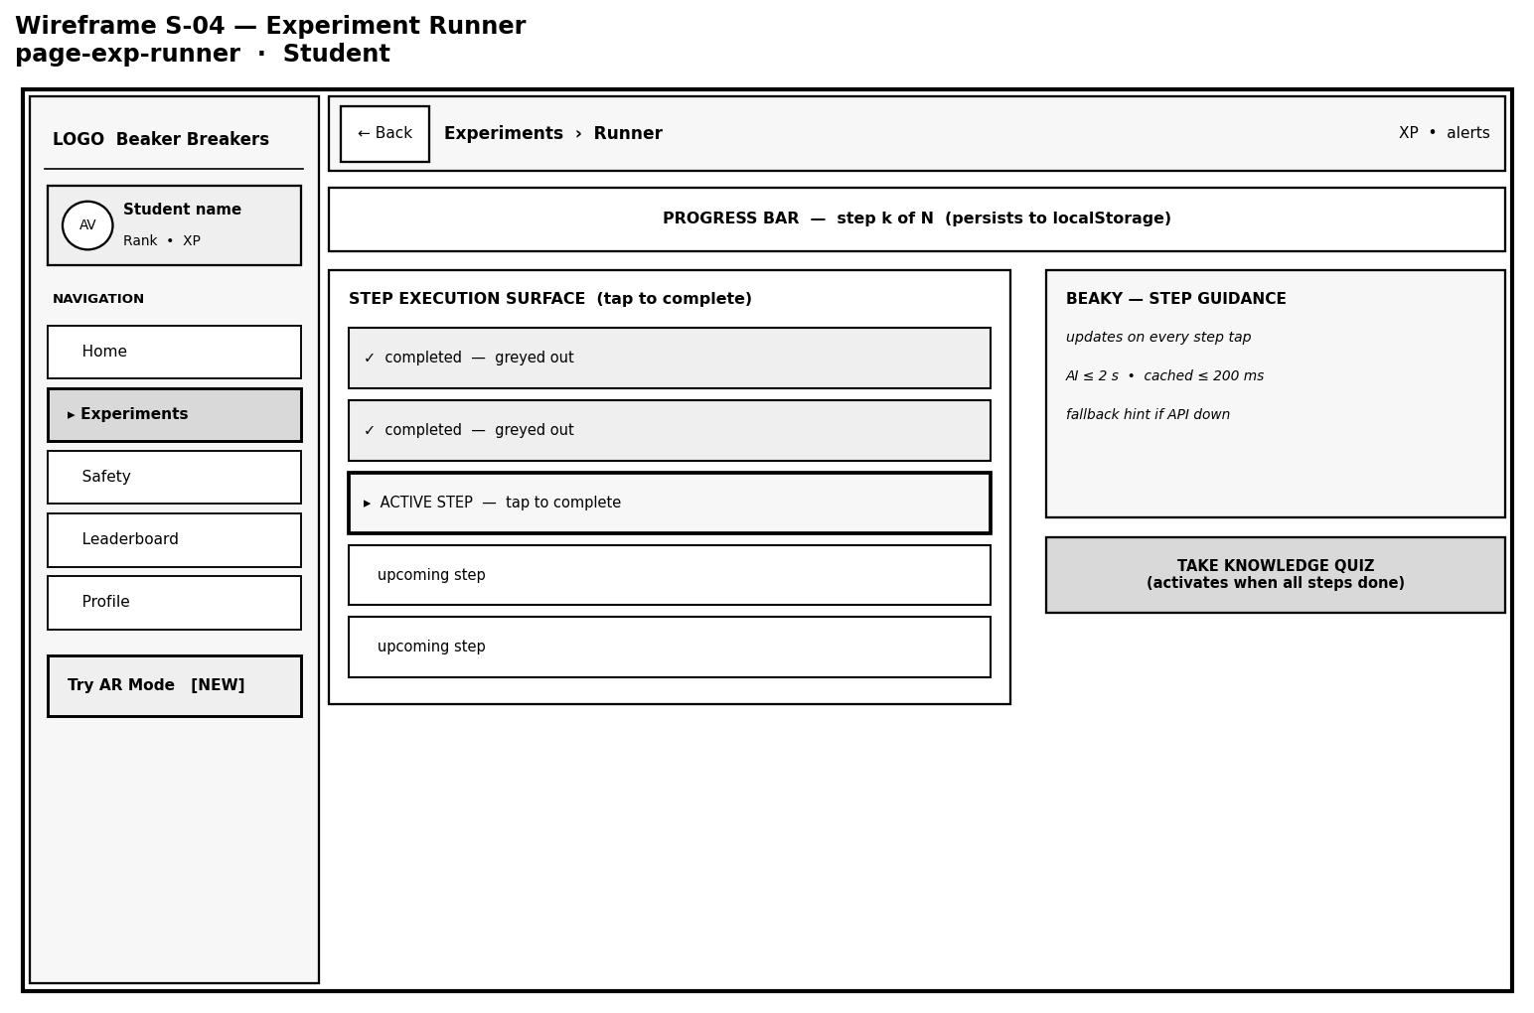
Figure 41 Wireframe S-04: Student experiment runner screen
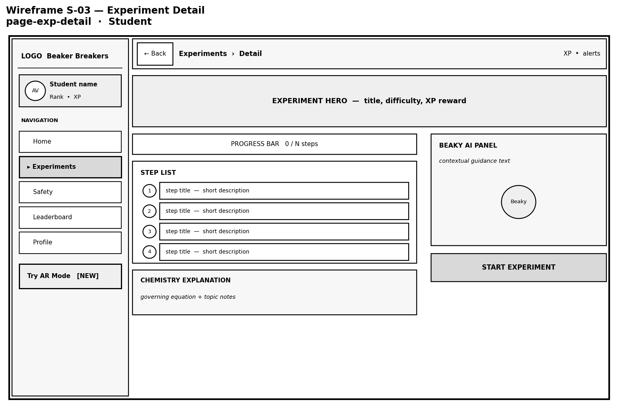
Figure 42 Wireframe S-03: Student experiment detail screen
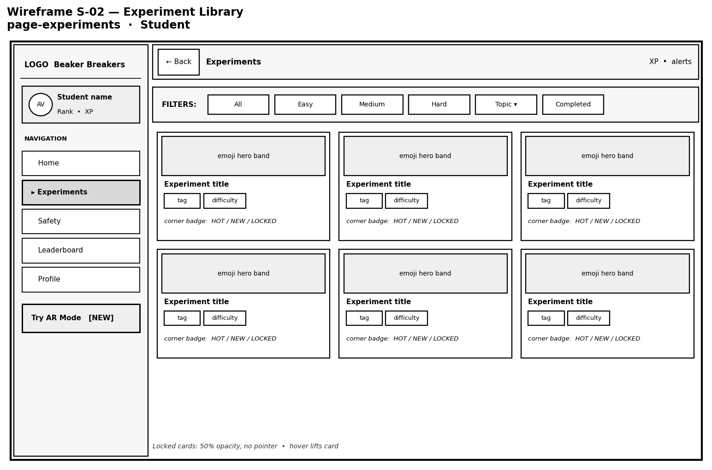
Figure 43 Wireframe S-02: Student experiment library screen
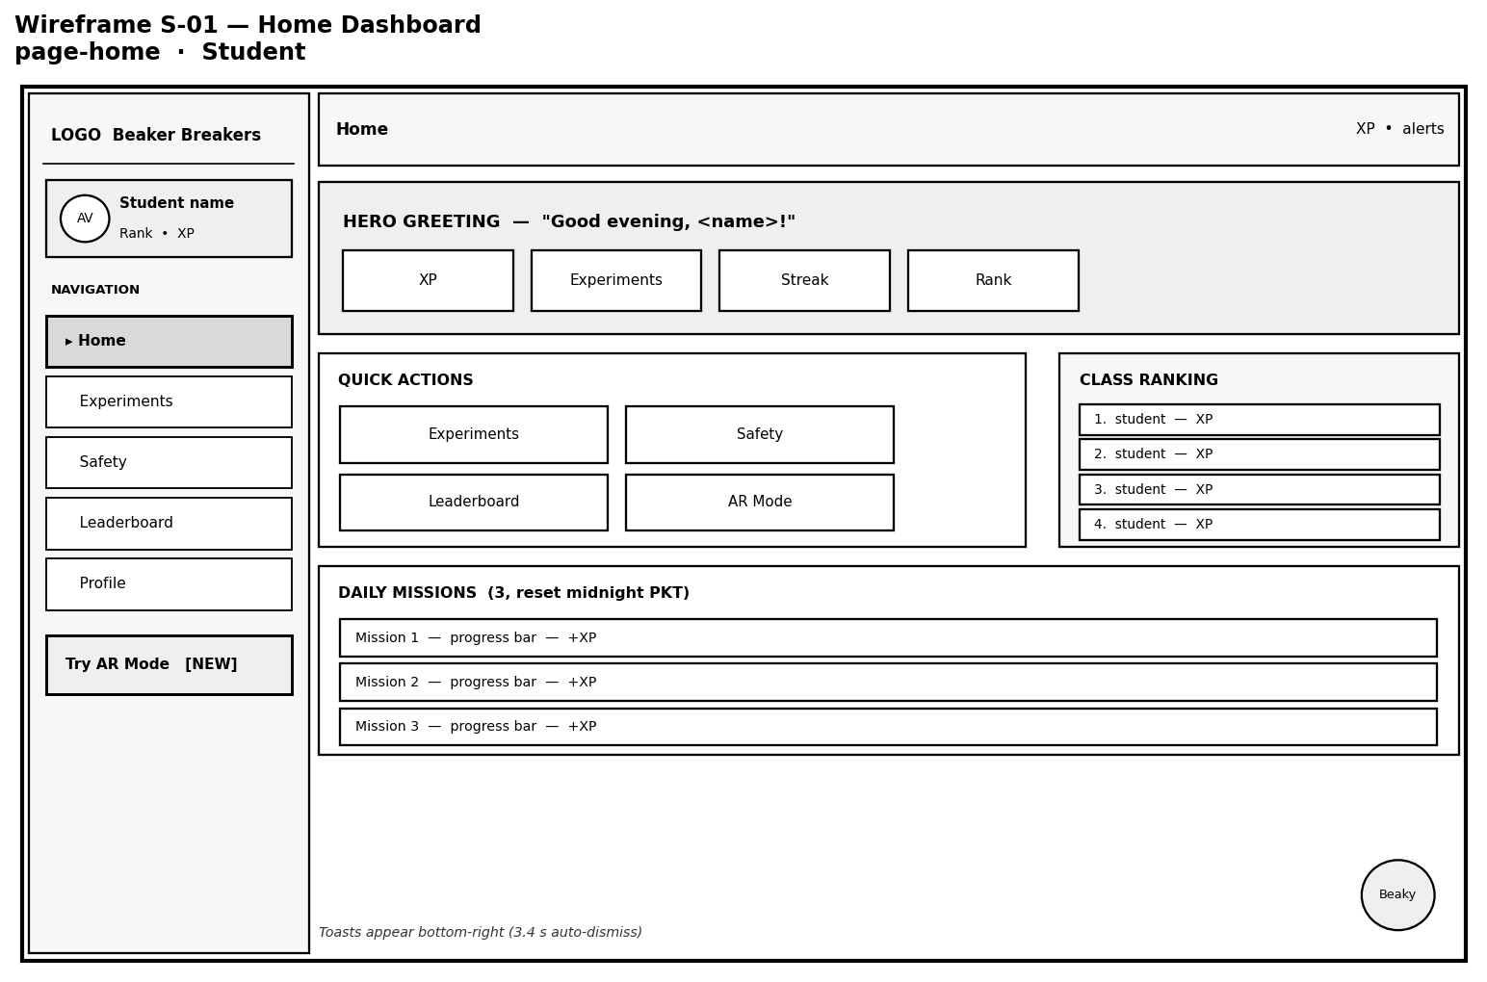
Figure 44 Wireframe S-01: Student home dashboard
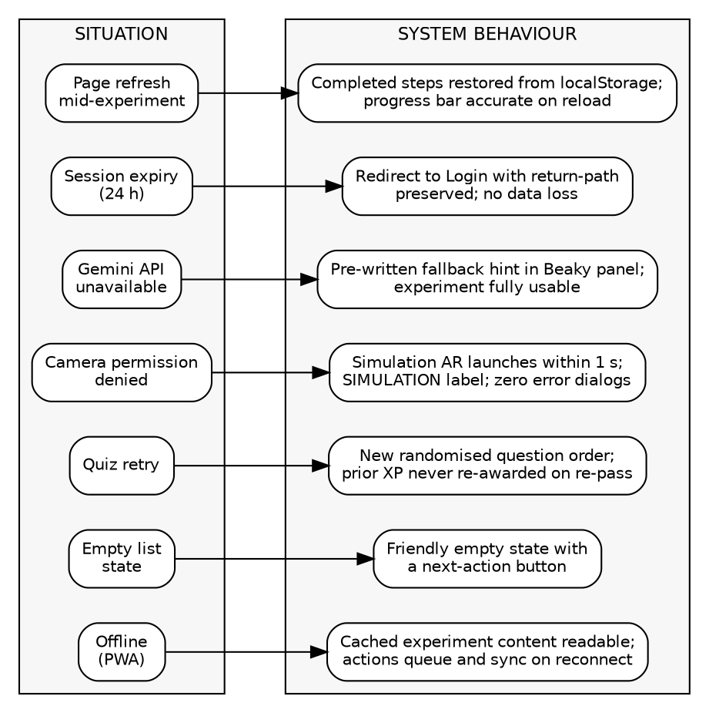
Figure 45 Error and edge-case states with the corresponding system behaviour
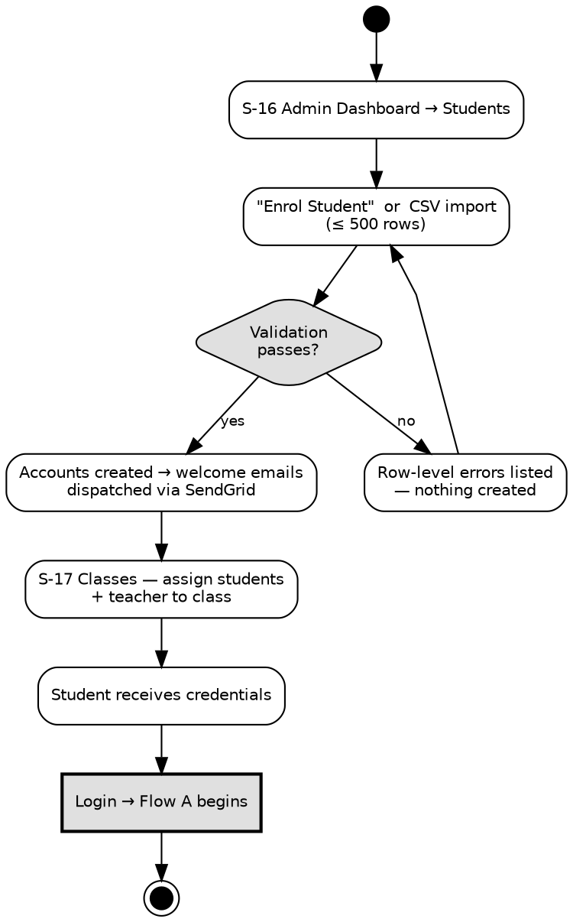
Figure 46 Administrator student onboarding flow
Figure 47 Screen navigation map with wireframe identifiers
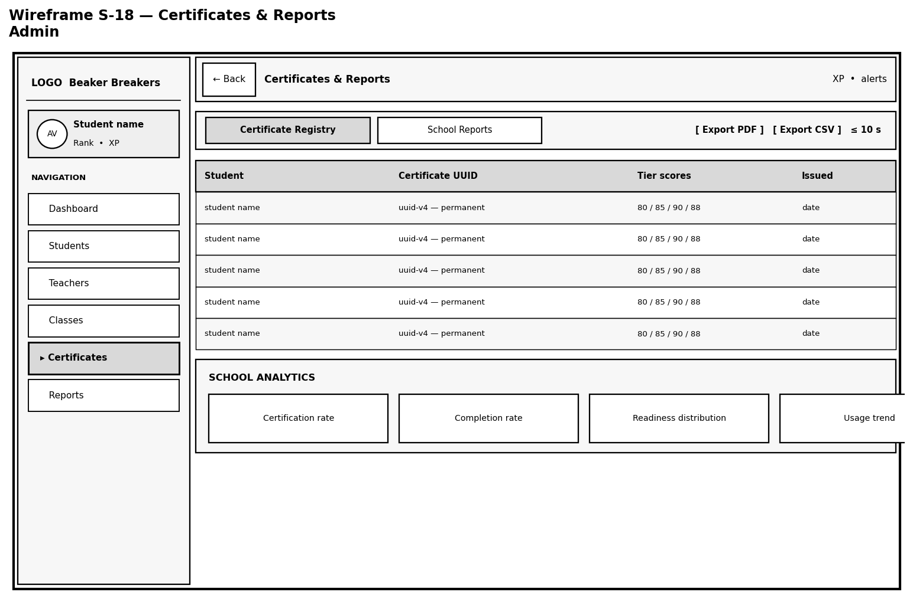
Figure 48 Wireframe S-18: Administrator certificates and reports screen

User Experience Measure
The measures below state what the interface design is expected to achieve and how each will be verified once the system is built.
Table 49 User experience measures and their verification.
Measure | Target | How it will be verified
Unassisted first use | A new student will complete login, Tier 1 and one experiment without assistance. | Observed sessions with students who have not used the system (NFR-07)
Accessibility | WCAG 2.1 Level AA on every web interface. | Automated accessibility audit and manual inspection (NFR-08)
Page responsiveness | First contentful paint within 3 seconds on a 4 megabit per second connection. | Measurement on a throttled connection (NFR-02)
Guidance latency | AI guidance within 2 seconds, or 200 milliseconds where cached. | Timed test across representative steps (FR-03.7)
Device coverage | Correct operation on the browsers and devices listed in Chapter 3. | Test on each listed platform (NFR-09, NFR-11)
Progress safety | No recorded progress, point or badge lost to a refresh, a session expiry or a network interruption. | Interruption testing at each step boundary (NFR-05)

Design Decisions and Rationale
Six decisions shaped the design more than any others. Each is recorded below with the alternative that was rejected, so that the reasoning can be examined rather than assumed.
Table 50 Key design decisions and their rationale.
Decision | Alternative rejected | Reason
Three tier architecture | Microservice architecture | The system will have one deployment target, a small team, and no component whose scaling needs differ sharply from the rest. The operational cost of independently deployed services would consume effort better spent on the laboratory itself.
All scoring computed on the server | Scoring in the client for speed | FR-02.5 and SR-07 forbid accepting a client computed score. A client that could compute its own result could also forge a safety certificate.
No self registration; accounts created by the administrator only | Public sign up with email verification | FR-01.6 states the rule. The system holds records of school students, so account creation is an administrative act rather than a self service one.
Pre authored guidance held for every step | Relying on the AI service alone | NFR-06 requires every experiment to remain completable when the external AI service is unavailable, so the fallback content is part of the design rather than an error path.
Rewards computed by a separate service, triggered by an event | Rewards computed inside the experiment engine | FR-04.3 requires the award to be made exactly once, and FR-06.2 forbids rewarding speed. Isolating the rules allows them to change without touching the laboratory.
Augmented reality offered as an optional presentation | Augmented reality as the primary mode | FR-05.1 provides augmented reality for no fewer than four experiments rather than all of them, and FR-05.4 requires a simulated presentation wherever the device cannot support it. The survey of Section 3.1.3 also ranked augmented reality fifth among the features respondents wanted, which is recorded here because it influenced this decision.

Design Traceability
Each figure in this chapter realises part of the requirement set of Chapter 3. The table below records the mapping, so that any requirement can be traced to the model that specifies how it will be met. Every identifier used in this chapter belongs to the numbering established in Chapter 3; no identifier from any earlier numbering scheme remains.
Table 51 Mapping of design figures to the requirements of Chapter 3.
Figure | Model | Requirements realised
4.1 | System flow chart | FR-01.1, FR-01.6, FR-02.3, FR-04.3, FR-04.5
4.2 | System context diagram | FR-01.1, FR-03.7, FR-08.3, FR-09.3, FR-09.6
4.3 | Use case: authentication | FR-01.1 to FR-01.6
4.4 | Use case: safety certification | FR-02.1 to FR-02.9, FR-10.5
4.5 | Use case: virtual experiment | FR-02.3, FR-03.1 to FR-03.8, FR-04.1 to FR-04.5, FR-05.1 to FR-05.6, NFR-06
4.6 | Use case: teacher class management | FR-08.2, FR-09.1 to FR-09.7, SR-04
4.7 | Use case: AI readiness reporting | FR-08.1 to FR-08.6, FR-09.1, SR-08
4.8 | Use case: gamification | FR-04.3, FR-06.1 to FR-06.5, FR-07.1 to FR-07.3
4.9 | Use case: administration and reporting | FR-10.1 to FR-10.8
4.10 | Class diagram | FR-01.1, FR-03.3, FR-09.1
4.11 | Sequence: readiness check | FR-02.3, FR-02.5, FR-08.2
4.12 | Sequence: AI assistant query | FR-03.7, NFR-06
4.13 | Sequence: completion and reward | FR-04.3, FR-06.1, FR-07.2
4.14 | Block diagram | NFR-01, NFR-03, NFR-04, SR-06, SR-07
4.15 | Component diagram | FR-03.7, FR-07.2, FR-09.6, FR-10.8, SR-03
4.16 | Deployment diagram | NFR-03, NFR-04, NFR-11, SR-02, SR-10
4.17 | Activity: safety certification | FR-02.1 to FR-02.9
4.18 | Activity: virtual experiment | FR-02.3, FR-03.3 to FR-03.7, FR-04.1 to FR-04.4, NFR-05, NFR-06
4.19 | Activity: AR session | FR-03.5, FR-05.2 to FR-05.6
4.20 | Activity: readiness report | FR-08.1 to FR-08.5, FR-09.1, FR-10.8
4.21 | Activity: task assignment | FR-09.1 to FR-09.6, FR-10.8
4.22 | State machine: task lifecycle | FR-04.1, FR-09.4 to FR-09.6
4.23 | State machine: safety certification | FR-02.1 to FR-02.9
4.24 | Data flow diagram, Level 0 | System boundary in data terms
4.25 | Data flow diagram, Level 1 | FR-01 to FR-10 (process and store view)
4.26 | Entity relationship diagram | FR-02.7, FR-03.3, FR-10.8, SR-01, SR-06
4.27 | Navigation map | FR-01.6, FR-02.3, FR-03.2, SR-04, NFR-08

The twenty eight use case descriptions of Section 4.2.4 provide the complementary mapping in the opposite direction: each names in its final field the Chapter 3 requirements it realises, so that a requirement may be traced forward to its specification and a specification traced back to its requirement.

Summary
This chapter has set out the design that will be implemented. The structural models define the use cases, the classes and the data, and each of the twenty eight use cases is specified in full. The architectural models define the tiers, the components within them and the nodes on which those components will run. The behavioural models define the interactions, the workflows and the two state machines whose permitted transitions are themselves requirements. The interface design applies established human computer interaction principles, fixes the navigation structure, and sets out the screen layouts as wireframes.
Three constraints shaped the design more than any others and appear in several models at once: all scoring is computed on the server and never accepted from a client (FR-02.5, SR-07); every experiment remains completable when the external AI service is unavailable (NFR-06); and no account can exist without administrator action (FR-01.6). Section 4.4 records the full mapping from figure to requirement, which will serve as the basis for the test design of the next chapter.

