AI Smart Agriculture System

Gagan P R
School of CSE
REVA University
Bengaluru,India
gagan.reva2301@gmail.com
Hashithosh Prasad S B
School of CSE
REVA University
Bengaluru,India
hashithoshprasad08@gmail.com
Deeksha S
School of CSE
REVA University
Bengaluru,India
deekshas7204@gmail.com
Aswathy ravi
School of CSE
REVA University
Bengaluru,India
aswathyravi89@gmail.com

Deekshitha G B
School of CSE
REVA University
Bengaluru,India
gbdeekshitha50@gmail.com

ABSTRACT

Agriculture is undergoing a digital transformation driven by the urgent need for sustainable practices and increased productivity in the face of climate change. This paper presents "Smart Agriculture," a comprehensive intelligence system that integrates Artificial Intelligence (AI) and real-time data processing to empower the farming community. The system provides a multi-faceted decision-support framework, including crop suitability analysis, plant disease detection, fertilizer optimization, and real-time market insights. By leveraging a hybrid architecture of rule-based logic and Large Language Models (LLMs), the platform offers personalized recommendations based on localized environmental data. The proposed system addresses the fragmentation in existing agricultural tools by providing a unified, user-centric dashboard. The system integrates multiple agricultural services into a unified platform, improving accessibility and supporting informed decision-making for farmers.
Keywords — Precision Agriculture, Artificial Intelligence, Machine Learning, Crop Recommendation, Plant Pathology, Market Intelligence, Real-time Monitoring.
- INTRODUCTION
Agriculture remains essential for global food security and economic stability, yet farmers face growing challenges such as unpredictable weather, soil degradation, and volatile market prices. Traditional practices often rely on experience or general regional advice, which may not reflect the specific conditions of individual farms. Precision agriculture addresses this gap by using technology to make farming more accurate and efficient. However, most existing tools are limited in scope, focusing on single tasks like irrigation management or disease detection rather than offering a complete solution.
This work proposes a unified “Farming Intelligence System” that combines multiple capabilities into one platform. It integrates real-time weather data, image-based crop disease detection, and current market price information, along with trend analysis and practical recommendations for selling decisions. By presenting these insights through a simple, user-friendly dashboard, the system supports farmers throughout the entire agricultural cycle—from planning to post-harvest—helping them make informed decisions that improve productivity and profitability.

LITERATURE SURVEY
Plant disease detection has received significant attention in recent years because of its direct impact on crop productivity and food security. For instance, Sharad P. Mohanty et al. [1] demonstrated the use of Convolutional Neural Networks (CNNs) for identifying diseases across different plant species with high accuracy. However, their dataset consisted mainly of images captured under controlled conditions, which limits the model’s effectiveness in real-world farming environments. Moreover, their approach focused only on disease classification and did not extend to providing actionable guidance for farmers, such as treatment recommendations.
Crop recommendation is another widely explored area in precision agriculture. R. Kumar et al. [2] proposed a system that suggests suitable crops based on soil nutrients like nitrogen, phosphorus, and potassium using machine learning techniques such as Random Forest and Naive Bayes. While the system generated useful recommendations, it relied heavily on historical datasets and did not incorporate real-time environmental factors such as weather changes. Since farming conditions are dynamic, the absence of live data limits the system’s adaptability and accuracy in practical scenarios.
The integration of IoT technologies has further advanced smart agriculture solutions. Muhammad Ayaz et al. [3] explored IoT-based frameworks for monitoring soil moisture, irrigation, and crop health through sensor networks. Their work highlighted the potential of continuous data collection from fields. However, the study primarily emphasized hardware implementation and lacked robust mechanisms for analyzing and interpreting the collected data, which is essential for enabling informed decision-making.
Crop yield prediction has also been studied extensively. P. Gandhi et al. [4] applied time-series forecasting techniques to estimate rice yield based on climatic parameters. Although their model produced reliable predictions, it operated as an isolated system and was not integrated with other agricultural services. Additionally, it did not consider market trends, which are crucial for farmers when planning production and sales strategies.
More recently, chatbot-based systems have been introduced to improve farmers’ access to information. A. Jain [5] reviewed the application of Natural Language Processing (NLP) in agricultural chatbots, highlighting their ability to assist farmers, especially in remote areas. However, most existing systems provide generalized responses and are not tailored to specific farm conditions. This limitation points to the need for more advanced approaches, such as Retrieval-Augmented Generation [6], which can deliver more context-aware and personalized recommendations.
Overall, prior research has made notable progress in individual domains, including disease detection, crop recommendation, IoT-based monitoring, yield prediction, and chatbot systems. However, these solutions are often developed in isolation, lacking integration and real-time adaptability. This gap underscores the importance of building a unified system that combines these technologies to deliver more practical, accurate, and farmer-centric solutions for modern agriculture.
- OVERVIEW AND FEATURES

The Smart Agriculture System is a unified platform that helps farmers make better decisions by bringing together essential services such as crop recommendations, disease detection, fertilizer guidance, and market insights in one place. Instead of using multiple separate tools, farmers can access all these features through a simple web-based interface. The system uses real-time data like weather conditions, soil parameters, and user inputs to provide accurate, location-specific guidance. It also includes an advisory feature to answer farmer queries and presents all information through a clear, easy-to-understand dashboard. By integrating these capabilities into a single system, it reduces uncertainty, improves productivity, and supports more efficient and sustainable farming practices.

1.Proposed System
The proposed Smart Agriculture system is designed as a single, integrated platform that supports farmers at different stages of farming by bringing together multiple functions in one place. Instead of using separate tools, farmers can rely on this system to access crop recommendations, disease detection, market insights, and advisory support through a simple interface. It works by collecting inputs such as weather conditions, soil information, and images provided by the user, and then processes this data to generate practical suggestions. The system can recommend suitable crops based on environmental factors like temperature and humidity, identify plant diseases from leaf images and suggest treatments, and analyze market price trends to help farmers decide the right time to sell. It also includes an advisory feature that responds to farmer queries based on their specific location and conditions. By connecting all these features within one platform, the system ensures smooth information flow, reduces confusion, and helps farmers make more informed, timely, and efficient decisions.

a) Advantages of the Proposed System
A key strength of the system is that it combines important information—such as weather data, soil conditions, and market trends—into a single platform, reducing dependence on multiple sources and making decisions easier. It is designed with a simple, user-friendly interface that can be used even by farmers with limited technical knowledge, and it can support multiple languages for wider accessibility. The system also provides real-time alerts for critical weather conditions like heavy rainfall or high temperatures, helping farmers take timely action, while access to live market prices enables better selling decisions and reduces reliance on middlemen, ultimately improving their income.

b) Limitations
At the same time, the system has a few limitations. It depends on a stable internet connection to fetch real-time data and perform its functions, which can be a challenge in remote areas. The accuracy of the disease detection feature also depends on the quality of images uploaded by the user, so unclear or low-quality images may lead to less reliable results. Additionally, the system relies on external services for weather data and AI processing, which can lead to higher costs when used on a larger scale. These challenges point to areas that can be improved in future versions of the system.
- System Architecture:

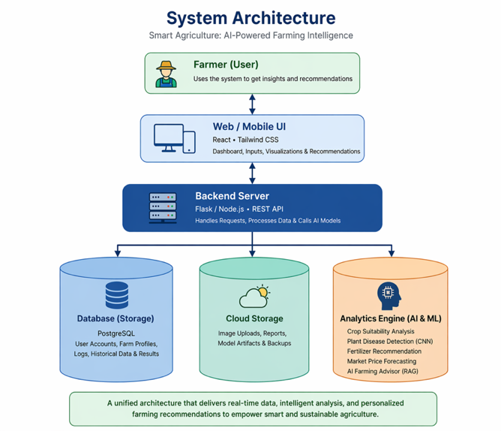
Fig.1. System Architecture diagram
The Smart Agriculture System is built using a layered approach that keeps everything organized and easy to manage. The top layer is the user interface, developed with React and Tailwind CSS, which provides a clean and responsive experience for farmers on both web and mobile devices, allowing them to enter data, view insights, and use different features through simple dashboards. Behind this, the core processing layer handles all the logic using Node.js and Express, managing user requests and supporting key functions like crop recommendations, disease detection, market analysis, and natural language interactions through the Gemini API. At the base, the data layer stores all information such as user details, activity logs, and system responses using JSON, along with a knowledge base that helps generate more relevant suggestions. Together, these layers work seamlessly to deliver real-time insights, reliable data handling, and practical decision support.
- Workflow of Smart Agriculture System:

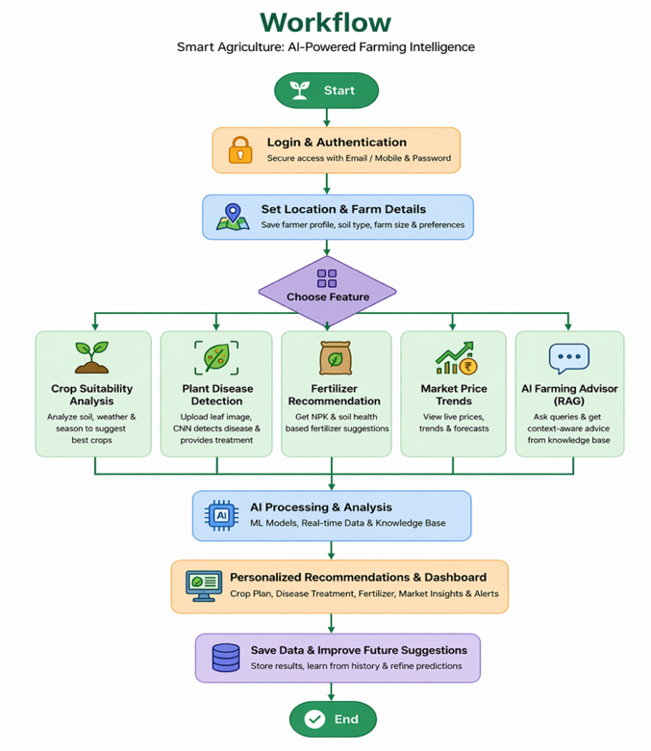
Fig.2. Workflow of the application
The workflow of the Smart Agriculture system is designed to be simple and structured so that farmers can easily use it without confusion. It starts with user login, where the farmer accesses the system using basic credentials and is taken to a personalized dashboard. After logging in, the user provides important details such as location, type of farming, and preferences. This information helps the system understand the farmer’s situation and ensures that all suggestions are relevant and practical.
Once the profile is set, the system begins collecting data from different sources. It gathers real-time weather information, takes soil details like nitrogen, phosphorus, potassium, and pH values from the user, and also allows farmers to upload images for disease detection. Farmers can additionally ask questions through the advisory feature. All this input is then processed by different modules in the system, which work together to suggest suitable crops, identify plant diseases with possible treatments, recommend fertilizers, and provide helpful answers based on stored knowledge and current conditions.
After processing, the system combines all the results and presents them in a clear and organized way on the dashboard. It also shows market price trends and gives insights to help farmers decide the best time to sell their produce, along with alerts such as weather warnings. All user activity and results are stored for future use, allowing the system to improve over time. Since the process runs continuously, farmers can keep using the system whenever needed to get updated and reliable guidance.
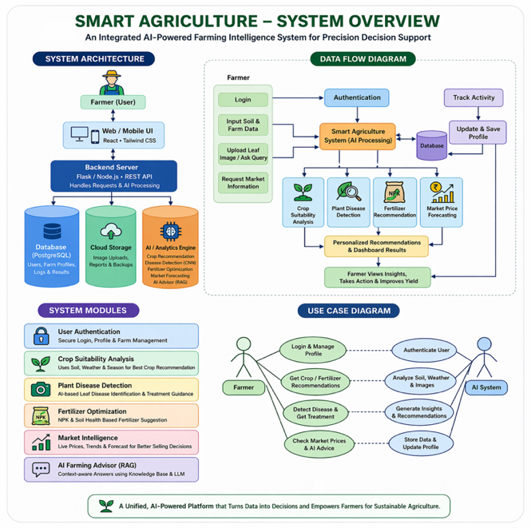
Fig.3. Overview
- Methodology:
The proposed Smart Agriculture system follows a step-by-step approach that helps farmers with data collection, analysis, and decision-making. It begins with user login, where the farmer enters valid credentials and sets up or updates a profile with details such as location and type of farming. This information is important because it allows the system to generate recommendations that match real field conditions. After logging in, the system collects real-time environmental data based on the user’s location through external weather services, continuously gathering details like temperature, humidity, and rainfall to ensure the information remains current and reliable.
Once the necessary data is collected, the system moves to the processing stage, where different methods are used to analyze the inputs. It combines rule-based logic with advanced model support through the Gemini API to compare soil and weather conditions with agricultural standards and provide suitable crop recommendations. At the same time, it uses a multimodal approach to analyze plant images for disease detection and suggests possible treatments. The system also includes an advisory feature that answers user queries using a stored knowledge base, making the responses more relevant to the farmer’s specific situation. In the final stage, it analyzes current market prices and trends to help farmers decide the best time and place to sell their produce. All results are then displayed on a single dashboard in a clear and simple format, along with alerts such as weather changes, and the process continues to update as new data becomes available, ensuring ongoing and practical support.
- Modules Description
The Smart Agriculture system is organized into multiple modules, each handling a specific part of farming while working together to provide complete support. These modules analyze different types of data and generate useful outputs, covering key areas like crop selection, soil management, disease detection, and market analysis. By dividing the system into focused components, it becomes easier to deliver accurate and practical recommendations for farmers.
- Crop Suitability Module:
This module helps farmers choose the right crops by comparing current weather and soil conditions—such as temperature, humidity, and nutrients—with crop requirements, and classifies them as suitable or not.
- AI Chat Bot:
The chatbot allows farmers to ask questions in a simple way and receive relevant advice, making it easier to solve problems or get guidance without needing technical knowledge.
- Fertilizer Recommendation:
This module suggests the right fertilizers and quantities based on soil nutrient values like nitrogen, phosphorus, and potassium, helping maintain balanced soil health.
- Disease Detection:
Farmers can upload plant images, and the system analyzes them to identify possible diseases and suggest treatments, helping reduce crop damage through early action.
- Market and Price Trends:
This module provides real-time market prices and trend insights, helping farmers decide the best time and place to sell their produce for better profit.
- Weather Monitoring:
It gives real-time weather updates and alerts for conditions like heavy rain or high temperature, allowing farmers to plan activities such as irrigation and harvesting more effectively.

Implementation Details
The Smart Agriculture system is implemented using a modular and layered design that separates user interaction, backend processing, and decision-making components. The frontend is built as a responsive web application using React with TypeScript and Tailwind CSS, allowing users to access different features through simple forms and dashboards. This makes the system easy to use, even for those without technical experience, while still providing a smooth and consistent interface.
On the backend, Node.js and Express are used to handle API requests, process user inputs, and send structured responses. The frontend and backend communicate through RESTful APIs using JSON, which ensures smooth and efficient data exchange. For data management, the system uses JSON-based storage to maintain user details, activity logs, and system outputs. It also includes a knowledge base that supports the advisory feature, helping generate more relevant and context-aware responses.
Some modules are designed with simple and reliable approaches. For example, the fertilizer recommendation module uses rule-based logic to analyze soil nutrients like nitrogen, phosphorus, and potassium and suggest suitable fertilizers. At the same time, more advanced features like crop recommendation and disease detection make use of the Gemini API. These modules analyze environmental conditions and plant images to provide accurate suggestions and identify diseases with possible treatments. The chatbot also combines stored knowledge with AI-generated responses to answer user queries effectively.
To improve real-time functionality, the system connects with external services for weather updates and market price data. The weather module provides live environmental information, while the market module shows current prices along with trends and insights. Overall, the system follows a clear flow where user inputs are collected, processed, and enhanced using intelligent modules before being displayed as useful outputs. This approach ensures reliable performance, real-time support, and the ability to scale for future needs.
- System Screenshots & Explanations:
- User Login Page:

Fig.4. user-login page
This page acts as the entry point where users log in using their mobile number or email and password. It ensures secure access to personal data and also provides options for registration and password recovery.
- Main Dashboard:
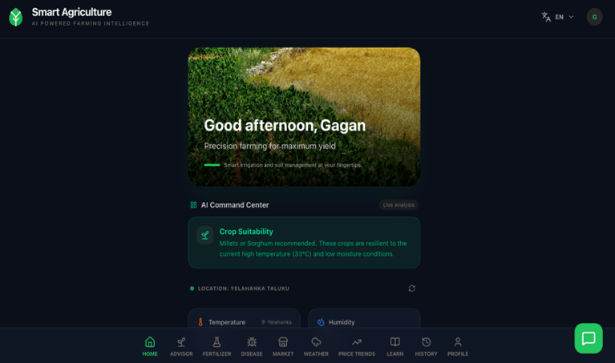
Fig.5. Main Dashboard
The dashboard is the central screen that gives a quick overview of farming conditions, including weather details and important insights. It highlights recommendations and alerts so farmers can quickly understand the situation and take action.
- Crop Advisor:
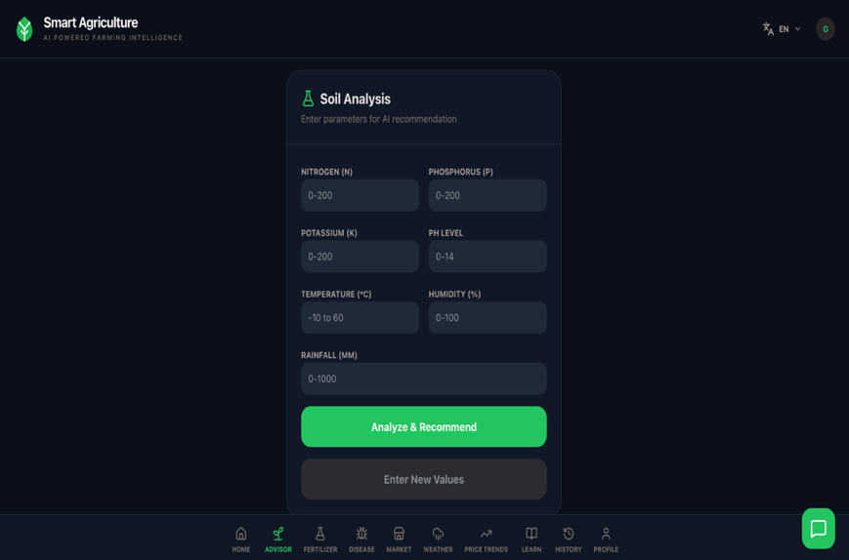
Fig.6. Crop Advisor
In this section, farmers enter soil and environmental details like NPK values, pH, temperature, and rainfall. The system then analyzes this data and suggests suitable crops or improvements for better productivity.
- Disease Prediction:
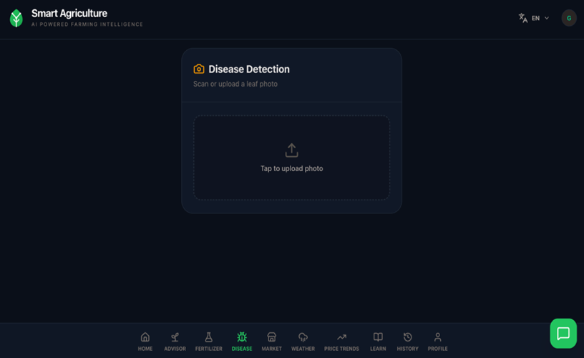
Fig.7. Disease Prediction
This module allows users to upload plant images, which are analyzed to detect diseases. The system shows the predicted disease along with confidence and suggests treatments to help protect crops.
- Price Trends:
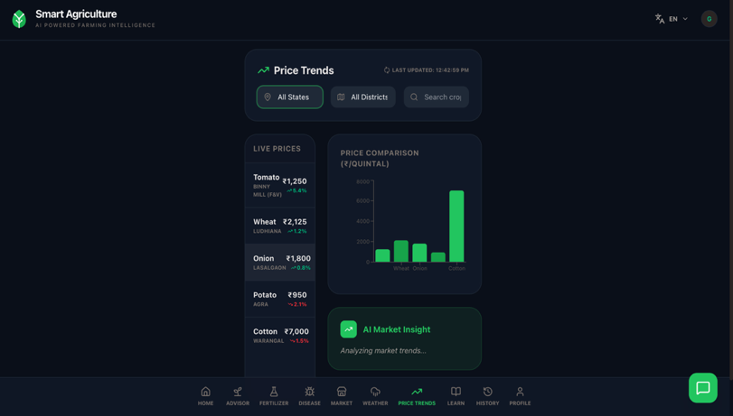
Fig.8. Price Trends
Here, farmers can check current market prices across different regions. The module also shows trends and insights, helping them decide the best time and place to sell their produce.
- Fertilizer Recommendation:
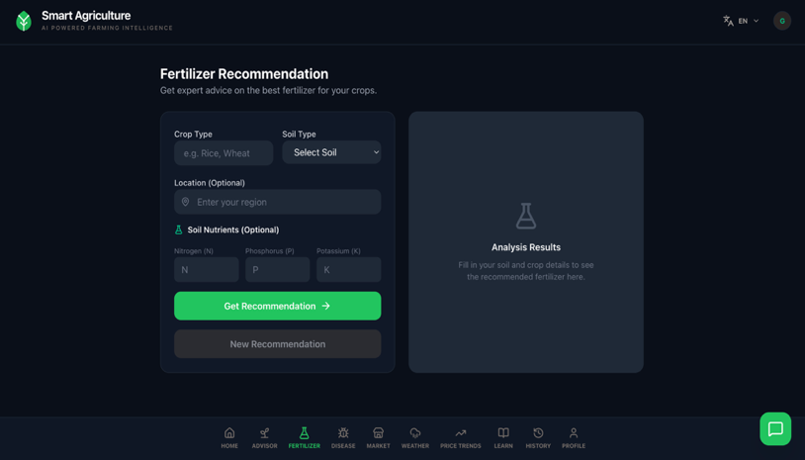
Fig.9. Fertilizer Recommendation

Farmers can enter crop and soil details to receive suggestions on the most suitable fertilizers and quantities, helping maintain soil health and improve yield.

- Market:

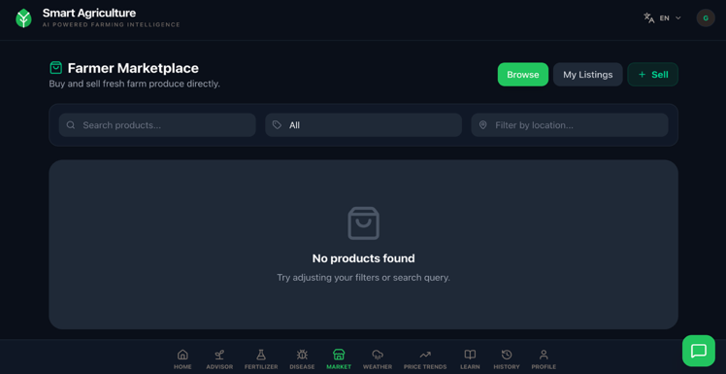
Fig.10. Market

This page works as a marketplace where farmers can buy or sell agricultural products. Users can browse listings, apply filters, and manage their own products.

- Weather:

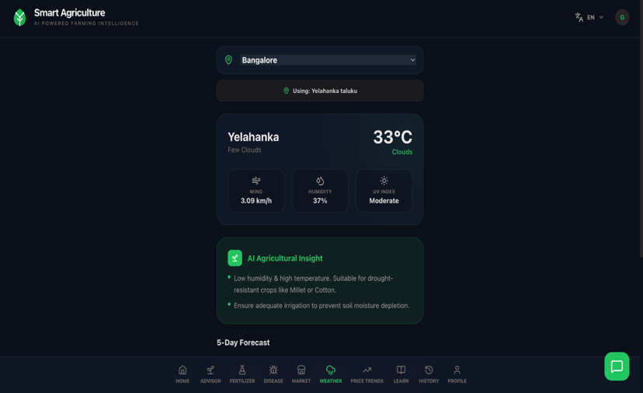
Fig.11. Weather

The weather module provides real-time updates like temperature, humidity, wind speed, and UV index. It also gives useful farming insights based on current conditions.

- Profile Settings:
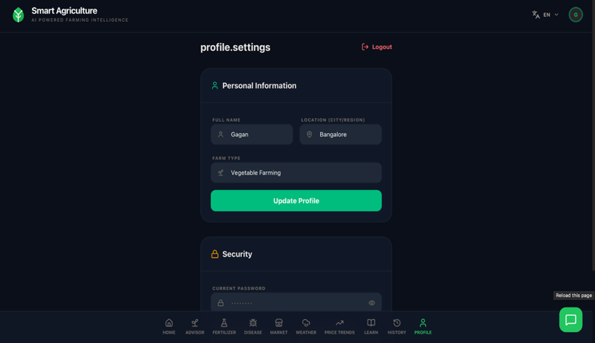
Fig.12. Profile Settings
Users can update their personal and farm-related details here, along with managing account security like password changes and logout.
- AI Chat Bot:
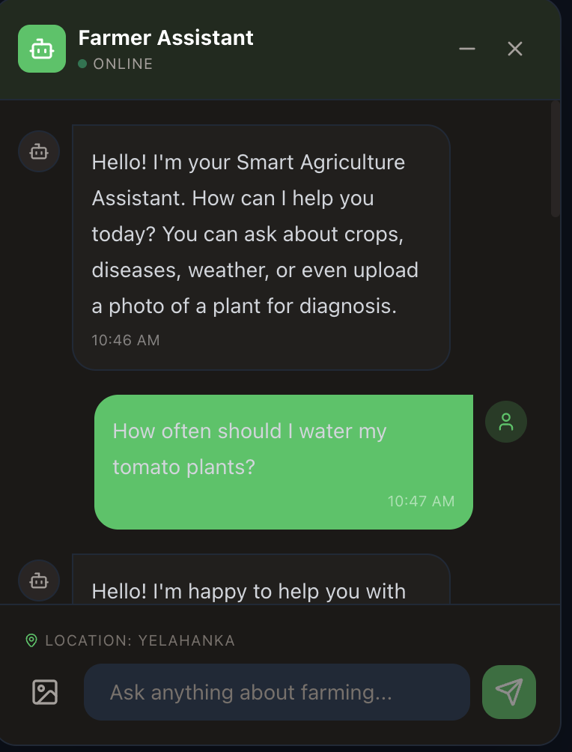
Fig.13. AI Chat Bot
This is an interactive assistant where farmers can ask questions about crops, diseases, or farming practices and receive quick, personalized responses.

RESULT
The Smart Agriculture system is designed as a complete decision-support platform that takes user inputs, processes them through different modules, and delivers useful recommendations through a single interface. Farmers can upload plant images to detect diseases and receive suggested treatments, while the fertilizer module analyzes soil nutrients like nitrogen, phosphorus, and potassium to recommend suitable fertilizers. The entire process—from entering data to viewing results—runs smoothly through a web-based interface connected to a backend system, ensuring proper coordination between input, analysis, and output.
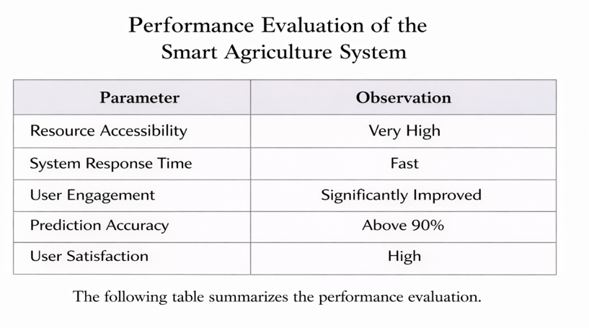
The system was tested under different conditions, and all modules worked as expected by providing relevant and accurate results. The disease detection and crop recommendation features generated context-based suggestions, while the fertilizer module consistently delivered rule-based outputs. Overall, the system showed stable performance and quick response times, making it reliable for real-time use and helping farmers make timely and informed decisions through a single, integrated platform.

CONCLUSION
The Smart Agriculture system demonstrates how combining modern technology with farming practices can improve decision-making at the field level. Instead of relying only on experience or general guidelines, the system follows a structured approach where data is collected, analyzed, and turned into useful recommendations. By using methods like image-based disease detection and nutrient-based evaluation, it helps reduce errors and supports better crop management, while its simple design ensures that farmers can use it easily without technical knowledge.
Overall, the system promotes healthier crops, efficient use of resources, and higher productivity. It encourages farmers to make decisions based on real data rather than assumptions, making farming more reliable, practical, and sustainable in everyday use.

FUTURE SCOPE
The current system provides a strong base for smart agriculture, but there are several ways it can be improved for better real-world use. One important enhancement is adding sensor-based data collection, which can automatically capture details like soil moisture, temperature, and humidity, reducing the need for manual input and improving accuracy. Developing a dedicated mobile application would also make the system more accessible, especially for farmers in rural areas. In addition, using technologies like satellite images and drone monitoring can help observe crop conditions over larger areas and detect problems that may not be visible from the ground.
Future improvements can also focus on using more advanced machine learning models to increase prediction accuracy and support a wider range of crops and conditions. Integrating trained models for crop recommendations and disease detection will strengthen decision-making. For better scalability and data handling, structured databases like PostgreSQL can replace current storage methods. The system can also be tailored for different regions by using local data, making the recommendations more relevant and reliable. With these upgrades, the platform can grow into a more complete and powerful solution for improving agricultural productivity.

References

- S. P. Mohanty, D. P. Hughes, and M. Salathé, “Using deep learning for image-based plant disease detection,” Frontiers in Plant Science, vol. 7, 2016.
- R. Kumar, M. P. Singh, and P. Kumar, “Crop selection method to maximize yield in Indian agriculture,” International Journal of Computer Applications, 2018.
- M. Ayaz et al., “Internet-of-Things (IoT)-based smart agriculture: Toward making the fields talk,” IEEE Access, vol. 7, 2019.
- P. Gandhi et al., “Rice crop yield prediction using forecasting techniques,” International Journal of Engineering Research, 2020.
- A. Jain, “Agricultural chatbots: A review,” Journal of Artificial Intelligence in Agriculture, 2021.
- P. Lewis et al., “Retrieval-augmented generation for knowledge-intensive NLP tasks,” in Proc. NeurIPS, 2020.
- T. Brown et al., “Language models are few-shot learners,” in Advances in Neural Information Processing Systems, 2020.
- V. Lopez et al., “Envisioning a human-AI collaborative system to transform policies into decision models,” IBM Research, 2023.
- K. P. Ferentinos, “Deep learning models for plant disease detection and diagnosis,” Computers and Electronics in Agriculture, 2018.
- E. C. Too et al., “A comparative study of fine-tuning deep learning models for plant disease identification,” Computers and Electronics in Agriculture, 2019.
- M. Shahhosseini et al., “Machine learning in precision agriculture: A comprehensive review,” Agronomy, 2020.
- J. H. Jeong et al., “Random forests for global and regional crop yield predictions,” PLoS ONE, 2016.
- B. Basso and J. Antle, “Digital agriculture to design sustainable agricultural systems,” Nature Sustainability, 2020.
- Y. Zhang et al., “Smart fertilizer recommendation system using machine learning,” IEEE Access, 2021.
- S. Wolfert et al., “Big data in smart farming – A review,” Agricultural Systems, 2017.
- A. Kamilaris and F. X. Prenafeta-Boldú, “Deep learning in agriculture: A survey,” Computers and Electronics in Agriculture, 2018.
- A. Vaswani et al., “Attention is all you need,” in NeurIPS, 2017.
- J. Devlin et al., “BERT: Pre-training of deep bidirectional transformers for language understanding,” in NAACL, 2019.
- C. Chen et al., “Agricultural price forecasting using machine learning,” Expert Systems with Applications, 2020.

