AWS BUCKETS

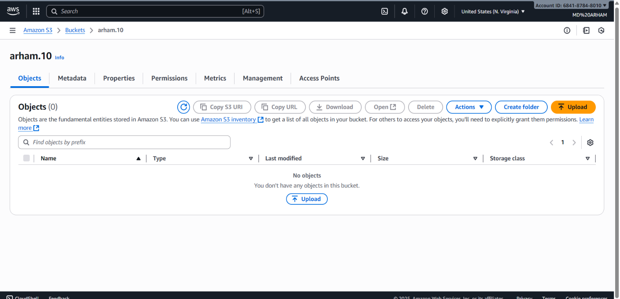

- Bucket Overview
- Bucket Name: arham.10
- Service: Amazon S3 (Simple Storage Service)
- Region: US East (N. Virginia)
- Tab Opened: Objects (main file storage area)
- Objects Section
- Number of Objects: 0 (Bucket is empty)
- Message displayed: "You don't have any objects in this bucket."
- You have the option to Upload files using the blue "Upload" button.
- Available Actions / Buttons
- Copy S3 URI
- Copy URL
- Download (disabled since no object is selected)
- Open (disabled)
- Delete (disabled)
- Actions dropdown (has additional functions)
- Create folder (to organize files)
- Upload (to add objects to the bucket)
- Search & Object Table
- Search/filter bar: "Find objects by prefix"
- Table columns visible:
- Name
- Type
- Last modified
- Size
- Storage Class
(All empty since no files exist)
- Navigation Tabs
- At the top of the bucket interface:
- Objects
- Metadata
- Properties
- Permissions
- Metrics
- Management
- Access Points
- Other Interface Elements
- Account info shown in top-right corner.
- Browser running on Windows machine.
- Several tabs open related to Colab and Google search.
- Time and date shown on taskbar: 22-09-2025, 16:17

