IDENTITY AND ACCESS MANAGEMENT

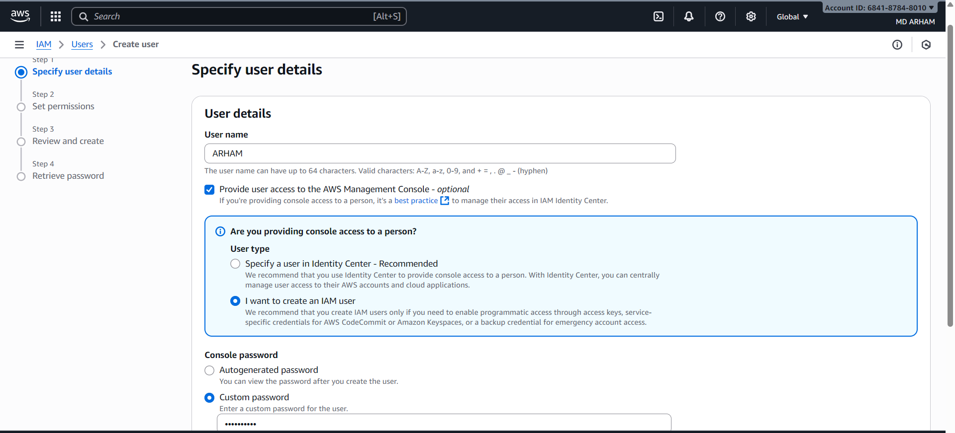

- Step 1 of AWS "Create User":
- Enter User Information
Name of User: Letters, numbers, and certain symbols are permitted; the character count must be between 1 and 64.
Options for Access:
The ability to visit the AWS Management Console.
Choose from the following options: Identity Center user (preferred for centralized access management).
IAM user (for console and programmatic direct access).
Setting Up a Password:
Select a bespoke password (minimum of 8 characters) or an autogenerated one.
On the first sign-in, check the box to force a password reset.
Notification: The user was removed.

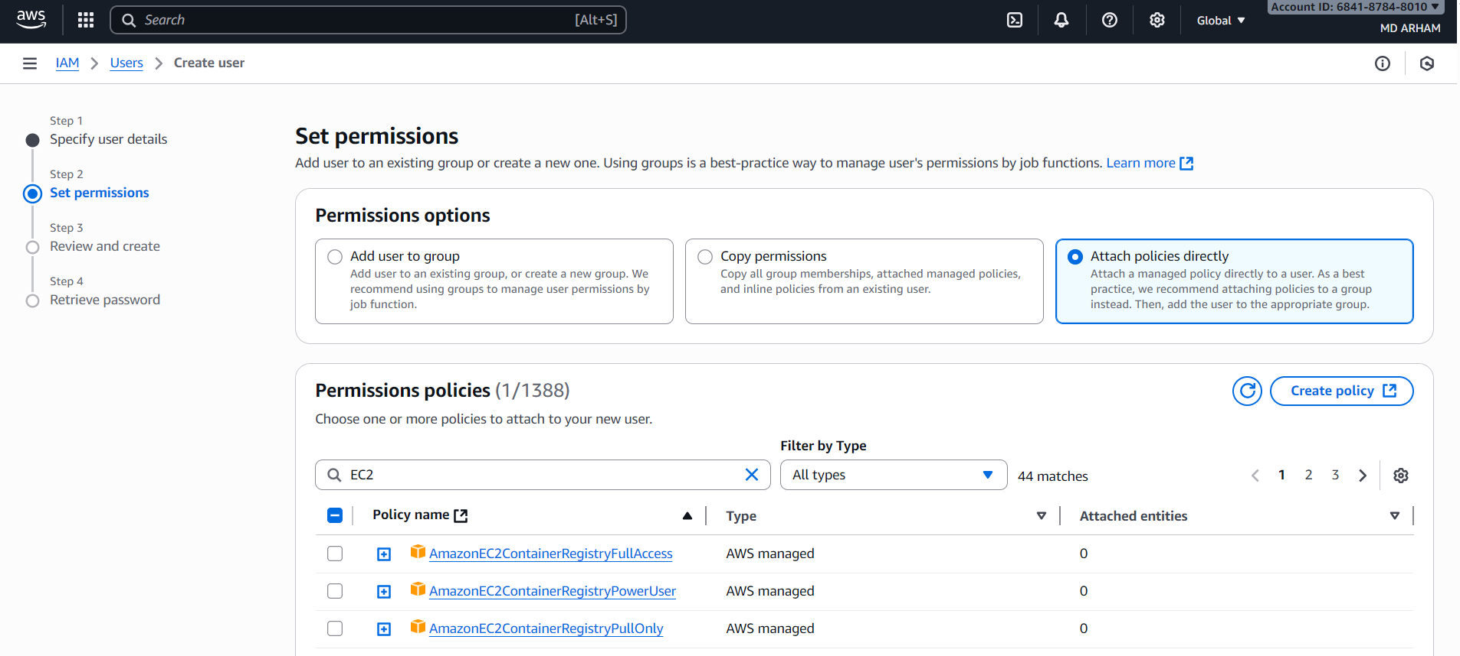

- Step 2 of the AWS
- "Create User" process is to set permissions (filtered for EC2).
The "EC2" search filter is used to show policies pertaining to Amazon EC2 services.
Policy List: Displays permission policies managed by AWS, such as:
AmazonEC2FullAccess (highlighted)
AmazonEC2 Read-Only Access
AmazonEC2ContainerRegistryFullAccess, etc.
Options for Assignments:
Include the user in a group
Copy an existing user's permissions
Directly attach policies (current method)
Highlighted Policy: Full access to EC2 resources is provided by AmazonEC2FullAccess.

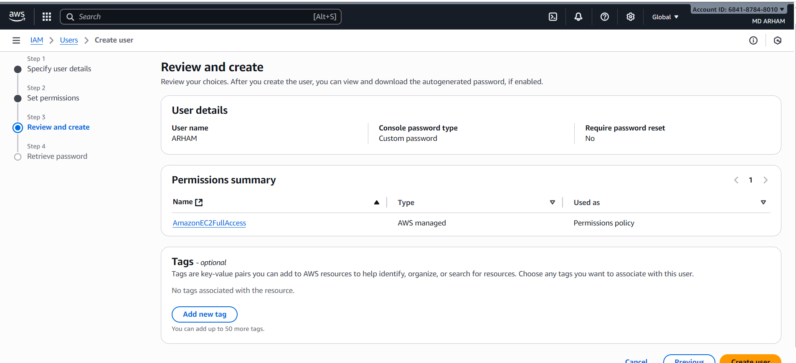

- Step 3 of the AWS
- "Create User" process involves reviewing and creating the following
- user details:
- username:
- test; password type:
- custom password;
- password reset required:
- no; permissions assigned:
- AmazonEC2FullAccess, which grants full access to EC2 resources (managed by AWS);
- IAMUserChangePassword, which enables the user to modify their own password (managed by AWS);
- tags: optional key-value pairs for resource organization; button to add new tag; next, click "Create user" to complete the setup.

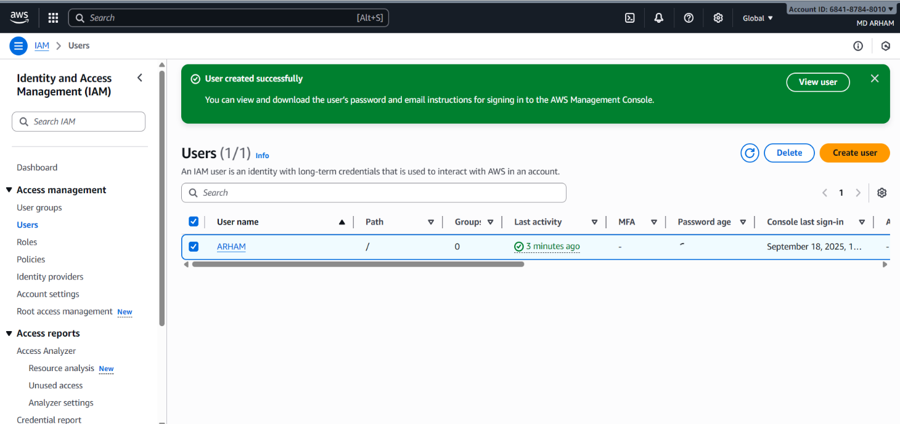
- Step 4 of "Create User" on AWS:
- Get Password
User Details:
ARHAM is the username.
The console URL to log in: https://61261611045.signin.aws.amazon.com/console
Password: tate (with the choice to reveal)
Actions: Instructions for email sign-in Get the credentials in a.csv file Go back to the list of users
Navigation of Workflow:
After providing information, establishing permissions, and evaluating, this is the last stage.

