AWS QUEUES

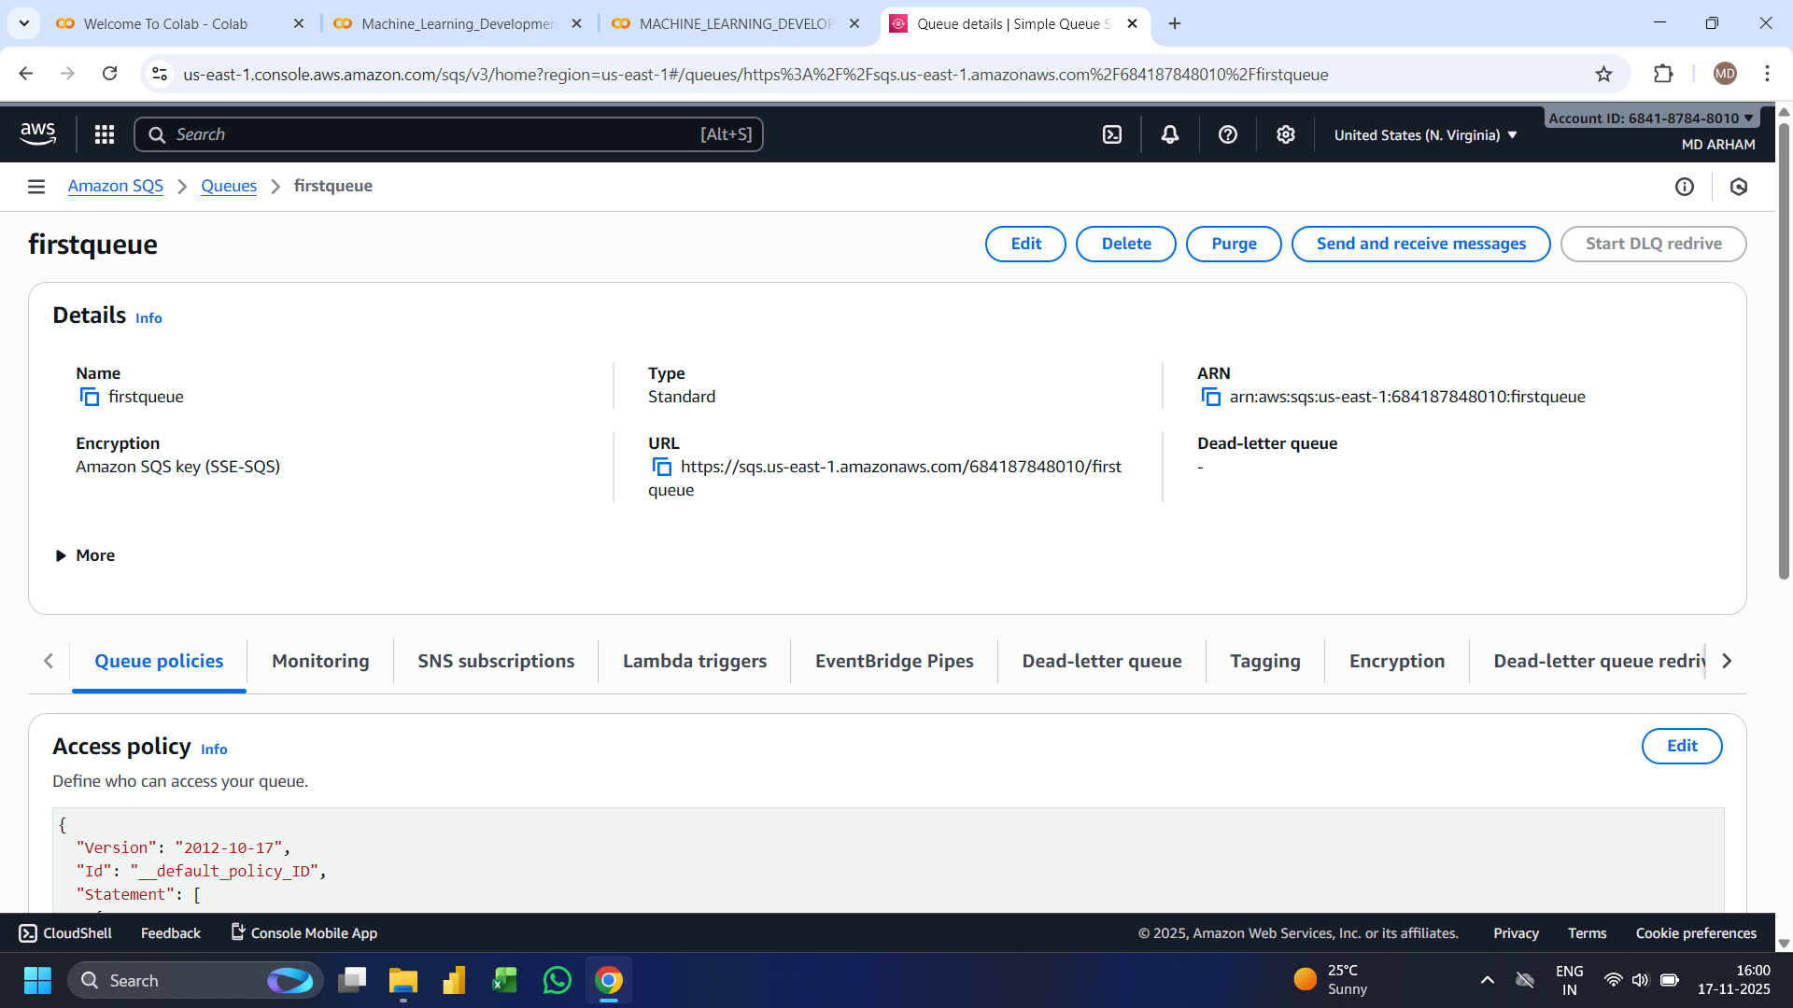
Queue Overview
- Queue Name: firstqueue
- Service: Amazon SQS (Simple Queue Service)
- Region: US East (N. Virginia)

Queue Configuration
- Type: Standard Queue
- Encryption: Enabled using Amazon SQS key (SSE-SQS)
- URL:
https://sqs.us-east-1.amazonaws.com/684187848010/firstqueue
- ARN (Amazon Resource Name):
arn:aws:sqs:us-east-1:684187848010:firstqueue
- Dead-letter queue: Not configured (shows -)

Available Actions
- Edit queue
- Delete queue
- Purge queue
- Send and receive messages
- Start DLQ redrive (disabled since no DLQ is set)

Visible Tabs / Sections
- Queue policies (currently open)
- Monitoring
- SNS subscriptions
- Lambda triggers
- EventBridge Pipes
- Dead-letter queue
- Tagging
- Encryption
- Dead-letter queue redrive

Access Policy
- A JSON access policy is shown (starting with version "2012-10-17" and ID "__default_policy_ID").

Additional UI Elements
- User account info shown at top-right
- AWS menu/navigation bar at top
- Time & date shown at bottom right of Windows taskbar
- Several browser tabs open related to Google Colab and ML development

