









sk 01:
Artificial Intelligence Lab (AI)
Full Stack Mobile app Development

Fu
nctional English

(
FE
)

Lab Task 08

(
Paragraph
writing
)

Topic:

A
I

(
Artificial

Intelligence
)

Group Me
mbers:

Mohsin Ali

M.Shaheer

M.
Hu
za
i
fa

C
lass:

BSCS

(
1
)

B

Class: BSCS (5) B
Name: Mohsin Ali
Reg ID: 245197

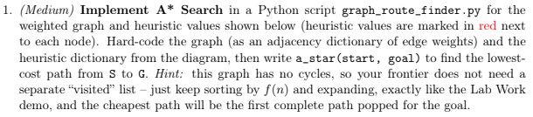
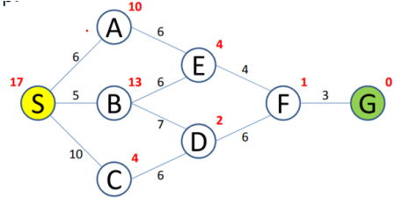
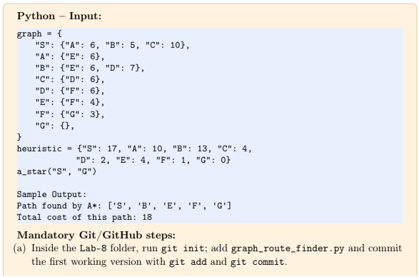

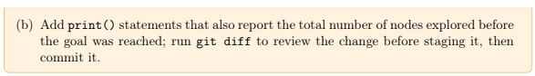
Solution:
Code:

graph = {
"S": {"A": 6, "B": 5, "C": 10},
"A": {"E": 6},
"B": {"E": 6, "D": 7},
"C": {"D": 6},
"D": {"F": 6},
"E": {"F": 4},
"F": {"G": 3},
"G": {}
}

heuristic = {
"S": 17,
"A": 10,
"B": 13,
"C": 4,
"D": 2,
"E": 4,
"F": 1,
"G": 0
}

def get_g(path):
total = 0
for i in range(len(path) - 1):
current_node = path[i]
next_node = path[i + 1]
total = total + graph[current_node][next_node]
return total

def get_h(path):
last_node = path[-1]
return heuristic[last_node]

def get_f(path):
return get_g(path) + get_h(path)

def a_star(start, goal):
frontier = [[start]]
explored = 0

while len(frontier) > 0:
frontier.sort(key=get_f)
path = frontier.pop(0)
node = path[-1]

explored = explored + 1

print("Exploring", node, " path:", path,
" g =", get_g(path),
" h =", get_h(path),
" f =", get_f(path))

if node == goal:
print("Total nodes explored:", explored)
return path

for neighbour in graph[node]:
new_path = path + [neighbour]
frontier.append(new_path)

print("Goal not found")
return None

answer = a_star("S", "G")

print()
print("Path found by A*:", answer)

if answer is not None:
print("Total cost of this path:", get_g(answer))

Output:
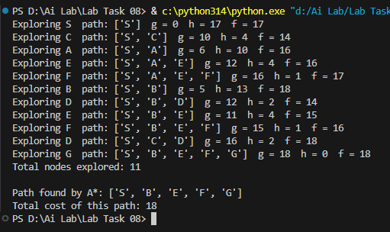
Git and GitHub
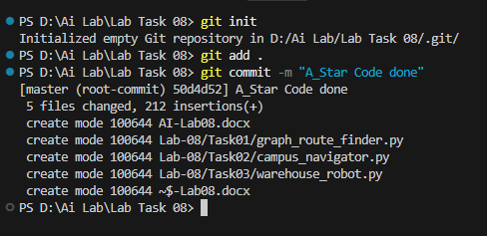
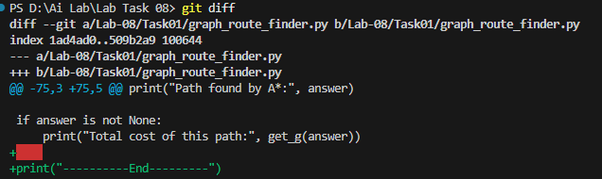

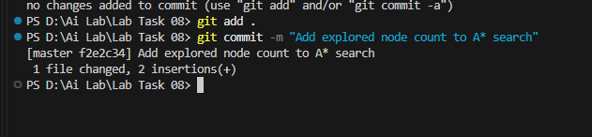

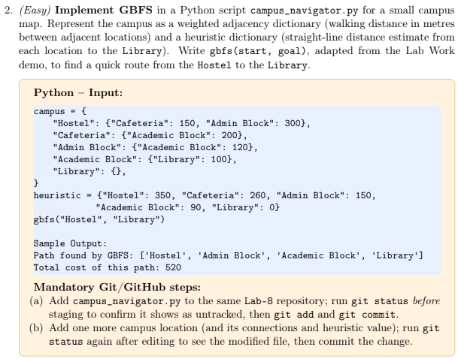
Solution:
Code:
Output:

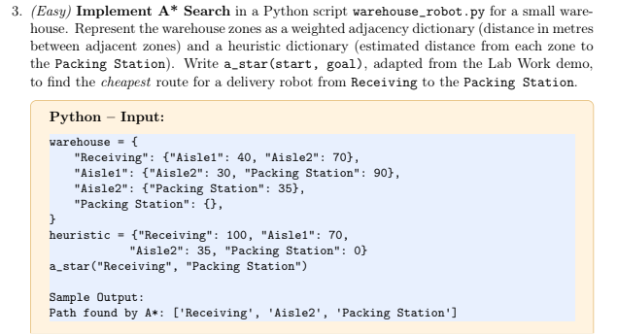
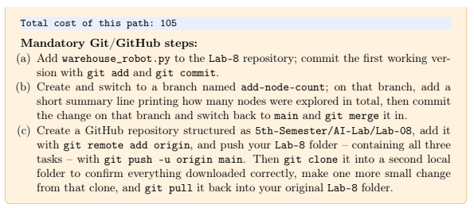
Solution:
Code:
Output:

