

Linux Basics
DEVOPS | Assignment 1
Practical Submission Documentation
Student Name | Mohd Mohsin
GitHub Repository Link | [Insert your GitHub repository link]
Project Folder | Linux_Basics_Mohsin
Objective
Practise essential Linux command-line operations: file and directory management, viewing files, searching, archiving, downloading, permissions, and environment variables.

Task 1 - Creating and Renaming Files/Directories

Task / Question
• Create a directory named test_dir using mkdir.
• Inside test_dir, create an empty file called example.txt.
• Rename example.txt to renamed_example.txt using mv.

Command Used
Purpose | Command
Create directory | mkdir test_dir
Create empty file | touch test_dir/example.txt
Rename file | mv test_dir/example.txt test_dir/renamed_example.txt
Verify result | ls -l test_dir

Short Explanation
mkdir creates the directory, touch creates an empty file, and mv renames the file. The ls -l command is used to verify the final filename.

Output / Result
Guide-supported result:
• mkdir and touch normally print no output when they succeed.
• The file is renamed to renamed_example.txt.
• The verification command should list renamed_example.txt inside test_dir.

Relevant Screenshot
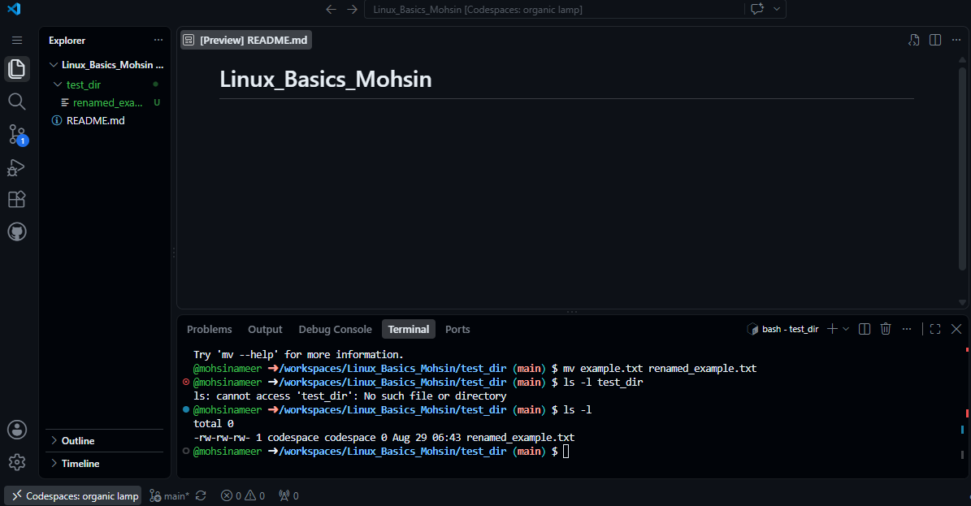

Task 2 - Viewing File Contents

Task / Question
• Use cat to display the contents of /etc/passwd.
• Display only the first 5 lines of /etc/passwd using head.
• Display only the last 5 lines of /etc/passwd using tail.

Command Used
Purpose | Command
Display entire file | cat /etc/passwd
Display first 5 lines | head -n 5 /etc/passwd
Display last 5 lines | tail -n 5 /etc/passwd

Short Explanation
cat prints the file contents to the terminal. head -n 5 shows the first five lines, while tail -n 5 shows the final five lines.

Output / Result
Guide-supported result:
• cat prints many account lines from /etc/passwd.
• head -n 5 displays exactly 5 lines from the beginning of the file.
• tail -n 5 displays exactly 5 lines from the end of the file.
• The exact account names can vary slightly by Linux environment.

Relevant Screenshot
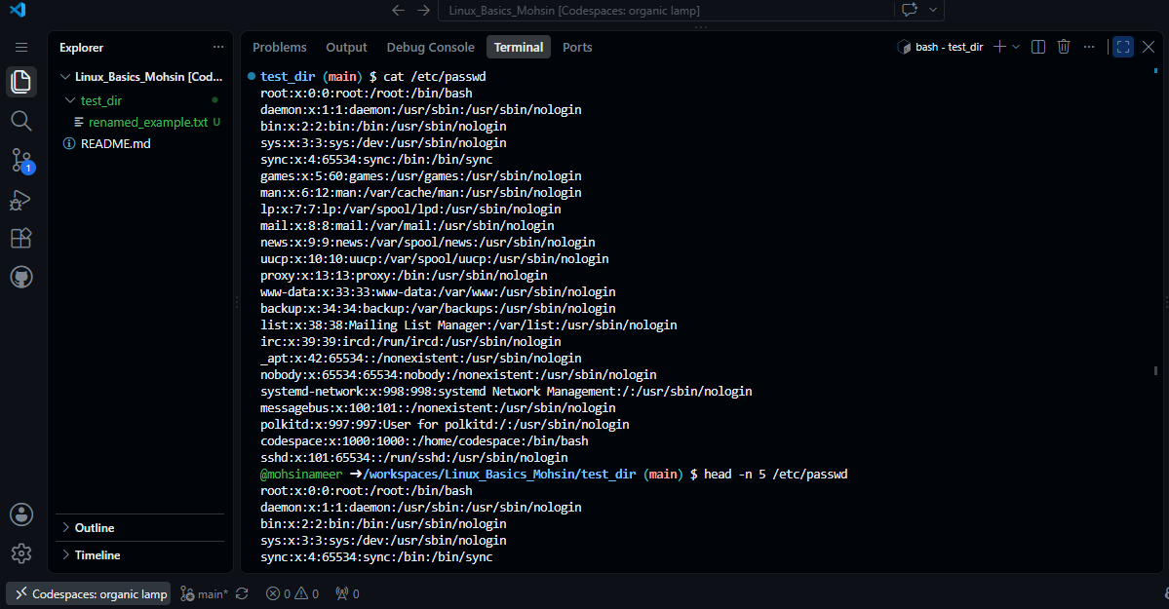

Task 3 - Searching for Patterns

Task / Question
• Use grep to find all lines containing the word “root” in /etc/passwd.

Command Used
Purpose | Command
Search for root | grep "root" /etc/passwd

Short Explanation
grep searches text for a pattern and prints every line that contains that pattern. Here it searches /etc/passwd for the word root.

Output / Result
Guide-supported result: one or more matching lines containing the word root are printed. A typical root-account match begins with root:x:0:0:root:/root:... .

Relevant Screenshot
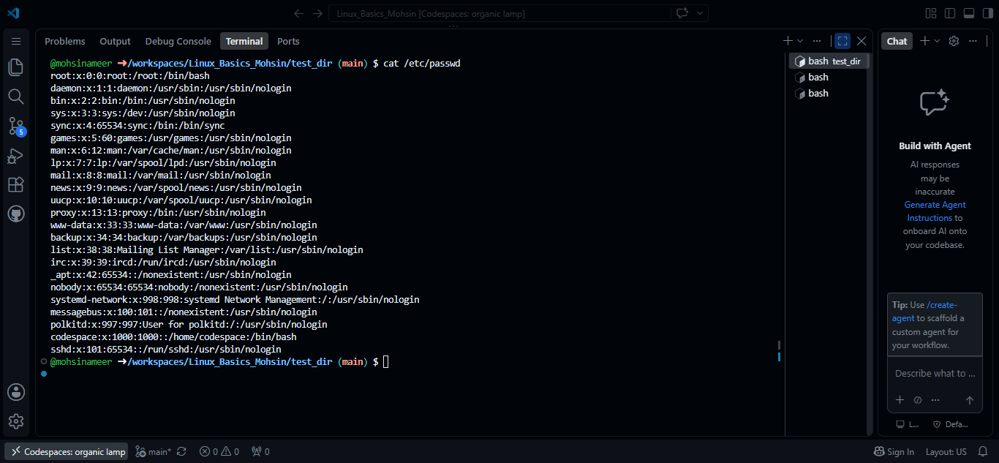

Task 4 - Zipping and Unzipping

Task / Question
• Compress the test_dir directory into a file named test_dir.zip using zip.
• Unzip test_dir.zip into a new directory named unzipped_dir.

Command Used
Purpose | Command
Create ZIP archive | zip -r test_dir.zip test_dir
Create extraction folder | mkdir unzipped_dir
Extract archive | unzip test_dir.zip -d unzipped_dir
Verify extracted files | ls -R unzipped_dir

Short Explanation
zip -r creates a ZIP archive and includes the directory contents. mkdir creates the extraction destination. unzip -d extracts the archive into that destination, and ls -R verifies the extracted directory tree.

Output / Result
Guide-supported result:
• The zip command reports files being added and creates test_dir.zip.
• The unzip command reports files being extracted into unzipped_dir.
• The final recursive listing should show unzipped_dir/test_dir/renamed_example.txt.

Relevant Screenshot
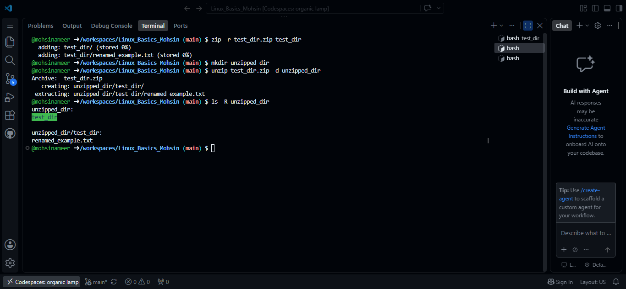

Task 5 - Downloading Files

Task / Question
• Use wget to download a file from a URL (the assignment gives https://example.com/sample.txt as an example).

Command Used
Purpose | Command
Download and save as sample.txt | wget https://example.com/ -O sample.txt
Verify downloaded file | ls -lh sample.txt

Short Explanation
wget downloads data from a URL. The -O sample.txt option chooses the local filename. ls -lh confirms that the file exists and shows its human-readable size.

Output / Result
Guide-supported result:
• wget should report a successful download and save a local file named sample.txt.
• The ls -lh command should show sample.txt with a non-zero file size.

Relevant Screenshot
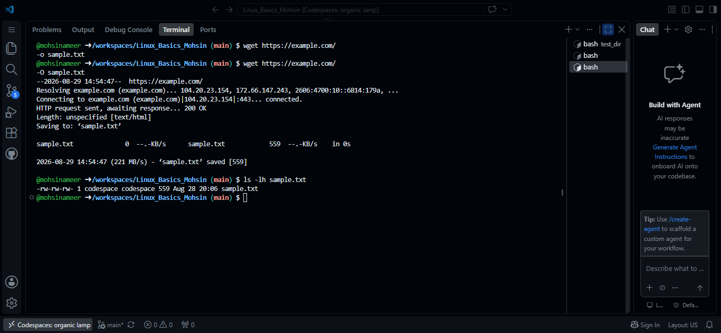

Task 6 - Changing Permissions

Task / Question
• Create a file named secure.txt and change its permissions to read-only for everyone using chmod.

Command Used
Purpose | Command
Create file | touch secure.txt
Set read-only permissions | chmod 444 secure.txt
Verify permissions | ls -l secure.txt

Short Explanation
touch creates secure.txt. chmod 444 gives read permission to the owner, group, and others, while removing write and execute permissions. ls -l displays the permission string for verification.

Output / Result
Guide-supported result:
• touch and chmod normally print no output when they succeed.
• The ls -l permission text should begin with -r--r--r--, showing read-only permission for everyone.

Relevant Screenshot
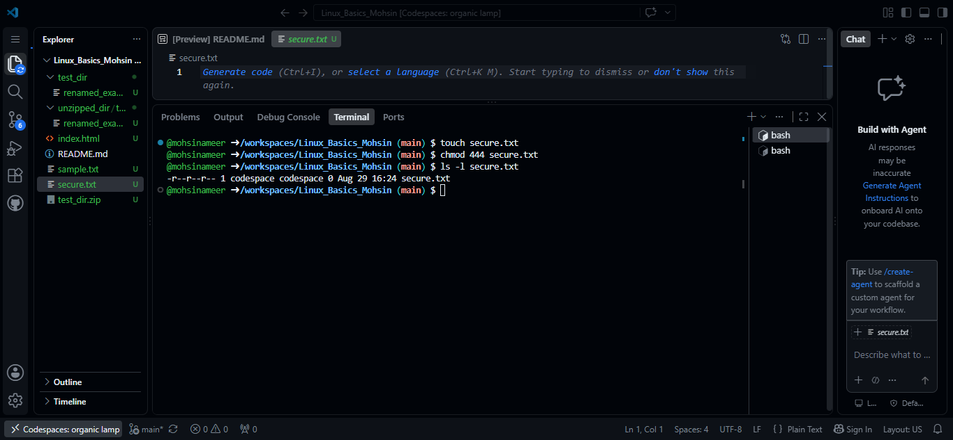

Task 7 - Working with Environment Variables

Task / Question
• Use export to set a new environment variable called MY_VAR with the value “Hello, Linux!”.

Command Used
Purpose | Command
Set environment variable | export MY_VAR="Hello, Linux!"
Display variable value | echo "$MY_VAR"

Short Explanation
export creates the environment variable for the current terminal session. echo prints the variable value so the setting can be verified.

Output / Result
Guide-supported result:
• The export command normally prints no output when it succeeds.
• The echo command prints: Hello, Linux!

Relevant Screenshot
